Ntirho POS
[Company name] | [Company address]
[Document subtitle]
Nkateko Mthembi
2023

Background Information
This is an enterprise point of sale application designed to be adaptable to most POS business use cases.
Application modes:
- Fast Foods.
- Restaurant.
- Supermarket.
- Garden centres.
- Laundromat.
- Bottle Store.

Application Overview.

- Username and password login page.
User Manager module creates application users.
Username and password are some of the options when creating the user.
- Landing page.
This provides a graphical overview of the sales of the previous day.
- Main Menu.
This provides menu of the sale items.
This is a multi-level menu for logical categorization of the sale items.
An option of item barcode scanning is provided for the supermarket mode of this application.
- Menu Manager.
New Menu Items are created including specifying fast food item options and grocery item barcode.
- Client list.
This is for food deliveries and collections. A database of clients is dynamically created.
- Reports.
Daily items sold report, monthly reports.
Any type of report can be added.

Application screens.
User Manager
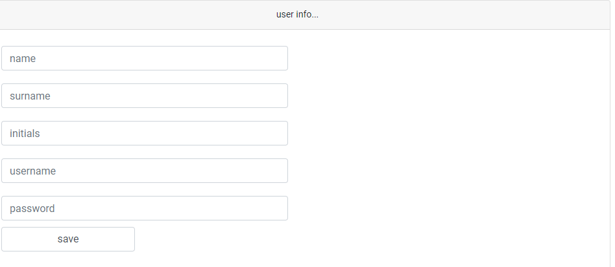
Login page
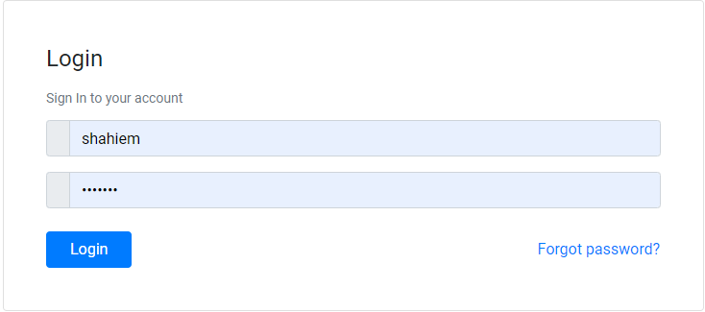
Landing page
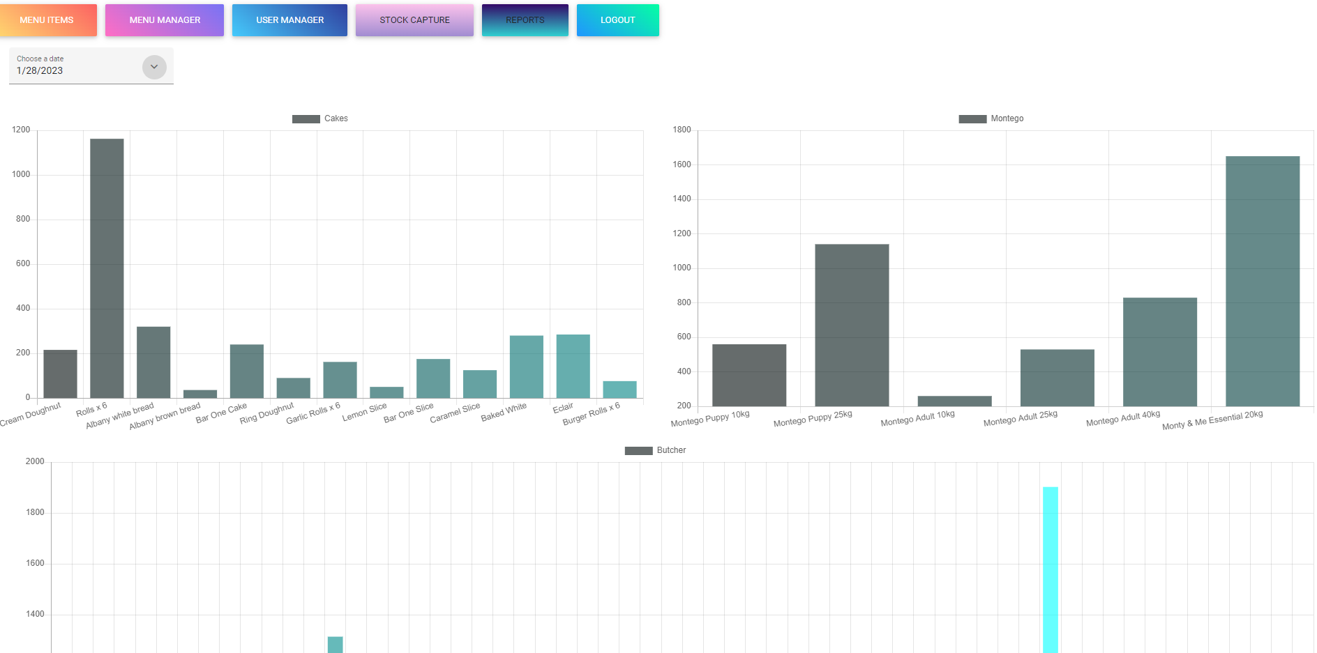

Main Menu – Fast Foods mode
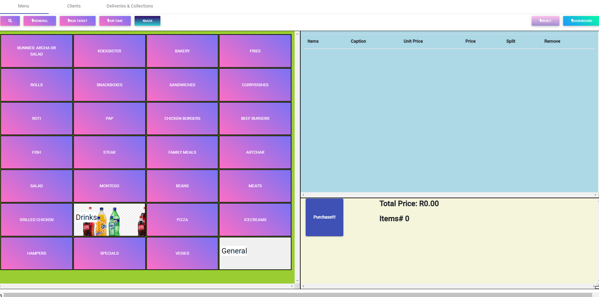
Groceries Items Accessible By Barcode Scanning.
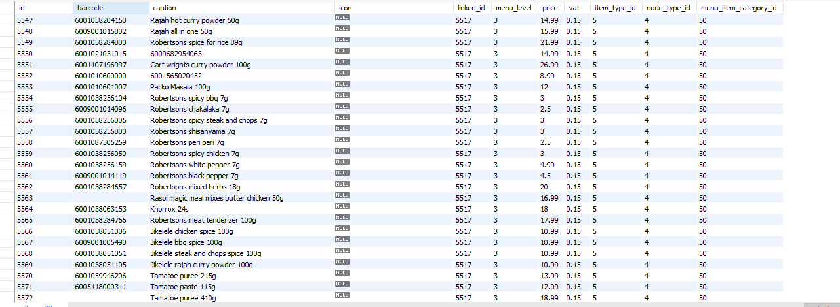

Main Menu – Garden Center mode
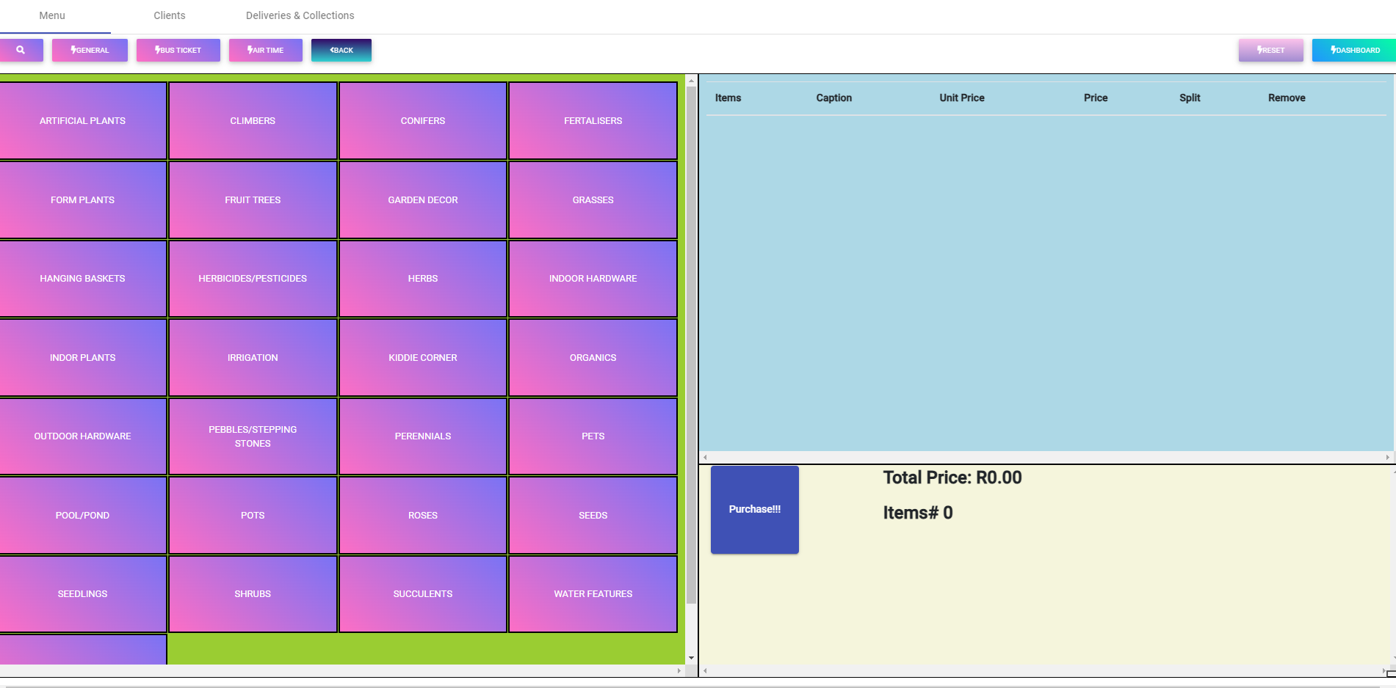
Main Menu – Landromat mode
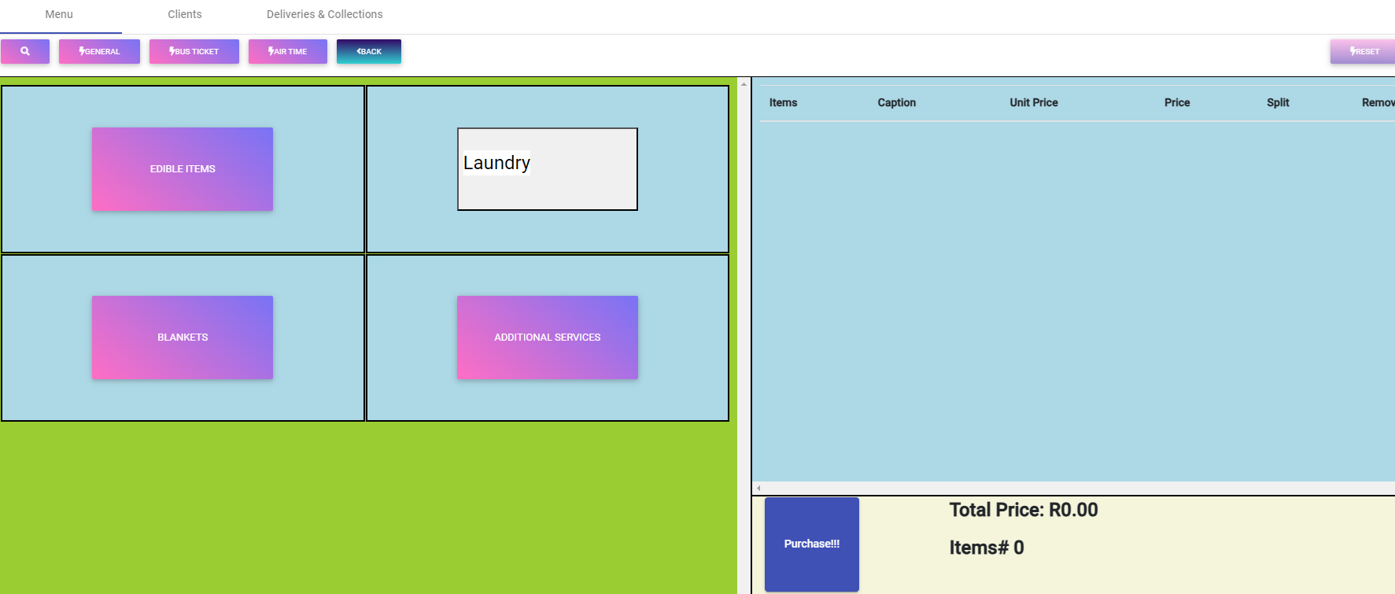

Invoice screen
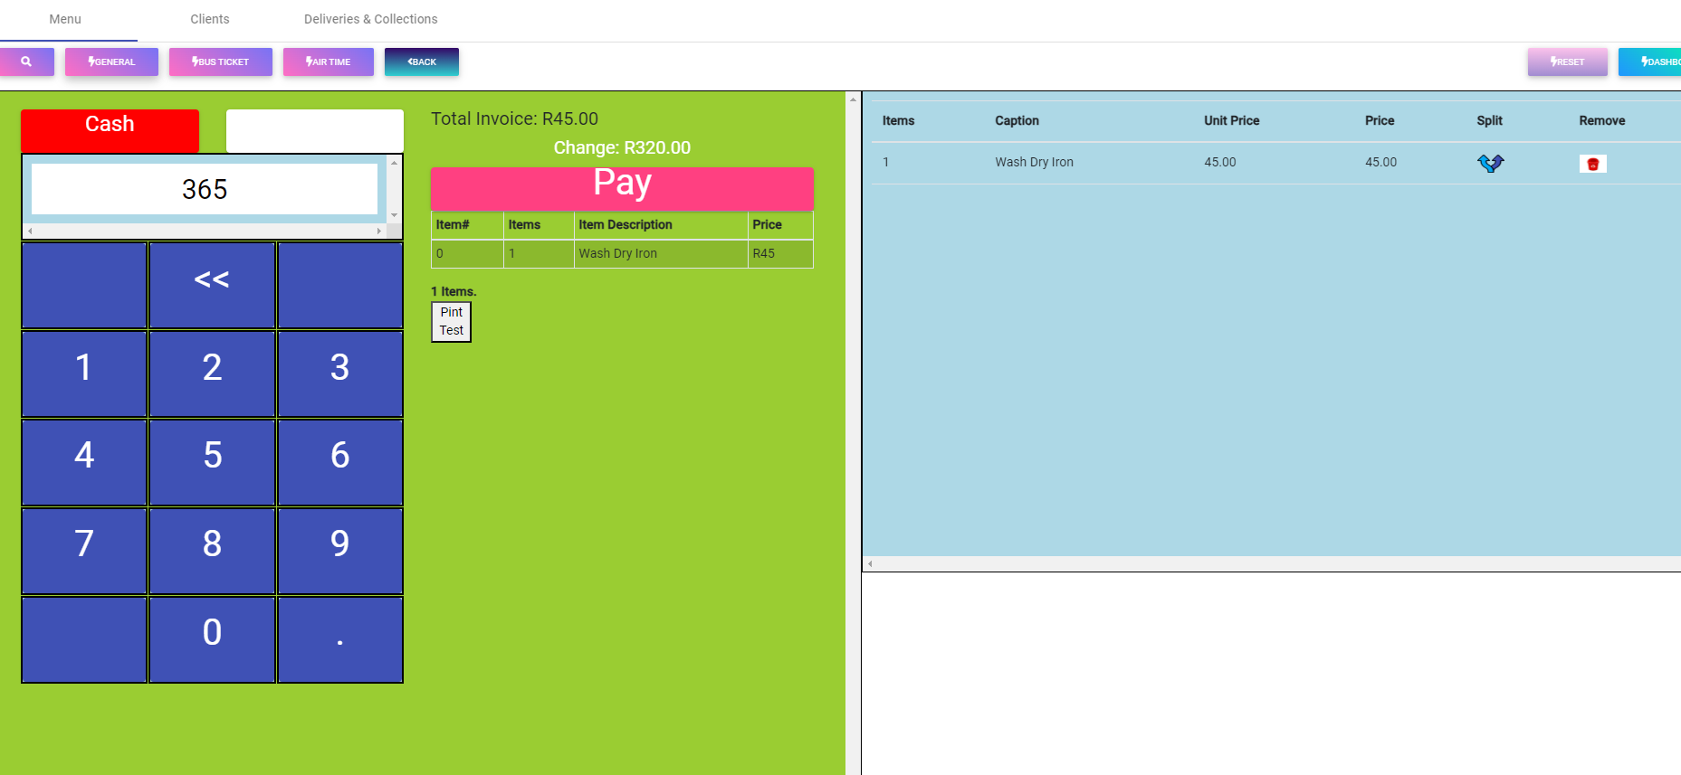

User Manager
Stock Capture
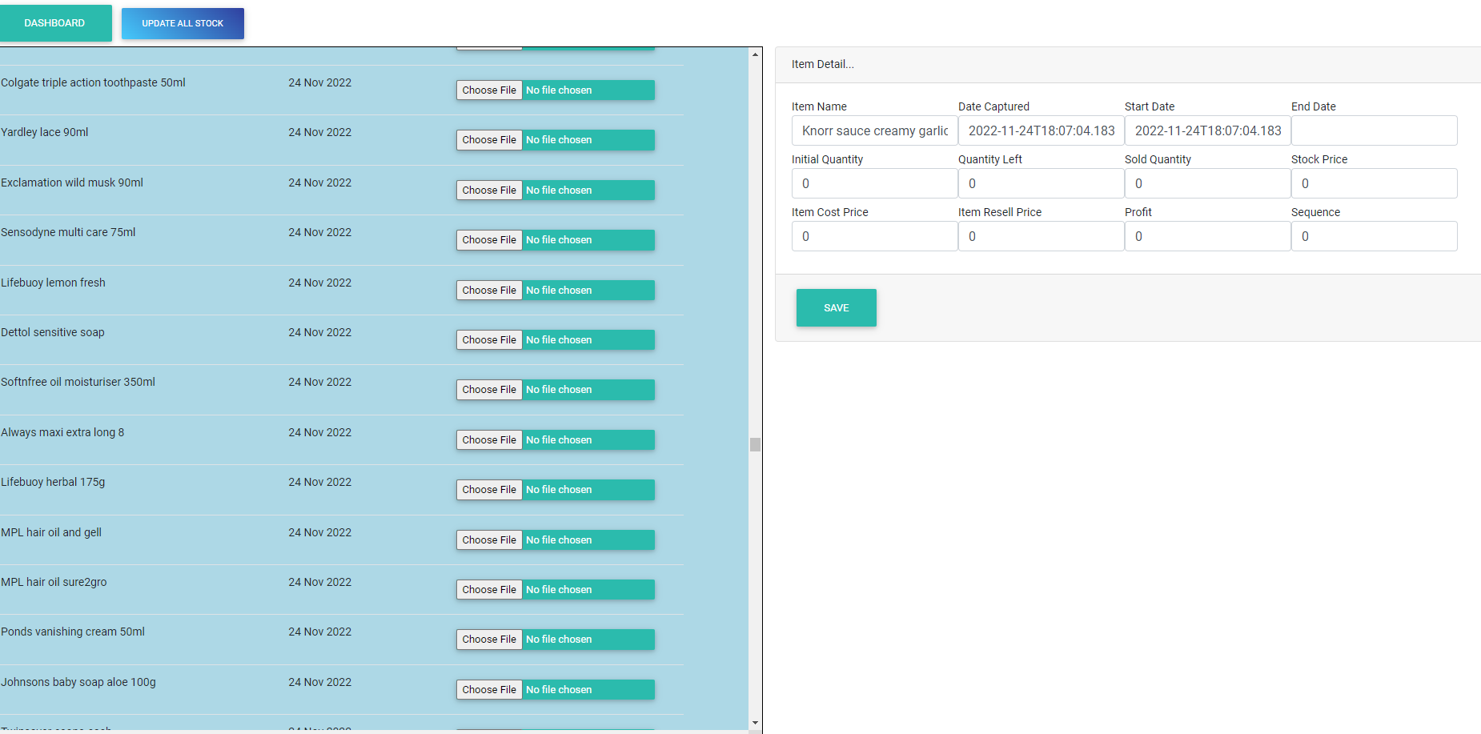

Clients List
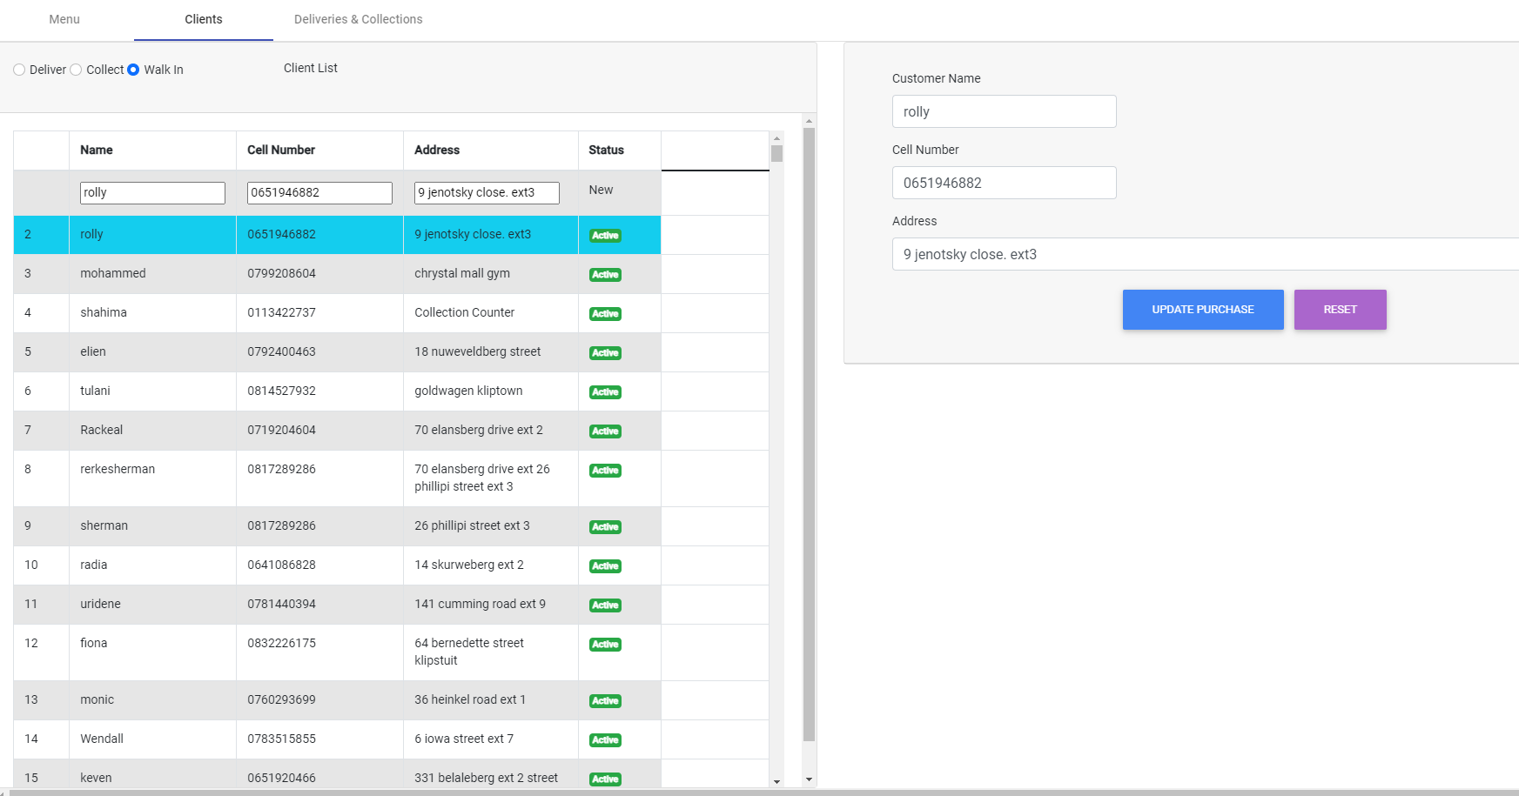

Deliveries and collections List
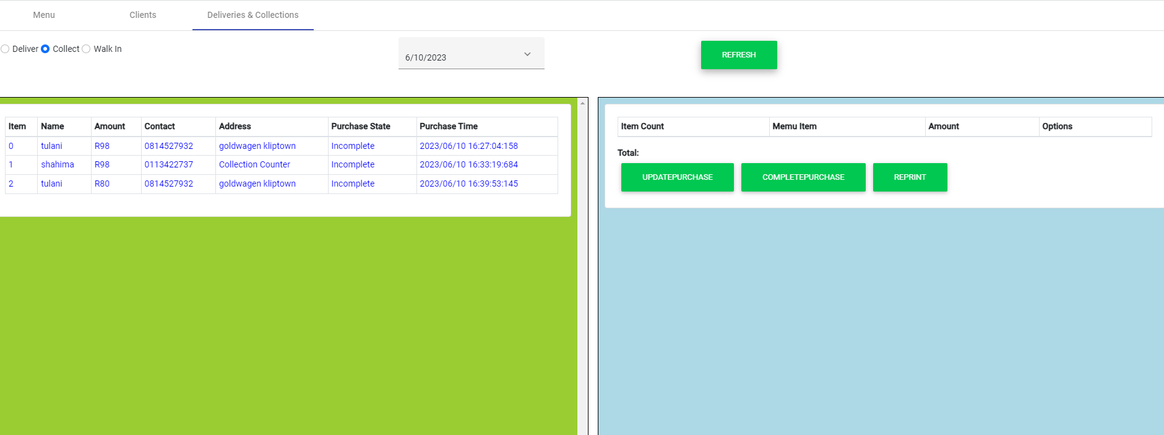

Reports
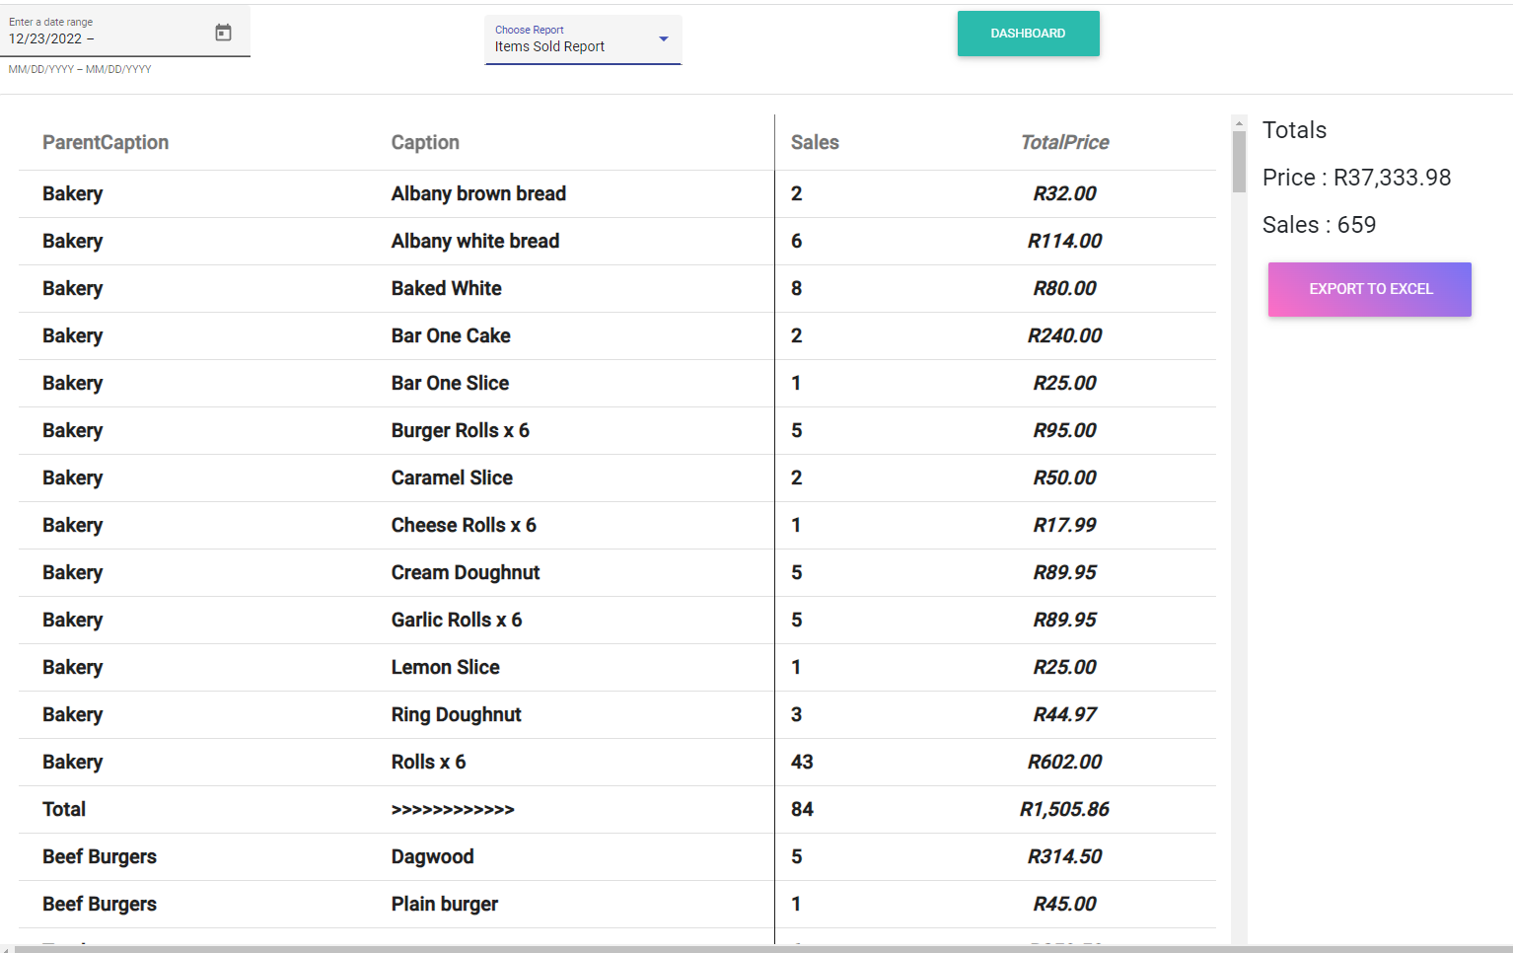
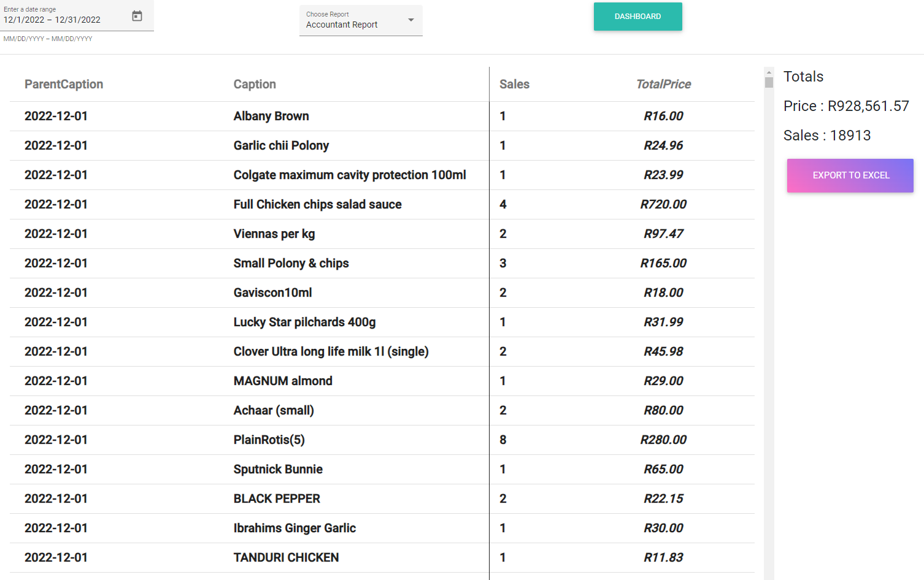

Menu Manager
