Tables for Peleke-1 Paper

Table [tab:tuned_models]
Caption: Base models and LoRA configurations used in this study.
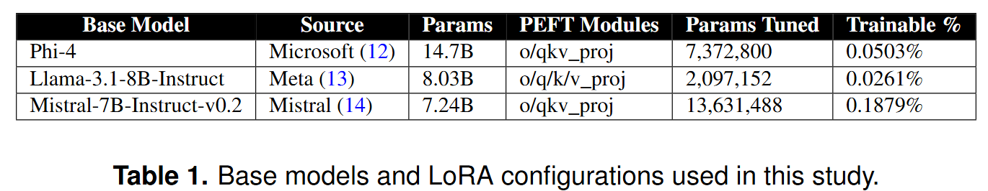

Base Model | Source | Parameters | PEFT Target Modules | Parameters Tuned | Trainable %
Phi-4 | Microsoft | 14.7B | o/qkv_proj | 7,372,800 | 5.03%
Llama-3.1-8B-Instruct | Meta | 8.03B | o/q/k/v_proj | 2,097,152 | 2.61%
Mistral-7B-Instruct-v0.2 | Mistral | 7.24B | o/qkv_proj | 13,631,488 | 0.19%

Table [tab:med-scores-by-model]
Caption: Percentage of complexes with van der Waals energies <-30 kcal/mol (mean value shown in parentheses) by fine-tuned model and antigen.
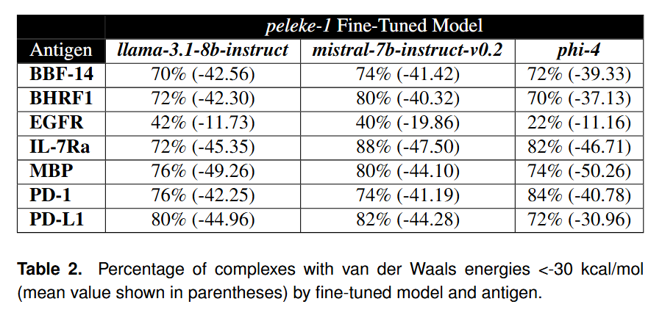

Antigen | peleke-1 Fine-Tuned Model
Antigen | llama-3.1-8b-instruct | mistral-7b-instruct-v0.2 | phi-4
BBF-14 | 70% (-42.56) | 74% (-41.42) | 72% (-39.33)
BHRF1 | 72% (-42.30) | 80% (-40.32) | 70% (-37.13)
EGFR | 42% (-11.73) | 40% (-19.86) | 22% (-11.16)
IL-7Ra | 72% (-45.35) | 88% (-47.50) | 82% (-46.71)
MBP | 76% (-49.26) | 80% (-44.10) | 74% (-50.26)
PD-1 | 76% (-42.25) | 74% (-41.19) | 84% (-40.78)
PD-L1 | 80% (-44.96) | 82% (-44.28) | 72% (-30.96)

Supplementary Table [tab:training_data]
Caption: Curated antibody-antigen complex training data from SAbDab.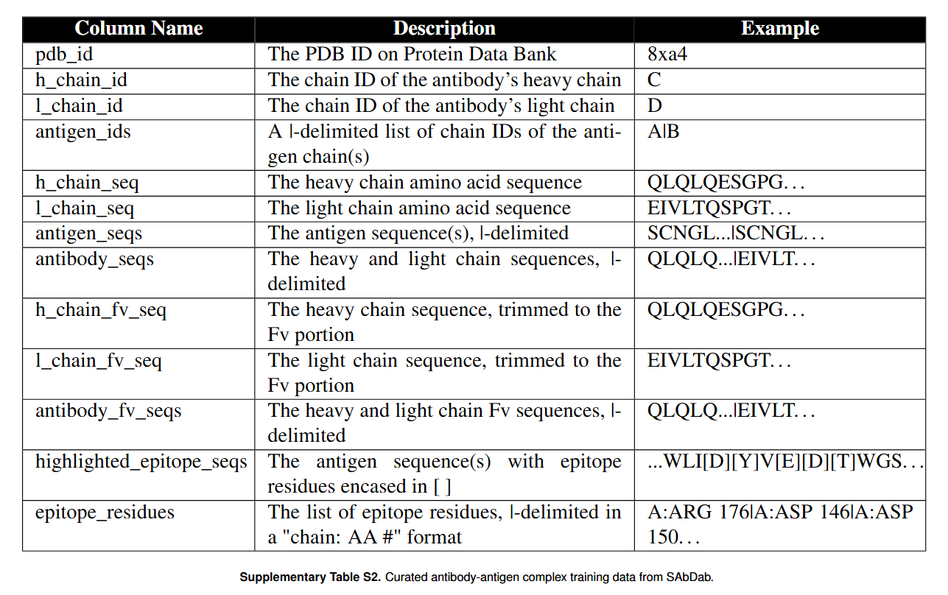
Column Name | Description | Example
pdb_id | The PDB ID on Protein Data Bank | 8xa4
h_chain_id | The chain ID of the antibody's heavy chain | C
l_chain_id | The chain ID of the antibody's light chain | D
antigen_ids | A |-delimited list of chain IDs of the antigen chain(s) | A|B
h_chain_seq | The heavy chain amino acid sequence | QLQLQESGPG…
l_chain_seq | The light chain amino acid sequence | EIVLTQSPGT…
antigen_seqs | The antigen sequence(s), |-delimited | SCNGL...|SCNGL…
antibody_seqs | The heavy and light chain sequences, |-delimited | QLQLQ...|EIVLT…
h_chain_fv_seq | The heavy chain sequence, trimmed to the Fv portion | QLQLQESGPG…
l_chain_fv_seq | The light chain sequence, trimmed to the Fv portion | EIVLTQSPGT…
antibody_fv_seqs | The heavy and light chain Fv sequences, |-delimited | QLQLQ...|EIVLT…
highlighted_epitope_seqs | The antigen sequence(s) with epitope residues encased in [ ] | ...WLI[D][Y]V[E][D][T]WGS…
epitope_residues | The list of epitope residues, |-delimited in a "chain: AA #" format | A:ARG 176|A:ASP 146|A:ASP 150…

Supplementary Table [tab:humatch]
Caption: Percentage of generated antibodies that are predicted to be human per Humatch.
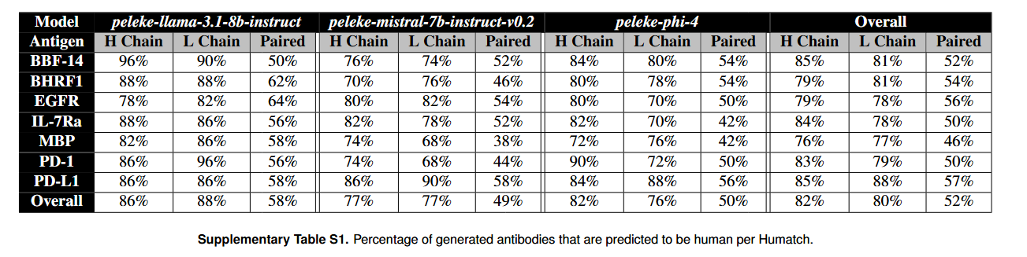

Model | Llama 3.1 8B |  |  | Mistral 7B |  |  | Phi-4 |  |  | Overall
Antigen | H Chain | L Chain | Paired | H Chain | L Chain | Paired | H Chain | L Chain | Paired | H Chain | L Chain | Paired
BBF-14 | 96% | 90% | 50% | 76% | 74% | 52% | 84% | 80% | 54% | 85% | 81% | 52%
BHRF1 | 88% | 88% | 62% | 70% | 76% | 46% | 80% | 78% | 54% | 79% | 81% | 54%
EGFR | 78% | 82% | 64% | 80% | 82% | 54% | 80% | 70% | 50% | 79% | 78% | 56%
IL-7Ra | 88% | 86% | 56% | 82% | 78% | 52% | 82% | 70% | 42% | 84% | 78% | 50%
MBP | 82% | 86% | 58% | 74% | 68% | 38% | 72% | 76% | 42% | 76% | 77% | 46%
PD-1 | 86% | 96% | 56% | 74% | 68% | 44% | 90% | 72% | 50% | 83% | 79% | 50%
PD-L1 | 86% | 86% | 58% | 86% | 90% | 58% | 84% | 88% | 56% | 85% | 88% | 57%
Overall | 86% | 88% | 58% | 77% | 77% | 49% | 82% | 76% | 50% | 82% | 80% | 52%

