Digital System Design with Verilog IIT BBS

Control and Datapath

1. Following figure shows the flow chart for multiplication using repeated addition. Sep- arate the data flow and control flow in this flow chart and write the Verilog modules for both data path and control path.

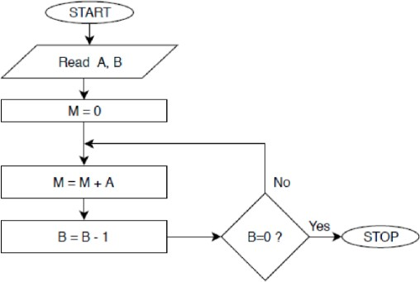

DDV 1 10.06.25