Use the cross-section analysis tool siliwiz (siliwiz.com) to do the following assignment.

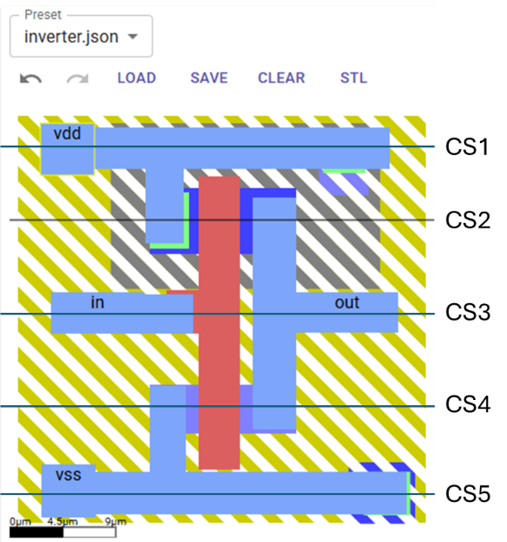 | Assignment-1: Using the inverter.json layout  - Draw the cross-section CS1 – CS5 and verify with siliwiz  - Extract the circuit from the layout with the transistor sizes.  - Assuming $10 Ω$ contact resistance and M1 sheet-rho of $0.1Ω/sq$ , calculate all the parasitic resistance.
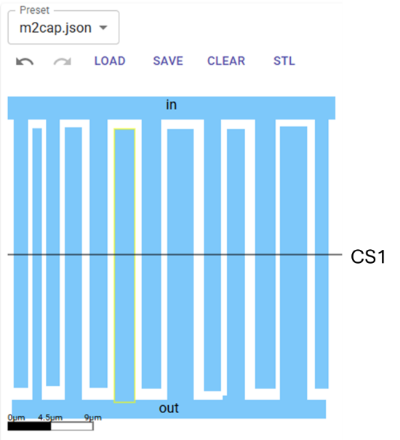 | Assignment-2: Using the m2cap.json layout  - Draw the cross-section CS1 and verify with siliwiz.  - Calculate the total capacitance between the terminal ‘in’ and ‘out’ with the following input:  - Thickness of M2 is 0.5um  - Spacing between M2 is 0.1um  - Dielectric is Silicon Dioxide
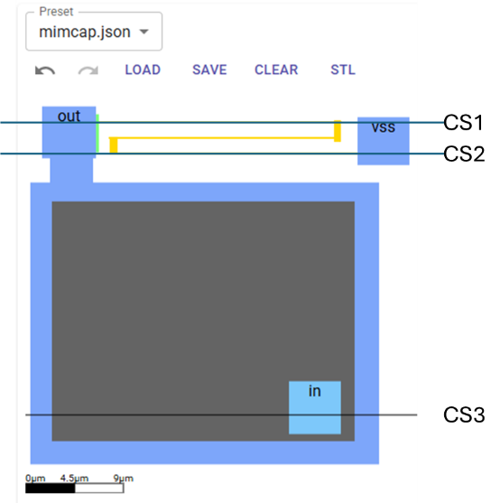 | Assignment-3: Using mimcap.json layout  - Draw the cross-section CS1 – CS3  - Extract the circuit from the layout.  - Calculate and R and C of the layout with the following input:  - The capacitance density of the Metal-Insulator-Metal (MIM) is $1 fF/μm^{2}$  - Poly res (yellow) sheet-rho is $200 Ω/sq$

