Solution to Charge Pump Differential Equations

Silicon DSP Corporation
http://www.silicondsp.com

Author: Sasan Ardalan
© 2007-2017 Sasan Ardalan
Copyright (C) 2007-2018 Sasan Ardalan
Permission is granted to copy, distribute and/or modify this document
under the terms of the GNU Free Documentation License, Version 1.3
or any later version published by the Free Software Foundation;
with no Invariant Sections, no Front-Cover Texts, and no Back-Cover Texts.
A copy of the license is included in the section entitled "GNU
Free Documentation License".

Summary:

A charge pump “C” Code Block for Capsim simulation has been written based on the
the formulas for the solution of the charge pump equations presented in Hanumolu, et. al [1]. The results show excellent correspondence with a Spice model. The differential equations were solved using State Space methods in [1] and accurately capture the initial conditions. A Capsim block has been developed called CHPStateSpace based on the approach in [1]. It has been successfully used to model a charge pump PLL. See separate documentation (http://www.silicondsp.com). Note the Capsim High Level Model of the PLL can be used prior to Spice simulations to speed up design and optimization.

Results:

Figure 1 shows the results for R=1kOhms, C₁=2pf and C₂=0.2pf. To show the impact of C₂ in smoothing the ripples Figure shows the case with C₂=2pf and C₁=2pf. Note this is for illustration. We need C₁ >> C₂.

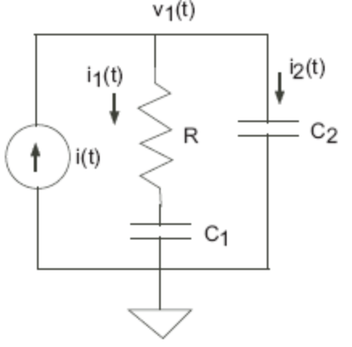
Figure 1 Charge Pump During Up Cycle

Appendix A shows the formulas from [1]. The C code is presented in Appendix B. Note tp is the duration of the “Up” pulse and T_ is the duration for example of the period of the reference or next edge of VCO/N. Ip is the current source value.

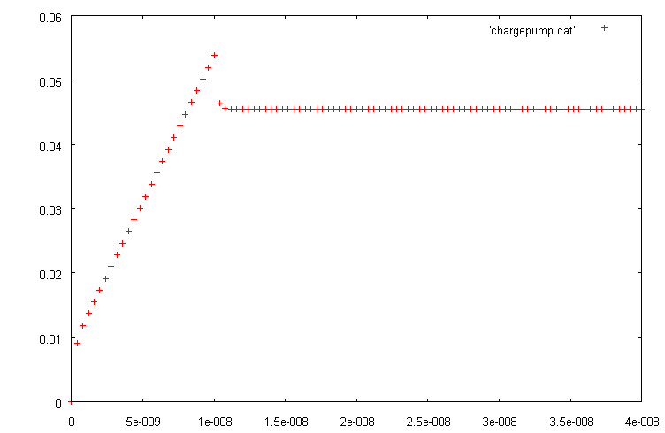
Figure 2 v(1) with C₁=2 pf and C₂=0.2 pf

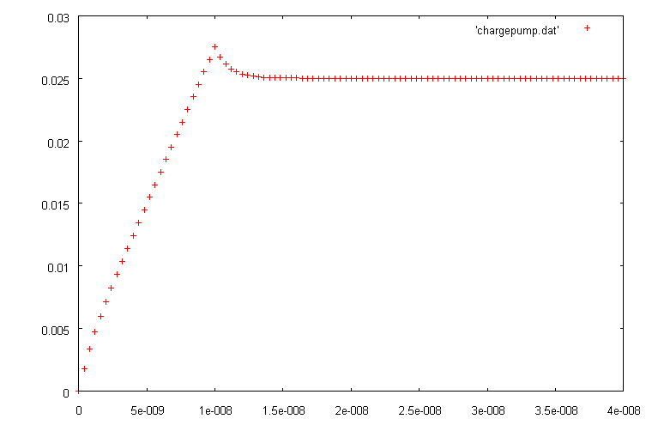
Figure 3 v(1) with C₁=2 pf and C₂=2 pf

References

[1] Hanumolu, P.K.; Brownlee, M.; Mayaram, K.; Un-Ku Moon,“Analysis of charge-pump phase-locked loops”, Circuits and Systems I: Regular Papers, IEEE Transactions on Circuits and Systems I: Fundamental Theory and Applications, Volume 51, Issue 9, Date: Sept. 2004, Pages: 1665 – 1674

Appendix A

In the following from [1], v_{ctrl} is v₁. and v_{c} is v₂ across C₂. t_{p} is the on time of Up or Down pulse. T_ is related to the period of the reference or the next edge of VCO/N. That is the time t_{p}<t<T_ is the off time of the Up or Down pulse. See Figure 3.

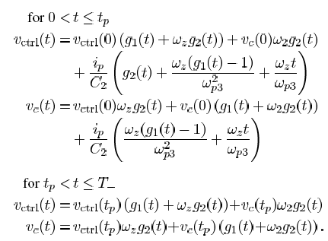
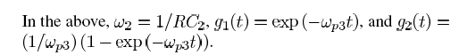

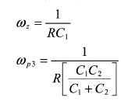

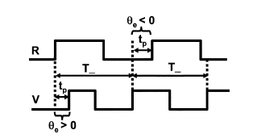
Figure 3 Definition of t_{p} ad T_ from [1].

In the above note that all the exponentials are based on e^{-at}, where, as we derived before:
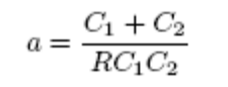

Appendix B: C Code.

#include <math.h>
#include <stdio.h>

int main(int argc, char* argv[])
{

double c1=2e-12;
double c2=2e-12;
double r=1000;
double Ip= 0.00001;

double dt=0.1e-9;
double tmax=100e-9;
double t;
double tt;
double tdelay=10e-9;
double a;
double v1;
double invC2;
double aInv;
double coeff;
double beta;

double vctrl;
double vctrlInit=0;

double vc;
double vcInit=0;
double tp=10e-9;
double T_;

double g1;
double g2;

double w2;
double wz;

int i;
int n=100;

int flag=0;

FILE *fp;

fp=fopen("chargepump.dat","w");
if(!fp) {
fprintf(stderr,"Could not open file to write:chargepump.dat \n");
return 0;
}

tp=10e-9;
T_=40e-9;
tmax=T_;

dt=tmax/(double)n;
a=(c1+c2)/(r*c1*c2);
aInv = 1/a;
w2=1.0/(r*c2);
wz=1.0/(r*c1);

printf("a=%le\taInv=%le\tw2=%le\n",a,aInv,w2);

vctrlInit=0;
vcInit=0;
flag=0;
for(i=0; i<n+1; i++) {
t=i*dt;

if(t <= tp) {

g1=exp(-a*t);
g2=aInv*(1-exp(-a*t));

vctrl = vctrlInit*(g1+wz*g2)+
vcInit*w2*g2+
(Ip/c2)*(g2+wz*(g1-1)/(a*a)+wz*t/a);
vc=vctrlInit*wz*g2+vcInit*(g1+w2*g2)+
(Ip/c2)*(wz*(g1-1)/(a*a)+wz*t/a);
}
if ((t > tp) && (t<T_) && !flag) {

vctrlInit=vctrl;
vcInit=vc;
flag=1;
}
if ((t > tp) && (t<T_) && flag) {
tt=t-tp;
g1=exp(-a*tt);
g2=aInv*(1-exp(-a*tt));

vctrl=vctrlInit*(g1+wz*g2)+vcInit*w2*g2;
vc=vctrlInit*wz*g2+vcInit*(g1+w2*g2);

}
//printf("%le\t%le\n",t,vctrl);
printf("%le\t%le\t%le\t%le\t%le\t%d\n",t,vctrl,vc,g1,g2,flag);
fprintf(fp,"%le\t%le\n",t,vctrl);

}

fclose(fp);

return 0;
}

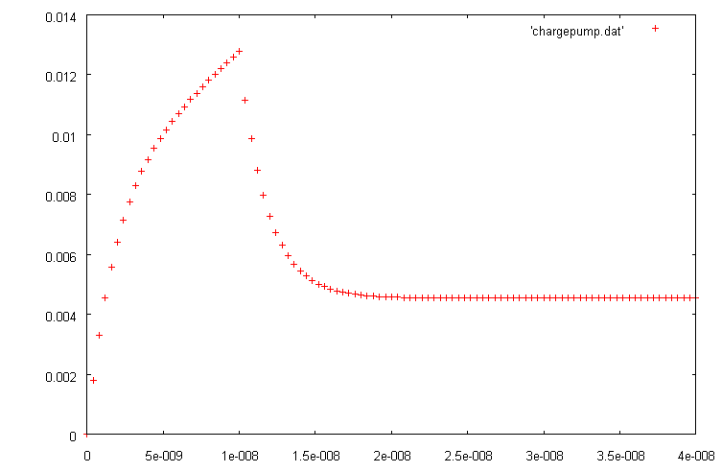

Appendix C
The file: chargepump.dat

0.000000e+00 0.000000e+00
4.000000e-10 1.824200e-03
8.000000e-10 3.376678e-03
1.200000e-09 4.747014e-03
1.600000e-09 5.995259e-03
2.000000e-09 7.161662e-03
2.400000e-09 8.273205e-03
2.800000e-09 9.347975e-03
3.200000e-09 1.039809e-02
3.600000e-09 1.143169e-02
4.000000e-09 1.245421e-02
4.400000e-09 1.346931e-02
4.800000e-09 1.447943e-02
5.200000e-09 1.548621e-02
5.600000e-09 1.649076e-02
6.000000e-09 1.749380e-02
6.400000e-09 1.849585e-02
6.800000e-09 1.949722e-02
7.200000e-09 2.049813e-02
7.600000e-09 2.149875e-02
8.000000e-09 2.249916e-02
8.400000e-09 2.349944e-02
8.800000e-09 2.449962e-02
9.200000e-09 2.549975e-02
9.600000e-09 2.649983e-02
1.000000e-08 2.749989e-02
1.040000e-08 2.667572e-02
1.080000e-08 2.612327e-02
1.120000e-08 2.575295e-02
1.160000e-08 2.550472e-02
1.200000e-08 2.533832e-02
1.240000e-08 2.522678e-02
1.280000e-08 2.515202e-02
1.320000e-08 2.510190e-02
1.360000e-08 2.506831e-02
1.400000e-08 2.504579e-02
1.440000e-08 2.503069e-02
1.480000e-08 2.502057e-02
1.520000e-08 2.501379e-02
1.560000e-08 2.500924e-02
1.600000e-08 2.500620e-02
1.640000e-08 2.500415e-02
1.680000e-08 2.500278e-02
1.720000e-08 2.500187e-02
1.760000e-08 2.500125e-02
1.800000e-08 2.500084e-02
1.840000e-08 2.500056e-02
1.880000e-08 2.500038e-02
1.920000e-08 2.500025e-02
1.960000e-08 2.500017e-02
2.000000e-08 2.500011e-02
2.040000e-08 2.500008e-02
2.080000e-08 2.500005e-02
2.120000e-08 2.500003e-02
2.160000e-08 2.500002e-02
2.200000e-08 2.500002e-02
2.240000e-08 2.500001e-02
2.280000e-08 2.500001e-02
2.320000e-08 2.500000e-02
2.360000e-08 2.500000e-02
2.400000e-08 2.500000e-02
2.440000e-08 2.500000e-02
2.480000e-08 2.500000e-02
2.520000e-08 2.500000e-02
2.560000e-08 2.500000e-02
2.600000e-08 2.500000e-02
2.640000e-08 2.500000e-02
2.680000e-08 2.500000e-02
2.720000e-08 2.500000e-02
2.760000e-08 2.500000e-02
2.800000e-08 2.500000e-02
2.840000e-08 2.500000e-02
2.880000e-08 2.500000e-02
2.920000e-08 2.500000e-02
2.960000e-08 2.500000e-02
3.000000e-08 2.500000e-02
3.040000e-08 2.500000e-02
3.080000e-08 2.500000e-02
3.120000e-08 2.500000e-02
3.160000e-08 2.500000e-02
3.200000e-08 2.500000e-02
3.240000e-08 2.500000e-02
3.280000e-08 2.500000e-02
3.320000e-08 2.500000e-02
3.360000e-08 2.500000e-02
3.400000e-08 2.500000e-02
3.440000e-08 2.500000e-02
3.480000e-08 2.500000e-02
3.520000e-08 2.500000e-02
3.560000e-08 2.500000e-02
3.600000e-08 2.500000e-02
3.640000e-08 2.500000e-02
3.680000e-08 2.500000e-02
3.720000e-08 2.500000e-02
3.760000e-08 2.500000e-02
3.800000e-08 2.500000e-02
3.840000e-08 2.500000e-02
3.880000e-08 2.500000e-02
3.920000e-08 2.500000e-02
3.960000e-08 2.500000e-02
4.000000e-08 2.500000e-02

