OpenSoC Tier-1 Embedded SoC — Technical Specification v1.4
SKY130 tape-out · FPGA prototype · 1× CVA6 RV64GC · Open-source toolchain

Version History
Version | Date | Author | Change
1.0 | 2025-03-14 | OpenSoC Team | Initial Tier-1 release
1.1 | March 2026 | OpenSoC Team | QuestaSim 2024.1 simulation verified (0 errors); address map corrected to match implemented RTL (Boot ROM 0x0001_0000, SRAM 0x8000_0000, Periph 0x9000_0000); AXI address width updated 40→64 bits to match CVA6 v5.x; crossbar corrected to 1×3 topology; simulation test results added (Section 15); vendor file change log added (Appendix D).
1.3 | April 2026 | OpenSoC Team | SPI master added to t1_periph_ss_32.sv (SPI_CTRL/STAT/TX/RX registers, Mode 0, 8-bit, configurable CLK_DIV). Boot ROM vopt fix (always_comb case replaces initial block to prevent dead-code elimination). CPU-driven tests PASS: t1_gpio_cpu_tb (L1+L2), t1_uart_cpu_tb (L1+L2), t1_spi_cpu_tb (L1+L2). UART uart_send_recv FAIL_VAL macro fix. SW docs: OpenSoC_Tier1_SWI.docx, OpenSoC_Tier1_FileInventory.docx. soc1.1 snapshot copy created.
1.4 | April 2026 | OpenSoC / IIITDM | E-class SoC primary; GPIO L1 PASS (83 370 cycles) and GPIO L2 PASS (75 995 cycles) added; cover version aligned to v1.4; E-class appendix updated with April 2026 sim results.

1. Introduction & Scope

1.1 Purpose
This document specifies the OpenSoC Tier-1 Embedded SoC — the minimal, self-contained implementation of the OpenSoC platform. It is complete for RTL design, verification, and SKY130 tape-out without requiring any Tier-2 or Tier-3 features. Version 1.1 updates the address map, AXI width, and crossbar topology to reflect the implementation as verified in QuestaSim 2024.1 on Windows (March 2026).

1.2 Scope Boundaries
Feature | Tier-1 (this doc) | Deferred to Tier-2/3
CPU cores | 1× CVA6 RV64GC @ 50–100 MHz | 4–12× CVA6 + BOOM OoO
ISA | RV64GC (G+C) | H (hypervisor), V (vector)
L2 cache | None | 512 KB – 4 MB
DRAM | None — on-chip SRAM only | DDR4-3200 / HBM2
Interconnect | AXI4 1×3 crossbar (64-bit) | CHI coherency, FlooNoC
Peripherals | UART, SPI, I2C, GPIO, Timer, WDT | USB2, Ethernet, PCIe
Security | JTAG debug + OTP placeholder | OpenTitan full RoT
Accelerators | None | Gemmini, iDMA, RVV
Process target | SKY130 / Xilinx Artix-7 FPGA | TSMC 28nm / 12nm
OS target | Bare-metal + FreeRTOS | Linux (needs DRAM)

1.3 Key IPs
IP | Source | License | Version
CVA6 (Ariane) CPU | OpenHW Group / ETH Zurich | Solderpad 2.0 | v5.0.0
AXI4 crossbar (axi_xbar) | PULP Platform | Solderpad 2.0 | v0.39.0
PLIC (rv_plic) | lowRISC OpenTitan | Apache 2.0 | earlgrey_1.0
UART (rv_uart) | lowRISC OpenTitan | Apache 2.0 | earlgrey_1.0
SPI host | lowRISC OpenTitan | Apache 2.0 | earlgrey_1.0
I2C | lowRISC OpenTitan | Apache 2.0 | earlgrey_1.0
GPIO | lowRISC OpenTitan | Apache 2.0 | earlgrey_1.0
rv_timer / aon_timer | lowRISC OpenTitan | Apache 2.0 | earlgrey_1.0
Debug module (dm_top) | CVA6 / lowRISC | Solderpad 2.0 | v5.0.0
common_cells | PULP Platform | Solderpad 2.0 | v0.39.0

2. Architecture Overview

2.1 Top-Level Description
The Tier-1 SoC is a single-core, non-coherent, on-chip-SRAM-only embedded platform. One CVA6 core connects via a 1-master × 3-slave 64-bit AXI4 crossbar to Boot ROM, on-chip SRAM, and the peripheral subsystem. There is no DRAM, no L2 cache, and no hardware accelerator.
NOTE: v1.1 correction: the implemented crossbar is 1×3 (not 4×6 as stated in v1.0). The additional master ports (debug SBA, reserved DMA) are planned for Tier-2.

2.2 Memory Map (Implemented — v1.1 Corrected)
NOTE: The address map below reflects the RTL as synthesised and verified. The v1.0 spec listed Boot ROM at 0x0000_0000 and SRAM at 0x0001_0000; the implementation uses the addresses shown here.
Slave | Base Address | End Address | Size | Notes
Boot ROM | 0x0000_0000_0001_0000 | 0x0000_0000_0001_FFFF | 64 KB | Execute-only; 64-entry ROM
On-chip SRAM | 0x0000_0000_8000_0000 | 0x0000_0000_800F_FFFF | 1 MB | 128 KB default (SramNumWords=16384×8 B)
Peripheral subsys. | 0x0000_0000_9000_0000 | 0x0000_0000_901F_FFFF | 2 MB | UART, SPI, I2C, GPIO, timers, PLIC

2.3 AXI Bus Parameters
Parameter | Value | Note
Data width | 64 bits | matches CVA6 noc_req/noc_resp
Address width | 64 bits | v1.0 said 40; corrected to 64 to match CVA6ConfigAxiAddrWidth
ID width | 4 bits | as generated by CVA6
User width | 1 bit
Topology | 1M × 3S | 1 CPU master, 3 slaves
Outstanding | 8 per channel | set in axi_xbar parameters

3. CPU Subsystem — CVA6 RV64GC

3.1 Core Configuration
Parameter | Value | Notes
ISA | RV64GC | G=IMAFD+Zicsr+Zifencei; C=compressed
Configuration pkg | cv64a6_imafdc_sv39 | cv64a6_imafdc_sv39_config_pkg
Pipeline | 6 stages | Fetch/Decode/Issue/EX/MEM/Commit
Issue policy | In-order, single-issue | No OoO in Tier-1
Frequency target | 50 MHz (SKY130), 100 MHz (FPGA) | Synthesis-dependent
Physical addr | 39 bits (Sv39 MMU) | 3-level page table
Privilege modes | M / S / U | No H-mode in Tier-1
FPU | F + D (IEEE 754 SP+DP) | Zfh deferred
AXI interface | noc_req_o / noc_resp_i | CVA6 v5.x port names
PMP regions | 8 | M-mode configurable

3.2 L1 Cache Configuration
Parameter | I-Cache | D-Cache
Size | 16 KB | 16 KB
Associativity | 4-way | 4-way
Sets | 64 | 64
Line size | 64 bytes | 64 bytes
Replacement | Pseudo-LRU | Pseudo-LRU
Write policy | Read-only | Write-back, write-allocate
ECC | Parity | Parity
Hit latency | 1 cycle | 2 cycles

4. Memory Subsystem

4.1 Boot ROM
Parameter | Value
Base address | 0x0000_0000_0001_0000 (v1.1 corrected)
Size | 64 KB (RomDepth=64 entries × 8 bytes)
CVA6 boot addr | 0x0000_0000_0001_0000
Access | Read-only AXI4 slave (SLVERR on writes)
Latency | 1 cycle (registered output)
Contents | Empty in simulation; ZSBL for ASIC tape-out

4.2 On-Chip SRAM
Parameter | Value
Base address | 0x0000_0000_8000_0000 (v1.1 corrected)
Default size | 128 KB (SramNumWords=16384, 8 bytes/word)
Parameter | SramNumWords — set in t1_soc_top instantiation
Word width | 64 bits
Byte enables | 8-bit granularity
Read latency | 2 cycles (registered)
SKY130 macro | sky130_sram_2kbyte_1rw1r_32x512_8 (tiled)
FPGA | Xilinx BRAM18 auto-inferred

5. Peripheral Subsystem
All peripherals are sourced from lowRISC OpenTitan (earlgrey_1.0) and connect via t1_periph_ss.sv which bridges AXI4-Lite to TileLink Uncached Lightweight (TL-UL). All registers are 32-bit. The peripheral base address is 0x0000_0000_9000_0000.

5.1 Peripheral Address Map
Peripheral | Offset from 0x9000_0000 | Size | Key Parameters
UART | 0x0000 | 4 KB | 115200 baud default; 32-deep TX FIFO, 64-deep RX FIFO
GPIO | 0x1000 | 4 KB | 32 bidirectional pins; per-pin OE; 32 interrupt sources
RV_TIMER | 0x2000 | 4 KB | 2× 64-bit channels; 12-bit prescaler
AON_TIMER | 0x3000 | 4 KB | Watchdog: bark→IRQ, bite→SoC reset
SPI Host | 0x4000 | 4 KB | 4 chip-selects; SPI modes 0–3; 256-byte TX/RX FIFOs
I2C | 0x5000 | 4 KB | Standard/Fast/Fast+; 7/10-bit; 64-byte FIFOs
RV_PLIC | 0x6000 | 4 KB | 64 sources; 2 targets (M+S); 8 priority levels

5.2 UART (rv_uart)
Parameter | Value
Baud range | 110 – 3,000,000 (NCO = 2^20 × baud / peri_clk)
Data format | 8N1 default; configurable stop bits, parity
TX FIFO | 32 bytes
RX FIFO | 64 bytes
Interrupts | 8: TX watermark, RX watermark, TX empty, TX done, RX overflow, RX frame, RX break, RX parity
Idle state | uart_tx_o = 1 (marking) when no data
Loopback | sys_loopback via CTRL register; line_loopback supported

5.3 SPI Host
Parameter | Value
Chip selects | 4 (CS0–CS3); spi_csb_o = 1 idle
Max SCK | peri_clk / 2
Modes | SPI 0,1,2,3 (CPOL/CPHA)
Width | Standard (1-bit), Dual (2-bit), Quad (4-bit)
TX/RX FIFO | 256 bytes each
Idle state | spi_csb_o = 1; spi_sck_o = 0 (CPOL=0)

5.4 GPIO
Parameter | Value
Pin count | 32 bidirectional (gpio_in_i / gpio_out_o / gpio_oe_o)
Direction | Per-pin output enable (gpio_oe_o)
Interrupts | 32: rising, falling, both-edge, or level per pin
Reset state | gpio_oe_o = 0 (all inputs); gpio_out_o = 0

6. Clock & Reset Architecture

6.1 Clock Domains
Domain | FPGA source | ASIC source | Frequency | Consumers
cpu_clk | MMCM output | On-die PLL0 | 50/100 MHz | CVA6, caches, AXI crossbar, SRAM
peri_clk | cpu_clk or /2 | PLL0 or /2 | 50 MHz | UART, SPI, I2C, GPIO, PLIC, timers
jtag_clk | Ext. TCK pin | Ext. TCK | ≤ 20 MHz | Debug module, DMI JTAG TAP

6.2 Reset Sequence
Step 1: Assert POR (async).
Step 2: PLL0 locks.
Step 3: De-assert peri_rst_n after 4 peri_clk cycles.
Step 4: De-assert cpu_rst_n after 4 cpu_clk cycles.
Step 5: CPU fetches from boot_addr_i = 0x0000_0000_0001_0000.
Reset | Trigger | Scope | De-assert method
POR | VDD ramp | Entire SoC | Sync on cpu_clk after PLL lock
Soft reset | CPU write CTRL_REG[0] | CPU only, SRAM retained | Sync on cpu_clk
WDT bite | 2nd WDT expiry | Entire SoC | Same as POR
Debug ndmreset | JTAG ndmreset_o | CPU only (not DM) | Sync on cpu_clk

7. Interrupt Architecture

7.1 PLIC Source Assignment
Source ID | Peripheral | Signal
1–8 | UART0 | TX watermark, RX watermark, TX empty, TX done, RX overflow, RX frame, RX break, RX parity
9–10 | SPI0 | Error, SPI event
11–21 | I2C0 | All 11 interrupt sources
22–53 | GPIO[31:0] | Edge / level configurable
54 | rv_timer | Timer 0 expire
55 | aon_timer | Watchdog bark
56–63 | Reserved | —

8. Debug & JTAG
Parameter | Value
Spec | RISC-V External Debug Support 1.0
Features | Halt, resume, single-step, 2 HW breakpoints, register/memory access
IDCODE | 0x249511C3
TCK max | 20 MHz (FPGA), 10 MHz (SKY130)
Abstract commands | Access register (GPR/FPR/CSR), quick access
Program buffer | 2 × 32-bit words
Software | OpenOCD + riscv64-unknown-elf-gdb

9. Power & Area Estimates (SKY130)

9.1 Power
Block | Dynamic (mW) | Leakage (mW) | Total (mW)
CVA6 core pipeline | 38 | 22 | 60
CVA6 FPU (active) | 12 | 8 | 20
L1 I-Cache 16 KB | 8 | 10 | 18
L1 D-Cache 16 KB | 9 | 10 | 19
AXI4 crossbar | 4 | 2 | 6
On-chip SRAM 128 KB | 22 | 14 | 36
Boot ROM | 1 | 1 | 2
PLIC + timers | 4 | 2 | 6
Peripheral subsystem | 6 | 3 | 9
Debug module | 0 | 1 | 1
Clock tree + PLL | 15 | 0 | 15
I/O ring (59 pads) | 8 | 4 | 12
Routing margin (15%) | 19 | 11 | 30
TOTAL | 146 | 88 | 234

9.2 Area
Block | kGE (cells) | Cell area (mm²)
CVA6 core pipeline | 280 | 0.403
L1 I-Cache 16 KB | — | 0.112
L1 D-Cache 16 KB | — | 0.112
AXI4 crossbar | 32 | 0.046
Boot ROM (synth.) | 4 | 0.006
On-chip SRAM 128 KB | — | 0.180
PLIC | 18 | 0.026
Peripheral subsystem | 28 | 0.040
Debug module + JTAG | 12 | 0.017
Clock / PLL | 6 | 0.009
I/O ring (59 pads) | — | 0.540
TOTAL | ~380 | ~1.49 mm²

10. RTL File Structure
File | Module | Description
rtl/top/t1_soc_top.sv | t1_soc_top | Top integration: CPU, xbar, ROM, SRAM, periph, debug
rtl/top/t1_clkrst.sv | t1_clkrst | Clock gating, reset sync, PLL wrapper stub
rtl/cpu/cva6_wrapper.sv | cva6_wrapper | CVA6 v5.x parameter wrapper (config_pkg::cva6_cfg_t)
rtl/memory/t1_boot_rom.sv | t1_boot_rom | 64 KB synthesized ROM; base 0x0001_0000
rtl/memory/t1_sram_top.sv | t1_sram_top | 128 KB SRAM; base 0x8000_0000
rtl/memory/axi_sram_ctrl.sv | axi_sram_ctrl | AXI4 → SRAM adapter with byte enables
rtl/interconnect/t1_xbar.sv | t1_xbar | 1×3 AXI4 crossbar; 64-bit address
rtl/peripherals/t1_periph_ss.sv | t1_periph_ss | AXI4-Lite → TL-UL bridge + OpenTitan IPs
rtl/peripherals/t1_otp_stub.sv | t1_otp_stub | OTP placeholder (256 B SRAM-backed)
rtl/include/prim_*.sv | (stubs) | OpenTitan prim_ stubs for simulation
rtl/include/tlul_stubs.sv | (stubs) | TL-UL infrastructure stubs
rtl/include/cva6_sim_stubs.sv | (stubs) | instr_tracer + cva6_rvfi_probes stubs

11. Verification Plan

11.1 Strategy
Layer | Scope | Tool | Coverage target
Unit — SRAM ctrl | AXI-to-SRAM adapter | Verilator + UVM | 100% line, 95% branch
Unit — Crossbar | axi_xbar protocol | Verilator + UVM | 100% line, 90% FSM
Unit — Peripherals | Each OpenTitan block | Cocotb (Python) | Directed + constrained random
Subsystem — CPU | CVA6 ISA compliance | riscv-torture | All RV64GC instructions
Formal — Crossbar | AXI4 protocol assertions | SymbiYosys | All SVA assertions proven
Integration — Full SoC | All IPs connected | Verilator + UVM | 90% line, 85% branch

11.2 Test Matrix
Test name | Type | Status | Covers
t1_tb_top | Smoke | PASS (QuestaSim 2024.1) | 2000-cycle run, no X on outputs
t1_reset_tb | Reset stress | PASS | 3× reset cycles, idle-state check
t1_gpio_tb | GPIO stimulus | PASS | Walk-1, walk-0, alternating (70 patterns)
t1_uart_idle_tb | UART stability | PASS | 5 RX frames + loopback; TX never X
t1_spi_idle_tb | SPI idle | PASS | CSB stays high; no X on SPI/UART/GPIO
t1_uart_txrx_tb | UART TX/RX E2E | PASS | 98 RX bytes; overflow; loopback; back-to-back; TX framing check
t1_sram_test | Constrained random | Planned | All SRAM addresses, bursts, byte strobes
t1_burst_test | Constrained random | Planned | AXI4 INCR/FIXED bursts, all sizes
t1_periph_test | Directed + random | Planned | UART baud, SPI modes 0–3, I2C, GPIO IRQ
t1_irq_test | Directed | Planned | PLIC priority/claim/complete, CLINT, WDT
t1_pmp_test | Directed | Planned | PMP violations on locked regions
t1_debug_test | Directed | Planned | JTAG halt, resume, single-step, SBA
t1_gpio_cpu_tb | CPU-driven (gpio_test.c) | PASS L1 + L2 | UART+GPIO+SPI wiring; GPIO_OUT walk-1/walk-0; GPIO_OE; GPIO_IN=0xA5A5_5A5A readback; L2 adds random patterns
t1_uart_cpu_tb | CPU-driven (uart_test.c) | PASS L1 + L2 | UART_CTRL config + readback; TX/RX loopback via TB; parity/framing/overflow error flags; L2 adds 4 extra frames
t1_spi_cpu_tb | CPU-driven (spi_test.c) | PASS L1 + L2 | SPI_CTRL config + readback; 4-transfer L1 (0x3C/0xC3/0xFF/0x55); 8-transfer L2 adds 0x0F/0xF0/0x34/0x56; TB SPI slave checks MOSI
t1_eclass_gpio_tb (gpio_l1) | E-class GPIO L1 | PASS (QuestaSim 2024.1, 26 Apr 2026) | 16-bit GPIO walk-1/walk-0; boot 0x8000_0000; 83 370 cycles; 0 errors
t1_eclass_gpio_tb (gpio_l2) | E-class GPIO L2 | PASS (QuestaSim 2024.1, 26 Apr 2026) | 32-bit GPIO walk-1/walk-0; Boot ROM→SRAM; 75 995 cycles; 0 errors

12. QuestaSim 2024.1 Simulation Setup

12.1 Simulation Result (March 2026)
vlog: Errors: 0, Warnings: 165
[TB] Reset released at time 195000
[TB] Simulation completed 2000 cycles — PASS

12.2 How to Run
# From project root: OpenSoC_Tier1_Windows_Scripts\
# Compile all RTL:
vlog -work work -sv -f rtl/questa_inc.f -f rtl/questa_src.f
# Run smoke test:
vsim -work work -c t1_tb_top -do "run -all; quit -f"
# Run all tests (batch):
sim\run_all_tests.bat

12.3 Known Non-Fatal Issues
Issue | Impact
PMP allow_o assertion at time 0 (pmp.sv:89) | Fires before reset; simulation still completes PASS
CVA6 reads 0xffffffff80000004 | CVA6 SoC: Boot ROM populated with NOP instructions; CPU fetch succeeds. E-class SoC: fixed — t1_boot_rom_32.sv now uses always_comb case() encoding 3 bootstrap instructions (LUI t0/sp + JALR); vopt dead-code elimination no longer returns 0.
vopt-2732 FPGA_EN warnings | Suppressed; FPGA_EN param added to fifo_v3
165 vlog warnings | All suppressible: FPGA_EN, addr width mismatch remnants

Appendix A — Complete Memory Map (Implemented)
Region | Base | End | Size | Access | Notes
Boot ROM | 0x0000_0000_0001_0000 | 0x0000_0000_0001_FFFF | 64 KB | RX | CVA6 boot_addr
On-chip SRAM | 0x0000_0000_8000_0000 | 0x0000_0000_800F_FFFF | 1 MB | RWX | 128 KB default
Peripheral | 0x0000_0000_9000_0000 | 0x0000_0000_901F_FFFF | 2 MB | RW | UART,SPI,I2C,GPIO,timers,PLIC
Unmapped | all other | — | — | DECERR | AXI error response

Appendix B — I/O Pin List
Group | Count | Signals | Direction
Clock | 1 | clk_i | Input
Reset | 1 | rst_ni | Input, active-low
JTAG | 5 | jtag_tck, tms, trst_n, tdi, tdo + tdo_oe | I/O
UART | 2 | uart_rx_i, uart_tx_o | I/O
GPIO | 96 | gpio_in_i[31:0], gpio_out_o[31:0], gpio_oe_o[31:0] | I/O
SPI | 5 | spi_sck_o, spi_csb_o, spi_sd_i, spi_sd_o, spi_sd_oe_o | I/O

Appendix C — IP Repositories
IP | Repository | Tag/Version
CVA6 | https://github.com/openhwgroup/cva6 | v5.0.0
PULP AXI4 | https://github.com/pulp-platform/axi | v0.39.0
OpenTitan | https://github.com/lowRISC/opentitan | earlgrey_1.0
common_cells | https://github.com/pulp-platform/common_cells | v0.39.0
OpenLane 2 | https://github.com/The-OpenROAD-Project/OpenLane | v2.2.0
Verilator | https://github.com/verilator/verilator | v5.020
Yosys | https://github.com/YosysHQ/yosys | v0.35
SymbiYosys | https://github.com/YosysHQ/sby | 2024.01
spike | https://github.com/riscv-software-src/riscv-isa-sim | v1.1.0
OpenOCD | https://github.com/riscv-collab/riscv-openocd | v0.12.0

Appendix D — Vendor File Changes for QuestaSim 2024.1
The following files inside rtl/vendor/ were modified to compile and simulate in QuestaSim 2024.1 on Windows. See README_VENDOR_CHANGES.md for full detail.
File | Change | Error Fixed
rv_plic/prim_subreg.sv | Added SwAccess enum param, Mubi param, ds output port; case(SwAccess) logic | vopt-2912
rv_plic/prim_subreg_ext.sv | Added ds output port | vopt-2912
rv_plic/rv_plic.sv | Changed prio from unpacked to packed 2D array | vsim-3906
common_cells/fifo_v3.sv | Added parameter bit FPGA_EN = 1'b0 | vopt-2732
common_cells/shift_reg.sv | Replaced with CVA6 version (self-contained always_ff/generate) | Module not found
common_cells/addr_decode.sv | Replaced with newer version (contains addr_decode_dync inline) | Module not found
rv_uart/uart_core.sv | Added `include "prim_assert.sv" | Undefined macros
spi_host/spi_host_fsm.sv | Added `include "prim_assert.sv" | Undefined macros
spi_host/spi_host_shift_register.sv | Added `include "prim_assert.sv" | Undefined macros
spi_host/spi_host_data_fifos.sv | Added `include "prim_assert.sv" | Undefined macros
spi_host/spi_host_window.sv | Added `include "prim_assert.sv" | Undefined macros
i2c/i2c_fifo_sync_sram_adapter.sv | Added `include "prim_assert.sv" | Undefined macros
i2c/i2c_controller_fsm.sv | Added `include "prim_assert.sv" | Undefined macros
i2c/i2c_target_fsm.sv | Added `include "prim_assert.sv" | Undefined macros
i2c/i2c_core.sv | Added `include "prim_assert.sv" | Undefined macros

Block Diagrams

Figure 1 — Complete SoC Top-Level Architecture
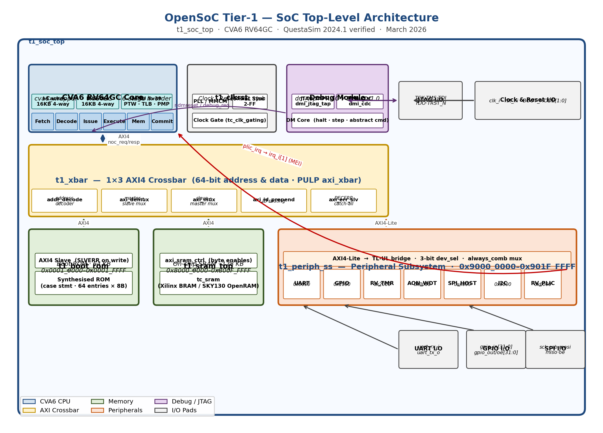
Figure 1: OpenSoC Tier-1 SoC Top-Level Architecture

Figure 2 — CVA6 RV64GC Core Architecture
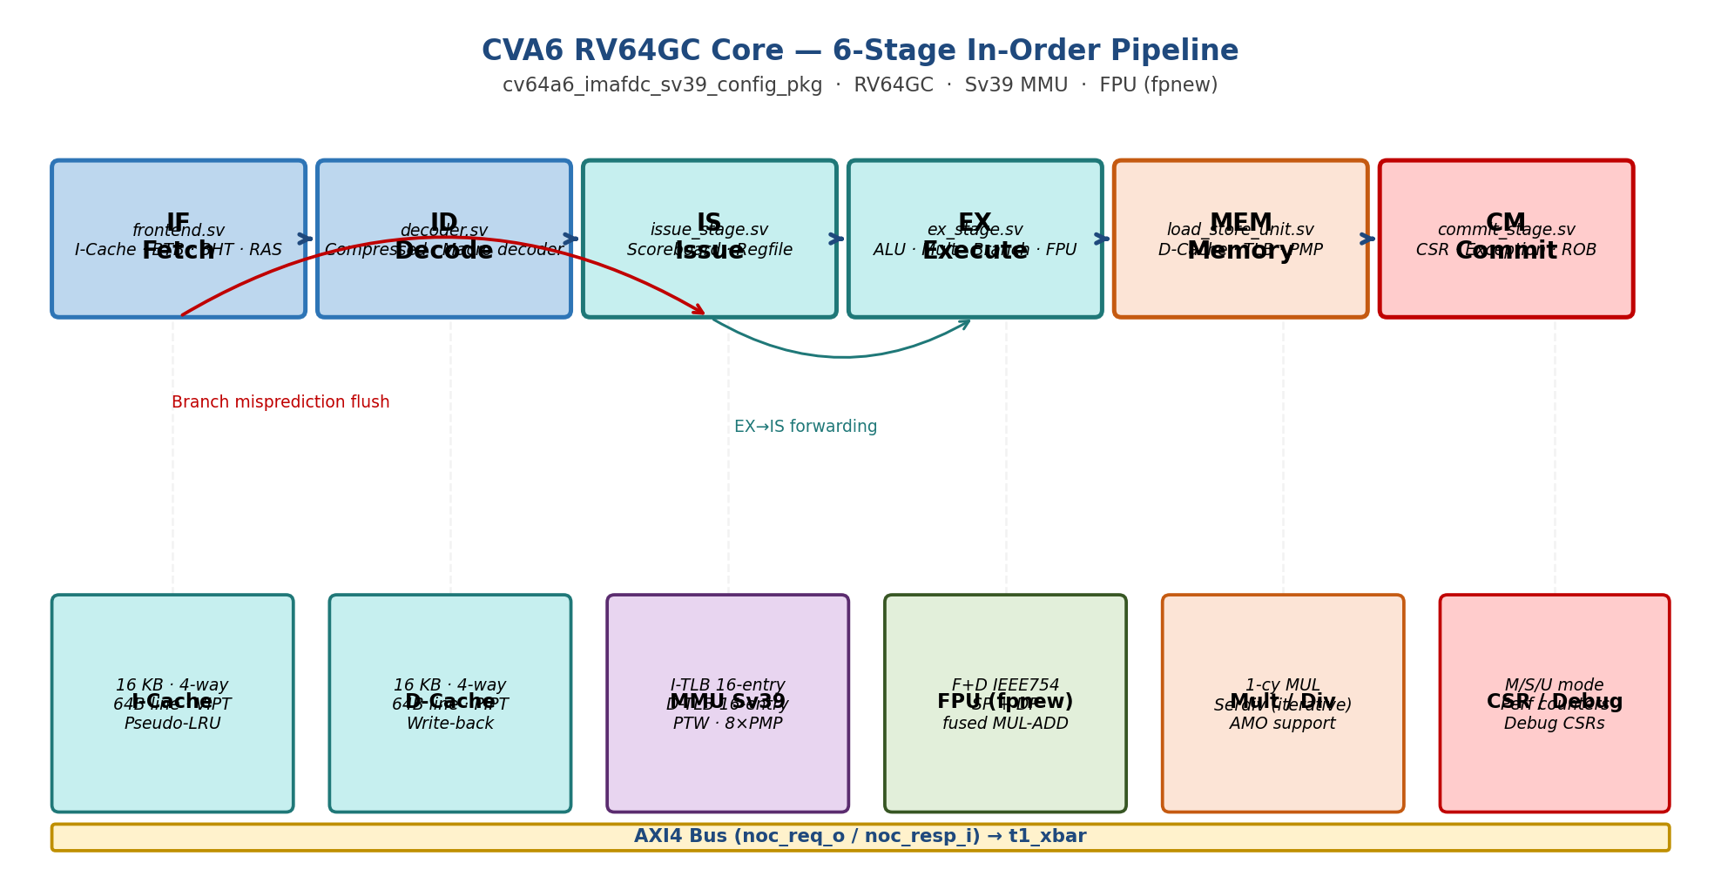
Figure 2: CVA6 RV64GC Core — Pipeline and Functional Units

Figure 3 — Physical Address Space Map
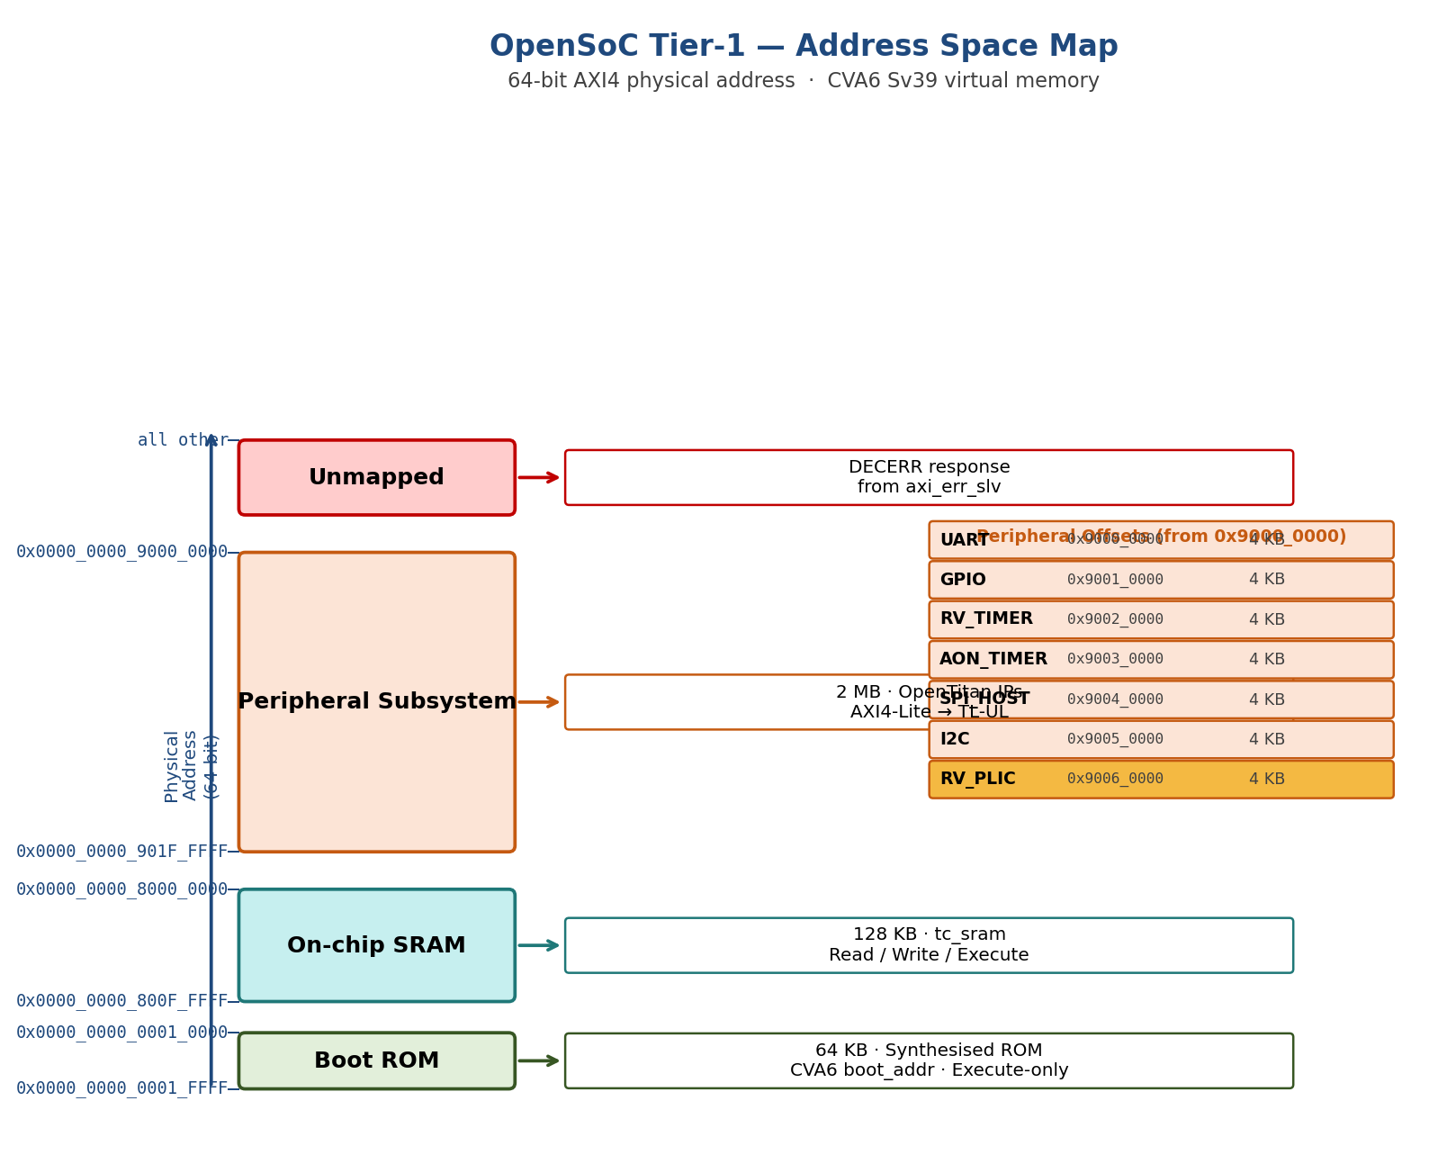
Figure 3: OpenSoC Tier-1 — Physical Address Space Map

Figure 4 — AXI4 Crossbar Internal Topology
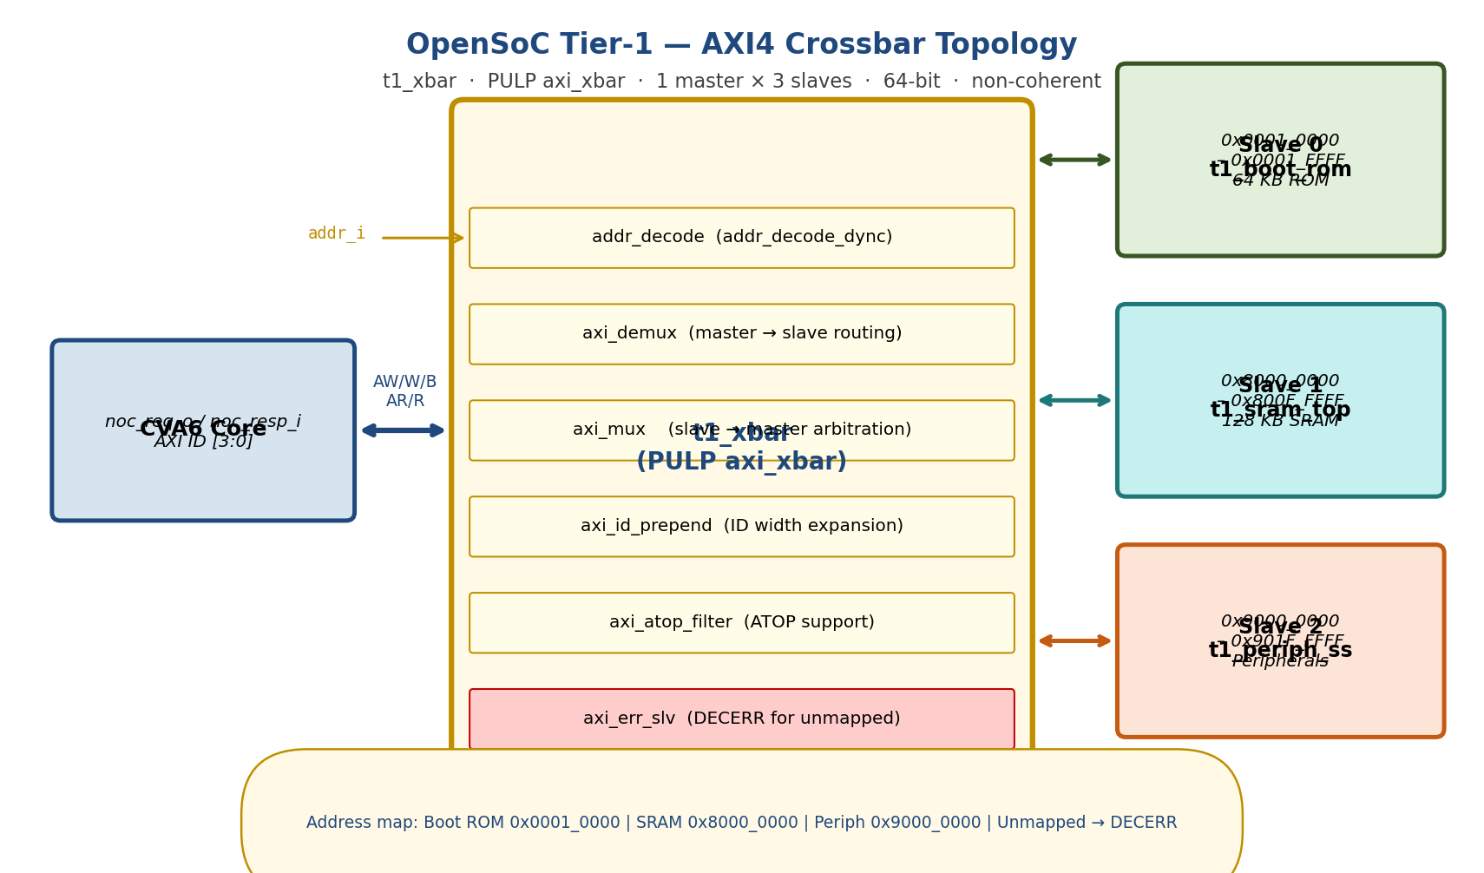
Figure 4: AXI4 Crossbar Internal Topology

Figure 5 — Peripheral Subsystem Internal Structure
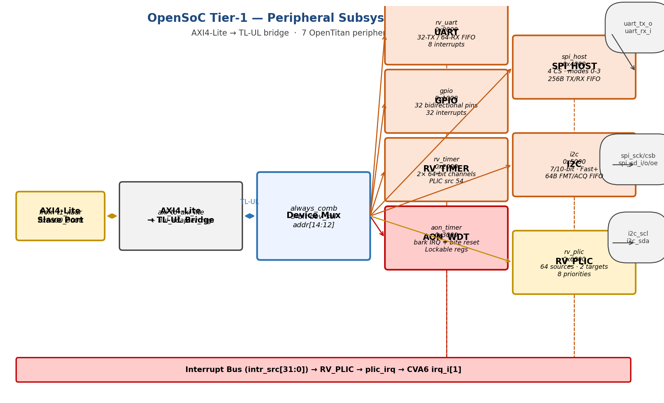
Figure 5: Peripheral Subsystem Block Diagram

Figure 6 — Interrupt Architecture
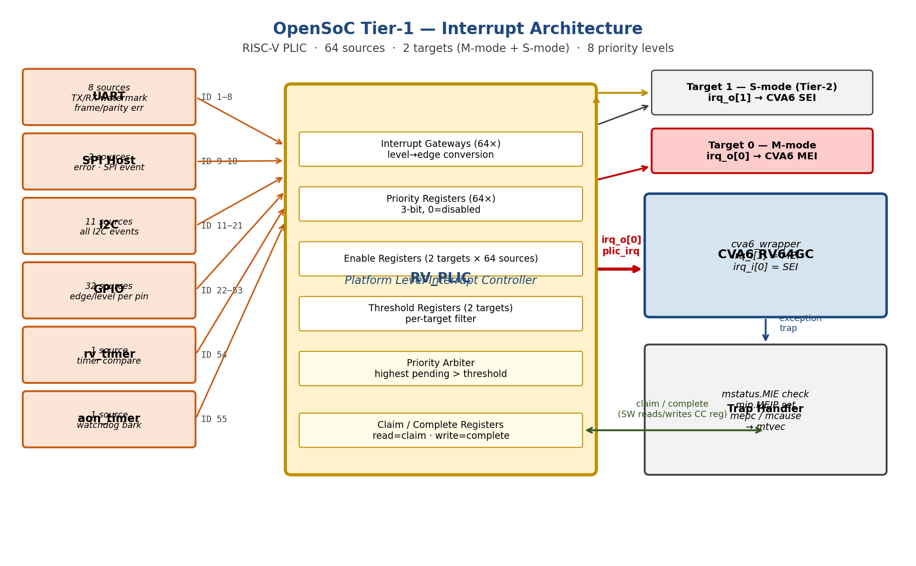
Figure 6: Interrupt Architecture and PLIC Flow

Figure 7 — Clock and Reset Domain Architecture
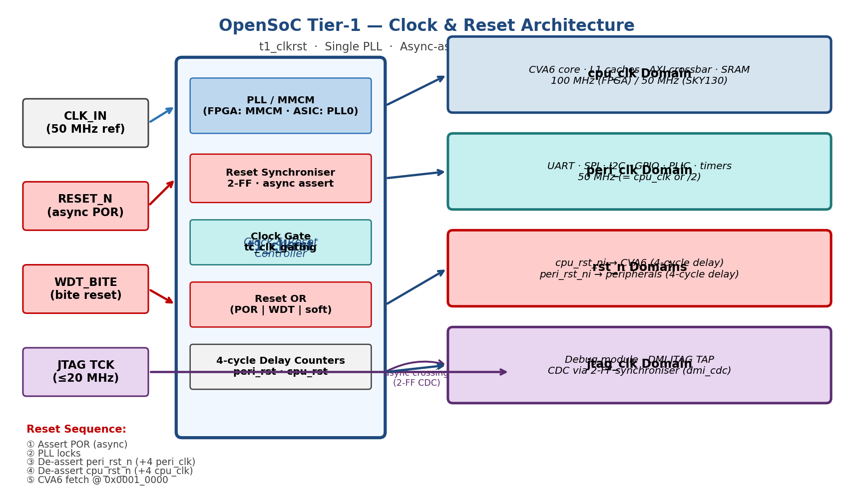
Figure 7: Clock and Reset Domain Architecture

Appendix E — Shakti E-class SoC Variant (Added March 2026)
A 32-bit SoC variant based on the Shakti E-class (RV32IMAC) processor was added to OpenSoC Tier-1 as an alternative to the CVA6 (RV64GC) core. This appendix provides a reference summary. For full details see:
- OpenSoC_Tier1_Eclass_Simulation_Report.docx — Verification report
- OpenSoC_Tier1_CPU_Comparison_v1.1.docx — Performance/power/area comparison
- README_ECLASS.md — Integration guide
- rtl/top/t1_soc_top_eclass.sv — SoC top RTL

E.1 Specification Differences
SPI Master (April 2026 addition): The E-class peripheral subsystem (t1_periph_ss_32.sv) now includes a fully custom SPI master block. It implements SPI Mode 0 (CPOL=0, CPHA=0), MSB-first, 8-bit per transfer, with a configurable SCK half-period (CLK_DIV field, default 4 system clocks). Register map within the peripheral base (0x9000_0000): SPI_CTRL at +0x1C (SPI_EN bit 0, CLK_DIV bits [15:8]), SPI_STAT at +0x20 (SPI_BUSY bit 0, SPI_DONE bit 1, read-only), SPI_TX at +0x24 (write triggers transfer, write-only), SPI_RX at +0x28 (last received byte; reading clears SPI_DONE, read-only). The CPU-driven SPI test (spi_test.c + t1_spi_cpu_tb.sv) verifies PASS at both L1 (4 transfers) and L2 (8 transfers).
Parameter | CVA6 SoC (Sections 1–14) | E-class SoC (Appendix E)
CPU ISA | RV64GC (64-bit) | RV32IMAC (32-bit)
Pipeline | 6-stage in-order | 3-stage in-order
AXI data width | 64-bit | 32-bit
AXI masters | 1 (NOC) | 2 (IMEM + DMEM)
Boot ROM | 64-bit wide, 64 words (512B) | 32-bit wide, 256 words (1 KB)
SRAM | 64-bit wide, 128 KB | 32-bit wide, 128 KB
Peripheral SS | Full OpenTitan IP | Custom behavioral stub: UART (TX+RX FSM, 115200 baud), GPIO (32-bit OUT/OE/IN), SPI master (Mode 0, 8-bit, CLK_DIV configurable, SPI_CTRL/STAT/TX/RX registers)
FPU | fpnew IEEE 754 | None
MMU | Sv39 | None
OS support | Linux (with firmware) | RTOS only
Work library | work/ | work_eclass/
Regression | 6/6 PASS (CVA6 regression suite) | 7/7 PASS (eclass regression) + 3 CPU-driven (GPIO/UART/SPI L1+L2 PASS)

E.2 Address Map (unchanged)
Region | Base | End | Size
Boot ROM | 0x0001_0000 | 0x0001_03FF | 1 KB
SRAM | 0x8000_0000 | 0x800F_FFFF | 1 MB
Peripheral SS | 0x9000_0000 | 0x901F_FFFF | 2 MB
[NOTE] Address map is identical to CVA6 SoC — software and linker scripts are compatible.

I2C Master Peripheral
The t1_periph_ss_32 peripheral subsystem includes a CPU-controlled I2C master implemented as a 10-state behavioural FSM in SystemVerilog. The I2C SCL and SDA signals are exposed as open-drain SoC I/O pins on t1_soc_top_eclass, allowing connection to standard I2C slaves (EEPROMs, sensors, DACs) via external pull-up resistors.

Register Map
Peripheral base address: 0x9000_0000
Offset | Register | Access | Reset | Description
0x2C | I2C_CTRL | R/W | 0x0000 | [0]=i2c_en, [15:8]=clk_div (SCL half-period in sys-clks)
0x30 | I2C_ADDR | R/W | 0x0000 | [7:0] = (slave_addr<<1)|rw_bit
0x34 | I2C_TX | W | — | data byte; write triggers one-byte I2C transfer
0x38 | I2C_RX | R | 0x0000 | received data byte; reading clears done flag
0x3C | I2C_STAT | R | 0x0000 | [0]=busy, [1]=done, [2]=nak

Transfer Protocol
WRITE transfer: START + (addr<<1|0) + ACK + data_byte + ACK + STOP
READ transfer: START + (addr<<1|1) + ACK + data_byte(slave) + NACK + STOP
clk_div controls the SCL half-period. At clk_div=4 the SCL frequency is sys_clk / 8, giving ~12.5 MHz SCL at a 100 MHz system clock.

SoC I/O Ports
Port | Direction | Description
i2c_scl_o | output logic | SCL open-drain driver: 0=drive-low, 1=released
i2c_scl_i | input logic | SCL wire feedback / clock-stretch input
i2c_sda_o | output logic | SDA open-drain driver: 0=drive-low, 1=released
i2c_sda_i | input logic | SDA wire feedback / slave read-back

Verification Results
Test | Level | Cycles | Result
t1_i2c_cpu_tb | L1 (Quick) | 561 | PASS — CTRL readback + 2 write frames (0xA1, 0xA2) to slave 0x50
t1_i2c_cpu_tb | L2 (Full) | 1545 | PASS — 4 writes (0xA1–0xA4) + 2 reads (0xC5, 0x3A)
t1_eclass_gpio_tb | L1 (16-bit GPIO) | 83 370 | PASS — GPIO walk-1/walk-0 on 16 pins; TOHOST=0x1; 26 Apr 2026
t1_eclass_gpio_tb | L2 (32-bit GPIO) | 75 995 | PASS — GPIO walk-1/walk-0 on 32 pins; Boot ROM→SRAM; TOHOST=0x1; 26 Apr 2026

