*Water Resources Research*

Supporting Information for

**Constraining plant hydraulics with microwave radiometry in a land surface model: Impacts of temporal resolution**

Nataniel Holtzman1, Yujie Wang2, Jeffrey D. Wood3, Christian Frankenberg2,4, and Alexandra G. Konings1

1. Stanford University, Department of Earth System Science.

2. California Institute of Technology, Department of Environmental Science and Engineering.

3. University of Missouri, School of Natural Resources.

4. Jet Propulsion Laboratory, California Institute of Technology.

Corresponding author: Nataniel Holtzman (nholtzma@stanford.edu)

**Contents of this file**

Text S1 to S5

Figures S1 to S4

Text S1. Hydraulic model description

In our version of CliMA Land, we introduce a non-steady-state plant hydraulic model to simulate water flow between leaves, branches, stems, and roots. For each plant tissue, the following equation expresses conservation of mass in terms of water storage volume *V* and water fluxes *Q*:

$\frac{dV}{dt}=Q_{in}-Q_{out}$ Eqn. S1

The water flux between two plant tissues that are physically attached (leaf and branch, branch and trunk, and trunk and root) is calculated with a Darcy-type equation:

$Q_{ij}=K_{ij}(ψ_{i}-ψ_{j}+Δψ_{g,ij})$ Eqn. S2

In this equation, the flow from tissue *i* to tissue *j* equals the conductance across the interface between the two tissues (*Kij*) multiplied by the difference in water potentials between the two tissues, with an additional factor accounting for the difference in gravitational potential due to height differences.

While Eqn. S2 describes flow *within* the plant, there are additional fluxes at the boundaries of the plant. For leaves, transpiration must be included in *Qout.* The transpiration rate is given by the stomatal conductance module in CliMA Land and is assumed to be constant within the duration of a time step. Details of the stomatal conductance scheme are found in Wang et al. (2021). For roots, root water uptake must be included in *Qin*. To model root water uptake, within a time step the soil water potential around each root is treated as constant from the viewpoint of the plant hydraulic model, as in the following equation:

$Q_{soil to root}=K_{root}(ψ_{soil}-ψ_{root}+Δψ_{g,soil to root})$ Eqn. S3

This equation effectively assumes the conductance across the rhizosphere is infinite. Note that root water uptake may be negative in the case of nighttime hydraulic redistribution.

Also, the conductance of each root layer is scaled according to both an exponential root area profile and the depth of the corresponding soil layer. Specifically, let the total conductance of all roots be $K_{total}$ and the root surface area profile be given by $A_{root}\left(z\right)=\frac{1}{α}e^{-αz}$.

Consider a root layer embedded in the soil between soil depths $z_{i}$ and $z_{i+1}$. Let its conductance *relative to the other layers* be:

$K_{i,i+1}^{rel}=\frac{\left(z_{i+1}-z_{i}\right)e^{-αz_{m}}}{z_{m}}$ Eqn. S4

Where $z_{m}$ is the midpoint depth of the corresponding soil layer, and the division by $z_{m}$ is necessary to go from conductivity to conductance (longer roots will have smaller conductance for the same conductivity).

Finally, the *actual* conductance of the same root layer is found by normalizing by the total relative conductance of all the layers and multiplying by the total actual conductance.

$K_{i,i+1}=K_{total}*K_{i,i+1}^{rel}*{\left(\sum_{j=1}^{n_{soil}}{K_{j,j+1}^{rel}}\right)}^{-1}$ Eqn. S5

Where $n_{soil}$ is the total number of root layers.

To relate *V* and *ψ* within each tissue, a linear pressure-volume (PV) curve is used:

$ψ_{i}=m_{i}(\frac{V_{i}}{V_{max,i}}-1)$ Eqn. S6

In this equation, *mi* is the slope of the pressure-volume curve in tissue *i*, and *Vmax,i* is the maximum possible water storage in that tissue (in other words, the volume of water stored at saturation).

Although PV curves measured on real plants typically have some nonlinearity, a linear approximation has been successfully used in plant hydraulic models (Liu et al., 2021; Manzoni et al., 2014).

To model xylem conductance, a Weibull curve is used:

$K_{i}=K_{max,i}\exp{(-{\left(\frac{ψ_{i}}{P{63}_{x}}\right)}^{2}) }$ Eqn. S7

In this equation, P63x is the water potential at which approximately 63% of conductance is lost (more precisely, at which relative conductance equals 1/e). Also, *Ki* is the conductance of tissue *i*, and *Kmax,i* is that tissue’s maximum possible conductance, which is achieved when it is saturated with water. Here, we fix the exponent in the Weibull curve at a value of 2, due to a previous study’s finding that this parameter was difficult to retrieve from observations and had little effect on the model outputs (Liu et al., 2020).

The conductance between two tissues is calculated with a harmonic mean:

$K_{ij}={2\left(K_{i}^{-1}+K_{j}^{-1}\right)}^{-1}$ Eqn. S8

We can combine equations S1 through S8 into a system of ordinary differential equations (ODEs). Because Eqn. S2 multiplies water potential by conductance, which itself is a function of water potential, the system is nonlinear. To reduce computation time, we approximate the system as linear by assuming that conductance values (*Kij*) change only slightly during a single timestep. At the beginning of each time step, we fix the conductance (*Ki*) of each tissue at its current value. Then we solve the resulting *linear* system of ODEs analytically. That solution gives an updated volume and water potential for each tissue, as well as root water uptake for each root layer. The root water uptake is removed from the corresponding soil layer. Finally, we update the conductance values according to the new water potential values.

Text S2. Coupling between hydraulic and stomatal models

We represent the effect of water stress on photosynthesis (often called the “beta factor”) by multiplying the maximum carboxylation rate (Vcmax) by a Weibull function of xylem water potential, where the exponent parameter in the Weibull function is fixed at a value of 2. That is,

$β\left(ψ_{l}\right)=\frac{V_{cmax} ( ψ_{l})}{V_{cmax} at saturation}=\exp\left(-{\left(\frac{ψ_{l}}{P{63}_{β}}\right)}^{2}\right)$ Eqn. S9

The parameter *P63β* is the leaf water potential at which the “beta factor” is 0.37. Note that while the plant tissue conductance and the carboxylation rate both depend on water potential through a Weibull function, the P63 parameters of those functions are separate parameters. Our use of distinct P63 values for xylem and stomata is supported by work showing that stomatal closure thresholds and xylem embolism thresholds are correlated across plant species but not exactly equal (Klein, 2014; Martin-StPaul et al., 2017). The difference *P63β* - *P63x* is a form of hydraulic safety margin. If a plant has a large value for this difference, then *P63β* is much less negative than *P63x*, and the plant can be characterized as risk-averse as it will close its stomata before xylem cavitation becomes a problem. Thus, allowing *P63β* to differ from *P63x* increases the diversity of possible hydraulic strategies within the space of model behavior, presenting the retrieval algorithm with the greater (and more realistic) challenge of operating in a higher-dimensional trait space.

Text S3. Unretrieved parameters

For the observing system simulation experiment, all other model parameters aside from the ones in Table 1 are assumed to be known with perfect accuracy. These fixed and unretrieved parameters include:

1. the porosity and wilting point of the soil
2. various parameters describing photosynthetic dependence on temperature
3. the soil surface roughness and soil clay content required by the microwave model
4. the slope of the xylem pressure-volume (PV) curve
5. the exponent that describes the steepness of the Weibull curve parametrizing PLC
6. the allocation of conductance and storage volume among plant tissues

The value of the xylem PV curve slope parameter should be inconsequential due to the formulation of the plant hydraulic model (Eqn. S3), in which the maximum storage volume (an unknown retrieved parameter) essentially represents a whole-plant PV curve in terms of absolute water volume. The assumption of fixed allocation ratios between plant tissues for hydraulic conductance and storage volume was used here to reduce model complexity, and could be a future source of model flexibility.

Text S4. Parameter normalization

We introduce a normalization of some of the model parameters for two reasons: first to reduce the effect of equifinality on the MCMC algorithm’s convergence, and second to allow the comparison of modeled plant water potential time series between models with different soil water retention curve parameters. The transformation does not affect the overall information contained in the model.

There is an ambiguity affecting some of the model parameters and VOD parameters. If the entire time series of plant water potential is multiplied by a constant factor, while the parameter *a* in Eqn. 1 is also divided by the same constant factor, there will be no change to the time series of VOD. Thus, if *a* is unknown a priori, the overall magnitude of plant water potential is impossible to constrain.

Knowing the soil water retention curve would provide an alternative constraint on plant water potential. Independent of VOD, microwave observations also constrain the soil moisture, and thus constrain pre-dawn plant water potential if the soil water potential corresponding to a given soil moisture is known and in equilibrium with the plant. However, in this study we treat both *a* and the soil water retention curve as unknown, due to the uncertainty in characterizing these parameters globally. We are thus left with equifinality in the model.

An intuitive way of understanding this equifinality is to observe that microwave observations are affected by water content, not directly by water potential, and that the curves that relate water content to water potential (the soil water retention curve and the plant pressure-volume curve) are not known a priori. From the perspective of microwave observations, water potential is only ever an intermediate variable.

To sidestep the equifinality, we normalize certain model parameters by a reference value of water potential. First, we choose a reference soil moisture that represents moderately dry conditions, here defined as 0.21 m3/m3. We chose this particular value because the soil water retention curve fitted to MOFLUX soil measurements has a value of -1 MPa at a soil moisture of 0.21. The soil water retention curve determines the value of soil water potential at that reference moisture. This reference soil water potential is then used as a normalizing factor for the other parameters related to water potential and water flux, as described in the following list. All the variables subject to this procedure either have units of water potential (pressure) themselves (MPa or MPa-1), or they directly multiply another variable with units of water potential. Thus, this parameter transformation can also be viewed as a change of dimensions in which the dimension of pressure is removed from all variables except for the reference soil water potential.

In each entry of the following list, the variable marked with a superscript “o” is the normalized value, which is used as a parameter in the MCMC, while the corresponding variable without the asterisk is the physical value of the parameter, which goes into the land model. The normalized value is equivalent to assuming that the reference water potential is 1 MPa.

$ψ_{ref}=|ψ_{soil}\left(0.21\right)|$

$k_{plant}^{o}=k_{plant}ψ_{ref}$

$V^{o}=Vψ_{ref}$

$P{63}_{x}^{o}={P63}_{x}/ψ_{ref}$

$P{63}_{β}^{o}=P{63}_{β}/ψ_{ref}$

$k_{soil}^{o}=k_{soil}ψ_{ref}$

$a^{o}=aψ_{ref}$

In all comparisons between the retrievals and “true model,” we use the normalized version of retrieved leaf water potential, while also accounting for the fact that the gravitational offset between leaf water potential and soil water potential is not affected by the soil water retention curve.

$ψ_{leaf}^{o}=(ψ_{leaf}+ρgh)/ψ_{ref}-ρgh$ Eqn. S10

Where $ρgh$ is the gravitational potential of leaves in the canopy, found by multiplying the density of water by gravitational acceleration and canopy height.

Text S5. Treatment of land surface parameters and radiative transfer parameters in MCMC

The MCMC algorithm requires an estimate of the likelihood of generating the observations given a candidate set of input parameters. We could calculate this likelihood using a candidate set that included all land surface model parameters as well as the parameters of the VOD model, as in the equation below:

$P\left(R,L | y\right)∝P_{obs}\left(y | R,L\right)P_{prior}(R,L)$ Eqn. S11

In this equation, *P* is the probability of the parameters given the observations, *R* and *L*are parameter vectors for the radiative transfer model and land surface model respectively, *y* is a vector of observations, *Pobs* is the probability of the observations given the parameters, and *Pprior* is the prior distribution for the parameters. As discussed in Table 1 of the main text, *R* includes the parameters *a, b,* and *c* related to VOD, as well as the single scattering albedo *ω*.

However, to accelerate convergence of the MCMC algorithm, here we treat the radiative transfer parameters as nuisance parameters. During each MCMC iteration, after running the land surface model with its candidate parameters as inputs, we find the optimal values of the radiative transfer parameters that minimize the error in predicted brightness temperature compared to the observations. Only then does the algorithm calculate the likelihood of the candidate parameters given the observations. Our two-step algorithm can be summarized in the equations below:

$R^{*}∶=\max_{R}{P_{obs}\left(y | R,L\right)}$ Eqn. S12

$P\left(L | y\right)∝P_{obs}\left(y | R^{*},L\right)P_{prior}(L)$ Eqn. S13

For each observation scenario, we ran three chains of length 10,000. We discarded the first 6000 iterations as burn-in. The Gelman-Rubin statistic indicated that all parameters had converged (Gelman & Rubin, 1992).

**References**

Gelman, A., & Rubin, D. B. (1992). Inference from Iterative Simulation Using Multiple Sequences. *Statistical Science*, *7*(4). https://doi.org/10.1214/ss/1177011136

Klein, T. (2014). The variability of stomatal sensitivity to leaf water potential across tree species indicates a continuum between isohydric and anisohydric behaviours. *Functional Ecology*, *28*(6), 1313–1320. https://doi.org/10.1111/1365-2435.12289

Liu, Y., Holtzman, N. M., & Konings, A. G. (2021). Global ecosystem-scale plant hydraulic traits retrieved using model–data fusion. *Hydrology and Earth System Sciences*, *25*(5), Article 5. https://doi.org/10.5194/hess-25-2399-2021

Liu, Y., Kumar, M., Katul, G. G., Feng, X., & Konings, A. G. (2020). Plant hydraulics accentuates the effect of atmospheric moisture stress on transpiration. *Nature Climate Change*, *10*(7), Article 7. https://doi.org/10.1038/s41558-020-0781-5

Manzoni, S., Katul, G., & Porporato, A. (2014). A dynamical system perspective on plant hydraulic failure. *Water Resources Research*, *50*(6), 5170–5183. https://doi.org/10.1002/2013WR015236

Martin-StPaul, N., Delzon, S., & Cochard, H. (2017). Plant resistance to drought depends on timely stomatal closure. *Ecology Letters*, *20*(11), 1437–1447. https://doi.org/10.1111/ele.12851

Wang, Y., Köhler, P., He, L., Doughty, R., Braghiere, R. K., Wood, J. D., & Frankenberg, C. (2021). Testing stomatal models at the stand level in deciduous angiosperm and evergreen gymnosperm forests using CliMA Land (v0.1). *Geoscientific Model Development*, *14*(11), 6741–6763. https://doi.org/10.5194/gmd-14-6741-2021

**Figure S1.** Samples from retrieved posterior distribution of leaf water potential, based on HOURLY observations.

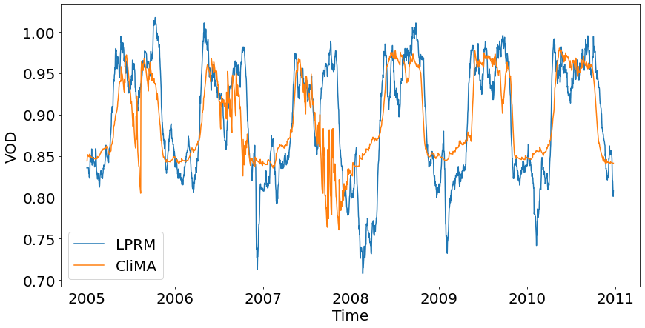

**Figure S2.** VOD time series comparison between LPRM data and CliMA Land output. For this figure, LPRM VOD was smoothed with a 15-day moving average.

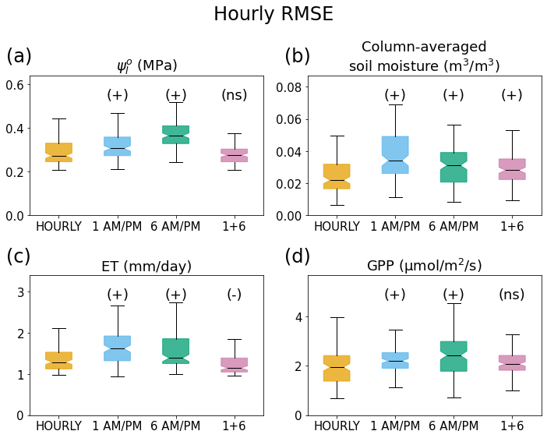

**Figure S3.** Box plots showing posterior distributions of RMSE for 4 *hourly* variables over the period 2005-2017. Note that leaf water potential is normalized with respect to the soil water retention curve, as discussed in S4. The symbols in parenthesis above the individual boxes represent statistical significance of the differences between scenarios, calculated with a Mann-Whitney U test using the HOURLY scenario as a baseline. A “(+)” mark represents significantly *greater* RMSE (i.e. worse model performance) compared to the “hourly” scenario; a “(-)” mark represents significantly *smaller* RMSE (i.e. better performance); a “(ns)” mark represents no significant difference in RMSE (p > 0.05).

**Figure S4.** Example comparison of simulated leaf water potential in CliMA Land using two different values of the vegetation capacitance parameter. The “baseline” model output uses the same parameter values