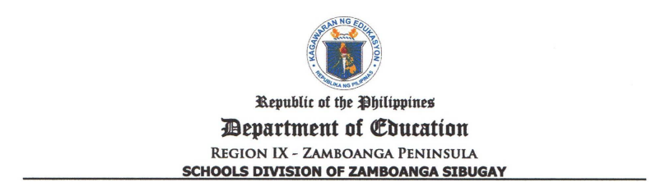

Annex 3. School Consolidated List of Least Mastered Competencies for the First Term, SY: 2026-2027
Imelda District
First Term Item Analysis Report
(SY: 2026-2027)

Name of School: Canaan Elementary School Assessment Conducted: ST -1
(Pls. put check in the box)
ST – 2
Learning Area: _________________________________
TE

Learning Area | Least Mastered Competencies | Reasons/s/Cause/s | Proposed Intervention Activity

Prepared by:

_______________________
Teacher

Reviewed by:

_______________________
School Head Approved:

MARDIE A. ACOTANZA, EdD.
PSDS/DIC
