
RESERVATION CONFIRMATION & CHECK-IN DETAILS
Mahalo for booking your retreat with us!
RESERVATION DETAILS
Primary Guest Name | {{GUEST_NAME}}
Email Address | {{EMAIL}}
No. of Guests | {{PAX}} | Contact Number | {{PHONE}}
Arrival Date | {{CHECKIN_DATE}} | Check-in Time | 1:00 PM
Departure Date | {{CHECKOUT_DATE}} | Checkout Time | 11:00 AM
Accommodations | Retreat House  Four bedrooms, three bathrooms, lānai, gathering room, dining room, kitchenette, and detached, fully-equipped commercial kitchen. Hand and body soap provided. 14 guests maximum.  Kapueokahi Studio Apartment  One bedroom with one king bed or two singles, full bathroom and tub, kitchenette, living room, outdoor patio. Hand and body soap provided. Double Occupancy.  Nahiku Cabin 1  Two single beds, full bathroom, desk and chair, and front patio. In-room amenities include a mini-fridge, microwave, hot water kettle, French press, coffee, tea, water glasses, and mugs. Hand and body soap provided. Double occupancy.  Nahiku Cabin 2  King bed, full bathroom, desk and chair, and front patio. In-room amenities include a mini-fridge, microwave, hot water kettle, French press, coffee, tea, water glasses, and mugs. Hand and body soap provided. Double occupancy.  Kipahulu Cabin 1  King bed, full bathroom, desk and chair, and front patio. In-room amenities include a mini-fridge, microwave, hot water kettle, French press, coffee, tea, water glasses, and mugs. Hand and body soap provided. Double occupancy.  Kipahulu Cabin 2  King bed, full bathroom, desk and chair, and front patio. In-room amenities include a mini-fridge, microwave, hot water kettle, French press, coffee, tea, water glasses, and mugs. Hand and body soap provided. Double occupancy.
Housekeeping, Security & General Property Information | Housekeeping service is provided for stays longer than four nights and will be scheduled mid-week. If you are in need of assistance, please contact us below. If you are in need of additional supplies, there are two General Store located in the Hāna Town Center.  Ala Kukui does not have security personnel on the property; however, key personnel do live close by. An unlocked gate is kept open during retreats.  Ala Kukui is located in a residential area, is an active farm, and a community-used space. At any given time, others including keiki, may be on the property or walking along the driveway. Please use great caution while driving on the premises.  Ala Kukui actively cultivates Hawaiian ʻawa on certain areas of the property. As with such organic farming practices, guests can expect to hear certain 'farming noises' such as, but not limited to, weed whacking, mowing, and tractor driving. We will do our best to keep these noises at a reasonable level during retreats.

Location
Ala Kukui is located at 4224 Hāna Highway between mile markers 33 and 34, on the mauka (mountainside) of the road. Look for our sign near the road, take the shared driveway off the highway, and pass through our red gate. Continue up the driveway and you will have arrived here! Click here for a map.
Use of the Hālau
Use of the Hālau for meetings, yoga and meditation is an amenity to retreat participants as part of your stay. The Hālau must be booked prior to your arrival for particular times, not exceeding 2 hours at a time, so as not to interfere with previously scheduled programming. The Hālau is stocked with yoga and meditation supplies for 14 participants. If your program will require these items or supplies, please let us know.
Self-Check-In
Check-in can begin at 1:00 PM. An estimated time of arrival is required to prepare your room. Proceed to your reserved room (map included below), your room will be unlocked, and the key will be inside. Check-in is contact-less, but please feel free to give us a call (number below) if you have any questions or concerns.
Self-Checkout
Checkout is at 11:00 AM. Please turn off all lights and fans, leave the key within the room, and lock the door behind you. You do not need to checkout at the Office. We wish you a safe journey back home and hope to accommodate you for your next Hāna retreat!
Contact Numbers
Ala Kukui Office | 808-248-7841 | if unavailable, call Kaui below
Kaui, Executive Director | 808-248-7677 | call/text for immediate assistance
Maui Police Department | 911 | call for emergencies

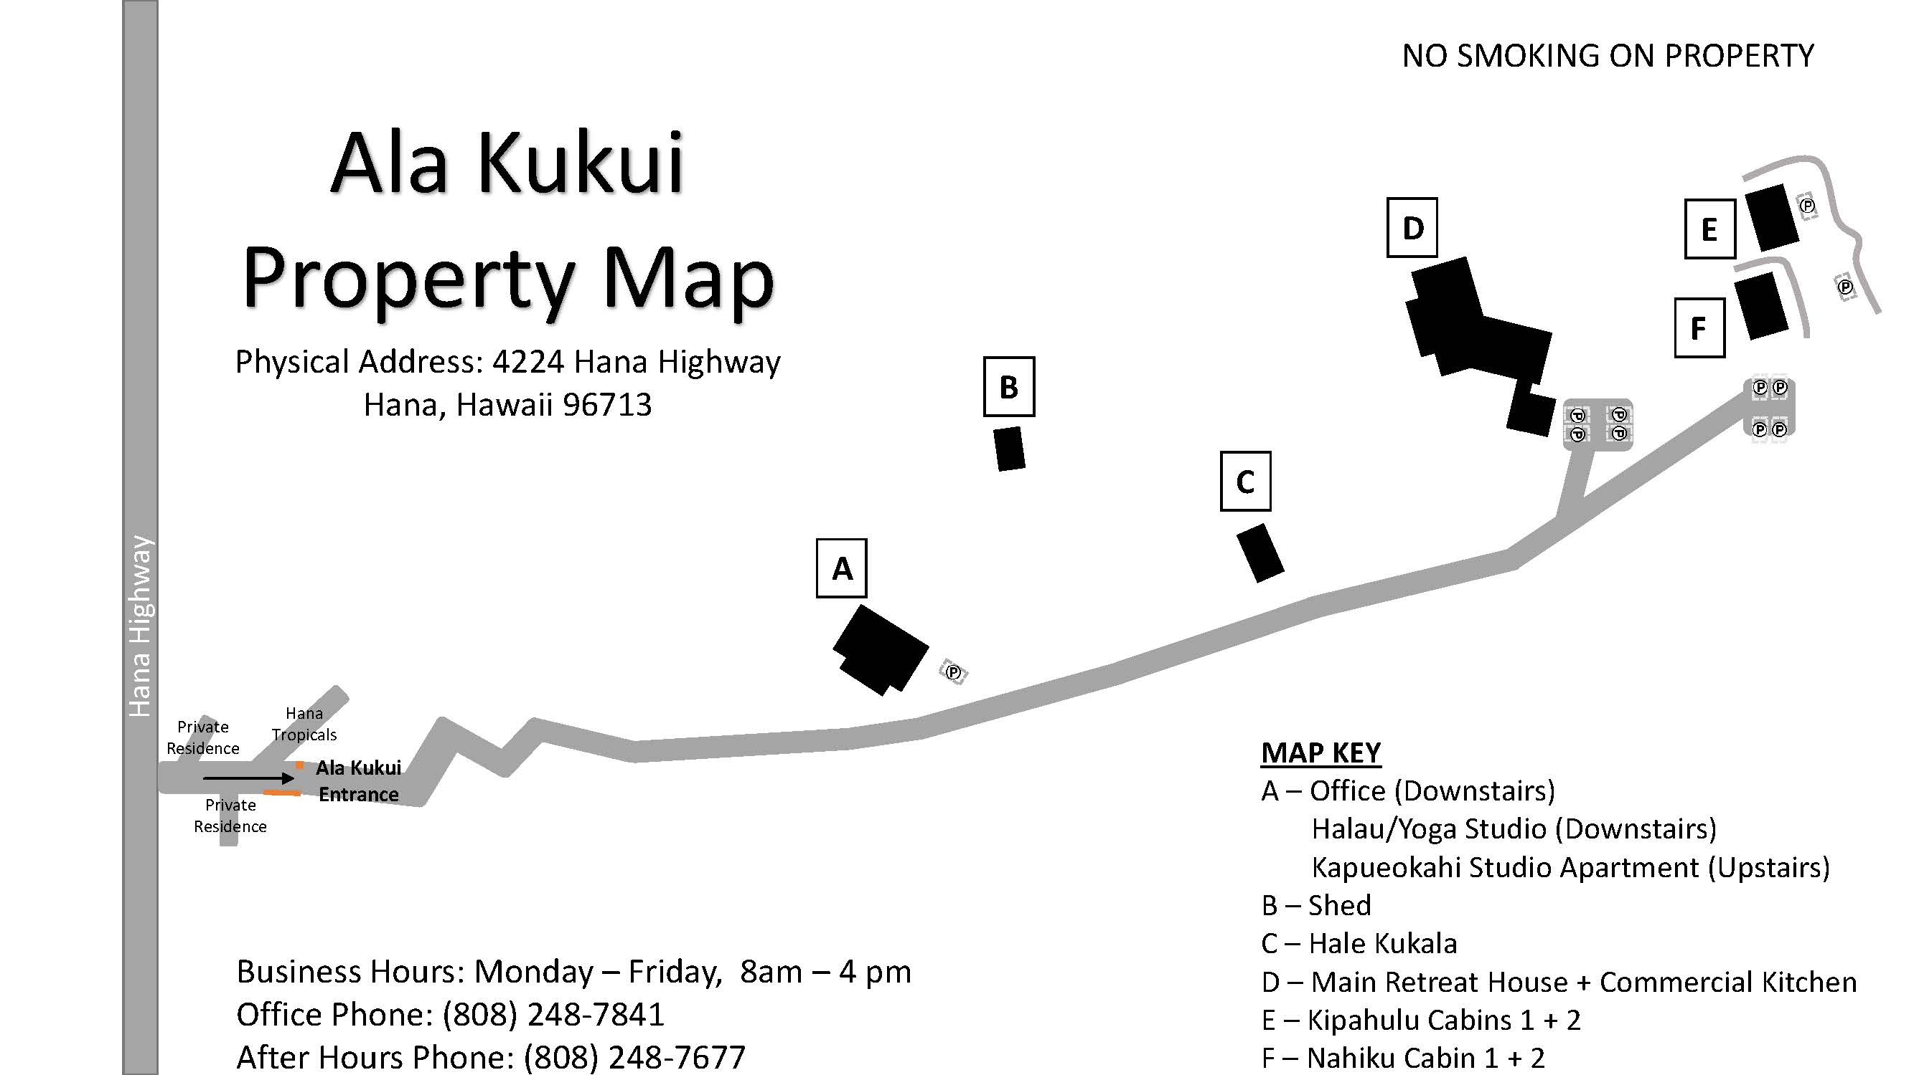
ALA KUKUI IS LOCATED IN A RESIDENTIAL AREA.
PLEASE DRIVE SLOWLY AND CAUTIOUSLY.
Mahalo for observing the following Housekeeping Rules!
General Housekeeping Notes (applies to all facilities & accommodations)
- Remove shoes/slippers before entering.
- Furniture shall not be moved or rearranged.
- Body wash, hand soap and toilet paper are provided. Guests shall bring their own toiletries.
- Please do not flush feminine products or sanitary wipes, use provided wastebaskets.
- Facilities are non-smoking, if you must smoke, please do so at least 10 feet away from buildings.
- Quiet time is from 8 PM – 8 AM.
- Coffee grounds can be discarded in the wastebasket or outdoor trash bin. Dumping grounds in the sink will cause clogging.
- Animals are not allowed inside the facilities/rooms.
- Please be mindful of tracking sand throughout the facilities. Excess sand will be subject to withholding of the security deposit.

Retreat House
- As these are the original door handles from the 70's, bathroom door locks do not have keys to open them. In the event that the door is locked from within, gently remove the nearest window screen to gain access.
- Dishes should be washed, dried, and put away prior to departure.
- If utilizing the dishwasher, please unload, dry, and put dishes away prior to departure.

Commercial Kitchen
- To keep compliant, the Commercial Kitchen (counter tops and floors) shall remain clean and tidy at all times.
- The sink, if left unchecked, has the tendency to overflow. To avoid this from happening:
- Please utilize drain strainers and periodically check underneath the sink for any signs of clogging or backup.
- If filling up the 3-compartment sinks with water, release drain plugs individually and monitor drainage underneath the sink.
- The Compost Bin shall be used for all compostable food waste. If the bin becomes full, simply empty the bin in the large black compost bin located outside under the kukui tree.
- Everything in the kitchen is available to you, free of charge. Should you require additional items, Hana Store or Hasegawa General Store is conveniently located in town.
- Wolf Range – To operate the stove top, push in and turn the knob left for regular flame. To simmer, push in and turn the knob left again. Wipe stove top with a rag to clean, please do not use a scrubber.
- Samsung Double Oven – To clean the outside of the stove, please wipe with a rag. Do not use a scrubber.
- Kitchen appliances shall be returned to their original place after use.
- Door must be closed overnight.
- Dishes should be washed, dried, and put away prior to departure.
- If utilizing the dishwasher, please unload and put dishes away prior to departure.
- If utilizing the outdoor grill, please clean it after use.

Failure to comply with any of these items will subject the refundable security deposit to a partial withholding at a discretionary rate determined by Ala Kukui administration.

