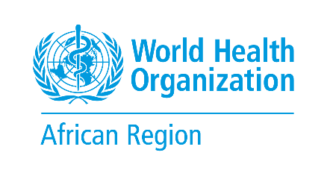 | MEC 2026 | DAY 1 | SESSION 2 | NOTE FOR PARTICIPANTS  Where are we on delivery?  Implementation of Programme Budget 2026–2027 in the 53 budget centres

Thursday 19 November 2026, 09:30–10:30 | Regional Office, Djoué, Brazzaville, and online | Moderator: DPM | Paper MEC-03 | Dashboard D-1
Draft for TWG review, 3 November 2026. Budget, expenditure and results figures will be added from MEC-03 before circulation on 17 November.
Why this session
Programme Budget (PB) 2026–2027 is the Region's promise to Member States: the 47 Country Offices and six Regional Office budget centres committed to deliver agreed outputs and products and services (P/S) in support of national health priorities. Ten months into the biennium, this session takes stock of that promise. Where are we on track, where are we not, and where must we act in 2027?
The session reads several sources together: workplans and budgets (SPM), expenditure (GSM), the 2026 Semi-Annual Monitoring exercise (SAM1), workforce data and country results reports. SAM1 is one of the main sources; it is not the subject of the session.
One question, four lenses
The session looks at implementation through four lenses. The places where several lenses point to the same problem become the hot spots the MEC will discuss.
MONEY  Is the money arriving where it was planned, and is it being used?  Planned, funded and spent, by outcome, funding source and type of budget centre |  | DELIVERY  Are outputs and priority P/S being delivered?  Delivery status of priority P/S; P/S at risk or off track; reported progress |  | RESULTS  What has changed in countries with WHO's contribution?  Documented results; contribution to country outcomes, backed by a source |  | PEOPLE  Do we have the people to deliver?  Positions filled and vacant; staff funding coverage
What we already know
1,336  priority P/S assessed in SAM1 2026  1,230 in 47 Country Offices, 106 in 6 Regional Office budget centres |  | 96%  reported on track or completed  13% already completed at the time of assessment |  | 44  P/S at risk or off track  in 27 of the 53 budget centres |  | 46 of 53  budget centres below 75% staff funding coverage  July 2026 analysis

- Delivery is broadly on track, with pockets of risk (Figure 1). In numbers, the P/S at risk or off track sit mostly in emergency detection and response (9), emergency preparedness (8), primary health care and health systems (8) and the enabling functions (8). In proportion, climate change and health stands out, with 3 of 16 P/S at risk or off track.
- The mix of priorities is uneven. The enabling functions (outcomes 7 and 8) account for nearly a third of the priority P/S assessed, climate change and health determinants for 6%. Session 3 will ask whether our priorities match country needs.
- Staffing is the first pressure point. In July 2026, 46 of the 53 budget centres had less than 75% of their staff costs funded.

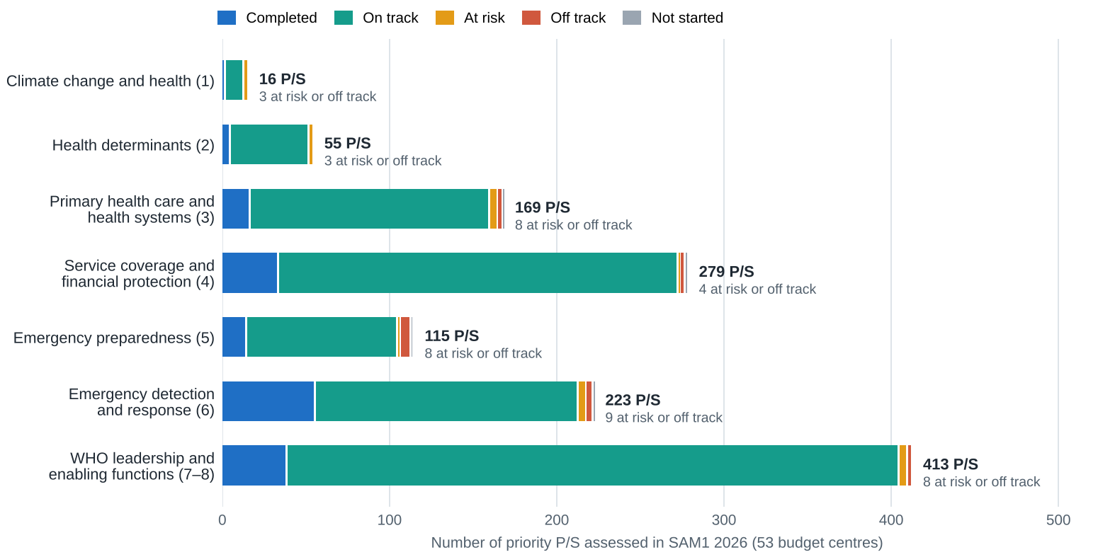
Figure 1. Priority P/S with a recorded delivery status, by GPW14 strategic objective (outcome code) and status. Source: SAM1 platform, export of 16 September 2026; 53 budget centres. Objective labels are shortened.
Budget and expenditure at 31 October 2026 (from MEC-03)
 | Planned cost (US$ m) | Funded (US$ m) | Share funded | Spent (US$ m) | Share of funds used
47 Country Offices | … | … | …% | … | …%
6 Regional Office budget centres | … | … | …% | … | …%
Region, 53 budget centres | … | … | …% | … | …%
WS1 inserts these figures from SPM and GSM (data freeze of 30 October) before circulation. The split by outcome and funding source (base flexible, base earmarked, emergency, polio) is in MEC-03 and dashboard D-1.
How to read the figures
Term | Meaning
Planned cost | The cost of the 2026–2027 workplans approved for a budget centre, all plans included (base, emergency, polio).
Funded amount | The part of the planned cost covered by funds allocated to the budget centre.
Expenditure | Funds spent and recorded in GSM as at 31 October 2026.
Share of funds used | Expenditure divided by the funded amount. At ten months of a 24-month biennium, a linear path would be about 42%; some activities are planned for later.
Priority P/S | The products and services each budget centre selected for assessment in SAM1 2026. They cover part of the budget, not all of it.
Delivery status | Completed, on track, at risk, off track or not started, as assessed by the budget centre and signed off by its manager.
Contribution | How far a P/S contributed to a country outcome (strong, moderate or weak), with the evidence cited.
Staff funding coverage | The share of the staff costs in the workforce plan that is funded.
Status bands | Red, amber and green bands that flag where action may be needed. They describe a situation, not the performance of an office, and are never used to rank.
How the session will run
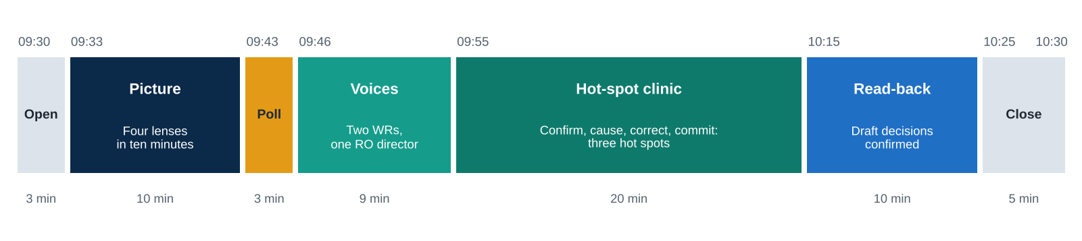

Time | Segment | What you will be asked to do
09:30 | Open | Hear the question and the three rules: the figures are read in advance, no office is ranked, and questions on figures go to the data desk.
09:33 | The picture | Follow a ten-minute presentation of the four lenses and six candidate hot spots.
09:43 | Poll | Choose, on your phone or laptop, the two hot spots that most threaten delivery in 2027.
09:46 | Voices | Listen to two WRs and one Regional Office budget centre director: one result, one thing off track, one decision needed.
09:55 | Hot-spot clinic | For the three hot spots with most votes: confirm the signal, name the cause, propose the corrective action and its owner.
10:15 | Read-back | Hear the draft decisions; the Regional Director confirms the direction.
10:25 | Close | Give your confidence that the Region will deliver its commitments by December 2027.
Questions to reflect on before the session
- Is the money arriving where it was planned in your budget centre, and are you using it at the pace your workplan needs?
- Which output or P/S that matters most to your national partners is behind, and why?
- What result from 2026 can you show, and what is the evidence?
- Which vacancy or staff funding gap most threatens your delivery in 2027?
- What one decision of the MEC would most help you deliver in 2027?
What we ask of you
Who | Before 19 November | During the session
All participants | Read MEC-03 and look at dashboard D-1 (about 30 minutes) | Vote in the poll; keep questions on figures for the data desk; speak to causes and actions
WRs and budget centre managers | Check your budget centre in D-1 and report any factual error to MSC by Wednesday 18 November at noon; prepare your answer to question 5 | Bring the country view in the hot-spot clinic; be ready to take ownership of an action
Discussants | Join the briefing call on Tuesday 17 November; send an optional visual to WS6 by Wednesday 18 November | Three minutes: one result, one thing off track, one decision needed
Online participants | Test your connection and interpretation channel | Join ten minutes early; use the chat to ask for the floor; vote through the same link
What the session will produce
- A shared picture of PB 2026–2027 implementation in the 53 budget centres, endorsed by the MEC.
- Up to three corrective actions, each with an owner and a deadline, recorded as draft decisions and confirmed in Session 7 at 15:45.
- Issues referred to Session 3 (priorities), Session 4 (Regional Office support) and Session 6 (bottlenecks).
Practical information
When | Thursday 19 November 2026, 09:30–10:30
Where | WHO Regional Office for Africa, Djoué, Brazzaville. Online link with the calendar invitation
Languages | English and French, with simultaneous interpretation
Papers | MEC-03 (PB 2026–2027 implementation report) and dashboard D-1, circulated on 17 November
Poll | One link and QR code shown on screen, for participants in the room and online
Contact | TWG secretariat, Monitoring and Evaluation, Special Initiatives and Change Management (MSC)

