 | MEC 2026 | DAY 1 | SESSION PLAN  Session 2. Where are we on delivery?  Facilitator's guide for the review of Programme Budget 2026–2027 implementation in the 53 budget centres

Thursday 19 November 2026, 09:30–10:30 (60 minutes) | Regional Office, Djoué, and online | Chair: Regional Director | Moderator: DPM | Paper MEC-03 | Dashboard D-1
1. The session at a glance
Question | Ten months into the biennium, where does the Region stand in delivering what Programme Budget (PB) 2026–2027 promised to Member States, and where must we act in 2027?
Purpose | Build one shared, evidence-based picture of implementation in the 47 Country Offices and six Regional Office budget centres, and agree on the areas that need corrective action in 2027.
Outputs | - A shared picture of implementation, endorsed by the MEC  - Up to three priority hot spots, each with a corrective action, an owner and a deadline, recorded as draft decisions for Session 7  - Issues parked for Session 3 (priorities), Session 4 (Regional Office support) and Session 6 (bottlenecks)
Evidence | Paper MEC-03 (PB 2026–2027 implementation report) and dashboard D-1, drawing on workplans and budgets (SPM), expenditure (GSM), SAM1 2026, workforce data and country results reports. Data as at the freeze of 30 October 2026.
Format | A ten-minute picture, a live poll, three voices from budget centres, a hot-spot clinic and a read-back of draft decisions. Two thirds of the time is kept for discussion and decisions.
Participants | MEC members; WRs in the room and online; Regional Office budget centre managers; TWG work stream 1. About 60 in person and up to 120 online.
Prepared by | TWG work stream 1 (PB implementation and performance) with work stream 6 (dashboards and meeting design); cleared by DPM.
Languages | English and French, with simultaneous interpretation; slides in both languages.
2. Design choices
The session has one hour to move a large room from information to decisions. Six design choices make that possible.
- One question, four lenses. Money, Delivery, Results and People each answer one sub-question. Hot spots are the places where several lenses point to the same problem.
- Picture first, debate second. Participants read MEC-03 before the meeting. The picture takes ten minutes on stage and figures are not debated from the floor: a contested figure goes to the data desk, which checks it during the session and reports back in Session 7.
- Voices from the budget centres. Two WRs and one Regional Office budget centre director anchor the figures in what happens on the ground, in three minutes each and without slides.
- Time where the decisions are. Forty of the sixty minutes go to the poll, the hot-spot clinic and the read-back.
- Status, not ranking. Budget centre data are shown in status bands and only after WR validation. No league tables.
- Connected to the rest of the day. Questions about priorities go to Session 3, about Regional Office support to Session 4, about root causes to Session 6. A visible parking board keeps them without derailing the hour.
3. The four lenses
MONEY  Is the money arriving where it was planned, and is it being used?  Planned, funded and spent, by outcome, funding source and type of budget centre |  | DELIVERY  Are outputs and priority P/S being delivered?  Delivery status of priority P/S; P/S at risk or off track; reported progress |  | RESULTS  What has changed in countries with WHO's contribution?  Documented results; contribution to country outcomes, backed by a source |  | PEOPLE  Do we have the people to deliver?  Positions filled and vacant; staff funding coverage

For each lens, WS1 applies the trigger criteria below to every outcome and type of budget centre. A red or amber band flags a candidate hot spot. The thresholds are proposals of the TWG, to be confirmed by DPM before the papers are circulated on 17 November.
Lens | Measures | Sources | Red | Amber
Money | Planned cost; funded amount and share funded; expenditure and share of available funds used; by outcome, funding source (base flexible, base earmarked, emergency, polio) and type of budget centre | SPM; GSM | Less than 70% of planned cost funded, or less than 30% of available funds used by 31 October | 70–84% funded, or 30–39% of available funds used
Delivery | Delivery status of outputs and priority P/S; P/S at risk or off track; reported progress | SAM1 2026; SPM | 10% or more of an outcome's P/S at risk or off track, or three or more in one budget centre | 5–9% of an outcome's P/S at risk or off track
Results | Documented results; contribution to country outcomes backed by a source; contribution stories | Country results reports; SAM1 narratives; Learning Hub | An outcome with significant investment and no documented result | Results claimed without a source
People | Positions filled and vacant; staff funding coverage | Workforce plans; HR data | Staff funding coverage below 60%, or a key programme post vacant for more than six months | Staff funding coverage of 60–74%
At ten months of a 24-month biennium, a linear spending path would have used about 42% of the funds received; the money thresholds allow for activities that are back-loaded.
4. What we already know
SAM1 2026 and the July 2026 workforce analysis already give four signals. Budget and expenditure figures from SPM and GSM, and results from country reports, complete the picture in MEC-03.
1,336  priority P/S assessed  1,230 in 47 Country Offices, 106 in 6 Regional Office budget centres |  | 96%  reported on track or completed  13% already completed at the time of assessment |  | 44  P/S at risk or off track  in 27 of the 53 budget centres |  | 46 of 53  budget centres below 75% staff funding coverage  July 2026 analysis

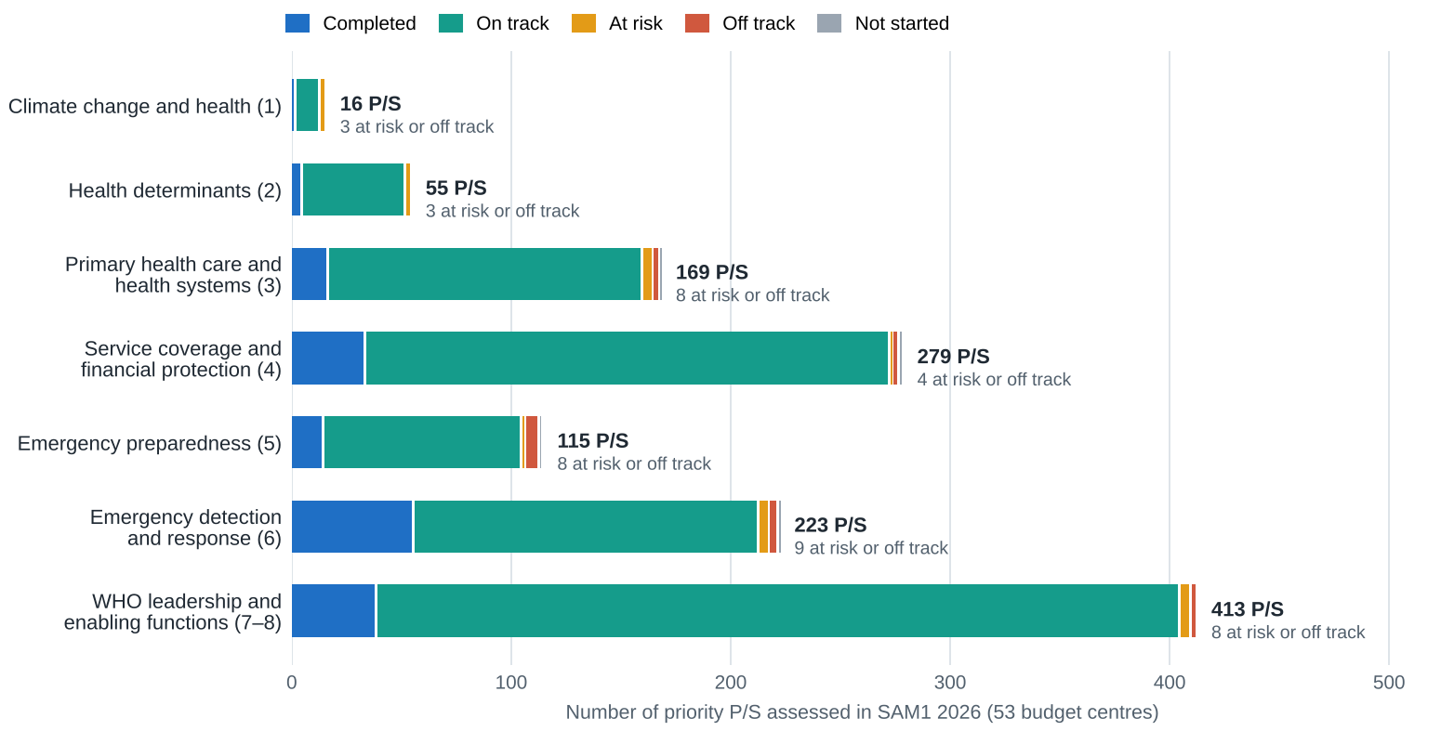
Figure 1. Priority P/S with a recorded delivery status, by GPW14 strategic objective (outcome code) and status. Source: SAM1 platform, export of 16 September 2026; 53 budget centres. Short objective labels.
Signals WS1 should verify before the session
- Climate change and health has the highest share of P/S at risk or off track (3 of 16, 19%); emergency preparedness follows (8 of 115, 7%).
- 105 country P/S rated "on track" report less than 30% progress, and 29 P/S rated "on track" carry an output risk flag. WS1 checks these with the Country Offices concerned so that the picture shown on 19 November is consistent.
- Regional Office budget centres: two of the six completed all their SAM1 assessments (60 of 106 complete). Their picture will rest mainly on SPM and GSM.
- Priority mix: enabling outcomes 7 and 8 account for 32% of the priority P/S assessed, climate and health determinants for 6%. This is a question for Session 3, not for this session.
5. Run of show
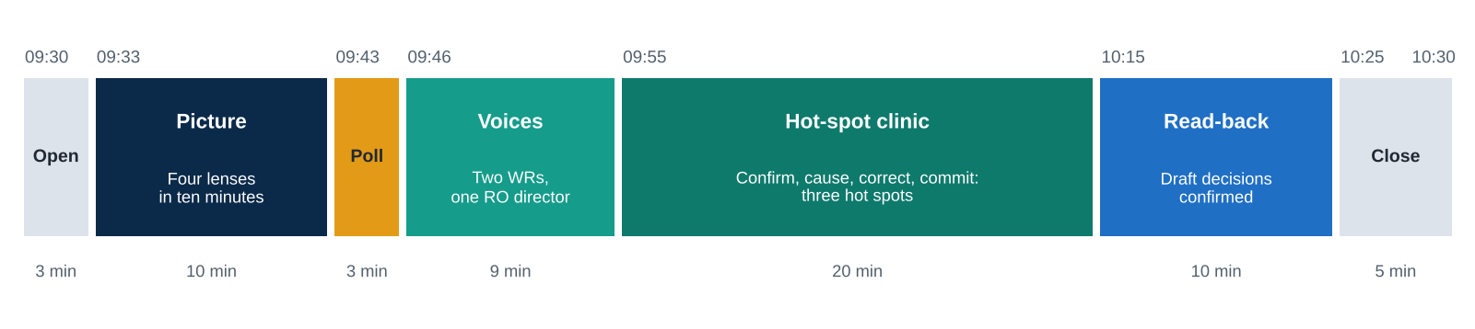

Time | Segment | What happens | Method and materials | Who | Online participants
09:30–09:33 | Open | The moderator states the question, shows the four lenses, announces the expected outputs and the three rules: pre-read, no ranking, data desk | Slide 1; visible timer | DPM | Poll link and QR code on screen; chat open
09:33–09:43 | The picture | Money (3 min), Delivery (3), Results (2), People (1), candidate hot spots (1) | Slides 2–6; D-1 on standby | WS1 lead | Slides shared; interpretation
09:43–09:46 | Poll | Each participant selects up to two of the six candidate hot spots; results shown live | Polling tool via QR code; paper ballots as backup | Online moderator | Same link
09:46–09:55 | Voices | Two WRs and one Regional Office budget centre director answer three prompts in three minutes each: one result we can show; one thing off track and why; one decision we need | No slides; one optional visual | Discussants; moderator keeps time | One WR may speak online
09:55–10:15 | Hot-spot clinic | The three hot spots with most votes, about six minutes each: Confirm, Cause, Correct, Commit (section 6) | Slide 6 updated live; D-1 drill-down; rapporteur template | DPM; cluster directors; WRs | One online voice per hot spot, read by the online moderator
10:15–10:25 | Read-back | Rapporteurs read the draft decisions; the Regional Director confirms the direction; open items are parked for Sessions 3, 4 and 6 | Decision template projected | Rapporteurs; Regional Director | Chat questions read
10:25–10:30 | Close | One-minute confidence pulse; the moderator summarises; the Regional Director gives a closing word and the bridge to Session 3 | Poll; slide 7 | DPM; Regional Director | Poll
6. Facilitation script
Opening words (suggested)
"Ten months ago, Programme Budget 2026–2027 committed our 53 budget centres to deliver for Member States. This hour answers one question: where are we? We will look through four lenses, money, delivery, results and people, and then spend most of our time on the few places where we must act. Three rules. We have read the figures, so we will not re-present them. No office is ranked. And if you doubt a figure, the data desk will check it during the break."
Transition to the poll
"Six places where the lenses point to trouble. Pick the two that most threaten our delivery in 2027. You have two minutes."
The hot-spot clinic: four questions per hot spot
Step | Moderator question | A good answer
Confirm | "Does this signal match what you see on the ground?" | Agreed, or corrected with a reason
Cause | "What is the main cause, and who controls it: the Country Office, the Regional Office, headquarters or partners?" | One main cause, at one level
Correct | "What single action would change this picture by June 2027?" | Concrete, feasible, within WHO's mandate
Commit | "Who owns it, and by when?" | A role and a date, recorded by the rapporteur
Closing words (suggested)
"We came in with one question. We leave with a shared picture and [number] corrective actions, each with an owner. The rapporteurs will bring them to Session 7 this afternoon for confirmation. Our next question is whether we are working on the right priorities."
Handling difficult moments
Situation | Response
A figure is contested | Acknowledge it, note it on the data desk sheet and move on. WS1 checks it at the break and reports in Session 7.
One office or person dominates | Thank them, summarise their point in one line, and invite another subregion or an online voice.
The discussion turns to blame | Reframe to systems: "What would make this work whoever holds the post?"
The discussion drifts to priorities or Regional Office support | Park it on the board for Session 3 or Session 4, visibly, and return to the hot spot.
Time runs over | Take the third hot spot as a read-back only and refer it to Session 6.
The poll or the connection fails | Use paper ballots or a show of hands; failing that, the moderator takes the three hot spots ranked highest by WS1.
Interpretation lags | Speakers slow down; key figures appear on the slides in both languages.
7. Roles and responsibilities
Role | Who | Responsibilities
Chair | Regional Director | Confirms the direction at the read-back; closing word
Moderator | DPM | Frames the session, keeps it on decisions, runs the clinic
Presenter | WS1 lead (MSC) | The ten-minute picture; technical answers
Discussants | Two WRs and one Regional Office budget centre director | Three-minute testimonies (Annex A)
Respondents | Cluster directors | Respond on hot spots in their areas; propose owners
Rapporteurs | Two members of WS6 | Live draft decisions and parking board (Annex C)
Online moderator | MSC | Poll, chat, one online voice per hot spot
Data desk | WS1 analyst | Checks contested figures during the session and the break
Dashboard operator | WS6 | D-1 drill-downs on request
Timekeeper | MSC | One-minute and stop cards for every speaker
Interpreters | Conference services | Receive slides and script on 18 November
8. Slide plan
Seven slides at most, each with a headline that states the finding, not the topic, no more than 40 words, every figure taken from the number register, in English and French.
No. | Headline (model) | Content | Visual
1 | Where are we on delivery? | The question, the four lenses, the three rules, the expected outputs | Four-lens graphic
2 | "[x]% of the planned budget is funded and [y]% of the funds received are used" | Planned, funded and spent by type of budget centre and funding source | Stacked bars with status bands
3 | "96% of priority P/S are on track or completed; 44 are at risk in 27 budget centres" | Status by GPW14 objective; where the risks are | Figure 1 of this plan
4 | "What changed in countries" | Three contribution stories with their source; share of P/S with documented results | Three story cards
5 | "[n] of 53 budget centres are below 75% staff funding coverage" | Filled and vacant positions by type of budget centre; coverage bands | Band chart
6 | "Six places where we must act" | Lens by area heat map; the six poll options | Heat map
7 | "What we agreed" | Live decision template | Table
Backup | Sources and definitions | Data dates, definitions, thresholds | Text
9. Building the candidate hot spots
WS1 proposes six candidate hot spots by 13 November (Kintele), each described in the same format: name, lens or lenses, evidence, budget centres affected and the level likely to own the action. Four candidates are already visible; the others will come from the money and results lenses once SPM, GSM and country reports are analysed.
Candidate | Lenses | Evidence so far | Still needed
Staff funding gap | People, Money | 46 of 53 budget centres below 75% staff funding coverage (July 2026) | Update at data freeze; link to P/S at risk
Emergency preparedness | Delivery, Money | 8 of 115 priority P/S at risk or off track | Funding of preparedness compared with response
Climate change and health | Delivery | 3 of 16 priority P/S at risk or off track | Funding and staffing behind these P/S
Slow use of funds in some budget centres | Money | To be established from GSM | Use of available funds by budget centre at 31 October
Base programmes compared with emergencies | Money, Results | In the DRC, 86% of funding came from three emergency and polio plans | Regional split of funding by source
Results without evidence | Results | Contribution ratings mostly self-reported | Share of results backed by a source in country reports
10. Preparation timeline
Date | Task | Owner | Done
Fri 30 Oct | Data freeze: SPM, GSM, SAM1, workforce data | MSC | ☐
Fri 6 Nov | First draft of MEC-03 and storyboard of the seven slides; first list of hot spots | WS1 | ☐
Mon 9 Nov | Discussants identified and invited (two WRs, one Regional Office budget centre director) | DPM | ☐
Wed 11 – Fri 13 Nov | Kintele: thresholds tested, six candidate hot spots, mock run of the session on 13 November | WS1; WS6 | ☐
Mon 16 Nov | Component B review of MEC-03 and of this plan | TWG Component B | ☐
Tue 17 Nov | MEC-03, dashboard D-1 and the participant note circulated; 30-minute briefing call with the discussants | MSC; DPM; WS1 | ☐
Wed 18 Nov | Slides final in English and French; poll built and tested; discussants' optional visuals received; dry run with DPM (15 minutes); slides and script sent to interpreters; technical check of poll, dashboard, online link, interpretation and timer | WS1; WS6; conference services | ☐
Thu 19 Nov, 08:45 | Room check; data desk and parking board in place; rapporteur template open | MSC | ☐
Thu 19 Nov, by 13:30 | Draft decisions from Session 2 consolidated into MEC-11 for Session 7 | Rapporteurs | ☐
11. Room, materials and technology
- Room. Cabaret tables of eight, mixing Country Office and Regional Office participants; discussants seated at the front; a data desk at the side of the room.
- Screens. Main screen for slides and poll; second screen for dashboard D-1 and the live decision template.
- Poll. One link and QR code for in-room and online participants; paper ballots printed as backup.
- Boards. A parking board with three columns (Session 3, Session 4, Session 6) and a data desk sheet.
- Online. Videoconference link with interpretation channels; online moderator with the chat; recording only with the Chair's agreement.
- Timer visible to speakers; one-minute and stop cards.
12. Success criteria
- The session starts at 09:30 and ends at 10:30.
- At least three hot spots leave the room with a corrective action, an owner and a deadline.
- At least 70% of participants vote in the poll, in the room and online.
- Every contested figure has a resolution route reported in Session 7.
- No budget centre is ranked or singled out without its WR's agreement.
ANNEX A

Brief for the discussants
You have three minutes and no slides (one optional chart or photo, sent to WS6 by 18 November). Please answer three prompts, in this order:
- One result we can show. What changed in your country, or for the Country Offices you support, that WHO contributed to in 2026? Name the source that shows it.
- One thing off track, and why. Which output or P/S is behind, and what is the main cause?
- One decision we need. What would you ask the MEC to decide today to deliver in 2027?
Tips: speak to the room, not the slide; one figure is enough; finish on the decision. A 30-minute briefing call with DPM and WS1 takes place on Tuesday 17 November.
ANNEX B
Poll questions
When | Question | Format
09:43 | Which two of these six hot spots most threaten our delivery in 2027? | Multiple choice, up to two answers; live bar chart
10:25 | How confident are you that the Region will deliver its PB 2026–2027 commitments by December 2027? | Scale from 1 (not confident) to 5 (very confident); result shown and repeated at the next MEC
Optional, 09:30 | In one word, how would you describe our delivery so far? | Word cloud, for online participants while the room settles
ANNEX C
Rapporteur template
One line per hot spot, completed live and read back at 10:15. A decision is complete only when every column is filled.
No. | Hot spot | Evidence | Main cause and level | Corrective action | Owner (role) | Deadline | Status
MEC26-D1-S2-01
MEC26-D1-S2-02
MEC26-D1-S2-03
Status: agreed in principle, or to refine for Session 7. Parked items are listed separately with the session that will take them up.

