Setting up the ini file for a PiJack device on powermon.org

The .ini file controls how the data from your PiJack will be plotted on the powermon.org website using our Django based graphing system.

Download the template file from here:
http://powermon.org/La-template-.yyyy.mm.dd.ini

You first need to rename the file for the system to recognize it. Remove the “-template-” from the name and substitute the date your PiJack started collecting data for yyyy.mm.dd so your name will look something like La.2016.07.22.ini
Note that the ini file takes effect on the date in the file name, and there can be multiple ini files. This allows you to change the physical configuration of your PiJack wiring at a later date and, by uploading a new ini file, display both the old and new data correctly.

It's possible to have two Labjack devices connected to one Raspberry Pi in order to collect uptp 32 different measurements. If you have two LabJack devices, the second one will have its own ini file beginning with Lb instead of La. Likewise the data files collected and uploaded by the second Laback will start with Lb.

Edit the ini file with a plain text editor. Be careful not to remove or add any comas to the file. The first entry on each line is the cryptic name that the Labjack calls that data line. “EIO0” is the brown wire coming from port “E” on the PiJack box. “FIO7” is the White wire coming from Port “F” on the PiJack box. The second number on each line is the gain to multiply the rraw data by to get correct voltage, and the third number is a negative offset, (see below).

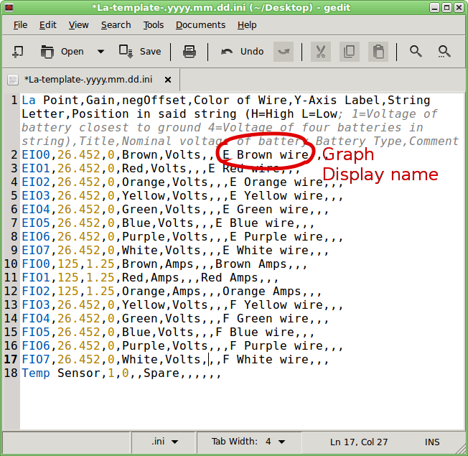
- The first thing to do is change the names that will appear on the graphs so that they are meaningful to you. In the template, the graph titles are simply “E” and the color of the wire or “F” and the color of the wire. You'll want to change this to whatever you call the battery you have attached it to, such as “Bank A – Battery 1”
- For some of your measurements you will want to set an offset number. For instance, if you have two 12V batteries in a series arrangement the first will measure 12.7V and the second will measure 25.4V; the combined voltage of the two. But you can display the individual battery voltage of the second battery by subtracting the voltage of the battery below it in the stack. The third number in each line is the offset, by default zero except for the current sensor lines on FIO0 through 2. (The current sensors read 1.25V when there is zero current.) In the third entry on the line, replace the zero with a lower case “a” or “b” followed by the input you want to subtract. This is case sensitive! Examples of valid entries are:
aEIO0
aFIO3
aFIO7
bEIO5
The last entry, beginning with a “b” would only be valid if you had two labjacks. The first Labjack uses “a” and the second “b”.
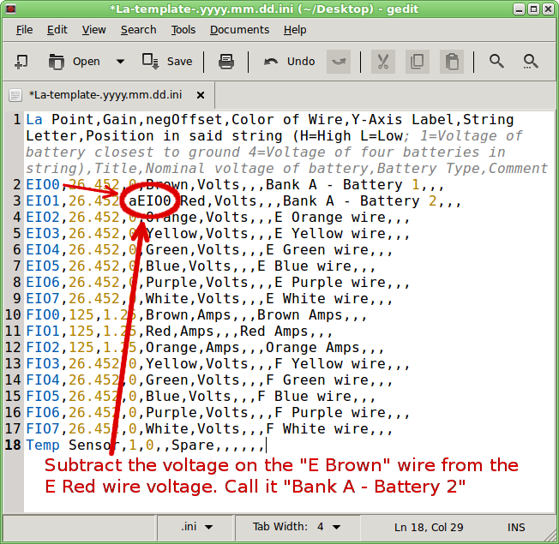

After you've collected some data you may notice the amp readings don't measure exactly zero when you know there was no current flowing. Changing the offset for the amp sensors in the thousandths place ( like 1.252 or 1.249) should get them accurately zeroed. None of the other values in the ini file should be touched. When you are done you need to upload you ini file to the powermon.org webserver. Use filezilla or another ftp client to login to powermon.org. If you don't know your username & password, contact power_systems@sil.org.
After logging in, create a folder named labjack and put the ini file in there. It becomes effective immediately.

If you PiJack has already uploaded some data you should be able to view it immediately. Browse to http://powermon.org/view/powermon/ and find your sitename. Click on the labjack link to see your graphs.

