FASTLOAD.

ALL IMAGES ,SCHEMATICS AND PCB DESIGNS BY BITBLASTER66.
ORIGINAL FASTLOAD PHOTO'S BY SHADOWFAX.
SCHEMATICS AND PCB DESIGNED IN 'PROTEL98'
ALL FILES ARE SUPPLIED FREE TO WHO EVER WANTS THEM.
ONLY LEAVE MY NAME AND OWNERSHIP ALONE.

THE COMPLETED CIRCUIT BOARD MEASURES 58MM X 37MM. MY PCB IS SMALLER THAN THE ORIGINAL.
-------------------------------------------------------------------------------------------
PARTS LIST:
-------------------------------------------------------------------------------------------
1 * 2764 EPROM - PROGRAMED WITH THE FASTLOAD.BIN FILE, NOT THE .CRT FILE.
1 * 7407 HEX BUFFER WITH HIGH VOLTAGE OPEN COLLECTOR OUTPUTS.
1 * 2K7 .25WATT RESISTOR.
1 * 0.47MF MONOLYTHIC CAPACITOR ( LEFT SIDE OF BOARD ).
1 * 0.1MF MONOLYTHIC CAPACITOR ( TOP, BETWEEN THE TWO CHIPS ), FOR SPIKE SURPRESSION.
THE ROM FILE SUPPLIED WITH THESE FILES IS © TO ‘EPYX’ & SCOTT NELSON(PROGRAMMER).
IT IS ONLY SUPPLIED AS A COURTESY WITH THESE FILES AS IT’S AVAILABLE ALL OVER THE INTERNET.

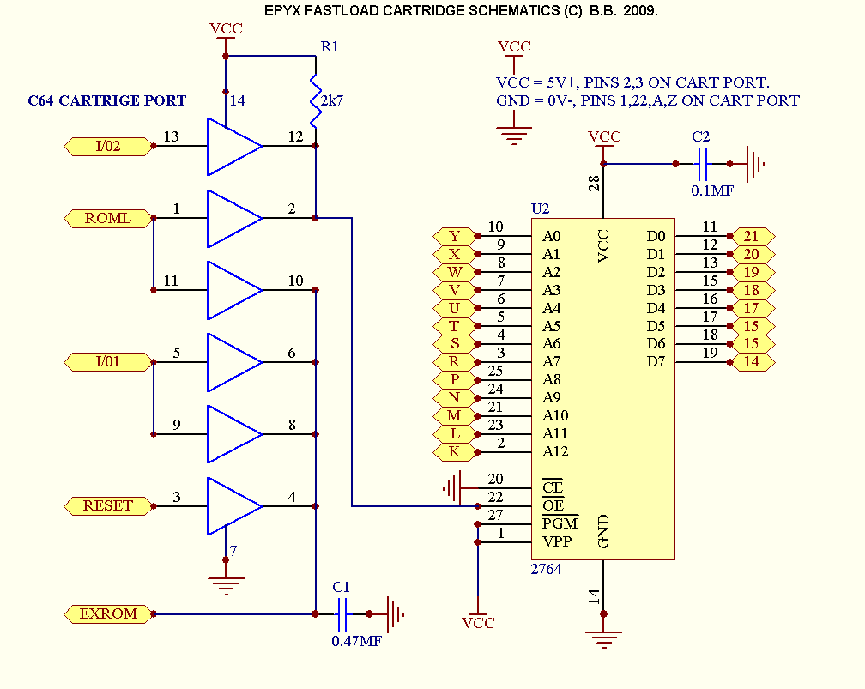

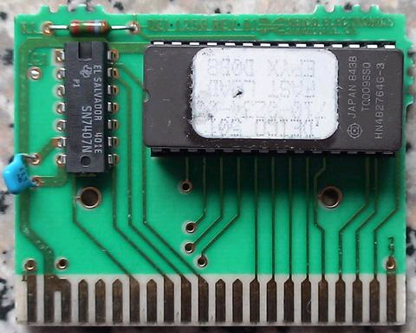

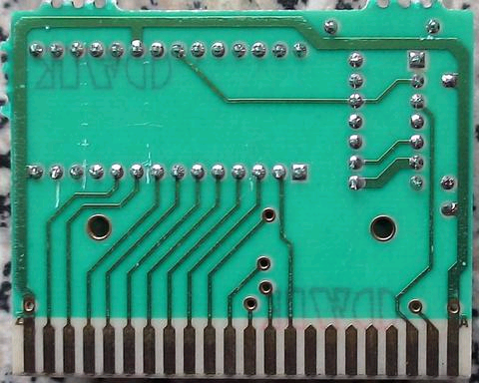

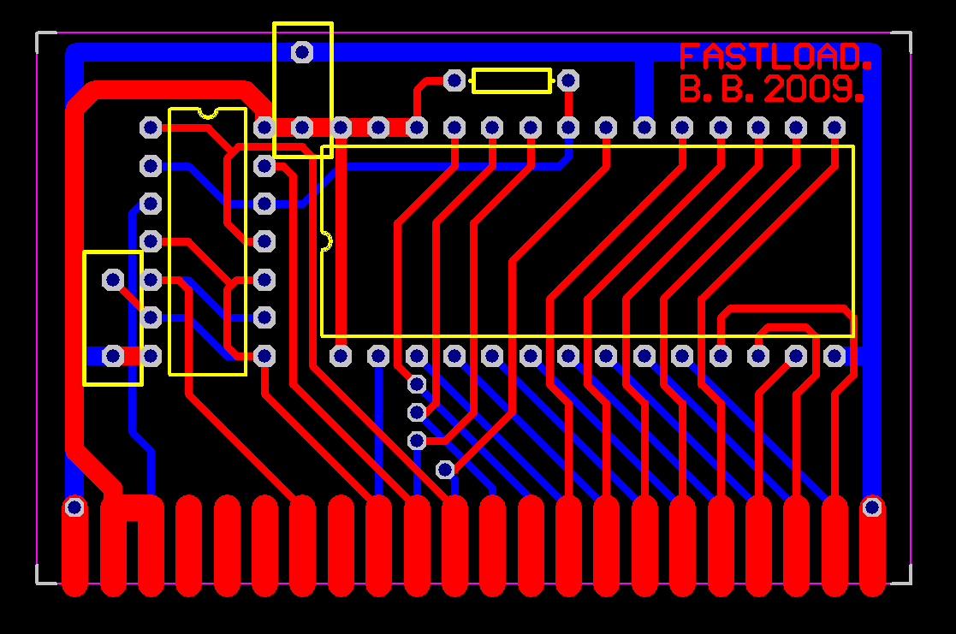

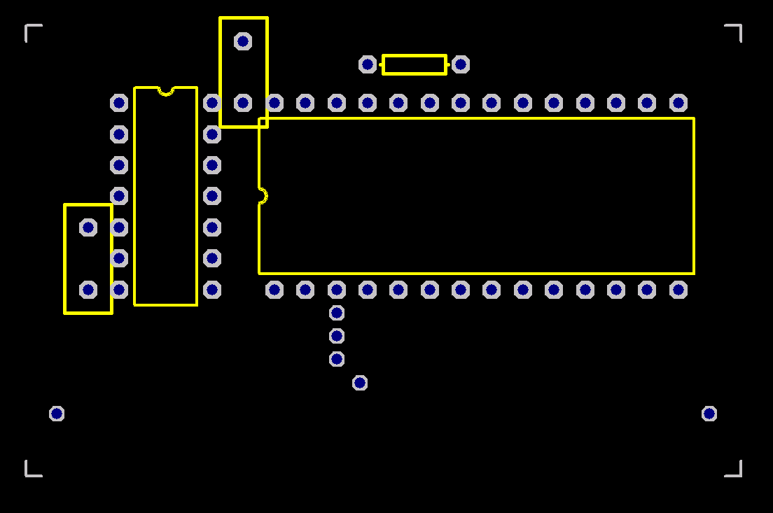
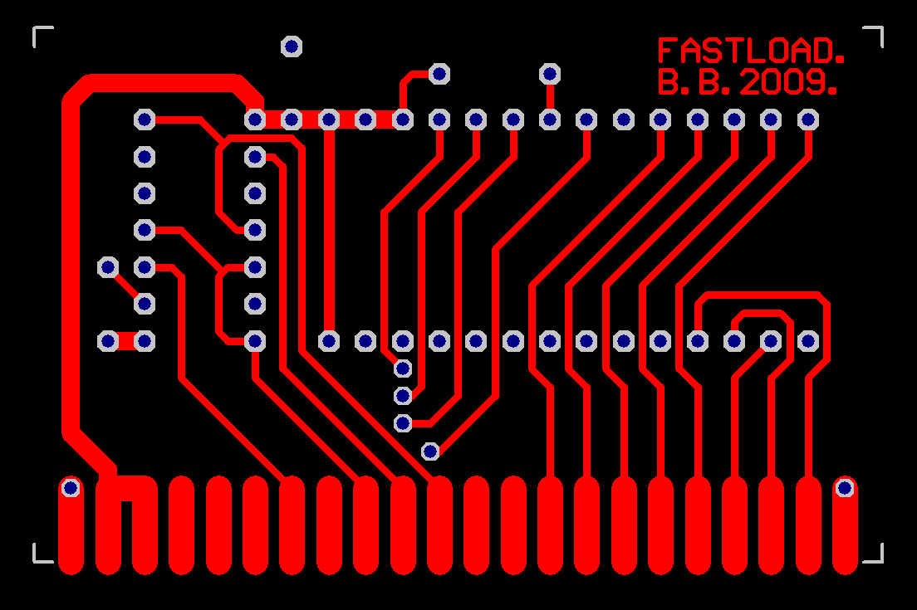

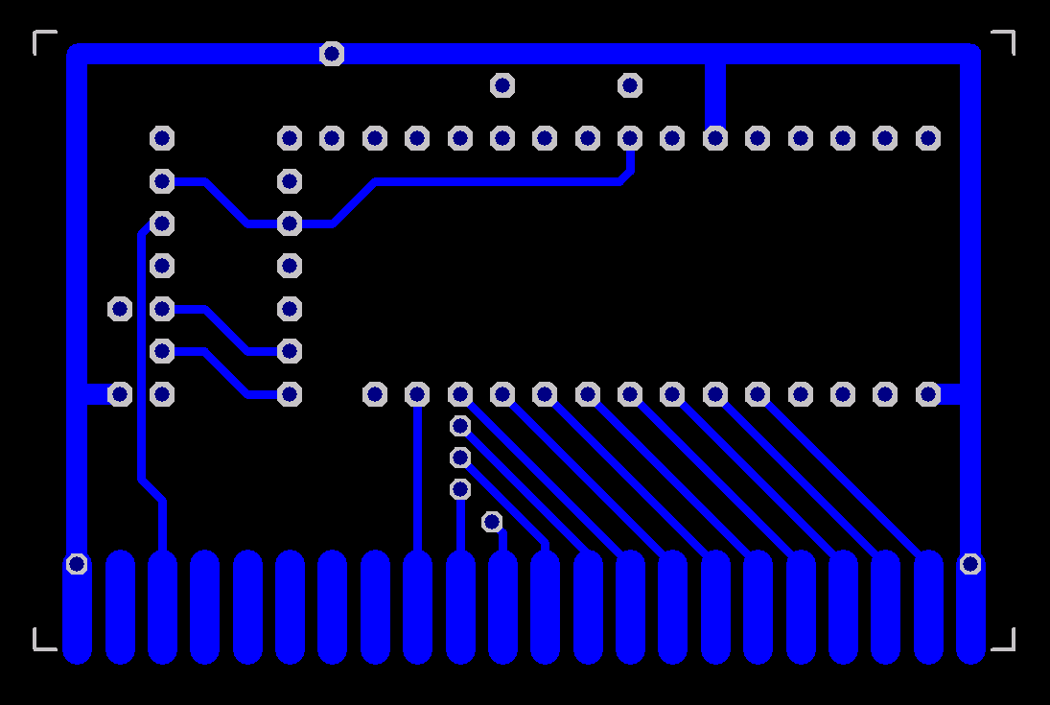
(C)BITBLASTER66 - HAPPY HACKING. 01/04/2009.

