**SUMMARY**

## USC ID/s:

3281934045

|  |  |  |  |  |
| --- | --- | --- | --- | --- |
| M+N | Time in MS (Basic) | Time in MS (Efficient) | Memory in KB (Basic) | Memory in KB (Efficient) |
| 16 | 0.16 | 0.37 | 12500 | 12860 |
| 64 | 0.88 | 1.90 | 12756 | 12564 |
| 128 | 3.21 | 6.60 | 12672 | 12400 |
| 256 | 11.71 | 24.39 | 13276 | 12436 |
| 384 | 25.82 | 53.50 | 13968 | 12804 |
| 512 | 45.99 | 93.74 | 15040 | 12452 |
| 768 | 102.80 | 206.27 | 18332 | 12312 |
| 1024 | 191.00 | 373.92 | 23080 | 12700 |
| 1280 | 306.33 | 592.85 | 28944 | 12576 |
| 1536 | 438.45 | 818.80 | 36208 | 12532 |
| 2048 | 796.32 | 1505.26 | 54944 | 12532 |
| 2560 | 1234.21 | 2277.78 | 79380 | 12756 |
| 3072 | 1813.13 | 3383.60 | 107680 | 12788 |
| 3584 | 2396.00 | 4446.96 | 140796 | 12752 |
| 3968 | 2997.05 | 5549.73 | 162424 | 12860 |

## Datapoints

## Insights

### Graph1 – Memory vs Problem Size (M+N)

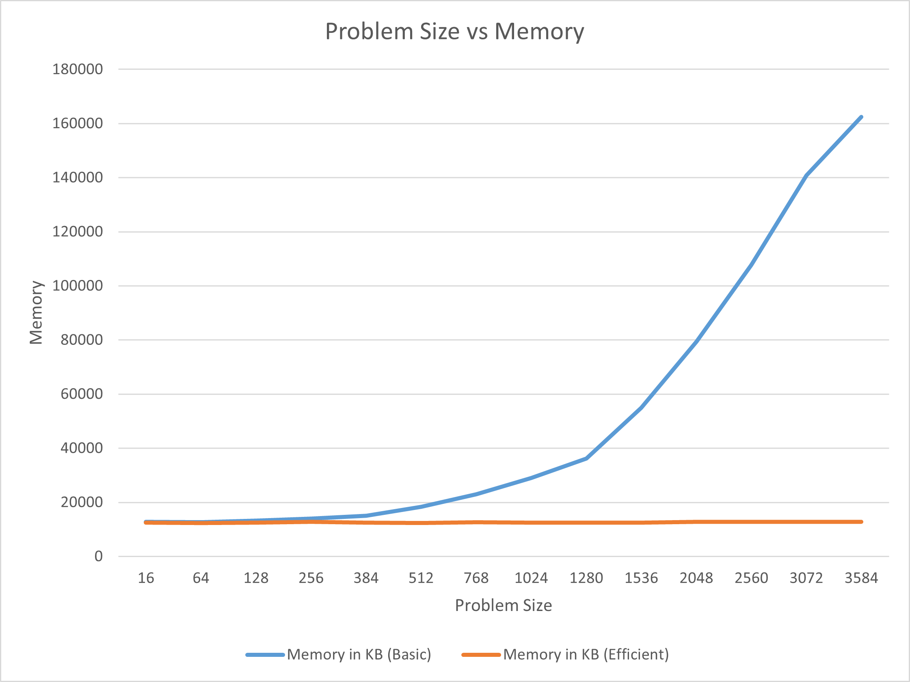

#### Nature of the Graph (Logarithmic/ Linear/ Polynomial/ Exponential)

Basic: logarithmic

Efficient: polynomial

#### Explanation:

As size grows up, the line of basic version grows in polynomial speed, while the line of efficient version is almost a horizontal line. Apparently, the efficient version uses much less memory when the size is huge.

### Graph2 – Time vs Problem Size (M+N)

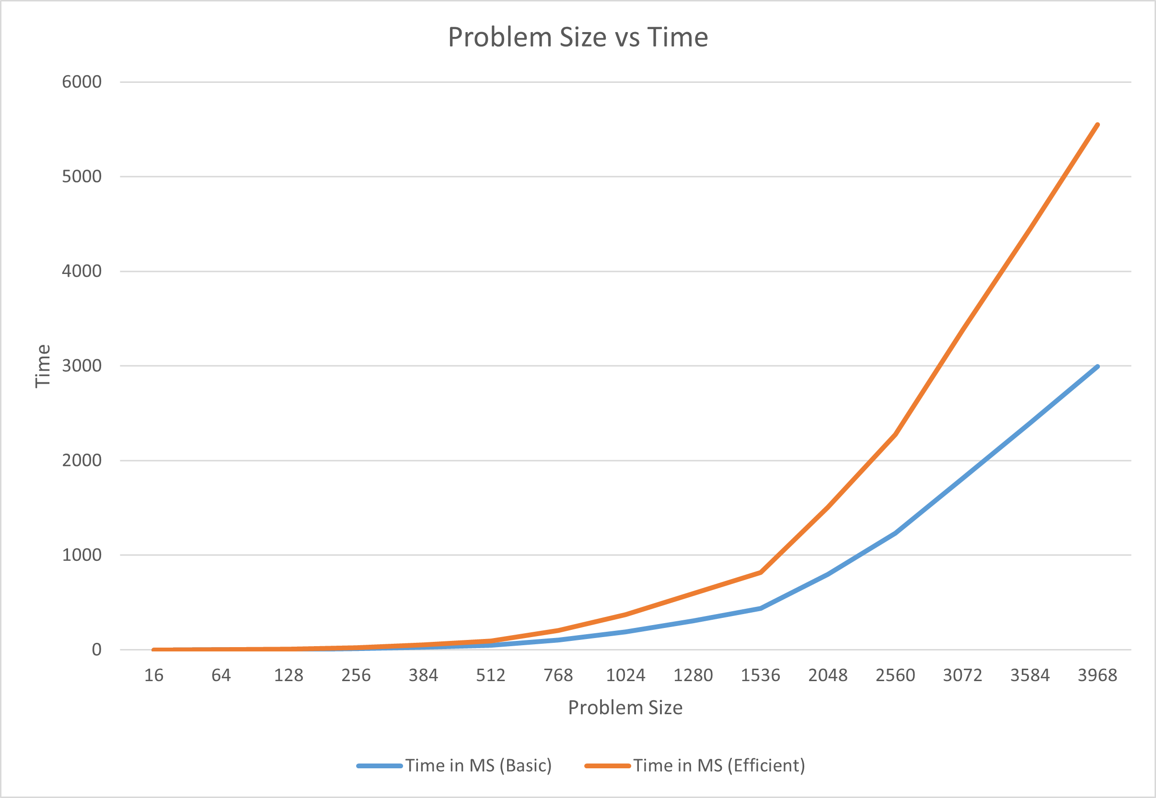

#### Nature of the Graph (Logarithmic/ Linear/ Polynomial/ Exponential)

Basic: polynomial

Efficient: polynomial

#### Explanation:

Both lines grow in polynomial speed as problem size increases, but the efficient version costs more time when size is huge.

## Contribution

(Please mention what each member did if you think everyone in the group does not have an equal contribution, otherwise, write “Equal Contribution”)

<USC ID/s>: <Equal Contribution>

3281934045: Equal Contribution