Resultados Aoki Velloso e Decourt Quaresma

# Dados de Entrada

Lista Nspt:  
   
 [0, 1, 1, 3, 6, 10, 11, 16, 30, 50, 50, 50, 50, 50, 50]  
   
 Tipo de Estaca: Hélice Contínua  
  
 Diâmetro da Estaca: 30.0 cm  
  
 Carga Admissível Esperada: 100 kN  
  
 Nível d'água: 5 m

# Resultados Aoki Velloso

Figura 1: Gráfico dos resultados pelo método de Aoki Velloso.

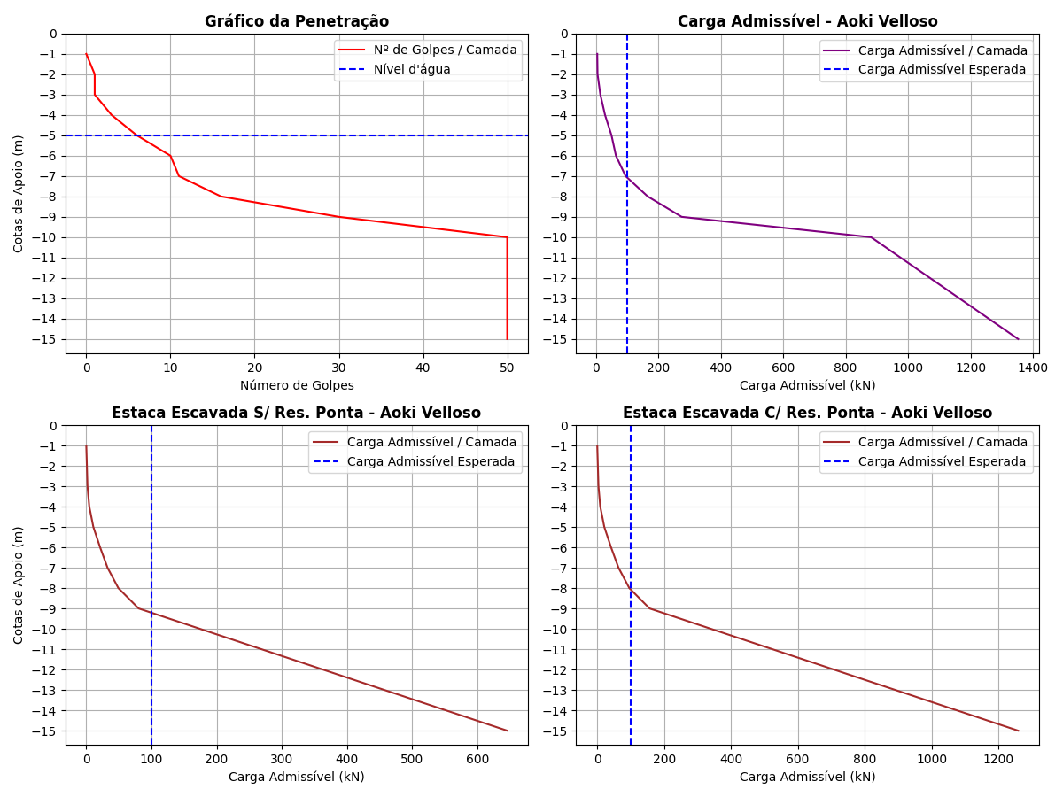

Tabela 1: Resultados pelo método de Aoki Velloso.

|  |  |  |  |  |  |  |  |  |  |  |  |
| --- | --- | --- | --- | --- | --- | --- | --- | --- | --- | --- | --- |
| Cotas | K (kPa) | α (%) | rp (kPa) | Rp (kN) | rl (kPa) | Rl (kN) | Rl Acum. (kN) | Rt (kN) | Padm (kN) | Padm Escavada S/Res. Ponta (kN) | Padm Escavada C/Res. Ponta (kN) |
| -1 | 230 | 3.4 | 115.0 | 8.13 | 0.0 | 0.0 | 0.0 | 8.13 | 4.07 | 0.0 | 0.0 |
| -2 | 230 | 3.4 | 115.0 | 8.13 | 1.96 | 1.85 | 1.85 | 9.98 | 4.99 | 0.92 | 1.8 |
| -3 | 230 | 3.4 | 345.0 | 24.39 | 1.96 | 1.85 | 3.7 | 28.09 | 14.04 | 1.85 | 3.61 |
| -4 | 230 | 3.4 | 690.0 | 48.77 | 5.87 | 5.53 | 9.23 | 58.0 | 29.0 | 4.62 | 9.0 |
| -5 | 220 | 4.0 | 1100.0 | 77.75 | 13.2 | 12.44 | 21.67 | 99.42 | 49.71 | 10.84 | 21.13 |
| -6 | 220 | 4.0 | 1210.0 | 85.53 | 22.0 | 20.73 | 42.4 | 127.93 | 63.96 | 21.2 | 41.34 |
| -7 | 220 | 4.0 | 1760.0 | 124.41 | 24.2 | 22.81 | 65.21 | 189.62 | 94.81 | 32.6 | 63.58 |
| -8 | 220 | 4.0 | 3300.0 | 233.26 | 35.2 | 33.18 | 98.39 | 331.65 | 165.82 | 49.2 | 95.93 |
| -9 | 220 | 4.0 | 5500.0 | 388.77 | 66.0 | 62.2 | 160.59 | 549.36 | 274.68 | 80.3 | 156.58 |
| -10 | 800 | 2.0 | 20000.0 | 1413.72 | 200.0 | 188.5 | 349.09 | 1762.81 | 881.4 | 174.54 | 340.36 |
| -11 | 800 | 2.0 | 20000.0 | 1413.72 | 200.0 | 188.5 | 537.59 | 1951.31 | 975.66 | 268.8 | 524.15 |
| -12 | 800 | 2.0 | 20000.0 | 1413.72 | 200.0 | 188.5 | 726.09 | 2139.81 | 1069.9 | 363.04 | 707.94 |
| -13 | 800 | 2.0 | 20000.0 | 1413.72 | 200.0 | 188.5 | 914.59 | 2328.31 | 1164.16 | 457.3 | 891.73 |
| -14 | 800 | 2.0 | 20000.0 | 1413.72 | 200.0 | 188.5 | 1103.09 | 2516.81 | 1258.4 | 551.54 | 1075.51 |
| -15 | 800 | 2.0 | 20000.0 | 1413.72 | 200.0 | 188.5 | 1291.59 | 2705.31 | 1352.66 | 645.79 | 1259.3 |

# Resultados Decourt Quaresma

Figura 2: Gráfico dos resultados pelo método de Decourt Quaresma.

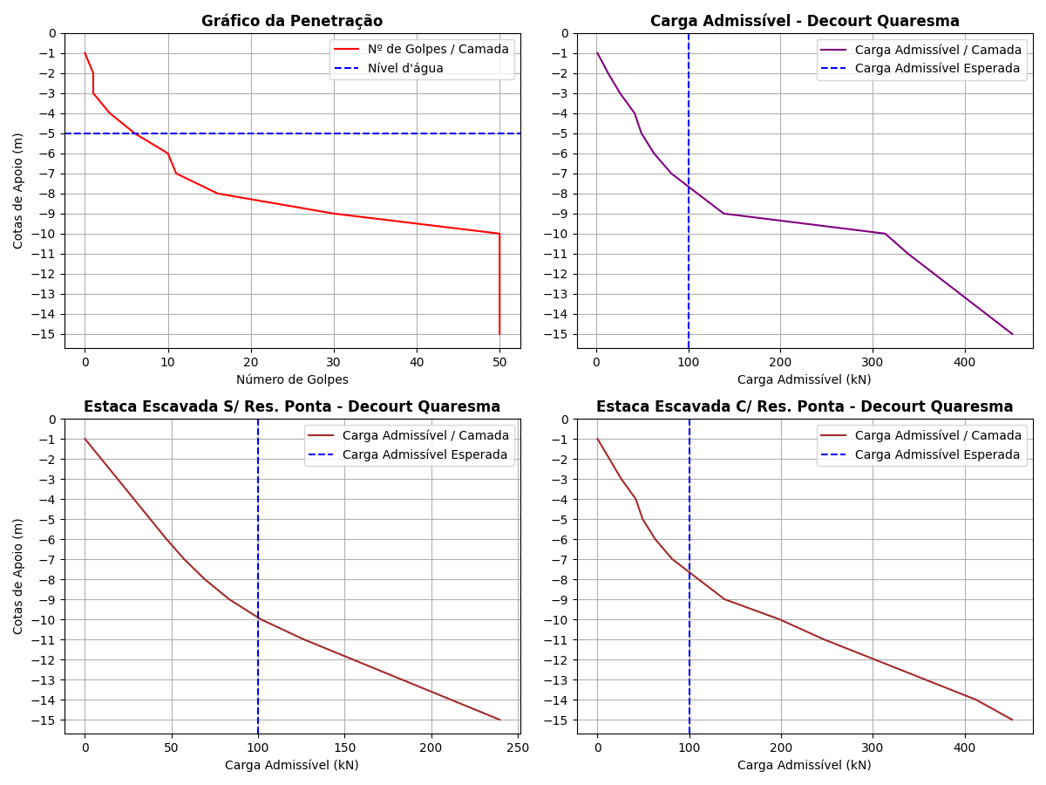

Tabela 2: Resultados pelo método de Decourt Quaresma.

|  |  |  |  |  |  |  |  |  |  |  |  |  |  |  |
| --- | --- | --- | --- | --- | --- | --- | --- | --- | --- | --- | --- | --- | --- | --- |
| Cotas | Nsptl | Nsptp | C (kPa) | α | β | rp (kPa) | Rp (kN) | rl (kPa) | Rl (kN) | Rl Acum. (kN) | Rt (kN) | Padm (kN) | Padm Escavada S/Res. Ponta (kN) | Padm Escavada C/Res. Ponta (kN) |
| -1 | 3.0 | 0.67 | 200 | 0.3 | 1 | 134.0 | 2.84 | 0.0 | 0.0 | 0.0 | 2.84 | 1.42 | 0.0 | 0.0 |
| -2 | 3.0 | 1.67 | 200 | 0.3 | 1 | 334.0 | 7.08 | 20.0 | 18.85 | 18.85 | 25.93 | 12.96 | 9.43 | 12.96 |
| -3 | 3.0 | 3.33 | 200 | 0.3 | 1 | 666.0 | 14.12 | 20.0 | 18.85 | 37.7 | 51.82 | 25.91 | 18.85 | 25.91 |
| -4 | 3.0 | 6.33 | 200 | 0.3 | 1 | 1266.0 | 26.85 | 20.0 | 18.85 | 56.55 | 83.4 | 41.7 | 28.28 | 41.7 |
| -5 | 3.0 | 9.0 | 120 | 0.3 | 1 | 1080.0 | 22.9 | 20.0 | 18.85 | 75.4 | 98.3 | 49.15 | 37.7 | 49.15 |
| -6 | 3.0 | 12.33 | 120 | 0.3 | 1 | 1479.6 | 31.38 | 20.0 | 18.85 | 94.25 | 125.63 | 62.82 | 47.12 | 62.82 |
| -7 | 3.5 | 19.0 | 120 | 0.3 | 1 | 2280.0 | 48.35 | 21.67 | 20.42 | 114.67 | 163.02 | 81.51 | 57.34 | 81.51 |
| -8 | 4.57 | 32.0 | 120 | 0.3 | 1 | 3840.0 | 81.43 | 25.23 | 23.78 | 138.45 | 219.88 | 109.94 | 69.22 | 109.94 |
| -9 | 6.0 | 43.33 | 120 | 0.3 | 1 | 5199.6 | 110.26 | 30.0 | 28.27 | 166.72 | 276.98 | 138.49 | 83.36 | 138.49 |
| -10 | 8.67 | 50.0 | 400 | 0.3 | 1 | 20000.0 | 424.12 | 38.9 | 36.66 | 203.38 | 627.5 | 313.75 | 101.69 | 198.3 |
| -11 | 12.8 | 50.0 | 400 | 0.3 | 1 | 20000.0 | 424.12 | 52.67 | 49.64 | 253.02 | 677.14 | 338.57 | 126.51 | 246.69 |
| -12 | 15.0 | 50.0 | 400 | 0.3 | 1 | 20000.0 | 424.12 | 60.0 | 56.55 | 309.57 | 733.69 | 366.84 | 154.78 | 301.83 |
| -13 | 15.0 | 50.0 | 400 | 0.3 | 1 | 20000.0 | 424.12 | 60.0 | 56.55 | 366.12 | 790.24 | 395.12 | 183.06 | 356.97 |
| -14 | 15.0 | 50.0 | 400 | 0.3 | 1 | 20000.0 | 424.12 | 60.0 | 56.55 | 422.67 | 846.79 | 423.4 | 211.34 | 412.1 |
| -15 | 15.0 | 50.0 | 400 | 0.3 | 1 | 20000.0 | 424.12 | 60.0 | 56.55 | 479.22 | 903.34 | 451.67 | 239.61 | 451.67 |

# Comparativo entre Aoki Velloso e Decourt Quaresma

Figura 3: Comparativo entre Aoki Velloso e Decourt Quaresma.

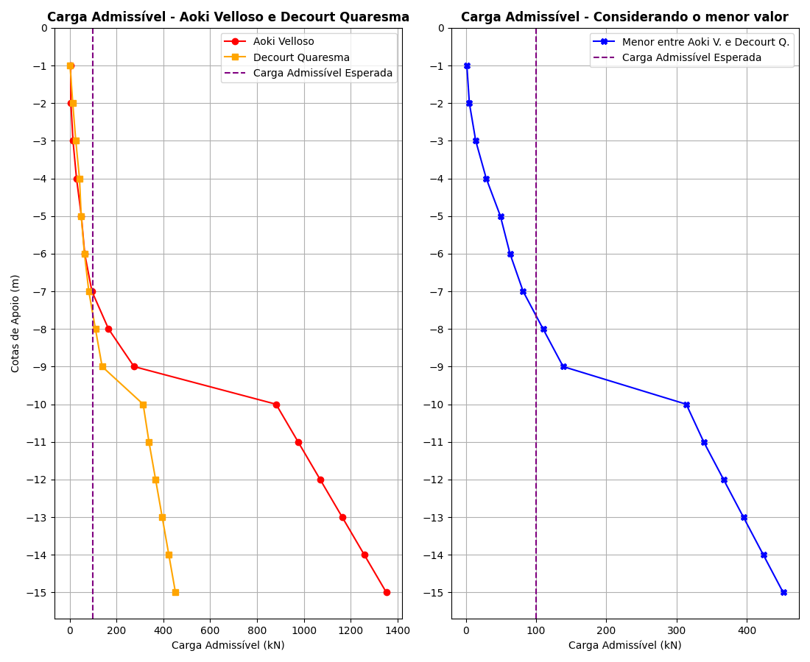

Tabela 3: Comparativo entre Aoki Velloso e Decourt Quaresma.

|  |  |  |  |
| --- | --- | --- | --- |
| Cotas | Padm - Aoki Velloso (kN) | Padm - Decourt Quaresma (kN) | Menor valor entre os métodos (kN) |
| -1 | 4.07 | 1.42 | 1.42 |
| -2 | 4.99 | 12.96 | 4.99 |
| -3 | 14.04 | 25.91 | 14.04 |
| -4 | 29.0 | 41.7 | 29.0 |
| -5 | 49.71 | 49.15 | 49.15 |
| -6 | 63.96 | 62.82 | 62.82 |
| -7 | 94.81 | 81.51 | 81.51 |
| -8 | 165.82 | 109.94 | 109.94 |
| -9 | 274.68 | 138.49 | 138.49 |
| -10 | 881.4 | 313.75 | 313.75 |
| -11 | 975.66 | 338.57 | 338.57 |
| -12 | 1069.9 | 366.84 | 366.84 |
| -13 | 1164.16 | 395.12 | 395.12 |
| -14 | 1258.4 | 423.4 | 423.4 |
| -15 | 1352.66 | 451.67 | 451.67 |