Resultados Aoki Velloso e Decourt Quaresma

# Dados de Entrada

Lista Nspt:  
   
 [0, 3, 6, 8, 12, 15, 16, 19, 20, 21, 23, 30]  
   
 Tipo de Estaca: Hélice Contínua  
  
 Diâmetro da Estaca: 30.0 cm  
  
 Carga Admissível Esperada: 100.0 kN  
  
 Nível d'água: 8.0 m

# Resultados Aoki Velloso

Figura 1: Gráfico dos resultados pelo método de Aoki Velloso.

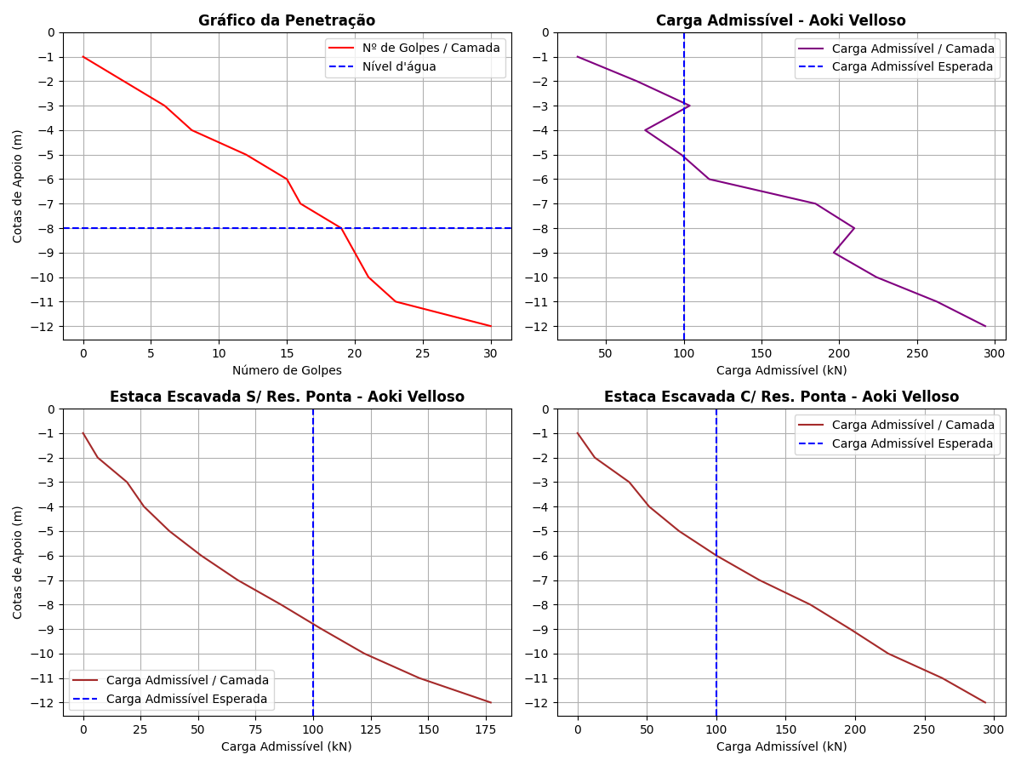

Tabela 1: Resultados pelo método de Aoki Velloso.

|  |  |  |  |  |  |  |  |  |  |  |  |
| --- | --- | --- | --- | --- | --- | --- | --- | --- | --- | --- | --- |
| Cotas | K (kPa) | α (%) | rp (kPa) | Rp (kN) | rl (kPa) | Rl (kN) | Rl Acum. (kN) | Rt (kN) | Padm (kN) | Padm Escavada S/Res. Ponta (kN) | Padm Escavada C/Res. Ponta (kN) |
| -1 | 600 | 3.0 | 900.0 | 63.62 | 0.0 | 0.0 | 0.0 | 63.62 | 31.81 | 0.0 | 0.0 |
| -2 | 600 | 3.0 | 1800.0 | 127.23 | 13.5 | 12.72 | 12.72 | 139.95 | 69.97 | 6.36 | 12.4 |
| -3 | 600 | 3.0 | 2400.0 | 169.65 | 27.0 | 25.45 | 38.17 | 207.82 | 103.91 | 19.08 | 37.22 |
| -4 | 230 | 3.4 | 1380.0 | 97.55 | 15.64 | 14.74 | 52.91 | 150.46 | 75.23 | 26.46 | 51.59 |
| -5 | 230 | 3.4 | 1725.0 | 121.93 | 23.46 | 22.11 | 75.02 | 196.95 | 98.48 | 37.51 | 73.14 |
| -6 | 230 | 3.4 | 1840.0 | 130.06 | 29.33 | 27.64 | 102.66 | 232.72 | 116.36 | 51.33 | 100.09 |
| -7 | 350 | 2.4 | 3325.0 | 235.03 | 33.6 | 31.67 | 134.33 | 369.36 | 184.68 | 67.17 | 130.97 |
| -8 | 350 | 2.4 | 3500.0 | 247.4 | 39.9 | 37.6 | 171.93 | 419.33 | 209.66 | 85.96 | 167.63 |
| -9 | 250 | 3.0 | 2625.0 | 185.55 | 37.5 | 35.34 | 207.27 | 392.82 | 196.41 | 103.64 | 196.41 |
| -10 | 250 | 3.0 | 2875.0 | 203.22 | 39.38 | 37.11 | 244.38 | 447.6 | 223.8 | 122.19 | 223.8 |
| -11 | 220 | 4.0 | 3300.0 | 233.26 | 50.6 | 47.69 | 292.07 | 525.33 | 262.67 | 146.04 | 262.66 |
| -12 | 220 | 4.0 | 3300.0 | 233.26 | 66.0 | 62.2 | 354.27 | 587.53 | 293.76 | 177.14 | 293.76 |

# Resultados Decourt Quaresma

Figura 2: Gráfico dos resultados pelo método de Decourt Quaresma.

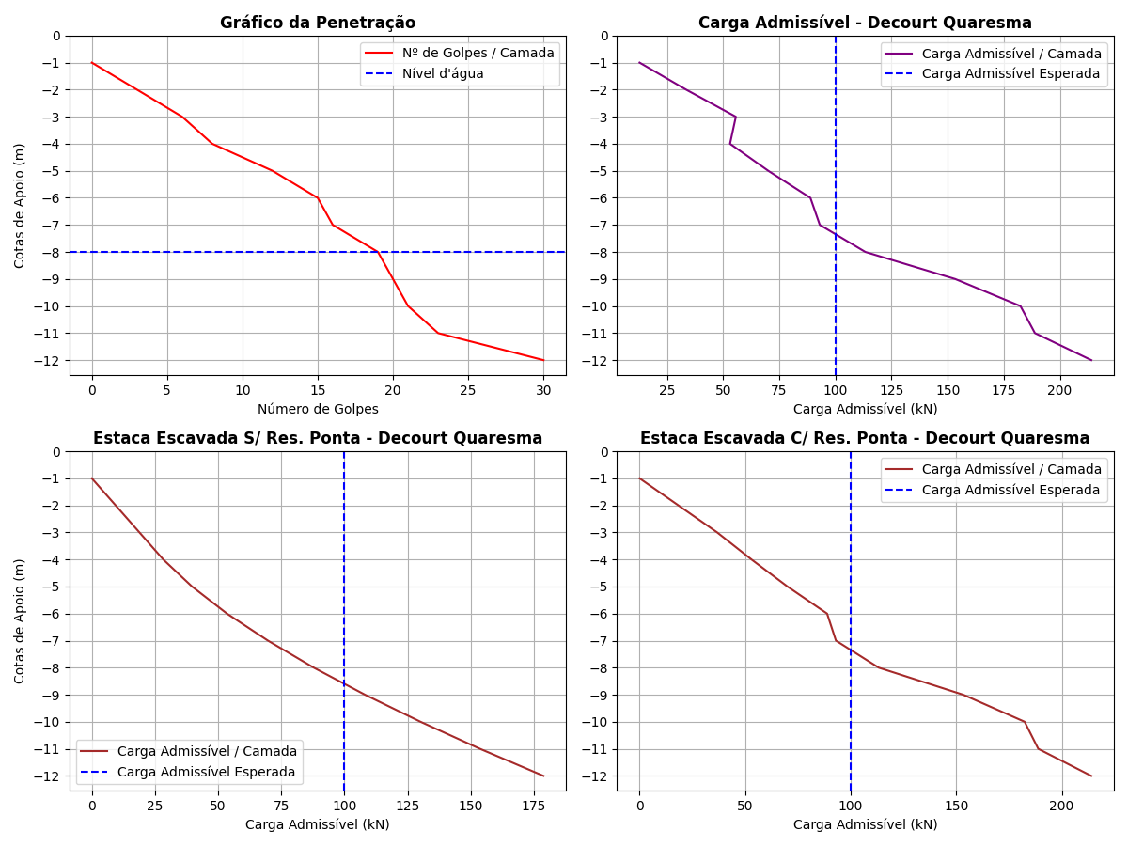

Tabela 2: Resultados pelo método de Decourt Quaresma.

|  |  |  |  |  |  |  |  |  |  |  |  |  |  |  |
| --- | --- | --- | --- | --- | --- | --- | --- | --- | --- | --- | --- | --- | --- | --- |
| Cotas | Nsptl | Nsptp | C (kPa) | α | β | rp (kPa) | Rp (kN) | rl (kPa) | Rl (kN) | Rl Acum. (kN) | Rt (kN) | Padm (kN) | Padm Escavada S/Res. Ponta (kN) | Padm Escavada C/Res. Ponta (kN) |
| -1 | 3.0 | 3.0 | 400 | 0.3 | 1 | 1200.0 | 25.45 | 0.0 | 0.0 | 0.0 | 25.45 | 12.72 | 0.0 | 0.0 |
| -2 | 3.0 | 5.67 | 400 | 0.3 | 1 | 2268.0 | 48.09 | 20.0 | 18.85 | 18.85 | 66.94 | 33.47 | 9.43 | 18.38 |
| -3 | 3.0 | 8.67 | 400 | 0.3 | 1 | 3468.0 | 73.54 | 20.0 | 18.85 | 37.7 | 111.24 | 55.62 | 18.85 | 36.76 |
| -4 | 3.0 | 11.67 | 200 | 0.3 | 1 | 2334.0 | 49.49 | 20.0 | 18.85 | 56.55 | 106.04 | 53.02 | 28.28 | 53.02 |
| -5 | 4.25 | 14.33 | 200 | 0.3 | 1 | 2866.0 | 60.78 | 24.17 | 22.78 | 79.33 | 140.11 | 70.06 | 39.66 | 70.06 |
| -6 | 5.8 | 16.67 | 200 | 0.3 | 1 | 3334.0 | 70.7 | 29.33 | 27.64 | 106.97 | 177.67 | 88.84 | 53.48 | 88.84 |
| -7 | 7.33 | 18.33 | 120 | 0.3 | 1 | 2199.6 | 46.64 | 34.43 | 32.45 | 139.42 | 186.06 | 93.03 | 69.71 | 93.03 |
| -8 | 8.57 | 20.0 | 120 | 0.3 | 1 | 2400.0 | 50.89 | 38.57 | 36.35 | 175.77 | 226.66 | 113.33 | 87.88 | 113.33 |
| -9 | 9.88 | 21.33 | 200 | 0.3 | 1 | 4266.0 | 90.46 | 42.93 | 40.46 | 216.23 | 306.69 | 153.34 | 108.12 | 153.34 |
| -10 | 11.0 | 24.67 | 200 | 0.3 | 1 | 4934.0 | 104.63 | 46.67 | 43.99 | 260.22 | 364.85 | 182.42 | 130.11 | 182.42 |
| -11 | 12.0 | 27.67 | 120 | 0.3 | 1 | 3320.4 | 70.41 | 50.0 | 47.12 | 307.34 | 377.75 | 188.88 | 153.67 | 188.88 |
| -12 | 13.0 | 27.67 | 120 | 0.3 | 1 | 3320.4 | 70.41 | 53.33 | 50.26 | 357.6 | 428.01 | 214.0 | 178.8 | 214.0 |

# Comparativo entre Aoki Velloso e Decourt Quaresma

Figura 3: Comparativo entre Aoki Velloso e Decourt Quaresma.

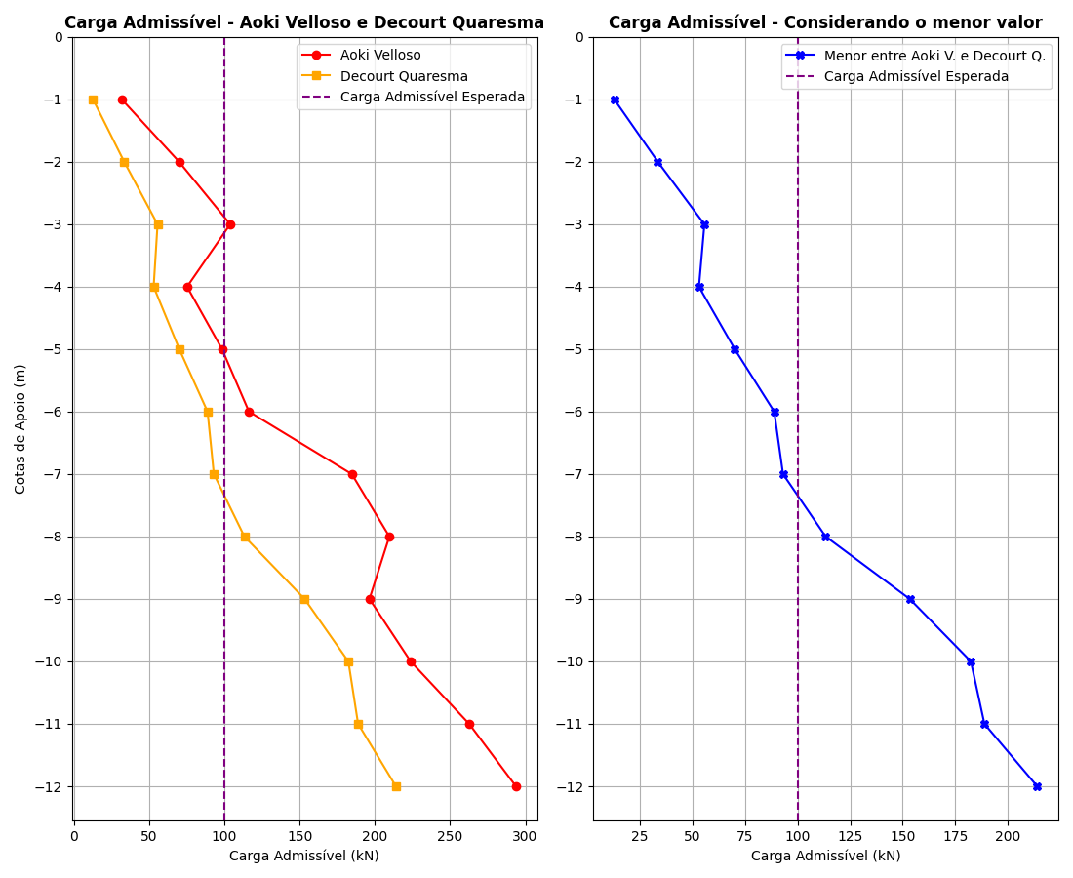

Tabela 3: Comparativo entre Aoki Velloso e Decourt Quaresma.

|  |  |  |  |
| --- | --- | --- | --- |
| Cotas | Padm - Aoki Velloso (kN) | Padm - Decourt Quaresma (kN) | Menor valor entre os métodos (kN) |
| -1 | 31.81 | 12.72 | 12.72 |
| -2 | 69.97 | 33.47 | 33.47 |
| -3 | 103.91 | 55.62 | 55.62 |
| -4 | 75.23 | 53.02 | 53.02 |
| -5 | 98.48 | 70.06 | 70.06 |
| -6 | 116.36 | 88.84 | 88.84 |
| -7 | 184.68 | 93.03 | 93.03 |
| -8 | 209.66 | 113.33 | 113.33 |
| -9 | 196.41 | 153.34 | 153.34 |
| -10 | 223.8 | 182.42 | 182.42 |
| -11 | 262.67 | 188.88 | 188.88 |
| -12 | 293.76 | 214.0 | 214.0 |