Resultados Aoki Velloso e Decourt Quaresma

# Dados de Entrada

Lista Nspt:  
   
 [0, 1, 1, 3, 6, 10, 11, 16, 50, 50]  
   
 Tipo de Estaca: Pré-Moldada  
  
 Diâmetro da Estaca: 30.0 cm  
  
 Carga Admissível Esperada: 150.0 kN  
  
 Nível d'água: 5.0 m

# Resultados Aoki Velloso

Figura 1: Gráfico dos resultados pelo método de Aoki Velloso.

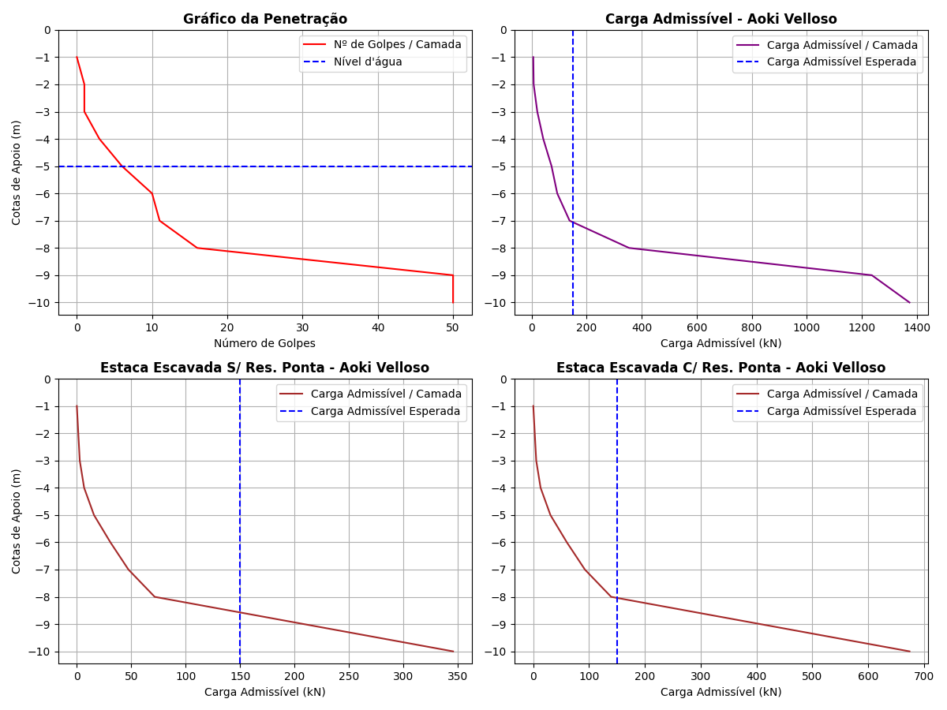

Tabela 1: Resultados pelo método de Aoki Velloso.

|  |  |  |  |  |  |  |  |  |  |  |  |
| --- | --- | --- | --- | --- | --- | --- | --- | --- | --- | --- | --- |
| Cotas | K (kPa) | α (%) | rp (kPa) | Rp (kN) | rl (kPa) | Rl (kN) | Rl Acum. (kN) | Rt (kN) | Padm (kN) | Padm Escavada S/Res. Ponta (kN) | Padm Escavada C/Res. Ponta (kN) |
| -1 | 230 | 3.4 | 167.27 | 11.82 | 0.0 | 0.0 | 0.0 | 11.82 | 5.91 | 0.0 | 0.0 |
| -2 | 230 | 3.4 | 167.27 | 11.82 | 2.84 | 2.68 | 2.68 | 14.5 | 7.25 | 1.34 | 2.61 |
| -3 | 230 | 3.4 | 501.82 | 35.47 | 2.84 | 2.68 | 5.36 | 40.83 | 20.42 | 2.68 | 5.23 |
| -4 | 230 | 3.4 | 1003.64 | 70.94 | 8.53 | 8.04 | 13.4 | 84.34 | 42.17 | 6.7 | 13.07 |
| -5 | 220 | 4.0 | 1600.0 | 113.1 | 19.2 | 18.1 | 31.5 | 144.6 | 72.3 | 15.75 | 30.71 |
| -6 | 220 | 4.0 | 1760.0 | 124.41 | 32.0 | 30.16 | 61.66 | 186.07 | 93.04 | 30.83 | 60.12 |
| -7 | 220 | 4.0 | 2560.0 | 180.96 | 35.2 | 33.18 | 94.84 | 275.8 | 137.9 | 47.42 | 92.47 |
| -8 | 220 | 4.0 | 8000.0 | 565.49 | 51.2 | 48.25 | 143.09 | 708.58 | 354.29 | 71.54 | 139.51 |
| -9 | 800 | 2.0 | 29090.91 | 2056.32 | 290.91 | 274.18 | 417.27 | 2473.59 | 1236.8 | 208.64 | 406.84 |
| -10 | 800 | 2.0 | 29090.91 | 2056.32 | 290.91 | 274.18 | 691.45 | 2747.77 | 1373.88 | 345.72 | 674.16 |

# Resultados Decourt Quaresma

Figura 2: Gráfico dos resultados pelo método de Decourt Quaresma.

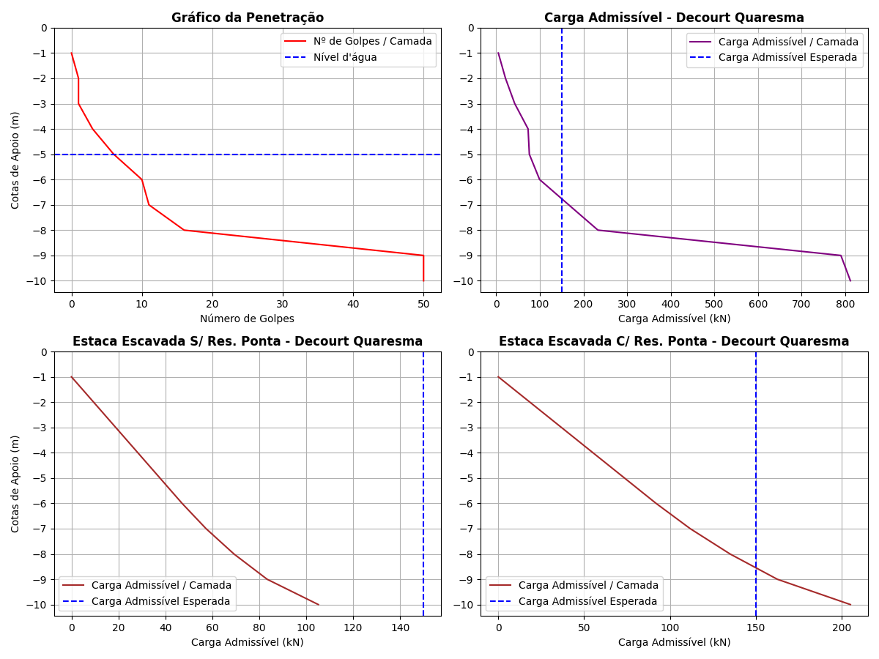

Tabela 2: Resultados pelo método de Decourt Quaresma.

|  |  |  |  |  |  |  |  |  |  |  |  |  |  |  |
| --- | --- | --- | --- | --- | --- | --- | --- | --- | --- | --- | --- | --- | --- | --- |
| Cotas | Nsptl | Nsptp | C (kPa) | α | β | rp (kPa) | Rp (kN) | rl (kPa) | Rl (kN) | Rl Acum. (kN) | Rt (kN) | Padm (kN) | Padm Escavada S/Res. Ponta (kN) | Padm Escavada C/Res. Ponta (kN) |
| -1 | 3.0 | 0.67 | 200 | 1 | 1 | 134.0 | 9.47 | 0.0 | 0.0 | 0.0 | 9.47 | 4.74 | 0.0 | 0.0 |
| -2 | 3.0 | 1.67 | 200 | 1 | 1 | 334.0 | 23.61 | 20.0 | 18.85 | 18.85 | 42.46 | 21.23 | 9.43 | 18.38 |
| -3 | 3.0 | 3.33 | 200 | 1 | 1 | 666.0 | 47.08 | 20.0 | 18.85 | 37.7 | 84.78 | 42.39 | 18.85 | 36.76 |
| -4 | 3.0 | 6.33 | 200 | 1 | 1 | 1266.0 | 89.49 | 20.0 | 18.85 | 56.55 | 146.04 | 73.02 | 28.28 | 55.14 |
| -5 | 3.0 | 9.0 | 120 | 1 | 1 | 1080.0 | 76.34 | 20.0 | 18.85 | 75.4 | 151.74 | 75.87 | 37.7 | 73.52 |
| -6 | 3.0 | 12.33 | 120 | 1 | 1 | 1479.6 | 104.59 | 20.0 | 18.85 | 94.25 | 198.84 | 99.42 | 47.12 | 91.89 |
| -7 | 3.5 | 25.67 | 120 | 1 | 1 | 3080.4 | 217.74 | 21.67 | 20.42 | 114.67 | 332.41 | 166.2 | 57.34 | 111.8 |
| -8 | 4.57 | 38.67 | 120 | 1 | 1 | 4640.4 | 328.01 | 25.23 | 23.78 | 138.45 | 466.46 | 233.23 | 69.22 | 134.99 |
| -9 | 6.0 | 50.0 | 400 | 1 | 1 | 20000.0 | 1413.72 | 30.0 | 28.27 | 166.72 | 1580.44 | 790.22 | 83.36 | 162.55 |
| -10 | 10.89 | 50.0 | 400 | 1 | 1 | 20000.0 | 1413.72 | 46.3 | 43.64 | 210.36 | 1624.08 | 812.04 | 105.18 | 205.1 |

# Comparativo entre Aoki Velloso e Decourt Quaresma

Figura 3: Comparativo entre Aoki Velloso e Decourt Quaresma.

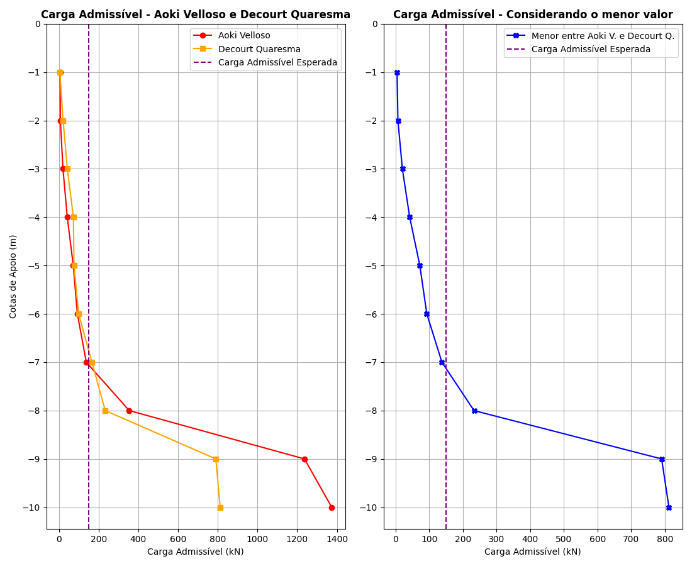

Tabela 3: Comparativo entre Aoki Velloso e Decourt Quaresma.

|  |  |  |  |
| --- | --- | --- | --- |
| Cotas | Padm - Aoki Velloso (kN) | Padm - Decourt Quaresma (kN) | Menor valor entre os métodos (kN) |
| -1 | 5.91 | 4.74 | 4.74 |
| -2 | 7.25 | 21.23 | 7.25 |
| -3 | 20.42 | 42.39 | 20.42 |
| -4 | 42.17 | 73.02 | 42.17 |
| -5 | 72.3 | 75.87 | 72.3 |
| -6 | 93.04 | 99.42 | 93.04 |
| -7 | 137.9 | 166.2 | 137.9 |
| -8 | 354.29 | 233.23 | 233.23 |
| -9 | 1236.8 | 790.22 | 790.22 |
| -10 | 1373.88 | 812.04 | 812.04 |