I've checked in a tool to help validate our HelpTopicPaths resourcetables against the actual user help files, and vice-versa. Attached are reports generated for Language Explorer (FLEx) and Translation Editor (TE). (Note: the links in attached reports probably make no sense on your computer.)

Description
The tool generates an HTML report with the following information:
1) Identify the HelpTopicPaths in our assemblies that have no correspondence to a real help file.
This is the first section in the sample report: Language Explorer (possibly) has 6 broken chm links.
2) Identify the help files that have no correspondence to HelpTopicPaths in our assemblies.
This is the second section in the report: Language Explorer has no direct help paths to 362 help files.
3) Identify the help files that have been filtered out based upon a regular expression.
This is the third section in the report: Language Explorer: The following 118 help files were excluded from this report because they matched the Regular expression pattern: /overview\.htm$/

The program does notdo the following:
1) Validate links internal to the help files or chm. (This is what Robo-help does.)
2) Identify places in the user interface that is missing a help. The best it can do is tell you that a help file exists for a certain area/topic but has no reference in the resource tables in our assemblies.
3) Figure out which paths in FwResources correspond to TE helps and which correspond to FLEx helps. As you can see in the first section of the attached report, we found references 6 references in FwResource HelpTopicsPaths that have no correspondence to existing FLEx help files. But upon closer inspection, these are helps that (should possibly?) exist in TE helps, but not in FLEx. Also in the TE report there are "broken" links that are only relevant to FLEx chms.

Some needed enhancements (feel free to implement them!):
1) Save user file/folder settings.
2) Provide exclusion lists and better filtering options, to remove links from the report that you've verified are okay.
3) Timestamps for the reports.
4) Configurable template for the report.
5) Support for decompiling chms with paths with spaces. (see Caution below).

User Interface (see attached screenshots
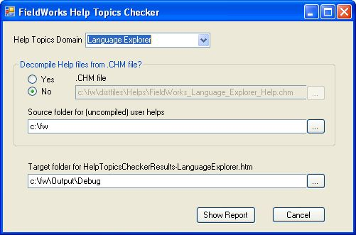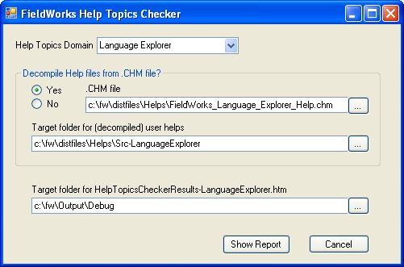):

Help Topics Domain:
This is the application you want to check helps for. Selecting a new domain (e.g. Translation Editor) will reset most of the form's default settings.

Decompile HelpFiles from .CHM file?
This section controls the location of the files against which the HelpTopicPaths in our assemblies will be checked. The default is to select an existing folder directory where the Help files and their directory structure exists. Alternatively, you can choose "Yes", to decompile an existing chm to a specified directory (though see Caution below about using paths with spaces in them.)

Target folder for HelpTopicsCheckerResults.htm
This is where we'll save the results report.

Show Report
This will first check your paths and such, asking if you want to create new directories, or remove previously decompiled chm files, etc... Then it will generate and save an report that will come up in your HTML viewer. Then it closes the HelpTopicsChecker dialog box.

Known Issues: Cautions & Limitations:
Cautions
1) Avoid decompiling chms with spaces in the path.

The program does not seem to be able to decompile chms in or to directories with spaces in them. I've tried to figure out a way to pass proc.StartInfo.Arguments for "hh.exe" with in a properly quotation qualified manner, but to no avail. The best I can do is to let the user know out what we're attemping to do with a message dialog box. :-( The work around is to copy your .chm in a directory path without spaces, and to specify a directory without spaces for decompiling into. As a result, the report will probably show that all links are probably broken (which is not true).

2) Decompiled chm directories persist.

If you decompile a chm into a directory. It will remain after the report is generated (so that links from the report will be good). You will need to delete it manually when you are finished. If you run the program again to decompile to the same directory, it will ask you if you want to delete all its files and subdirectories. if you say "No" then no report will be generated. If you want to keep the same directory with its decompiled chm files, then select the "No" radio button for Decompile HelpFiles from .CHM file?section of the HelpTopicsChecker dialog, and specify that directory to use a Source.

Limitations:
1) The exclusion file filter for section 2, is hard-coded to "/overview\.htm$/".
2) The folder/file dialog browse/finder boxes do not try to remember your last selections.
3) The program currently can only decompile and check one .chm per program (domain).

Perforce Info:
program files:
//depot/fw/Bin/HelpTopicsChecker.exe
//depot/fw/Bin/HelpTopicsDomains.xml

source:
//depot/fw/Bin/src/HelpTopicsChecker/HelpTopicsChecker.cs
//depot/fw/Bin/src/HelpTopicsChecker/HelpTopicsChecker.csproj
//depot/fw/Bin/src/HelpTopicsChecker/HelpTopicsCheckerSetupDlg.Designer.cs
//depot/fw/Bin/src/HelpTopicsChecker/HelpTopicsCheckerSetupDlg.cs
//depot/fw/Bin/src/HelpTopicsChecker/HelpTopicsCheckerSetupDlg.resx
//depot/fw/Bin/src/HelpTopicsChecker/HelpTopicsDomains.xml

Basic Setup
Environment:
1) Registry: The program depends upon the installation of Fieldworks directory where , where HKEY_LOCAL_MACHINE/Software/SIL/FieldWorks/RootDir points to the directory with LexTextDll.dll, FwResources.dll, TeResources.dll, (or in case of adeveloper machine, that path can be used to find the \Output\Debug directory with those assemblies). These assemblies contain the HelpTopicPaths resource tables used for validation.
2) Decompiling Chms. Answering Yes to“Decompile HelpFiles from .CHM File” requires HTML Help Workshop (WINDOWS\hh.exe).

Installation & Configuration
HelpTopicsChecker.exe should be able to run from any directory with HelpTopicsDomains.xml. The HelpTopicsDomain.xml is the configuration file that contains information about the assemblies containing the help files, and which program (i.e. Domain) they are appropriate to.

Eric D. Pyle

