Testing Graphite Behaviors in WorldPad
Author: Sharon Correll
Date: 27 November 2006
This document describes some tests that can be done using WorldPad to ensure that Graphite is working.

Roman text
Install the font called “FwGraphiteTest Roman” (based on Charis SIL); the filename is fwgrtest_roman.ttf. Then use WorldPad to open the file called romanTest.wpx.

Rendering
The correct rendering is shown below.
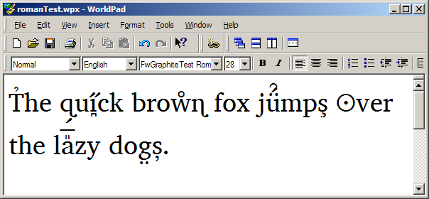
Check that the diacritics are centered and stack correctly. Note the difference between the diacritics on the two instances of lowercase ‘s’: this is caused by the Romanian diacritics feature.

Wrapping
The text should wrap at spaces.

Selections
Click on the right side of the ‘T’ in “The”. The result should be a split insertion bar.
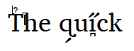
Click on the left side of the ̑ diacritic. The result should be a split insertion bar.
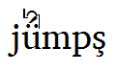
Click on the left size of the  character. Pressing the right arrow key through the word “ui̪̋ck” should show split insertion bars around the diacritics.
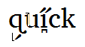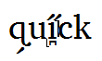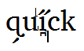
Then press Shift-left-arrow; this should show diacritics selected independently of the base characters.
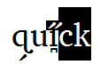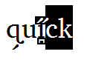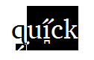

Arabic text
Install the font called “FwGraphiteTest Arabic” (based on Scheherazade); the filename is fwgrtest_arabic.ttf. Then use WorldPad to open the file called arabicTest.wpx.

Rendering
The correct rendering is shown below. Check that the PUA characters (red) use the appropriate cursive-attached forms.
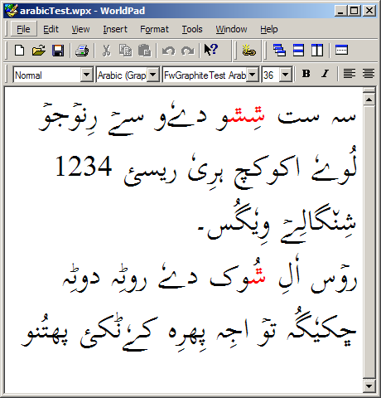

Wrapping
The text should wrap at spaces and be right-aligned.

Selections
It should be easy to create split insertion points in text that has diacritics. The following figures show the results of clicking at various positions.
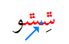 results in 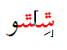
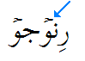 results in 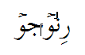

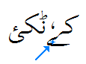 results in 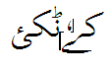

The following range selections should be easy to create by clicking and dragging or shift-clicking.
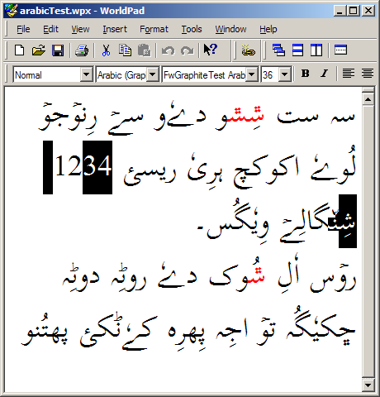

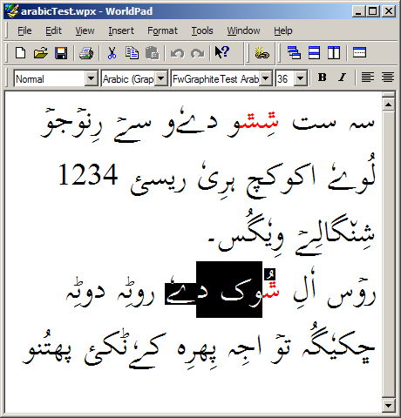
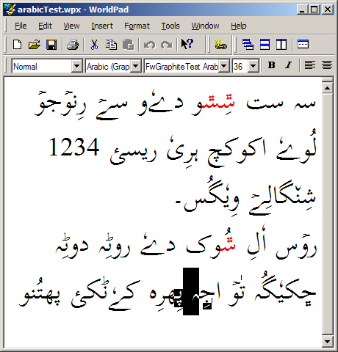

Editing
Click in the middle of words and type a space; the cursive connections should change, as shown by the following examples.
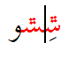 changes to 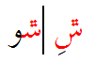

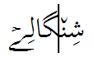 changes to 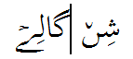

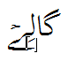 changes to 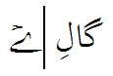

Burmese text
Install the font called “FwGraphiteTest Burmese” (based on Padauk); the filename is fwgrtest_burmese.ttf. Then use WorldPad to open the file called burmeseTest.wpx.

Rendering
The correct rendering is shown below.
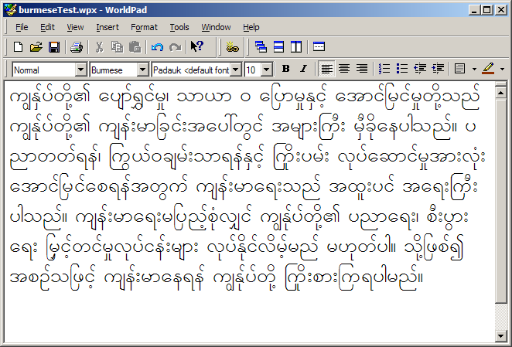

Wrapping
The text is left-aligned. Line breaks can occur in places other than visible whitespace. The screenshots below show the effect of wrapping as the window is made progressively more narrow (starting with the layout above). Red circles mark the text that is moved at each step.
