A New Program for doing Morphology: Hermit Crab

Mike Maxwell

International Linguistics Department

and

Academic Computing

Introduction
This paper* introduces a new computer program for working with morphology, Hermit Crab. Hermit Crab resembles some of the tools in the traditional CARLA suite in that it can be used to create an analysis of the morphological component of a language’s grammar, and can parse words into their morphemes (like AMPLE) or generate words out of morphemes (like STAMP). Hermit Crab differs from these programs in that it takes a process view of morphology: in line with many modern theories of morphology, affixation is viewed not as the result of concatenating allomorphs, but as a process that modifies the form of a word. This makes it nearly as easy to describe infixation, reduplication, and other sorts of ‘exotic’ morphology as it is to describe prefixation or suffixation. Furthermore, Hermit Crab employs a version of generative phonology to create allomorphs. Hermit Crab therefore implements “Item and Process Morphology” in both senses of this term. Finally, Hermit Crab uses a linguistically motivated treatment of morphosyntactic features and their ‘percolation’, making it straightforward to restrict the co-occurrence of affixes and stems.
Hermit Crab utilizes LinguaLinks (version 2.5 and later) for its user interface. This provides not only an easy way to build rules and other complicated structures, but also a grammar debugging environment.
Sections two and three of this article describe the morphological and phonological capabilities of Hermit Crab from a linguistic viewpoint. Section four presents some example analyses using Hermit Crab, while section five describes some of the limitations of this program. Section six outlines possible enhancements for the future.

Morphological Capabilities of Hermit Crab

Morphological Processes
As mentioned above, Hermit Crab takes a process view of morphology: affixation is seen not as the simple concatenation of allomorphs or morphemes, but as a sequence of steps in which a stem is modified to create a word. Each step represents the attachment of a single affix, but in addition to simple prefixes or suffixes, it is straightforward to describe infixation, reduplication, suprafixation, and even truncation processes. The process view of affixation can be traced back at least to Hockett (1954), but has been revived within the generative linguistics tradition by Aronoff (1976); Anderson 1992) is a more recent description.
As an example of a morphological process, consider an affix whose phonological effect consists of reduplicating the first syllable of the stem. Up until the most recent version of AMPLE, it has been necessary to list all possible allomorphs, i.e. all word-initial syllables (or at least those which occur on stems that undergo reduplication). In Hermit Crab, such an affix would instead be represented as the following morphological rule:
CV X
1 2 → 1 1 2
C and V are “natural classes,” representing consonants and vowels respectively, while X is a variable that represents anything at all – in this case, the remainder of the stem. Natural Classes have a similar function to “string classes” in AMPLE, but are defined as a set of phonetic features rather than as a set of character sequences. The user defines the natural classes to be used in the analysis of a language; they can be as simple as the set of consonants or vowels, or as complex as the set of non-low back unrounded vowels.
The process notation illustrated above also makes it easy to represent infixes. For instance, the following morphological process would infix i and a after the first and second consonants respectively of a triconsonantal root (similar processes are found in many Semitic languages):
C C C
1 2 3 → 1 i 2 a 3
Other sorts of affixes which are easily represented as morphological rules include suprafixes, simulfixes, circumfixes, zero morphemes, and affixes of truncation, as well as ordinary prefixes and suffixes.

Allomorphy
In Hermit Crab, morphological rules may have subrules, which can be useful for representing allomorphs. (It is also possible to derive allomorphs using phonological rules, as will be described in section 3.) For instance, if the above infixing process resulted in a different form for biconsonantal roots (e.g. by epenthesizing some additional consonant, or by reduplicating one of the consonants of the stem), that could be easily represented as an additional subrule.
Subrules of morphological (and phonological) rules apply in disjunctive order, allowing the use of an ‘elsewhere case.’ For instance, the English regular plural noun suffix can be described as follows: if the stem ends in a strident (sibilant) sound, append –; otherwise, if the stem ends in a voiceless sound, append –; otherwise (the elsewhere case), append –. Such an affix could be represented by the following three subrules (assuming the user has defined the two natural classes strident and voiceless):
X Strident
1 2 → 1 2 
X Voiceless
1 2 → 1 2 
X
1 → 1 
Since the ordering of these three subrules is disjunctive, the application of the first subrule to  ‘place’ to give  blocks the application of the second and third subrules, preventing incorrect forms like * or *.
The above example also illustrates the fact that the use of morphological rules does not greatly complicate the description of ordinary suffixation (and prefixation). In fact, for any affix that has been marked as a prefix or suffix in the LinguaLinks lexicon, Hermit Crab can automatically generate a simple rule, which the user may use “as is” or modify as necessary.

Morphosyntactic Properties of Affixes
In addition to their phonological properties, affixes are characterized by semantic and morphosyntactic properties. The English plural noun suffix, for instance, attaches to a singular noun (not a plural noun: *scissorses) to produce a plural. Hermit Crab therefore allows the user to specify the part of speech (category) of the stem to which an affix attaches, and (for derivational affixes, but not inflectional affixes) the part of speech of the word resulting from the affixation process. In addition, the user can specify any restrictions based on morphosyntactic features (such as the requirement that the stem be [-plural]), and the set of morphosyntactic features added by the affix (such as [+plural]). The morphosyntactic features of the affixed word are defined by a special percolation algorithm: the features of the output are those of the affix and stem, except that the features of the affix override any conflicting features of the stem. For instance, if the noun dog was provided in the lexicon with the features [–plural +animate], the attachment of the plural affix would result in a word with the features [+plural +animate].
This linguistically motivated form of feature percolation should be contrasted with the treatment of morpheme properties (which do the duty of morphosyntactic features) in AMPLE. In the latter program, all the properties of the other morphemes of the word are visible to any given morpheme. While it is possible in AMPLE to restrict attention to the morpheme immediately to the left or right, or the second morpheme to the left or right, or to all the morphemes to the left or right, there is no general notion of a hierarchical order of affixation in which each affix can override the morphosyntactic properties supplied by other affixes or by the root. The ability of an affix to override features present in the stem to which it attaches appears to be a general property of human language (Lieber 1980, and Di Sciullo and Williams 1987), and this behavior has therefore been built into Hermit Crab. The result is a great simplification in what the grammar writer needs to do in order to capture the morphosyntactic properties of affixation (see Maxwell 1996 for further discussion).

Realizational Morphology
There is one area of morphology in which some linguists have argued that percolation is not the appropriate way to treat morphosyntactic features, namely inflectional morphology (as opposed to derivational morphology). These linguists (see e.g. Anderson 1992, Matthews 1972a, Matthews 1972b, and Zwicky 1985) have proposed a “realizational” treatment of inflectional morphology, in which inflectional affixes realize, rather than impose, morphosyntactic features. Under the theory of realizational morphology, then, the derivation of a word like dogs would begin with the singular stem dog, together with a set of morphosyntactic features to be realized: in this case, the feature [+plural]. The attachment of the plural suffix would be triggered by the presence of this feature among the set of features to be realized. While the advantage of this approach is not apparent in such a simple example, the realizational approach greatly simplifies cases in which there is a set of affixes that fills some slot. It is generally the case that the affixes belonging to a slot can be arranged in order from most specific (in the sense of realizing the largest set of morphosyntactic features) to least specific, with a default affix applying when no other affix of the slot matches the features to be realized. If there is no default affix for a particular slot, the effect is equivalent to a zero affix, but without the drawbacks of actually postulating a zero morpheme. Realizational morphology is also well suited to languages which exhibit extended exponence, the situation in which more than one affix marks some morphosyntactic feature. (See Matthews 1972a, 1972b for some examples of extended exponence.)
In light of the advantages, both theoretical and practical, of realizational approaches to morphology, Hermit Crab allows the user to define templates for realizational affixes. Each template pertains to a particular part of speech, and contains a sequence of slots to which the various realizational affixes belong. Within each slot, the order of the member affixes defines the order in which those affixes are tested against the set of morphosyntactic features to be realized. As discussed in the previous paragraph, this order is generally from most specific to least specific, with a disjunctive ordering assumed: the first affix of a slot that realizes a subset of the morphosyntactic features to be realized is attached, blocking the attachment of the remaining affixes of that slot. The realizational affixes themselves are given in the LinguaLinks lexicon, together with the morphosyntactic features that each affix realizes.

Phonological Capabilities of Hermit Crab
Hermit Crab implements a version of generative phonology, which I will refer to as “classical generative phonology.” This is close to the kind of feature-based phonology which preceded autosegmental phonology, of the kind popularized by The Sound Pattern of English (Chomsky and Halle 1968; see also Schane 1973, Hyman 1975, and Kenstowicz and Kisseberth 1979), enriched by the notions of strata (levels) of rules, as proposed by lexical phonologists in the 1980s (Mohanan 1986, 1995; Kaisse and Shaw 1985; Kenstowicz 1994, chapter five). For readers who are not familiar with these theories, I will contrast them with two other theories which may be more familiar: structuralist phonology (of the American variety), and autosegmental phonology.
Classical generative phonology differs from structuralist phonology in at least three major ways. The first is that segments (phones, phonemes, and morphophonemes) are analyzed as bundles of features, where each feature is phonetically based, and usually (but not necessarily) binary (i.e. “+” or “–“). Under such a system, classes of sounds which often behave as a group in human languages—natural classes—emerge naturally, being the sounds which are picked out by a small set (often just one) of phonetic feature values. For instance, the set of stops and affricates in English are selected by the feature value [-continuant], and the set of voiceless stops and affricates by the set of feature values [-continuant -voiced]. Hermit Crab allows the user to define a feature system, assign features to the segments of the language, and define natural classes on the basis of sets of feature values.
Another way in which classical generative phonology (at least in its original form) distinguished itself from structuralist phonology, was in the rejection of the idea of a distinguished phonemic level, or indeed in the rejection of any distinguished levels between that of the “underlying form” and the “surface form.” This is not the place to go into the reasons for that stance; rather, I will note that the theory of lexical phonology represented a step back towards (but not to) the earlier notion of significant intermediate levels. Under lexical phonology, the phonological rules were assumed to belong to specific strata of rules; the result of applying all the phonological rules of a given stratum to some word was a representation of a distinguished intermediate level. Theorists differed in the number of strata required to describe language; indeed, it was often assumed that the number of strata was a language-particular matter. Nonetheless, most lexical phonologists assumed at least one intermediate level, the post-lexical level, resulting from the application of the phonological rules of the lexical stratum, and preceding the application of the rules of the post-lexical stratum. To some extent, this level resembled the structuralist’s phonemic level, but there were differences.
In addition to having phonological rules apply in strata, an important property of lexical phonology was the idea that morphological rules (or the affixes which they represented) also belonged to strata. The fact that both morphological and phonological rules applied in strata meant that the output of the “shallower” morphological processes might not be subject to phonological rules which the output of deeper morphological processes were subject to. Alternatively, phonological processes which apply at a deeper level might appear to overapply to a reduplicated affix (in the sense of having applied in an environment where they should not have applied), because they in fact apply to the base before reduplication takes place, so that the change they effect is copied over to the new environment. (See Wilbur 1973, Aronoff 1976: 73ff; see also McCarthy and Prince 1997 for discussion of this phenomenon in the context of a different theory.)
Hermit Crab follows the theory of lexical phonology in that it allows the user to define any number of strata, and assign morphological and phonological rules to these strata. The shallowest stratum used by the parser need not be a completely phonetic level; indeed, if the linguist is only interested in parsing an orthographic representation, the shallowest level will probably be some sort of phonemic level.
A third difference between structuralist phonology and generative phonology concerns rule ordering. Structuralists did not usually discuss this topic, but most expositions were consistent with the idea that at least allophonic rules applied simultaneously. Classical generative phonology (as well as most other versions of rule-based generative phonology, such as derivational versions of autosegmental phonology) assumed that rules applied in linear order, that is one after another. That is, part of analyzing the phonology of a language is determining the order in which the rules apply, since different orders can lead to different results (and it was generally, although not unanimously, agreed that there were no universal constraints on rule order).
Hermit Crab implements linear rule ordering. Individual phonological rules can be applied in simultaneous fashion, or in left-to-right or right-to-left iterative fashion.
Autosegmental phonology was a development from generative phonology during the 1980s. The most radical difference was its rejection of the idea that a word could be represented by a linear sequence of segments, where each segment was a set of features. Instead, features are seen as arrayed in a sort of tree structure. As a result, it is possible to view phonological rules as deleting a node in this structure, or ‘spreading’ other nodes, that is, attaching them to multiple parent nodes. Syllabification (and other metrical structure) also plays an important part in modern approaches to phonology.
It is fair to say that autosegmental phonology has replaced “classical” generative phonology. From a computational perspective, however, it is much harder to see how autosegmental phonology can be implemented in a parsing algorithm. For that reason, Hermit Crab does not implement autosegmental phonology (although that is a possible future development). Nor does Hermit Crab implement metrical structure directly, although it is possible to simulate rule-based syllabification using features such as [onset] and [coda]. Again, it may be possible in the future to provide true metrical structure, with resyllabification taking place after each application of a phonological rule.

Examples of Hermit Crab Analyses
This section describes how a linguist might use Hermit Crab to do morphological analysis. It is assumed that the linguist has already created a dictionary in LinguaLinks, and has therefore defined one or more encodings (writing systems), which are more or less phonemically based. Affixes are listed in lexical entries in the LinguaLinks lexical database. From an Item-and-Process point of view, this is actually a debatable point, since the lexicon presumably consists of a set of morphemes, not processes. However, if one thinks of the LinguaLinks lexical database as a dictionary, rather than as a lexicon in the linguist’s sense, this objection loses some of its force: the lexical database is simply a convenient repository for certain kinds of information, among which are lexical entries for morphemes (roots), stems and words, as well as for morphological processes.

Assigning Features to Segments
In order to set up Hermit Crab, the linguist would first create a phonological feature system. As mentioned earlier, built-in feature systems are provided, which the linguist can either use as-is, or modify as necessary; alternatively, one can produce a new phonological feature system from scratch.
Next, the linguist needs to define the relationship between the encodings (writing systems) and the phonological feature system. This is done by creating a table listing the segments (phonemes, phones, etc.) for each encoding, together with their feature representation, as in the following screen snapshot:
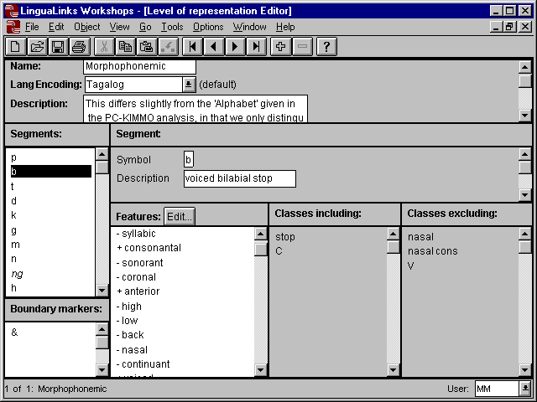
On the left-hand side of the screen, the linguist has defined a set of characters representing phonemes of the language (which happens to be Tagalog). Note that the phonemes are not restricted to single characters; one of the phonemes is represented by the digraph ng, and representations using diacritics are also possible. Having clicked on the phoneme b, the linguist has given it a description, and assigned a set of phonetic features. Elsewhere in Hermit Crab, the linguist has defined a number of natural classes; the two panes in the lower right-hand corner of the window show that the features assigned to b imply that b is included in the natural classes stop and C (consonant), but not in the natural classes nasal, etc. The use of a gray background for these two panes is intended to represent the fact that they cannot be directly altered by the user: the assignment of b to natural classes is derived from the phonetic features assigned to b and to the natural classes. That is, b belongs to the natural class of stops because this class is defined by the feature values [-continuant –delayed release], both of which are also assigned to b.
The user can also define boundary markers, which can be used to separate affixes and stems. While boundary markers have been superceded by other concepts in more recent theories of phonology, they can sometimes be useful in practice.
Several additional views of the mapping between phonemes and features are provided, including a table-based view to allow easy comparison of features among related sounds.

Setting up Strata
Next, the linguist would set up one or more strata to which phonological rules, affixes, and the lexical entries in the lexicon may be assigned. (The lexicon as a whole is assigned to a single stratum, but there is provision for overriding this in the case of lexical entries for unassimilated loanwords, etc.)
For each stratum, the user would also assign one of the tables relating characters to phonetic features which he created in the previous step. It is possible to use a single table for all strata, or separate tables for each stratum. The latter may be appropriate if the user wants to define special segments which are ambiguous for certain features—archiphonemes, for instance.

Setting up Affixes
Hermit Crab uses the lexical entries in the user’s lexical database for affixes, roots, and stems. For roots and stems, the typical lexical entry contains all the information Hermit Crab needs. But for affixes, there is a certain amount of information which Hermit Crab needs, but which the typical lexical entry in a bilingual dictionary does not contain. This additional information is therefore stored in a “computational enrichments” field in the lexical entry. For instance, Hermit Crab needs to know whether an affix is a derivational affix, an inflectional affix, or a realizational affix. (The distinction between realizational affixation and the traditional approach to inflectional morphology was discussed in section 2.4.) Hermit Crab also needs to know what change (if any) a derivational affix makes to the part of speech of a stem to which it attaches, as well as what morphosyntactic features a derivational or inflectional affix introduces, or what morphosyntactic features a realizational affix realizes.
Finally, Hermit Crab needs to know the phonological form of an affix. For prefixes and suffixes, Hermit Crab defaults to the assumption that the underlying form of the affix is simply the citation form, and that it attaches before (or after) the stem without changing the form of the stem itself. The user can override any of this, as well as define a process for affixes other than prefixes and suffixes; examples of more complicated morphological processes were given in section 2.1. Hermit Crab provides a structured editor, shown in the following picture, which makes it easy (or at least easier) to define such morphological rules. The example illustrates a realizational affix, which happens to mark durative aspect in Tagalog; its phonological effect consists of reduplicating the penultimate syllable (CV) of the stem.
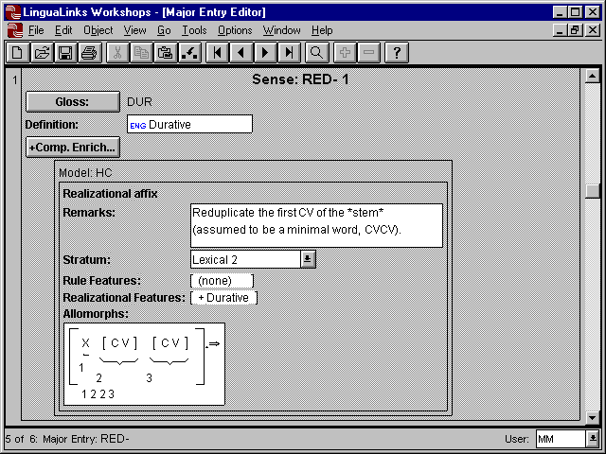
Also shown in the above picture are several other features of Hermit Crab, none of which are actually used for this example. One such capability is that of defining and using “rule features.” A rule feature is a diacritic (exception) feature; that is, a feature which is not phonetically based, but which is none the less important for the morphology (and sometimes for the phonology). For example, many languages have conjugation or declension classes, where words in each of these classes take distinct sets of affixes. The classes can be encoded by rule features which are typically assigned to stems, but in some cases are introduced by affixes (particularly derivational affixes). An affix which belonged to a particular conjugation class would then be marked in the lexicon as requiring that rule feature on a stem to which it attaches.
Another capability not used in the above example, is that of defining “feature variables.” A feature variable represents a phonetic feature, or set of features, which are required to agree in two or more places in the rule, typically between the input and the output of the rule. For instance, in English the prefix in- has several allomorphs, among which are -, -, and - (the latter is not distinguished in the orthography, of course). The prefix un- does not have any such allomorphs. One way to capture the difference between these two prefixes would be to assign the point of articulation features (such as coronal, back and high) to a feature variable in the in- prefix, such that the point of articulation features of the nasal and a stem-initial consonant were required to agree. The un- prefix, on the other hand, would simply attach the string un- to the beginning of a word, making no use of feature variables.

Creating Phonological Rules
In addition to defining affixes, the linguist will often wish to define phonological rules. While these may be allophonic rules, more typically (at least in the context of doing morphological analysis), these will be ‘deeper’ rules, such as morphophonemic rules.
The following picture shows an example of the phonological rule editor:
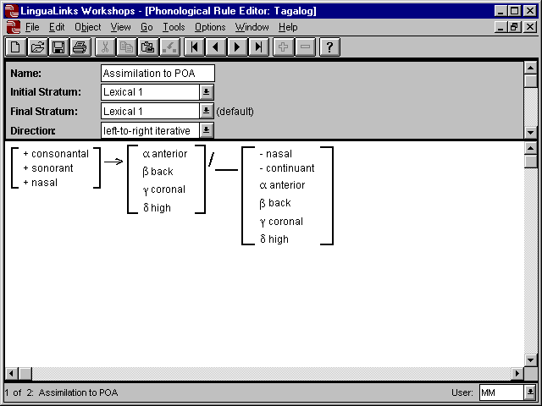
The rule in question assimilates a nasal consonant to the point of articulation of a following obstruent. Note the use of feature variables in this example to indicate the assimilation: the Greek letters (alpha, beta…) are used as variables of those features. Thus, the output of the rule assigns to a nasal consonant whatever value the features coronal, back, anterior and high have on the following obstruent.
Hermit Crab allows other views of such a rule. For instance, it is possible to ignore such individual features as consonantal and nasal, and to instead display just the natural classes which those features define, as shown in the following picture:
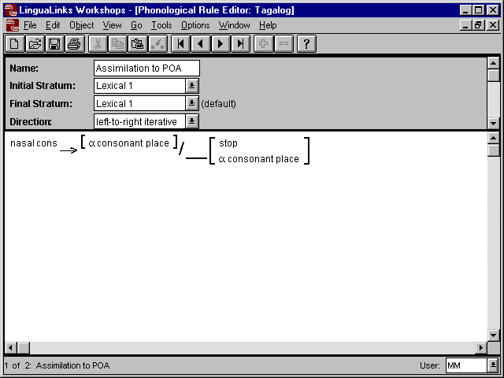
In this view, the natural classes nasal cons and stop are shown in place of their component feature values. Similarly, the feature variable consonant place is shown. Recall that a feature variable represents one or more features which must agree wherever the feature variable appears in the rule. In this example, the linguist has defined the feature variable consonant place as a set of four features, namely coronal, back, anterior and high; the individual features of this set must agree in both places the feature variable appears.

Debugging the Analysis
Probably every linguist who has used a computer to test a grammatical analysis has come away from the experience with a deeper understanding of the grammar. The down side of this is that no matter how long one has studied a language, one’s first attempt at modeling a grammar is likely to be wrong. Grammars are more complicated than we as linguists can reason through in our heads. Accordingly, a computer grammar model must provide tools to debug the grammar. For derivational models of morphology and phonology, one such tool is a derivation tracer: a tool which shows each step in the derivation. If one is parsing complete words (surface forms) into their component morphemes (or a stem and a set of affixation processes), it is possible to trace the steps the computer went through in analyzing the word into its constituents. However, this may be more confusing than enlightening, particularly if there are numerous dead ends in analysis, or if there are ambiguities. Instead, it is usually easier to explore a derivation beginning with a known stem and set of affixes, since the derivation (as opposed to a parse) will be more or less unambiguous.
Hermit Crab allows both kinds of traces: parse traces, which begin from a surface form and show the steps followed in analyzing it; and derivation traces, which begin with a stem and affixes, and show the steps followed to yield a surface form. The following picture illustrates a derivation trace produced by running Hermit Crab:
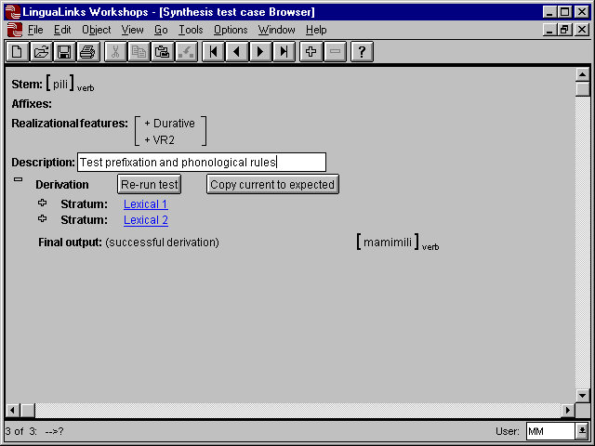
This example illustrates the attachment of a two affixes to the verb stem pili. The derivation is shown as an outline, with certain portions of the derivation collapsed for ease of viewing. The analysis uses a two strata (called ‘Lexical 1’ and ‘Lexical 2’). The affixes to be attached are inflectional affixes, and rather than being specified explicitly, they are determined by the set of inflectional features to be realized ([+Durative +VR2]), in accordance with the theory of Realizational Morphology. (If the affixes were derivational affixes, they would be specified explicitly, and would then appear after the label ‘Affixes’.) The last line shows the final output, the verb mamimili.
In the following screenshot, the user has decided to look more closely at what happens in each stratum, and has therefore slightly expanded those portions of the outline. (The user has also scrolled the display down slightly, so that what appeared near the top of the previous screen is no longer visible.) The ‘Stratum input’ and ‘Stratum output’ are now shown for each of the two strata. Because the affixes dealt with here are treated as realizational affixes, no ‘ordinary’ affixes are attached, hence the ‘(none)’ after the label ‘Affix applications’ in each stratum. However, in the first stratum (‘Lexical 1’), an inflectional affix template does apply, and this portion of the derivation is therefore represented by an outline point, here unexpanded (as indicated by the large ‘+’ sign to the left of the label ‘Template application’). Likewise, the first stratum has several phonological rules, whose application is represented by another outline point. In the second stratum (‘Lexical 2’), there is another template application (represented by yet another outline point), but no phonological rules (hence the ‘(none)’ after the label ‘Phonological rule applications’).
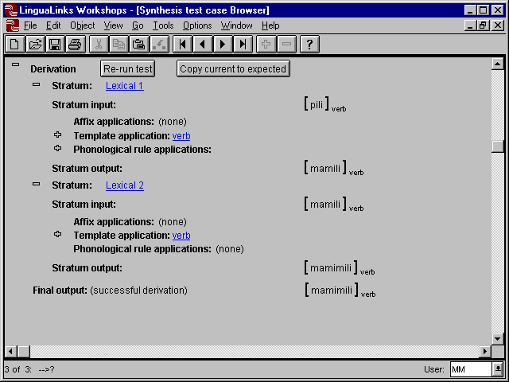
In the next illustration, the user has opened the two outline points in the first stratum to show the application of that stratum’s affix template and phonological rules:
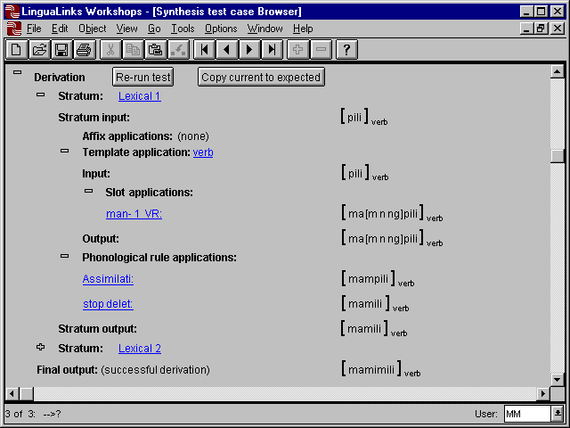
For the template application, the input and output of the template are shown, between which appears the application of the slots of the template. (In this example, there is only one such slot.) The attachment of the prefix maN– has been triggered by the feature [+VR2]. The form of this prefix is represented in the morphological rule of its lexical entry as ma followed by a nasal consonant with an unspecified point of articulation. There are three nasal consonants in the Tagalog encoding used here: m, n, and ng. Since a nasal consonant with an unknown point of articulation could correspond to any of these, Hermit Crab represents the ambiguity as a list of the three possibilities, enclosed in square brackets: [m n ng]. Thus, the output of the affixation process, as well as that of the template as a whole, is given as ma[m n ng]pili. The ambiguity is only resolved by the application of the phonological rule of ‘assimilation’ (the rule shown earlier in this article; note that the rule name is truncated to ‘Assimilati’ in the picture above), as shown under the ‘Phonological rule applications’ in the above screenshot. This rule assimilates the nasal consonant to the point of articulation of the following p, thereby resolving the ambiguity, and giving as output the form mampili. The application of the other phonological rule of this stratum, ‘stop deletion’, deletes the p, resulting in the final stratum output mamili.
In the second stratum, another realizationally-triggered affix applies to give the final output mamimili. The details of the application of the second stratum are not shown here, but would be revealed by expanding the outline point for that stratum.
Had there been an error in the above derivation, in the sense that the final output was not the expected form, the linguist could locate the problem by examining such a derivation trace. If the problem is that an affix or a phonological rule did not apply as desired, the editor for the particular affix or rule can be immediately called up by clicking on the underlined names of the phonological rule or affixes, which thus function as a sort of hypertext link to the appropriate editing tool.
Alternatively, if the problem were that a rule needed to be added, or the order of the rules needed to be changed, then the user can bring up the editor for the overall analysis, and either add a rule or re-order the existing rules. The tool for doing this is shown in the following picture:
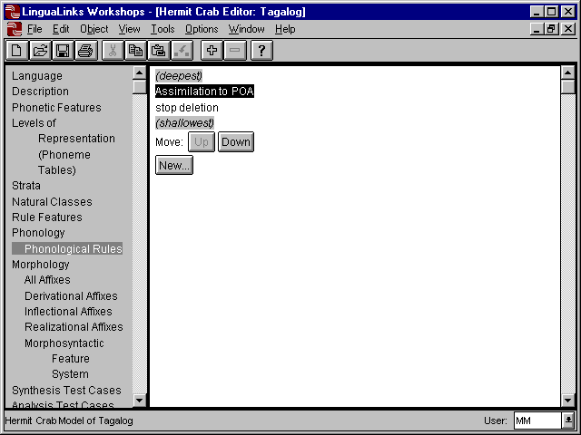
In this editor, the user has clicked in the left-hand pane on the topic ‘Phonological Rules’, and the right-hand pane displays the list of rules the linguist has defined for Tagalog. In the right-hand pane, the rule that applies first in derivation order (‘Assimilation to POA’) is shown at the top, and the rule which applies last (‘stop deletion’) is shown at the bottom. The user has selected the first rule, which can be re-ordered in the list of rules by clicking on the ‘Down’ button (since the first rule can’t be any higher in the derivation order than it already is, the ‘Up’ button is grayed out). Clicking on the ‘New…’ button would insert a new rule after the selected one, and launch an editor for it.
Hermit Crab is an interactive system, not a batch system (although it can be run in batch mode, for instance in processing ‘ptext’, as described in section 6). The fact that it runs in interactive mode means that the linguist can make most changes to the grammar without stopping to reload the grammar. For instance, modifications to a phonological rule, reordering of rules, and changes to lexical entries are made to the running system as soon as the user makes a change in an editor. The interactive nature of such changes is only blocked if the user changes something which requires reloading the entire grammar and lexicon. For instance, a change to the features assigned to a phoneme, or a change to the phonetic feature system itself, will require reloading the entire lexicon (because the lexical entries are stored internally to Hermit Crab in a feature-based representation, not a character representation). When changes are made that require reloading the entire grammar into Hermit Crab (a process which can take several minutes if the dictionary is large), the system so notifies the user. If the user elects to go ahead with the change, the grammar is unloaded from Hermit Crab, and the user can reload it after completing in LinguaLinks whatever edits are required.
Context sensitive help is available everywhere in Hermit Crab (and elsewhere in LinguaLinks), using the ‘Help’ menu at the top of the screen, or by right-clicking on an object and choosing the ‘Help’ item from the pop-up menu.

Sliding Scale Morphology
At first glance, using Hermit Crab to do morphological analysis might seem a daunting task. The use of feature-based phonological rules to derive allomorphy is not something which many—perhaps most —field linguists are comfortable with. Nor is classical generative phonology taught today as a viable linguistic theory. How does the linguist start out using Hermit Crab, if he is not already comfortable with these approaches?
The general problem of creating a morphological analysis from scratch has been a topic of discussion over the last year or so among linguists and linguistic programmers in SIL. The terms “Sliding Scale Morphology” and “Stealth-to-wealth parsing” have been used to refer to the notion of a parsing system which is useful starting from the stage at which the field linguist knows very little about the morphology (or syntax) of a language, and which grows in its capability as the linguist’s understanding of the language being analyzed grows. The idea, then, is:
- to make it easy for the linguist to begin using a parser;
- to make it easy for the linguist to fill in details of the grammar analysis as he comes to understand the language better; and
- to encourage the linguist to add depth to the analysis in order to avoid such tedious tasks as manual disambiguation.
The last point may require some clarification. Consider a field linguist who is analyzing a previously unstudied language, English. The linguist would observe that there are three homophonous suffixes –s: one marking the plural on nouns, one marking the third person singular on verbs, and another suffix marking possessives. Suppose the user has not yet indicated which part of speech each of these suffixes attaches to. Each time the parser finds a word in interlinear text which can be analyzed as a stem + s, it will present the user with three analyses, one for each suffix. Eventually the user will grow tired of doing manual disambiguation. At this point, either the program becomes too cumbersome to use, or it provides the user with an easy way to automate the disambiguation. Suppose the user is looking at the word speaks. The plural and possessive parses are impossible, the user realizes, because speak is a verb, while the plural and possessive suffixes attach only to nouns. The user therefore tells the computer this, with the result that (1) the grammar has become more accurate, and (2) disambiguation has become more automatic. This simple example glosses over a number of issues, but suffices to give an idea of how a grammar development system can encourage the user to improve the accuracy and depth of an analysis.
While acting as such a “sliding scale” morphological analyzer was not one of Hermit Crab’s original design goals, it is of interest to see to what extent this notion is supported in the current system.

The first step in using Hermit Crab is to choose a phonetic feature system for the phonemes of the language, as these are represented in whatever orthography the user has chosen. This requires the user to create a table of all the phonemes, and to distinguish each of them using the feature system. Several feature systems are supplied with Hermit Crab, so this step is mainly a case of choosing one of these feature systems, and then deciding whether a particular phoneme is voiced, consonantal, strident, etc. If the user is unsure of the meaning of a particular feature, on-line definitions are available.
Hermit Crab initially assumes a single stratum, to which all lexical entries in the lexicon belong. As the user discovers prefixes and suffixes, these are automatically loaded into Hermit Crab, along with stems and roots; most of these will be supplied in the early stages of analysis from the user’s hand-glossed interlinear texts. At present, Hermit Crab requires the user to tell it what category of stem each affix attaches to, but this restriction could be relaxed to allow attachment to a stem of any category.
In languages which have long sequences of inflectional affixes, the affixes typically attach in a fixed order. (The same cannot be said for derivational affixes, whose order may instead be dependent on the category of the stem to which they attach, to the stratum to which they belong, or to their scope with respect to other affixes.) Likewise, certain sets of inflectional affixes may be mutually exclusive (affixes marking person/ number of the subject, for instance: a verb cannot take both a first person subject affix and third person subject affix at the same time). The use of templates to define slots of mutually exclusive affixes, and the order in which these slots attach to a stem, was discussed in section 2.4, and defining such templates is quite easy. However, in order to distinguish among the affixes of a given slot, Hermit Crab requires the use of morphosyntactic features, which some linguists may be uncomfortable with. At the moment, making it easier to discover what morphosyntactic features are relevant to a particular language’s inflectional morphology is a matter for research. Also, Hermit Crab does not presently have an across-the-board method to change from a traditional view of inflectional affixes (using feature percolation) to a realizational view of inflection, but such a method could be programmed in.
Accounting for allomorphy is another task which becomes necessary in most languages. When the linguist tackles allomorphy, there are two directions which could be taken initially: either write allomorphy rules for each affix exhibiting allomorphy, or choose underlying forms for each such affix and write phonological (morphophonemic) rules to derive the allomorphs. Most field linguists will doubtless choose the former path, since it will usually be easier at first to define the conditioning environments for each morpheme individually than to generalize across all morphemes and their allomorphs. Thus, the user will write phonological constraints on the environments in which each allomorph attaches, using the notation shown in section 2.1. The user can also encode in such allomorphy rules any changes which attachment of an affix causes to the stem. While this is not simple, it is hard to see how it could be much simpler; and the linguist who wishes to postpone writing generative phonological rules (and determining their order of application) can do so.
Finally, the linguist may be faced with non-concatenative affixes, particularly infixes or affixes of reduplication. While there can be complications, the typical situation is that such affixes are fairly straightforward: an infix is attached after the first consonant or before the last consonant, etc.; a reduplicant often consists of a CV or a CVC copied from the adjacent part of the stem, or a fixed phoneme plus a copy of part of the stem. At least with these simple kinds of non-concatenative morphology, the rules are not too complicated to write. (See for instance the example of a reduplicative prefix in section 2.1.) And if there are variants—prefix something to a vowel-initial stem, but infix it to a consonant-initial stem, for instance—these are readily handled by the same sorts of allomorphy rules discussed in the previous paragraph, or they can often be treated by making part of the morphological rule’s input template optional.
In summary, while it cannot be said that building a morphological grammar with Hermit Crab is simple, the process may not be as daunting as it at first appears, and it may well turn out to be simpler (and more linguistically satisfying) than analyzing morphology with other computational systems. Moreover, there is an “upgrade” path: if the linguist finds he has written identical allomorphy rules for a number of different affixes, it is possible to replace those allomorphy rules with single underlying forms and one (or more) general phonological rules.

Limitations of Hermit Crab
Many of the limitations of Hermit Crab have been described in sections 2 and 3. Perhaps the most important of these are the fact that Hermit Crab cannot do autosegmental phonology, nor does it have any concept of metrical structure. Both autosegmental and metrical phonology are possible future enhancements, although it may turn out to be difficult to implement a parsing algorithm for these theories. (Generation using autosegmental and metrical phonology, that is going from an underlying form to a surface form similar to what STAMP does, would not be too difficult.)
In the area of morphology, Hermit Crab’s morphosyntactic features are flat: there is no provision for one feature having another feature as its value. This may be a limitation for languages in which verbs agree with both their subject and their object. What one would like to do in such a case is to have a morphosyntactic feature structure like the following:
Subject | [person 1  number PL]
Object | [person 2  number SG]
A work-around here would be to have features like this:
subject_person | 1
subject_number | PL
object_person | 2
object_number | SG
Hierarchical morphosyntactic features will probably be a future enhancement.
Compounding and incorporation has not been implemented, but would not require much additional programming.
Cyclic rule application is not currently supported, but would be simple to implement (although it would slow down the parsing process when used). Implementing strict cyclicity might be more difficult, as this constraint was never completely formalized (Cole 1995, Mohanan 1995).
The speed of the parsing algorithm is probably not an issue, at least with the current system. The actual parsing of a word takes on the order of one tenth to several tenths of a second on an 80486/66 running under Microsoft Windows, depending on the number of lexical entries for stems, and the number of affixes and phonological rules. If tracing is turned on, parsing is slowed down somewhat, although typical times are still under a second. However, this speed is not always apparent to the user, as the user interface takes significantly longer to interpret and display the results: on the order of several seconds, or as much as ten or twenty seconds if tracing is turned on (these times are on a Pentium-class processor). The user interface speeds may be significantly improved if Hermit Crab is ported to the Santa Fe system, as described in the next section.
Finally, Hermit Crab should be considered an experimental system at this point. While I have tested it on a typologically wide variety of language data, I am painfully aware of the fact that bugs are still lurking, waiting to trip up users. Anyone planning to use Hermit Crab should check with me (Mike_Maxwell@sil.org) or the LinguaLinks development team (Academic Computing) for any patches which may be available.

Future Directions
Priorities in the further development of Hermit Crab depend on the development of a user community. Overcoming some of the limitations discussed in the previous section would be high on the list of things to do: hierarchical morphosyntactic features, compounding and incorporation, and autosegmental and metrical phonology are all possible enhancements (with autosegmental phonology being the most difficult).
At present, Hermit Crab cannot use or produce “ptext,” which is a file format intended for easy transfer among CARLA programs (Simons 1996). Modifying Hermit Crab to produce ptext would not be difficult; modifying Hermit Crab to use ptext files produced by AMPLE might be more difficult, because of the radically different concepts of morphology these two programs represent. (For instance, AMPLE produces a left-to-right morphological analysis, while Hermit Crab expects an “inside-out” analysis, i.e. an analysis which begins with the root or stem, regardless of the existence of prefixes.)
Software development in SIL’s Academic Computing department is now targeted at the development of the Santa Fe suite of programs, rather than at LinguaLinks as it currently exists. Porting Hermit Crab to the Santa Fe suite will require reprogramming Hermit Crab’s user interface, which would take time, but would also offer a number of advantages. Not the least of these is speed, since it would probably be possible to avoid the translation between the parser’s output and LinguaLinks. This translation involves converting Hermit Crab’s internal structures into text, and then parsing the text representations into the different structures used in LinguaLinks. This translation phase is the biggest bottleneck in the process at present.

References
Anderson, Steven R.. 1992. A-Morphous Morphology. Cambridge Studies in Linguistics 62. Cambridge: Cambridge University Press.
Aronoff, Mark. 1976. Word Formation in Generative Grammar. Linguistic Inquiry Monograph One. Cambridge, MA: MIT Press.
Chomsky, Noam; and Morris Halle. 1968. The Sound Pattern of English. New York: Harper and Row.
Cole, Jennifer. 1995. “The Cycle in Phonology.” Pp. 70-113 in Goldsmith 1995.
Di Sciullo, Anna-Maria, and Edwin Williams. 1987. On the Definition of Word. Cambridge, MA: MIT Press.
Goldsmith 1995, John A. (editor) The Handbook of Phonological Theory. Cambridge, MA: Blackwell Publishers.
Grimes, Joseph E. 1983. Affix Positions and Cooccurrences: The Paradigm Program. Dallas: SIL.
Harris, Zellig S. 1951. Structural Linguistics. Chicago: University of Chicago Press.
Hockett, Charles. 1954. “Two models of grammatical description.” Word 10: 210-231. Reprinted in Joos (1957), pages 386-399.
Hyman, Larry M. 1975. Phonology: Theory and Analysis. New York: Holt, Rinehart and Winston.
Joos, Martin (editor). 1957. Readings in Linguistics I. The Development of Descriptive Linguistics in America 1925-56. Chicago: University of Chicago Press.
Kaisse, Ellen M., and Patricia A. Shaw. 1985. “On the theory of Lexical Phonology.” Phonology 2: 1-30.
Kenstowicz, Michael. 1994. Phonology in Generative Grammar. Blackwell Textbooks in Linguistics 7. Cambridge, MA: Blackwell.
Kenstowicz, Michael, and Charles Kisseberth. 1979. Generative Phonology: Description and Theory. New York: Academic Press.
Lieber, Rochelle. 1980. “On the Organization of the Lexicon.” Ph.D. dissertation, MIT; published 1981 by the Indiana University Linguistics Club.
Matthews, P.H. 1972a. Inflectional Morphology: A Theoretical Study Based on Aspects of Latin Verb Conjugation. Cambridge Studies in Linguistics 6. Cambridge: Cambridge University Press.
Matthews, P.H. 1972b. “Huave verb morphology: some comments from a non-tagmemic viewpoint.” IJAL 38: 96-118.
Maxwell, Michael. 1996. “Two Theories of Morphology, One Implementation.” Pp. 203-230 in Proceedings of the 1996 General CARLA Conference. Dallas, TX: SIL. Also available as http://www.sil.org/silewp/1998/001/SILEWP1998-001.html.
McCarthy, John J., and Alan S. Prince. 1997. “Faithfulness and Identity in Prosodic Morphology.” Rutgers Optimality Archive report ROA-216-0997. (http://ruccs.rutgers.edu/pub/OT/TEXTS/archive/216-0997/216-09972.ps).
Mohanan, K.P. 1986. The Theory of Lexical Phonology. Dordrecht: Reidel.
Mohanan, K.P. 1995. “The Organization of the Grammar.” Pp. 24-69 in Goldsmith 1995.
Schane, Sanford A. 1973. Generative Phonology. Prentice-Hall Foundations of Modern Linguistics Series. Englewood Cliffs, NJ: Prentice-Hall.
Simons, Gary. 1996. “PTEXT: A format for the interchange of parsed texts among natural language processing applications.” Pp. 383-402 in Proceedings of the 1996 General CARLA Conference. Dallas, TX: SIL.
Weber, David J.; H. Andrew Black; and Stephen R. McConnel. 1988. AMPLE: A Tool for Exploring Morphology. Occasional Publications in Academic Computing Number 12. Dallas: Summer Institute of Linguistics.
Weber, David J.; Stephen R. McConnel; H. Andrew Black; and. Alan Buseman. 1990. STAMP: A Tool for Dialect Adaptation. Occasional Publications in Academic Computing Number 15. Dallas: Summer Institute of Linguistics.
Wilbur, Ronnie. 1973. The Phonology of Reduplication. Ph.D. dissertation, University of Illinois; published by Indiana University Linguistics Club.
Zwicky, Arnold M. 1985. “How to describe inflection.” BLS 11: 372-386.

* I am thankful to Andy Black for his helpful comments on an earlier version of this paper.
AMPLE is described in Weber, Black and McConnel (1988), and STAMP is described in Weber, McConnel, Black and Buseman (1990). In addition to its synthesis (generation) capabilities, STAMP also has some transfer capabilities, e.g. reordering morphemes between a source language and a target language. Hermit Crab does not deal with transfer.
The term “Item and Process Morphology,” as originally used by Hockett (1954), referred to a theory in which affixation was a process of modifying a stem, as opposed to the simple concatenation of morphemes. The term has also been used for theories in which a word may be modified from its ‘underlying form’ by phonological (morphophonemic) rules.
Hermit Crab is a separate application running under Microsoft Windows, and communicates with LinguaLinks via the Windows “DDE” messaging protocol. In theory, one could build the rules and other necessary structures using any text editor, then run Hermit Crab from another application which supports the DDE protocol. This is not recommended, as it is very difficult to write rules in the correct format without the structured editor facilities provided by LinguaLinks, and next to impossible to interpret the debugging information without the special display facilities of LinguaLinks.
Version 3.2.0 (1 October 1998) of AMPLE allows for creating reduplicative allomorphs automatically, using a notation related to Hermit Crab’s. Those allomorphs are stored internally to AMPLE, whereas in Hermit Crab, the reduplicant is created on the fly. Because phonological rules may modify the reduplicant apart from the base (or the base apart from the reduplicant), Hermit Crab allows the reduplicant to differ in phonological form from the portion of the base, something which is still not easily done in AMPLE.
This example is merely illustrative, and not intended to represent the appropriate analysis of this English affix. Since several other affixes and a clitic behave in a similar fashion, a better analysis might postulate a single underlying form, together with phonological rules to generate the allomorphs.
Blocking works both in parsing and in generation. Thus, if the incorrect form * appears in a text, Hermit Crab will report failure to parse it (assuming the appropriate lexical entries and rules).
Again, this example is merely illustrative; the putative morphosyntactic feature animate has little or no role in English morphosyntax.
The term “slot” is used here in the sense of a set of mutually exclusive affixes which fill some general morphosyntactic role, but which need not all appear in the same position relative to the stem (although they generally do). For instance, one affix of such a slot might be an infix, while another was a prefix.
Autosegmental phonology has since replaced classical generative phonology; I will return to the question of what it would take to implement autosegmental phonology in a parser in section 22.
The phonetic features relevant in a given language are often referred to as “distinctive features,” since they serve to distinguish the sounds of that language. I will continue to use the descriptive term “phonetic features,” to distinguish these features from morphosyntactic features and from rule (exception) features.
By “distinguished level,” generative phonologists meant a level which had some special properties, as structuralist phonologists claimed for the phonemic level. In classical generative phonology, the phonological rules are applied in linear order, with the output of each rule being a sort of level by itself. The important point was that none of these intermediate representations resulting from the application of phonological rules had any important properties which distinguished it from any other intermediate representation.
Actually, a given phonological rule could apply in more than one stratum, provided that all the strata in which a given rule applied were adjacent.
Perhaps the most important difference was that lexical phonology did not adhere to the principle of “bi-uniqueness,” because a segment at the phonetic (surface) level could be ambiguous between two segments at the post-lexical level. For instance, if a language had word-final devoicing, the phonetic segment p could come from either b or p at the post-lexical level. Such a situation in structuralist phonology would be equivalent to saying that [p] could be an allophone of either the phoneme /p/ or the phoneme /b/ at the phonemic level, which was ruled out under that theory.
“Morphological rules” is more general than “affixes,” because compounding and incorporation may also be included by the former term.
Hermit Crab does not currently implement the notion of cyclic rule application, commonly used in lexical phonology. Adding cyclic rule application would not be difficult; see section 5.
Since Hermit Crab represents sounds internally by their feature composition, not by the orthographic (or other) characters used to represent them, the character representation of words needs to be unambiguously translatable into a feature-based representation. This would be a problem for an orthography like that of English, but for the orthographies most field workers deal with, this is not an issue.
The fact that allophonic rules were intended to be applied simultaneously can be deduced from the fact that the environment of the rules was phonemic, not phonetic (Harris 1951, section 7.31 is one of the few explicit discussions of this requirement, but it appears to have been the general practice). Structuralist phonologists’ expositions were also consistent with the idea that each individual rule applied simultaneously to an entire word, rather than iteratively. The status of morphophonemic rules in the grammar was uncertain, hence the question of whether they were ordered was even more uncertain.
Actually, a directed acyclic graph, which is a potentially more complicated structure than a tree.
Derivational autosegmental phonology, in which the grammar consists of a series of rules, has in turn been largely superceded by declarative approaches, of which the chief is Optimality Theory. While it is too early to be certain, it appears that it would be computationally difficult to implement a parsing algorithm for Optimality Theory.
Sometimes referred to as “alpha variables.”
Again, this example is only intended for illustration. Another, and perhaps better, way to capture this difference would be to assign in- to a deeper stratum, and un- to a shallower stratum, with a phonological rule of assimilation applying only in the deeper stratum. The rule would also need to create the other two allomorphs of in-, namely - and -, as well as account for the default form of - found with vowel-initial stems.
Because of the nature of generative phonology, the representation of a word being parsed becomes increasingly ambiguous as a sequence of phonological rules is “unapplied.” Hermit Crab displays these ambiguities to the user in a regular expression notation. Ambiguities of analysis also occur whenever an affix is removed, since the removal of an affix may be incorrect (as e.g. the removal of the affix –ing from the word ring would be incorrect). Hermit Crab shows these ambiguities as branching points in the analysis.
A small amount of ambiguity may arise at intermediate steps in the derivation, if the set of features for some underinstantiated segment corresponds to more than one phoneme in the chosen encoding. This will be illustrated in the example in the text, in which the linguist has chosen to represent a Tagalog nasal consonant in an underinstantiated form.
The use of a left-hand pane to list the sorts of information which may be displayed, and the right-hand pane to display the currently selected class of information, resembles many Internet browsers. I am indebted to John Hatton and Randy Regnier for the idea and much of the code of this tool, as well as several other usability enhancements.
The possessive is actually a clitic, but I will ignore this subtlety here.
Since the possessive is a clitic, it can actually attach to verbs as well, as in the person who speak’s idea. But this is rare; for the sake of exposition, I will assume such cases are unimportant.
Most orthographic representations distinguish upper and lower case letters. Since such case distinctions are irrelevant to Hermit Crab, it is possible to use only lower case letters in defining the phonemes, and ‘transduce’ the upper/lower case orthography into a lower case only orthography using the built-in “transduced font” capabilities of LinguaLinks. This is usually sufficient for interlinear glossing, but a more sophisticated method will be necessary for CARLA purposes.
However, it would be easier if there were an automated way to determine the minimal number of slots, and the affixes which belonged to each slot. The PARADIGM program (Grimes 1983) provided that capability, and it should be possible to code the algorithm described there into a morphology workbench.

