

Installing and
Building Apps on a Mac



Dictionary App Builder:
Installing and Building Apps on a Mac

© 2021, SIL International

Last updated: 25 March 2025

You are free to print this manual for personal use and for training workshops.

The latest version is available at
http://software.sil.org/dictionaryappbuilder/resources/

and on the Help menu of Dictionary App Builder.

Contents

1. Introduction 5
2. Installing Dictionary App Builder 5
3. Installing Prerequisites for Android 5
3.1. Java Development Kit (JDK) 6
3.2. Installing Android Software Development Kit (SDK) 7
3.2.1. Downloading the Android SDK packages from the internet 7
3.2.2. Copying the Android SDK files from someone else 10
4. Installing Prerequisites for iOS 10
4.1. Install Xcode 11
4.2. Verify Xcode Installation 11
4.3. Install Transporter 11
5. Testing App in iOS Simulator 12
5.1. Run the iOS Simulator 12
5.2. Installing Additional Simulators 13
5.3. Manually Installing Apps Into The Simulator 13
6. Creating iOS Certificates and Provisioning Profiles 13
6.1. Enroll in the Apple Developer Program 13
6.2. Create Signing Certificate 14
6.3. Create Provisioning Profile 15
7. Building an iOS App 16
8. Testing an iOS App 20
9. Using Xcode to Test an iOS App 20
10. Using DeployGate to Test an iOS App 21
10.1. Creating a DeployGate Account 21
10.2. Uploading Your First App 21
10.3. Registering a Device 23
11. Uploading an iOS App to Apple App Store 29
12. Using Test Flight to Test an iOS App 30
13. Building from Terminal 31
13.1. Installing Command Line Interface 31
13.2. Command Line Interface Options 31

Introduction
This document provides information on how to install Dictionary App Builder and build apps on an Apple macOS system. It is possible to build an Android app using DAB on Windows, Linux or Mac, but if you want to build an iOS app for the iPhone or iPad, you will need to build it using a Mac computer.

App Builder  Platform | Build  Android Apps | Build  iOS Apps
Windows
Linux
macOS

Creating an Android app on a Mac is essentially the same process as it is for Windows or Linux. To create a corresponding iOS app, you will need to enter a few more configuration items.
The apps generated by DAB for iOS will run on iPhones and iPads with iOS 12.2 or higher.

Installing Dictionary App Builder
To install the Dictionary App Builder program files:
- Download the current Mac installer file (dmg) from the DAB website:
http://software.sil.org/dictionaryappbuilder/download/
- Double click on the file within Finder to open the disk image that contains the Dictionary App Builder application.
- Copy the Dictionary App Builder application to your Application folder. This can be done by dragging the Dictionary App Builder icon from the disk image window to the shortcut of the Applications folder in the same window.

Installing Prerequisites for Android
If you want to build Android apps, you need to install the following components on your computer:
- Java Development Kit (JDK)
- Android Software Development Kit (SDK)

Java Development Kit (JDK)
You will need version 17 of the Java Development Kit (JDK) to build apps. We recommend you use Zulu, which is a free distribution of OpenJDK from Azul.
- Go to the Download Zulu Builds of OpenJDK website:

https://www.azul.com/downloads/?version=java-17-lts&os=macos&architecture=arm-64-bit&package=jdk-fx#zulu

There are many downloads on this page, but the above link will filter the ones you see (Java Version: Java 17 LTS; Operating System: MacOS; Architecture: ARM 64-bit; Java Package: Java FX).

- Scroll down the page until you see the downloads under the heading Download Azul Zulu Builds of OpenJDK:

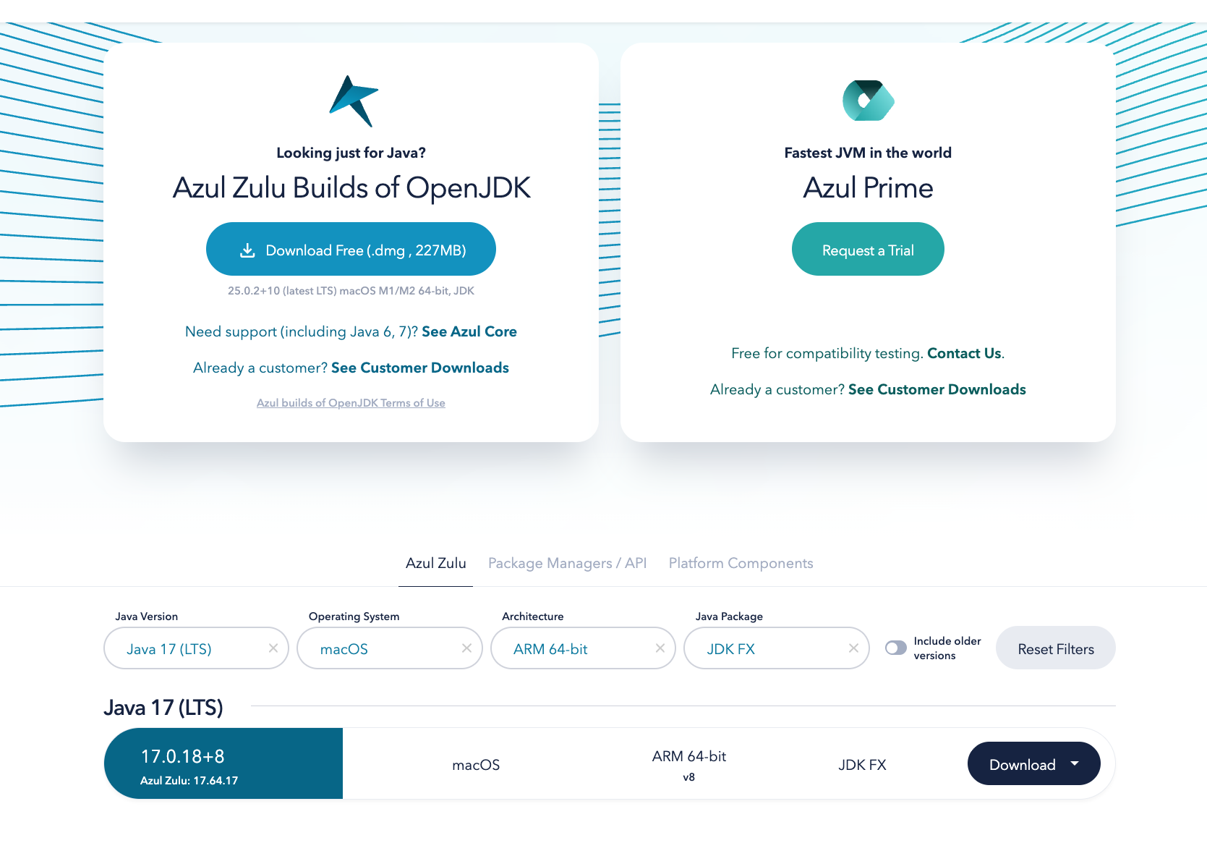

- You have a choice between two different architectures: x86 64-bit and ARM 64-bit. You can find the processor type of your machine by clicking on the Apple symbol at the top left of your screen and selecting About This Mac. If you have an older Mac running with an Intel x86 chip, select x86 (64 bit) otherwise you will need the ARM 64-bit.

Once you have identified your device architecture, you have a choice between a dmg file, a tar.gz file and a zip file. Download the .dmg file since it comes with its own installer program.

The file you download will have a filename something like this:
zulu17.64.17-ca-fx-jdk17.0.18-macosx_x64.dmg
- Double-click the file in Finder and follow the instructions in the installation wizard to install it. By default, the installer will install the JDK to the following folder:

/Library/Java/JavaVirtualMachines/zulu-8.jdk/Contents/Home

Important: If you change the JDK install folder to something other than the default folder, you will need to remember the location of the folder so you can tell Dictionary App Builder where to find the JDK.

Installing Android Software Development Kit (SDK)
The Android Software Development Kit (SDK) is needed for building Android apps. There are two ways of installing the Android SDK:
- Online: Download the Android SDK packages from the internet:
Use the Android SDK Installation wizard to download and install the command line tools and three additional packages. This method will require an internet connection.
See 3.2.1 for more details.
- Offline: Copy the Android SDK files from someone else:
If you know someone who has already downloaded and installed the Android SDK, you can copy all the files from them.
This method is especially useful in a training workshop where several people need to install the SDK but have limited internet bandwidth.
See 3.2.2 for more details.

Downloading the Android SDK packages from the internet
To install the Android SDK from the internet:

- Launch Dictionary App Builder.

- Select Dictionary App Builder Ø Preferences from the main menu.

- Go to the Android SDK tab, which is the second tab.

- Click the Install Android SDK button.
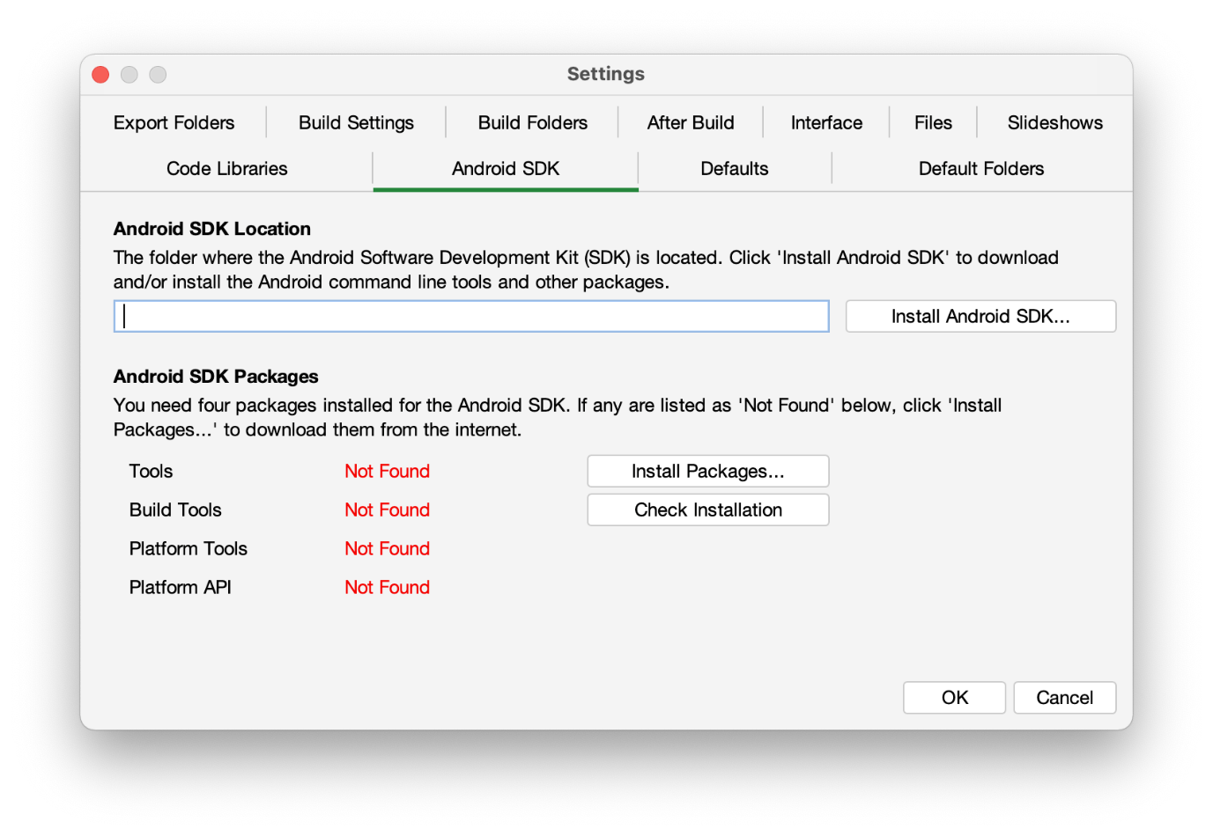

- Follow the instructions on each page of the Install Android SDK wizard to download each of the Android SDK packages and install them.

When you are asked to specify a target folder, a good place is:
/Users/your-name/Android-SDK.

Four packages will be downloaded and installed:
- Command line tools,
- Build Tools,
- Platform Tools, and
- Platform API.

If the installation was successful, you will see the version numbers displayed in green.
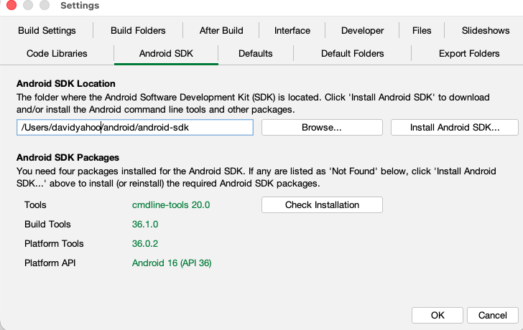

If any of the Build Tools, Platform Tools or Platform API is listed as “Not Found” (displayed in red), click the Install Packages button to install them.

Click the Check Installation button to confirm that all the packages have been installed correctly.

You can skip section 3.2.2 and go straight to section 4.

Copying the Android SDK files from someone else
If you know someone who has already downloaded and installed the Android SDK and is successfully building apps with it, you can copy all of their Android SDK files to a folder on your computer.
You need to look for the top-level Android SDK folder, such as /Users/user-name/Android-SDK, and copy the whole folder and its contents to your computer. A location such as /Users/your-name/Android-SDK is good. If it makes it easier, you can zip the folders and then unzip them onto your computer.
Note that there is no setup program to run. Copying the files from one computer to another is sufficient.

Tip: A typical Android SDK folder can be quite large (over 1 GB, depending on which additional packages have been installed). To build an app, you do not actually need all of the Android SDK files. If you want to cut down the number of files, here is a list of the essential and optional folders:

Android SDK Folder | Required for building apps?
cmdline-tools (or tools) | Yes
build-tools | Yes (you only need the sub-folder for the latest version)
platforms | Yes (you only need android-30 for now)
platform-tools | Yes
add-ons | No
docs | No
emulator | No, unless you want to use an emulator
extras | No
licenses | Yes
sources | No
system-images | No, unless you want to use an emulator
temp | No

Installing Prerequisites for iOS
If you want to build iOS apps and upload them to the Apple App Store, you need to install the following components:
- Xcode
- Transporter

Install Xcode
Xcode is required to build iOS Apps. To install Xcode, simply search for Xcode in the Mac App Store and install it. Open Xcode at least once to agree to the licensing restrictions and install components.
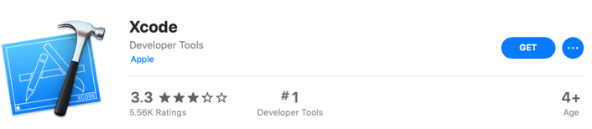

Verify Xcode Installation
To verify that you have successfully installed Xcode and that it is will be correctly used by Dictionary App Builder, please open Terminal and run the following command to print the path to the active developer directory:
xcode-select -p
$ xcode-select -p
/Applications/Xcode.app/Contents/Developer
If you have had Xcode Command-line Tools installed previously, it might still be pointing to that installation directory and Dictionary App Builder will not work correctly.
$ xcode-select -p
/Library/Developer/CommandLineTools
To correct this situation, run the following command to set the active developer directory.
sudo xcode-select -s /Applications/Xcode.app/Contents/Developer

Install Transporter
Transporter is used to upload iOS apps to App Store Connect. To install Transporter, simply search for Transporter in the Mac App Store and install it.

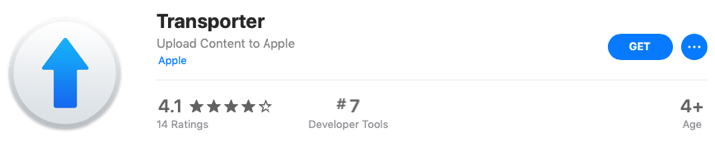

Testing App in iOS Simulator
When you want to test your app, you can either use a device or a simulator. To test with a device, you will need a signing certificate and provisioning profile (see next section). To test with a simulator, you will need to download Xcode, the integrated development environment used to build and test iOS and Mac apps. Xcode is available for free in the Mac App Store and is quite large (5.46GB). DAB requires Xcode 26 or greater (which requires macOS Sequoia). To install:
- Go to https://itunes.apple.com/us/app/xcode/id497799835?mt=12 or search for “Xcode” in the App Store app on macOS.
- Install from the App Store
- Start Xcode at least once to complete the installation

Run the iOS Simulator
Once you have a project configured and ready to test, click on the Run iOS App in Simulator on the toolbar.
Select the simulator you would like to run on and click Start. It takes a little bit of time for the simulator to start. If you want to switch simulators, select a different Simulator from the Simulator Type combo box and click Start again. It will close the previous Simulator and start the new own.
Select the project you want to test (it defaults to the selected project in the Apps list) and click on Build. This will build the app for the Simulator in a separate terminal window. When the build is complete, you can click on Launch to run the app in the Simulator.
You may close the dialog and make changes to your project. When you restart the Run iOS Simulator dialog again, you will need to Build and Launch again for the changes to be included.

Installing Additional Simulators
You may install simulators for previous versions of iOS by launching Xcode and viewing the preferences dialog and selecting the Components tab.

Manually Installing Apps Into The Simulator
If there is some problem with launching the simulator from the Run iOS Simulator dialog, you can manually install the app by dragging the built app from the Simulator output folder (found in ~/App Builder/Dictionary Apps/Sim Output) onto the Simulator.
To start the Simulator, launch Xcode and from the Xcode menu select Open Developer Tool Simulator. You will still need to rebuild the app from the Run iOS Simulator dialog.

Creating iOS Certificates and Provisioning Profiles

Enroll in the Apple Developer Program
To build iOS apps and distribute them through the Apple App Store, you will need to be enrolled in the Apple Developer Program. You can do this as either (i) an individual, or (ii) an organisation. The cost is USD $99 per year.
To enroll:
- Go to https://developer.apple.com/programs/enroll/
- Press the Start Your Enrollment button to start.

Create Signing Certificate
When you create an iOS app, it needs to be signed with a certificate.

To create a certificate:
- Go to the Apple Developer website and log in to your account if you are not already.
- Select Certificates, Identifiers & Profiles.
- Click the button to the right of the Certificates header.
- On the Create a New Certificates page, select Apple Distribution. Then press the Continue button.
- Upload a Certificate Signing Request. Press the Learn more link for instructions on how to use Keychain Access on your Mac computer to complete this task. Then press the Continue button.
- On the Download Your Certificate page, press the Download button to download the certificate (distribution.cer) to your Mac.
- Open the Keychain Access application. Choose the login item from the Keychains section on the left. Choose the File Import Items… menu item and browse to the Downloads folder and select the certificate (distribution.cer).

Now that the certificate is installed in the Keychain, you will be able to access it from within Dictionary App Builder.
Note: To work with certificates, you will need the Apple Worldwide Developer Relations (WWDR) Certification Authority. It should have been installed with Xcode. When viewing your certificate in the Keychain Access application, if there is an error stating the certificate is not trusted, then install the certification authority.
To get the certification authority:
- Download the Apple WWDR Certification Authority from:
https://developer.apple.com/certificationauthority/AppleWWDRCA.cer
For signing certificates created after January 28, 2021:
https://www.apple.com/certificateauthority/AppleWWDRCAG3.cer
- Open the Keychain Access application. Choose the System item from the Keychains section on the left. Choose the File Import Items… menu item and browse to the Downloads folder and select the certification authority (AppleWWDRCA.cer). You will be prompted for a username and password that has admin privileges in order to modify the System Keychain.
- Choose the File Lock Keychain “System” menu item.

Create Provisioning Profile
Distribution provisioning profiles are used to for two primary purposes:
- AdHoc - to install your app on a limited number of registered devices for testing.
- App Store - to submit your app to the App Store.
Creating a provisioning profile
To create a new AdHoc provisioning profile, you will need an App ID and at least one registered device. To create a new App Store provisioning profile, you will need just the App ID.
To create an App ID:
- Go to the Apple Developer website and log in to your account if you are not already.
- Select Certificates, Identifiers & Profiles.
- Select Identifiers on the left of the page.
- Click the button to the right of the Identifiers header.
- Select App IDs and click the Continue button.
- Select App and clock the Continue button
- Enter a Description of your choice.
It can be the App Name from the App Package page of Dictionary App Builder.
- For Bundle ID, choose Explicit and enter your app package name from the App Package page of Dictionary App Builder.
- Leave all the App Services unchecked. None are needed in the app.
- Click the Continue button.

To register a device (i.e. a specific iPhone or iPad for testing):
- Select Devices on the left of the page.
- Click the button to the right of the Devices header.
- In the section Register a Device, enter a name of the device (such as “John Smith’s iPhone”) and its UDID (unique device identifier, a sequence of 40 letters and numbers). Press Continue.
- On the next page, check that the device information is displayed correctly and click Register to confirm.
Note that you can register up to 100 devices of each type (e.g. up to 100 iPhones, 100 iPads) per year of your Apple Developer Program membership. You can remove devices that you no longer need at the beginning of the next membership year.

To create a provisioning profile:
- Select Profiles on the left of the page.
- Click the button to the right of the Profiles header.
- On the Register a New Provisioning Profile page, under Distribution, select Ad Hoc (for testing) or App Store (for submission to the App Store). Click Continue to move to the next page.
- On the ‘Select an App ID’ page, select the App ID from the list of App IDs you have already defined. Click the Continue button.
- On the ‘Select Certificates’ page, select the certificate (Distribution) to include in the profile. Click the Continue button.
- If creating an AdHoc provisioning profile:
On the ‘Select Devices’ page, check the device(s) that you want to be able to install and run the app. Click the Continue button.
- On the ‘Review, Name, and Generate’ page, give the profile a name of your choice. It is helpful to include “App Store” or “AdHoc” in the name. Click the Continue button.
- On the ‘Download and Install’ page, click Download to save your new .mobileprovision file to your computer.
This is the Provisioning Profile file that you will select in Dictionary App Builder.
Download existing mobile provision files
If other members of your team have already created provisioning profiles, there are several ways to download them. They can be downloaded from the App Developer website by selecting the profile to be downloaded and pressing the Download button.

Building an iOS App
To build an iOS app:
- Create a new app project following the instructions in the DAB Building Apps document.
- Select the Signing (iOS) tab to open the iOS signing options for the app.
- Select the Signing Identity from the drop-down list of signing certificates which have been downloaded and installed to this system in the earlier steps.
- For the Provisioning Profile entry, enter or browse to the mobile provisioning file associated with the app that was downloaded in the earlier steps.
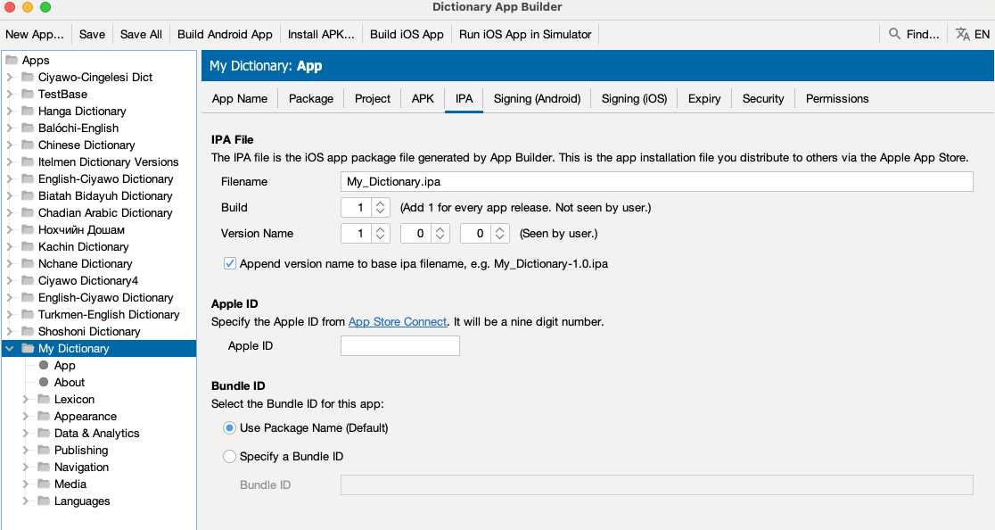

- Click on the IPA tab.
This allows you to set the name of the ipa file to be generated as well as the build and version information.
The Filename field on the screen specifies the base name of the ipa file to be generated. If the checkbox at the bottom of the screen for Append version name to ipa filename is checked, then the version indicated by the Version Name fields is added to the base filename.
The Build field referenced as Build is also called Bundle Version String, Bundle Version or CFBundleVersion within Xcode and ITunes Connect. It represents the build number. The Build field expects an integer value and should be incremented with each file that is submitted to the ITunes Connect for release or testing.
The Version Name field is referenced as Version, Bundle Short Version String, Bundle versions string, short and CFBundleShortVersionString within Xcode and ITunes Connect. The field is created as a concatenation of the values of the three fields separated by a period. If the final field has a value of 0, then the version string is created from just the first two values. So for values of 1, 2 and 0, the resulting string is “1.2”. For values of 1, 2 and 3, the resulting version string is “1.2.3”.
The Apple ID field is the id assigned by App Store Connect to the application in the app store. It can be obtained from Apple ID filed on the App Information tab in the App Store Connect entry for the app.
The Bundle ID section allows the user to specify a Bundle ID for the app that is different than the package name. By default, the Package Name field from the Package tab is used as the Application Bundle ID that is used in creating the provisioning profiles and as the application identifier for the Apple App Store. If the user wants the iOS version of the app to have an identifier that is different than the package name that is used for the Android version of the app, press the Specify a Bundle ID button and then enter the ID to be used in the text box labelled Bundle ID.

- Click on the Build iOS App button at the top of the screen. A terminal window should open. The build script for the iOS app should run within that terminal window.
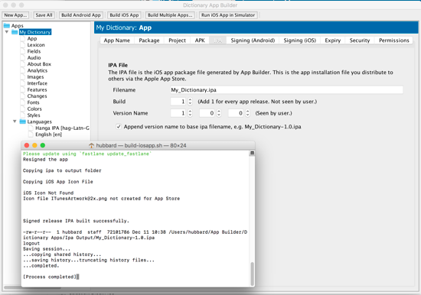
- Examine the terminal window once the shell script has been completed. The message “Signed release IPA built successfully” should appear in the window if the app has been built successfully. (Note that occasionally the terminal window will appear behind the Dictionary App Builder and that you have to select the terminal to review the results).
- The results of the build are an IPA file and an app that can be run in the simulator.
They can be found in ~/App Builder/Dictionary Apps/Ipa Output/ and ~/App Builder/Dictionary Apps/Sim Output/.
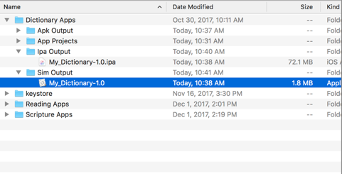

Testing an iOS App
After building the iOS IPA file, you will want to install it and test it on one or more devices before you submit it for publication to the Apple App Store. This manual describes two ways of doing this:

- Use Xcode to install the IPA file to an iPhone or iPad that is connected to your computer.
This method is recommended if you have your test devices with you. It does not involve uploading and downloading the IPA to and from the internet.
- Use DeployGate to upload the IPA file to the internet and share it with limited number of devices to download, install and test.
This method is recommended if you have good internet access and/or you have a team of testers who are elsewhere.

Using Xcode to Test an iOS App
To test your iOS IPA file using Xcode, do the following:
- Launch Xcode and select Window Devices and Simulators.
- Connect an iPhone or iPad to the Mac using a cable and unlock the device.
- On the Mac, iTunes may launch and show a dialog asking “Do you want to allow this computer to access information…” Click on the Cancel button.
  - Note: This feature can be turned off in iTunes. Select iTunes Preferences…, select the Devices tab, and click on the Prevent iPods, iPhone, and iPad from syncing automatically checkbox.
- On the device, it may prompt to Trust This Computer. Tap on the Trust button. This may require to enter the Passcode to trust this computer. The device will show up in the Xcode Devices window.
- The first time the device is connected to the Mac, Xcode will take some time to Prepare debugger support. This may take some time. Please wait.
- In the Xcode Devices window, there will be a section named INSTALLED APPS. Click on the + button.
- Find the IPA file to add. Click Open after you have selected it.
- Click the Install button next to the name of the app.
- Wait until the Mac installs the app to your device.

After the install is complete, you will see the app icon on your device and you can test it.

Using DeployGate to Test an iOS App
DeployGate enables you to test your app and share it with a limited number of users to test. You upload the IPA file for iOS apps or the APK for Android apps and then download them to your phone or tablet device. You can also invite testers to install your app and help with the testing.
A DeployGate app is installed on the testing device. It will show all of the apps that you have uploaded to DeployGate and allows them to be installed on the device.

Creating a DeployGate Account
The first step is to create a DeployGate account. To do this:
- Go to https://deploygate.com
- Press the Get Started button.
- Enter an email address, a user name and a password.
- Press the Sign up for DeployGate button.

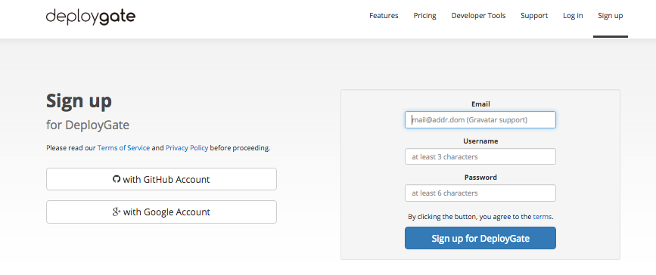

Uploading Your First App
Once the sign in screen has been successfully completed, you are presented with a screen that prompts you to upload your app. While there are several methods described for embedding it as part of your build process, the way we have used this to date is to simply upload the IPA file that has been created by locating the ipa file in Finder and then dragging it to the bottom area of the screen where it has a green Upload App area:
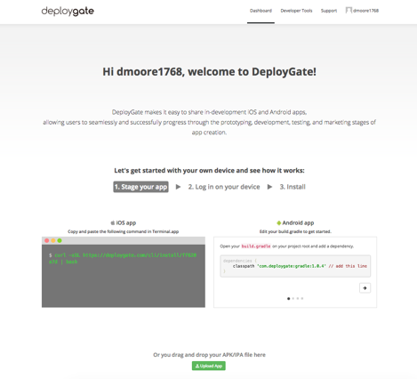
Dragging the file to the upload area causes a new dialog to be displayed with the name of the file and a text box where you can enter a short note that will be displayed on your profile window and also on the DeployGate app when the user is selecting the app. It is a good place to write a short note on the reason for the update so that it is easy for the testers to see that the app has been updated and to see what the primary reason they need to update is. Complete the screen and press the Upload button.

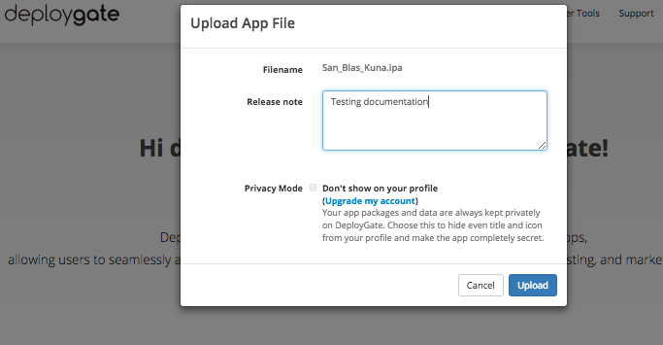

When the upload is complete, a new dialog is displayed with a QCode bar code and the option to send an email to your device. The QCode can be read in with your iPhone or iPad which will trigger an installation of the DeployGate app using your app profile.
Alternatively, you can enter an email address at this point, which you would also open on the iPhone to install the DeployGate app with the correct profile. Or you can simply go on and add users and devices later.
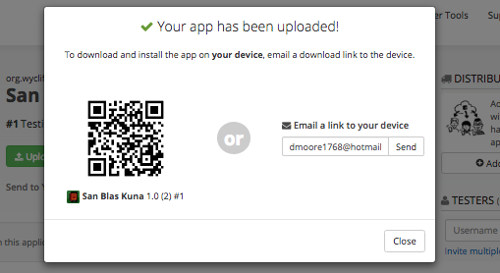
After this, the screen that is displayed is what you will normally see when you login. The screen has an entry for each app that you have uploaded. It has an Upload App button that can be used to upload new versions of the same app or to upload a new app.
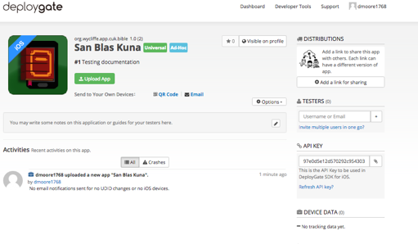

Registering a Device
If the iOS device was not originally in the mobile provisioning profile and if the device has not been previously registered in your Apple Developer account, you need to add it to both. There is a method for manually doing this, but DeployGate provides a way of simplifying the process so that you don’t need to go and look up UDID for the device.
First, try to install the app using the method described above. You will not be able to install it because the UDID is not registered for the app. However this will result in the device being registered in DeployGate which allows the following steps.
After attempting to install the app, re-enter DeployGate in your browser and open the entry for your app. As you can see in the screen below, it will show that a new UDID has been registered for the device. Press the Options button below and select the Package Archive option. Next click the little tag symbol inside the app box to open the UDID list.

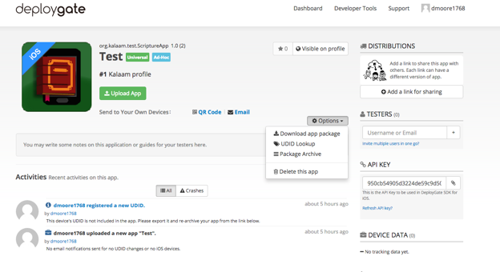
The next screen shows a list of the devices that have been observed by DeployGate or that were included in the provisioning profile. Your new device entry will show up on the screen with a Not Exist entry. Make sure that the entry for the new device is checked and then press the Export Selected UDIDs button. This will create a file “multiple-device-upload-ios.txt” that can be used on the Apple Developer website to add these devices to the mobile provisioning file.

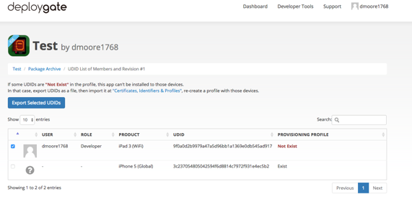
After logging in to Apple Developer, click on Certificates, IDs and Profiles. Press the All selection under Devices as shown in the illustration below and then select Register Multiple Devices. Then press the Choose File button.
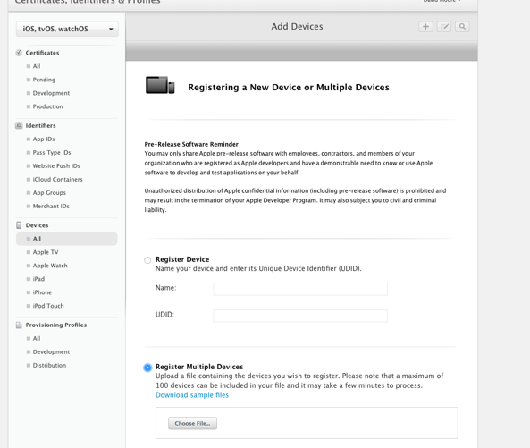
Find the multiple-device-upload-ios.txt file that was created by DeployGate and then press Continue.
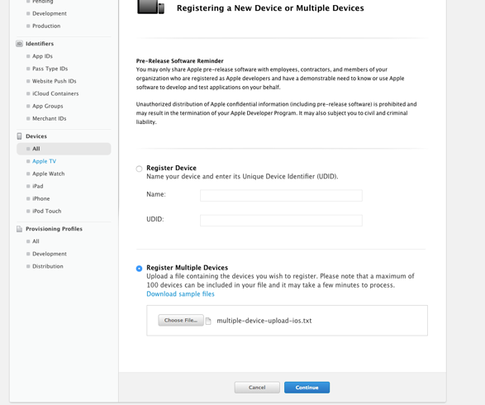

A review screen will be displayed which should list the name to be assigned to the device along with the UDID associated with the device. Review to ensure this is correct and press Register.
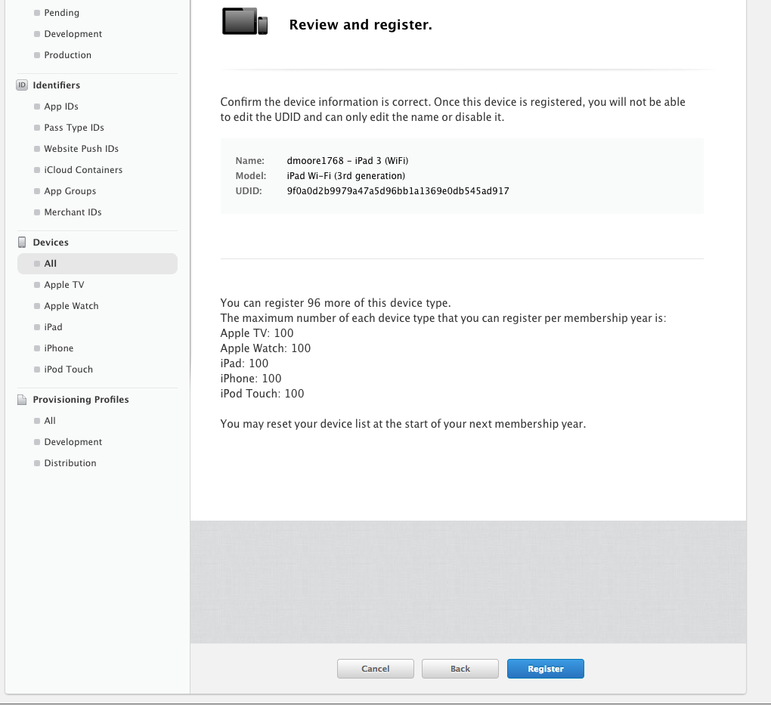

At this point your device has been registered to your Apple Developer account. You now need to add the device to the provisioning profile for your app. Select the provisioning profile being used to test the app. Make sure your test device is checked in the list of devices at the bottom of the screen. Press Generate.
Note: For the purposes of testing with DeployGate, an AdHoc type of provision profile must be created and used. If you have not selected AdHoc, the list of devices will not be available on the screen.
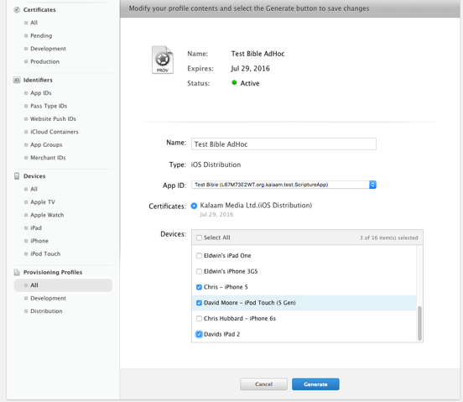

The following screen will display:
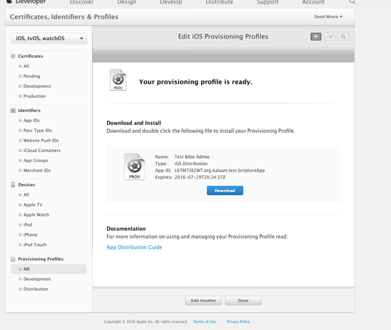
Now you can download the new provisioning profile that has been generated.
Next you need to rebuild the iOS app using the new profile and upload it to DeployGate again. This time when you attempt to install it, the Install button should be enabled and will allow you to install your app.

Uploading an iOS App to Apple App Store
Before attempting to upload the app, you will need to create an entry in App Store Connect (https://appstoreconnect.apple.com).

Select the appropriate distribution Signing Identity and App Store provisioning profile on the Signing (iOS) tab and click Build iOS App. This will create an IPA file in the IPA Output Folder.

Launch Transporter and click Sign In using the Apple ID for your Apple Developer Account. Drag and drop the IPA file from the IPA Output Folder to Transporter. Once the app is added to Transporter, click on the Deliver button. After it is uploaded, you can click on the … button and select View in App Store Connect. Selecting the Activity tab will show the status of the processing of the upload.

Using Test Flight to Test an iOS App
It will take a little bit of time (around 20 minutes) for the app to be processed in App Store Connect. You will receive an email when the app is done processing. Switching to the Test Flight tab in App Store Connect, you will see that app is Missing Compliance.
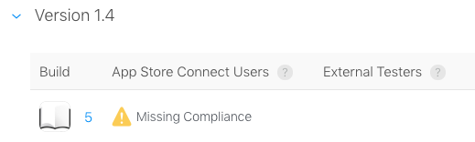
Click on the build number and you will be taken to a page where you can click on Provide Export Compliance Information. The app uses an encryption algorithm to protect the text of the app.

Click Yes to the first dialog that the app uses encryption and then click Next.
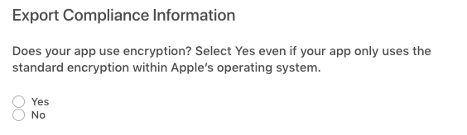
Click Yes to the second dialog to indicate that the app qualifies for an exemption due to (b) Limited to intellectual property and copyright protection and then click Start Internal Testing.
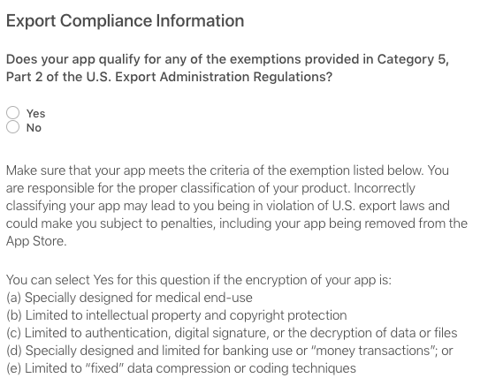
You can add App Store Connect users (normally users in your organization) to test the app. There is a link at the left for Add External Testers. This will require the app to go through Beta App Review.

Building from Terminal
Dictionary App Builder has a command line interface which allows you to create a new app and build it or load an existing app and build it.

Installing Command Line Interface
Choose the Tools Install dab command in PATH menu item to enable the use of the command line interface. You will be prompted to enter your login password to install the command.

Command Line Interface Options
Run the following command to run the Dictionary App Builder application followed by a series of options described below. The command is:
dab
The available parameters are:

Option | Description
-new | Create a new app project
-load <project> | Load an existing app project
-build | Build app project (use with either -new or -load)
-no-save | Do not save changes to app (use with -load)
-resign | Resign iOS Template App (use with either -new or -load)
-? | Show command line help
-n <app-name> | Set app name.  Enclose the name in "double quotes" if it contains spaces.
-p <package-name> | Set package name, e.g. com.myorg.language.appname
-b <filename> | Add book or bundle file. This could be a USFM file or a zipped set of USFM files. It could also be a Digital Bible Library text release bundle.
-i <filename> | Include additional parameters file.  Use the full path of the file and enclose it in "double quotes" if there is a space in the path.
-a <filename> | Set about box text, contained in text file.  Use the full path of the file and enclose it in "double quotes" if there is a space in the path.
-f <fontname> | Set font name or filename, e.g. "Charis SIL Compact", "c:\fonts\myfont.ttf"  The font name must be one of the items in the list of fonts in the New App wizard. For other fonts, specify the full path to the font filename.
-g | Use Grandroid
-ic <filename> | Add launcher icon (one or more .png files).  Use the full path of the files and enclose them in "double quotes" if there is a space in the path.
-l <lang-code> | Set language for menu items and settings, e.g. en, fr, es
-ft <feature=value> | Set a feature, e.g. book-select=grid
-vc <integer> | Set version code, e.g. 1, 2, 3, or +1 to increment the current version code by 1.
-vn <string> | Set version name, e.g. 1.0, 2.1.4, or use +1, +0.1, +0.0.1 to increment the current value.
-ks <filename> | Set keystore filename.  Use the full path of the file and enclose it in "double quotes" if there is a space in the path.
-ksp <password> | Set keystore password
-ka <alias> | Set key alias
-kap <password> | Set key alias password
-fp <folder=path> | Set a folder path, e.g. "app.builder=/Developer/Dictionary App Builder".
-ta <target-api> | Set Target API, e.g. 21 for Android 5.0, 22 for Android 5.1.
-si <signing identity> | Set Signing Identity to use for iOS Resigning
-pp <provisioning profile> | Set full path to provisioning profile for iOS resigning
-bn <integer> | Set build number for ipa file, e.g. 1, 2, 3, or +1 to increment by 1
-vs <string> | Set version string for ipa file, e.g. 1.0, 2.1.4 or +1, +0.1, +0.0.1

Examples:
dab -load "Mali" -resign -bn "5" -vs "2.3.2" -si "iPhone Distribution: Summer Institute of Linguistics, Inc (SIL) (4YF5X97M4H) " -pp "/Users/builder/Documents/MobileProvision/AdHoc_org.wycliffe.app.mali.mobileprovision"

Running the command line with no parameters will start the Dictionary App Builder UI from the command line.

