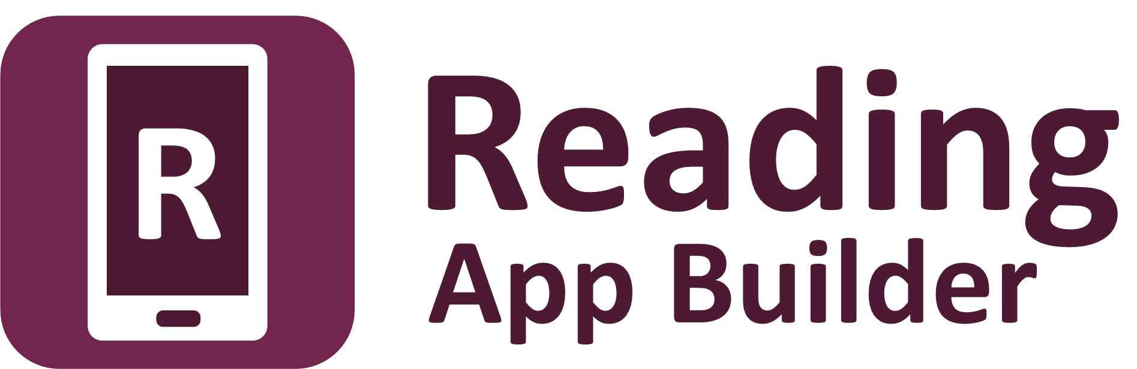

Using Audacity for
Audio-Text Synchronization



Reading App Builder: Using Audacity for
Audio-Text Synchronization

© 2017, SIL International

Last updated: 5 December 2017

You are free to print this manual for personal use and for training workshops.

The latest version is available at
http://software.sil.org/readingappbuilder/resources/

and on the Help menu of Reading App Builder.

Contents

1. Introduction 4
2. Getting Started 7
2.1. Phrase Lists 7
2.2. Installing Audacity 9
3. Producing Timing Files 9
4. Timing Labels Assistant 14
5. Usability Tips 15
5.1. Tip #1: Change the keyboard binding for the spacebar 15
5.2. Tip #2: Change the keyboard binding for adding a label 16
6. FAQ 19
6.1. How can I change the punctuation characters which are recognised as ‘end of phrase’ marks? 19
6.2. How can I get it to highlight section headings? 19
6.3. There are parts of the audio where I don’t want any text highlighted. How can I turn off the highlighting for a few moments? 20
6.4. I’d like to give someone else the task of creating timing files. Is there any way of them testing these without needing to know how to build the app? 20
7. Appendix – How to Install Audacity 22

Introduction

To add audio-text synchronization to apps built with Reading App Builder, you need to create a timing file to go alongside each audio MP3 file. The timing files provide the information the app needs to highlight phrases in the text as the audio is playing.

You can choose between two different methods to create the timing files:
- Audacity: listen to an audio file in the Audacity audio editor and lay down a labels track, placing a label at the start of each phrase.
- aeneas: an automated method of synchronizing text and audio.

This document takes you through the first of these methods: using Audacity to create the timing files. Instructions on the other method can be found in the user manual Using aeneas for Audio-Text Synchronization.

PLEASE NOTE:
Many users of Reading App Builder are finding that aeneas is providing very accurate synchronization results, so we do recommend you try it out.

One timing file for each audio file
To synchronize audio and text in your app, you will need:
- one MP3 audio file and one timing file per chapter, or
- one MP3 audio file and one timing file per picture story book.
For example, if you have a book ‘History of Mali’ with 20 chapters, you will need 20 audio files and 20 timing files. If you have a picture story book with 8 pages, you need a single audio file which covers all 8 pages together with a single timing file.
Example: if you have an audio file for ‘History of Mali’ chapter 1, History_Mali_01.mp3, you need to create a corresponding timing file, e.g. History_Mali_01.txt.
Note: If you have several audio files per chapter or several chapters in one audio file, you will need to concatenate or split your files to create files of one chapter each before creating the timing files. This could be done in Audacity.

Timing files
A timing file for a single chapter will look like this, with a line for the timing of each phrase to be highlighted:
8.252945 8.252945 a
16.401422 16.401422 b
27.235258 27.235258 c
33.809408 33.809408 d
66.545898 66.545898 e
74.952265 74.952265 f
96.749997 96.749997 g
111.571459 111.571459 h
127.398309 127.398309 i
130.636807 130.636807 j
149.545453 149.545453 k
157.938255 157.938255 l
172.479752 172.479752 m
190.809003 190.809003 n
206.453448 206.453448 o
217.292729 217.292729 p
229.985550 229.985550 q

The first and second columns indicate the time in seconds. The third column contains the phrase label (a-z).
For a longer chapter, you will soon run out of letters of the alphabet. When you get to “z”, the next label you need to use is “aa”, then “ab”, “ac”, “ad”, etc. When you get to “az”, the next label you need to use is “ba”, then “bb”, “bc”, “bd”, etc. In other words, this follows a similar naming convention to the column names in a spreadsheet.
Phrases can be between punctuation marks, e.g. up to the next “.” or “,”. You can define the set of punctuation characters that mark the end of a phrase. Individual poetic lines can also be highlighted one by one, for example in a psalm or a song.

A timing file for a picture story book will look like this, with the number representing the page of the book and the letter representing the phrase within that page:
0.000 2.920 1a
2.920 5.840 1b
5.840 10.080 1c
10.080 13.560 2a
13.560 15.260 2b
15.260 17.240 2c
17.240 19.020 2d
19.020 21.540 2e
21.540 24.560 2f
24.560 27.660 3a
27.660 30.060 3b
30.060 32.620 3c
32.620 36.140 3d

Word level highlighting:
If you want to split a phrase after one or more words, you can use word-level highlighting for that phrase. For this, the labels in the timing files should contain an underscore and then the index of the word, e.g.

a_4 starts at the 4th word of the first phrase (a)
b_5 starts at the 5th word of the second phrase (b)
b_9 starts at the 9th word of the second phrase (b)

A timing file with word-level phrase breaks might look like the following example:

3.188682 3.188682 a
7.415084 7.415084 a_4
12.934091 12.934091 a_11
16.746603 16.746603 b
17.356305 17.356305 b_5
18.853311 18.853311 b_9
19.829615 19.829615 c
20.905796 20.905796 d
21.884018 21.884018 e
22.858863 22.858863 f
25.613723 25.613723 g
27.108508 27.108508 h
28.839213 28.839213 i_6
29.158316 29.158316 i_10
30.192832 30.192832 j
31.388587 31.388587 k
32.683989 32.683989 l
36.440027 36.440027 m
38.297624 38.297624 n

Getting Started

Phrase Lists
To help you identify when to mark a timing break, we recommend you create Phrase Lists. These will arrange the phrases line by line for you.

To create phrase lists for each of the chapters in your app:
- Launch Reading App Builder.
- Navigate to the Book Collection page for your app.
- Go to the Audio Synchronization tab.
- Click on Create Phrase Lists and follow the instructions in the wizard.

A set of Word documents (.docx), comma-separated files (.csv) or tab-separated files will be created, one for each chapter.

A phrase list document for a single chapter looks like the following:

Chicken and Millipede 1

a | Chicken and Millipede were friends.
b | But they were always competing with each other.
c | One day they decided to play football to see who the best player was.
d | They went to the football field and started their game.
e | Chicken was fast,
f | but Millipede was faster.
g | Chicken kicked far,
h | but Millipede kicked further.
i | Chicken started to feel grumpy.
j | They decided to play a penalty shoot-out.
k | First Millipede was goal keeper.
l | Chicken scored only one goal.

Each row in the phrase list document represents a separate timing phrase which will need to be marked.

You can define which characters are recognised as phrase ending characters in the Features Audio page of Reading App Builder. By default, it is: a full stop/period (.), a question mark (?), an exclamation mark (!), a colon (:) and a comma (,).

A phrase list document for a picture story book looks like the following:

Chicken and Millipede

1 | Chicken and Millipede were friends.
 | But they were always competing with each other.
 | One day they decided to play football to see who the best player was.
2 | They went to the football field and started their game.
 | Chicken was fast,
 | but Millipede was faster.
 | Chicken kicked far,
 | but Millipede kicked further.
 | Chicken started to feel grumpy.
3 | They decided to play a penalty shoot-out.
 | First Millipede was goal keeper.
 | Chicken scored only one goal.
 | Then it was the chicken’s turn to defend the goal.

Installing Audacity
Install the Audacity sound-editing program if you do not already have it. Please see Appendix: How to install Audacity.



Producing Timing Files

- Launch Audacity.

- Open the MP3 file using File Open on the main menu.

- If the file is stereo with two tracks, it can be helpful to reduce it to mono for this process so it doesn’t take up so much room on your screen. Do this with Tracks Stereo Track to Mono.

- Zoom in a couple of times so it is easier to see the gaps between the audio waveforms.

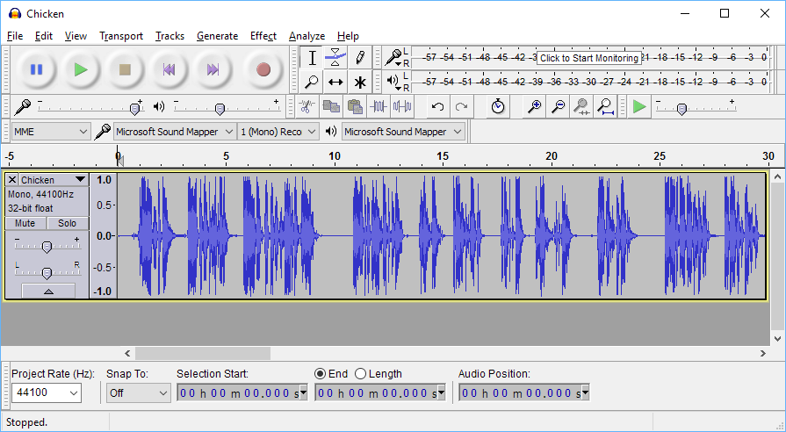

- Have the Scripture text or Phrase List open to the chapter you will be listening to.

You could display the text in a different window (i.e. have Audacity take up the left part of the screen and the Scripture text on the right, or have the screens arranged at the top and bottom of the screen), but this can be awkward since you will need to scroll the text from time to time and then click in the Audacity window to give it focus again. While you are doing this you might lose your place and miss a phrase break. What can work better is if you have a printed text in front of you or if the text is already on a smartphone or tablet. Then you can concentrate more fully on the text and avoid the complication of switching between windows.

- Move the cursor to just before the beginning of the first phrase (i.e. after any titles or chapter headings).

- Place the first label marker using CTRL-B. A label track will be created.

If you are using a Mac, the shortcut to use is Command B.

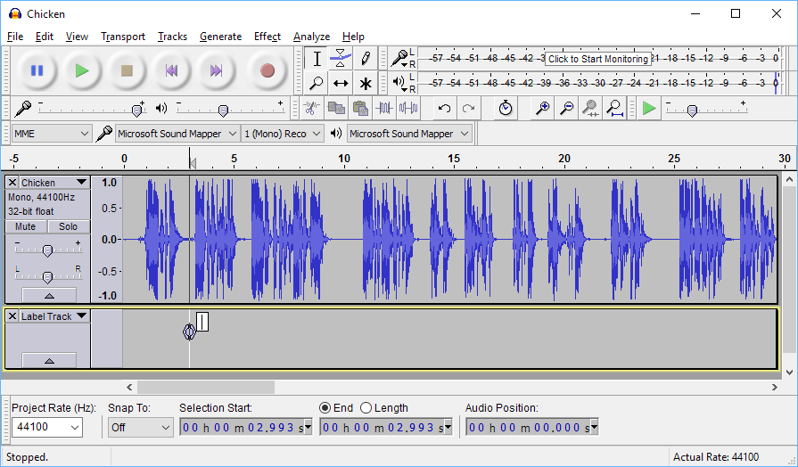

- Type the first label, such as “a”. This indicates that “phrase ‘a’ starts here”. (Look at the phrase list document to tell you which label to use. In the case of a picture story book, the first label will be “1” rather than “a”.)

The cursor should already be in the label, so you just need to press the “a” key after pressing CTRL+B above.

- Press ‘Play’ to start listening to the audio. As you listen, place a label at each timing break using CTRL-M.

You don't really need to look at Audacity for this. Just follow the text closely and keep pressing CTRL-M at the phrase breaks.

If you are using a Mac, the shortcut to use is Command . – that is Command and period (.) together.

 | Windows | Mac
Add Label At Selection  (at cursor position when paused) | CTRL-B | Command B
Add Label At Playback Position  (at current position when playing audio) | CTRL-M | Command .
Default key mappings for adding labels

Usability Tip: Instead of pressing two keys together (CTRL-M) to add a label, it is easier if you reassign the key binding to be a single key, such as F1. See Section 4: Usability Tips for more details on how to do this.

- When you get to the start of a new phrase, type the label while the audio is still playing.

If you are quick, you’ll find there is no need to stop the audio for this. The cursor is in the new label already so all you have to do is type the letters or numbers. If you miss typing a label, you can always come back to it at the end.

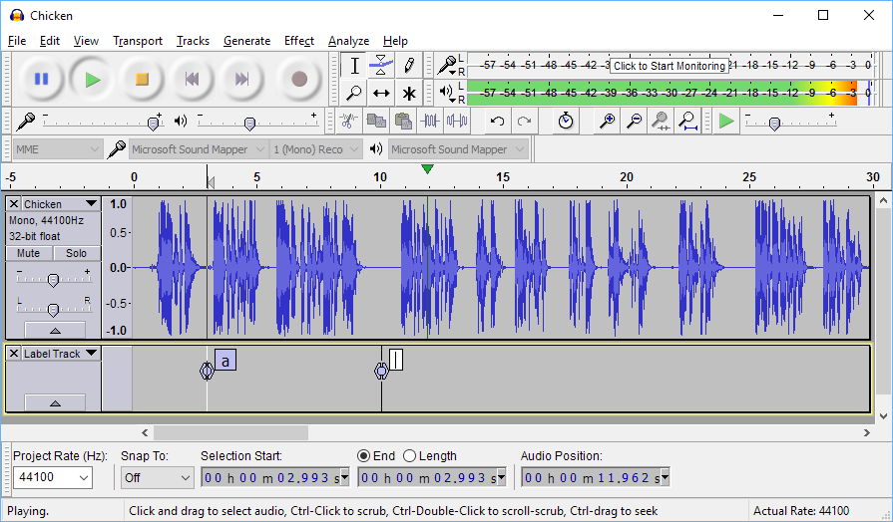

If you lose your way, stop playback, move back a few seconds and press play again.

To delete a label you have placed by accident, press the DELETE key when the label is selected.

- When you have finished placing labels for the whole chapter or picture story book, go back to each label :
  - Move it slightly if you missed the middle of the blank section between phrases. Do this by dragging the circle in the middle of the marker.
  - Type timing labels into the small white boxes in the label track if you didn’t do this earlier.
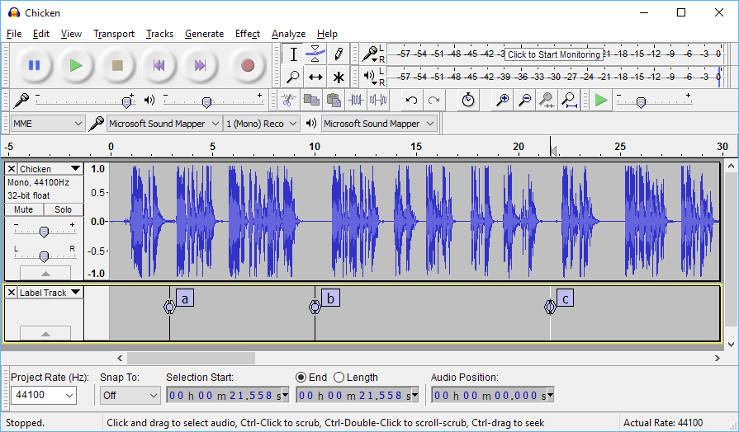

Another way of adding labels is via Tracks Edit Labels... This is an easier way to add timing labels quickly. You can also delete unwanted labels here.
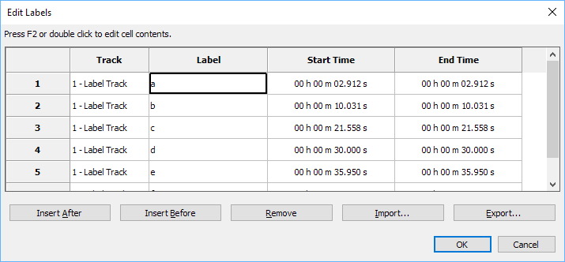

During this process you will be able to see if you have missed out a phrase somewhere or if you have added an unwanted marker that needs to be deleted.

- Export the label track to a text file using File Export Labels... Choose a name such as My-Book-01.txt (for chapter 1), My-Book-02.txt (for chapter 2), etc.

- Open the timing file in a text editor such as Notepad. You should see something like this:

3.188682 3.188682 1
7.415084 7.415084
12.934091 12.934091
16.746603 16.746603 2
19.829615 19.829615
20.905796 20.905796
21.884018 21.884018 3
22.858863 22.858863
25.613723 25.613723 4
27.108508 27.108508
30.192832 30.192832
31.388587 31.388587
32.683989 32.683989 5
36.440027 36.440027
38.297624 38.297624

- The three columns are From, To and Label. Make sure all the timing labels are present. If you have missed out a label somewhere, fix it in the text file or within Audacity and export again.

The timing file is now ready to be used in an app.

Timing Labels Assistant

If you are using Audacity in Windows, there is a helpful utility program that will make marking labels significantly easier. It is called Timing Labels Assistant (TLA).
TLA is built with AutoHotKey to simulate keystrokes in Windows. It allows you to specify a phrases file and will insert the label name (a, b, etc.) for you automatically when you press the key to add the next label.

You can find it here: https://github.com/indiamcq/timing-labels-assistant

Download the zip file, Timing-Labels-Assistant_v1.2.29.zip (or a later version), and unzip it to a writable folder on your computer (i.e. not in Program Files). The main TLA executable is called Timing-Labels-Assistant.exe.

To use TLA:
- Run the Create Phrase Lists wizard within Reading App Builder to create a set of tab-delimited .phrases files for the book chapters you want to synchronize. That’s the 3rd option in the choice of file types.
- Open Audacity with the audio file to be synchronised and zoom into the waveform 2-3 times.
- Launch Timing-Labels-Assistant.exe.
- Choose the .phrases file corresponding to the audio file you have open in Audacity. It will be opened for you in Notepad.
- Arrange Notepad to the side of your Audacity window so you can see both.
- Start playing the audio.
- Press the TAB key or the + key on the numeric keyboard to place a marker. (This much easier than pressing CTRL+M). The markers will appear in the order they are in the .phrases file.
If markers do not appear when you press TAB or +, check that CTRL+M is still associated with the command Add Label at Playback Position. See section 5.2 for more details.
- You will hear a beep when the list of markers comes to an end.

To restart from a given label:
- Click on the icon in the taskbar and select Restart timing at label….
- Enter the label you want to start from, e.g. b.
- Press OK and continue from step 6 above.

To exit:
- Click on the icon in the taskbar and select Exit.

Usability Tips

Tip #1: Change the keyboard binding for the spacebar

By default, the spacebar is assigned to Play/Stop. This is good, but the problem is that if you stop somewhere and then start again, the playback goes back to the original start position rather than playing from where you stopped.

To modify this:

- Go to Edit Preferences Keyboard.
- Select the line Play/Stop and Set Cursor. To find this quickly, type ‘play/stop’ into the Search field at the top.

You are looking for the line that ends with ‘…and Set Cursor’ rather than simply ‘Play/Stop’.

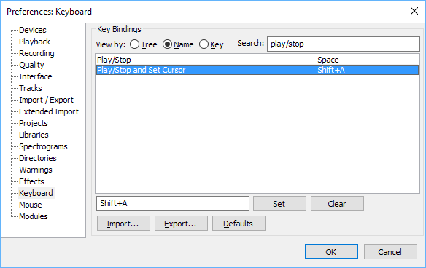

- Change the key binding for this line to Space (rather than Shift+A).

- Press Set.

- You will be asked if you want to make the change. Click OK to do this.

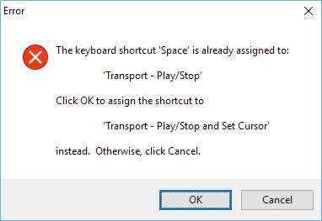

- Click OK to save the changes to the Preferences.

Tip #2: Change the keyboard binding for adding a label

Instead of pressing two keys together (CTRL-M) to add a label, it is easier if you reassign the key binding to be a single key, such as F1. Then you have one hand free to type the labels.

NOTE: This tip is only useful if you are not using Timing Labels Assistant (TLA). If you are using TLA, you need to keep CTRL-M as the key combination to add a label.

To change the keyboard binding for adding a label:

- Go to Edit Preferences Keyboard.
- Select the line Add Label at Playback Position. To find this quickly, type ‘add label’ into the Search field at the top.

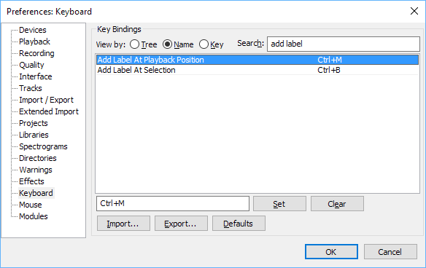

- Type the key you want to use instead of CTRL-M, such as F1.

- Press Set.

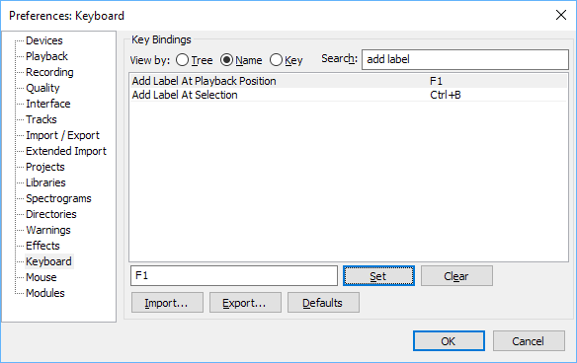

- If the keyboard shortcut you have chosen is already in use for another function, you will be asked if you want to make the change. Click OK to do this.

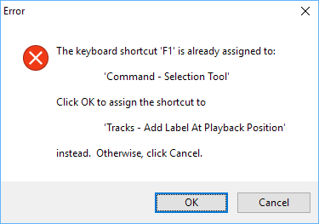

- Click OK to save the changes to the Preferences.

FAQ

How can I change the punctuation characters which are recognised as ‘end of phrase’ marks?

You can define which characters are recognised as phrase ending characters in the Features Audio page of Reading App Builder.

You can add Unicode characters here using the format \uABCD where ABCD is the hexadecimal Unicode code point, e.g. \u061F for an Arabic question mark, \u1362 for an Ethiopic full stop.

How can I get it to highlight section headings?

In some audio files, the section headings are read out by the narrator as well as the main text. To include them in the highlighting, use labels ‘s1’, ‘s2’, ‘s3’, etc., where ‘s1’ is the first section heading, ‘s2’ is the second section heading and so on.

Note that the ‘s’ is lower-case and there is no space between the ‘s’ and the number.

Use this same method for other types of headings, e.g. use ‘d’ as the prefix for \d headings, ‘sp’ as the prefix for \sp headings, ‘is’ for \is, etc.

For section headings in picture story books, add the page number before the label, e.g. 1s1, 1s2, 1s3 for section headings on the first page; 2s1, 2s2, etc. for section headings on the second page.

There are parts of the audio where I don’t want any text highlighted. How can I turn off the highlighting for a few moments?

You might want to turn off text highlighting during musical interludes or sound effects. To do this, you need to give the labels a range, rather than being at a single point.

Here is an example:

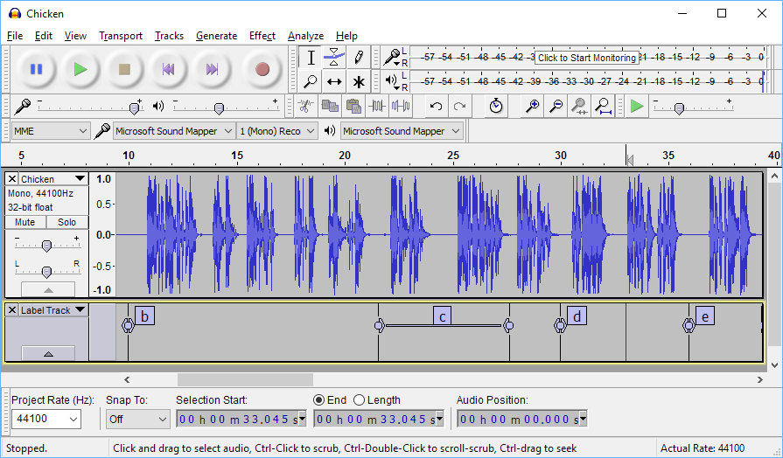

In the above timing file:
- Phrase “b” highlighting will start at the “b” label and end at the beginning of the “c” label (as normal).
- Phrase “c” highlighting will start at the initial point of the “c” label range and continue until the end of the “c” label range.
- Nothing will be highlighted between the end of the “c” label range and the “d” label.
- Phrase “d” highlighting will start at the “d” label.

To create a label range, drag the < or > part of the label marker.

I’d like to give someone else the task of creating timing files. Is there any way of them testing these without needing to know how to build the app?

Yes, if you have chosen Audio Distribution by external folder or download, the MP3 files will be in a folder on the SD card. The app will look for a corresponding timing file in this folder if it doesn’t already have a timing file packaged inside the APK.

The timing filename in this case should be same as the mp3 file, but with the .txt extension rather than .mp3.

So, for example, if you have a file such as My-Book-01.mp3 in the folder, you can put the file My-Book-01.txt in the same place and the app should recognise it.

Using this method, others can work on providing timing files for the app and test them, without needing to rebuild the app. Once the timing files are working, you can rebuild the app and package them inside the apk. They are very small so should not increase the size of the apk significantly.

Appendix – How to Install Audacity

- Download the latest Audacity installation program from the Audacity website:
http://www.audacityteam.org

For version 2.1, the filename is audacity-win-2.2.0.exe. It is 19 MB in size.
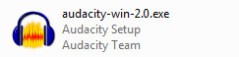
It might be that a newer version than 2.2.0 is available. If so, download this newer version instead.

- Double-click audacity-win-2.2.0.exe to start the installation.

- Select English as the language to use :
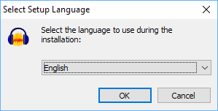

The Setup Wizard opens:
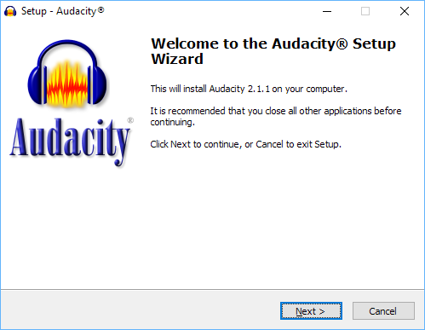
- Click Next to continue.
A page of licence information will appear:
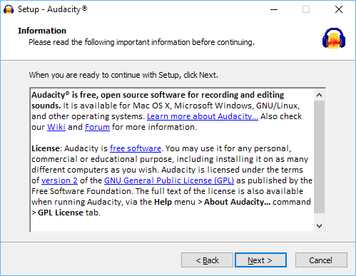
- Click Next to continue.
You will see the page Select Destination Location:
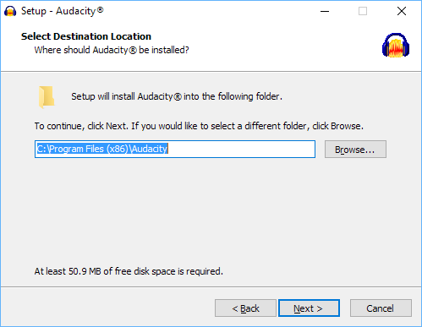
- The suggested location in which to install Audacity is normally fine, so click Next.
You’ll see the Select Additional Tasks page:
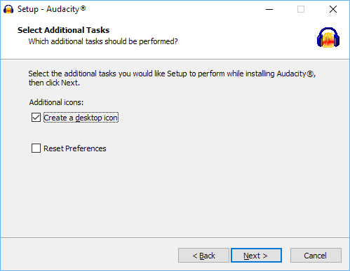
- Click Next to continue.
You’ll then see the Ready to Install page:
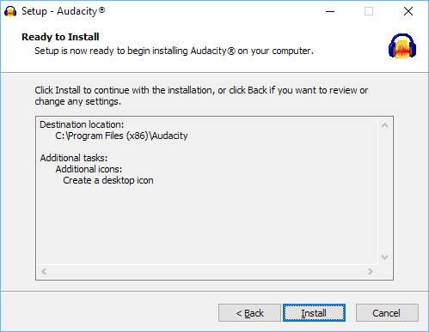

- Click Install to begin the installation.
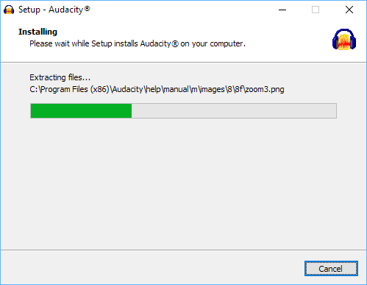
When the installation is complete, you will see a page of information:
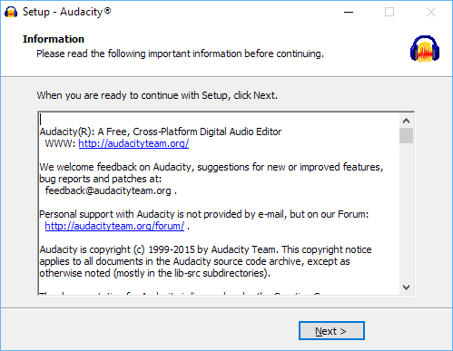

- Click Next to continue.

You will then see the final page of the Setup Wizard:
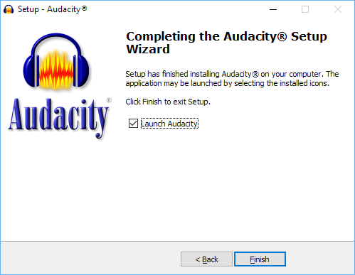

- Click Finish to close the Setup Wizard and launch Audacity.

Audacity is now ready to use.

