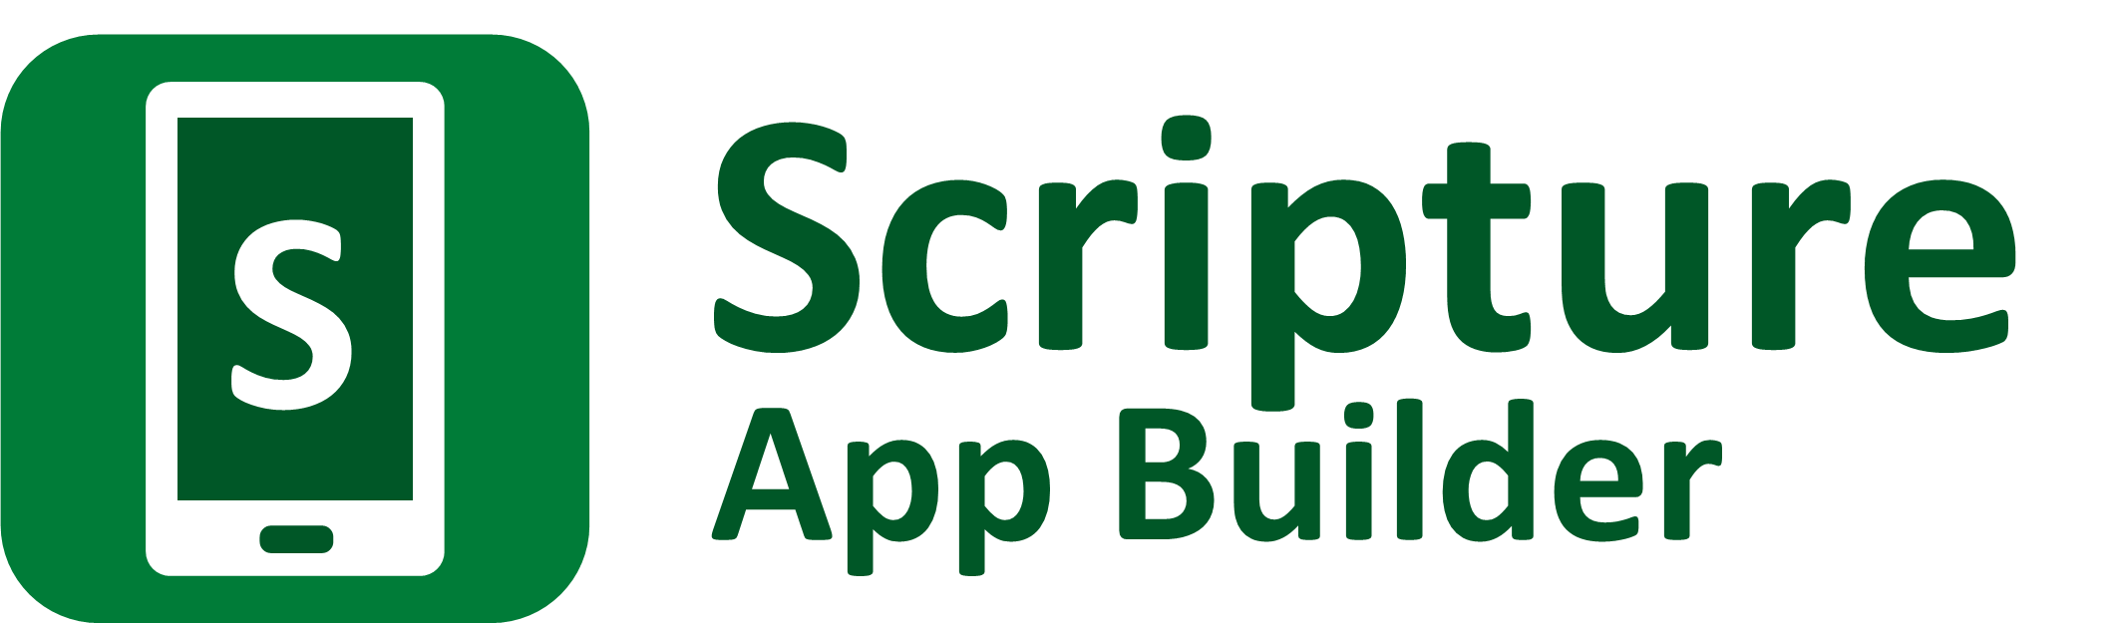

Distributing Apps



Scripture App Builder: Distributing Apps

© 2026, SIL Global

Last updated: 30 January 2026

You are free to print this manual for personal use and for training workshops.

The latest version is available at
http://software.sil.org/scriptureappbuilder/resources/

and on the Help menu of Scripture App Builder.

How to Use This Manual

This guide includes notes and tips to help you get the most out of the software. Notes and tips will appear like this:

Notes:

Users may have to click on a security message to permit the app to install.

Tips:

Provide a variety of options for users to find and install your apps based on the specific needs of the target groups.

Contents

1. Introduction 5
1.1. Checking that your app is ready to publish 5
1.2. Distribution options for Android apps 5
1.3. Distribution options for iOS apps 6
1.4. Advantages and disadvantages of each distribution method 7
2. Publishing apps on Google Play (using the Play console) 10
3. Publishing Apps on the Google Play Store (using Scriptoria) 14
3.1. The Scriptoria tab 14
3.2. The Google Play Store Listing tab 15
3.2.1. Manage Translations 15
3.2.2. Import From Google Play… 15
3.2.3. The Product Details tab 15
3.2.4. The What’s New tab 16
3.2.5. The Screenshots tab 16
3.2.6. High-res Icon 16
3.2.7. Feature Graphic 16
3.3. The Scripture Earth tab 17
3.4. The Publish Properties tab 17
3.5. Republishing an App 17
4. Distributing apps by memory card 17
5. Sharing apps by Bluetooth 18
6. Sharing apps by Wi-Fi transfer 18
7. Other Ways to Share Your App Installer File 19

Introduction

Checking that your app is ready to publish
Before you distribute your app, please use the App Publishing Checklist (available via the Help menu in SAB or on the SAB website) to verify that it is ready to publish.

Distribution options for Android apps
There are several possible ways of transferring Android apps to a smartphone. These include both online and offline options:

Copying an APK (app installer) file directly to a phone (rather than installing from the Play Store) is called side-loading and, though allowed on an Android phone, may cause a warning message to display, asking for the user’s permission to install the file. This warning may be concerning to many users, so you will have to assure them that it’s okay to install.

Online distribution
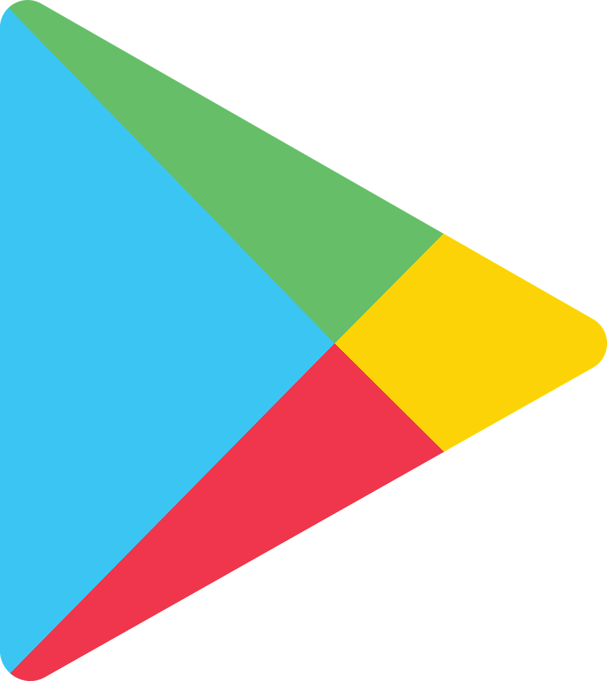 | Google Play | Publish the app on Google Play for people to find and download. This is where most Android apps are distributed.
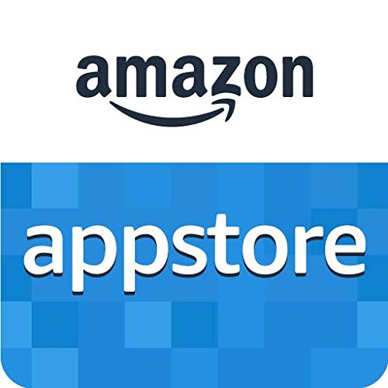 | Amazon Appstore | Publish the app on the Amazon Appstore for people to find and download.
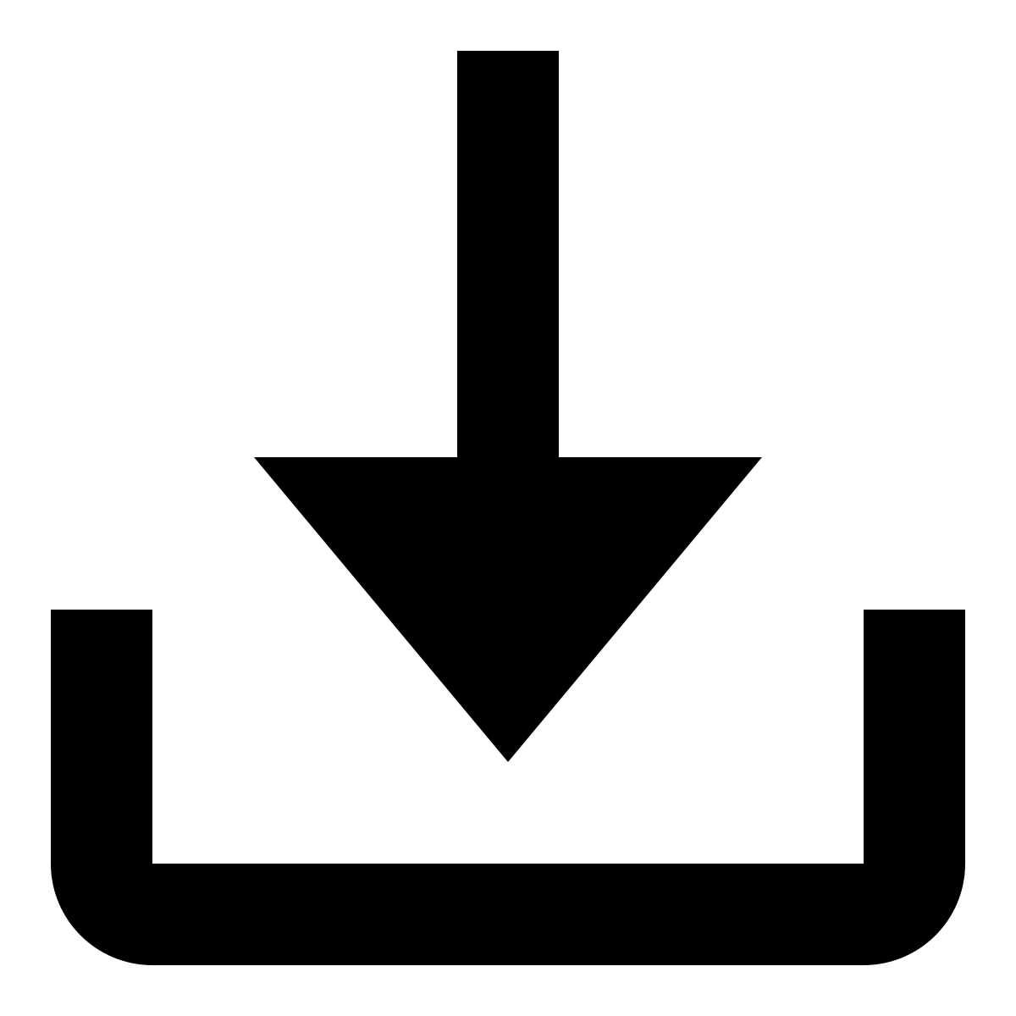 | Web Sites | Post the app installation file (APK) on your website for people to find and download. Once people have downloaded the file, they tap on it to install it.
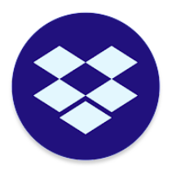 | Cloud Storage (Dropbox, Google Drive, etc.) | Upload the app installation file (APK) to a folder in a cloud storage service (such as Dropbox or Google Drive). Share the link with others. Once people have downloaded the file, they tap on it to install it.
 | Email | Email the APK directly to one or more people. Save the attachment to their phone and tap to install the app.
 | Social Media messaging | Send the APK directly to one or more people. They can tap the link to install the app.

Offline distribution
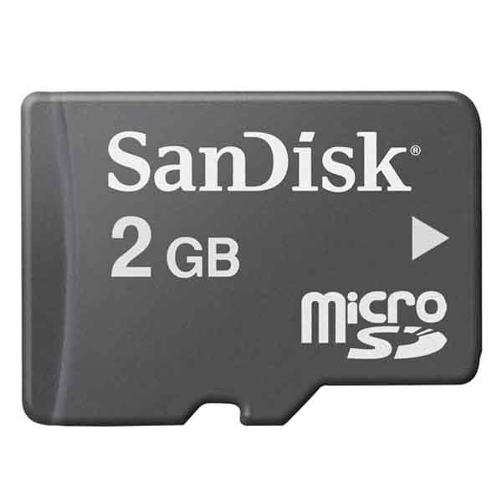 | Memory cards | Copy the app installation file (APK) onto microSD memory cards. People insert the card into their phone’s memory card slot, find the APK file using a file explorer app and tap on the file to install it.
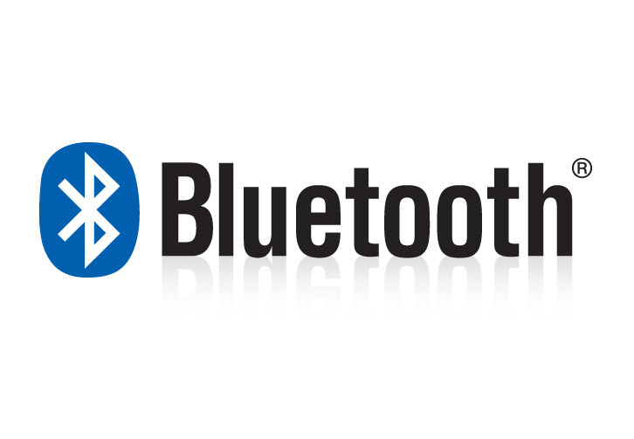 | Bluetooth | Use Bluetooth to transfer the app from your phone to another phone. Once people receive the app installation file (APK) they tap on it to install it.
 | Wi-Fi Transfer App | Transfer the app from phone to phone, like Bluetooth but much faster. Both sender and receiver phones need the same app installed, e.g. Xender, SHAREit or SHAREit Lite.
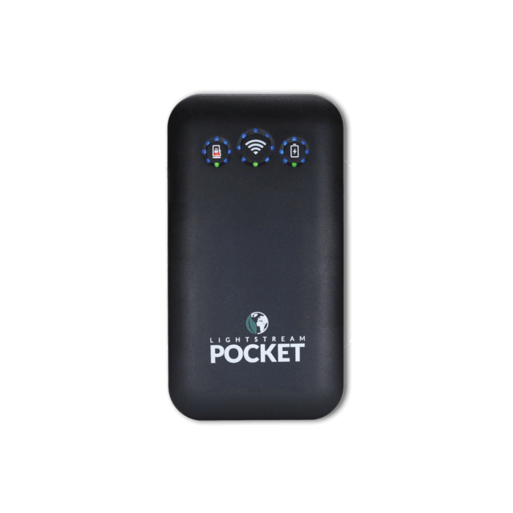 | Wi-Fi Media Box (LightStream, ConnectBox, MicroPi, etc.) | Copy the app installation file (APK) into the memory of a Wi-Fi media box, such as the LightStream, ConnectBox or MicroPi. Users connect to the Wi-Fi device and choose the file to transfer to their phone. Once the file arrives, they tap on it to install it.

Distribution options for iOS apps
For iOS apps, your main option for app distribution is the Apple App Store. You cannot distribute iOS apps from phone to phone offline.

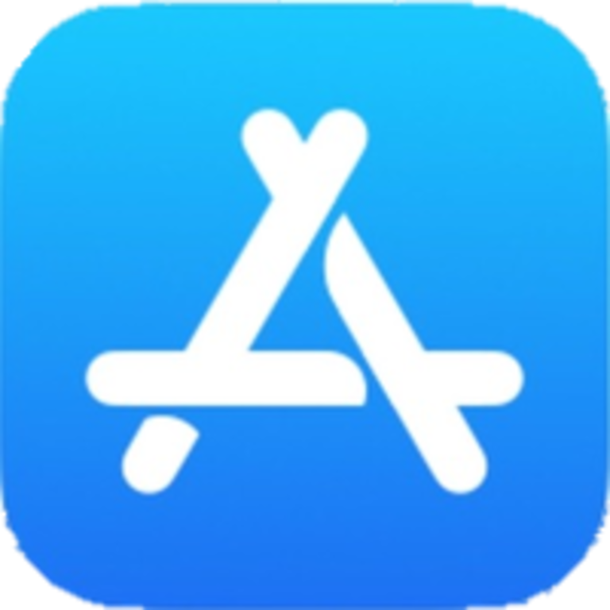 | Apple App Store | Publish the app on the Apple App Store for people to find and download. This is where all iOS apps are distributed.

When you are testing your iOS app, it is possible to share it with a limited number of known devices using Apple Test Flight. For more details on how to do this, please see the documentation on Installing and Building on a Mac.

Advantages and disadvantages of each distribution method
The following table lists some of the advantages and disadvantages of each distribution method.

 | Advantages | Disadvantages
Google Play | Users can find the app by searching on the Google Play store (pre-installed on most Android devices).  If you update the app, users will receive updates automatically next time they have an internet connection.  The Play Store provides worldwide access to your app and is the best way to ensure compatibility with each user’s phone.  Provides automatic security services. No warning messages for non-standard installation. | Requires an internet connection.  If you are uploading the app to Google Play yourself, you need to create a developer account ($25 one-time fee) and learn the publishing process.  The maximum Android App Bundle (AAB) size is 150 MB.  Audio files will often need to be hosted online and so it will cost the user for each chapter of audio they choose to download or stream.  When an app is installed from Google Play, it will be trimmed and repackaged for the user’s specific device. This means that if you want to share it offline with a friend it might not contain all that their device needs.  At least yearly, Google will introduce new API updates that will require updating and reposting the app to the store.  Google occasionally rejects apps without providing much recourse for resolving the issue.
Amazon Appstore | Good for users who like Amazon’s ecosystem  Works seamlessly on Fire tablets and Amazon’s devices | Might be more challenging to publish as the process is more intentionally curated.  Not widely known outside of specific Amazon devices.  Apps may exhibit compatibility issues for certain Google services.
Website download | No restriction on app file size: you can distribute hundreds of MB of audio files and images packaged inside the app. You are not limited to a maximum app size of 150 MB like you would if you published it on Google Play.  Website can be designed to handle multiple languages including the local, target language  Multiple apps / items can be linked to so users can easily find other resources in the target language | Requires an internet connection.  When you update the app on Google Play, users who downloaded the app from a website will not get automatic updates.  It may be challenging for users to copy the APK to their phone, find it and install it.
Cloud Storage  (Dropbox, Google Drive, etc.) | No restriction on app file size: you can distribute hundreds of MB of audio files and images packaged inside the app. You are not limited to a maximum app size of 150 MB like you would if you published it on Google Play. | Requires an internet connection.  When you update the app, users who receive the app from the cloud will not get automatic updates.  Having enough space to host a large number of resources may necessitate a yearly fee.  It may be challenging for users to copy the APK to their phone, find it and install it.
Email | Allows you to share new apps with specific people. | Not recommended if your APK size is over 5 MB.  Some email servers may reject this type of attachement.  Requires an internet connection.  Limited distribution to those you have in your address book.  When you update the app on Google Play, users will not get automatic updates so you will need to email the latest version.
Social Media direct messaging | Allows you to share new apps with specific people.  Very easy for users to see and install the APK file  Allows large APK files | Requires an internet connection.  When you update the app on Google Play, users will not get automatic updates so you will need to email the latest version.  Limited distribution to those you have in your contact list
Memory cards  (microSD) | No internet connection needed.  No restriction on app file size: you can distribute hundreds of MB of audio files packaged inside the app. | Users have to remove their current memory card in order to insert the new one, then copy files from one memory card to the other.  When you update the app on Google Play, users who installed from a memory card will not get automatic updates.  You need a sales/distribution strategy to get the memory cards to people.  People may need direct help in finding and installing the app APK from the card.
Bluetooth | No internet connection needed.  Allows friends to share the app with each other and encourages viral distribution. | When you update the app on Google Play, users who installed by Bluetooth will not get automatic updates.  A slow method if you have a lot of audio files to transfer.
Wi-Fi Transfer  (e.g. with the Xender or SHAREit apps) | No internet connection needed.  Up to 40 times faster than Bluetooth.  Allows friends to share the app with each other and encourages viral distribution.  No restriction on app file size: you can distribute hundreds of MB of audio files and images packaged inside the app. | Both phones need the Wi-Fi transfer app installed.  When you update the app on Google Play, users who installed by Wi-Fi transfer will not get automatic updates.
Wi-Fi Media Box (LightStream, ConnectBox, MicroPi, etc.) | No internet connection needed. | Requires specialist equipment, not always available locally.  When you update the app on Google Play, users who downloaded the app from a Wi-Fi media box like Lightstream will not get automatic updates.

Publishing apps on Google Play (using the Play console)
Publishing an app yourself through the Play Console is the most direct, hands-on method, but may also be more complicated.
You may find it easier and more efficient to use SIL’s Scriptoria publishing service (see the section below). For more info on the different ways to publish to the Play Store, see Publishing App Store App Publishing under your app’s project in SAB.

Note also that Google often changes the exact steps for app publishing, so the steps below may not be up to date.

To publish an Android app on Google Play:

- Select Build Build Android App Bundle from the menu in Scripture App Builder to build an Android App Bundle (an .aab file).
This is a different format from the APK file that you use for offline distribution.
To publish your app on Google Play, the AAB file size must be no more than 150 MB.

- Go to the Google Play Console:
https://play.google.com/apps/publish

- Create a new account or login with an existing Google account.
If this is the first time you do this, there is a one-time fee of USD $25 to create a Google Play developer account.
Note: If you are publishing an app on behalf of an organisation rather than you personally, we strongly recommend you create a new Google account for this purpose rather than using your personal Gmail account.

- Click the Create app button at the top right of the screen.

- Enter the App name (which should be your app’s project name) and the default language. Specify App (rather than Game) and Free (rather than Paid).

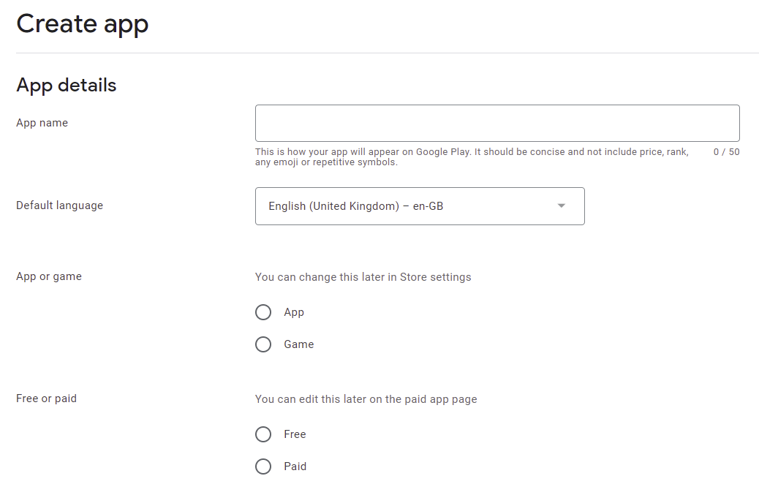

- Read and check the declarations to confirm that the app meets the terms and conditions.

- Click to accept US export laws.

- Select Monitor and Improve > Policy and Programs > App content. Under Privacy policy, click Start Declaration and provide the URL to your app’s privacy policy. Click Save.

- Select Monitor and Improve > Policy and Programs > App content. Under Ads, click Start Declaration. Click No, then Save.

- Select Monitor and Improve > Policy and Programs > App content. Under App access, click Start Declaration. Select the appropriate radio button based on your app features. Click Save.

- Select Monitor and Improve > Policy and Programs > App content. Select Content Ratings and Start Declaration. Select the appropriate ratings and click Save.
- Click Create app at the bottom of the page.

- Select Grow Store presence Main store listing from the menu on the left of the screen, and enter the following details:

App Details
- Short description of the app (up to 80 characters)
- Full description of the app (up to 4,000 characters)
  - These descriptions should describe the app clearly to the target audience in the most appropriate language(s). Mention the country and alternative language names to increase the chance of users finding the app when they search on Google Play.
Google encourages you to “highlight what's great about your app. Share interesting and exciting facts about your app to help users understand what makes your app special.”
You must not include user testimonials, excessive details or long lists of keywords. See https://play.google.com/about/storelisting-promotional/metadata/ for more details.

Graphics
- App icon (512 by 512 pixels)
  - This should be the same as the app icon but a higher resolution 512 x 512 version. Ensure it is clear and not blurred, i.e. it might not work well to take a 144 x 144 icon and stretch it to 512 x 512.
- Feature graphic (1024 by 500 pixels)
  - The feature graphic is displayed at the top of your store listing page in the Play Store app. Do not include any copy or important visual information near the borders of the image - specifically near the bottom third of the frame. Try to center align any logo or information in the vertical and horizontal center of the frame.
- Phone Screenshots
  - Take screen captures from your phone when running the app. The way to do this differs from phone to phone: try pressing the Power and Volume down buttons simultaneously or the Home and Volume down buttons simultaneously. Find the screen capture images in your phone’s Pictures folder.
You need to specify at least 2 screenshots of the app running on a smartphone. You can add up to 8 screenshots for each device type: phone, 7-inch tablet and 10-inch tablet.

Click Save at the bottom of the screen when you have finished.

- Select Store presence Store settings from the menu on the left of the screen, and enter the following details:
- App Category:
  - Example: Books & reference.
- Store Listing contact details:
  - Email address (a contact email address, publicly displayed with your app)
    - Avoid using a personal email address, such as john.smith@gmail.com, or a work email account that is unrelated to the publishing of your apps. It might be best to create a new email address for this purpose.
  - Phone number (optional)
  - Website (optional)

Click Save at the bottom of the screen when you have finished.

- Select Release Production from the menu on the left of the screen, and click the button Create new release at the top right of the screen.

- In the App Bundles section of the screen, upload the Android App Bundle (.aab) file for your app and give release a Release name in the field below.

If there is a problem with the AAB file you upload, you will see a message in red. Possible error messages include:
- “For new apps, Android App Bundles must be signed with an RSA key.” – this means that the app has been signed with an old keystore which is now deprecated because it is insecure. You need to create a new keystore with the Tools Create New Keystore wizard and change the keystore on the App App Signing tab.
- “Your Android App Bundle is signed with the wrong key. Ensure that your App Bundle is signed with the correct signing key and try again.” – this means that you have previously used a different signing key to upload your app.
- “You need to use a different package name because 'com.example' is restricted.” – this means that you need to change the package name of your app on the App Package tab.

- Click the Save button and then Review release button at the bottom right of the screen.
If there are still steps to take before rolling out your app, you will see these listed under Errors, warnings and messages. Go to the Dashboard (at the top of the menu on the left of the screen) for links to take you to where you need to fill out any missing information.

- After you have finished providing any missing information, click the Start roll-out to Production button at the bottom right of the screen. You will be given further information about the publication of your app.

To increase the visibility of your app on the app store, we recommend that you familiarize yourself with the principles of App Store Optimization (ASO). For more details, please see document #10 ‘App Store Optimization’.

Publishing Apps on the Google Play Store (using Scriptoria)
You may find it easier and more efficient to use SIL’s Scriptoria publishing service.
Note also that Google often changes the exact steps for app publishing, so the steps specified in Scriptoria may not be exactly up to date.

Go to Publishing App Store App Publishing under your app project in SAB. If you do not yet have access to Scriptoria, click the link requesting access.

Under App Publishing Service, choose We would like to use Scriptoria. This will cause four more tabs to appear to the right of the App Publishing tab.

The Scriptoria tab

Once you have received confirmation that you have access to Scriptoria, select the Scriptoria tab. Under Request Scriptoria, click on Go to Scriptoria Website…

Once at the Scriptoria website, click My Projects and make sure your organization is selected at the top left of the screen. Click Add Project towards to the top right. Follow the instructions for naming the project. Add the language code and a description. You will need to select which of your organization’s publishing page (Project Group) you want to publish to. Click Save. This will open a project page for your project. It will take a few seconds for the Repository Location to get filled in. Once it is, you will be able to add a Product. Normally, you will select an Android app for Google Play.

On the Scriptoria webpage, click your profile icon in the top right corner of the page and choose Help. This will give you step-by-step help on adding and deleting products.

Copy the project URL and paste it into the field back in SAB under Enter App Project URL.

Under Send App Data, you can upload your project data to Scriptoria by clicking the Upload button. Note that you may have to log in again using the Login button.

If you have filled in all the Play Store listing data (see the Google Play Store Listing tab), make sure to check Verify Google Play Store listing when sending app data.

Care must be taken in Uploading and Downloading from Scriptoria. If the project was already placed in Scriptoria, you need to make sure that no-one else has downloaded it on another computer and made changes. If they have, you will need to click Download to get the latest version. You do not need to do this if you are creating a Scriptoria product entry for the first time.

If you are working by yourself on an app project, you will most likely have the latest version on your computer. You can then Upload it to Scriptoria (to save your project there) whenever you like until you are ready to publish. Once published, it would be wisest to Download the project again when you are ready to make changes. Then make the changes, test them and upload the project again. See Republishing an app.

The Google Play Store Listing tab
You can use this tab to enter all the pertinent information required for the app’s Play Store listing including title, descriptions, screenshots and feature graphic.

Manage Translations
Click this button to add one or more translations to the listing information. Google will normally display the Play Store in the language the user has selected for their browser. You can use Manage Translations to provide a translation for your app information in several languages. You do not have to do this, but if your target audience uses several trade or national languages for which there is normally a translation available online, you may want to submit your own texts to make sure they are exactly correct.

Choose the translation languages you want to add. The language selector will now display them when you click the drop-down list box arrow. Changing the language will load a complete, unique set of information fields under the 5 tabs. You can then enter the Play Store information for each language by clicking on the various tabs and entering the text or images.

Import From Google Play…
Click this button to import the Play Store information for an app that was already published before being put into Scriptoria.

The Product Details tab
These fields provide the user with important information that they can use in determining whether they want to install the app or not. Care should be taken to clearly explain the purpose and features of the app. Google does verify that features listed here actually exist in the app. Apparently, Google also indexes the words in these text fields for helping with searches on the Play Store. In practice, this does not seem readily apparent, but it’s still worth thinking through some key terms that might be useful in searches. For more information, see the respective fields below:

Title
This is the main title that displays on the Play Store page for the app. It doesn’t have to be the same as the app name that appears under the app icon. It’s helpful to include the target app language in the title as well as one or more descriptive words. For a Bible app for the Wolof language that includes audio, an English app title could be Wolof Bible with audio. Note that there is a 30 character limit.

Short Description
This information is shown on the Google Play Store phone app page for your app under the heading About this app. It currently does not display on the page if accessed on a PC. Use this description to give the user more details about your app, perhaps including alternate language name spellings, the main target country and specific resources the user can access (Bible plans, videos etc.). Note that there is an 80 character limit.

Full Description
This information is shown on the Google Play Store phone app page for your app if you tap the arrow next to About this app. It will then appear under the Short Description. It currently is the only information displayed if the page if accessed on a PC (meaning that the Short Description is not shown). Use this description to give the user more complete details about your app, perhaps including which books of Bible are included (if just a subset), a list of features in the app (verse on image, highlighting, notes, reminder notifications, other book resources included etc.). Note that there is an 4000 character limit.

Whether it’s done by AI or a real person, Google may apparently reject an entry if it contains much more than a description of the app functionality. E.g. if your description contains reasons to read the Bible and the impact it can have, it may be rejected. This was based on personal experience.

The What’s New tab
Use this to enter information pertaining to any changes you’ve made since the last published version. Do not fill this out for the first time you publish an app.

The Screenshots tab
You are required to provide between 2 and 8 screenshots for your app publishing page. You may add screenshots for tablets too, if you wish. Try to provide screenshots that highlight important and attractive functionality. You can provide different screenshots for all the languages you’ve selected under Manage Translations. Enhanced Screenshots that show your app displayed on a phone with an image spread across several screenshots can be particularly effective. There are several free tools available online that can help in producing these.

High-res Icon
This is used to display a larger version of your app icon on the Play Store page. You can select the icon from the drawable-web folder under your project’s data > images subfolder.

Feature Graphic
This is only used on the Publishing page when the Google Play Store is viewed on a computer browser (not on a phone). See the details for requirements. It can be simply the app icon on a background with a descriptive name—or a completely unique image—but it should reflect your app’s design.

The Scripture Earth tab
Scripture Earth is a website that allows users to find Scripture resources based on the language name or code. You can notify Scripture Earth to add a link to your app by entering the information on this tab.

The Publish Properties tab
Some Scriptoria projects may need additional information entered here. You Scriptoria contact person will let you know if this is necessary.

Republishing an App
Once an app has been published to the Play Store, it is fairly easy to update it. Make sure to do the following:
- Download your app from Scriptoria so you have the latest version.
- Make sure your app version code (App > APK > Version Code) matches the version code on your app’s page in Scriptoria. This information can also be found on your app’s Google Console page under Test and Release > Latest releases and bundles. Look for the Latest Version number.
- Update your app’s version name by one (incrementing whichever number field you think is most appropriate for the amount of changes).
- Update your app in SAB, build and test it.
- Update the What’s New information under Publishing > App Store > Google Play Store Listing > What’s New.
- Make sure your About box information and publishing page descriptions are correct and up-to-date.
- Under Publishing > App Store > Scriptoria, choose Upload and Rebuild. This will send your app to Scriptoria to rebuild and republish.

Distributing apps by memory card
Copy the Android app’s APK file onto microSD memory cards. People insert the card into their phone’s memory card slot, browse for it in a file explorer app, and tap on the APK to install it.

Most phones come with a pre-installed file explorer app, but if not, search for “File Explorer” on Google Play. These types of app allow you to browse files and folders on the phone – both internal memory and external memory cards.

If you have audio files to distribute together with the app, these can be placed in a sub-folder on the memory card.

There are three main problems that you might encounter when installing an app from memory cards:

- Install blocked
Most phones are configured only to install apps that are downloaded from the Google Play store – rather than those that are shared offline by memory card or Bluetooth. In that case you will get an “Install blocked” message. To fix this, go to Settings > Security (or Settings > Applications) and check the box next to Unknown sources.

- Low on Space
If there is not much space left in the phone’s internal storage, you will get a message saying that the phone is low on space. Check the internal storage space by going to Settings > SD card & phone storage and looking at the Available space under Internal phone storage. It should be at least 27 MB. If it is less than that, clear up space by deleting unused apps (with the phone owner's permission of course). Similarly, the SD card will need to have sufficient space for installing the app and associated audio files. You can check the available space on the SD card in Settings > SD card & phone storage.

- Problem with Parsing the Package
If you get an error about a problem parsing the package or if the application installation finishes and says that the application could not be installed, then the phone is unable to write the files to the memory card. When this happens, you need to remove the memory card from the phone and put it in a computer or other device and write the files directly to the memory card. Then put the memory card back in the phone and try the install again. It should work this time.

Sharing apps by Bluetooth
Use Bluetooth to transfer the Android APK file from your phone to another phone. Once people receive the file, they tap on it to install it.

Make sure to turn on the option to share your app’s APK. Go to Navigation > Navigation Drawer > Share App and check the box next to Share App Installer File.

If you have audio files to distribute together with the app, these will need to be transferred as well.

Troubleshooting
Some Android devices block you from sending or receiving APK files. This is analogous to some email systems stopping you from sending .exe or .zip files because of security concerns. To get round this, you can rename the file extension to MP3, send it, and then change it back to APK before installing it. Alternatively, it may give a security warning (which can simply be dismissed).

Sharing apps by Wi-Fi transfer
If you have large Android APK files to transfer from phone to phone or if you have a lot of audio files, Bluetooth can be a slow method of transfer. In such cases, using a Wi-Fi transfer app can give you phone to phone transfer speeds up to 40 times faster than Bluetooth.

Both devices (the sender and the receiver phone) need to have a Wi-Fi transfer app installed, and both need to have Wi-Fi turned on.

Popular apps for Wi-Fi transfer include:
- Xender
- SHAREit
- SHAREit Lite

If you are in doubt about which Wi-Fi transfer app to use, ask around in the community, especially among young people, to find out which app they use to share digital content between them.

Other Ways to Share Your App Installer File
There are various other ways to share your app APK file. You can host it on a website for people to download, or on Cloud storage (Google Drive, Dropbox etc.). In these cases, the user may need some help locating the APK file on their phone using a File Explorer app. Once located, tap on the APK file to install.
You can alternatively attach it to an email (if it is less than 20 MB or so) or send it via Social Media by selecting the APK file to share. Simply tapping on the attached APK file should install it.

Troubleshooting
Some Android devices block you from sending or receiving APK files. This is analogous to some email systems stopping you from sending .exe or .zip files because of security concerns. To get round this, you can rename the file extension to MP3, send it, and then change it back to APK before installing it. Alternatively, it may give a security warning (which can simply be dismissed).

