

Using aeneas for
Audio-Text Synchronization



Scripture App Builder: Using aeneas for
Audio-Text Synchronization

© 2025, SIL Global

Last updated: 19 December 2025
SAB version 13.3.2

You are free to print this manual for personal use and for training workshops.

The latest version is available at
http://software.sil.org/scriptureappbuilder/resources/

and on the Help menu of Scripture App Builder.

Contents

1. Introduction 6
1.1. What is aeneas? 6
1.2. Will it work with our language? 7
1.3. How long does it take? 7
1.4. How do we run aeneas? 7
2. Windows Installation 7
3. Linux Installation 10
4. Using aeneas within Scripture App Builder 10
4.1. Preparing Your Audio Files 10
4.2. Performing the Audio Synchronization 10
4.2.1. Where to launch the synchronization process 10
4.2.2. Stepping Through the Synchronization Wizard 11
4.3. Troubleshooting 16
4.4. Viewing and testing the timing files created by aeneas 17
4.5. Fine tune timing files using the Preview Audio feature 17
4.6. Fine tune timing files using the Fine Tune Timings viewer 17
4.7. Keyboard shortcuts when doing fine tuning in your browser 20
4.8. Sending Fine Tuning files to others 21
4.9. Fine tune timing files using Audacity 21
5. Adding voices to eSpeak 22

Acknowledgements

Thank you very much to Alberto Pettarin, Italy, for all his work developing aeneas and for making it freely available for use in synchronising text and audio around the world.
Website: https://github.com/readbeyond/aeneas/#aeneas

These instructions were written using aeneas 1.7.2, released 09 mars 2017.

Thank you to Firat Özdemir for inventing the Fine Tuning feature, a modified version of which is built into Scripture App Builder.
Website: https://github.com/ozdefir/finetuneas

Thank you to Daniel Bair for his work on the Windows installer for aeneas.
Website: https://github.com/sillsdev/aeneas-installer

How to Use This Manual

This guide includes notes and tips to help you get the most out of the software. Notes and tips will appear like this:

Notes:

Make sure your audio file names do not include any special characters.

Tips:

Before synchronizing an audio file, try listening to it to determine how long the introduction is.

Introduction

What is aeneas?
aeneas is a tool designed to “automagically synchronize audio and text”. It takes an audio file and a list of phrases as inputs. Its output is a synchronization timing file, i.e. the same kind of labels file you would create manually in Audacity.

The way aeneas works is to synthesize each phrase using a text-to-speech engine, and then compare the synthesized audio files against the input audio file to find the phrase breaks. To do this, a lot of clever mathematical computation goes on behind the scenes:

Using the Sakoe-Chiba Band Dynamic Time Warping (DTW) algorithm to align the Mel-frequency cepstral coefficients (MFCCs) representation of the given (real) audio wave and the audio wave obtained by synthesizing the text fragments with a TTS engine, eventually mapping the computed alignment back onto the (real) time domain.

Or to illustrate it more simply, the synthesized phrases…
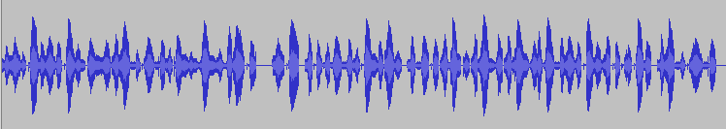



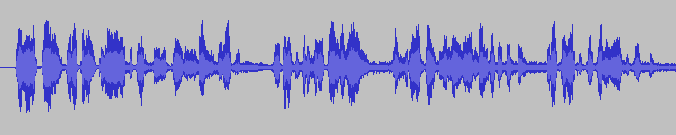

…are mapped against the input audio file to find phrase breaks.

Best results are obtained:
- if you have a clearly spoken recording,
- if any background music is low enough in volume not to confuse the system,
- if there is a minimal amount of sounds effects or pauses in the audio
- if the synthesized phrases correspond well enough to how the language is pronounced.

Will it work with our language?
aeneas is producing impressively accurate timing files for languages around the world. We would recommend you try it out and see how well it works for your text and audio files.

What about special characters or tone marks? Since the text-to-speech engine copes best with simple A-Z Roman scripts, the Synchronize using aeneas wizard in Scripture App Builder has a Character Replacement page, designed to replace special characters with simple ones (ɓ to b, ɛ to e, etc.). It also strips out accents and tone marks. The comparison algorithms are tolerant enough to match up the phrases even though the pronunciation differs.

If you have a non-Roman script, you will need to define a set of character replacements, transliterating your non-Roman script into a simple A-Z Roman script (अ to a, क to ka, उ to u, etc.). This approach has already been used successfully to synchronize text and audio for the whole of the Hebrew Bible. If you create a set of additional character replacements that work well for your script and language, please let us know so that we can add them to the default set of replacements.

You can find a selection of Romanization tables here:
http://www.loc.gov/catdir/cpso/romansource.html

How long does it take?
For a typical phrase-by-phrase synchronisation, running aeneas takes 1-2 minutes to process an hour of audio, and less than an hour for all 27 books of the New Testament. Actual times will depend on the speed of your computer.

How do we run aeneas?
You need to Install aeneas on your computer and use the Synchronize using aeneas wizard in SAB to launch the synchronization process.
See section 2 for instructions on how to install aeneas on Windows, and section 3 on how to install aeneas on Linux. This is especially easy for Ubuntu users since aeneas is included automatically in the SAB installation.

Windows Installation
To set up aeneas on Windows, there are several programs and modules to download and install: FFmpeg, eSpeak, Python and aeneas. These can all be installed with a single setup program.
- Go to the Download page on the Scripture App Builder website http://software.sil.org/scriptureappbuilder/download/ and download the latest aeneas setup program for Windows. You will find it under the heading Audio Synchronization Tools.
- The filename will be something like aeneas-windows-setup-1.7.2.exe.

- Double-click the file you have downloaded to start the installation wizard.

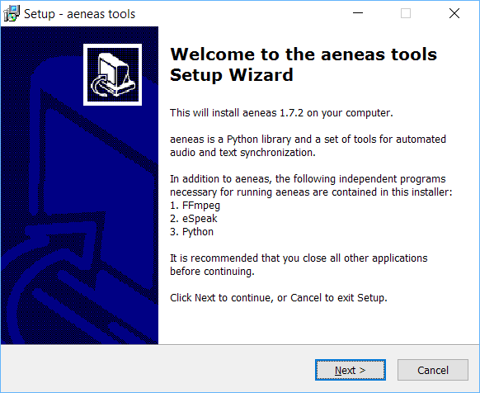

- Follow the instructions in the wizard. You can accept all the defaults.

- On the Select Components page, you need the Full Installation which should be selected by default.

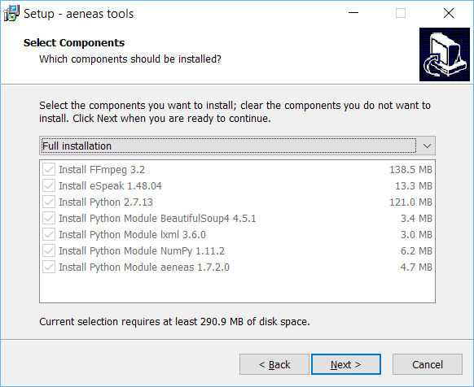

- On the Ready to Install page, click Install.

You will see the wizard running several different installers: for FFmpeg, eSpeak, Python. It will also install three Python modules.

Before the wizard completes, you should see a command box appear for a few seconds which verifies the aeneas installation.

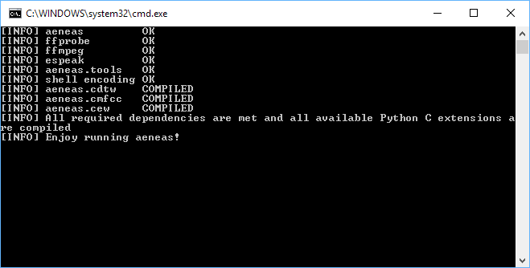

Important: If Scripture App Builder was open while you installed aeneas, close it and start it again to ensure that it picks up the changes to your Path settings.

Linux Installation

If you are using Ubuntu, the aeneas software is a required dependency of Scripture App Builder. This means that aeneas is automatically installed or updated along with Scripture App Builder and you do not have to install it manually.

Using aeneas within Scripture App Builder

Aeneas sometimes does not work with special characters in file names. If you receive an error when running aeneas, make sure your audio files names only include standard English letters from A to Z or a to z. This means that accented letters like à or é will not work.
If the path to your audio files includes folder names with special characters, you may also encounter problems.

Preparing Your Audio Files
As mentioned above, the best results are obtained:
- if you have a clearly spoken recording,
- if any background music is low enough in volume not to confuse the system,
- if there is a minimal amount of sounds effects or pauses in the audio
- if the synthesized phrases correspond well enough to how the language is pronounced.
You may not have control over these elements, but most of them can be corrected in the fine-tuning process.
For recordings of Scripture texts, you will need one audio file per chapter. It is often the case that the recordings for the first chapter of a book have a longer introduction than subsequent chapters. These book introductions are normally not synchronized so you will have to tell aeneas how much time to ignore at the beginning of a chapter’s audio.

Before synchronizing a set of audio files, try listening to several books to determine how long the introductions are. Try to determine the approximate length of the introduction to the first chapter of a book, and the approximate length for subsequent chapter introductions.

Performing the Audio Synchronization

Where to launch the synchronization process
You can run the Audio Synchronization using aeneas wizard from five places within Scripture App Builder:
- The Audio Files tab for a book or book collection. Select one or more rows in the table, right-click and select Synchronize using aeneas.
To select more than one audio file, click on one file name, hold down the Ctrl key and click on any others you want to select. Alternatively, to select a range of files, click the first one, hold the Shift key down and click the last in the range. This should select the whole range. To select all the files, click on any file and then hit Cntrl-A.

- The Audio Synchronization tab for a book collection. Click on the button Synchronize using aeneas...
- The Audio Synchronization tab for a book. Click on the button Synchronize using aeneas...
- The Book Collection tab for a book collection. Right-click on a book in the table and select Synchronize using aeneas...
- The project’s tree view on the left of the screen. Right-click on a book or book collection and select Synchronize using aeneas...

All of these menu selections should launch the synchronization wizard and produce the same result. Follow the instructions in the wizard to configure the synchronization.
To get the best initial results, it is important to know how much audio to skip at the beginning of the file (if any) before the Scripture text audio actually starts. Try just listening to the first chapter of a book and experimenting with the Start of Audio value. Then do the same with the second chapter. If the values seem correct, synchronize all of the rest of the chapters in one go, using the values you determined.
For Windows users, if the wizard asks, “Where have you installed aeneas?”, please follow the installation instructions in this document.

Stepping Through the Synchronization Wizard
- Voice
This is the voice that eSpeak uses for the text-to-speech process. You should choose the Language code for the voice that most closely corresponds to your target language. The default choice is esperanto, which is a phonetic language and which works very well for many languages. If you don’t see any other language in the list that is closer to your language, try esperanto.

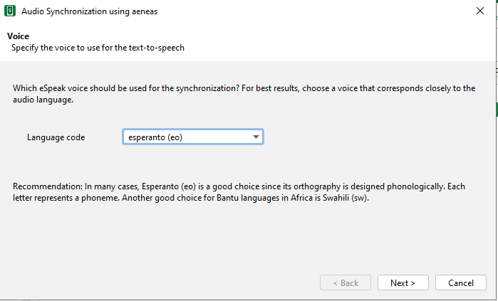

- Character Replacements
If your language has non-alpha numeric characters (including characters with accents), you may achieve better results by giving aeneas a set of character replacements. Some default ones are provided, but through experimentation with the synchronization process, you may discover that you need to add or remove some. For non-roman languages, you can provide character replacements with roman letters, or temporarily transcribe your text into roman characters for the synchronization. Either way, the timings should still be correct.

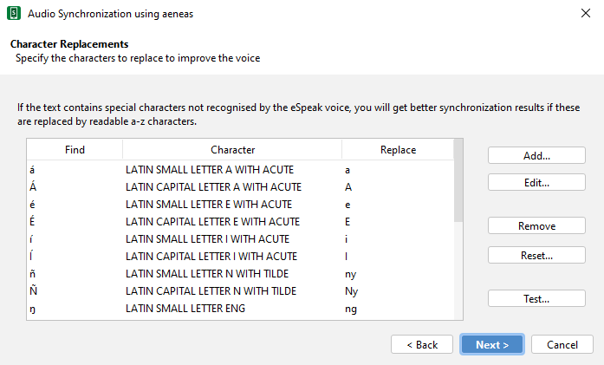

- Start of Audio
Scripture book audio normally has the book name, chapter number and sometimes some introductory information before the actual Scripture text commences. It is normally not recommended for these parts of the text to be synchronized and highlighted, so you will need to tell aeneas how many seconds of audio to skip at the start of the audio file. If there is no introductory audio, choose option 1: No, there is no section to ignore in these files.
Option 2 is a bit unreliable, so we recommend using option 3 if you have audio to skip. See Preparing Your Audio Files for tips on how to determine the First Chapter and Other Chapters amounts to skip. Alternatively, start with a value like 7 seconds for First Chapter and 4 for Other Chapters. You can test several files to see how accurate that is before synchronizing a whole book or set of books.

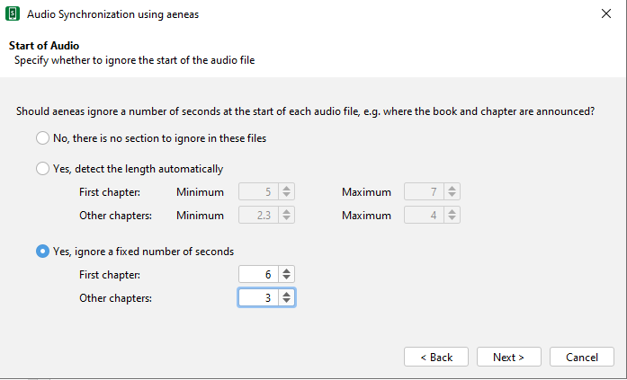

- End of Audio
This is less common and refers to anything (like closing music) in the audio after the voicing of the last verse of Scripture text. Normally, you can just select Option 1: No, there is no section to ignore in these files.

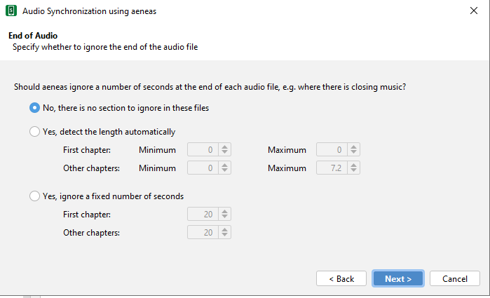

- Phrase Boundaries
This screen allows you to select where between phrases the highlight moves. The default is usually the best: In the middle of the silence…

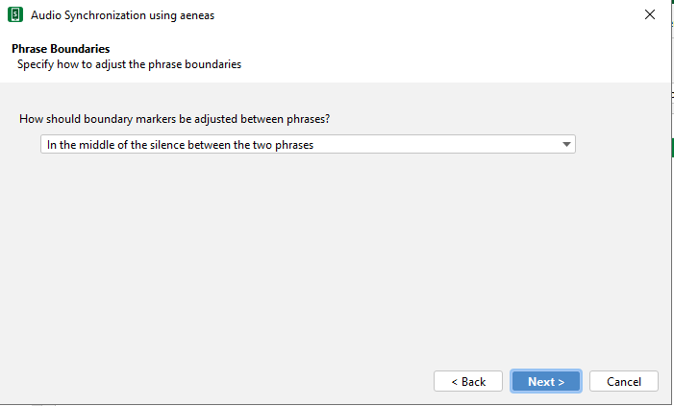

- Synchronization Level
Synchronization level determines how the text is broken up into discreet pieces to highlight. Phrase by phrase allows you to select a set of characters (usually punctuation) that tell aeneas how to split up the text, allowing for smaller sections of a verse to be highlighted at a time.
Verse by verse will highlight the whole verse at a time.

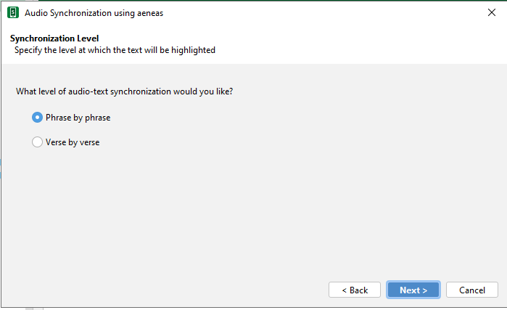

Verse by verse is easier to sync, but it means that potentially large sections of text—even several sentences—are highlighted at once. In rare cases, an entire verse may not fit on the app screen. Phrase by phrase is normally more helpful for allowing people to follow along.

- Phrases
If you are using the Phrase by phrase synchronization level, you can specify here the phrase-breaking characters. SAB provides a default set that can be edited. You can use \u and a Unicode number to specify a specific Unicode character.

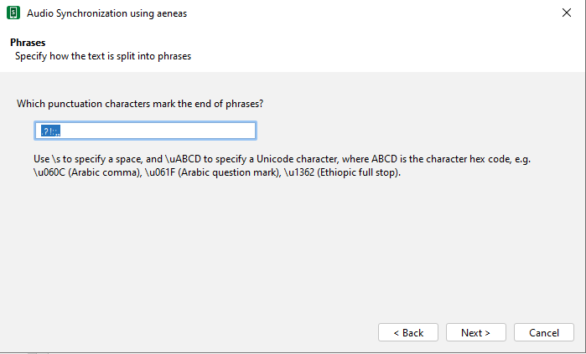

- Headings and Markers
If your recorded text includes chapter headings, select the Section Headings option.
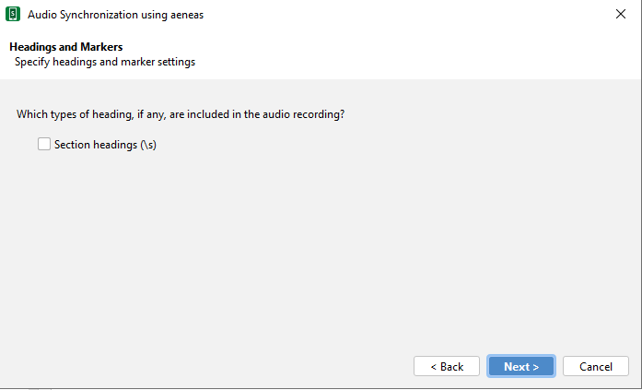

- Output Folder
Specify the output folders for the phrase lists and timing files. The default locations are usually fine unless you have a specific need to save them elsewhere.

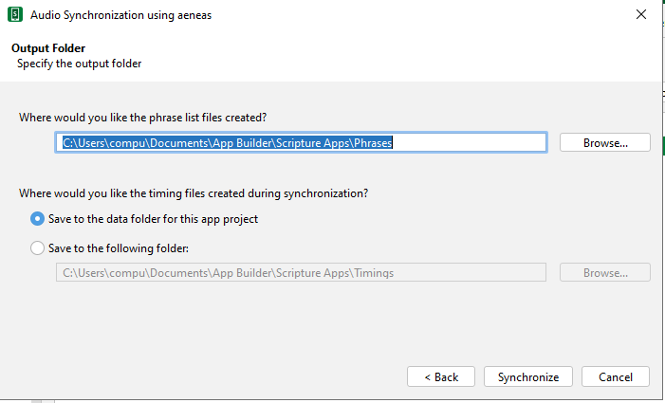

After the final page of the wizard, the synchronization process will start in a separate command Window. It runs a batch file (or bash script) which calls an aeneas task for each chapter of each book.
As timing files are generated you will see their filenames being added to the table on the Audio Files page.

Troubleshooting
If the synchronization fails, please ensure that aeneas has been installed correctly. You can check the installation by selecting Tools Check aeneas installation… from the Scripture App Builder main menu. See also the warning note regarding file and folder names with special characters.
A common problem on Windows is that eSpeak stops working after a while. To correct this, run the aeneas Windows setup program again.
To verify that eSpeak has been installed correctly and is in your path, open a new Windows command prompt and type:
espeak hello
If all is well, you should hear the word “hello” pronounced.

Viewing and testing the timing files created by aeneas
To view a generated timing file, select a row on the Audio Files page, right-click, and select View Timing File.
To test the generated timing files with the text and audio, select a row in the Audio Files page, right-click and select Export to HTML.

Fine tune timing files using the Preview Audio feature
You can view a waveform preview of each audio file and adjust the timing positions from within. To do this, either right click on a single audio file (under Books Collection name Book name Audio Files) or double-click on an audio file instead. The Preview Audio viewer screen will appear.

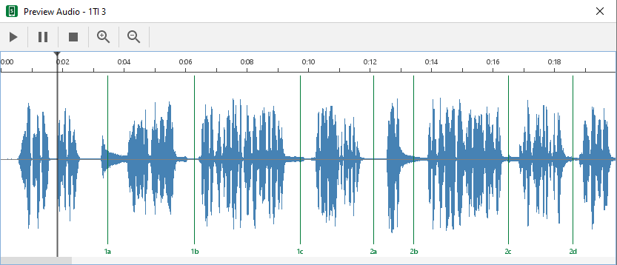

Current position in the audio file during playback.
Current position in the audio file.
Phrase breaks in the timing file.

From the Preview Audio viewer, you can play, pause or stop the audio. A moving, vertical bar will show the current position in the audio file. Synchronized text will be displayed at the bottom of the viewer as each phrase is read. Vertical green lines show the phrase breaks, each one labeled with the verse and phrase number (e.g. 1a, 1b).
You can click and drag a phrase break line to adjust its position. Use the zoom controls for more accurate positioning. When you are satisfied, close the viewer window using the close box (X) in the upper right corner. You will be prompted to save the changes to the underlying timing file.

Fine tune timing files using the Fine Tune Timings viewer
To fine tune a generated timing file using the browser-based timings viewer:
- Select a row on the Audio Files page, right-click, and select Fine Tune Timings.
A page should open in your default browser, looking something like this:
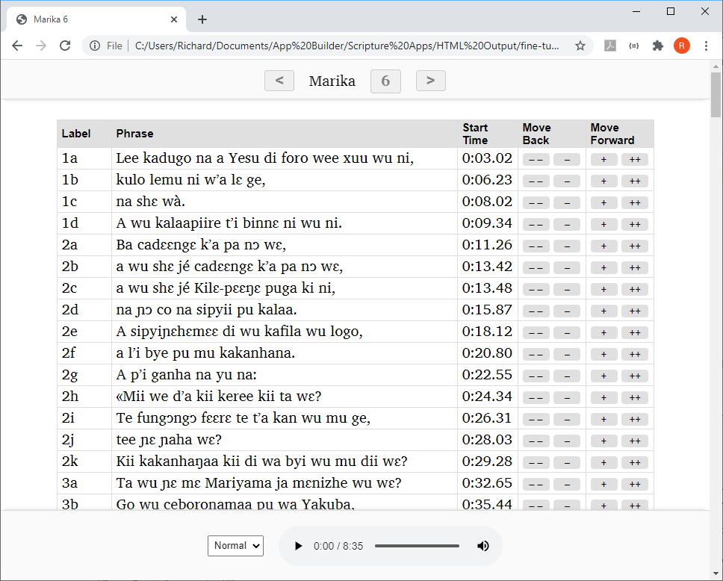
- Click on the first row of the table to start the audio playing. The row will highlight in yellow. See if the audio matches the text in the highlighted phrase.

- As soon as you hear the first word or two from the selected row and it seems that the text and audio match exactly, click on the next row.

- Continue clicking on each row to listen for enough time to determine whether the timing break has been placed in the right place, i.e. not too early and not too late.

You can also use the N keyboard shortcut to move to the next row.

- If you hear that the timing for a row needs to be fine-tuned, you can move it backwards or forwards by increments:
- click the plus (+) button to move the start time forward by 0.1 seconds
- click the double-plus (++) to move forward by 1 second
- click the triple-plus (+++) to move forward by 10 seconds
- click the minus (–) button to move the start time backwards by 0.1 seconds
- click the double-minus (– –) to move back 1 second
- click the triple-minus (– – –) to move back 10 seconds
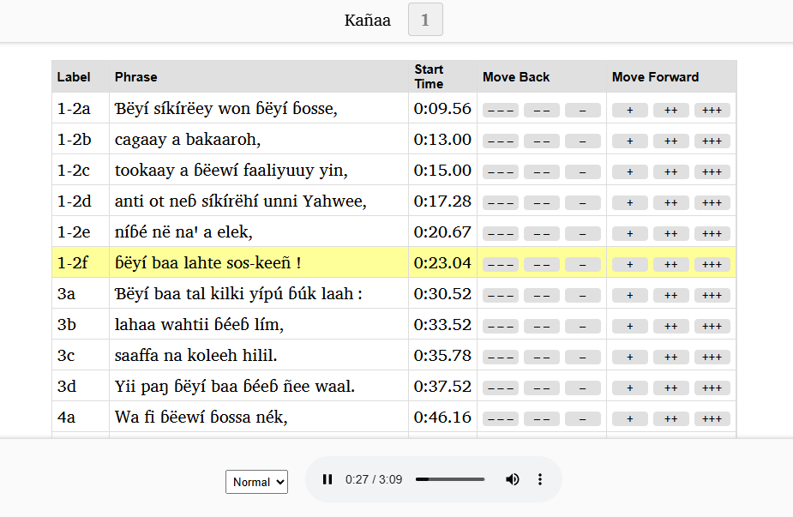
Adjust the start time of the currently selected timing using the plus and minus buttons.
Click on each row for enough time to check if the audio starts at the right place.

When you click on a phrase, it is highlighted and the audio plays from the point specified in Start Time. If the audio that plays corresponds to a phrase further on in the text, you need to adjust the start time by moving it earlier, and vice versa.

- When you are happy with the current row, continue clicking on the subsequent rows in the same way, fine tuning those that need adjusting.

- IMPORTANT! When you have reached the last row of the table, save your changes by clicking on the button Save Changes to Timing File at the bottom of the page (or by using the keyboard shortcut T).

NOTE: For security reasons, your browser does not have permission to save the modified timing file in its original location. It will be saved to your default Downloads folder. Scripture App Builder can watch this folder for modified files and move them back to your project data folder. Specify the Downloads folder to watch in Settings Files. Otherwise, you will need to move the modified files back to your project manually, e.g. using the Add Timing Files button.

- Changing audio speed when doing fine tuning
If the audio is playing too quickly for you to fine tune accurately, you can slow down the playback speed using the speed selector at the bottom of the screen.
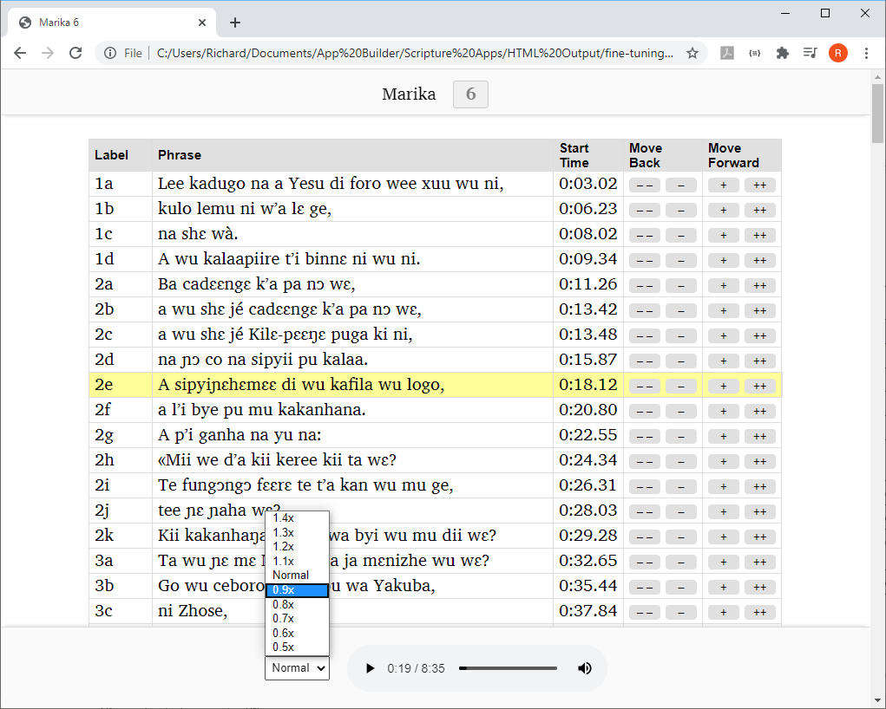
Change the playback speed here

Keyboard shortcuts when doing fine tuning in your browser
The following keyboard shortcuts are available in the Fine Tuning interface:

Key | Action
Spacebar | Start/Pause audio
T | Save timing file
N | Start playing from the next row
P | Start playing from the previous row
B | Set the phrase start time to be at the current audio position
A (or Q) | Move the start time of the current row back 1 sec
S | Move the start time of the current row back 0.1 secs
D | Move the start time of the current row forward 0.1 secs
F | Move the start time of the current row forward 1 sec

Sending Fine Tuning files to others
If you want to do fine tuning well, it can take a lot of time of concentrated listening. You might have friends and colleagues who are willing to help with this. It is possible to send them the Fine Tuning files to work on without them needing to install Scripture App Builder.
To do this:
- Select one or more books, or a book collection, in the left-side project menu. Right-click, and select Fine Tune Timings.
- In the Fine Tuning wizard, choose The files will be sent to others to help with the fine tuning.
- On the next page, Audio Files, choose to copy the audio files (if you have a good internet connection) or choose not to copy them (if your internet connection is limited and you will tell your friends where they can download the audio files).
- On the next page, Zip Files, choose to zip the fine tuning files together to send to your friends.
- On the next page, Output Folder, choose where you would like the files to be created, then click Create Files.
- Send the files to your friends, ask them to unzip them on their computer, and explain to them how they can work on the timings. They can open the html file for each chapter and that will load the Fine Tune Timings page in their browser. They do not need to have SAB or RAB installed. When done, they should save the timings and send the modified timing files back to you.

There is currently a group of volunteers called SAB Assist who can crowd-source the fine-tuning of projects—even whole Bibles. Contact andrew_shafe@sil.org for more details.

Fine tune timing files using Audacity
Instead of using the Fine Tune Timings viewer, you can make corrections in Audacity. To do this:
- Open the audio MP3 file in Audacity.
- Import the timing file, by selecting File Import Labels…
- Zoom into the waveform.
- Adjust the position of any labels that are not in the right place.
- Export the modified labels track, using File > Export Labels…
- Test the synchronisation again within Scripture App Builder using the Export to HTML utility (see above) to see if the timing problems have been resolved.

Adding voices to eSpeak
By using character replacements in the Synchronize using aeneas wizard, you will find that you can get good synchronization results for many languages using the existing eSpeak voices.

Adding a new voice in eSpeak is not easy, but if you would like to try, please follow the instructions here: http://espeak.sourceforge.net/add_language.html

https://github.com/readbeyond/aeneas/#aeneas
https://github.com/readbeyond/aeneas/blob/master/wiki/HOWITWORKS.md

