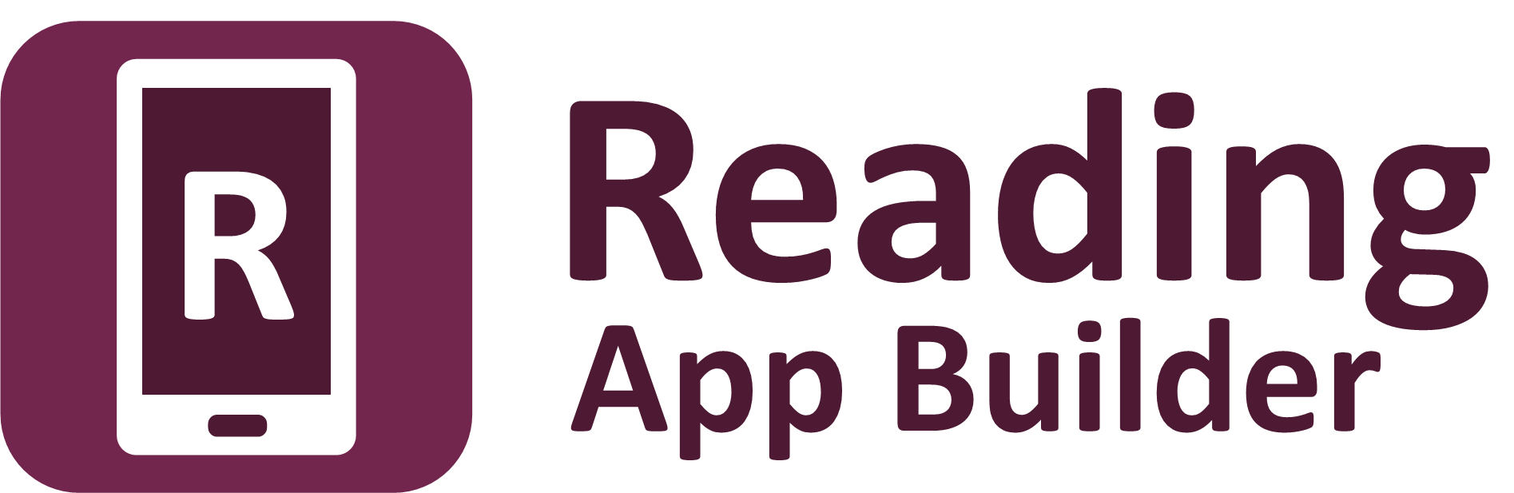

Building Apps



Reading App Builder: Building Apps

© 2026, SIL Global

Last updated: 25 June, 2026

You are free to print this manual for personal use and for training workshops.

The latest version is available at
http://software.sil.org/readingappbuilder/resources/

and on the Help menu of Reading App Builder.

How to Use This Manual

Reading App Builder (RAB) has many features to help users access and engage with app resources. It is recommended that you at least familiarize yourself with the many options available by taking a brief look over all the chapter topics.

If you are new to RAB, it is recommended that you read sections 1, 2 and 3 of this manual before running the New App wizard for the first time. Section 4 has some Frequently Asked Questions. Sections 5 and on systematically cover the menus, project features and configuration settings.

This guide includes notes and tips to help you get the most out of the software. Tips and notes will appear like this:

Notes:

Each page in the wizard will have explanatory text to help you in choosing options.

Tips:

To center text in the About box, add “text-align: center;
“ to the CSS in the body.about UI style.

Most of the interface items in your app can be customized through the User Interface (UI) styles. For each section, the related UI styles will be shown in text boxes like the following:
To modify this… | Adjust this style…
Navigation drawer background | ui.drawer
Navigation drawer item text | ui.drawer.item.text

See Appendix 3 for a comprehensive list of styles and explanations.

RAB includes a helpful search feature to aid in finding the various features and settings. Click on Find… at the right side of the RAB tool bar. See also Find Settings and Features…

To change RAB’s interface language, click on the language button at the far right side of the RAB tool bar. See the example below:
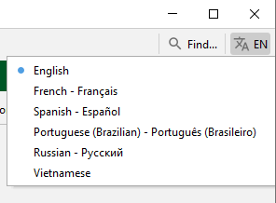

The RAB software interface has four main areas: The Menu bar, the Tool bar, the Project menu area (tree view) and the Configuration area. These will be referenced in the various chapters.

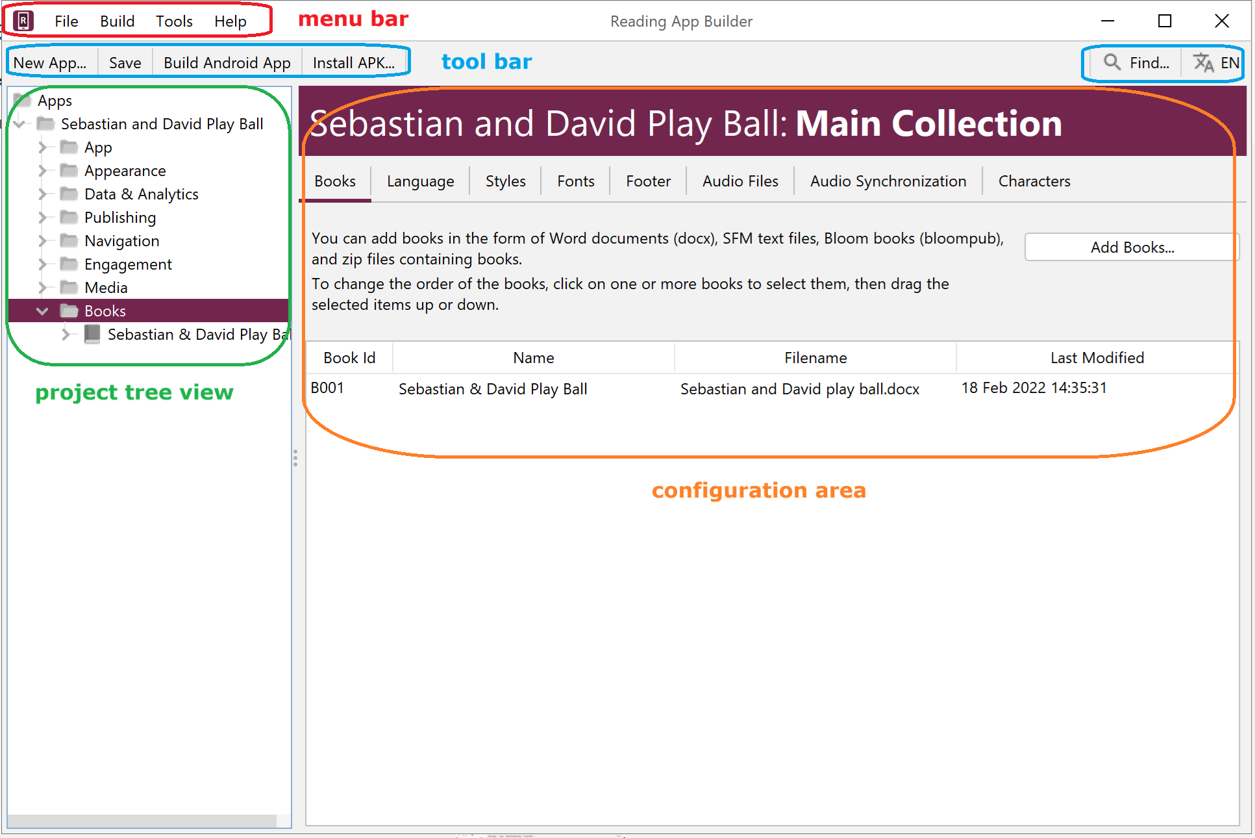

Contents

1. Preparing content for your app 13
1.1. Preparing text 13
1.1.1. Word document (.docx) 13
1.1.2. SFM text files 14
1.1.3. HTML files (.html) 14
1.1.4. Bloom books (.bloompub) 14
1.1.5. EPUB documents (.epub) 15
1.2. Preparing images 15
1.3. Preparing audio 16
2. How to build your first app 16
3. Installing the app on your phone 21
4. Frequently Asked Questions 25
4.1. What sort of apps can I build? 25
4.1.1. Picture Storybook apps 25
4.1.2. A collection of Bloom books 26
4.1.3. Song Book apps 26
4.1.4. Quiz apps 26
4.1.5. Hybrid apps (combining different types of resources) 27
4.2. How can I contextualize my app for a specific audience? 27
4.3. How can I find the setting or feature that I need in my RAB project? 27
4.4. How should I choose the app package name? 28
4.5. How can I add audio to my app? 28
4.6. How can I synchronize the text and audio in my app (creating timing files)? 28
4.7. Do I have to create a new keystore for each app? 28
4.8. How can I include pictures in my apps? 28
4.9. How can I handle a “right-to-left” language? 29
4.9.1. Setting the UI layout direction 29
4.9.2. Setting a specific book’s text direction. 29
4.9.3. Changing the Orientation of the Contents Menu 30
4.10. Can I build apps when I do not have internet access? 30
4.11. Can I build an app from the command line? 30
4.12. How can I add a horizontal line to separate certain paragraphs in text? 32
4.13. I don’t like the name “Reading App”. Have you thought of calling the app something else? 32
5. The RAB Menu Bar 32
5.1. The File menu 33
5.1.1. New App… 33
5.1.2. Open App… 33
5.1.3. Open Multiple Apps… 33
5.1.4. Open App From Scriptoria… 33
5.1.5. Close 33
5.1.6. Save 33
5.1.7. Save All 33
5.1.8. Reload App 33
5.1.9. Copy App 33
5.1.10. View Project Folder 34
5.1.11. View APK Output Folder 34
5.1.12. View IPA Output Folder 34
5.1.13. Exit 34
5.2. The Build menu 34
5.2.1. Build Android App APK 34
5.2.2. Build Android App Bundle 34
5.2.3. Build iOS Asset Package 34
5.2.4. Build Multiple Apps 35
5.2.5. Install Latest APK on Device 35
5.2.6. Export Data Safety to CSV 35
5.3. The Tools menu 35
5.3.1. Settings… 35
5.3.2. The Code Libraries tab 35
5.3.3. The Android SDK tab 35
5.3.4. The Defaults tab 36
5.3.5. The Default Folders tab 36
5.3.6. The Export Folders tab 36
5.3.7. The Build Settings tab 36
5.3.8. The Build Folders tab 37
5.3.9. The After Build tab 37
5.3.10. The Interface tab 37
5.3.11. The Files tab 38
5.3.12. Create New Keystore… 38
5.3.13. Install JDK… 38
5.3.14. Install Android SDK… 38
5.3.15. Check Android SDK installation… 39
5.3.16. View Logs… 39
5.3.17. Check aeneas installation… 39
5.4. The Help menu 39
5.4.1. Find Settings and Features 39
5.4.2. Help Documents 40
5.4.3. Community Website 40
5.4.4. Customer Support Agent Website 40
5.4.5. About App Builder 40
6. The RAB Tool Bar 40
6.1. New App… 40
6.2. Save 40
6.3. Save All 40
6.4. Build Android App 40
6.5. Install APK… 40
7. The Project Root Tree Node (Project Name) 41
8. The App project menu 41
8.1. Name and Package 41
8.1.1. The App Name tab 41
8.1.2. The Package tab 41
8.1.3. The Project tab 42
8.2. Android 43
8.2.1. The APK tab 43
8.2.2. The App Signing tab 44
8.2.3. The App Registration tab 45
8.2.4. The Permissions tab 45
8.3. iOS 45
8.4. About 45
8.4.1. The About tab 45
8.4.2. The Copyright and Licensing tab 45
8.4.3. The Viewer tab 45
8.4.4. What information should I include in the About page? 45
8.4.5. Which formatting codes can I use in the About page? 46
8.4.6. Which variables can I use in the About page? 48
8.5. Security 48
8.5.1. The Expiry tab 48
8.5.2. The Security tab 49
9. The Appearance project menu 50
9.1. Icons 50
9.1.1. The Android Icon tab 50
9.1.2. The Android Icon Layers tab 50
9.1.3. The Android Legacy Icons tab 51
9.1.4. The Notification Icon tab 52
9.2. Graphics 52
9.2.1. The Android Splash Screen tab 52
9.2.2. The Navigation Drawer tab 52
9.2.3. The Borders tab 54
9.3. Interface 56
9.3.1. The Languages tab 56
9.3.2. The Translations tab 57
9.3.3. The Layout Direction tab 57
9.4. Colors 58
9.4.1. The Color Scheme tab 58
9.4.2. The Main Colors tab 58
9.5. Fonts 58
9.5.1. The Main Font tab 58
9.5.2. The Font Files tab 58
9.5.3. The Font Handling tab 59
9.5.4. The Keyboards tab 59
9.5.5. The Lexical Models tab 60
9.6. Styles 60
9.6.1. The Text Styles tab 60
9.6.2. The User Interface Styles tab 60
9.6.3. The Custom Styles tab 61
9.6.4. Setting styles at the book level 61
9.7. Changes 61
10. The Data & Analytics project menu 61
10.1. Analytics 61
10.1.1. S3 Digest Analytics 62
10.1.2. Data Payload for S3 Digest Analytics 63
10.1.3. Amplitude Analytics 64
10.1.4. Firebase Analytics 64
10.2. Firebase 64
10.2.1. The Firebase Features tab 65
10.2.2. The Firebase Configuration tab 66
10.2.3. The Push Notifications tab 66
10.2.4. The In-App Messaging tab 66
11. The Publishing project menu 67
11.1. App Store 67
11.2. E-books (EPUB) 67
12. The Navigation project menu 68
12.1. Contents Menu 68
12.1.1. The Contents Items and Screens tab 68
12.1.2. The Contents Settings tab 74
12.1.3. The Contents Navigation tab 74
12.1.4. The More Settings tab 74
12.1.5. The Viewer tab 74
12.2. Navigation Drawer 75
12.2.1. The Menu Items tab 75
12.2.2. The Settings tab 75
12.2.3. The Sharing tab (sharing apps) 75
12.2.4. The History tab 76
12.2.5. The Search tab 76
12.3. Bottom Navigation 77
12.4. Book Navigation 78
12.4.1. The Formatting and Navigation tab 78
12.4.2. The First Book and Page tab 79
12.4.3. Tab Types (Book Tabs) 79
12.5. Deep Linking 80
12.5.1. Setting up Deep Linking 81
12.5.2. Creating Deep Links 82
12.5.3. Deferred Deep Linking 83
12.6. Tab Types 84
13. The Engagement project menu 84
13.1. Onboarding 84
13.1.1. The Onboarding Screens tab 84
13.1.2. The Settings tab 85
13.1.3. The Viewer tab 85
13.2. News Feeds 85
13.2.1. The Settings tab 85
13.2.2. The Viewer tab 86
13.3. Notifications 86
13.3.1. The Daily Reminder tab 86
13.3.2. The Notification Icon tab 86
14. The Media project menu 86
14.1. Audio 86
14.1.1. The File Source tab 87
14.1.2. The Audio Toolbar tab 89
14.1.3. The Audio Settings tab 89
14.1.4. The Audio Synchronization tab 90
14.1.5. The Audio Clips tab 90
14.1.6. The Downloads tab 91
14.1.7. How can I associate audio files with the text? 91
14.1.8. How can I reduce the size of my audio files? 92
14.1.9. How do I create the audio timing files for audio-text synchronization? 93
14.1.10. How are the timing files distributed for the app? 93
14.1.11. How can I use audio clips in the app? 94
14.1.12. How can I create subtitles from text and timing files? 94
14.2. Video 95
14.2.1. The Videos tab 95
14.2.2. The Video Settings tab 96
14.2.3. The File Source tab 96
14.2.4. How do I modify a video’s location and configuration options? 96
14.2.5. How do I reduce the size of a video that I want to package within the app? 97
14.3. Illustrations 97
14.3.1. Adding Illustrations / images 98
14.3.2. Viewing Image Properties 98
14.4. Documents 98
14.5. Radio 98
15. The Books project menu 99
15.1. Configuring the book collection 99
15.1.1. The Books tab 99
15.1.2. The Language tab 100
15.1.3. The Styles tab 100
15.1.4. The Fonts tab 100
15.1.5. The Footer tab 100
15.1.6. The Audio Files tab 101
15.1.7. The Audio Synchronization tab 101
15.1.8. The Characters tab 102
15.1.9. Book Table Actions 102
15.1.10. The book table context menu actions 103
15.2. Configuring a Book 105
15.2.1. The Book tab 105
15.2.2. Adding a New Book Group 106
15.2.3. The Song Index tab 106
15.2.4. The Styles tab 106
15.2.5. The Fonts tab 107
15.2.6. The Features tab 107
15.2.7. The Audio Files tab 107
15.2.8. The Audio Synchronization tab 108
15.2.9. The Tabs tab 108
15.2.10. The Cover tab 108
15.2.11. The Changes tab 108
15.2.12. The Characters tab 109
15.2.13. The Book File tab 109
15.2.14. The Viewer tab 110
15.2.15. The project tree view Book context menu 110
16. Picture Story Books 112
16.1. How do I define a picture story book? 113
16.2. What do picture story books in Word documents look like? 113
16.3. What do picture story books in SFM format text files look like? 115
16.4. Where do the pictures go? 117
16.5. How can I get the pictures to move when the audio is playing? 117
16.6. What about font and font size? 118
16.7. What audio timing labels are used? 118
16.8. How can I add background music when the audio is playing? 119
16.9. How can I record the audio files? 119
17. Song Books 120
17.1. How do I define a song book? 120
17.2. What do song books in Word documents look like? 120
17.3. What do song books in SFM format text files look like? 123
17.4. How can we associate audio with each song? 125
18. Registration Screen 126
18.1. Setting up the Registration Screen 126
18.2. Setting up the database in the Google Firebase console 127
19. Publishing and Distribution 131
20. Appendix 1: How RAB stores your project data files 132
20.1. General-use RAB data folders 132
20.2. Project-specific data folders 133
21. Appendix 2: Useful App Builder SFM markers 134
21.1. Headings 134
21.2. Pages and Chapters 134
21.3. Paragraphs 134
21.4. Media 134
21.5. Links to other books or audio files. 135
21.5.1. Examples 135
21.6. Character markup 135
22. Appendix 3: RAB body and text styles explanation 135
22.1. Body Styles 135
22.2. Link Styles 136
22.3. Heading Styles 136
22.4. Paragraph Styles 137
22.5. Poetry Styles 137
22.6. List Styles 138
22.7. Formatting Styles 138
22.8. Footnotes Styles 138
22.9. Cross Reference Styles 139
22.10. Illustrations and Video Styles 139
22.11. Introduction Styles 139
22.12. Table Styles 139
22.13. Formatted Block Styles 140
22.14. Highlighter Pen Styles 140
22.15. Footer Styles (with reference styles) 140
22.16. Contents Menu Styles 141
22.17. Layout Styles 142
22.18. Verse by Verse / Interlinear Pane Styles 142
22.19. Annotations Styles 143
22.20. History Styles 143
22.21. Downloads Styles 144
22.22. Search Results Styles 144
22.23. Quiz Styles 144
22.24. AI Assistant Styles 145
22.25. Settings Styles 146
22.26. Message Box Styles 147
22.27. Onboarding Screens Styles 147
22.28. User Accounts Styles 147

Preparing content for your app
Before you build an app with Reading App Builder (RAB), you need to get your content (text, images and audio) into formats that RAB can handle.

Preparing text
The text format you need depends on the type of app content you have.

- Text content such as literacy materials, picture story books or song books:
The text needs to be in one of the following formats:
  - Word documents (.docx)
  - SFM text files (.sfm)
  - HTML files (.html)
  - Bloom books (.bloompub)
- Song books with chords:
These need to be in the .chordpro (or .cho) format

For more information on how RAB stores your text files, see How RAB stores your project data files.

Here are some more details about each of these formats:

Word document (.docx)
RAB can import text and images from Microsoft Word (.docx) documents. This is the recommended format for text and is likely to be used by most users of RAB.
When Word documents are displayed in the app, basic formatting will be preserved such as character styles (bold, italic, underline), numbered lists, bullet points, hyperlinks and simple tables.
To define separate chapters or pages, insert page breaks using CTRL+Enter.
Even though Word documents may appear easier, they work best only for very simple story books. If you want more control over the formatting and features of the book, use the SFM format.

As a starting point, you can add a Word file to RAB, click on its Book File tab and then the Export as Text File button. This will convert your Word doc to the SFM file format. You can then edit this SFM file, adding the correct title, page and other markers necessary. Then remove the book from Word and replace with this SFM one.
For more details about how to define picture story books and song books using Word documents, please see the sections on Picture Story Books and Song Books.

SFM text files
RAB can import text from SFM (standard format marker) files. This is a good option for those who are familiar with Paratext and USFM markers.
In SFM text files, the pages, section headings and paragraphs are marked by standard format markers such as \page, \s and \p. For more details, please see http://paratext.org/about/usfm.
The first marker in the file must be in the form \id XYZ, where XYZ is a unique, alphanumeric code you choose (with no spaces or hyphens, but you can have underscores). Do not choose a code already reserved for any other book in your project. SFM book files must be plain text files. If you have Unicode characters, the text files should use UTF-8 encoding.
To create an SFM text file in Windows, use a text editor such as Notepad.
To create a text file on a Mac, use TextEdit, remembering to choose Plain text files in the preferences because otherwise the default file type is RTF (which contains a lot of additional formatting codes).
For more details about how to define picture story books and song books using SFM text files, please follow the links to see their respective sections.

HTML files (.html)
RAB can display HTML files and make use of associated stylesheets (CSS) and images. Audio-text synchronization is not supported yet with this format.

Bloom books (.bloompub)
RAB can create apps with books created with Bloom. It uses an embedded Bloom Player, as used in the Bloom Reader app.
To create a Bloom Reader file for use in RAB:
- Open the Bloom book in Bloom.
- Select the Publish tab at the top of the Bloom screen.
- Select Bloom Reader on the left of the screen.
- Select the option Save Bloom Reader File.
- Click the Save button.
- Save the Bloom book to your computer as a .bloompub file. This is the file that you will need in Reading App Builder.
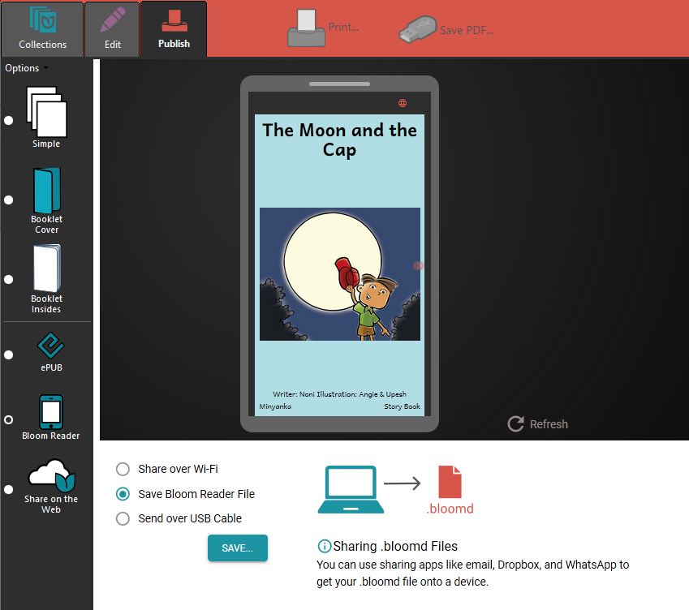
To find out more about Bloom, please see: http://bloomlibrary.org

EPUB documents (.epub)
There is basic support for displaying the contents of EPUB documents, including images and associated styles. Audio and audio-text synchronization is not supported yet with this format.

Preparing images
Images are imported automatically from Word documents or need to be specified separately if you use SFM format. They should be in JPEG or PNG format. Certain interface items require a particular format, size or shape, and that will be specified in the descriptive text on that screen in RAB. For example, the navigation drawer image is required to be a PNG file with an aspect ratio of 16:9.
Keep the image size small enough so that they will not make the app size too large yet will display well on a small screen. If your pictures are in a Word document, you can use the Compress Pictures tool in Word. Otherwise, RAB will allow you to resize the images after you have added them to the app project.

Preparing audio
If you want to include audio files in your app, these need to be in MP3, 3GP or WebM (Ogg Opus) audio format. Normally this should be one audio file per page or chapter. You can also include audio clips which are short audio files that are played when the user taps on a word, phrase or image. If you want to include timing files so the text and audio are synchronized, the audio must be Constant Bit Rate (CBR).
Go here for more information on including audio.
Keep the audio files at a size where the quality is good enough for a phone and where the file size is not too large. Go here for more information on compressing audio files to make them smaller

Make sure that audio files are clearly and uniquely named. RAB will need to figure out which audio file to associate with which page or chapter, so clearly include that number in the file name (i.e. at the end of the name) using a leading zero.
E.g. my_book_page_01.mp3
Audio from Faith Comes By Hearing will already have unique file names, so it is not recommended to change them.

How to build your first app
To build your first app with Reading App Builder, you should use the New App wizard.

The wizard will offer many choices in setting up your app. If you do not yet know exactly what you need, just choose the default option for now. All the app elements can be added or modified later within RAB, before you publish the app. Each page in the wizard will have explanatory text to help you in choosing options.

- Launch Reading App Builder from its icon on the desktop.

- Click New App… on the toolbar. The New App wizard will appear.

If this is your very first app, or you have no projects opened in RAB, the New App button will show in the middle of screen.

- On the first page of the wizard, specify the App Name, such as “Dogon Stories”, “Manuel de santé”, “Supyiré Proverbs”, etc. This is the main title of your app and will appear under the app icon on the user’s phone. Do not include underscores or hard to understand abbreviations and try to keep the length under about 20 characters. (You can modify this later under App Name & Package App Name.)

Click Next to move to the next page.

- On the second page of the wizard, specify the Package Name--a dot-separated string which uniquely identifies your app. (You can modify this later under App Package.)
More details about choosing a good package name can be found in the section How should I choose the package name?

Click Next to move to the next page.

- On the Book Type page, choose if you want an app with data from Word, Bloom, Word or other text files, or an audio-only app.

If you choose audio-only, the wizard will present several screens asking the name of the audio-only book, which audio files you want to add and which image you want to display while the audio is playing. It will also give you the opportunity of adding it to a contents menu

Click Next to move to the next page.

- If you choose to add books with text, the next page of the wizard is titled Books. Click Add Books… and select the books you want to see in the app. These can be Word documents (docx), SFM (standard format marker) text files, ChordPro files, or a zipped file of USFM or USX files. (You can add more books later under Books Books Add Books.)

Click Next to move to the next page.

- If the book names are in all-caps, the next page of the wizard is titled Book Names and will allow you to change them to mixed case if desired.

Click Next to move to the next page.

- On the page of the wizard titled Language, specify the language code and name of the main language used in the app. Click Select… to choose the language code from a list of languages. If required, select the checkbox to specify additional identification information, such as the script, region and variant. (You can modify this later under Books Language.)

Click Next to move to the next page.

- On the Copyright and Licensing page, specify the copyright and licensing information that you would like to appear on the About box in the app. This includes the copyright owner for the text. Use the Copyright Helper wizard to help you.

If you do not know what to put here, please ask the publishing department of your organization for advice. They will want to make sure you get this right and do not simply make a guess as to what to include. (You may add this information at a later time if you do not have it available right now under App > About Copyright & Licensing. Also see more on where and how to include copyright information in the About Page section.)

Click Next to move to the next page.

- On the page of the wizard titled Font, choose the font. You can either select from the given list of fonts or specify a different TrueType font file. (You can modify this later under Appearance Fonts Main Font.)

Click Next to move to the next page.

- If this next page is titled Choice of Fonts, choose some more fonts to add to the app. The app user will be able to change the default font to one of these fonts in the font chooser and in the Verse on Image editor. (You can modify these settings later under Appearance Fonts Font Files.)

Click Next to move to the next page.

- On the page of the wizard titled Font Handling, you can select GeckoView if you know that the standard Android components will have trouble displaying the text correctly (e.g. if it is a complex script). (You can modify this setting later under Appearance Fonts Font Handling.) More information on GeckoView can be found in the Fonts section of this document.

Click Next to move to the next page.

- On the page of the wizard titled Color Scheme, choose the color scheme for the app. The color you choose is the one that will be used for the main app bar. (You can modify this later under Appearance Colors Color Scheme.)
Individual colors for text, titles, links, backgrounds, etc. can be customized later.

Click Next to move to the next page.

- On the page of the wizard titled Default Interface Language, choose the language you want users to see when they first enter the app (the language for the app menus). This can be the current system language, but you can specify a default language just in case--perhaps a language of wider communication. (You can modify this later under Appearance Interface Languages.)

Click Next to move to the next page.

- On the page of the wizard titled Interface Languages, choose the app interface languages from which the user can choose in the app settings. (You can modify this later under Appearance Interface.)

Click Next to move to the next page.

- On the page of the wizard titled Icon, choose the application launcher icon. You can select one of the images in the table or if you have your own PNG image files for the icon, click Browse and select them. (You can see more options for creating an icon and/or modifying the icon later under Appearance Icons.)

Click Next to move to the next page.

- On the page of the wizard titled Signing, you need to specify the keystore and alias to use to sign the app. A keystore is a digital certificate file that ensures the app is legitimate. An app must be signed in this way so that it can installed on a phone.

If you already have created a keystore for another app, see reusing a keytore. If you do not already have a keystore file (which you are unlikely to have if this is your first time using the program), do the following:
- Click Create KeyStore.

- Enter a new filename for the keystore, such as “keystore1.” Specify a password. Click Next to continue.

- Enter an alias name for a key to create within your new keystore, such as the default “key1”. Specify a password, which can be the same as the password you entered on the previous page.

It is very important to securely store the password for your keystore. Once the app is published, it cannot be updated without the keystore password. Make sure someone else in your organization has access to the app keystore passwords.

Click Next to continue.

- On the Certificate Issuer page, provide details of your organisation in at least one of the fields. Click Next to continue.

- A new keystore will be created for you. Click Close.

- Back on the Signing page of the New App wizard, you need to specify the keystore password, select the key alias and enter the alias password--just as you entered them in the step above. (You can modify your keystore settings later under App App Signing.)

Click Next to continue.

- On the page of the wizard titled Project, you can enter or modify the project name and add an optional description of the app project. Neither of these will be visible to the user of your app. They are just for your own use and might help you distinguish between multiple app projects. (You can modify this later under App Project.)

RAB will create a project folder using the title of your project. It is recommended that you don’t include any special characters in the project name as they may not be compatible with the folder name rules.

Click Finish to continue. The New App wizard will close, and the app project definition will be added to the tree view on the left of the screen.

Take a look at each of the app configuration pages by selecting them in the tree view on the left. Look in each of the tabs on each page to verify that you have the settings you want. You can always go back to them later to change them if you find you need to make modifications to fonts, colors, styles, etc.

When you have finished configuring the app, click the Build Android App button on the toolbar at the top of the screen.

If something is not configured correctly for the build to work, you will be notified.

If you need to see the error information at a later time (e.g. to send to one of the support staff for help), you can find it on the menu bar under Tools View Logs… Error Log.

A compilation window will appear. Wait while the app is compiled. It may take several minutes or more.

The first time the build process is run, the compiler needs to connect to the internet to download some files. After this, subsequent app builds will not require internet access. See the menu Tools Settings… Build Settings to turn on offline mode after the first app build.

If the build succeeds, you will have a new APK file – the installation file for an Android app.

To understand more about where RAB stores files like your APK file, see How RAB stores your project data files.

The next section describes how to copy this APK file to your phone and launch the app.

Installing the app on your phone
In the above section, you have seen how to compile an Android app. The result is an APK file, the installation file for an Android app. You now need to copy this APK file to your phone, install it and launch the app.

Because you are installing your APK directly (a process called side-loading) instead of through the Play Store, your phone may alert you to the fact that this is a suspicious file and require an extra step for permitting the install and/or a virus scan. This is normal, but if you are sharing your APK this way, you will want to prepare users that they may encounter these checks.

There are several ways to do this:

Copy the APK via WIFI transfer
Use a WIFI transfer app (Xender, WhatsApp) on your phone and computer. Open the APK output folder, select your APK and copy it or send it to your phone. Locate the APK file and tap on it to install.

Copy the APK directly
If you have a USB data cable, connect your phone to your computer so that it shows up as a device (like an external hard drive or USB drive). Open the APK output folder, select your APK and copy it to an easily-found folder (e.g. Downloads) on your phone. Then, on the phone, find the APK and tap to install.

Automatically install the APK from within RAB
This is a very convenient way to test your APK and worth setting up. Use the following steps:

- Connect your Android phone to your computer using a USB data cable.

(Sometimes you get cheap USB cables that can only charge a phone but cannot transfer data, so make sure you have the right kind of cable.)

When you connect your phone to your computer, if your phone appears as an icon under “This PC”, you have a data cable.

- Ensure that Developer Options USB Debugging is enabled on your phone. By default, on new phones, Developer Options is turned off. This is how you can enable it:
  - Open the Settings menu of your phone.
  - Scroll down to the bottom of the menu and tap on About Phone.
  - Find the Build Number. This could be on the About Phone page, or under a sub-menu such as ‘Software Information’.

If you have trouble finding the Build Number, search for “Build Number” in the settings Search bar.

  - Tap on the Build Number seven times. As you do this, you will see a series of messages appearing: “You are now 3 steps away from being a developer”, “You are now 2 steps away from being a developer”, “You are now 1 step away from being a developer”, “You are now a developer!”.
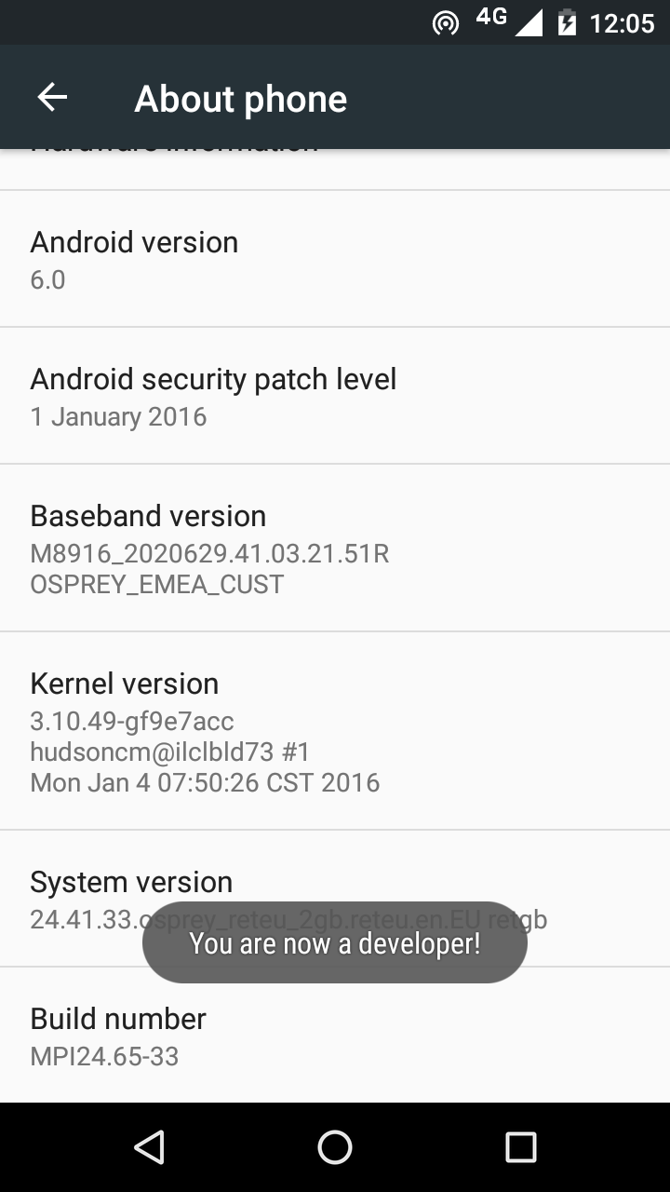

  - Now return to the Configuration menu of your phone. Look for the Developer Options menu item. You might see Developer Options above the About Phone menu item. If you do not see it here, it could be in System settings, under Advanced.

If you have trouble finding the Developer Options, search for “Developer Options” in the settings Search bar. You can even just search for “USB Debugging” to go directly to that setting.

Different phones place Developer Options in different places, so look around your Configuration menu until you find it (see image below).
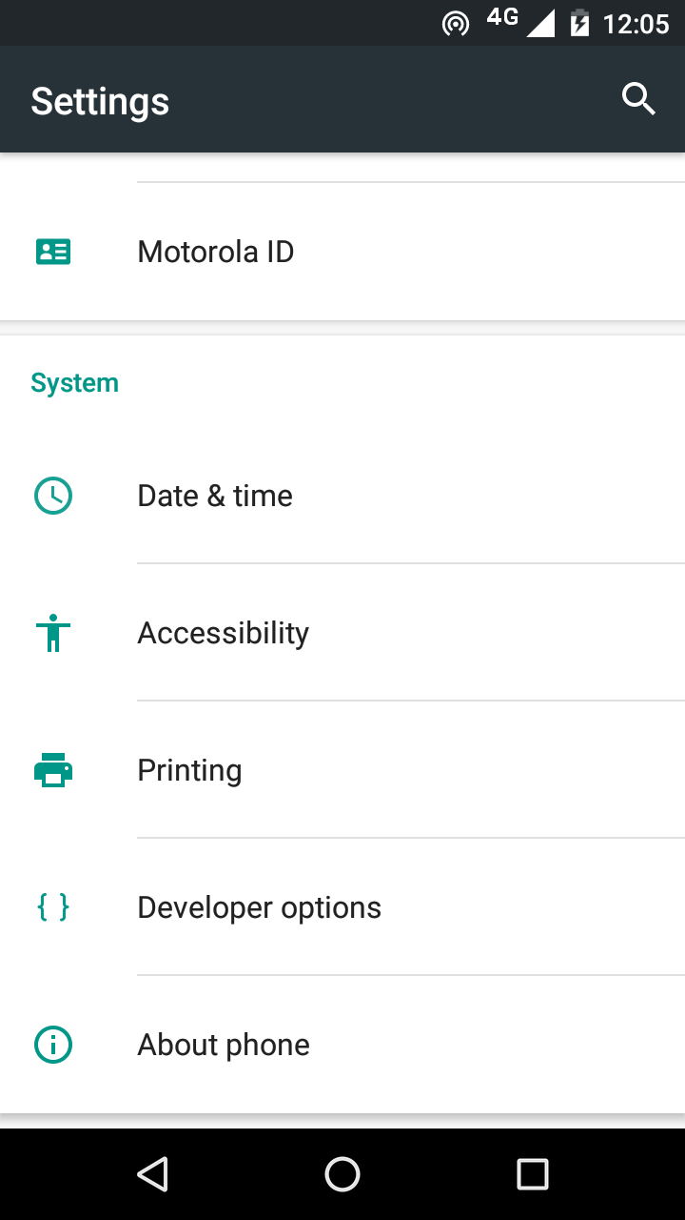

  - Tap on Developer Options and ensure that it is turned on.
  - Scroll down the Developer Options page and find USB Debugging. Enable this setting.
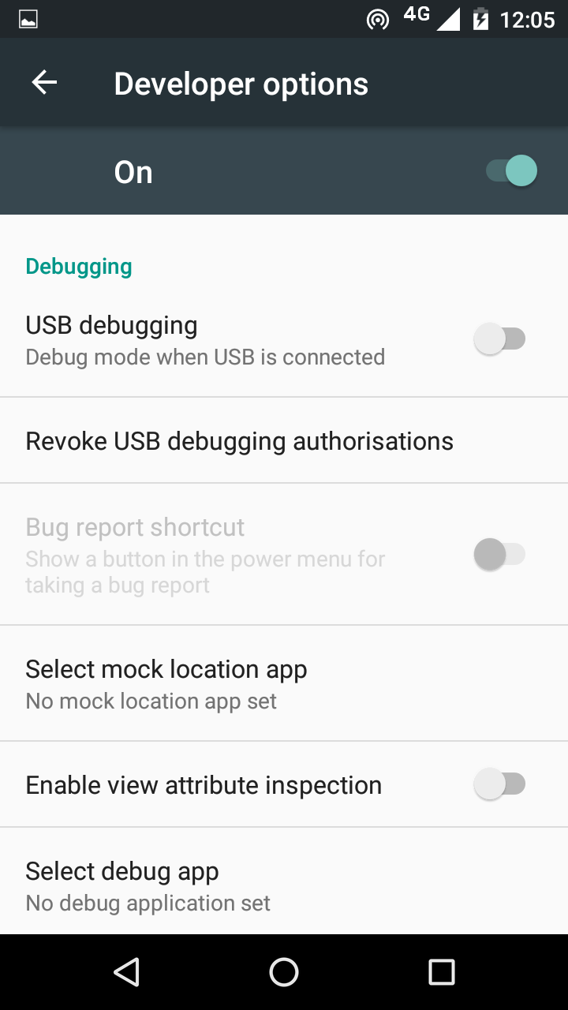

When you do this, you will probably get a message “Allow USB Debugging?” Tap OK.
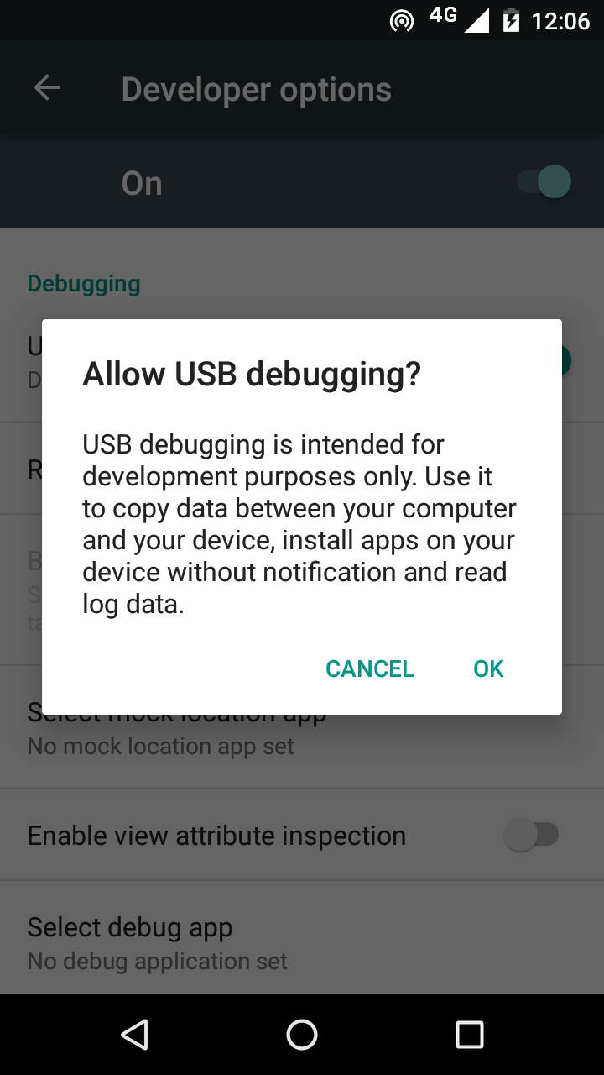

If you see a message box like this, check the box “Always allow from this computer” and tap OK:
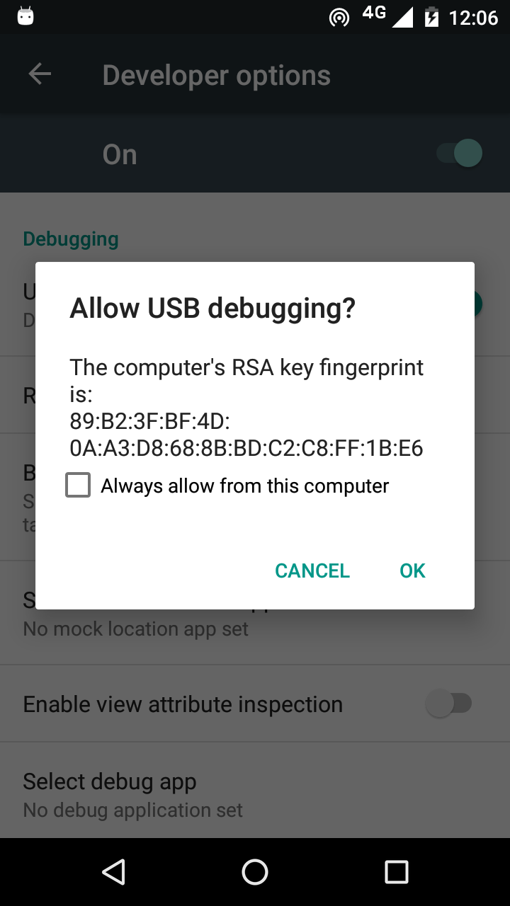

- In Reading App Builder, click the Install APK button on the toolbar at the top right of the screen.

A window will open and the APK file will be copied to your phone and installed. The app will then be launched.

If this does not work, look at the command window to see if there is an error message. If you see a message such as “No devices/emulators found”, it means that your phone and computer are not connected correctly, your phone is locked, or that you have not enabled USB debugging on your phone.

Described above is a two-step process: Build App and then Install APK. If you prefer, you can tell Reading App Builder to do this in one step, i.e. for the APK to be installed and launched automatically after building an app. See Tools Settings… After Build to enable this feature.

Frequently Asked Questions

What sort of apps can I build?
Reading App Builder is very versatile, and you can build quite a few different types of apps including story books, health manuals, literacy books, song books and quiz books. You can even combine these different types of “modules” into a single app according to your wider strategy. Think of the “building blocks” that you have—literacy materials, audio, videos, study materials, images—and seek how to combine them in different ways in different apps to help people with their specifics needs.

Use the links below to help you get more info on the various types of app types and modules you can build with Reading App Builder:

Picture Storybook apps
These comprise one or more storybooks, each generally with text and an image on each page. They are very versatile and can be used for illustrated cultural stories, literacy materials, teaching aids, health manuals and any other illustrated resources.

To create storybooks, see the following:
- Creating a Picture Story Book.
- Preparing text for your storybook in SFM or Word formats, or importing Bloom books.
- Preparing your images.
- Using a contents menu to access your books
- Adding audio to your books.
- Including copyright info for your text, images and other resources.
- Including links between books.

A collection of Bloom books
While the Bloom reader app gives access to any published Bloom books, it might fit your context better to have a contextualized app for a language group that includes just the Bloom books you want to group together. To do this, create an app with multiple books that you import from Bloom. Add a contents menu to clearly show which books are available.

See the following:
- Importing Bloom books into your app
- Using a contents menu to access the books.
- Including copyright info.

Song Book apps
You can easily create a song / hymnbook app that has an automatically-generated menu allowing the user to select by song number or name. You can even put several songbooks in a single app if the songs are grouped in logical ways i.e. an Old Testament song book and a New Testament one.

See the following:
- Creating a Song book
- Including copyright info.
- Creating a contents menu to access several different song books.

Quiz apps
For information on how to include quizzes in your app, see the document Creating Apps with Quizzes under the RAB Help menu.

Hybrid apps (combining different types of resources)
Depending on your goals, you may decide to create apps that have only one type of resource (i.e. a songbook app) or have several resources (e.g. a set of Bloom books and some quizzes).

If you do have different types of resources in the same app, they will by default appear in the drop-down book selector (on the app menu bar) with all other resources. This may be confusing for the user and/or result in a long and unwieldy list of books to scroll through. In this case, it is preferable to hide certain books from the list.

For example, if your app has a set of Bloom books and several quizzes, it may be best to have the Bloom books available in the drop-down book list and hide the quizzes. You will then need to make a contents menu with links to the hidden resources so the user can access them. Use nested contents menus to group your similar resources together.

To disable a book from appearing in the drop-down book selector, select the book in the project tree view, click on the Features tab and choose No under Show in book selector.

How can I contextualize my app for a specific audience?
One of the main advantages of RAB is the ability to completely customize each app for a specific audience. The following are links to the various app components that you may consider customizing:
- The app icon
- App graphics including the splash screen, border and navigation drawer image
- Available interface languages and text direction
- Interface colors
- Fonts
- Text and interface styles
- A contents menu
- Items available under the navigation drawer
- The bottom navigation bar
- What audio is available, if any
- Whether text should be highlighted when read
- Whether to include Videos or pictures in the text
- Whether to include different resources in the same app, like story books, quizzes, or hymn books.

How can I find the setting or feature that I need in my RAB project?
RAB includes a helpful search feature to aid in finding the various features and settings. Click on Find… at the right side of the RAB tool bar. You can also search in this Building Apps document, which covers almost all of the available settings.

How should I choose the app package name?
The app package name needs to be unique and cannot change once the app is published. For details on how to select a good package name for your app, see the Package section under the App Project Menu.

How can I add audio to my app?
You can add audio files to books (usually one audio file per chapter / page) and short audio clips for quizzes or when a user taps on an image, word or contents menu item.
For information on how to add and manage audio files, see Media > Audio.

How can I synchronize the text and audio in my app (creating timing files)?
Synchronizing the text and audio allows for the text to be highlighted as it is spoken, helping people follow along. This is done by creating a set of timing files, one per audio file. Timing files are also used to clip out audio so that verses can be shared via social media and slideshow videos can be produced. For help with synchronization, see How do I create the audio timing files for audio-text synchronization?

Do I have to create a new keystore for each app?
You can use the same keystore and key alias for all or several of your apps.

See here for more details:
http://developer.android.com/tools/publishing/app-signing.html

How can I include pictures in my apps?
You can include JPG or PNG image files in the text of the app. There are a few ways of doing this:
Method 1: Specify the image filenames within the SFM files
The app recognises the USFM illustrations markers \fig…. \fig*:
\fig DESC|FILE|SIZE|LOC|COPY|CAP|REF\fig*
i.e. 7 parameters, separated by six vertical line characters.
The only required parameter is FILE – the filename. If the file extension is .tif, the app will look for a file with the same name but with a .png or .jpg extension instead.
You can optionally include captions (CAP) and page references (REF).
Examples:
\fig |picture1.jpg||||This is a picture|5:3\fig*
\fig |picture2.tif||||This is another picture|\fig*
\fig |picture3.jpg|||||\fig*
\fig picture3.jpg\fig*

It also recognizes the \img marker which allows an image to “stick” to the top of a page while the page text scrolls underneath.
The syntax is \img FILE
Add the image files to the Media Illustrations page of Reading App Builder so they can be included in the app.

Method 2: Include the images inside a Word document
If your book is specified by a Word document, you can embed the images directly in the document between the lines of text.

The images will be included in the app assets and compiled into the final APK, so try to keep them as small as possible.

How can I handle a “right-to-left” language?
With Reading App Builder it is possible to format your app all or in part as “left to right” (the default) or “right-to-left”, which is the norm for a number of languages including Arabic, Hebrew and Urdu.

Setting the UI layout direction
The UI layout direction affects the position of the book name in the menu, and the side from which the navigation drawer slides out. To set the UI layout direction, See Appearance Interface Layout Direction.

Setting a specific book’s text direction.
Occasionally, you may want to change the text direction on a book-by-book basis. To do this, click on the book name in the project tree view and select the Styles tab. Click Customize styles for this book and select the direction from the Text Direction selector.

Changing the Orientation of the Contents Menu
You can switch the images in the contents menu to the right side of the menu screen and right-justify the text by changing the following styles:

To modify this… | Adjust this style…
The menu item’s text background, style and justification (set justification to “right”) | div.contents-text-block
The location of the image block. Set “float” to “right” to have the image on the right. | div.contents-image-block
The main Contents Menu. Set direction to “RTL.” | body.contents

Can I build apps when I do not have internet access?
The first time you build an app, you will need to be connected to the internet otherwise the compiler will fail. It will download a set of libraries used by the Gradle compiler. After that you can set the 'offline' version in Tools Settings so you can work offline.

If you want to be able to build your first app without needing internet access, it is possible to copy the Gradle cache files from another computer that has already downloaded them. This will only work, however, if the absolute path to the files is exactly the same on the computer from which the files are taken as on your computer, e.g. “C:\gradle” on computer A and “C:\gradle” on computer B. It will not work if you have “C:\Users\John\.gradle” or computer A and “C:\Users\Jenny\.gradle” on computer B (which is the default Gradle cache folder).
So, on computer A, to get the cache files to distribute:
- Go to Tools Settings Build Folders Gradle Cache Folder.
- Enter “C:\gradle” and OK.
- Build an app. The Gradle cache files will be downloaded to C:\gradle.
Then, on computer B:
- Copy the C:\gradle folder from computer A to C:\gradle.
- Go to Tools Settings Build Folders Gradle Cache Folder.
- Enter “C:\gradle” and OK.

Can I build an app from the command line?
Yes, Reading App Builder has a command line interface which allows you to create a new app and build it, or load an existing app and build it.
The command line tool is named rab and can be found in the Program Files folder, usually c:\Program Files\SIL\Reading App Builder.

rab takes the following parameters:

Option | Description
-new | Create a new app project
-load <project> | Load an existing app project
-build | Build app project (use with either -new or -load)
-no-save | Do not save changes to app (use with -load)
-? | Show command line help
-n <app-name> | Set app name.  Enclose the name in "double quotes" if it contains spaces.
-p <package-name> | Set package name, e.g. com.myorg.language.appname
-b <filename> | Add book or bundle file. This could be a USFM file or a zipped set of USFM files.
-i <filename> | Include additional parameters file.  Use the full path of the file and enclose it in "double quotes" if there is a space in the path.
-a <filename> | Set about box text, contained in text file.  Use the full path of the file and enclose it in "double quotes" if there is a space in the path.
-f <fontname> | Set font name or filename, e.g. "Charis SIL Compact", "c:\fonts\myfont.ttf"  The font name must be one of the items in the list of fonts in the New App wizard. For other fonts, specify the full path to the font filename.
-ic <filename> | Add launcher icon (one or more .png files).  Use the full path of the files and enclose them in "double quotes" if there is a space in the path.
-l <lang-code> | Set language for menu items and settings, e.g. en, fr, es
-ft <feature=value> | Set a feature, e.g. book-select=grid
-vc <integer> | Set version code, e.g. 1, 2, 3, or +1 to increment the current version code by 1.
-vn <string> | Set version name, e.g. 1.0, 2.1.4, or use +1, +0.1, +0.0.1 to increment the current value.
-ks <filename> | Set keystore filename.  Use the full path of the file and enclose it in "double quotes" if there is a space in the path.
-ksp <password> | Set keystore password
-ka <alias> | Set key alias
-kap <password> | Set key alias password
-fp <folder=path> | Set a folder path, e.g. "app.builder=c:\Reading App Builder".

Examples:
rab -new -n \"My App\" -p com.example.myapp -b MyBookBundle.zip
-f \"Charis SIL Compact\" -i keys.txt –build

rab -load \"My App\" -build

How can I add a horizontal line to separate certain paragraphs in text?
Use the marker \zhr to add a horizontal line. This will add a <hr> element in the HTML.

I don’t like the name “Reading App”. Have you thought of calling the app something else?
The program that allows you to define and build apps is called “Reading App Builder” but the app itself doesn’t have a name. It is up to you to choose the names for the apps you build.

You will not see “Reading App” anywhere in the apps you create, so feel free to use an appropriate name in an international, national or local language. App names that work well in certain contexts will be less helpful in other contexts, which is why RAB allows you to contextualise it.

The subsequent sections follow the project menu structure in Reading App Builder. Each main project menu topic has sub-categories for each sub-menu and tabs.

The RAB Menu Bar
The menu bar runs along the top of the Reading App Builder program window (Linux and Windows) or at the top of the screen (Mac).

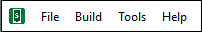

The File menu

New App…
This launches the New App wizard. See How to build your first app for more details.

Open App…
This opens the Select App Project dialog box. To open an app project, find and select its .appDef file. This will located in the project’s folder under App Projects. See How RAB stores your project data files.

Open Multiple Apps…
This will display a list of your most recently modified app projects. Check the selection box for each one you want to open and RAB will load them all into the project tree view.

Open App From Scriptoria…
If your project has been uploaded to Scriptoria, choosing this menu item will allow you to enter the Scriptoria project URL, download the project and load it into RAB.

Close
This will close the currently selected project in the project tree view.

Save
This will save the current project, and is the same as clicking the Save button in the tool bar.

Save All
This will save all unsaved projects.

Reload App
This is will reload the last saved version of your app project, erasing any modifications you had made since that time.

Copy App
This will create a mirror image of the current project, by default adding the word “(Copy)” to the project name to distinguish it from the copied project. This may be useful in creating similar projects but for different languages, or creating a test project to experiment with.

The project copy will have the same package name as the original, so be sure to change it to avoid confusion or overwriting the original project installation.

View Project Folder
This will open the current project’s project folder. This folder holds the project’s .appDef configuration file and the project’s data subfolders. See How RAB stores your project data files.

If you want to share your app project with someone else (i.e. someone who can help you test and find problems with your app), you’ll need to give them your project folder and all it contains. They can copy it into their own App Projects folder, open it in RAB and use their own, temporary keystore to build, run and test your project. If audio files are necessary for your app and they are not stored in your project’s audio subfolder, you will need to copy those separately.

View APK Output Folder
This will open RAB’s output folder where is places any compiled APK files, ready for copying to a phone to test or share with others. You can change the default output folder under Settings Default Folders on the RAB menu bar.

View IPA Output Folder
This will open RAB’s output folder where is places any compiled IPA (iOS) files, ready for copying to a phone to test or share with others.

Exit
Use this to close Reading App Builder.

The Build menu

Build Android App APK
This menu item will initiate the compilation of the currently selected project, duplicating the functionality of the Build Android App APK button on the RAB tool bar. Note that multiple, device-specific APKs will be built instead of one, comprehensive APK if the Generate device-specific APKs… option is selected under the App APK Multiple APKs tab.

Build Android App Bundle
This menu item will initiate the compilation of the currently selected project, creating an Android App Bundle (AAB) rather than an APK. An AAB file is necessary for publishing to the Google Play Store.

Build iOS Asset Package
For details on building an iOS Asset Package, please see Installing and Building Apps on a Mac under the RAB Help menu.

Build Multiple Apps
In some cases it may be expedient to set multiple app compiles going at one time. This may take a long time, however, depending on available memory. Selecting Build Multiple Apps displays a dialog listing the currently open projects in RAB. You can check or uncheck the box next to each app project to select whether it is built. Use the drop down list box to choose whether you want to build APKs or Android App Bundles.

Install Latest APK on Device
This duplicates the functionality of the Install APK... button on the RAB tool bar. If a phone is connected and set up for USB debugging, RAB will attempt to copy and launch the currently selected project’s last built APK. See Installing the app on your phone. If no APK is found for the project, RAB will prompt you to compile one.

Export Data Safety to CSV
Publishing an app to the Google Play Store requires you to specify a series of answers to data safety questions. Selecting Export Data Safety to CSV will export a comma separated values file into the APK output folder. This file can be imported as part of the process of publishing.

The Tools menu

Settings…
The Settings dialog box allows you to modify the RAB build settings and folders.

The Code Libraries tab
JDK Location
The Java Development Kit is a required set of code libraries for building apps. The normal RAB installation process should prompt you to download and install the JDK, and the JDK Location field should show the location of the installed files. If for any reason this is blank, or you need to change the version of the JDK, you can either Browse to another version already on your computer, or use Install JDK… to download and install a new version.

App Builder Location
This is the folder in which RAB was installed. If you need to install a previous version for test purposes, you can download it from the Previous Versions section at the bottom of the RAB download page and Browse to it here.

The Android SDK tab
Android SDK Location
The Android Software Development Kit is a required set of code libraries for building apps. The normal RAB installation process should prompt you to download and install the Android SDK, and the Android SDK Location field should show the location of the installed files. If for any reason this is blank, or you need to change the version of the SDK, you can either Browse to another version already on your computer, or use Install Android SDK… to download and install a new version.

Android SDK Packages
If installed correctly the four SDK packages should have green version numbers displayed (see example below).

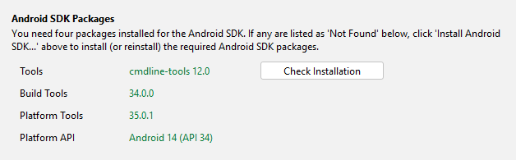

Click on Check Installation to make sure the four SDK packages are installed. If any of the four fields are listed as ‘Not Found,’ click Install Android SDK… to install or reinstall the packages.

The Defaults tab
Currently, the Defaults tab has one field…

Start of Package Name
Use this field to enter the default beginning parts of a package name that you generally use. See How Should I choose the app package name? for more details.

The Default Folders tab
Default App Projects Folder
Use this field to change the default location where RAB looks for app projects.

App Output Folder for Android Apps
Use this field to change the default location where RAB places your compiled APK files.

The Export Folders tab
HTML Output Folder
Use this field to change the default location where RAB places your exported HTML files.

EPUB Output Folder
Use this field to change the default location where RAB places your exported EPUB files.

PWA Output Folder
Use this field to change the default location where RAB places your exported PWA files.

The Build Settings tab
Offline Mode
The actual program that compiles your project to create an app installer file is named Gradle. The first time you compile your app, Gradle will need to download some additional files to run. From that point on, it will try to check from time to time if more updates are required. If you do not have internet available after the initial extra download, check the Use compiler offline box. You may, however, need to uncheck this when you have an internet connection to get any updates.

Fast APK rebuilds
RAB can speed up the app compile time by reusing some compiled files from the last build. If you are not seeing expected changes in your app, trying unchecking this option.

Memory Use
Normally, you do not have to modify this value. The accompanying explanatory text explains when you may need to change it.

The Build Folders tab
Gradle Cache Folder
Normally, you should leave this field blank to use the default cache folder unless you have a specific reason to choose another location.

Build Folder
Normally, you should leave this field at the default folder unless you have a specific reason to choose another location.

The After Build tab
You can set RAB to automatically install and launch an app after it is compiled if your phone is attached via a USB data cable and set up for USB debugging. See Installing the app on your phone. You may need a 3rd-party app to determine your phone’s architecture.

The Interface tab
User Interface
Use the User Interface dropdown to select the default user interface language for your version of Reading App Builder. You can also change this using the interface language selector at the far right of the tool bar.

Theme
Select the theme for the RAB interface.

Dark Theme
Select the dark theme for the RAB interface. This will be used if your computer has its dark theme mode enabled. If you want RAB to use the normal theme, even if the computer’s dark theme mode is active, select Always use the main theme.

The Files tab
Audio Files
Audio files can comprise some of the largest project data files. Use the setting here to tell RAB whether to keep audio files in their source location or copy them to the project folder’s audio data subfolder. This second option will make it easier to save or share the project, and is necessary for publishing an app through Scriptoria. However, it will double the size the audio files will take up on your computer (if you don’t delete them from the original location).

Fine Tune Timings
As explained in the tab text, RAB will automatically look in the specified folder for saved timing files and copy them to the project. You can modify the location if necessary.

Create New Keystore…
A keystore is a digital certificate file that ensures the app is legitimate. An app must be signed in this way so that it can installed on a phone. You may use an existing keystore or follow this wizard to create a new one. This process is also included as part of the “New App” wizard.

Enter a new filename for the keystore, such as “keystore1.” Specify a password. Click Next to continue.

Enter an alias name for a key to create within your new keystore, such as the default “key1”. Specify a password, which can be the same as the password you entered on the previous page.

It is very important to securely store the password for your keystore. Once the app is published, it cannot be updated without the keystore password. Make sure someone else in your organization has access to the app keystore passwords.

Click Next to continue.

On the Certificate Issuer page, provide details of your organisation in at least one of the fields. Click Next to continue.

A new keystore will be created for you. Click Close.

Install JDK…
This menu item duplicates the Install JDK feature under the Tools Settings Code Libraries tab.

Install Android SDK…
This menu item duplicates the Install Android SDK feature under the Tools Settings Android SDK tab.

Check Android SDK installation…
This menu item duplicates the Check Android SDK Installation feature under the Tools Settings Android SDK tab.

View Logs…
As RAB builds an app APK file, it opens a window that displays the internal steps it is taking as it compiles the app. Once you close this window (when the app compilation has finished), you can still view the output or any error information in the View Logs window. There are two tabs—one for any error information and one for the compilation output. These are useful if you need to figure out why a build failed and/or can be sent to a technical specialist for help.

Check aeneas installation…
Selecting this menu item runs a process that checks that aeneas was installed correctly. This can help in troubleshooting problems and/or can be sent to a technical specialist for help. Below is an example of a successful installation check:

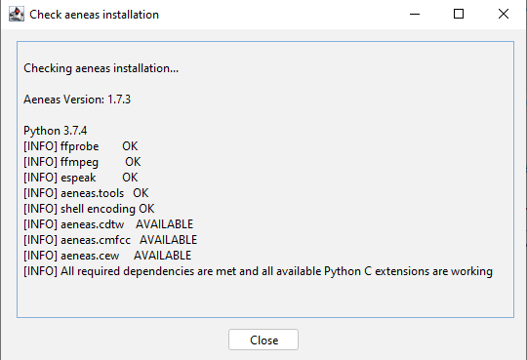

The Help menu
The Help menu gives access to a number of helpful features, documents and links.

Find Settings and Features
Use the Find Settings and Features dialog box to search for app settings you wish to set or modify. Start typing any keywords in the Find entry area and possible settings will display below. Double-click on a setting to open that location in RAB.

This feature can also be accessed using the Find… button on the right side of RAB’s tool bar.

Help Documents
Following Find Settings and Features are a list of helpful documents. Clicking on an item opens a PDF file that you can save locally if you wish.

Community Website
SIL maintains a community website where users can post questions, comments or feature requests. The app builder community is quite active and members like helping each other with specific needs. If you have a question or are trying to do something in an app that is not clearly specified in the RAB help documents, searching for a comparable issue in the community website is a good first step.

Customer Support Agent Website
This launches a browser page that provides an AI assistant to help answer questions about RAB.

About App Builder
The RAB About box shows the current version and build number, copyright information and a link to the Reading App Builder website.

The RAB Tool Bar
The RAB tool bar is a series of buttons directly below the menu bar.

New App…
This launches the New App wizard. See How to build your first app for more details.

Save
This saves the currently selected project.

Save All
This saves all the unsaved open projects.

Build Android App
This menu item will initiate the compilation of the currently selected project, duplicating the functionality of the Build Android App APK item on the Build menu. Note that multiple, device-specific APKs will be built instead of one, comprehensive APK if the Generate device-specific APKs… option is selected under the App APK Multiple APKs tab.

Install APK…
This duplicates the functionality of the Install Latest APK on device item under the Build menu. If a phone is connected and set up for USB debugging, RAB will attempt to copy and launch the currently selected project’s last built APK. See Installing the app on your phone. If no APK is found for the project, RAB will prompt you to compile one.

The Project Root Tree Node (Project Name)
You can have multiple projects open at a time in Reading App Builder. The projects are listed by project name in the project menu area. If you click on the project name (it’s root tree node), the app summary will appear in the zone on the right.
On this page you will see at a glance the app name, package name, version number, engagement features, font names, number of audio files, etc.
If the app is ready to build, the bottom card on the page will be green with a “Ready to Build” message. If the app is not ready to build, the bottom card on the page will be pink and a list of steps to take will appear (the same list that is displayed if you try to build an app).
Many of the elements on the page are hyperlinked, allowing you to move directly to the corresponding configuration pages. Pause your mouse over an item to show its hyperlink, if any.

The App project menu
These are the details for all the tabs under the App menu in the project tree view on the left side of the RAB screen.

Name and Package

The App Name tab
The app name is what the user sees displayed on the phone under the app icon. Depending on the phone settings, the number of visible letters in the name may only be around 20 and may get truncated. Keep this in mind and keep the name short and descriptive.
You can use the Translations… button to set several app names, each based on the interface language of the phone (set under Appearance Interface Languages). Alternatively, you can just have one name in the actual target, vernacular language.

The Package tab
The app package name needs to be unique and cannot change once the app is published. The standard for an app package name is to begin with the reversed web address of the publishing organisation, e.g. if it is SIL, the package name could begin with:
org.sil

and will be followed by something identifying the language and type of publication (a health manual etc.), e.g.

org. sil.cccc.nnnn.health

where ‘cccc’ is the country name and ‘nnnn’ is the language name.

Your organization might have standards to follow for package names, so please contact your digital publications coordinator for advice on this.

Once you publish your app on an app store, you cannot change its package name later if you want users to continue to receive updates. The package name uniquely identifies the app. Those who install the app will be able to find its package name on their device. It will also appear in the web address for your app if you make it available on Google Play.

If you are building apps for test purposes on your devices, you can use a package name beginning with com.example, e.g. com.example.test.app123

But remember to change it before you publish the app.

The Project tab

The Project tab allows you to name or rename your project. The Project Name is not seen by the user, but it is important as RAB uses it to name the actual project folder on your computer (see How RAB stores your project data files). If you will using a partner organization like Kalaam Media to publish your project to the Play Store, it is helpful for them if the project name starts with the language code and a hyphen e.g.
wol-Miracles of Jesus

You can assign a Project Group to nest similar projects together in RAB’s project tree view. This might be useful if you are working on multiple languages. Creating a Project Group will also create a project group subfolder under your App Projects folder.

If you modify a project name or group name later, you may have to close any affected projects in RAB, look in the App Projects folder and move projects back into their correct group.

The Project Description is just for your own purposes and is not see by the user.

Android

The APK tab
APK stands for Android Package and is an app installation file. An APK file is the result of compiling an app in RAB and is the file that needs to be copied to a target phone to install and run the app. As such, the name of the APK is primarily only important to distinguish it from other files. If the user will receive the APK directly (via file transfer or WhatsApp message or something similar), and therefore will be able to actually see filename, the name of the APK should clearly reference the project or app name. Selecting the checkbox to Append version name (number) to the filename can also help with distinguishing between versions. If the app is installed from the Play Store, the user will not see the APK file.

The Version code is just an internal number that you can use within your project as you do internal updates.

The Android Versions tab
The Target Android Platform refers to the current android platform that Reading App Builder supports. This is the required platform supplied by Google who update this requirement about once a year. All new apps being published to the Play Store have to support this version, and existing apps will have to be upgraded within a few years depending on Google’s specifications. New versions of Reading App Builder are designed to keep pace with these requirements and simply compiling and republishing the app with the latest version makes the app compliant.

In contrast, the Minimum Android Platform can be specifically set to target a generation of Android phones using a particular Android version or later. In general, the older the platform (meaning the smaller the version number) the older the phone that can run the app. However, if you app uses a feature that only works on newer phones, this minimum platform with have to be set accordingly.

The Install Location tab
You can specify here if the app is installed to a phone’s external storage (i.e. a micro SD card) or its internal storage.

The Multiple APKs tab
There are 4 types of Android phone architectures, and an APK file is designed to work on any of them. However, certain features (e.g. allowing saving as a video or the inclusion of GeckoView) can make the APK much bigger. Since these features depend on the phone architecture, smaller, device-specific APKs (known as Android App Bundles or AABs) can be built to target each architecture. The downside is that this prevents the sharing of the app bundle to another phone with a different architecture.

To Publish to the Play Store you will need to create Android App Bundles (AABs). When a user installs an app from the Play Store, they receive the APK associated with their phone’s specific architecture, not a universal APK. To explicitly create AABs, go to the Compile menu in the main RAB menu bar and select Compile Android App Bundle. If you are using Scriptoria, you can create the AABs there.
If you want to distribute you app on SD cards or other direct means to ANY phone, you will have to build an APK.

The App Signing tab
Your app must be “signed” to have permission to be installed on an Android phone. Signing means providing a way to authorize its installation by confirming that it is indeed created by you, the developer, and is not malware or a virus (or just an illegal app) in disguise. This is done by creating an encrypted, password-protected “certificate” file called a keystore.

If you don’t have one already, create a keystore by clicking on the Create Keystore… button which launches the Create New Keystore wizard.

If you want, you can use the same keystore for all your apps. However, for various reasons, you may want to have a single, shared keystore for just a selection of apps—perhaps all the apps for a particular language. If you ever need to give your projects to someone else, they will need the password to be able to change the app.

- Enter a new filename for the keystore, such as “keystore1.” Specify a password. Click Next to continue.

- Enter an alias name for a key to create within your new keystore, such as the default “key1”. Specify a password, which can be the same as the password you entered on the previous page.

It is very important to securely store the password for your keystore. Once the app is published, it cannot be updated without the keystore password. Make sure someone else in your organization has access to the app keystore passwords.

Click Next to continue.

- On the Certificate Issuer page, provide details of your organisation in at least one of the fields. Click Next to continue.

- A new keystore will be created for you. Click Close.

Select your desired keystore and enter the password.

The App Registration tab
This provides settings for the required registration of your app.

The Permissions tab
This tab lists all the required permissions drawn from the options selected in the app project.

iOS
This tab is for building iOS apps. For more details on this, please see the document Installing and Building Apps on a Mac under the Help menu.

About
Every app must have an About page, which is displayed to the user when they select About from the bottom of the app’s navigation drawer menu.

The About tab
Here is where you can define the about page text for your app.

The Copyright and Licensing tab
Enter the copyright and licensing information for every element (text, videos, images, audio etc.) in your app. Use the copyright helper to lead you through the formation of copyright information. See the section below for more information. If you do not know what to put here, please ask the publishing department of your organization for advice. They will want to make sure you get this right and do not simply make a guess as to what to include.

The Viewer tab
Click on the Viewer tab to see how the About box will appear in your app.

What information should I include in the About page?
The About page can contain any information. What you include is your choice, but commonly included items include:
- The app name and version
- The name of the organization publishing the app
- Copyright and license information for the contents of the app (texts, images, audio). In most cases, the license agreements will require you to include such information.
- Copyright information for the app itself.
- Link to your website
- Link to a privacy policy
- Contact information, such as an email address or phone number.
- A “brand” image for your local organization and/or the icon image for your app.

Which formatting codes can I use in the About page?
You can use the following formatting codes:

Bold text | Surround the text you want in bold with <b> and </b> markers.  Example: <b>This is in bold</b>
Italic text | Surround the text you want in italics with <i> and </i> markers.  Example: <i>This is in italics</i>
Underlined text | Surround the text you want underlined with <u> and </u> markers.  Example: <u>This is underlined</u>
Website links | Use the format [text](url), where ‘text’ is the text to display and ‘url’ is the web address.  Example: Here is our [website](http://www.example.com)
Email links | Use the format [text](mailto:address), where ‘text’ is the text to display and ‘mailto:address’ contains the email address.  Example: Contact us by [email](mailto:contact@example.com)
Phone numbers | Use the format [text](tel:number), where ‘text’ is the text to display and ‘tel:number’ contains the number to call.  Example: Our number is [012-345-678](tel:012345678)
Image | To add an image, first add the image file to the app illustrations (Images Illustrations) and use the following HTML code:  <img src="image1.jpg"/>  You can specify width information, as a percentage (e.g. "80%") or a fixed number of pixels (e.g. "80px"), or in the img.about-image style:  <img width="80%" src="image1.jpg"/>
Left, right or centered alignment | To align text or images, surround them with the following <div> markers:  <div align="center">This is centered</div>  <div align="left">This is left aligned</div>  <div align="right">This is right aligned</div>  To center an image:  <div align="center"><img width="75%" src="img2.jpg"/></div>
Styles | To apply styles (defined in the Styles page):  <div class="q2">This is styled as poetry</div>
Fonts | To apply specific fonts to text, first make sure that the fonts are specified on the Fonts page. Then use the following syntax:  <span style="font-family:font1;">This is in font1</span>  <span style="font-family:font2;">This is in font2</span>
Links within the About box | Set a marker to jump to when a text phrase is clicked. For example, set a language marker (Eng) to allow the user to jump to About box text in English—if you want to have multiple languages in the text.  <h3 id="Eng">English</h3> (sets the id Eng associated with this section)  <a href="#Eng">(Click here for the English version)</a> (marks the section to jump to)

To center all the text in the About box, add “text-align: center;
“ to the CSS in the body.about UI style

To modify this… | Adjust this text style…
About page formatting | body.about
Background block for an image (see above on how to add an image) | div.about-image-block
Image size / width | Img.about-image

Which variables can I use in the About page?
You can use certain variables on the About page. These are replaced by text in the app. For example, the variable %version-name% will be replaced by the app version number, e.g. “1.2” in the app.

App name | To display the app name, use the variable %app-name%
App version | To display the app version, use the variable %version-name%
Program Type | To display the program type (RAB), use the variable %program-type%
Program Version | To display the version of the program used to create the app, use the variable %program-version%

Security

The Expiry tab
Normally, if your app is published to the Play Store or App Store, you don’t want it to expire. If you want to update it, adding books or functionality, you can just publish the update and users will be able to get the new version. However, if you are creating a test version to distribute informally, you will probably want to set an expiration date.
There are three options on the Expiry tab for setting the app duration:

App does not expire
This is the default and appropriate for published apps.

App expires on a specific date
You can specify a date when all copies of the app will expire on all phones. This would be appropriate for a test version that you want to be in circulation for a limited time before getting feedback.

App expires a certain number of days after it is installed
You can specify a number of days (up to 1000) that the user can access the app before it expires. Again, this might be useful for a test period.

You can also display an optional message when the app expires. There are two options here as well:

Show message and exit app
This would be appropriate for ending a trial period and telling people to watch for the release version of the app, or perhaps to contact a certain person in order to give feedback. After showing the message, the app exits and cannot be run again.

Show message but allow the user to continue using the app
This would be appropriate, for example, if the test version is accurate (consultant checking has been finished on the books) and the app has been distributed from phone to phone, especially if it is difficult for the user to get an updated version over the internet.

You can type the desired message in the text entry area at the bottom of the screen.

The Security tab
Compression and Encryption
By default, RAB encrypts and compresses the data in the app. Normally, you should leave this setting enabled.

You can also choose to prevent users from taking screenshots in the app. A possible reason to enable this is if you have copyrighted art in the app and the artist does not want people to be able to copy their pictures without an associated copyright notice.

Restricted Users
You can choose to let anyone install the app or restrict the installation in the following various ways:

Allow only selected devices to use this app
This is the most restrictive setting and may be applicable in certain high-security contexts where only a very specific set of people should be able to install the app, based on their exact phone ID or serial number. Click Specify Devices… and add an entry for each phone you want to permit.

Require a device-specific access code to use this app
With this option you can create a series of access codes to send to users so they can access the app. This requires one or more administrator accounts to be set up to send codes to users. This method allows a broader reach than just having selected devices set up to install the app.

The access code will depend on two things: the device id and the app's secret key (defined in Access Code Settings). If the secret key is defined as the same for two apps, then the same access code will open both apps on a given device. To avoid this, make sure that the secret key is completely different between apps. A slightly different key (i.e. one or two characters different) might generate the same access code.

Require each user to register with their details when they first use the app
This option is useful for setting up a campaign directed at registering users and keeping them informed on updates and advertising things like listening groups to enhance collaboration in a community.

Show a calculator on start-up. Entering a code will give access to the app content
This option is useful for high-security situations where the app needs to be completely hidden on a phone. A specific, long, digital number can be specified (e.g. 84567.294) as a code to put in the calculator’s number field. Then hit = to transform and open the app.

It is advised to make the app name and icon correspond to those of a calculator app.

The Appearance project menu

Icons
Icons are important graphical elements of your app. In some sense, they represent your app to the user. Though RAB provides a gallery of icon images, it is recommended to put some prayerful, creative thought into creating a unique app icon, perhaps following a wider brand design for all your apps.
The Icons menu item covers both the icon the user sees on their phone screen which launches the app, and the notification icon associated with your app that appears next to any notification text messages that pop up. The Icons menu has four tabs:

The Android Icon tab
Devices from Android version 8.0 to Android 11 support Adaptive Icons. It is important to define an adaptive icon for your app, otherwise the icon will not be shown well on those phones. The Android Icon tab gives an example of how your icon will look with each of the Adaptive Icon choices. It also shows how it will look at several different sizes.

Use the Create New Icon… wizard to create an icon for your app. This will produce both an adaptive icon for newer Android versions, and all the sizes necessary for older versions. This wizard has two screens:

Foreground Image
Select the foreground image for your icon and adjust the padding percentage.

Background Image
Select a color for the icon background or an image with a non-transparent background. Android will use the background image to fill in the outer border of the various adaptive icon shapes.

The Android Icon Layers tab
Foreground and background layers for adaptive icons are specified separately. Users can decide which shape they want their icons, and the Android system will use the background layer to fill that shape, then place the foreground layer on top.

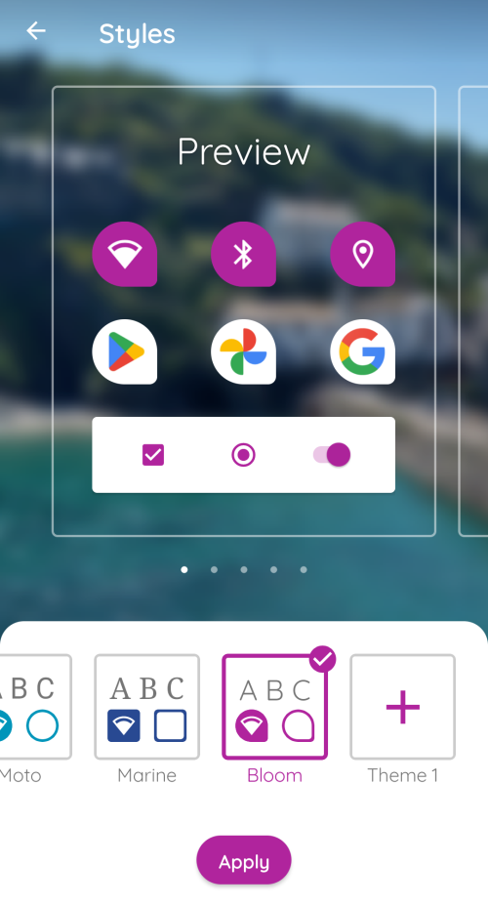

You can further adjust the foreground layer image using the percentage slider. Aim to have the image just a tiny bit larger than the circled area. You can also modify the background image you selected in the Create New Icon wizard. Use the preview list box to view the various adaptive icon images Android will create.

The Android Legacy Icons tab
Legacy icons (those for versions of Android earlier than 8.0) need to be specified in a variety of sizes, and the phone’s operating system will select which icon size that is best to display. Use the Generate from Adaptive Icon button to create these sizes automatically from the icon specified in the Create New Icon wizard. You can alternatively use a tool like IconKitchen. IconKitchen will create a .zip file that you can download with all the various sizes. Use Add Icon Images… to select the downloaded zip and RAB will open the file and assign all the various sizes.

While IconKitchen has some basic tools to design an icon from scratch, you might prefer experimenting with using an AI picture generator like CoPilot to make a base icon image that you can then select into IconKitchen, adjust and download.

RAB will create a series of folders under the project data folder’s Images sub-folder, one for each icon size. (See Project-specific data folders). You can see these folder names under the Filename column of the Legacy icon display list. Each icon name is identical: ic_launcher.png

If you want to publish your app on the Google Play store, you will need the 512 x 512 icon image stored in the drawable-web subfolder. You may want to use this image as part of the required Feature Graphic, too.

The Notification Icon tab
This tab is identical to the Notification Icon tab under Engagement Notifications.

Graphics
This menu allows you to set several optional graphical elements for your app. Click on a tab to modify that element.

The Android Splash Screen tab
A splash screen is a title screen for your app that can automatically display for a specified number of milliseconds when your app launches. A splash screen can be an attractive “intro” to your app and should be set to display long enough for the user to read any text on it, but not so long that it becomes annoying.

There are three recommended sizes for Android splash screens. Presumably, the phone’s system will choose the one most appropriate for the particular phone’s resolution and aspect ratio. If one doesn’t fit exactly, we assume the OS will scale the nearest size to fit. In that case, for best results you should at least supply the largest size (720x1280).

If the book to which your app is related has already been published as a physical book, you might use the cover of that book as your splash screen to show continuity with the printed text. You could alternatively use a design incorporating your app icon with the app name. Try to harmonize the colors in the splash screen with the icon and interface colors.

Check the box to Show splash screen on start up, and set the number of milliseconds. Around 800 – 1000 milliseconds is a reasonable, suggested interval.

The Navigation Drawer tab
The optional navigation drawer image appears at the top of the app’s slide-out navigation drawer. By default it is a simple, open book image. Adding your own image makes the app more aesthetically pleasing, especially if you use elements of the icon, interface colors and / or splash screen in the design. It can be a photo, your organisation’s logo or any relevant graphic design.

The top part of the navigation drawer image will be partially obscured by the shadowed area. Make sure your image clearly displays what you want the user to see.

As with the splash screen, RAB gives a number of suggested sizes, all using a 16:9 aspect ratio. If you want to include your own navigation drawer image, you should at least provide the largest size so it will scale well.

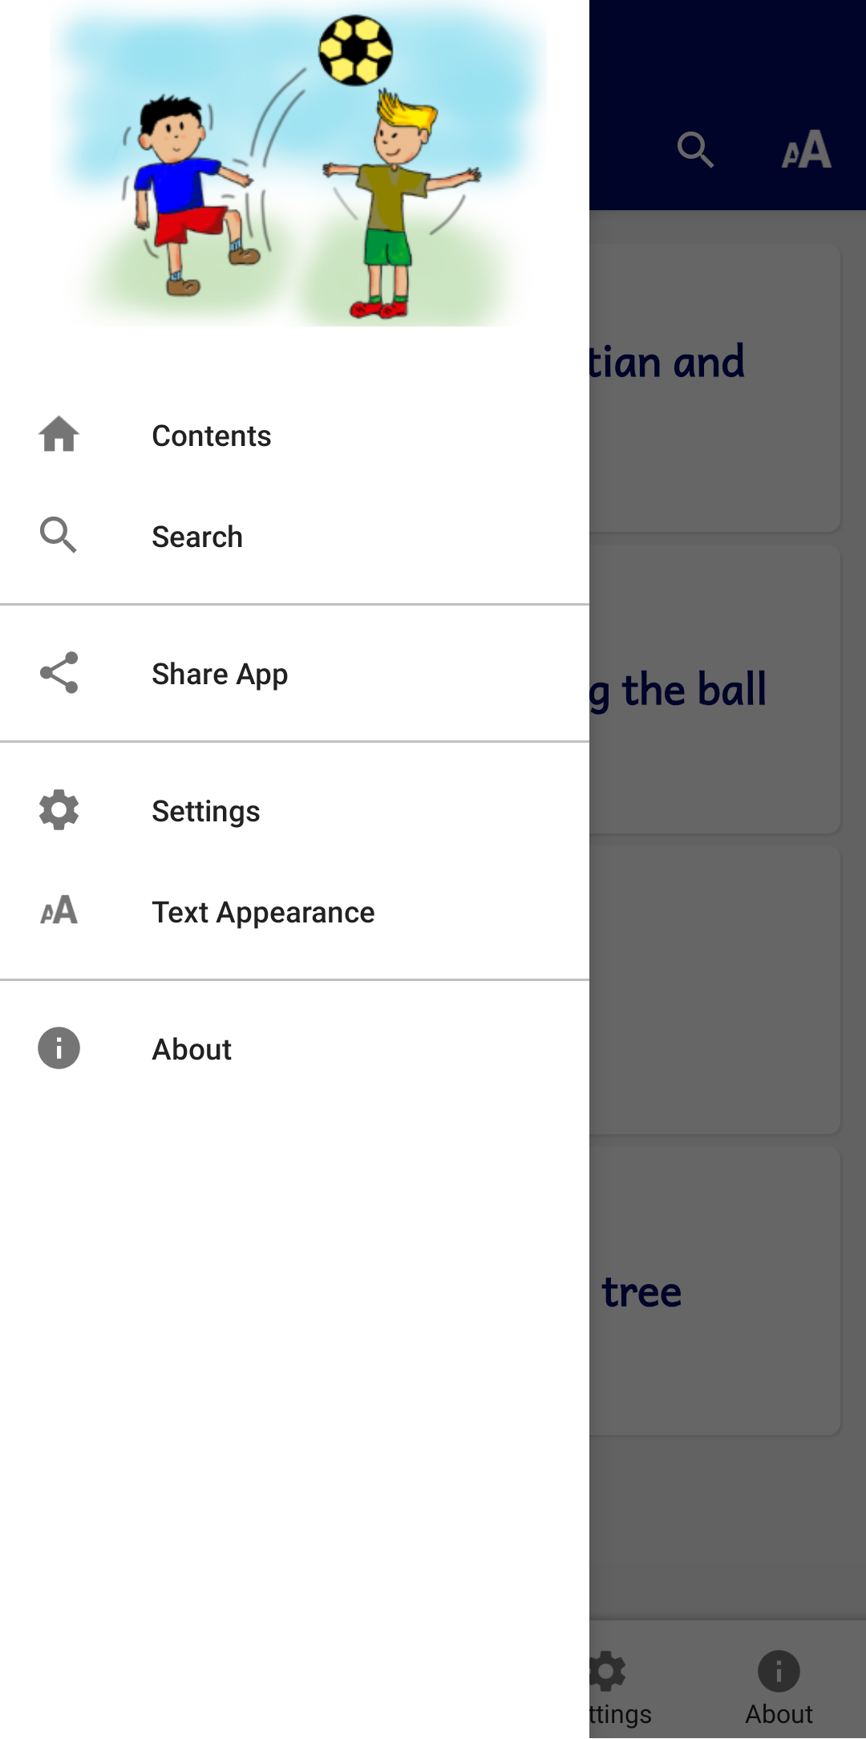

Example navigation drawer image

To modify this… | Adjust this interface style…
Navigation drawer background | ui.drawer
Navigation drawer item text | ui.drawer.item.text
Navigation drawer item icon | ui.drawer.item.icon

NOTE: to change the font size in the navigation drawer, go to Appearance Interface Languages and double click on an interface language. Change the percentage of the font size higher or lower

The Borders tab
You can add a decorative border frame around the text in the app, for example:

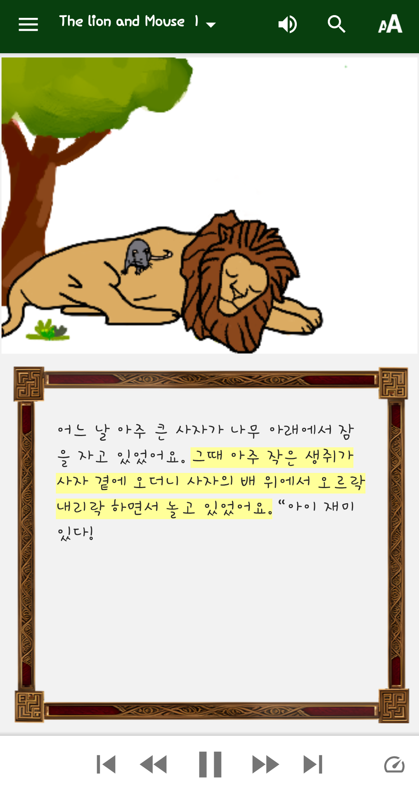

You can select a border from the gallery of border images supplied with Reading App Builder, or you can create your own border.

To select a border from the border gallery:
- Click Choose from Gallery…
- Select an image from the gallery and click OK.
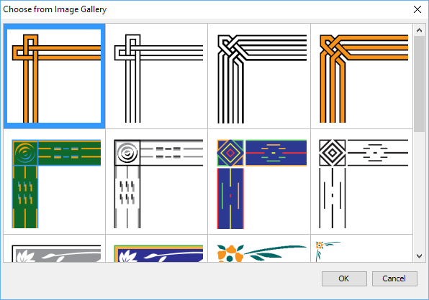

To add your own border:
- Create the border as an image file (JPEG or PNG) in portrait orientation. Ensure that the middle rectangular area of the image is blank. This blank area is where the text will be displayed.
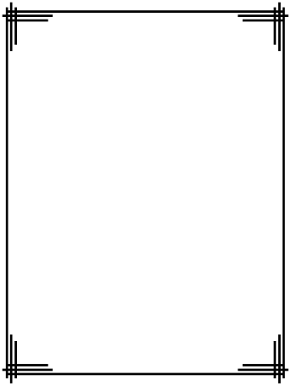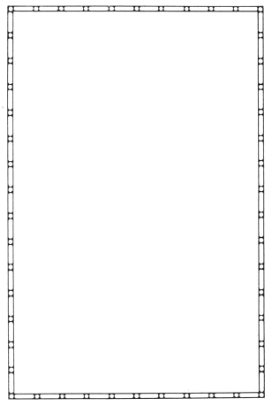
You do not need to provide a border image in landscape orientation. This will be generated automatically. It does not matter too much what the width-to-height ratio of the image is, since the app will cut up the border and arrange it for different screen sizes.
Try not to make the border too wide, otherwise there will be limited space to display the text.
- Go to the Appearance Graphics Border tab.
- Click Add Image… and select the border image.
- Ensure that the checkbox Include a border around the text in this app is selected.
- If you want to display the border for some books and not others, or on main book pages but not book introductions, go to the Features page for each book and modify the Show border around text and Show border around introduction settings.

Reading App Builder takes the border image file you provide and finds the blank rectangle area inside of it. It then cuts up the remaining image into 8 pieces: top-left corner, top, top-right corner, left, right, bottom-left corner, bottom and bottom-right corner.
When the border is displayed on the app screen, the corner images are scaled according to the screen size, and the side, top and bottom images are scaled and stretched to fill the space between the corners. In this way, the border adapts itself to display with different screen sizes. This technique allows the app to display the border in full screen view, or when there is a toolbar displaying at the bottom.

Interface
The Interface menu allows you to specify in which languages the user interface is available and how that translation is displayed. It has three tabs: Languages, Translations and Layout Direction.

The Languages tab
The Languages tab allows you to specify which interface languages are available for the user to select from. This is best determined by knowing the app’s intended audience and choosing languages that will meet their needs. NOTE: this does not refer to the actual language in which your book resources are written.

RAB has a list of languages that already have interface translations, covering many of the world’s national languages e.g French, English, Spanish and Chinese. You can choose which languages the user can select from when they access the app’s settings. Use the Add language… button (see below) to add an interface language and provide the translation of all the terms.

RAB will detect what language the user’s phone is set to. This is normally one of the national languages in RAB’s list. At this point, you can specify what you want the app to do using one of two choices:

Use the current system language of the device. If no translations exists in this language, use…
Select this option to detect the phone’s current system language and try to match it with one of the languages you’ve provided. If the phone happens to have a language that is not in your list, you can specify which default language to choose.

Research where major communities in your target local language are living and what are the national languages in those areas. Provide those languages for them to choose from, and select one to be the default. For example, the Wolof people in francophone Senegal have diaspora communities in France and the USA. In this case, select French and English as available interface languages and perhaps select French as the default language if a user’s phone isn’t in English or French.

Use this language:
Use this option to force the app’s interface to appear in a certain language, no matter what the phone may be set to. Users can still change the language to one of the ones you’ve provided in the app settings.

This option is useful if your app contains interface text or book resources in one particular national language. This would normally be if the specific audience are almost exclusively in just one country with one national language.

Which interface languages do you want users to be able to choose from in the app Settings?
This is the list of available interface languages. Choose all those that you think would help the app users, covering the countries where there are significant communities. Including a choice of languages does not significantly increase the size of the app.

Double-click a language name to specify the Font, Size and Text Direction (i.e. Left to Right) that the interface will display for that language.

Add Language…
Use this button to add your own interface language. You specify the name, language code, default font and size, and the text-direction (for right-to-left languages). Once you select OK, the new language will appear already selected at the very bottom of the interface languages list. Click on the Translations tab to enter the translated interface element names for this language.

The Translations tab
The Translations tab allows you to modify the names of interface items in any of the languages you selected to be available in the app. If you added your own language, it will appear in the right-most tab.

Use the Export button to export a text file with all the interface items to translate, in each of the available languages. This is useful if you want to give the list to someone else to translate. If you added your own language, you may have to enter its code and translation for each item. E.g. if I add the Wolof language and code “wol” (using the Add Language button on the Languages tab), then export the interface translations list using the Export button, I can add the Wolof translations. In the exported text file, each interface item has a heading (e.g. $ Menu_About) followed by a list of language codes and their translation for the Menu_About interface element. At the end of the list for Menu_About I can add a line wol: <put translation here>. I can then do this for all the interface elements.

Once the list is finished, use the Import button to import the changes into RAB.

The Layout Direction tab
The UI layout direction affects the position of the book name in the menu, and the side from which the navigation drawer slides out. There are four options:

- Left to Right – the default, with the book name displayed in the upper left and the navigation drawer sliding out from the left side.
- Right to Left – with the book name displayed in the upper right and the navigation drawer sliding out from the right side.
- Use the direction from the current user interface language. If the current language is normally written in a certain direction, the app will mirror that setting. This means that a user may change the app language in the settings and the app will respond with the correct UI direction.
- Use the direction from the text being displayed. This will depend on the book text being displayed in the screen area, or the top screen in two-pane view. See Setting a specific book’s text direction.

Colors
The Colors menu lets you customize almost any color in your app. The Color Scheme tab lets you set an overall look and you can further customize colors using the Main Colors and Book Colors tabs.

The Color Scheme tab
RAB comes with around 28 pre-made color schemes. The color scheme affects the menu bar, bottom navigation bar icons, font sliders, book selection tabs and title text color. Click on the scheme you want and then choose which themes (Normal, Sepia, Dark, Rose, Sage and Charcoal) the user will have access to. These will appear under the text size (AA) icon on the menu bar.

The Main Colors tab
The Main Colors tab allows you to customize all the named color settings for all six themes (Normal, Sepia, Dark, Rose, Sage and Charcoal). Double-click on a color entry to display the Edit Color selection dialog for all three theme. Use Select Color… to launch the color picker for each theme entry.

Fonts
With the various tabs of the Fonts project menu, RAB allows you to specify one or more fonts to use in the app and to specify one or more keyboards and lexical models to aid users in typing in their language.

The Main Font tab
RAB allows you to specify a main or “common” font for use in the app (by default). You can alternatively choose to specify a number of other fonts (using the Font Files tab) that will be embedded in the app for use with different books. If you provide several fonts, users will be able to choose between them in the Text Appearance popup and the Verse on Image editor.

To specify a default size for a font, set it under Books Styles Default Text Size.

The Font Files tab
Use this tab to specify all the font files from which you can choose for the main font and fonts available under the Fonts tab at the Book or Books levels.

Click Add Font… and specify a reference “Family name” for the font. Then either select one of the suggested common RAB fonts or one of your own choosing. After clicking Finish, the font will be added to the list of available fonts from which to choose.

Right-click on a font file in the list to either delete it or edit its properties.

The Font Handling tab
Use the Font Handling tab to activate the GeckoView font handling component. If you are using a non-Roman script or a Roman script with combining diacritics, it is possible that Android devices will not display your fonts correctly. To overcome these problems, try using the GeckoView library.
GeckoView is a viewer component from Mozilla that replaces the standard Android viewer. It can render Graphite fonts correctly.

The required GeckoView library files will add at least 55 MB to your app size, so do not enable GeckoView unless you know you need it to display your fonts correctly.

You will find that when you build an Android APK with GeckoView, the APK size will be at least 200 MB larger than without GeckoView. This is because it contains the GeckoView libraries for four different device architectures (32-bit ARM, 64-bit ARM, 32-bit Intel and 64-bit Intel). In practice, your app users do not need to install such a large file.
- For online app distribution, you need to upload an AAB file (app bundle) to Google Play rather than an APK. The AAB file contains all the GeckoView libraries for all four device architectures, but when a user installs an app from Google Play, Google will create a tailored APK for them, with just the libraries and components their phone needs. The AAB file might be over 300 MB, but the actual size of the app for any user will be much smaller.
- For offline app distribution, you can ask for Reading App Builder to create multiple APKs, one for each device architecture. Do this on the App APK tab. Each of these APKs will be significantly smaller (around 55 MB extra for GeckoView). You just need to choose the right one(s) to distribute, according to the types of phones people have. Many of the phones today will use the 64-bit ARM APK. Otherwise, the 32-bit ARM APK is used for most older phones. Intel phones are less common, but it will depend on the phones being sold in your country.

The Keyboards tab
Use the Keyboards tab to specify one or more Keyman keyboards to include in your app. This allows users to use the keyboard for typing notes etc. in their language(s). The Keyboards tab includes links to Keyman Developer (for creating your own keyboards) and the Keyman website. It is worth checking the website to see if someone has already created the keyboard you desire.

Important: To allow the user to use a keyboard, make sure and select it at the Books level on the Styles tab.

The Lexical Models tab
Use the Lexical Models tab to specify one or more lexical models to provide predictive text for embedded Keyman keyboards. The Lexical Models tab includes a link to the Keyman Developer website for designing and compiling your own models.

Styles
One of the powerful advantages of Reading App Builder is the ability to make a fully-contextualized app for a specific target language and culture. To that end, RAB gives the app designer a lot of control over the text and interface styles. To see specific references and explanations to all the styles available in RAB, see Appendix 3.

Each style has multiple fields that can be customized, stored as underlying CSS fields. Styles are divided into two main categories: Text Styles and User Interface Styles. You can also create Custom Styles. Use the Find feature to search for a particular style to modify. If you know the USFM marker for the style, you can try using that for searching. For example, if you want to modify the style of a line of poetry, search for either “poetry” or “q” which is the USFM poetry marker.

Each style lists the Name, Description and Designation—the specific characteristics of the style. Double-click on a style to display the Edit Style dialog box. Use the Style Properties tab to modify the style and/or the CSS tab to add or modify specific style elements. Click OK when done. The modified style name will now be displayed in blue to show that it has been changed. To revert to the default values, right-click on the style and choose Reset to Default.

The Appearance Styles menu is for setting “app level” styles. Styles can be set in 2 places: at the app level, the Books level and the book level. By default, styles set at the app level apply to all books. Some styles are only applicable to the app itself (e.g. menus, navigation drawer etc.). However, many styles, especially text styles, can be individually set for specific books.

The Text Styles tab
This is a broad category that contains many formatting marker styles and many other descriptive and functional elements in the app’s content. Also included in the text styles are the various elements for quizzes (see the document Creating Applications with Quizzes). Use the Find feature to search for a particular style. For more information, see Appendix 3.

The User Interface Styles tab
Interface styles generally affect the user interface elements of your app. This includes the menus, icons, dialog boxes, tabs and navigation drawer. For more information, see see Appendix 3.

The Custom Styles tab
Use the Add Style… button to add a custom style.

Setting styles at the book level
To change a particular book’s styles, click on Books <Book name> and then choose the Styles tab in the configuration area on the right.

Changes
You can define a set of regular expression “find and replace” changes to apply to the text in your source files. The changes will be applied during the app build process and the original source files will not be changed. For example, if you have added Paratext files from a Paratext folder that receives updates from your team and yet you need to modify certain text styles or markers to display correctly in the app, you should apply those modifications using the Changes feature. In this way, they will not be overridden by Paratext updates, or affect the Paratext project itself.

Changes applied at this level will affect the whole app. You can use the Changes tab in the book menus for changes at those levels.

Once Change items have been added, you can turn them off or on by clicking in the Enable checkbox. Right-click on a Change item to edit or delete it.

Add Change from Gallery…
RAB comes with a limited set of Changes already defined. Click on the Add Change from Gallery… button, select any you wish to use and click OK.

Add Change…
Click the Add Change… button to add a Change item. You can give it a descriptive name and specify the regular expressions to use for the Find and Replace fields.

The Data & Analytics project menu

Analytics
If you enable Analytics, the app will connect to the internet from time to time to send app usage information to one or more analytics accounts. This will give you an idea of the extent to which people are interacting with the app.

The information sent will include the model of the device (such as ‘Google Nexus 7’, ‘Samsung Galaxy S4’), the Android version (such as ‘4.2’), the mobile network provider and an approximate location (city/country). No personal information is included.

You can configure your app to send usage data to one or more of the following analytics engines:

S3 Digest Analytics | Sends a digest of analytics data to an Amazon S3 Bucket of your choice.
Amplitude Analytics | Sends data to an Amplitude account of your choice.
Firebase Analytics | Sends data to a Google Firebase Analytics account of your choice.

To set up analytics:
- Select Enable Analytics.
- Choose whether users can opt out of sharing user data
- Click Add Analytics Account…
- Choose an account type and enter your analytics account information.
  - For S3 Digest Analytics, you will need an S3 Bucket ID and an Identity Pool ID.
  - For Amplitude Analytics, you will need an API Key.
  - For Firebase Analytics, you will need a google-services.json configuration file for your account.

S3 Digest Analytics
To use S3 Digest Analytics, ensure you have admin permissions to an Amazon AWS account, and go to:
https://aws.amazon.com/console/

You will need to:
- Click Sign In to the Console at the top right of the screen.
- Create an S3 Bucket.
  - Go to the S3 Service and click Create bucket, enter a Bucket name, select a Region near where the app will be distributed, and click Next.
  - On the Set properties and Set permissions steps, use the defaults and click Next.
  - Review the configuration and click Create bucket.
  - Copy the Bucket name into the S3 Bucket ID field in Reading App Builder.
- Create a Federated Identity.
  - Go to the Cognito Service and click Manage Federated Identitites. The first time you use this service it will start creating an identity pool for you. If the AWS account already has identity pools, then it will show a grid of existing one. If this is the case then click Create new identity pool.
  - Enter an Identity pool name, click Enable access to unauthenticated identities (which allows users of the app to submit analytics without logging into some service), and click Create.
  - Click Show Details to see the Role Name for the unauthenticated identities (in the next step, we will give them permission to put objects in the bucket created in the previous step). Click Allow.
  - Copy the Identity pool ID value inside the quotes in the Get AWS Credentials section of the Sample code page shown after completion of the previous step. Copy this string into the Identity Pool ID field in Reading App Builder.
- Give permission to put data into the S3 Bucket.
  - Go to the IAM Service and click Roles category.
  - Click on the Role created in step #3 (e.g. Cognito_<IdentityPoolName>Unauth_Role).
  - Click Add inline policy, click Service and choose S3.
  - Click Actions, type in PutObject to search for actions, and check PutObject to select that action.
  - Click Resources, use default Specific, click on Add ARN link, enter the Bucket name from step #1 into the Bucket name field, click the Any checkbox at the end of the Object name field, and click Add.
  - Click Review policy, enter a name in the Name field, and click Create policy.

Data Payload for S3 Digest Analytics
S3 Digest Analytics will send a small daily digest (about 300 bytes for each day the app is used) of compressed, completely anonymous data (no personal, phone, or GPS location information) via an encrypted transport (https) to an Amazon data center, when the device is connected to the Internet (via cell or WIFI) while the app is running. You are responsible for hosting the Amazon S3 Bucket and processing the received data.

Files are uploaded to the S3 Bucket and in a sub-folder based on the format (e.g. the current format is f1) and stored with a unique filename using a randomly generated GUID as the basename. We are working to package a Splunk configuration so that you can deploy your own server to analyze the data.

S3 Digest Analytics uses a JSON payload format. A complete sample data payload is below:
{"startTime":"20180306T0835Z","period":1440,"id":"12db7e3f-93d9-4370-b12b-fe048804e4f5","package":"org.sil.picturebooks.cuk","version_name":"1.0.1","sessions":1,"sessionMins":21,"shares":3}

This sample is comprised of the following fields:
- One day of activity (1440 minutes), starting on 2018-03-06
- The id is a GUID which was randomly generated on the phone when the app was first launched, enabling determination of how many unique installations of the app are in use (but no user-identifying information).
- Package and version indicate which app is in use.
- This report was for a single 21-minute session. This (and other) values would be incremented if the app had been used multiple times within the reporting period.
- The user pressed share in the app 3 times.

Amplitude Analytics
To use Amplitude analytics, you will need to create an account. Go to:
https://amplitude.com

You will need to:
- Click Sign Up at the top right of the screen and create an account. You will receive an email to finish activating your account. Copy the link to your browser and go to the page and complete the activation process.
- You will be prompted to create a new organization. You can do that to invite team members to join your organization and access the data. You will also be prompted for some additional information.
- Click Create Project, enter the project name and click Create. There will be a project for each individual app.
- Click Projects on the left of the screen. This will show the list of projects and the properties including a long string of hexadecimal characters under the label API Key.
- Highlight and copy this string into the API Key field in Reading App Builder.

Firebase Analytics
To configure Firebase Analytics, go to the Data & Analytics Firebase menu (see below).

Firebase
The Firebase menu allows you to configure multiple options available with a Firebase account. You can specify which options to enable using the Firebase Features tab, copy in your Firebase configuration file (.json) in the Firebase Configuration tab, and set up Push Notifications and In-App Messaging under their respective tabs, if so desired.

The Firebase Features tab

Firebase Analytics
To sign up for Firebase Analytics, ensure you have a Google account.

You will need to:
- Go to the Google Firebase website at https://firebase.google.com/ and ensure you are signed in with your Google account.
- Click Add project to create a Firebase project for this app.
- In Step 1, you will need to give your new project a Project name.
- In Step 2, titled Google Analytics for your Firebase project, select Set up Google Analytics for my project and press Continue.
- In Step 3, titled Configure Google Analytics, click on the drop-down box and choose Create a new account. Give it a name, which can be the same as your Firebase project name.
- Check the boxes to confirm that you accept the analytics and data protection terms. Click Create project and wait a few seconds for the project to be created.
- Click the Settings button (a cog wheel icon near the top) and select Project settings.
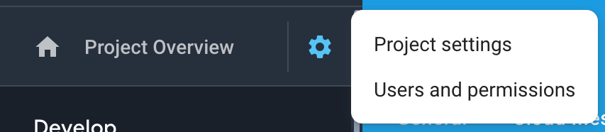

- On the General tab of the Settings, scroll down to the My apps section and click the Android app icon.
- On the Add Firebase to your Android app page, enter your app package name and click Register app.
- Download the config file, google-services.json. That is all you need from the app registration. You can ignore the information on the rest of the screens and return to Settings.
- Go to the Data & Analytics Firebase page in Reading App Builder.
- Select Firebase Analytics as one of the features to use in the app.
- On the Firebase Configuration Android tab, click the Browse button and find the google-services.json config file that you have just downloaded from the Firebase console.

The Firebase Configuration tab
Specify your Firebase Configuration file by clicking on Browse… and selecting your downloaded google-services.json file.

The Push Notifications tab
You can send direct messages over the internet to all the users who have your app installed on their phone.
Such messages could include:
- Sending greetings on special occasions.
- Sharing news of app updates, new resources and special offers.
- Encouraging people to use the app.

Setting up Firebase Cloud Messaging
To set up the push notifications feature:
- If you have not already done so, follow the instructions on setting up a Firebase project, described in the section above on Firebase Features.
- In Reading App Builder, go to the Data & Analytics Firebase tab and enable Firebase Messaging.

Sending messages
To send a push notifcation message to all users of your app:
- Go to the Firebase Console for your Firebase project.
- Select Cloud Messaging from the menu on the left of the screen.
- Click Send your first message.
- Enter the Notification title and Notification text, then click Next.
- In the Target section, you want to send messages to users of your app. Click Next.
- For Scheduling, you want Now (unless you choose another time). Then click Next.
- Accept all the other default options and then click Review at the bottom of the screen.
- Re-read your message to verify that all is OK, then click Publish to send it. The message will be sent to all the app users (if they are connected or connect to the internet).

The In-App Messaging tab
To set up the In-App Messaging feature:
- Enable Firebase In-App Messaging under the Firebase Features tab
- If you have not already done so, follow the instructions on setting up a Firebase project, described in the section above on Firebase Features.
- Under the In-App Messaging tab, follow the instructions under Configure In-App Messaging.

The Publishing project menu
The Publishing menu helps you prepare your app for publishing to the Play Store, as a Progressive Web App or as an e-book (EPUB).

App Store
Documentation coming soon. See the App Publishing Checklist and Distributing Apps PDFs under the RAB Help menu.

E-books (EPUB)
As well as building a smartphone app, you can create e-books in EPUB format. EPUB documents are readable by a number of e-book readers on Windows, Mac, iOS and Android platforms.

If you have timing files for your audio, the e-books can contain ‘Read Aloud’ text-audio synchronization. These are readable by a few EPUB 3 readers, such as Adobe Digital Editions or Thorium Reader.

To create an EPUB e-book:
- Use the Table of Contents tab to choose which items should be available in the table of contents.
- Use the Cover tab to choose a cover design. If you are creating separate e-books for each book, a different cover image can be specified for each book on the Cover tab of each individual Book page.
- Go to Publishing E-books (EPUB) and click the button Create EPUB File... This will launch the Create EPUB Document wizard. You can choose which book collection and which books to include. You can choose whether to create a single e-book containing all the books or whether you want to create a separate e-book for each book. The latter is the best option if you will have audio in the book, since otherwise a whole NT with audio would be a very large e-book.
The generated EPUB documents will be saved in the default EPUB output folder. See Tools Settings… Default Folders.
- Open the EPUB documents in your chosen e-book reader.

Reading App Builder generates EPUB 3 documents which should be backwardly compatible to be able to be read using EPUB 2 readers. EPUB 3-only features such as the text-audio synchronization will only be seen on compatible readers.

The Navigation project menu

Contents Menu
When the user launches the app you might want to display a contents menu, giving them an easy way to jump to books and specific references. This can be an essential part of helping users locate content in your app that otherwise might be hard to find. For more information on setting the styles for the various contents menu elements, see Appendix 3.

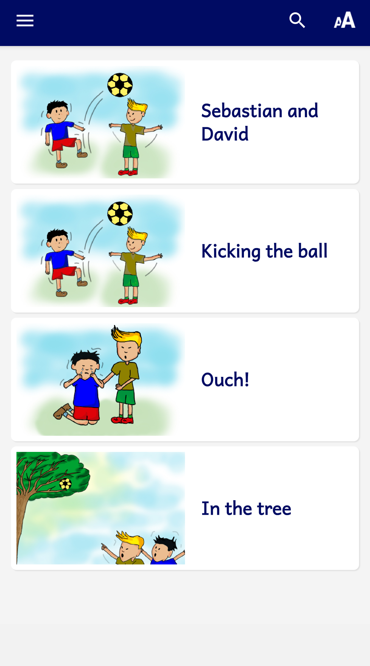
The contents menu contains a list of images and titles and can have several levels as needed.

The Contents Items and Screens tab
Contents menus are comprised of Items (clickable elements), headings (non-clickable items) and screens (groups of items representing a level in a nested menu structure). Each menu has by default one screen representing the top level menu.

You can quickly add an existing book to the contents menu. Click on Books in the project menu tree view. This displays the app’s list of books in the Books tab. Right-click on the book and select Add to Contents Menu. If you have more than one menu “screen” (see below), you can choose which screen to add it to.

Contents Menu Items
- For each contents menu item you want to add, click the Add Item… button and follow the Add Contents Menu Item wizard to add the item to the screen.
    - Single Clickable Items
To add a single item (one item on its own row) choose Single Item (the default) and click Next.
You can choose to target the following: a Book reference, Another menu screen or Elsewhere.
Book References
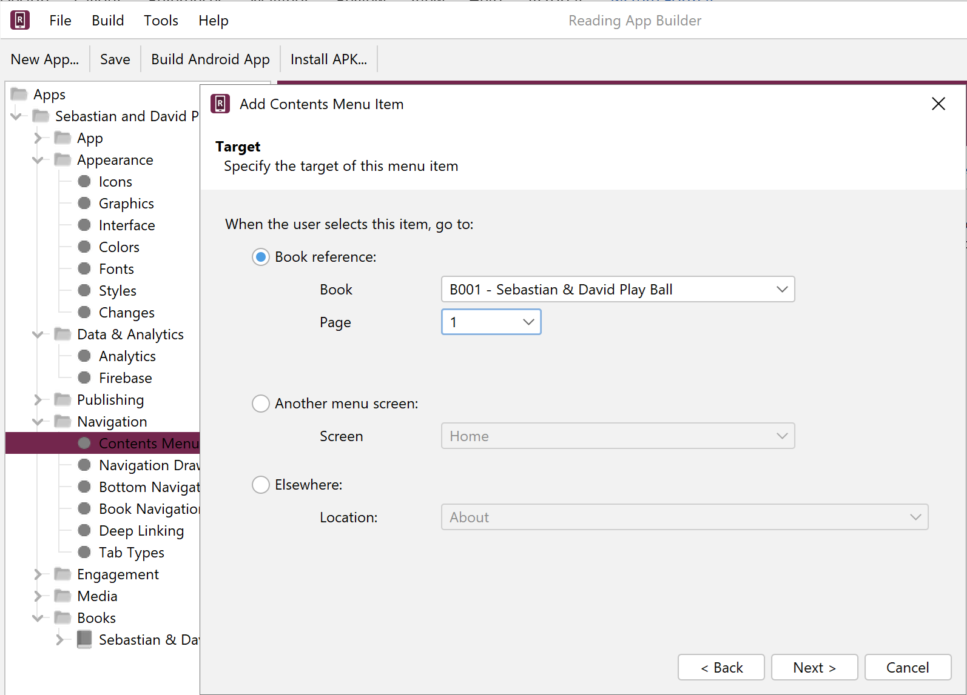
For a book reference, you will need to specify the following:
- The target reference, such as My Story, page 1.
This reference can be a book name, or a book and page.
- The title of the item, such as ‘Using a Mosquito Net’ (you can also specify alternate translations for the title and subtitle)
- An optional subtitle
- An image (optional) – to appear to the left of the title.
Try and make your contents menu item images the same dimensions. Alternatively, you can set the Image width percentages to all be the same on the Contents Settings tab under Contents Items Display.

You can now add an animated GIF as a contents menu image. This is useful to add things like sign language videos to the menu.

- An optional Audio clip to provide a brief description of the item (this will display a speaker icon that can be tapped to play the audio)
- A layout (how the picture and text are arranged).

Another Menu Screen
Choose an existing menu screen from the drop-down list box. You will need to first Add a Screen… from the main Contents Items and Screens tab to choose this option.

Elsewhere
Choose one of the locations in the drop-down list box:
- the About Box
- the Settings screen
- a PDF Document (specified under Media > Documents)
- a News Feed (specified under Engagement > News Feeds)
- an Illustration (specified under Media > Illustrations)
- a website URL

    - Headings
You can add non-selectable headings or dividers in your lists of items in the menu. You may want to do this to group certain items under a header, or just to provide some decoration. To add a heading, choose Heading. Select a layout, choose an image, then add an optional title, subtitle and/or audio clip to play when its speaker icon is tapped.

To make a decorative heading, create a landscape image and set its width percentage to be 100%. Do not add a title or subtitle.
    - Several Items on the Same Row (Grids)
To add multiple items on the same row, choose Grid and click Next. You can then choose an optional heading (title and subtitle) above the row. Click Next. Then, on the Grid Menu Items screen, add 2 or 3 items, one by one. Choose their target location, layout, image, title and subtitle.
To edit a grid, double-click on it in the Contents Items and Screens tab view. This will open the Edit Contents Item dialog box. Use the Heading tab to add/remove/modify a heading. Use the Grid Menu Items tab to rearrange the items by dragging them up or down. Double-click on a grid item to edit it.
You can select 2 or 3 items in your contents menu, right-click and choose Group into Grid to facilitate creating a grid of items. You can also select an already made grid, right-click and choose Ungroup to single items to split the items back into separate elements.
    - A Carousel
To add a rotating horizontal set of items, choose Carousel and click Next. You can then choose an optional heading (title and subtitle) above the row. Click Next. Then, on the Carousel Menu Items screen, add items, one by one. Choose their target location, layout, image, title and subtitle.
You can select several items in your contents menu, right-click and choose Group into Carousel to facilitate creating a carousel of items. You can also select an already made carousel, right-click and choose Ungroup to single items to split the items back into separate elements.
    - News Feed
To add one or more items from a News Feed, select Feed, then choose an available News Feed and the number of items from the feed you would like to display.
- You can reorder the items on the screen by selecting rows in the table and dragging up or down.
- Double-click on an item to open the Edit Contents Item dialog box. From here you can select one of the following tabs to edit one of the settings you have chosen: Layout, Image, Titles, Background, Padding, Target, Audio, Languages.
Note that Padding and Languages give you additional control over your menu item.

Padding
Use the Padding tab to adjust the space around the menu item.

Languages
If you have more than one interface language in your app, the Languages tab will appear. You can specify if a contents menu item only shows up in a particular language has been chosen. This is helpful if you want to provide several versions of a resource (e.g. a “how to use this app” book) in the different languages. To do this, specify in which of the available languages you want it to be shown.
- Double-click on an item to open the Edit Contents Item dialog box. From here you can select one of the following tabs to edit one of the settings you have chosen: Layout, Image, Titles, Background, Padding, Target, Audio, Languages.
Note that Padding and Languages give you additional control over your menu item.

Padding
Use the Padding tab to adjust the space around the menu item.

Languages
If you have more than one interface language in your app, the Languages tab will appear. You can specify if a contents menu item only shows up in a particular language has been chosen. This is helpful if you want to provide several versions of a resource (e.g. a “how to use this app” book) in the different languages. To do this, specify in which of the available languages you want it to be shown (see example below):
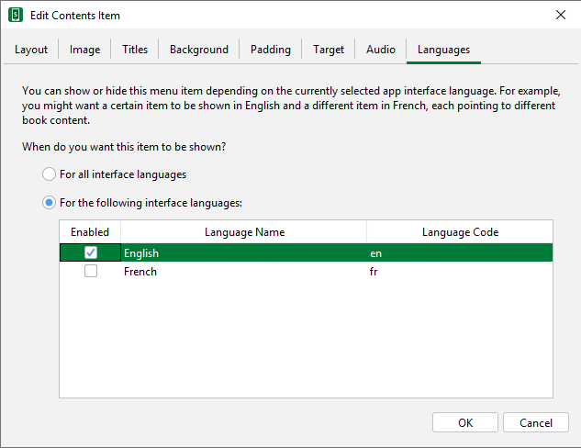
- Go to the Contents Settings tab to specify display formatting and navigation options for the menu.
- Select the Viewer tab to see how the contents menu will appear in the app.

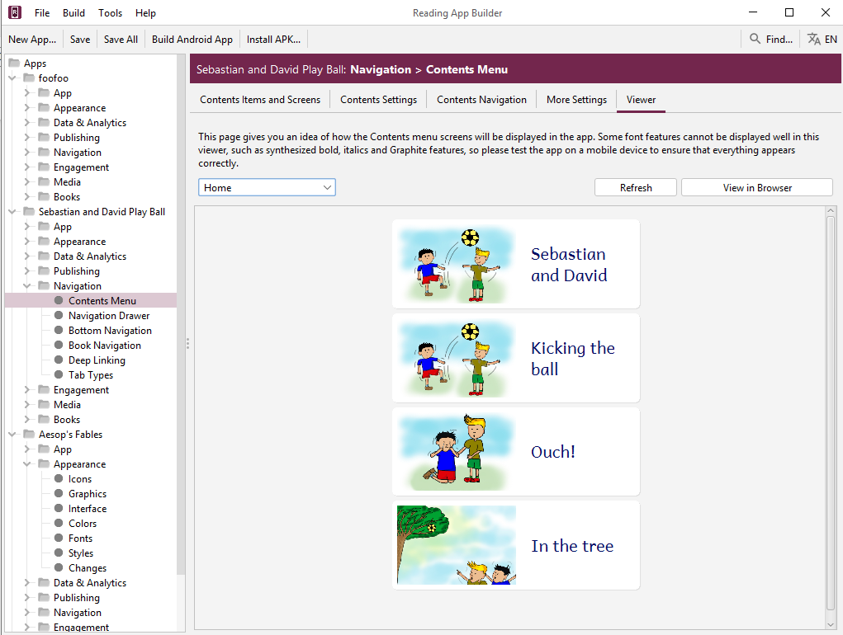

Contents Menu Screens
In some cases, you might want to have multiple contents screens (nested groups of items), i.e. you select an item in the first screen and it takes you to a second contents screen.

Grouping your items under screens can really help users find and access the content in your app, especially if you have different types of books or content like quizzes, PDFs, learning modules etc. It is recommended to sketch out a proposed layout for your menus and then create the screens and items necessary.

A screen is a group of items. Items on a screen can lead directly to books, or to other screens. By default a contents menu has one implicit screen called “HOME.”

To add a contents screen:
- Click the Add Screen… button and give the screen a name.
- You will need to link to this new screen from the screen a level above (its parent screen). Select the parent screen by clicking on it so it highlights. Click the Add Item… button for that parent screen, specify its target to be Another menu screen and select the name of your new screen. This will mean that when the user taps on this item in the first screen they will be taken to your new screen.
- Add menu items to your new screen as described above.

Make sure that the screen to which you want to add an item is selected by clicking to highlight it on the Contents Items and Screens page. Then click Add Item…
- You can move items between screens by dragging item rows up or down.

The Contents Settings tab
Use the Contents Settings tab to specify exactly how the contents menu works, including the title displayed (if any), what menu items are displayed and how users navigate between books and the contents menu.

Contents Menu Title
Use this setting to choose what is displayed in the app toolbar while the contents menu is showing.

Contents Items Display
Each item has a title, subtitle and a reference that shows which book page the item is pointing to. You can choose which of these elements to display.
You can also adjust the proportion of the menu item image and text.

The Contents Navigation tab
Use this setting to specify what type of navigation button is shown when a user is viewing a book and what happens when the user launches the app.

Navigation
Use this setting to specify what sort of navigation button the app shows when the user is viewing the pages of a book.

Launch Action
Use this setting to specify whether the app always launches to the contents menu, or to the last book viewed.

The More Settings tab
Image Resizing
You can specify the maximum pixel width of contents menu images to reduce their size, if necessary.

The Viewer tab
Use the viewer tab to get an indication of how each screen in the menu will appear.

Navigation Drawer
The navigation drawer is the menu that slides out from the left or right side of the screen, depending on the current text direction setting. This menu can also be accessed via the “hamburger” menu (three horizontal lines) in the menu bar.

The Menu Items tab
As an aid to the user, you can add items to the navigation drawer that point to various, useful elements that can aid in helping the user go further in their studies or get answers to their questions.

As part of a broader engagement strategy, you can add links to language websites, Facebook pages, News Feeds and WhatsApp groups.

To add an item, click Add Menu Item… and choose from the list of possibilities. Be sure to add multiple translations of the menu item if you have multiple interface languages.

The Settings tab
The Settings tab allows you to specify which app settings the user can modify. The list of settings is determined by which options you have enabled in your app.
Click Show next to each setting you want the user to be able to modify in the app. These will appear under the Settings menu item in the app’s navigation drawer.

To modify the style of the settings menu, see Appearance Styles. The specific settings styles are listed in Appendix 3.

To specify whether a setting option is turned on by default, see the respective setting’s menu item in the RAB project menu.

The Sharing tab (sharing apps)
One advantage of an app resource over a printed one is that users can freely share the resource with other people. RAB provides several, helpful ways to share an app with others. You can choose to allow the user to use any or all of them:

Share link to app on Google Play
We strongly recommend publishing your apps to the Google Play store so that the diaspora can have access, even if your local context don’t have internet access. If you have published it, then use this setting to provide an easy way to share the link via email or social media (e.g. WhatsApp).

Share link to app on website
Enable this if you have your APK available to download from an external site (e.g. a language-specific website for a translation project).

Share app installer file
Enable this to share your app’s APK file directly with another device, e.g. by Bluetooth, Wifi transfer or email. This option is especially useful in contexts where not everyone has easy internet access and where you want to promote offline app sharing.

The History tab
Enable the history screen so users can easily select previously viewed books and pages. They can access the History list of saved locations under the app’s navigation drawer menu. For information on setting the styles for various elements of the history feature, see Appendix 3.

The Search tab
The Search function allows users to find words across all the included books. There are several options you can set to specify how searches take place.

Show Search icon and allow searching
If you enable this, the Search menu item will appear in the navigation drawer menu and the magnifying glass search icon will appear in the app menu, if there is room.

‘Match whole words’ is selected by default
You can choose whether or not users are restricted to searching for whole words.

Show ‘Match whole words’ option on the Search page
This allows the user to turn off or on the ‘match whole words’ functionality.

‘Match accents and tones’ is selected by default
You can choose whether or not users are restricted to searching using accents and tones, if there are any in the language.

Show ‘Match accents and tones’ option on the Search page
This allows the user to turn off or on the ‘match accents and tones’ functionality.

Show special character input buttons on Search page
If you are allowing searching matching accents and tones, it is very helpful to include a list of any special characters (that would require an accent or tone marker) to be available for the user to select from.

Specify the replacements and diacritics to remove…
If you are not requiring ‘Match accents and tones,’ it is important to specify which characters should have simple equivalents. You can either the syntax X > Y, with X being the accented character and Y being the non-accented equivalent (e.g. à > a) OR just specify the Unicode character number of the diacritic to remove.

Bottom Navigation
The bottom navigation bar provides a quick way for users to access various elements of the app. It can be used in addition to or instead of a contents menu, but there is a limit of five items.

After selecting Enable bottom navigation bar, click Add Button… to add a button to the menu bar. For each button you can specify a name (with multiple translations if needed) and an icon. Once an element is added to the list in RAB, double-click on it to modify it.
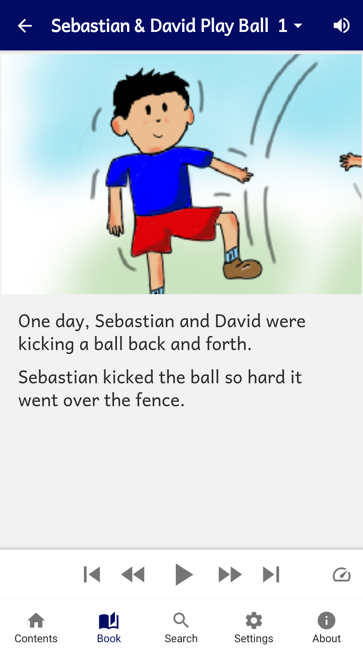

There are six possible elements to link to:

Contents
This displays the contents menu screen, if there is one.

Book
This will display the last, current book being viewed, or can display any book in the app. When adding the button you can specify the target book to open or modify it later under the button’s Book tab.

Search
If the Search function is enabled, this open the search screen.

News
If you have a News Feed enabled, you can point to it here.

Settings
This will display the settings screen, allowing the user to modify the app settings.

About
This will display the About box.

To modify this… | Adjust this style…
The bottom navigation bar background | ui.bottom-navigation.
The text under each icon | ui.bottom-navigation.item.text
The highlighted text of the current icon | ui.bottom-navigation. item.text.selected
The icon color | ui.bottom-navigation.item.icon
The highlighted color of the current icon | ui.bottom-navigation.item.icon.selected

Book Navigation
The book navigation menu allows the customization of how a user selects and views books.

The Formatting and Navigation tab
Formatting
This allows you to specify how the app displays pages.
You can set it to Show page numbers in the text by checking the option, or hide them by unchecking it.
You can also specify whether to hide empty pages.

Navigation
Books are most commonly selected by tapping on a book name displayed in the main app menu bar (the book selection popup). You can specify whether selecting a book automatically displays the page selector.
If you turn off the book selection popup, you will need to provide another way to switch books e.g. a contents menu.
You can also set various options here as to how the user can interact with pages.

To modify this… | Adjust this style…
Book selector in menu bar | ui.selector.book
Page selector in menu bar | ui.selector.chapter
Book and page selector tabs | ui.selector.tabs
Background for drop-down book list view | ui.button.book-list

The First Book and Page tab
If there is no contents menu, you can specify which book and page is displayed when the app starts for the first time.

You may choose to open at a “Getting Started” or “Help” book to give the user help in learning how to navigate in your app. You can create this using the Word or SFM formats and add it to the list of books.

Normally, you will want to open the app at the last book viewed, but you can specify here to always open at your specified First Book and Page.

Tab Types (Book Tabs)

It is possible to create an app which displays books with two or more tabs, for example:
- A “Text” tab in which you display the book text, and a corresponding “Questions” tab which contains applicable study questions.
- A “Text” tab in which you display the book text, and a “Commentary” tab which contains an explanation and application of the text.
- A “Song” tab in which you display the words of a song, and a corresponding “Music” tab which contains the music score or guitar chords.

Tabs can be labelled with a title or an icon.
You can associate audio files with a tab.
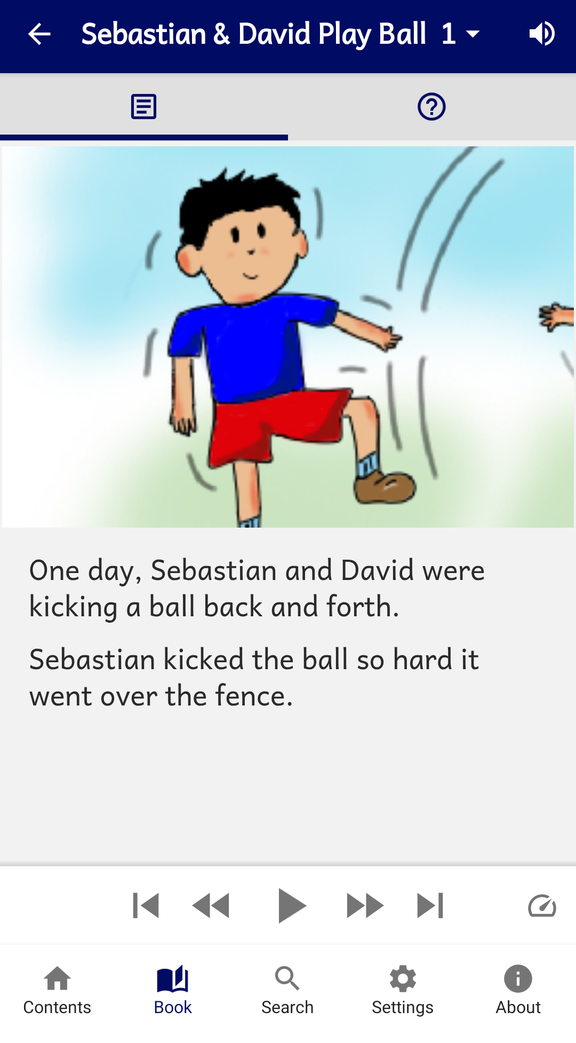 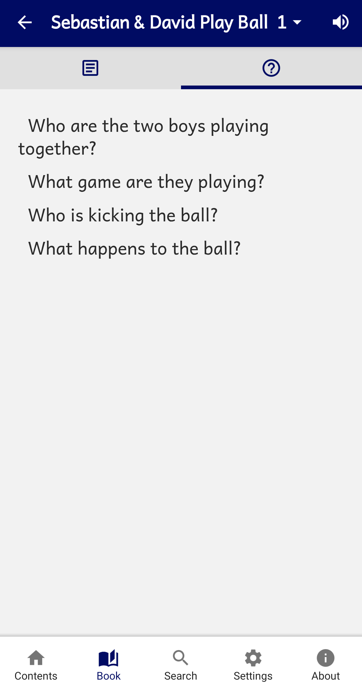
Text and Question tabs

To create a tab type:
If the type of tab you would like to use is not yet defined, click the Add Tab Type button and follow the instructions in the wizard.
To add a tab to a book, see Books <book name> Tabs.

Deep Linking

Deep Linking allows you to direct people to specific pages within the app, using a link on a website, in a messaging app, social media or email.

A deep link can look something like this:
tharaka-stories://B002
or
https://tharaka.org/stories/B002
or
https://www.example.com/tharaka/stories?ref=B002

If you share one of these links with a friend on WhatsApp, Facebook or email, and they tap on the link on their smartphone, the app (if already installed) will open and go directly to story book 2.

Setting up Deep Linking
To set up deep linking in your app:
- Go to the App Deep Linking page within Reading App Builder.
- Select Enable Deep Linking.
- Specify one or two link schemes to be associated with your app: a custom URI and/or a URL.

Custom URI Scheme
The first type of link scheme is a custom URI (Uniform Resource Identifier). This is a sequence of characters beginning with a letter and then any combination of letters, digits, plus (+), period (.), or hyphen (-). It is followed by a colon and two forward slashes (://).

Here are some examples:
mamara-stories://
booksmalinke://
proverbstoday://
tharaka-health://
literacy-tanzania://

Make sure that you do not choose a custom URI already in use by a popular app, such as:
fb:// Facebook
twitter:// Twitter
whatsapp:// WhatsApp
youtube:// YouTube

URL Scheme
The second type of scheme is a URL (Uniform Resource Locator), which is like a web address. It begins with http:// or https://. It can include a path.

Here are some examples:
https://mamara.org/
https://mamara.org/stories/
http://www.literacy-tanzania.org/
https://sil.org/mexico/huichol/stories/

Creating Deep Links
This section explains how you create deep links to content in the app. We will look at how to specify book references (books, pages), and how to turn the audio toolbar on when the app opens.

Specifying book references in a deep link
A reference is specified in the form BBB.P, where BBB is the book ID and P is an optional page number.

Examples:
B002.15 Book 2, page 15
B004 Book 4
B010.1 Book 10, page 1

Please note that the reference is case insensitive, so b001.15 and B001.15 are recognised as referring to Book 1, page 15.
There are two ways of specifying the reference in a deep link:

Method 1: Append the reference immediately after the link scheme, e.g.
mamara-stories://B002.3
https://mamara.org/stories/B002.3

Method 2: Specify the reference in a query string, after ‘?’ and ‘ref=’, e.g.
mamara-stories://?ref=B002.3
https://mamara.org/stories?ref=B002.3

When someone taps on this link, the app (if installed) will open at the specified book and page.

Turning on the audio toolbar in a deep link
You can turn on the audio toolbar when the app launches, with the addition of the audio=1 parameter in the query string of the deep link.

Here are some examples:
mamara-stories://B002?audio=1
https://mamara.org/stories/B003.2?audio=1

Note that a query string begins with the question mark (?) character before the first parameters, and then an ampersand (&) before subsequent parameters. So if you are using the ‘ref=’ method of specifying a reference, you will need to use ‘&’, e.g.
mamara-stories://?ref=B002&audio=1
https://mamara.org/stories?ref=B003.2&audio=1

Deferred Deep Linking
The deep links described above will only work if the user already has the app installed. If they do not have the app, when they tap on the link, their device will not recognise it and an error message will appear.
Branch (branch.io) provides a way of handling deferred deep links. If a user taps on a link to the app but does not have the app installed yet, the link will first redirect the user to the app store to download the app. Then after the app is installed and launched for the first time, the user will be taken to the deep link page.

Setting up the app to use Branch
To use Branch for deferred links:

- Go to the Branch website, https://branch.io/ and Sign Up for an account if you do not already have one.

- Create a new app in the Branch dashboard.

- Go to the Link Settings page, find the Android section and click the checkbox ‘I have an Android App’.

- Enter the custom URI scheme and where to download the app (e.g. on Google Play).

- Within Reading App Builder, go to the App > Deep Linking page.

- Select Use Branch for Deferred links.

- Enter the Branch Key for this app. This can be found on the Account Settings page in Branch and will be something like:
key_live_abCdEF2GQ7ID9rLPlxk91khczmpGZl71

- Enter the Default Link Domain for this app. This can be found on the Link Settings page in Branch and will be something like:
mamara-stories.app.link

Creating deferred links
Deep links using Branch will look something like this:

https://mamara-stories.app.link?ref=B002

where mamara-stories.app.link is the Default Link Domain specified on the Branch Link Settings page.

Please note that you need to use the ?ref= method of specifying the reference. You cannot use https://mamara-stories.app.link/B002.

Tab Types
For a creating Tab Types, see tab types.

The Engagement project menu
It is important to design your apps with the elements necessary to help users access and understand the resources it contains. RAB has a number of important engagement features to help in this regard.

Onboarding
Onboarding screens are a series of screens that user can step through the first time the app is opened after being installed. This allows you to display certain features, give help or other useful information to the user.

Although there is not a theoretical limit to the number of onboarding screens, you should consider a maximum of about 10.

There are 3 tabs in the Onboarding parameters area:

The Onboarding Screens tab
Use the Add Screen… button to add a screen to the series. This launches the short Add Onboarding Screen wizard:
- First, choose an image to display. This can be a screenshot of a particular feature of your app. You might annotate the screenshot to highlight a certain feature or setting.
- Click Next.
- Add optional title text above and/or below the image. Title text will be centered and bold. You can add optional, centered subtitle text as well. You can also add multiple translations to these text fields, based on the number of interface translations in your app.
- Click Finish when you’re done.

To modify the top or bottom text styles, see the Onboarding Screens Styles.

When you have created several screens, you can click and drag them in the list window to reorder them.

To edit a screen, double-click on it to change the picture, text or background color (see the Settings tab below). You can also right-click on a screen to Edit, Delete or Export to HTML.

The Settings tab
Under Navigation Drawer, check the box to add a link to (re)view the onboarding screens. You can change the default menu item title (App Tour) and add translations.

Under Background Color, click Change Default Color to adjust the background color of the onboarding screens. You can select a different color for each of the Normal, Sepia and Dark color themes.

Under Image Resizing, select the maximum width in pixels of your onboarding images.

The Viewer tab
Use the Viewer tab to see an example of how your onboarding screens will look in your app. Use the page arrows or dropdown screen number to view all your screens.

News Feeds
News Feeds allow for dynamic, up-to-date content to be displayed in your app. A News Feed is delivered to your app via an RSS feed. This is a standardized web feed format (usually XML) that allows apps to pull data updates from a website. For you app to have a news feed from a particular website, that website must have an accessible URL that points to the RSS feed (see Add Feed… below).

The Feeds tab
Use the Feeds tab to add one or more RSS feeds to your app. Once added here, you will need to provide access to the feed by adding it to the Contents Menu, Navigation Drawer and/or bottom navigation toolbar. You can do this under their respective settings, or right-click on a feed to add them directly.

Click Add Feed… to add an RSS feed. You will need to add a title and then enter the URL to the feed. As stated above, this is usually the main website address with /feed/ added at the end, e.g. https://nigeria-del-unesco.org/news-and-events/feed/
Click the Test button to test the URL.

The Settings tab
Use the Image Resizing setting to set a limit to the size of the images coming from the feed. The default maximum width is 1,080 pixels, but you might be able to have a smaller maximum. Test a few sizes to see.

The Viewer tab
Use the Viewer tab to see how a feed will be displayed in your app. Use the dropdown list box to select a feed to view. Click View in Browser to see the feed in a browser page.

Notifications
Notifications can be helpful for developing the habit of reading every day.

The Daily Reminder tab
Your app can be configured to send a daily reminder to read. The reminder appears as a notification in the device’s notification tray. When you tap on it, the app will open.

These notifications work offline. They are sent from the app rather than being sent over the internet. The user can turn on or off this feature and set their preferred time of day for the notification in the app settings screen.

By default, Daily Reminder notifications are not included in the app. To configure them in the app builder:
- Select Include Daily Reminder in this app. If this option is not selected, a Daily Reminder will not be included in the app and the app user will not be able to turn it on.
- If you want the notifications to be turned on by default, select Turn on Daily Reminder by default. If this option is not selected, the user will need to go to the Settings screen in the app in order to turn on the notifications.
- Choose a default Time of day for the Daily Reminder to appear. The user will be able to change this in the app Settings.
- You can customize the Title of the Daily Reminder and the Message that is displayed. You can add different text translations for any of the interface languages you have selected in Appearance Interface Languages.

The Notification Icon tab
Click on the Notification Icon tab. You can create your own notification icon that will be used for both the Verse of the Day and Daily Reminder notifications.
Use the provided link to the Notification Icon Generator to easily create a notification icon. Download the zip package and use Add Icon Images… to select the zip file.

The Media project menu

Audio
Audio is a critical part of any app, as it is possible that many users do not have strong reading skills, especially in their own language.

Here are some questions you may be asking about audio. Click each one to jump to the related section:
- How can I associate audio files with the text?
- How can I reduce the size of my audio files?
- How do I create the audio timing files for audio-text synchronization?
- How do I distribute the audio files with my app?
- How are the timing files distributed for the app?
- How can I use audio clips in the app?
- How can I create subtitles from text and timing files?

The File Source tab
Use the File Source tab to specify how audio files are accessed and distributed with your app. There are three ways of including audio files in your app: assets, external folder or internet download. You can use a single file source for all of the files in an app or you can combine two or more sources in an app. You can specify a file source for each audio file (though not audio clip) and therefore specify them on a page by page basis.

In deciding whether to include audio within the APK or via another file source, it is important to consider the needs of the users and their access to the Internet. You may consider putting just one book’s audio in the APK (or even just a set of pages) and have the rest available for download. If you do this, consider having the app open at a book and page with audio, and make sure the audio toolbar is displayed.
To open the app at a specific book, go to Navigation Book Navigation Navigation and look for the First Book and Page fields.
To make the audio toolbar appear by default, go to Media Audio Audio Toolbar and select Show audio toolbar when the app is launched. RAB will automatically hide the toolbar for pages with no audio.
To specify the file source(s) in Reading App Builder, you need to do two things:
- Define the available file sources under the File Source tab. You can modify, add and remove file sources here.
- Go to the Audio Files tab for a book and after adding audio, assign a file source for each file. To change the source for a file or files, select the rows you want to change, right-click on the selection and choose Change Source.
The following sections describe the different file source types:
1. Assets
The audio files will be packaged inside the APK file for the app. This is the easiest method for a few files (e.g. one book) and requires no permissions. But be beware that the APK will get very large if you have several books of audio. The maximum size of an app that can be installed from the Google Play store is 200 MB.
2. External Folder
No audio files are packaged within the app, so the apk is small. The app will look in a specified SD card folder to find the audio files it needs. If you are distributing the app via SD card, you include the folder of audio files on the SD card together with the apk. This method requires the 'Read external storage' permission but not internet access.
You can place the audio files inside sub-folders and sub-sub-folders in the specified SD card folder, using any folder names you choose. Alternatively, you can place all the audio files in a single folder without using any sub folders.

If the app does not find audio files in the specified folder or its sub-folders, it will also search the other folders on the device to see if it can find them there. For example, if the specified folder name is ‘Audio 123’ but the files are located in the ‘Audio 456’ folder instead, the app should find them. Once it has found a folder with a needed audio file, it will keep a note of it so it knows where to look next time.
3. Internet Download
Like method 2, no audio files are packaged within the app, so the APK is small. The app will look in a specified SD card folder to find the audio files it needs. If it doesn't find them there, it will look in all the other folders on the device. If it still cannot find them, the app can download the files one by one when it needs them from a website of your choice. This method requires the 'Read external storage', 'Write external storage', 'Connection state' and 'Internet' permissions.
Audio filenames
The internet download works best if your audio filenames do not include any spaces. A filename of the form “LNG-MAT-01.mp3” is better than “LNG MAT 01.mp3”.

Audio file hosting
Recommended storage locations for the files on the internet include:
- A language-specific website
If you have a language-specific website for making resources available for download, you could place the audio files in a folder on the website.
For example, if your website is called ‘www.ourlanguage.org’, you could upload the audio files to a folder called ‘audio’. The http address for your audio files would then be: http://www.ourlanguage.org/audio
Your website administrator should be able to help you do this.
- Cloud Storage Services
Amazon S3 (Simple Storage Service): http://aws.amazon.com/s3/
Backblaze B2 Cloud Storage: https://www.backblaze.com/b2/cloud-storage.html
Google Cloud Storage: https://cloud.google.com/storage/

These cloud storage services are designed for fast, reliable and secure online storage. Once you have created an account, you create a 'bucket' in which to place your audio files. When you add the files, you need to make them public and make a note of the web address link to use to access them, e.g. http://s3.amazonaws.com/yourbucketname
You will get some months of free storage before there is a charge according to the bandwidth used, i.e. how many MB of audio users download. It might be easiest to organise this kind of cloud storage at an organisational level rather than creating a new account for each language.

4. The Audio Files tab
Audio files can be added here or under the Books project menu or an individual book’s Audio Files tab. For details on how to add files, see How can I associate audio files with the text?

The Audio Toolbar tab
The audio toolbar automatically appears at the bottom of a book page that contains audio. Use the settings here to specify how the toolbar appears.

We recommend enabling Show audio toolbar when the app is launched (to make it clear to the user that there is audio), and the setting Allow the user to turn off/on the audio toolbar.

Use the Play Button Style and Size options to specify how the toolbar looks.

Use the Repeat Mode and How a Hint checkboxes to enable those features which can help users in memorizing a passage or just listening to it several times.

The Audio Settings tab
The Audio Settings tab contains a miscellaneous group of audio-related functions that you can enable or diRABle.

Highlight the current phrase when playing audio…
If your audio has timing files, checking this box will highlight the audio as it’s read. This is enabled by default. You can specify if the user can turn this feature off under Navigation Drawer Settings.

At the end of a chapter/page…continue playing audio
This is enabled by default. Uncheck the box if you want the audio to stop at the end of a page.

At the end of a book…continue playing audio
This is not enabled by default. Check the box to enable.

Pause audio if the phone receives an incoming call
This option is on by default and is a courtesy to the user. Do not uncheck unless you have a specific reason for disabling this.

Access Method
As the option states, this provides the default choice for the case where a user has the option to download or stream audio. The user can modify this in the app settings.

Audio Speed and Audio Timer
There are two items that are automatically added to the audio toolbar on the right side under the three vertical dots: the Audio Speed and the Audio Timer. You do not have to add anything to your app to make these available (apart from having audio in the active book). Users can use the Audio Speed to adjust the speed of the recorded audio (it does a nice job!). Users can set the Audio Timer to listen to the recorded audio for a set number of minutes. The three-dot menu will display the current time remaining.
For Audio Only books, the timer icon will appear on the bottom row of the audio toolbar, next to the Playback speed icon.

To turn off a timer that is running, press the menu button, select “Timer” and choose “Off”.

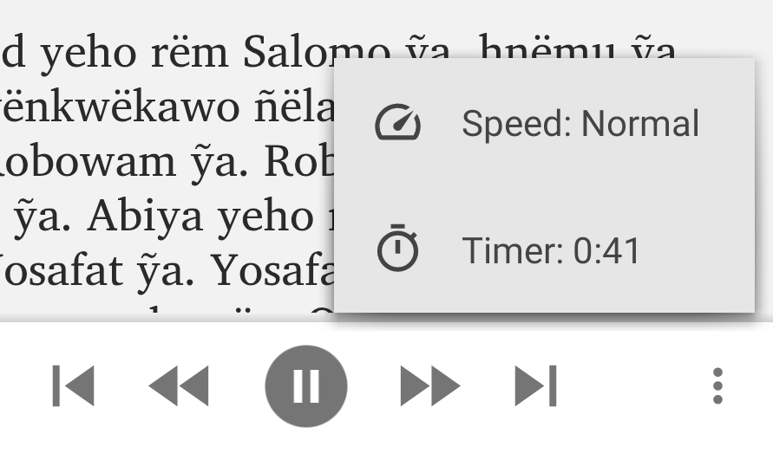

The Audio Synchronization tab
The Audio Synchronization tab allows you to configure the settings for creating timing files in order to highlight text as it is read and/or create slideshow videos.
You can specify global, phrase-ending markers to separate your text files into discreet phrases for highlighting.

To actually create audio timing files, go to the Audio Synchronization tab under the Books menu item or an individual book’s settings.

The Audio Clips tab
The Audio Clips tab is similar to the Audio Files tab, but is for adding short audio files that are associated with actions, including quiz items and sound effects, and titles in the Contents menu. For more information on adding audio clips, see How can I use audio clips in the app?

The Downloads tab
The Downloads tab allows you to specify several parameters regarding the download of audio.

Download Manager
The download manager allows users to manage the download of audio for multiple books at the same time. This greatly facilitates users who have occasional internet access and wish to get a quantity of audio at one time, rather than page by page.
Select Use the Download Manager in this app to enable this feature to appear under the navigation drawer menu.

Android Storage Locations
For devices running Android 9 or below, use the following options to specify how audio files are handled:

Search all folders on the device…
If audio files can be downloaded using a specified File Source, the download folder is specified on the File Source’s Edit File Source page. If RAB cannot find the audio file there, enabling this option (which is on by default) will search the whole phone for the audio file.

A user may possibly move audio files on their phone. If you want to ensure that a user does not have to download an audio file again, enable the Search all folders function. However, when a user plays audio for a page with no downloaded audio, RAB will first search the whole phone for the file before offering to download it. This may take a long time (minutes), so it is preferable in most cases to uncheck this option.

Write a .nomedia file…
Normally, downloaded audio can be found by a phone’s media player and played outside the app. There may be cases, though, where security concerns make it better to hide the audio. If this is the case, check the box to write the .nomedia file.

For devices running Android 10 and above, you can specify where downloaded audio files are stored. See the text on this tab in RAB for details on the options.

How can I associate audio files with the text?
Reading App Builder allows you to use two different types of audio file:
- Audio files that correspond to a page of text in the app, e.g. the audio recording of a page in a picture story book. These can be linked to timing files to enable synchronized highlighting of the text when the audio is playing.
- Short audio clips which are played when the user taps a linked word, phrase or image in the app.

The first of these types of file is the most common in RAB apps and the instructions in this section will refer to these. Go here for more information on using audio clips

To associate audio with pages of text in your app, you will need one audio file per chapter or page. For example, if you have a book ‘Learn How to Read’ with 30 pages, you will need 30 audio files, one for each page.
For Learn How page 1 LearnHowToRead-01.mp3
For Learn How page 2 LearnHowToRead-02.mp3
For Learn How page 3 LearnHowToRead-03.mp3, etc.
If you have several audio files per page or several pages in one audio file, you will need to concatenate or split your files to create files of one page each before RAB can use them. This could be done using Audacity.

For picture story books, you can choose whether you have one audio file per page, or a single audio file for the whole book. We normally recommend having one file per page.
To add audio files:
- Go to the Audio Files tab for the book, or the Audio Files tab under the Books project menu.
- Click the Add Audio Files… button to select audio files you have available.
- Select the audio files to add.

RAB will try to match the audio files to the pages in the book(s), so you should use audio filenames that will make it obvious which file corresponds to which book and page.

Put page numbers at the end or beginning of the filename and use a leading zero for numbers less than 10. E.g. Storybook_A_01.mp3

The optional timing files can be added on the same page: one timing file per audio file.

How can I reduce the size of my audio files?
It is possible to reduce the size of audio files by using various tools (e.g. Audacity or Reading App Builder) to compress them. Care must be taken, though, to make sure the quality of the files does not suffer. Since the audio files will generally be playing on a phone, you can probably at least convert the files from stereo to mono (from 2 channels to 1). You can also experiment with reducing the frequency and bit-depth of the files and then playing them through a phone speaker or on your computer to check the quality.

Reading App Builder has some simple, built-in audio file compression tools and can convert your audio files into various formats. To do this, select one or more of your audio files in RAB, right-click on the selection and choose Convert Audio Files… Choose the format and quality settings you desire, confirm the output folder and click Create Files. By default, the converted audio files will be placed in an Audio subfolder in your Reading Apps folder. If you want to use these converted files, you will need to remove your original files within RAB and then add the new ones.

How do I create the audio timing files for audio-text synchronization?

The timing files tell the app when to begin highlighting each verse or phrase.
There are three ways of creating these files:
- Create the timing files manually using the Audacity audio editing program. For instructions, please refer to the document Using Audacity for Audio-Text Synchronization.
- Automate the creation of the timing files using aeneas. For instructions, please refer to the document Using aeneas for Audio-Text Synchronization.
- Use HearThis to record the audio. When you export the MP3 files, there is an option to export a set of timing files at the same time. For instructions, please refer to the document Using HearThis for Audio Recording.
To modify this… | Adjust this style…
Text highlight color when playing audio | highlighting

How are the timing files distributed for the app?
If you have timing files for audio-text synchronization, they are always packaged in the app assets whatever the audio source setting chosen in Error! Reference source not found. above. They are not downloaded from anywhere.

If timing files are not available when the app is compiled and are subsequently created by someone who isn't building the app (such as a volunteer), they can be placed in the external folder for testing. For more details, please see section 6.7 in the document Using Audacity for Audio-Text Synchronization, which answers the question “I’d like to give someone else the task of creating timing files. Is there any way of them testing these without needing to know how to build the app?”

How can I use audio clips in the app?
Audio clips are short audio files which are played when the user taps a linked word, phrase or image in the app. Audio clips are used as sound effects in quizzes, as audio prompts in a contents menu and can be set as sounds to play when an image or text phrase is tapped on.

To include an audio clip in your app:
- Go to Media Audio Audio Clips.
- Click Add Audio Clips… and select the audio file you want to add.
- Add a hyperlink to this audio file in your text.
You can do this using the markdown format with [] and (), e.g.
[Click me to hear this word](word1.mp3)
[\fig image with sound \fig*](image_sound.mp3)
or if your text is in a Word document, select a word or a phrase, right-click, Hyperlink… and enter the audio filename as the address to link to.

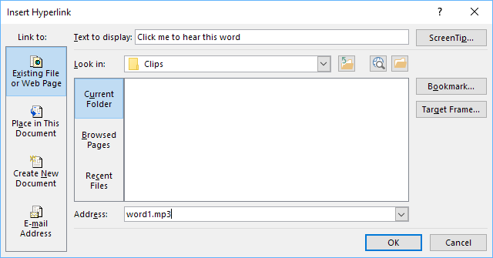

Clips added here can be used anywhere in a text file, and also in the Contents menu.
Specify the audio filename without a path, e.g. “word1.mp3” rather than “C:\My clips\word1.mp3”.

To modify this… | Adjust this style…
Audio clip links | a.audio-link

How can I create subtitles from text and timing files?
If you have text and timing files for audio synchronisation, Reading App Builder can create subtitle files for you. These can be of one of the following four formats:
- SubRip SRT subtitles (.srt)
- SAMI subtitles for Windows Media Player (.smi)
- WEBVTT Web Video Text Tracks (.vtt)
- Adobe Encore Text Scripts (.txt)
To create a subtitles file, go to the Audio Files tab, right-click and select Export Subtitles.

Video
Videos can be very powerful and engaging. However, they can also dramatically increase the size of your app if they are included in your app installer file. It is therefore recommended that you include links to online videos whenever possible.

The Videos tab
The app can handle two types of video:
- Videos for offline use--MP4 files which can be packaged within the app assets, distributed on memory cards, or downloaded from the internet for use and sharing offline.
- Videos hosted online for streaming, e.g. YouTube, Vimeo or other (MP4) streaming video files, and Jesus Film and LUMO (Gospel Films) video clips.
When added to your project, videos are assigned a video ID and can then be added to one or more places in your book files.

To add an offline MP4 video file:
- Click Add Videos…
- Select Video files in MP4 format, and click Next.
- Click Add Videos… and select the MP4 video files to add.
- Click Finish.

To add a single online video :
- Click Add Videos…
- Select Online streaming video, from YouTube, Vimeo, etc., and click Next.
- Enter the video URL in the Online Address field, e.g. http://www.youtube.com/watch?v=ABcDEdGHiJ.
- Click Finish.

Once a video has been added, it will appear in the table under the Videos tab and each assigned a video ID. Double-click on a video to access its configuration options e.g. its location, thumbnail and title.

To specify the exact placement of the video, you will need to edit the book file and use markdown format to specify the location.

The Video Settings tab
This tab allows you set various configuration options for playing videos in your app.
To modify this… | Adjust this style…
Video block (background around video) | div.video-block
Video title (title of video if added) | span.video-title
Video title block (background of title) | div.video-title

The File Source tab
Use different File Sources to specify where a particular resource is accessed—either built into the APK or downloaded or streamed from an external source. Note that this tab mirrors the File Source tab under Media Audio. See that section for more details. Remember that it is not advised to include video files in your APK installer file unless they are relatively small.

How do I modify a video’s location and configuration options?
Double-click on a video in the Videos table to access its Edit Video dialog box. This dialog box has two tabs:

Video
- Video ID: RAB assigns a unique video ID to each video. You may modify it here.
- Title: Use the Title field to display a title under a video’s thumbnail.
- Online Video: You can modify the video’s URL here.
- Offline Video: For an offline video, update the File Name and File Source.

Thumbnail
- Select File: Choose a jpg or png image to display as a thumbnail.
- Select Frame: Choose a frame from the video (if an offline MP4).
- Grab Online Image: RAB will try to get an image from the video service (YouTube etc.)

To specify where a video appears in a source book file, do the following:
- Video markers in SFM book files: Use the \video marker, together with the ID of the video within an SFM book file, e.g.
\s This is a sub heading
\p Here is an example video to view:
\video V1
\p Here is another video:
\video V2

- Video markers in Word documents: Use the word VIDEO:, together with the ID of the video within a book’s Word document, e.g.
This is a sub heading
Here is an example video to view:
VIDEO: V1
Here is another video:
VIDEO: V2
The VIDEO: tag should be at the start of a new paragraph, and include a colon (:) before the video ID.

How do I reduce the size of a video that I want to package within the app?
If you want to include MP4 video files within the app, you need to make sure that they are as small as possible, otherwise your app will become too big to publish.
There are some good video compression tools online which can reduce the size of a video considerably without losing much quality. An example is the Clideo Compress Video tool, at https://clideo.com.

Illustrations
Use the Illustrations configuration screen to add images to your app. Note that these are not the specific interface images found under the Appearance > Graphics menu, but rather images that are available to be placed in books or the About box.

There are several configuration options:

Include and show illustrations in this app
Make sure this box is checked for pictures to show up. Uncheck it if for any reason you want to temporarily hide all images.

Allow users to view images full screen and zoom in to see the details
Check this box if you want to allow users to view the images at a larger size.

Resize the image files to reduce the app size
This is recommended to keep your app size as small as possible. Pick a maximum width that reflects an average screen resolution of your target phones e.g. 720 - 1024 pixels. This will apply to all your illustrations in the table, unless modified individually.

You can override the size and zoom settings for a specific picture by double-clicking on it in the image list and modifying its settings.

Adding Illustrations / images
Use the Add Image… button to add one or more images. These can be in JPEG, PNG or GIF format. Images will appear in the image table with a thumbnail, dimensions, file size and file name. Note that the file size is the original image file size, not the size after RAB reduces the file size (if the Resize option is selected).

Make sure the references to your images use a file name that is exactly the same as the image file you add to RAB. Image file names are CASE SENSITIVE.
When an image is added, RAB copies the image into the images\illustrations subfolder of the project’s data folder.

Viewing Image Properties
Once an image has been added to the Illustrations table list, double-click on it to open the Image dialog box to view a summary of the image properties.

Documents
You can add PDF documents to your app. These can be accessed via the Contents Menu or the Navigation Drawer. Add the PDF here, and it will be selectable as an item to link to in those areas. The PDF will appear in the app in a PDF viewer that can be navigated and zoomed in or out.

The Document tab
To add a PDF document, click Add Documents…

The Viewer tab
Use the Viewer tab to get an idea of how the PDF will appear in the app.

Radio
You can include streaming web radio (internet radio) stations in your app.
To add a web radio station:
- Go to Media Radio.
- Click Add Radio Station…
- Enter a unique ID for the station (not seen by the user), a short name, and the web address (URL) from which the radio station is being streamed. Sample URLs can be found at https://streamurl.link.
Click Next.
- Choose an image to display when the radio station is playing. This could be the radio station’s logo.
Click Next.
- Choose whether to add a link to this station from the Contents menu.
Click Finish.
- Compile the app to test the radio stations on your device.

The Books project menu
The Books project menu is where all your individual books are added and modified. A Book Collection is a set of books that can be logically grouped together. RAB apps have a single book collection (called Main Collection by default). Books that are in the same collection show up in the book list on your app’s menu bar, unless you specifically hide them.

Configuring the book collection
To configure the book collection, click on the Books project menu.

The Books tab
The Books tab allows you to add or remove books from the collection.

Add Books…
Use the Add Books… button to add one or more books to a collection. The Add Books wizard first asks if you want to add a text book or an audio-only book.

Once a book or books have been added, they will appear in the book table. To modify a book’s settings, double-click on it in the table. Right-click on the book in the table to access its context-sensitive menu. See the Book table context menu actions.

You can change the order of books in the collection by clicking and dragging them in the book table. This will rearrange the order of books in the drop-down book selector in your app.

Many of the options at the global app level also have a corresponding setting at this book collection level. The book collection setting will override the global setting. Similarly, many of the book collection settings also have corresponding settings at the book level. These will affect only the specific book.

The Language tab
You can set an optional language code and name for the book collection here (with script, region or variant info, if needed).

The Styles tab
The book collection Styles tab is very similar to the Appearance Styles menu, with a few exceptions. First of all, setting a style here will override the global style setting for this specific collection.

This tab also allows some more customization for this specific book collection:

Text Font
Specify which font is used for the collection. The font must have been added in the Appearance Fonts Font Files tab.

Default Text Size
Specify a default text size for this collection.

Default Line Height
Adjust the default line height here if necessary.

Text Direction
Set the Text Direction for this book collection. This will be independent of the overall text direction in the app, set under Appearance Interface Layout Direction.

Language Code
Set the language code for this collection, if desired.

Numeral System
If the book collection language has a unique numeral system, select it from the list of available systems here.

Keyboard
If you have added a language-specific keyboard under Appearance Fonts Keyboards you will need to select it here to make it available for this collection.

The Fonts tab
Using the Fonts tab you can either allow the user to select from any of the fonts you have provided under Appearance Fonts Font Files or you can restrict their choice for this collection. These fonts are the ones that will be available under the app’s Text Appearance popup.

The Footer tab
It can be useful to display a footer block at the bottom of each page of text. This can contain information such as:
- Copyright and licensing details
- Contact email addresses and phone numbers
- Website links for more resources or to order printed materials
- Link to discussion groups on social media

You can also define a book-specific footer. Click on the book in the project tree view and then select the Features tab. Set the Footer selector to “Use book-specific setting.” This will activate a Footer tab for the book. Select that tab and define the footer block as desired.

On the Footer tab explanatory text, you will find details of the formatting codes you can use, which are similar to those you can use on the About page (see the About page section). You can also set the font, text size and text direction.

To modify this… | Adjust this text style…
Footer box (box around the footer) | div.footer
Footer text | span.footer
Footer line | div.footer.line

The Audio Files tab
Specify any audio files for this book collection under the Audio Files tab. Alternatively, you can add the audio files on a per book basis using the individual book settings, in which case they will still automatically appear here. For more details on adding audio, see How can I associate audio files with the text?

The Audio Synchronization tab
The Audio Synchronization tab allows you to configure the settings for creating timing files in order to highlight text as it is read and/or create slideshow videos.

Audio Synchronization
You can specify phrase-ending markers to separate your text files into discreet phrases for highlighting. These can be set at the app-level under Media > Audio > Audio Synchronization or overridden here for this specific collection.

Phrase Lists for Audio Synchronization
You can create phrase list text files based on the phrase-ending markers set above. These files can be used for creating timing files with Audacity (rather than with Aeneas).

Click Create Phrase Lists… to enter the Phrase Lists wizard which has the following screens:
- Phrase List File Type – Choose from Word, comma-separated values or tab-delimited.
- Synchronization Level – Choose phrase by phrase or verse by verse.
- Phrases – confirm the punctuation marks you want to use to delineate phrases.
- Headings and Markers – specify whether section headings should be included (i.e if section headers are recorded in the audio) and whether abc markers should be used.
- Output Folder – specify the output folder.
Select Create Files to create the phrase lists.

Synchronization using aeneas
Select this button to initiate the Audio synchronization using aeneas wizard. For more details, please see the document Using aeneas for Audio-Text Synchronization, available under the RAB Help menu.

Timing File Validation
Use this to validate your timing files to find any missing labels.

The Characters tab
RAB will create a list of all the characters found in all books in this collection and list them under the Characters tab. Click Validate Font to make sure that the font you selected under the book collection’s Styles tab can display all the characters.

Book Table Actions
The book collection book table appears when Books is clicked on in the project tree view. It is the list of books in the collection that appears in the project configuration area to the right of the screen.

Selecting one or more books
In the book table, select a book by clicking on it. To select more than one book, hold the Ctrl key down and click on the books. To select a range of books, click on the first book, hold the Shift key down and click on the last book in the range. Alternatively, click anywhere in the book table and use Cntrl + A to select all the books. In the example below, a single book (Prologue) is selected in the book table.

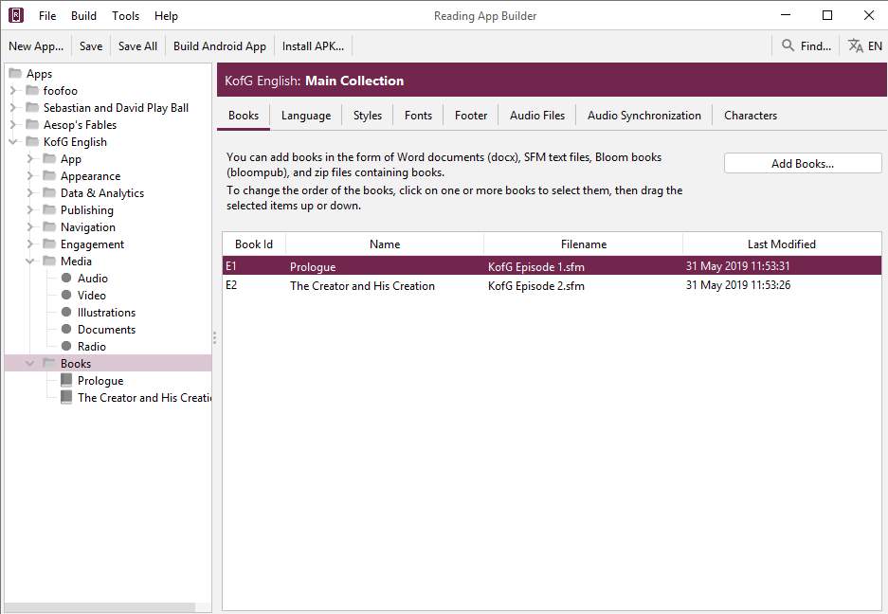

Rearranging the order of books
Select the book or books you want to move and click and drag them to the desired ordered position.

The Book context menu
With one or more books selected in the table, right-click on any of them to display the collection’s Book context menu. See the book table context menu actions below. Note that this is different from the Book context menu that displays when right-clicking on a book in the project tree view.

The book table context menu actions
With one or more books selected in the book collection book table, right-click on any of them to display the collection’s book context menu. This has the following items:

View Book
This opens the target book’s configuration window.

Remove Book
This removes the target book from the collection. Note that this will not remove it from the project data folder or delete the original source file, but will append a .deleted suffix to the copy in the data folder, preventing it from being incorporated into the project.

Add to Contents Menu
You can quickly add an existing book to a contents menu by choosing “Add to Contents Menu”. If you have more than one contents menu “screen”, you can choose which screen to add it to. Go to Navigation > Contents Menu to further customize the menu entry.

Export to HTML
Selecting this will convert the book into HTML files, one per page, along with the accompanying CSS (Cascading Style Sheets), fonts and JS (java Script) files. These will all be placed in a folder named with the project’s package name and placed under App Builder > Reading Apps > HTML Output on your computer. The first page will then be displayed in your browser. You can step through the pages to view their formatting, and test any audio and timing files.

Export to HTML settings
Selecting this displays the Export to HTML settings dialog box with two tabs:
- Audio Files tab
You can specify from where the HTML Output retrieves any necessary audio files.

- Progressive Web App tab
If you have a Progressive Web App set up, you can select to have that included in the HTML output.

Export to EPUB
Selecting this will convert the book into an .epub file which will be placed in the folder App Builder > Reading Apps > EPUB Output on your computer. See Publishing E-books (EPUB) for more details.

Create Phrase Lists…
For help with Phrase Lists, see the Audio Synchronization tab under Books for more details.

Synchronize Audio and Text…
Selecting this will open the Synchronize Audio and Text wizard. For more details, see the book-level Audio Synchronization tab.

Fine Tune Timings…
Selecting this will open the Fine Tune Timings interface in your browser. For more details, please see the document Using Audacity for Audio Text Synchronization under the RAB Help menu.

Fine Tuning File Manager…
Selecting this will open the Fine-Tuning File Manager wizard for exporting timing files to be fine-tuned.

Show Original Source
This will display a dialog box showing the book file’s original source file location and when it was last updated.

Update from Source
If the source book file is newer than RAB’s copy in the project data folder, RAB’s copy will be updated.

Change Name to Mixed Case
If the book name is in all-caps, this will change it to mixed case.

Change Book Group…
Selecting this allows you to assign or change this book’s book group to any of the default or added book groups. For more details on book groups, see Adding a New Book Group.

Configuring a Book
To configure an individual book, click on Books to display the list of books in the app’s single collection. They will appear in table form in the configuration area to the right, and also as a list in the project tree view. Double-click on a book in the table or single click a book in the project tree view list to display its configuration tabs. You can also right-click on a book in the project’s tree view on the left side of the screen to bring up the book’s tree view context menu. This is slightly different than the context menu that displays when right-clicking on a book in the book table.

The Book tab
The Book tab displays information that RAB determined from the book ID and the marker information in the book file.

Book IDs must have a unique id using only alpha-numeric characters or underscores.

Book Name
RAB will do its best to find the book name in the book file. Normally, the book name is specified using the \toc2 marker. If RAB cannot find the book name, it will just use the book ID. You can modify the book name using the text entry field. Click More… to enter additional spellings.

Abbreviation
RAB will do its best to find the book abbreviation in the book file. Normally, the book abbreviation is specified using the \toc3 marker. If RAB cannot find the book name, it will just leave the field blank.

Book Type
There are four book types. RAB will attempt to figure out the type of book based on either the specific ID or by the content.
The book types are the following:
- Default – this is the most commonly used type for normal books and represents a text-centric series of pages.
- Picture Story Book – this is a particular type of book that includes at least one picture per page, normally with accompanying text. If the book uses an \img image marker, RAB will normally automatically set its type to Picture Story Book.
- Song book – If your book is intended to be a song book, with one song per page, you should manually set its book type to song book. See the song book section for more details.

Groups
Books can be assigned a group and subgroup if desired. In the app’s book selector menu, books will be listed under their group.

For details on how to add your own groups, see Adding a New Book Group.

You can change the names and/or add translations for the book groups under the Appearance Interface Translations tab. Search for the translation string name.

Adding a New Book Group
You can add your own book groups if you want to differentiate between certain types of books in your app. For example, you may have an app with health manuals and quizzes. You can add a “Health manuals” book group as a category in the book selector. To do this, go to any book’s Book tab and type the name of the new group directly into the Group list field. Keep the name fairly short—it is just going to be an internal name to represent the group. Now go to the Appearance Interface Translations tab and search for Group. You will see a new group entry named with your group name. For example, if your group name is “Manuals”, you will see an entry named Book_Group_Manuals. You can then fill in the translated name that you wish to appear e.g. Health Manuals.

The Song Index tab
This tab only appears if your book type is set to Song Book and your book file has the correct song book format. See Song Books for more details. The Song Index tab displays how the automatically-generated song book index will display in the app, allowing the user to select a song by song number or alphabetically by title.

The Styles tab
The book Styles tab presents two choices:
- Use default styles for this book – This sets the book style based on the book collection’s style set under Books Styles.
- Customize styles for this book – Choosing this transforms the Styles tab to resemble the Books styles tab with all the same settings. Changing these settings will only affect the current book, however. For more information on the various settings, see the Books Styles tab.

The Fonts tab
The book Fonts tab presents two choices:
- Use the same fonts as specified for the book collection – This sets the book’s available fonts as those set on the book collection’s Fonts tab. See Books Fonts.
- Use any of the fonts selected below – Choosing this transforms the Fonts tab to display the table of fonts available in the associated book collection. Select or unselect any fonts that you want the user to be able to use for this book in the Text Appearance popup and Verse on Image editor.

The Features tab
By default, books inherit the app-level and collection-level book configuration settings. The Features tab allows you to override those specific settings for the current book.

Show in book selector
By default, all books in a collection appear in the app’s book selector. Use this setting to hide a book from the selector list.

If, for example, you have a mix of literacy texts and other book resources (quizzes, song books, manuals etc.) in the same book collection, the book list selector will become very long. In this case, it might be better to hide the certain types of resource books in the list, and instead provide a contents menu to access them. This can be much more user-friendly.

Continue playing audio at end of page
You can override this setting if for some reason you want this book’s audio setting to be different than that set at the app level.

Lock orientation of screen
Use this setting to force a certain orientation (portrait or landscape) for the viewing of this book.

Footer
By default, this is set to display any footer applied at the book collection level. You can choose to specify a particular footer for this book by choosing the book-specific setting.
This will cause an extra Footer tab to appear in this book’s configuration screen.

The Audio Files tab
Specify any audio files for this book under the Audio Files tab. Alternatively, you can add the audio files using the book collection Audio Files tab, in which case they will still automatically appear here. For more details on adding audio, see How can I associate audio files with the text?

The Audio Synchronization tab
The Audio Synchronization tab allows you to configure the settings for creating timing files in order to highlight text as it is read and/or create slideshow videos. This tab is identical to the one at the Books level, but allows you to modify the phrase-ending characters for this book alone. It also provides a way to create phrase lists, run the synchronization and validate the timing files for this book alone.

The Tabs tab
It is possible to create an app which displays books with two or more tabs, with different content on each one. You will first need to set up which tab types you have available. See Navigation Tab Types for more details.

To add a tab to a book:
- Select the book to which you would like to add the tab, and go to its Tabs tab.
- Click the Add Tab button.
- On the Tab Type page of the wizard, select the tab type for the tab you would like to add. Then click Next.
- On the Book page of the wizard, click the Browse button and select the book file to use in the tab. This could be a text file in SFM format or a Word document.
- If the book you choose for the tab has a single page, this will be displayed in the tab whatever page is chosen in the main tab (e.g., the same study questions for each page).
- If the book you choose for the tab has multiple pages, the app will display the page in the tab that corresponds to the page selected in the main tab (e.g. a different set of study questions for each page).
- Click Finish.
- If you have any audio files for the tab, go to the Audio Files tab and add the audio and timing files.
- Compile the app and test it on your device.

The Cover tab
As well as building a smartphone app, you can create e-books in EPUB format. EPUB documents are readable by a number of e-book readers on Windows, Mac, iOS and Android platforms. See Publishing E-books (EPUB) for more details.

If you want to create an EPUB book from a single book, you can specify its cover here on the Cover tab. The image specifications are listed in the tab description in RAB.

The Changes tab
You can define a set of regular expression or find / replace entries that will be applied to a book during the build process, not affecting the original file. The entries under this book Changes tab override the app-level and collection-level entries set under Appearance Changes.

The Characters tab
RAB will create a list of all the characters found in this book and list them under the Characters tab. Click Validate Font to make sure that the font you selected under the book or book collection’s Styles tabs can display all the characters.

The Book File tab
Use the Book File tab to view the actual book SFM file. Note that even if the book was added as a Word document, RAB will convert it internally to SFM. Viewing it this way may help you figure out any formatting problems.

Page
Use the page selector to step through the pages.

Project
The Project field shows the path to where RAB is storing its copy of the file, usually in the books subfolder of the project data folder. To the right of the path is the last time that the file was updated. If instead it says (Not found), that file has been deleted or moved.

Source
The Source field shows the path from where the source book file was added. For Paratext projects, this may be the Paratext project’s local data folder. See using RAB with Paratext files. To the right of the path is the last time that the file was updated. If instead it says (Not found), that file has been deleted or moved.

It is not generally recommended to directly modify book files in the project data folder, since updating them from their source file will erase any changes.

Edit Source
If RAB can find your source file, the Edit Source button will be displayed. Click to open the source book file in your text editor. Note that this will not modify RAB’s copy of the book. Once finished editing, save the file and then click the Update from Source button.

Update from Source
If you have edited your source file, click Update from Source to make sure RAB copies this updated file to its project folder. A message will be displayed stating that the file has been updated.

Export As Text File
If you imported a Word doc as your book file, RAB will convert it internally to SFM. You can export this converted file as a .txt file which will allow you to have greater control over the markers and formatting. You will need to remove the original Word doc file and then add the text file as your new book file.

Show After Changes
If any Change expressions have been added at the app, collection or book level, the Show After Changes checkbox will be displayed. Click to show the book file after the changes have been applied. This is a good way to make sure your changes were applied correctly before building the app.

The Viewer tab
The Viewer tab displays the book file using all the current styles, colors, formatting and settings. If an audio file is associated with the book file, an audio toolbar will display at the bottom of the viewer allowing the audio to be tested. If there is timing information associated with the file and highlighting is enabled, the text and audio should be synced in the Viewer.

Refresh
Use the Refresh button to update the Viewer if you’ve modified the source file.

View in Browser
Use the View in Browser button to convert your book to HTML and open a browser window to display it.

The project tree view Book context menu
If you right-click on a single book in a book collection’s list of books in its project tree view (on the left side of the RAB screen), the book’s context menu will display.

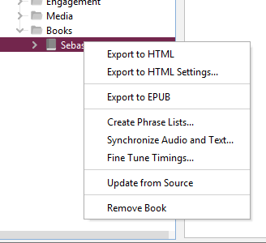

Export to HTML
Selecting this will convert the book into HTML files, one per page, along with the accompanying CSS (Cascading Style Sheets), fonts and JS (java Script) files. These will all be placed in a folder named with the project’s package name and placed under App Builder > Reading Apps > HTML Output on your computer. The first page will then be displayed in your browser. You can page through the pages to view their formatting, and test any audio and timing files.

Export to HTML settings
Selecting this displays the Export to HTML settings dialog box with two tabs:
- Audio Files tab
You can specify from where the HTML Output retrieves any necessary audio files.

- Progressive Web App tab
If you have a Progressive Web App set up, you can select to have that included in the HTML output.

Export to EPUB
Selecting this will convert the book into an .epub file which will be placed in the folder App Builder > Reading Apps > EPUB Output on your computer. See Publishing E-books (EPUB) for more details.

Create Phrase Lists…
For help with Phrase Lists, see the book collection’s Audio Synchronization tab for more details.

Synchronize Audio and Text…
Selecting this will open the Synchronize Audio and Text wizard. For more details, see the book-level Audio Synchronization tab.

Fine Tune Timings…
Selecting this will actually open the Fine Tuning File Manager wizard for exporting timing files to be fine-tuned. To fine tune this particular book’s timings instead, right-click on the book in the book table in the project’s configuration area and select Fine Tune Timings…

Update from Source
If the source book file is newer than RAB’s copy in the project data folder, RAB’s copy will be updated.

Remove Book
This removes the target book from the collection. Note that this will not remove it from the project data folder or delete the original source file, but will append a .deleted suffix to the copy in the data folder, preventing it from being incorporated into the project.

Picture Story Books
In most cases, a picture story book is a book with a picture at the top of each page and a few sentences of text underneath. In the app, the picture will stay at the top of the screen and the text will scroll, though it is possible to have the picture or pictures scroll with the text instead. Picture Story Books are intended to be fairly simple books for things like illustrated literacy or health books.

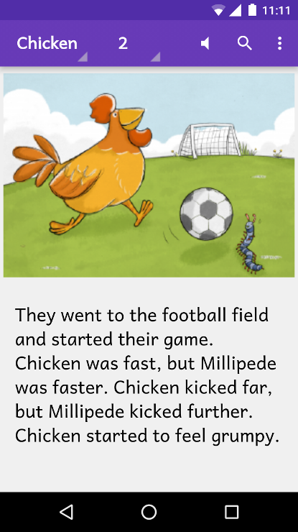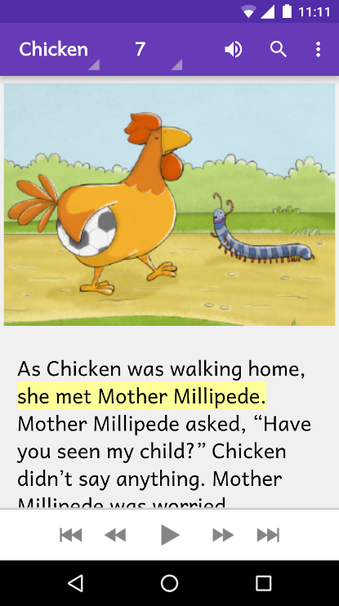

Audio-text highlighting works as for other kinds of book, and when the audio reaches the end of a page the app will move to the next page of the story.

When the device screen is in landscape orientation, the picture will be displayed to take up the whole screen. If you specify a timing file alongside the audio file, each phrase will be displayed as a subtitle over the image.

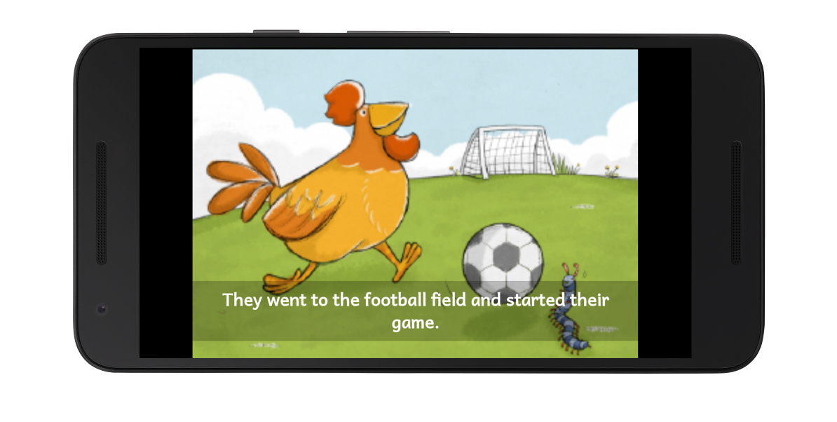You can choose to associate a single audio file with the whole picture story book, or one audio file per page. One file per page seems to work better when the audio pauses between page turns.

Make sure that audio files are clearly and uniquely named. RAB will need to figure out which audio file to associate with which page, so clearly include the number in the file name (i.e. at the end of the name) using a leading zero. Include the book name so you don’t confuse the audio for several books.
E.g. my_book_page_01.mp3

How do I define a picture story book?
Picture story books can be defined in one of two formats:
- Microsoft Word (.docx) documents, or
- Text files using standard format markers (SFM).

Even though Word documents may appear easier, they work best only for very simple story books. If you want more control over the formatting and features of the book, use the SFM format.

What do picture story books in Word documents look like?
To create a Microsoft Word document to define a picture story book:
- Start with a new blank document in Word.
- Insert a picture at the top of the first page.
- Add the story text for this page below the image.
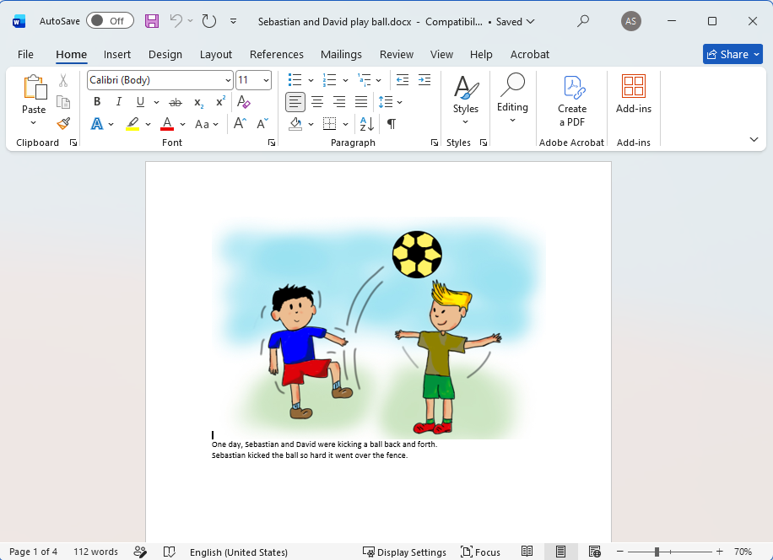
- Insert a page break after the text using CTRL+Enter, or Insert Page Break.
- Insert a picture at the top of the second page and place the story text under it.
- Insert a page break after the text using CTRL+Enter, or Insert Page Break.
- Continue adding additional pages in this way.
- Save the document in .docx format.

You can add images to the document in .jpeg, .jpg, .png, .tif or .gif formats and Microsoft Word will convert them automatically to the format recognised by Reading App Builder.

If you have large image files it is best to resize them. You can do this either before adding them to the document or within Word itself:
- Select one of the images in Word.
- Click Compress Pictures on the picture format ribbon or toolbar.
- Select All Pictures in document.
- Select the resolution as Web/Screen.

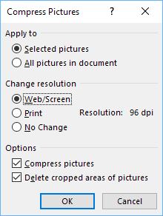

- Click OK.
- Save the document.

RAB converts Word documents into its own internal SFM document format with a unique book ID. When you click the book file in the project tree in RAB, choose the Book File tab in the configuration area on the right. This will display the converted file and can help you fix formatting issues. In general, it is best to create your own SFM file over which you will have greater formatting control.

What do picture story books in SFM format text files look like?
They start with an id of your choice (using only alpha-numeric characters or underscores):

\id STO29
and a title:
\toc2 The Story of the Unmerciful Servant

Each page begins with the \page marker:

\page 1

followed by an image filename:

\img obs-29-01.jpg

and then the text for that page, using USFM markers like \p for paragraphs:

\p One day, Peter asked Jesus, “Master, how many times should I forgive my brother when he sins against me? Up to seven times?”
\p Jesus said, “Not seven times, but seventy times seven!”
\p By this, Jesus meant that we should always forgive. Then Jesus told this story.

Here is an example:

------------------------------------
\id STO29
\toc2 The Story of the Unmerciful Servant
\page 1
\img obs-29-01.jpg
\p One day, Peter asked Jesus, “Master, how many times should I forgive my brother when he sins against me? Up to seven times?”
\p Jesus said, “Not seven times, but seventy times seven!”
\p By this, Jesus meant that we should always forgive. Then Jesus told this story.
\page 2
\img obs-29-02.jpg
\p Jesus said, “The kingdom of God is like a king who wanted to settle accounts with his servants. One of his servants owed a huge debt worth 200,000 years' wages.”
\page 3
\img obs-29-03.jpg
\p “Since the servant could not pay the debt, the king said, 'Sell this man and his family as slaves to make payment on his debt.'”
\page 4
\img obs-29-04.jpg
\p “The servant fell on his knees before the king and said, 'Please be patient with me, and I will pay the full amount that I owe you.' The king felt pity for the servant, so he canceled all of his debt and let him go.”
etc.
For a more complete list of SFM markers you can use with Reading App Builder, see Appendix 2

The book files must be plain text files. If you have Unicode characters, the text files should use UTF-8 encoding. To create a text file in Windows, use a text editor such as Notepad. To create a text file on a Mac, use TextEdit, remembering to choose Plain text files in the preferences because otherwise the default file type is RTF (which contains a lot of additional formatting codes).

Where do the pictures go?
If you have defined the picture story book as a Word document, the images in the document will be added automatically to the app Media Illustrations list when you add the book. You can see them on the Illustrations page for the book.
If you have defined the picture story book as an SFM text file, you need to add the images to Reading App Builder separately. Do this on the Media Illustrations page. You can use either PNG or JPG files. Try and make them as small as possible without compromising image quality. This will keep your app size small and reduce page load time.

How can I get the pictures to move when the audio is playing?
If you have audio in your book, you can add pan and zoom effects to the images when the audio is playing. To specify the motion:
- Go to the Story Pages tab for the book.
- Select an image at the top of the page.
- Select the Motion tab below the images.
- Select Specify the start and end positions.
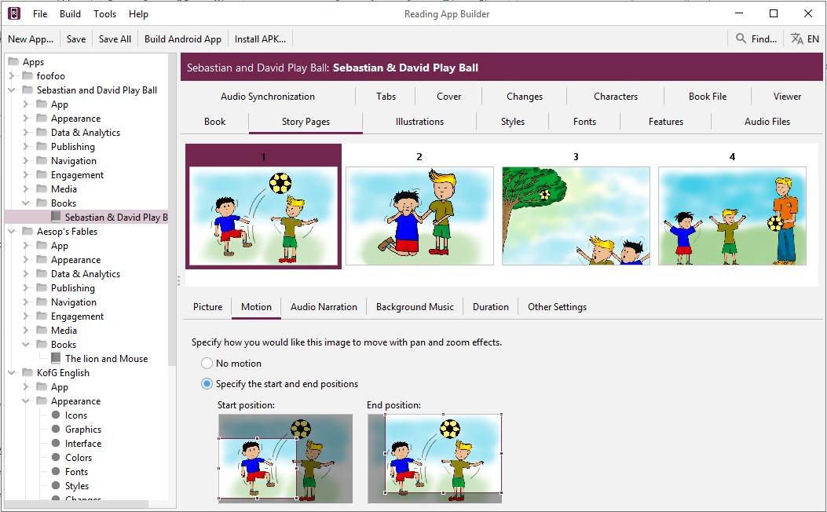

- Drag and resize the start and end rectangles in the images to specify the start and end positions.

Vary the positions to add some interest. For example, alternate between panning in and panning out, or follow the indicated motion of the image itself (e.g. pan left to right if the people are walking towards the left).

- Do this for each image in the book. By default, the movement effect is timed to correspond to the length of the audio.

If your audio is longer than around 20 seconds, the movement may occur too slowly. Click on the Duration tab and set the duration to be around 20 seconds and adjust as necessary.

What about font and font size?
A popular font designed for those learning to read is Andika or Andika Compact.
Specify the fonts available to the user under the Appearance Fonts menu. Set the specific book collection’s font under the Books Fonts tab.

If you have a small amount of text per picture, it is best to use a larger font size by default. You can change this within Reading App Builder on the Books Styles tab by modifying the Default text size property.

What audio timing labels are used?
If you have one audio file for the whole book, timing labels are of the form:
1a - 1st phrase on page 1
1b - 2nd phrase on page 1
1c - 3rd phrase on page 1
2a - 1st phrase on page 2
2b - 2nd phrase on page 2, etc.

If you have one audio file per page, timing labels are of the form:
a - 1st phrase on the page
b - 2nd phrase on the page
c - 3rd phrase on the page

To help with the creation of the timing files, generate phrase lists on the Audio Synchronization tab for the book, or use aeneas to automate the synchronization process.

How can I add background music when the audio is playing?
You can add background music and sound effects behind the audio narration track. To do this:
- Go to the Story Pages tab for the book.
- Select the first image at the top of the page.
- Select the Background Music tab below the images.
- Select Play this audio file as background music.
- Click Select File… and choose the background music audio file.
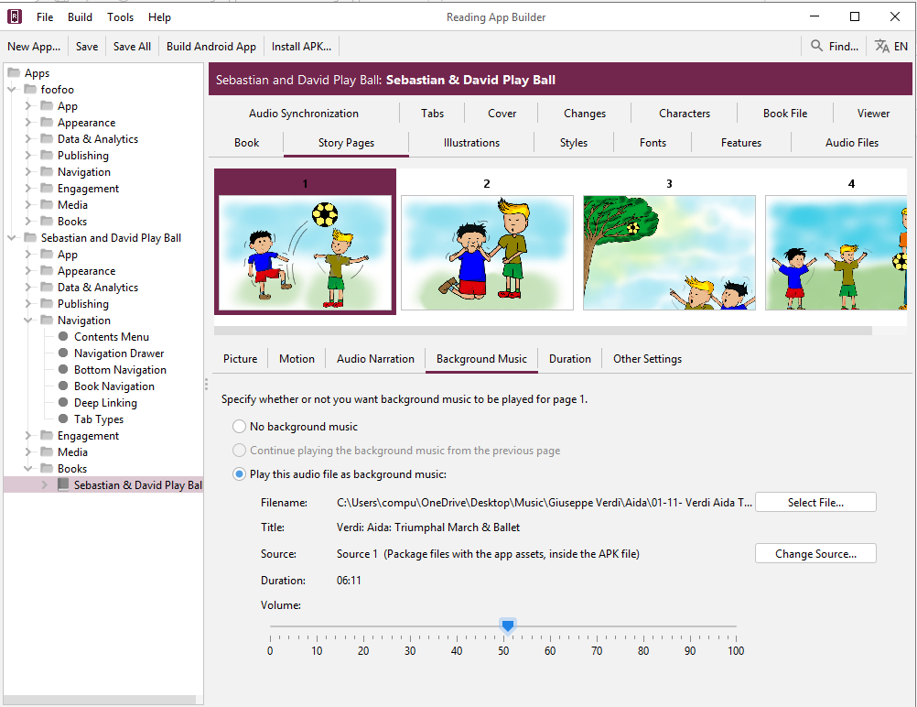

- Drag the slider to modify the volume of the background music.
- Select each of the following pages in the book and specify whether to Continue playing the background music from the previous page, whether to play a different background music track or whether to stop playing any background music.

How can I record the audio files?
Use your favourite sound recording software, such as Audacity. You will need to decide how fast or slow you want the reader to read. In some contexts, it might be good for picture story books to be read fairly slowly. Remember that it is generally best to record one file for each page.

Song Books

How do I define a song book?
You can build a song book file similar to other book files, but with one song per 'page'. Song books are defined in one of two formats:
- Microsoft Word (.docx) documents, or
- Text files using standard format markers (SFM).

See the sections below for a description of these formats.

Audio can be added with audio-text synchronization so that each line of the song is highlighted as it is sung.

When you add your songbook to the app, click on the book in the project tree view and select the Book tab. Make sure the Book Type selector is set to Song Book. If it is, RAB will automatically a Song Index comprised of 2 contents menus—one listed by song title and the other by song number. You can preview these under the Song Index tab.

What do song books in Word documents look like?
To create a Microsoft Word document to define a song book:
- Start with a new blank document in Word.
- Type the songs or copy them from another document.
- For each song, place the song number on a line by itself before its corresponding title and lyrics.
- Create the following paragraph styles:
Style | Use
c | Chapter/page number
s | Song title
q1 | Line of the song
q2 | Line of a chorus (more indentation)
To create a style:
- Select the line/paragraph of text that corresponds to this style, i.e. if you are creating the style ‘c’, select one of the lines with a song number. If you are creating the style ‘q1’, select a line of the song lyrics.
- Click on the down arrow to the right of the styles ribbon.
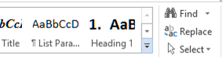

- Then select Create a style from the menu that appears.
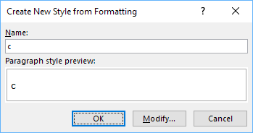
- Type the style name into the dialog box and press OK.
Do this for c, s, q1 and q2.
- Apply the above styles to all the page numbers, song titles and the lines of the song lyrics.
To apply a style:
- Select the line/paragraph to which you want to apply the style.
- Click on the down arrow to the right of the styles ribbon.

- Select the style you want to apply.

Apply style ‘q2’
Apply style ‘q1’
Apply style ‘s’
Apply style ‘c’

As you apply the styles, the F4 key can be useful to repeat your previous action.

All of the songs are contained within a single Word document.
- Save the document in .docx format.

What do song books in SFM format text files look like?
Start with an id of your choice (using only alpha-numeric characters or underscores):

\id SONGBOOK1
and a title:
\toc2 Our Song Book

Each song begins with the \c marker and the number of the song:

\c 1

The marker \q (or \q1) is used for line of the song lyrics and \q2 for indented lines, such as for a chorus.

Use \b for blank lines between verses.

\id SONGS
\toc2 Song Book

\c 1
\s My Favorite Things

\q1 Raindrops on roses and whiskers on kittens
\q1 Bright copper kettles and warm woollen mittens
\q1 Brown paper packages tied up with strings
\q1 These are a few of my favorite things
\b
\q1 Cream colored ponies and crisp apple strudels
\q1 Doorbells and sleigh bells and schnitzel with noodles
\q1 Wild geese that fly with the moon on their wings
\q1 These are a few of my favorite things.
\b
\q1 Girls in white dresses with blue satin sashes
\q1 Snowflakes that stay on my nose and eyelashes
\q1 Silver white winters that melt into springs
\q1 These are a few of my favorite things
\b
\q2 When the dog bites, when the bee stings
\q2 When I'm feeling sad
\q2 I simply remember my favorite things
\q2 And then I don't feel so bad
\b
\q1 Raindrops on roses and whiskers on kittens
\q1 Bright copper kettles and warm woolen mittens
\q1 Brown paper packages tied up with strings
\q1 These are a few of my favorite things

\c 2
\s Edelweiss

\q1 Edelweiss, edelweiss
\q1 Every morning you greet me
\q1 Small and white
\q1 Clean and bright
\q1 You look happy to meet me
\b
\q1 Blossom of snow
\q1 May you bloom and grow
\q1 Bloom and grow forever
\q1 Edelweiss, edelweiss
\q1 Bless my homeland forever

If you are used to using Paratext, these SFM codes will be familiar since they are how you mark up poetry in such as Psalms. For a list of poetry markers see Poetry Styles.

All of the songs are contained within a single file.

The SFM songbook file must be a plain text file. If you have Unicode characters, the text files should use UTF-8 encoding. To create a text file in Windows, use Notepad. To create a text file on a Mac, use TextEdit, remembering to choose Plain text files in the preferences because otherwise the default file type is RTF (which contains a lot of additional formatting codes).

When you add your songbook to the app, click the book in the project tree and select the Book tab. Make sure the book type selector is set to Song Book. If this is the case, RAB will automatically display a Song Index consisting of 2 content menus, one listed by song title and the other by song number. You can preview them under the Song Index tab.

If you do not see a Song Index tab for the song book, make sure the Book Type is set to Song Book. If you try to add an image in your Song Book using an \img marker, RAB will change your Song Book type to Picture Story Book. Instead, use the \fig <image filename> \fig* markers.

How can we associate audio with each song?
A separate audio file and corresponding timing file needs to be created for each song.

Timing labels are of the form:
a - 1st line of the song
b - 2nd line of the song
c - 3rd line of the song
d - 4th line of the song, etc.

To help with the creation of the timing files, generate phrase lists on the Audio Synchronization page for the book.

Automated synchronization is unlikely to work for songs, so you will need to use the manual tagging method using Audacity and Timing Labels Assistant. Please see the document Using Audacity for Audio Text Synchronization for instructions.

If your song text exactly matches the song lyrics, including all repetitions, you may be able to create timing files automatically using aeneas. It becomes more challenging if there are musical introductions or conclusions to the songs, and especially if there is one or more musical interludes during the song.

Registration Screen

You can define a registration screen to be shown when a user launches the app for the first time. This allows you to collect contact information, for example to connect people with reading/listening discussion groups.

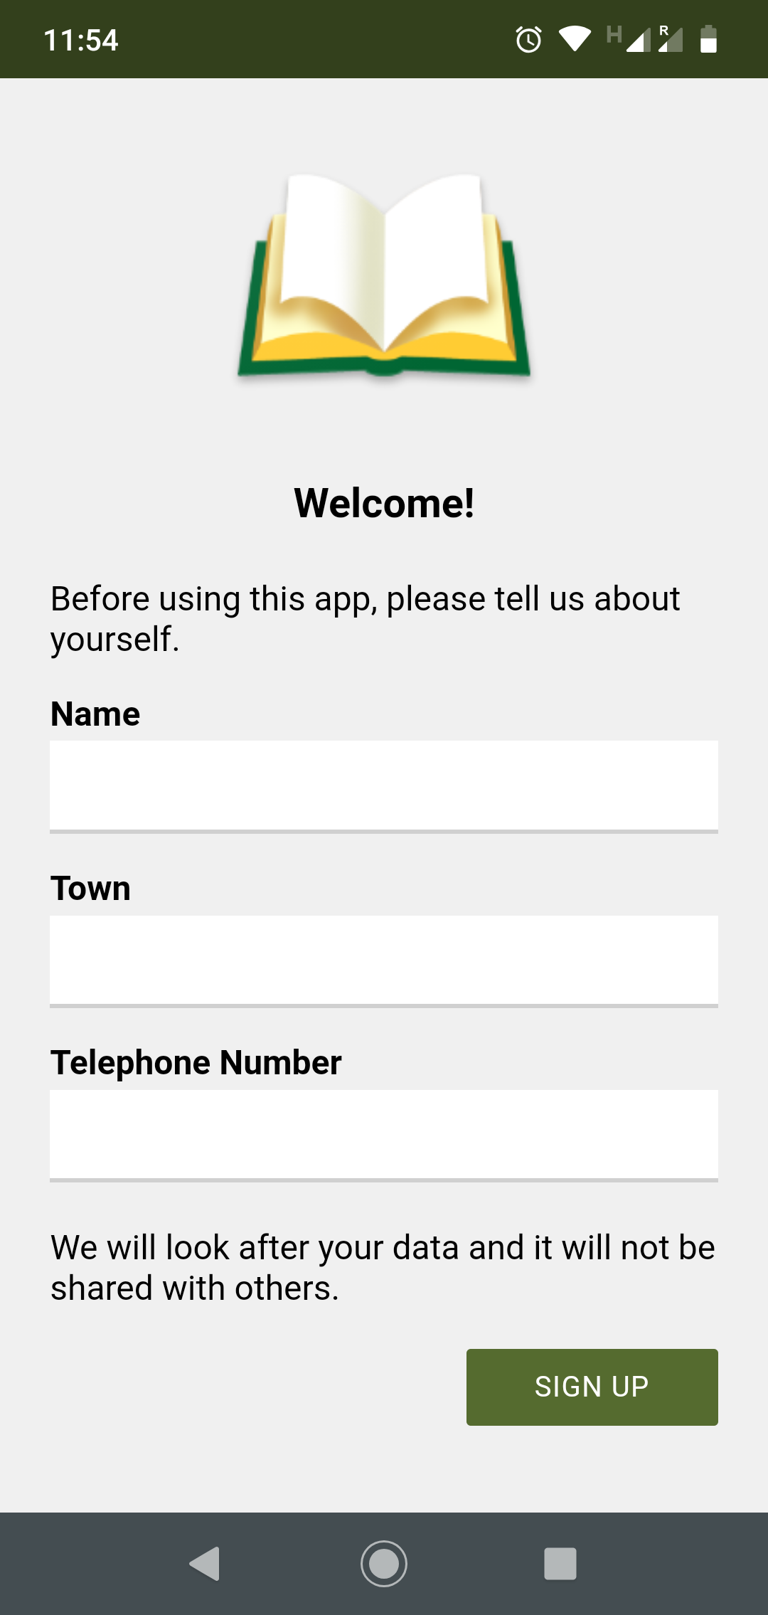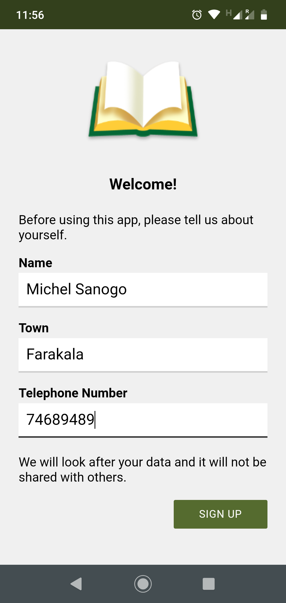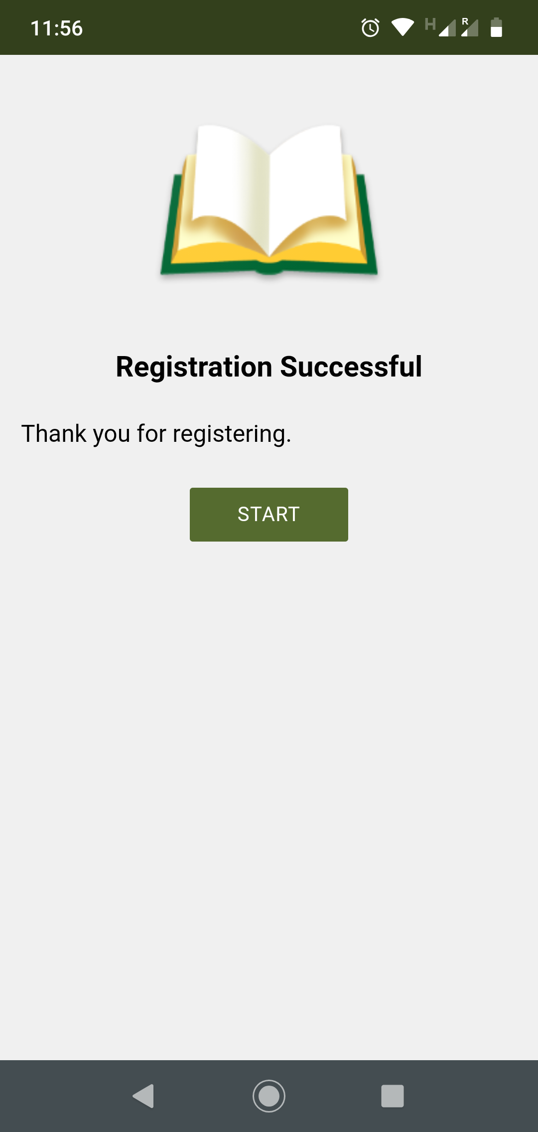

To set up a registration screen, you need to do some configuration work in two places:
- within Reading App Builder, and
- in the Google Firebase console.

Setting up the Registration Screen
To set up the registration screen within the app builder:
- Go to the App Security page.
- Select Require each user to register with their details when they first use the app.
- Click the Configure Registration button.
- Follow the instructions in each of the tabs in the Configure Registration dialog:
    - Registration Screen: specify the title and text to show on the registration screen.
    - User Details: specify the input fields (such as name, telephone number, email adress), that you will ask the user to provide. You can specify which of these are required and which are optional.
    - Skip Registration: choose whether you want the user to be able to skip the registration process. If they do press the Skip button, specify when you want the app to ask them again.
    - Registration Completed: specify the title and text to be displayed on the screen which is shown to the user after they have successfully registered.
    - Image: specify an image to be displayed at the top of the screen, such as your organisation’s logo or the app icon.
    - Database: choose whether the user data will be stored in an app-specific path in the database (which is useful if you use the same database for several apps), or at the top level of the database (which is fine if you have just one app). More information about configuring your database can be found in the following section.
    - Styles: you can adjust the styling of the screens by adjusting the style declarations.
Use the Test buttons on the Registration Screen and Registration Completed tabs to preview the screens in a browser.
- Click OK when you are finished in the dialog.

Setting up the database in the Google Firebase console
To set up the database, which will contain the registered users’ information, you need to add Firebase to your app, create a database, set up authentication and configure rules.
Add Firebase to your app
Follow the instructions in setting up a Firebase project, described in the section above on Firebase Analytics.

Create a Database
To create a database:
- In your Firebase project console, select Realtime Database from the menu on the left of the screen (the option below Firestore Database).
- Click the Create database button.
- On the first page of Set up database, choose where you would like the data to be stored, then click Next.
- On the second page of Set up database, choose Start in locked mode, and click Enable.

Set up Authentication
To set up authentication:
- In your Firebase project console, select Authentication from the menu on the left of the screen.
- Select the Sign-in method tab.
- Click on Email/Password and enable this authentication method. This is used when viewing registered users in a web browser
- Click Save to confirm your changes and return to the Sign-in method tab.
- Click on Anonymous (at the bottom of the Sign-in providers list) and enable this authentication method. This is used during user registration in the app.
- Click Save to confirm your changes and return to the Sign-in method tab.

Configure Rules
Rules are required to tell Firebase who will have access rights to read and write to the database. To configure the database rules:
- In your Firebase project console, select Realtime Database from the menu on the left of the screen.
- Select the Rules tab.
- The rules you specify will depend on the path you have chosen on the Database tab in the Registration configuration.
If you have chosen to store the user information in an app-specific location, e.g. “/apps/your-app-package-name/users/”, the rules need to be as follows:

{
"rules": {
"apps": {
"$package": {
"users": {
"$uid": {
".read": false,
".write": "$uid === auth.uid"
}
}
}
}
}
}

If you have chosen to store the user information at the top level of the database, e.g. “/users/”, the rules need to be as follows:

{
"rules": {
"users": {
"$uid": {
".read": false,
".write": "$uid === auth.uid"
}
}
}
}

These rules give write access only to the user who is making the registration. No one will have read access (except for you when you view the database from the Firebase console).

Make sure you copy the rules exactly. An easy way to get the rules you need is to click the Database Rules button on the Database tab. This will give you the rules you can copy.

If you are also using User Accounts in this app, you will need to combine the database rules for the registered users (Registration screen) with the rules for the signed up users (User Accounts). Please see below, Rules FAQ, for more details.

- Click Publish to confirm your changes.

Rules FAQ
Q. If we have also enabled User Accounts for this app, what rules do we need to use?
If you are using both User Accounts and a Registration Screen, you need to combine the rules as follows:
{
"rules": {
"apps": {
"$package": {
"users": {
"$uid": {
".read": false,
".write": "$uid === auth.uid"
}
}
}
},
"authenticated-users": {
"$uid": {
".read": "$uid == auth.uid",
".write": "$uid == auth.uid"
}
}
}
}

The above rules assume that you want to store the user information in an app-specific location. If you have chosen the top-level location, you need to remove the “apps” and “$package” elements above.

Q. If we want an administrator to have read access to the Registered users to display in a web browser, what rule do we use?
If you want to give an administrator read access to the data, to be displayed in a web browser (See Configure Registration User Details View Data), here is the rule to use:
{
"rules": {
"apps": {
"$package": {
"users": {
"$uid": {
".read": "(auth != null) && (auth.token.email == 'me@abcd.com')",
".write": "$uid === auth.uid"
}
}
}
}
}
}

(where me@abcd.com is a user added on the Authentication page)

The above rules assume that you want to store the user information in an app-specific location. If you have chosen the top-level location, you need to remove the “apps” and “$package” elements above.

Publishing and Distribution
Before you distribute your app, please use the App Publishing Checklist (available via the Help menu in RAB or on the RAB website) to verify that it is ready to publish.

Apps built with Reading App Builder can be published on the Google Play store, distributed by memory card, shared by Bluetooth or Wi-Fi transfer, uploaded to websites, or sent out by email. For more information, please see the user manual Distributing Apps (available via the Help menu in RAB or on the RAB website).

Appendix 1: How RAB stores your project data files

When you select a source file to load into your app, RAB will make a copy of it in the project’s data folder. However, it will maintain the link to the source file. If you update the source file, you will need to select the file in the project tree view, right-click it and select Update From Source. This will copy the updated file into the project’s data folder.

Alternatively, select the file, select the Book File tab in the configuration area and click the Update From Source button.

As part of the installation process, RAB creates a number of folders for its data files. By default, these are in a hierarchy under your Documents folder. The following is an explanation of the various folders from the top-level down:

General-use RAB data folders

- App Builders: this folder contains the top-level folders for the various installed app builders i.e. Dictionary Apps, Reading Apps etc.

- Reading Apps: this folder contains all the subfolders related to Reading App Builder data files.

- APK Output: this folder is where RAB places your compiled APK files (the app installation files that need to be copied to a phone). You can open this folder by selecting File View APK Output Folder.

- App Projects: RAB stores your app projects in this folder, with the subfolders named after each project. If you have a project selected in the Tree View, you can view its project folder by selecting File View Project Folder.

If you want to share your app project with someone else (i.e. someone who can help you test and find problems with your app), you’ll need to give them your project folder and all it contains. They can copy it into their own App Projects folder, open it in RAB and use their own, temporary keystore to build, run and test your project. If audio files are necessary for your app and they are not stored in your project’s audio subfolder, you will need to copy those separately.

    - <group names>: If you have created a group for your project files, the group folder will be at this level.

    - <project names>: Your project folders will be either at this level or underneath the <group name> folder, if appropriate.

    - <project name>.appDef: For example, My_Stories_App.appDef. This is your project’s definition file—the file that stores most of the project’s attributes.

    - <project name>_data: For example: My_Stories_App_data. This is the project’s parent data folder. All the project’s data items are in subfolders beneath.

- Audio: Any audio files that are converted within RAB are placed here.

- Epub Output: Any created Epub files are placed here.

- HTML Output: If you use the Export to HTML feature, the output files will go here.

- IPA Output (Mac only): If you are building apps for iOS, output files will be placed here. You can open this folder by selecting File View IPA Output Folder.

- Phrases: Phrase list files generated as part of the text / audio synchronization process go here.

- PWA Output: The output from the Build PWA function is placed here. You can open this folder by selecting File View PWA Output Folder.

Project-specific data folders

RAB project folders have the project definition file (<project-name>.appDef) and a parent data folder (<project-name_data). The following are explanations of the various project data subfolders:

- About: several text files including the text of the About box, the expiry notice and the “audio not found” notice.
- Audio: the audio files for your app. These are copied here from your source audio folder if you have selected Copy files to app projects data folder under the Audio Files section of Tools Settings Files.
- Books: RAB stores your book files here in folders named after the book collection’s ID.
- Contents: the Contents.xml file that describes your contents menu structure and data, and an images subfolder for the contents menu images.
- Firebase: if your project uses Firebase, the google-services.json file is placed here.
- Fonts: the font files included with your app
- Images: most of the images associated with your app in their respective sub-folders including illustrations, backgrounds, borders, menu, watermark and all the various sizes of icon files.
- Plans: reading plan text files and their images.
- Publish: all the Google Play Store listing data in its various subfolders and associated json files.
- Timings: timing files for audio synchronization
- Verses: the verses.txt file describing the verses of the day
- Video: MP4s included in your app and video image stills.

Appendix 2: Useful App Builder SFM markers

Headings
- \id a unique, internal identifier for the book, not visible to the user.
- \h or \toc2 the wording that appears in the book list selection menu
- \toc3 the abbreviation that appears in the Book grid selection menu
- \rem Not displayed. Comment line for your use

Pages and Chapters
- \c or \page Used to separate material into different chapters or pages

Paragraphs
- \s1 section header or for songs a song title
- \b a blank line
- \p a paragraph with indented first line
- \pi an indented paragraph with indented first line
- \pc a centered paragraph
- \pmr paragraph right aligned, Used for chords in song books
- \m a paragraph with no first line indent
- \mi an indented paragraph with no first line indent
- \q1 used in songs for song verse, indented with first line hanging indent
- \q2 used in songs for song chorus, more indented with first line hanging indent

Media
- \video Video ID
- \img File name of image to go at top of page (text scrolls independently) – used for story books
- \fig filename.jpg\fig* Used for inline picture insertion
- \fig |filename.jpg||||Caption here|\fig* Used for inline picture with caption.
- \fig DESC|FILE|SIZE|LOC|COPY|CAP|REF\fig* Full specification from USFM reference.

Links to other books or audio files.
[Hyperlink text](link location) used for internal or external hyperlinks.

Examples
To link to a website:
[this page](https://github.com/SILAsiaPub/AppBuilder-workaround/edit/master/RAB-cheat-sheet.md) – this shows a “this page” link that links to the specified website
To link to a book page in the current collection:
[go to Book Id B001 page 2 in app](B001.2) – the book ID is B001
To tap on a link to play a sound:
[Play the sound](audioclip.mp3) -- Tap on Play the sound to play the clip
To tap on an image to play a sound:
[\fig image.jpg \fig*](audioclip.mp3) Tap on the jpg image to play a sound

Character markup
- \bd bolded words\bd* bold words
- \it italicised words\it* italicised words

Appendix 3: RAB body and text styles explanation
For more detailed explanations of styles see the USFM documentation.

Body Styles
These apply to the page or box areas that contain text and images.
To modify this… | Adjust this style…
Display of page body – default body style that applies to all other body styles | body
Display of single or two-pane view page body – specific changes from default body style including page margins | body.single
Display of verse by verse view page body– specific changes from default body style including page margins | body.verse-by-verse
The About box | body.about
Link popup box | body.scrpopup
Display of page for a story book including page margins | body.story
Glossary word popup box | body.glossary

Link Styles
To modify this… | Adjust this style…
The default link style. Other links are based on this style. | a:link
A link to a verse | a.verse-link
A link to an audio file | a.audio-link
A link to a website | a.web-link
A link to an email address | a.email-link
A link to a telephone number | a.tel-link
The text / audio synchronization highlight | highlighting

Heading Styles
Most of these header styles relate directly to styles in the USFM documentation.
To modify this… | Adjust this style…
Section heading style 1 | div.s
Section heading style 2 | div.s2
Major section style 1 – e.g. Psalms Book One | div.ms
Major section style 2 | div.ms2
Parallel passage reference (usually under a section heading) | div.r
Parallel passage reference link (color of the ref link) | div.r a
Reference after section heading style 1 | div.s + div.r
Reference after section heading style 2 | div.s2 + div.r
Section reference range – shows what verses this section applies to | div.sr
Major section reference, used after major section | div.mr
Inline quotation reference (e.g. for OT passage quoted in NT) | span.rq
Descriptive title – used in Psalms under Psalm title | div.d
Speaker identification – used to identify speaker in books of Job and Song of Songs (Solomon) | div.sp
Major Title 1 – most important part of title e.g. ACTS | div.mt
Major Title 2 – subordinate part of title e.g. of the Apostles | div.mt2
Major Title 3 – subordinate part of title | div.mt3
Major Title 4 – subordinate part of title | div.mt4
Major Title at ending 1 – most important part of ending title e.g. JOHN | div.mte
Major Title at ending 2 – subordinate part of ending title e.g. The End of the Gospel of | div.mte2
Major Title at ending 3 – subordinate part of ending title | div.mte3

Paragraph Styles
Most of these paragraph styles relate directly to styles in the USFM documentation.
To modify this… | Adjust this style…
Default normal paragraph style | div.p
Continuation (margin) paragraph with no indent | div.m
Opening of an epistle | div.po
Closing of an epistle – usually right aligned | div.cls
Centered paragraph | div.pc
Embedded text opening – e.g. used for a note or letter within the text | div.pmo
Embedded text paragraph | div.pm
Embedded text closing salutation | div.pmc
Embedded text refrain | div.pmr
Right-aligned paragraph | div.pr
Indented paragraph style 1 | div.pi
Indented paragraph style 2 | div.pi2
Indented flush left paragraph style – no first line indent | div.mi
Liturgical note | div.lit

Poetry Styles
Most of these poetry styles relate directly to styles in the USFM documentation.
To modify this… | Adjust this style…
Poetry line 1 – default attributes for line style 1 | div.q
Poetry line 1 single digit number style | div.q-v
Poetry line 1 double digit number style | div.q-vv
Poetry line 2 – default attributes for line style 1 | div.q2
Poetry line 2 single digit number style | div.q2-v
Poetry line 2 double digit number style | div.q2-vv
Poetry line 3 – default attributes for line style 1 | div.q3
Poetry line 3 single digit number style | div.q3-v
Poetry line 3 double digit number style | div.q3-vv
Poetry line 4 – default attributes for line style 1 | div.q4
Poetry line 4 single digit number style | div.q4-v
Poetry line 4 double digit number style | div.q4-vv
Poetry line centered | div.qc
Poetry line right | div.qr
Embedded text poetic line 1 – when someone quotes a poem | div.qm
Embedded text poetic line 1 – when someone quotes a poem | div.qm2
Acrostic Heading – Hebrew letter e.g. Aleph | div.qa
Hebrew note – e.g. musical direction at the end of a Psalm | div.qd
Selah | span.qs
Acrostic within a line of text | span.qac
Blank line | div.b
Semantic division between sections of text 1 | div.sd
Semantic division between sections of text 2 | div.sd2
Extra spacing at top of a list or poetry | div.top-spacing

List Styles
These are used for numbered lists in a text block. Most of these list styles relate directly to styles in the USFM documentation.
To modify this… | Adjust this style…
An optional header line for the list | div.lh
List level 1 formatting including background | div.li
Single-digit list number formatting for a list level 1? | div.li-v
Double-digit list number formatting for a list level 1? | div.li-vv
List level 2 formatting including background | div.li2
Single-digit list number formatting for a list level 2? | div. li2-v
Double-digit list number formatting for a list level 2? | div. li2-vv
List level 3 formatting including background | div.li3
A optional footer line for the list

Formatting Styles
These are used for the various standard formatting requirements for text sections. Most of these styles relate directly to the Words and Characters > Character Styling styles in the USFM documentation. They are all “span” styles, meaning that both a leading and trailing marker are needed to define the extent of the formatting.

For example:
span.it refers to words written in italics. To define a text section in italics, you would need the \it and \it* markers around the text: \it This is in italics \it*
Change the span.it style to affect how the text between the markers appears.

Footnotes Styles
These are used for the various standard formatting requirements for footnotes. Most of these styles relate directly to the Footnotes and Footnote > Footnote Content Elements styles in the USFM documentation.

To modify this… | Adjust this style…
The footnote popup body including background color | body.footnote

Cross Reference Styles
These are used for the various standard formatting requirements for cross references. Most of these styles relate directly to the Cross References and Cross References > Cross Reference Content Elements styles in the USFM documentation. One extra style is body.crossref as shown below.

To modify this… | Adjust this style…
The cross reference popup body including background color | body.crossref

For the reference popup title, and actual reference background, see Footer Styles (with reference styles).

Illustrations and Video Styles
These are used for formatting the parts of the app screen used for displaying images or videos. This includes formatting the captions and video titles.

To modify this… | Adjust this style…
The general placement of the image within the image block | span.image
The block around the image, including padding margins | div.image-block
The block around the caption, including padding margins | div.caption
The general placement of the caption (and text style) within the caption block | span.caption
The block around the video, including padding margins | div.video-block
Placement and style of the video title (title of video if added) | span.video-title
The block around the video title, including padding margins | div.video-title

Introduction Styles
These are used for the various standard formatting requirements for introductions. Most of these styles relate directly to the Introductions styles in the USFM documentation.

Table Styles
These are used for the various standard formatting requirements for tables. Most of these styles relate directly to the Tables styles in the USFM documentation.

Formatted Block Styles
These can be used for providing a shaded background to a section of text. To specify the start and end of the shaded section, use the \zblock# … \zblocke markers. There are currently four block styles available. For example:

\zblock1
\v 1 In the beginning was the Word, and the Word was with God, and the Word was God.
\v 2 He was with God in the beginning.
\v 3 Through him all things were made; without him nothing was made that has been made.
\zblocke

To modify this… | Adjust this style…
The padding and background color for formatted block style 1 | div.block1
The padding and background color for formatted block style 2 | div.block2
The padding and background color for formatted block style 3 | div.block3
The padding and background color for formatted block style 4 | div.block4

Highlighter Pen Styles
These are used for the five highlighter pen color choices displayed when a verse is selected and Engagement Annotations Highlighting is turned on in the app.

To modify this… | Adjust this style…
Highlight background and text color for highlighter pen 1. | div.hlp1
Highlight background and text color for highlighter pen 2. | div.hlp2
Highlight background and text color for highlighter pen 3. | div.hlp3
Highlight background and text color for highlighter pen 4. | div.hlp4
Highlight background and text color for highlighter pen 5. | div.hlp5
The visual formatting of selected text | div.selected

Footer Styles (with reference styles)
These are used for the various standard formatting requirements for footers, specified under the Books Footer tab.

To modify this… | Adjust this style…
The footer box including padding | div.footer
Not sure | div.footer-line
The actual footer text including its color and background color. | span.footer
The footer box background | div.footer-pane2
The reference popup title | span.ref
The reference background and text style | span.reflink

Contents Menu Styles
These are used for the various Navigation Contents menu elements.

To modify this… | Adjust this style…
The contents page including padding and overall background. Set direction to RTL for right-to-left | body.contents
An individual contents menu item’s inset rectangular area containing both the image and titles, no matter what the item links to. This effects all menu items. | div.contents-item-block
The total block area containing a contents menu heading item | div.contents-heading-block
The area containing just the menu item’s text, including background and text style | div.contents-text-block
The total area of a menu item that goes directly to a book | div.contents-link-ref
The total area of a menu item that goes directly to another menu screen | div.contents-link-screen
Not sure | a.contents-link :hover
The location of the image block. Set “float” to “right” to have the image on the right. | div.contents-image-block
Set the overall percentage of what the images width is set to in the contents settings tab. i.e. if the contents settings’ image width is set to 40% and img.contents-image width is 80%, image width will be 80% of 40% | img.contents-image
The text attributes for just the contents menu item’s subtitle | div.contents-title
The text attributes for just the contents menu item’s title | div.contents-subtitle
The text attributes for just the contents menu item’s reference text | div.contents-ref
The text attributes for just a contents menu heading item’s title | div.contents-heading-title
The text attributes for just a contents menu heading item’s subtitle | div.contents-heading-subtitle

Layout Styles
These are used for formatting the various panes under Books Layouts.

To modify this… | Adjust this text style…
Background of the whole layout page | body.layout
Layout type title (e.g. “single pane”, “two-pane”) | div.layout-title
Layout item number and background for dual pane and interlinear views | div.layout-subtitle
Margin before first item in the list | div.layout-subtitle-first
Layout book collection name whole block | div.layout-item-block
Layout book collection name selection | div.layout-item-selected
Layout book collection name text block | div.layout-text-block
Not sure | div.layout-image-block
Not sure | image.layout-image
Layout book collection name text | div.layout-item-name
Layout book collection description text | div.layout-item-description
Position of dropdown arrow for collection selection | div.layout-dropdown-right
Position of dropdown arrow for collection selection | div.layout-dropdown-left

Verse by Verse / Interlinear Pane Styles
These are used for formatting the verse by verse pane under Books Layouts. Verse by verse breaks the text into individual verses with up to two other translations displayed per verse in an interlinear format. Translation (or language) 1 is the current main language for the book collection. Translation (or language) 2 is the first extra language to be displayed. Translation (or language) 3 is the second extra language. Note the difference in numbering, therefore, in the style names.

To modify this… | Adjust this text style…
Not sure | div.verse-block
Position of 2nd and 3rd verse texts | div.verse-by-verse-block
Spacing between verses | div.verse-by-verse-verse
Text formatting for 2nd verse text | div.verse-by-verse-1
Text formatting for 3rd verse text | div.verse-by-verse-2

Annotations Styles
These are used for formatting elements of the Notes and Bookmarks features, including the position of the icons and the appearance of the Notes and Bookmarks lists under the navigation drawer menu.
To modify this… | Adjust this text style…
Body of notes page that displays lists of notes | body.annotations
Body of the notes entry page | body.annotation-note
Rectangular block holding an individual note (including note background) | div.annotation-item-block
Not sure | div.annotation-item-color
Position of note icon within a note (margins etc.) | div.annotation-item-icon
The block holding the 3-dot menu including height, width and background color | div.annotation-item-menu
The verse reference in each note | div.annotation-item-reference
Formatting of the note text itself | div.annotation-item-text
Not sure | div.annotation-item-title
Formatting for the note’s date text | div.annotation-item-date
Not sure | div.annotation-edit-button
Positioning of note icon image | img.annotation-note
Positioning of bookmark icon image | img.annotation-bookmark
Formatting of text for main title of message when there are no notes (“You do not have any notes.”) | div.annotation-message-none
Formatting of text for subtitle of message when there are no notes (“To add one, tap…”) | div.annotation-message-none-info

History Styles
These are used for formatting elements of the History list under the navigation drawer menu. The History shows a list of the last book and page accessed, including the book collection name and the date.
To modify this… | Adjust this text style…
Body of the history page that displays lists of history items | body.history
Rectangular block holding an individual history item | div.history-item-block
The book collection of the history item | div.history-item-book-collection
The verse reference in each item | div.history-item-reference
The date reference in each item | div.history-item-date
Formatting of text for main title of message when there are no history items (“There is no history.”) | div.history-message-none
Formatting of text for subtitle of message when there is no history (“Items will be added here…”) | div.history-message-none-info

Downloads Styles
These are used for formatting the download manager screen. These are not currently in use.

To modify this… | Adjust this text style…
 | body.downloads
 | div.download-title
 | div.download-select-all-items
 | div.download-checkbox
 | div.download-item
 | div.download-item-name
 | div.download-item-info
 | div.download-item-progress
 | div.download-item-progress-bar
 | div.download-item-selected

Search Results Styles
These are used for formatting the various aspects of the search function.
To modify this… | Adjust this text style…
The entire background of the search results screen | body.search-results
 | div.search-result-block
 | div.search-result-reference
 | div.search-result-context

Quiz Styles
These are used for formatting the various aspects of quizzes.
To modify this… | Adjust this style…
The entire background of a quiz page | body.quiz
The quiz question number including the background of the block it’s contained in | div.quiz-question-number
Formatting for the quiz question | div.quiz-question
Positioning of the question image (if any) | img.quiz-question-image
Formatting for the quiz answer | div.quiz-answer
The formatting of an answer explanation | div.quiz-answer-explanation
The block for the quiz score | div.quiz-score-block
The actual quiz score and background | span.quiz-score
The text displayed before (above) the quiz score (“you have received a score of…) | div.quiz-score-before
The text displayed after (below) the quiz score stating the total number of questions | div.quiz-score-after
 | div.quiz-score-commentary
Name of the quiz if protected by a lock code on the code entry screen | div.quiz-keypad-title
Message on the code entry screen | div.quiz-keypad-message
For the “quiz locked” message screen, the name of the quiz that is locked | div.quiz-locked-title
The message saying that the user needs to pass a different quiz | div.quiz-locked-message
The name of quiz that has to be passed first | div.quiz-locked-name

AI Assistant Styles
These are used for formatting the various aspects of the AI assistant.
To modify this… | Adjust this style…
Information about these styles coming soon… | body.assistant-tasks
 | body.assistant-response
 | div.assistant-reference
 | div.assistant-heading
 | div.assistant-message
 | div.assistant-task
 | div.assistant-task-color-1
 | div.assistant-task-color-2
 | div.assistant-task-color-3
 | div.assistant-task-color-4
 | div.assistant-response
 | div.assistant-response-p
 | div.assistant-response-h1
 | div.assistant-response-h2
 | div.assistant-response-h3
 | div.assistant-response-h4
 | div.assistant-response-bq
 | div.assistant-footer
 | div.assistant-button

Settings Styles
These are used for formatting the various aspects of the settings menu.
To modify this… | Adjust this style…
Formatting and background for the overall settings screen | body.settings
 | body.settings-list
Formatting for the category items text (e.g. “Text Display”) | div.settings-category
Overall padding for an individual settings item | div.settings-item
The thin line separating settings items | div.settings-separator
Formatting for the settings items’ titles | div.settings-title
The text for each settings’ current state or explanation | div.settings-summary
Position and size of a checkbox on the right | div.settings-checkbox-right
Position and size of a checkbox on the left | div.settings-checkbox-left
For settings with a choice of options, the title of the option list | div.settings-list-title
For settings with a choice of options, the background block of a single option | div.settings-list-entry
The format of a list option’s text | div.settings-list-entry-name
Position and size of a left-side radio button in the options list | div.settings-radio-left
Position and size of a right-side radio button in the options list | div.settings-radio-right

Message Box Styles
These are used for formatting the various aspects of message boxes.
To modify this… | Adjust this style…
Information about these styles coming soon…

Onboarding Screens Styles
These are used for formatting the various aspects of the onboarding screens.
To modify this… | Adjust this style…
The margin and background of the top text area | div.onboarding-top-text
The style of the top text title | div.onboarding-top-text-title
The style of the top text subtitle | div.onboarding-top-text-subtitle
The margin and background of the bottom text area | div.onboarding-bottom-text
The style of the bottom text title | div.onboarding- bottom -text-title
The style of the bottom text subtitle | div.onboarding- bottom -text-subtitle

User Accounts Styles
These are used for formatting the various aspects of the user accounts settings.
To modify this… | Adjust this style…
Information about these styles coming soon…

