

Creating Apps
with Quizzes



Scripture App Builder:
Creating Apps with Quizzes

© 2026, SIL International
10 June 2026

You are free to print this manual for personal use and for training workshops.
The latest version is available at
http://software.sil.org/scriptureappbuilder/resources/
and on the Help menu of Scripture App Builder.

Contents

1. Quiz files 4
2. Questions and answers in words 6
3. Question with picture, and answers in words 7
4. Question in words, and answers in pictures 8
5. Question and answer in words, with audio 9
6. Question and answer in words, with explanations 10
7. Question and answer in words, with explanations and audio 11
8. Sound effects for right and wrong answers 12
9. Configuring Your Quiz 13

Quiz files

Quizzes can form an important part of a Scripture Engagement or learning strategy, confirming whether users are understanding the material. Quizzes can be quite simple True/False or multiple choice sets of questions, or be slightly more complex with explanations to help users learn from their mistakes.
Quizzes are developed using text files (.txt), created with a text editor such as Notepad. They follow the basic structure of other SFM (standard format marker) files used with Scripture App Builder. Do not use a word processor such as Word or LibreOffice to create them.
A quiz file contains :
- Some information at the beginning: ID, name, short name;
- Questions: at least one question (there is no limit to the number of questions).
In Scripture App Builder, you add quiz files as you do with other kinds of books on the Books page. Click Add Book... and select the file. If you correctly put the \quiz marker in the book file (see below), the book type should automatically be set to Quiz.
Codes to use at the top of the quiz book file

\id abc Quiz ID
\quiz Specify that this file is a quiz
\qn xyz Quiz Name
\qs hjk Short name or abbreviation

Example 1

\id QUIZ1
\quiz
\qn Quiz on Mali
\qs Mali

Example 2

\id Q123
\quiz
\qn The cities of the world
\qs Cities

Note that ids must only contain letters, numbers and underscores. Do not use an id that is the same as any other book in your app, or is a reserved Scripture book id. See Book Identifiers — Unified Standard Formal Markers 3.0.0 documentation

Questions and answers in words

The easiest questions to write have one question in words followed by a few answers in words. You need to provide one right answer and one or more wrong answers. The order of the answers will be automatically mixed up in the app. You can have two answers, like "True" and "False", or three or four answers, or even more depending on the question.
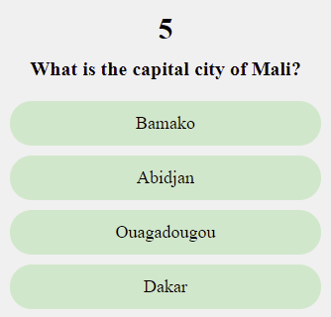

Codes to use

\qu abc Question
\ar xyz Right answer (a = “answer”, r = "right")
\aw xyz Wrong answer (a = “answer”, w = "wrong")

Example

\qu What is the capital city of Mali?
\ar Bamako
\aw Abidjan
\aw Ouagadougou
\aw Dakar

Question with picture, and answers in words

Here we have a question with an image and text, and the answers are in words.
In Scripture App Builder, you need to put the image (a JPG or PNG file) in the Illustrations tab for the quiz book.
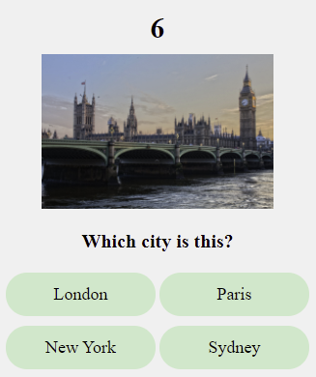
Codes to use

\qu abc Question in words
\qu qqq.jpg Image to be displayed in the question (a JPG or PNG filename)
\ar xyz Right answer
\aw xyz Wrong answer
Example

\qu Which city is this?
\qu city.jpg
\ar London
\aw Paris
\aw New York
\aw Sydney

Question in words, and answers in pictures

Here we have a question in words, and the answers are pictures.
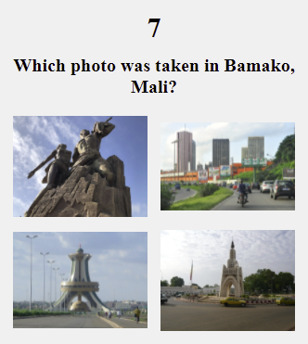
Codes to use

\qu abc Question in words
\ar xyz.jpg Right answer - image file (JPG or PNG)
\aw xyz.jpg Wrong answer - image file (JPG or PNG)

Example

\qu Which photo was taken in Bamako, Mali?
\aw dakar.jpg
\aw abidjan.jpg
\aw ouaga.jpg
\ar bamako.jpg

Question and answer in words, with audio

You can provide an audio recording for the question and for each answer. The recording can be done in a program like Audacity (https://www.audacityteam.org). Use File > Export > Export Selected Audio.
In Scripture App Builder, you need to put the audio clip (MP3 file) in the Audio Clips tab for the quiz book.
Codes to use

\qu abc Question
\qu abc.mp3 Audio recording of the question (MP3 audio file)
\ar xyz Right answer
\ar xyz.mp3 Audio recording of the right answer (MP3 audio file)
\aw xyz Wrong answer
\aw xyz.mp3 Audio recording of the wrong answer (MP3 audio file)

Example

\qu What is the capital city of Mali?
\qu capital-question.mp3
\ar Bamako
\ar bamako.mp3
\aw Abidjan
\aw abidjan.mp3
\aw Ouagadougou
\aw ouagadougou.mp3
\aw Dakar
\aw dakar.mp3

Question and answer in words, with explanations

You can give an explanation to the user after they select an answer, helping them to see why it is the right or the wrong answer.
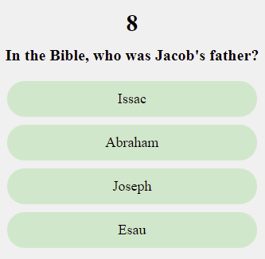
Codes to use

\qu abc Question
\ar xyz Right answer
\ae hjk Explanation - why the answer is right
\aw xyz Wrong answer
\ae hjk Explanation - why the answer is not right

Example

\qu In the Bible, who was Jacob's father?
\ar Issac
\ae Yes, Isaac was the father of Jacob and Esau.
\aw Abraham
\ae No, it was Isaac. Abraham was Jacob's grandfather.
\aw Joseph
\ae No, it was Isaac. Joseph was one of Jacob's sons.
\aw Esau
\ae No, it was Isaac. Esau was Jacob's brother.

Question and answer in words, with explanations and audio

It is possible to give the explanations in audio.
Codes to use

\qu abc Question
\qu abc.mp3 Audio recording of the question (mp3)
\ar xyz Right answer
\ae xyz.mp3 Audio recording of the answer (mp3)
\ae hjk Explanation - why the answer is right
\ae hjk.mp3 Explanation - audio file (mp3)
\aw xyz Wrong answer
\aw xyz.mp3 Audio recording of the answer (mp3)
\ae hjk Explanation - why the answer is not right
\ae hjk.mp3 Explanation - audio file (mp3)

Example

\qu In the Bible, who was Jacob's father?
\qu question-jacob-father.mp3
\ar Issac
\ar isaac.mp3
\ae Yes, Isaac was the father of Jacob and Esau.
\ae expl-isaac.mp3
\aw Abraham
\aw Abraham.mp3
\ae No, it was Isaac. Abraham was Jacob's grandfather.
\ae expl-abraham.mp3
\aw Joseph
\aw joseph.mp3
\ae No, it was Isaac. Joseph was one of Jacob's sons.
\ae expl-joseph.mp3
\aw Esau
\aw esau.mp3
\ae No, it was Isaac. Esau was Jacob's brother.
\ae expl-esau.mp3

Sound effects for right and wrong answers

After a right or wrong answer, there is a sound effect to indicate to the user whether the answer is right or wrong. You can change these sound effects. You will need to record your alternate right and/or wrong answers as mp3s and add them in two places:
- As audio files under the quiz book file’s Audio Clips tab (make sure your audio file source is correct for them).
- As fields in the actual quiz document (see below).

Codes to use
Put these codes at the end or beginning of the quiz file. They apply to all questions.

\ra abc.mp3 Sound effect for a right answer
\wa hjk.mp3 Sound effect for a wrong answer

Example 1

\ra good.mp3
\wa wrong.mp3
Example 2
You can give several files for the right and wrong answers. The application will choose among them for each answer.

\ra very-good.mp3
\ra excellent.mp3
\ra good-answer.mp3
\wa sorry.mp3
\wa incorrect.mp3
\wa not-good.mp3

Configuring Your Quiz
If you add your quiz book to your app project, and double check your Book Type is set to Quiz (Books > Collection name > Quiz book name > Book), you should see an additional tab in your configuration area named Quiz. Click on that tab to view the Quiz configuration options.
Quiz Questions
You can choose to have the order of your set of questions shuffled (randomized) each time the user accesses the quiz, or have them always presented in the order they appear in your quiz file.
Quiz Pass Mark
You can choose the “pass mark” for this quiz—the number of questions the user needs to get correct to mark the quiz as completed. “Completion” in this case means that the user has successfully passed the quiz, unlocking any dependent quiz (see Quiz Access).
You can choose a percentage of the questions or an actual number of correct answers they must achieve.
Quiz Access
There are 3 options for setting the access a user has to a specific quiz:
- At any time (no restrictions): the quiz is always available
- After successfully answering a previous quiz: You can choose another quiz file from the drop-down list as a pre-requisite for the user to complete (according to the Quiz Pass Mark for that quiz). The quiz will display a message specifying which quiz needs to be completed first.
- After entering a code: specify a numerical code that the user has to enter. In this way you can “unlock” quizzes by sending the code to your user(s) at a certain time.

