# Dokimion Install and Build Procedure

# Virtual Box Install

1. Download and install Virtual Box 7.0 from [www.virtualbox.org](http://www.virtualbox.org/)
2. Download iso image for ubuntu version 22.
3. Start Virtual Box and click “New” to create a new virtual machine
4. Follow the tutorial at this link and configure the resources listed.

Remember to click the “unattended install” checkbox.

[https://ubuntu.com/tutorials/how-to-run-ubuntu-desktop-on-a-virtual-machine-using-virtualbox#1-overview](https://ubuntu.com/tutorials/how-to-run-ubuntu-desktop-on-a-virtual-machine-using-virtualbox" \l "1-overview)

1. After executing the tutorial, verify the following Virtual Box configuration.
   1. Number of processors: as many as your hardware and host operating system can support

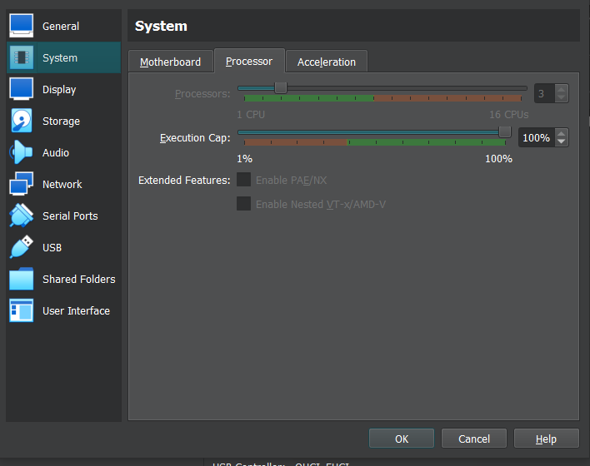

* 1. Base Memory: 3257 MB or greater

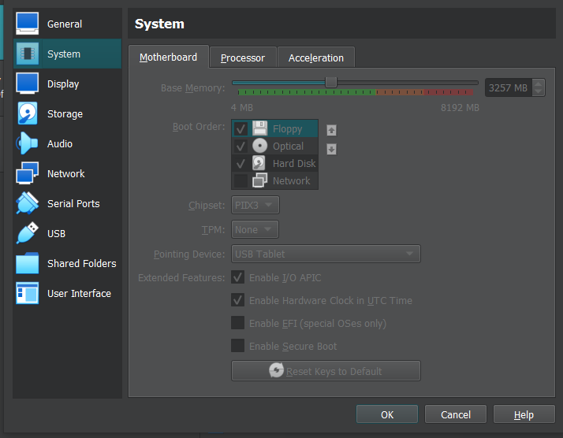

* 1. Hostname: dokimiondev

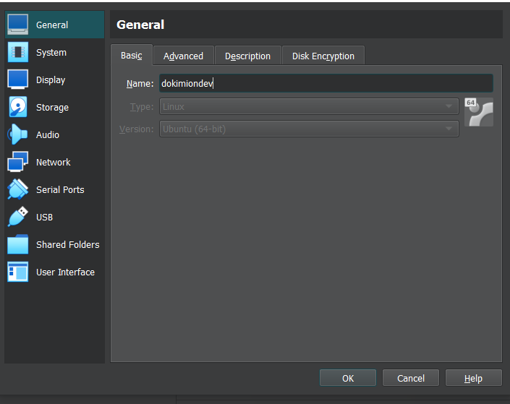

* 1. Storage:
     + - * Controller: IDE – VboxGuestAdditions
         * Controller: SATA – Virtual Hard Disk (vdi) file, 100 GB (pre-allocate full size)

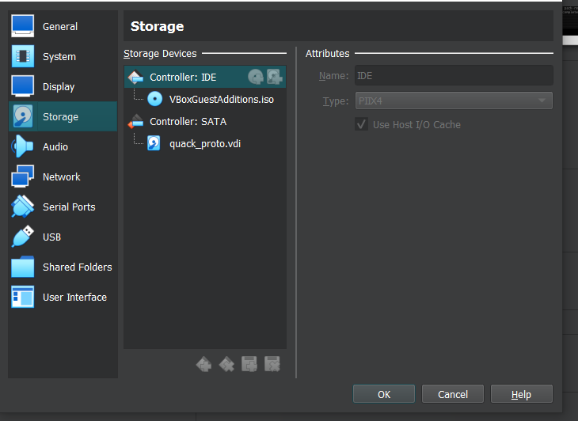

Click Guest Additions and select the path and filename. (Downloaded as part of virtual box)

* 1. Network:
     + - * Adapter 1 – NAT, Cable connected
         * Adapter 2 – Host only adapter, Cable connected, Promiscuous mode: Deny

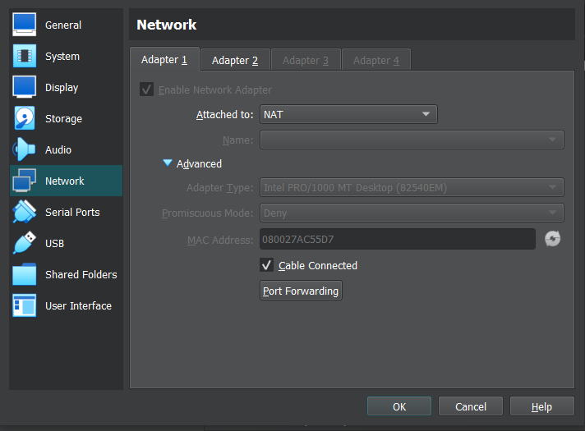

# 



# Ubuntu Configuration

1. Create a user with login id “username”.
2. Login to the VM using “username”.
3. Configure your account as a “sudo” account to make maintenance easier.

> su -

> In /etc/group, append “username” to the end of the line starting with sudo

> reboot

1. sudo hostnamectl set-hostname dokimiondev

# Software Installation and Start up

1. Download and install chrome browser

wget <https://dl.google.com/linux/direct/google-chrome-stable_current_amd64.deb>

sudo dpkg -i google-chrome-stable_current_amd64.deb

1. Follow Nginx download and installation instructions at [https://nginx.org/en/linux_packages.html](https://nginx.org/en/linux_packages.html" \l "Ubuntu)#Ubuntu for version 1.22 or later.
2. Verify successful installation by rebooting and pointing the browser to [http://127.0.0.1](http://127.0.0.1/).
3. Install ssh-server from using instructions at <https://www.cyberciti.biz/faq/ubuntu-linux-install-openssh-server/>.
4. Copy your ssh keys for your github.com account to the /home/user/.ssh directory and set the permissions correctly. (google for help if you want.)
5. Type “ssh-add”.
6. Install “git” by typing “sudo apt install git” if needed.
7. Type “git clone [git@github.com](mailto:git@github.com):sillsdev/dokimion
8. Run “sudo python3 dokimion/config/common/install_configfiles.py <absolute home dir path>”
9. Change ip address in /etc/mongod_dev.conf, /etc/nginx/sites-available/dokimion_dev.conf, and /etc/dokimion/quack.properties to this VM’s ip address
10. Start up the nginx service

sudo sysemctl daemon-reload

sudo systemctl enable nginx.service

sudo systemctl restart nginx.service

sudo systemctl restart nginx.service

1. Download and install mongo database community edition, version 4.4.22, for ubuntu 22

https://www.mongodb.com/docs/manual/tutorial/install-mongodb-on-ubuntu-tarball/

(Choose manual install from .tgz – version 4.4.24, platform Ubuntu 20.04 x64, package tgz)

tar xvzfmongodb-linux-x86_64-ubuntu2004-4.4.24.tgz

cd mongodb-linux-x86_64-ubuntu2004-4.4.24/bin

sudo cp mongo* /usr/bin/

1. Download and install openssl 1.1.1

sudo wget http://archive.ubuntu.com/ubuntu/pool/main/o/openssl/libssl1.1_1.1.1f-1ubuntu2_amd64.deb

sudo dpkg -i libssl1.1_1.1.1f-1ubuntu2_amd64.deb

Verify with a successful output from “mongod --version

1. Install mongosh with your OpenSSL1.1 libraries

Download from mongodb.com/try/download/shell

(Select platform Debian/Ubuntu 64 bit, paackage deb)

sudo dpkg -i mongodb-mongosh_1.10.6_amd64.deb or later

1. Create needed directories with default permissions

cd /var/lib

sudo mkdir mongodb_dev

cd /var/log

sudo mkdir mongodb

1. Start mongod

Update /etc/mongod_dev.conf with the ip address of this VM

sudo systemctl enable mongod_dev.service

sudo systemctl restart mongod_dev.service

sudo systemctl status mongod_dev.service

1. Install Java 1.8

sudo apt-get update

sudo apt-get install openjdk-8-jdk

java -version should display version 1.8

1. Install node and npm

curl -fsSL https://deb.nodesource.com/setup_18.x | sudo -E bash - &&\

sudo apt-get install -y nodejs

node -v should show v18

npm -v should show 9

1. Install Apache maven

[https://archive.apache.org/dist/maven/maven-3/3.6.3/binaries/apache-maven-3.6.3-](https://archive.apache.org/dist/maven/maven-3/3.6.3/binaries/apache-maven-3.6.3.zip)bin.tar.gz

cd Downloads

tar xvzf apache-maven-3.6.3.tgz

sudo mv apache-maven-3.6.3 /opt

export PATH=”/opt/apache-maven-3.6.3/bin:$PATH

mvn -version should display 3.6.3, java version 1.8

1. Build Dokimion and run unit tests

cd dokimion

sudo config/common/mvn_unittests.sh

1. Create “dokimion” user and deploy software artifacts

sudo adduser dokimion

login to dokimion user

mkdir bin

cp ../username/dokimion/config/common/startup_dokimion* ~/bin/.

sudo mkdir /deploy

cd /deploy

sudo chmod a+w .

cd ~/dokimion

repeat step 5 instructions to get .ssh dir and contained files

if (deploy is done from the dokimion account, not the original user) then

* + - * + Type “git clone [git@github.com](mailto:git@github.com):sillsdev/dokimion
        + Repeat steps 5-7

endif

sudo config/common/deploy.sh _dev (Deploys files to the dokimion deploy directory.)

1. Start up Dokimion

cd /var/log

sudo mkdir dokimion

sudo systemctl enable dokimion_server_dev.service

sudo systemctl restart dokimion_server_dev.service

sudo systemctl status dokimion_server_dev.service

sudo systemctl enable dokimion_ui_dev.service

sudo systemctl restart dokimion_ui_dev.service

sudo systemctl status dokimion_ui_dev.service

1. Point browser to http://<VM ip address>

Try to login to dokimion

1. Optional – Add Security between Dokimion and mongod
2. Add admin and dokimion users via mongosh

cd dokimion/config/common

mongosh mongodb_create_users.js

1. sudo systemctl stop mongod service
2. enable security in mongod.conf
3. sudo systemctl start mongod service
4. mongosh -u admin
5. mongosh -u dokimion --authenticationDatabase dokimion
6. update quack.properties with db = dokimion,
7. sudo systemctl restart mongod service
8. sudo systemctl restart dokimion server service
9. sudo systemctl restart dokimion ui service

Reference: https://www.mongodb.com/docs/manual/tutorial/configure-scram-client-authentication/