Background
The PALASO library contains, among other things, a small set of classes for working with writing systems. These help with sorting, spelling, keyboards, etc. They are standards based; it helps you construct RFC4646 language tags, define sort orders that work with ICU, choose a keyboard, define a default font. It stores all of this in a standard LDML xml file. They take care of keeping copies of your work in a known location on the computer, so that other language applications will find and offer to reuse them. In this way, we envision a day when language workers will set up the writing systems they need only once and then use them from all their applications. Further, if we can move towards a common user interface, then again life gets easier for our users.
The Palaso library has also played host to various user interfaces for setting up user interfaces. Thus far, these have not been deemed appropriate for our flagship application, WeSay. So we need to keep working at it. This document is intended to promote discussion of the next version of these user interface components, which would be rolled out in WeSay and SOLID, and offered to OurWord and perhaps FieldWorks.
We are implementing these components in .net, but we'd like to see other groups develop implementations for other platforms as well: minimally, reading/writing LDML, but also, we suggest, copying the same user interface.

Walkthrough
Ok, so let’s get started.
Our first scenario is where a user is making a new project (in WeSay, for example), and the application wants to get just enough information to get him started. In this example, he's never set up this writing system in any other WSEdit-using application (e.g. SOLID, OurWord, HearUs, etc.), so he has to create it by finding it in the ethnologue. As he types the first few letters, the list is filtered down to possible matches:
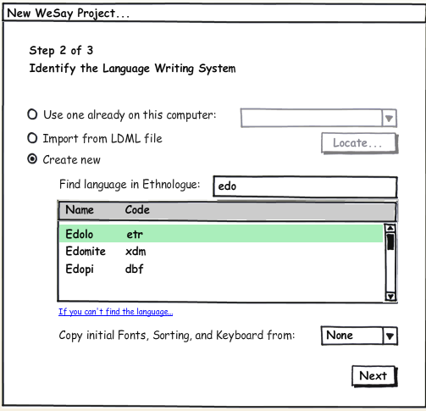
OK, so he has a single writing system basically defined, and he goes on with the rest of the project setup wizard.
Later, our user wants to make changes or add another writing system, so he discovers the full Writing System setup in his application's settings:
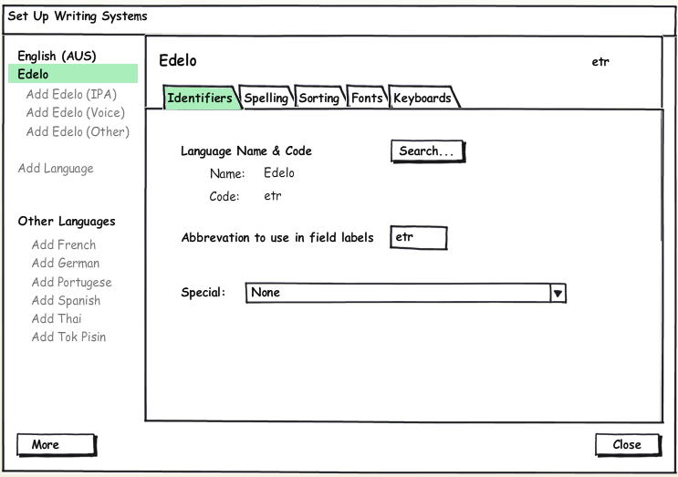
Hopefully things other than Special are self explanatory. When the writing system was created, the system guessed at an abbreviation for him.

Adding typical variation: IPA
A common thing to do in dictionary applications is to enter data in IPA. So we make it only a single click to set everything up, including making the proper language tag, selecting a font that has IPA, and even looking through the installed keyboards and choosing the first one which contains the letters "IPA".
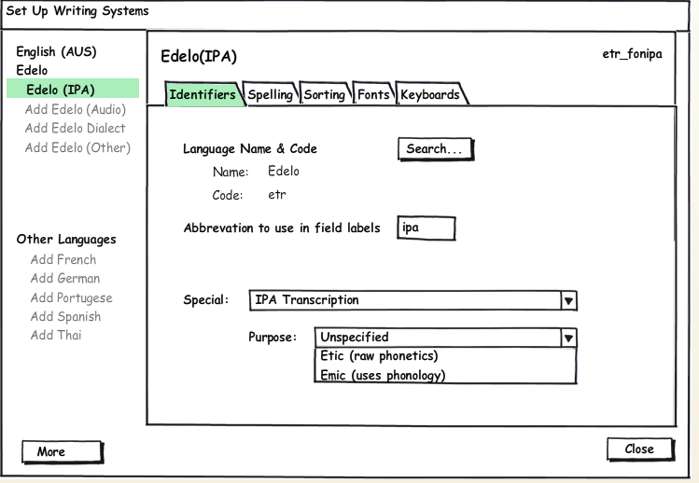
Ok, now we see the first use of this Special control. It is key to keeping things only as complicated as they need to be. When the user clicked on “Add Edelo (IPA)”, we created that writing system for them, setting this combo to “IPA Phonetic Transcription”. By default, the purpose of the ipa is undefined. If the user wants to, he can specify if this is an etic or emic rendering.

Adding typical variation: Dialect
Another common thing to do, at least in FLEx, is to add a writing system to hold text which belongs to a dialect. Our user can do that by clicking “Add Edolo Dialect”:
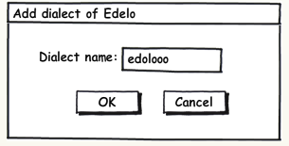
After which we see:
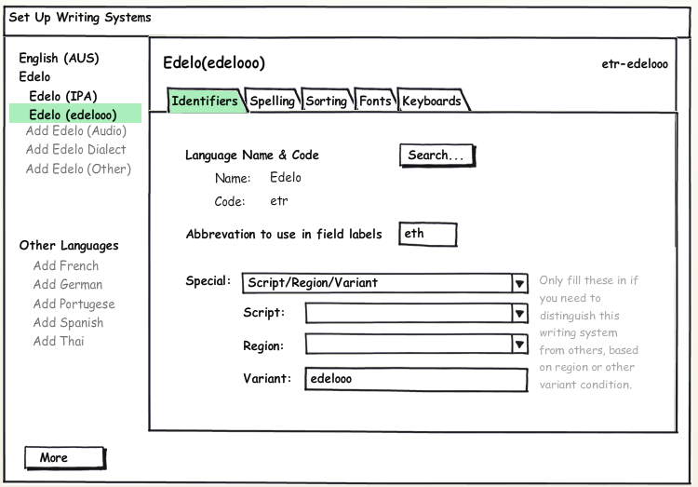
Here we see another special combo setting. This one reveals all the components of a language tag. For script and region, it limits the user to choosing from the officially registered choices. Variant is just a text field.
As we come to the end of that scenario and recognize that it is where the majority of users live. They don’t venture into the more complex stuff which follows.

Complex Writing Systems
With non-roman scripts, just setting up the collation (sorting) stuff can be a ton of work. So it’s important that we can leverage existing writing systems when making new ones.
Our user in Thailand, using the original wizard, takes the time to say that this writing system is something like the Thai one:
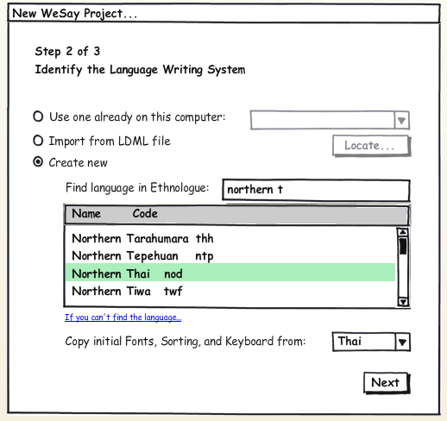
Outside of this wizard, we can also make a new writing system by copying an existing one, by using the “More” menu.
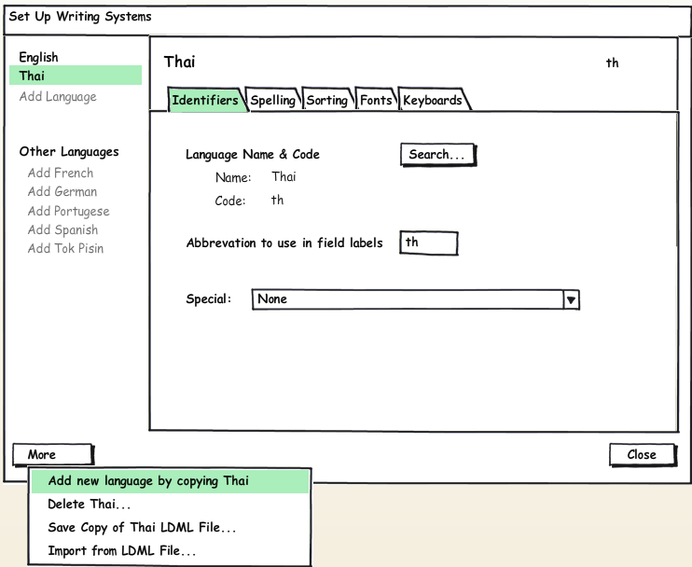

And finally, some users will need to define codes that this user interface just can’t help with. By choosing “custom” in the Special Combo, they can just type in anything they want. Notice that a hyperlink appears, pointing them to the standard.

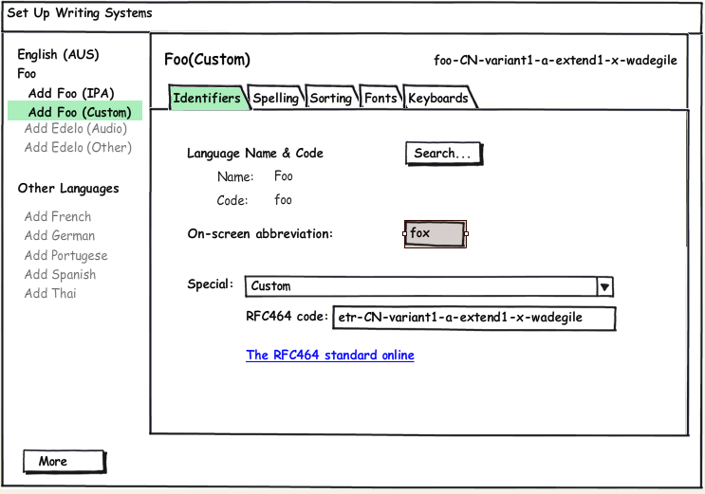

FW would need to add some more tabs; they handle PUA and encoding converters. It’s perhaps more likely that they would use the non-UI components.
Notice here that reusable components of the Palaso library were embedded in the application's setup wizard.
In this walk-through, we won’t be showing any of the tabs other than this identifiers one.
We should probably grab the 1st three characters of the name, and just not lose any sleep over the fact that there could be multiple writing systems with the same abbreviation.
Better name?
Better short explanations for etic and emic than I have here?
This is a criminal example, since Northern Thai has its own, beautiful script (sorry Martin!).
in the real thing, it will look more like a menu

