Ww
a w x y z
waiting list waiting lists N-Count oft on N A waiting list is a list of people who have asked for something which cannot be given to them immediately, for example medical treatment, housing, or training, and who must therefore wait until it is available. There were 20,000 people on the waiting list for a home.
waitress weɪtrəs waitresses waitressing waitressed N-Count A waitress is a woman who works in a restaurant, serving people with food and drink. Verb A woman who waitresses works in a restaurant serving food and drink. She had been working in a pub, cooking and waitressing. waitressing She does a bit of waitressing as a part-time job.
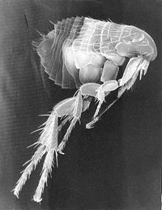Flea
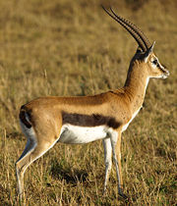Gazelle

