Activitat

Classe on xifrem:  
import java.io.File;

import java.io.FileOutputStream;

import java.io.ObjectOutputStream;

import java.nio.file.Files;

import java.security.SecureRandom;

import javax.crypto.Cipher;

import javax.crypto.KeyGenerator;

import javax.crypto.SecretKey;

import javax.crypto.spec.IvParameterSpec;

public class Xifrar {

public static void main(String[] args) throws Exception {

String inputFile = "missatge.txt";

String outputFile = "xifrat.txt";

String keyFile = "clau.txt";

SecretKey secretKey = null;

byte[] iv = new byte[8];

KeyGenerator keyGen = KeyGenerator.getInstance("DES");

SecureRandom random = new SecureRandom();

secretKey = keyGen.generateKey();

FileOutputStream keyFileStream = new FileOutputStream(keyFile);

ObjectOutputStream keyOutStream = new ObjectOutputStream(keyFileStream);

keyOutStream.writeObject(secretKey);

keyOutStream.writeObject(secretKey.getAlgorithm());

keyOutStream.writeObject(secretKey.getEncoded());

keyOutStream.close();

Cipher desCipher = Cipher.getInstance("DES/CBC/PKCS5Padding");

random.nextBytes(iv);

desCipher.init(Cipher.ENCRYPT_MODE, secretKey, new IvParameterSpec(iv));

byte[] input = Files.readAllBytes(new File(inputFile).toPath());

int paddingLength = 8 - (input.length % 8);

byte[] paddedInput = new byte[input.length + paddingLength];

System.arraycopy(input, 0, paddedInput, 0, input.length);

byte[] output = desCipher.doFinal(paddedInput);

byte[] outputWithIV = new byte[iv.length + output.length];

System.arraycopy(iv, 0, outputWithIV, 0, iv.length);

System.arraycopy(output, 0, outputWithIV, iv.length, output.length);

FileOutputStream outputFileStream = new FileOutputStream(outputFile);

outputFileStream.write(outputWithIV);

outputFileStream.close();

}

}

# Classe on desxifrem:

import java.io.File;

import java.io.FileInputStream;

import java.io.FileOutputStream;

import java.io.ObjectInputStream;

import java.nio.file.Files;

import java.security.spec.KeySpec;

import javax.crypto.Cipher;

import javax.crypto.SecretKey;

import javax.crypto.SecretKeyFactory;

import javax.crypto.spec.DESKeySpec;

import javax.crypto.spec.IvParameterSpec;

public class DesXifrar {

public static void main(String[] args) throws Exception {

String inputFile = "xifrat.txt";

String outputFile = "desxifrat.txt";

String keyFile = "clau.txt";

byte[] iv = new byte[8];

FileInputStream keyFileStream = new FileInputStream(keyFile);

ObjectInputStream keyInStream = new ObjectInputStream(keyFileStream);

SecretKey secretKey = (SecretKey) keyInStream.readObject();

String algorithm = (String) keyInStream.readObject();

byte[] encoded = (byte[]) keyInStream.readObject();

keyInStream.close();

KeySpec keySpec = new DESKeySpec(encoded);

SecretKeyFactory keyFactory = SecretKeyFactory.getInstance(algorithm);

SecretKey reconstructedKey = keyFactory.generateSecret(keySpec);

Cipher desCipher = Cipher.getInstance("DES/CBC/PKCS5Padding");

FileInputStream ivStream = new FileInputStream(inputFile);

ivStream.read(iv);

ivStream.close();

desCipher.init(Cipher.DECRYPT_MODE, reconstructedKey, new IvParameterSpec(iv));

byte[] input = Files.readAllBytes(new File(inputFile).toPath());

byte[] output = desCipher.doFinal(input, 8, input.length - 8);

FileOutputStream outputFileStream = new FileOutputStream(outputFile);

outputFileStream.write(output);

outputFileStream.close();

}

}

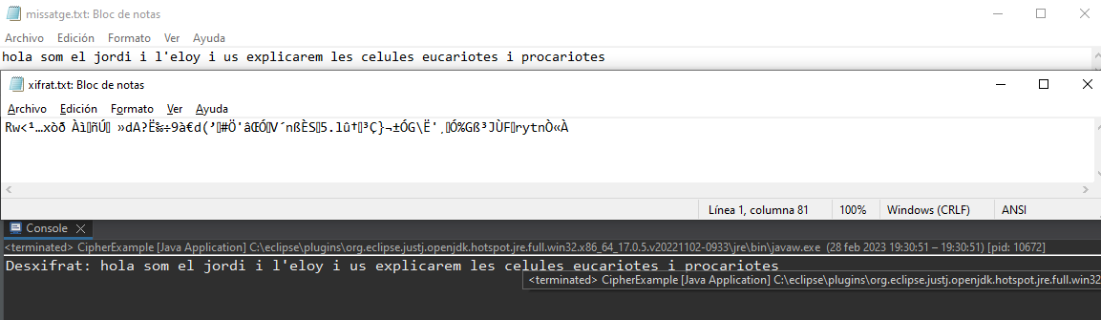

En aquesta captura podem veure el missatge normal, el missatge xifrat i el missatge desencriptat per terminal

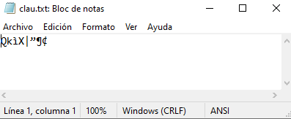

En aquesta captura podem veure quina es la clau que ha fer servir per a encriptar i desencriptar el fitxer

**Autoavaluació**:

Creiem que ho tenim tot be ja que ens xifra i ho desxifra amb la clau transparent que s'ha creat.

1. Genera bé la clau i ho llegeix bé el fitxer on hi surt el missatge a encriptar 2/2

2. Encripta el fitxer i ho guarda en un altre 2/2

3. Es guarda bé les dades de la clau en un altre fitxer 2/2

4. Hem fet el codi de desencriptar i ens retorna bé el missatge desencriptar i es el mateix que l'original 2/2

5. Comentat el codi amb imatges que funciona l'aplicació 1/1