

**CSE370 : Database Systems**

**Project Report**

**Project Title : Movie Review & Recommendation**

| **Group No : __, CSE370 Lab Section : 01, Summer 2024** | | |
| --- | --- | --- |
| **ID** | **Name** | **Contribution** |
| 21301647 | Md. Tasnim Kabir | Watchlist |
| 21201420 | Asma Faria Mayami | Movielist |
| 22201262 | Md. [Sadman Siddique](mailto:oppobad263@gmail.com) | Login Logout Registration |
| 22301637 | Mahrufa Binta Ali | Rating, Review |

**Table of Contents**

| **Section**  **No** | **Content** | **Page No** |
| --- | --- | --- |
| 1 | ER/EER Diagram | 3 |
| 2 | Schema Diagram | 4 |

**ER/EER Diagram**

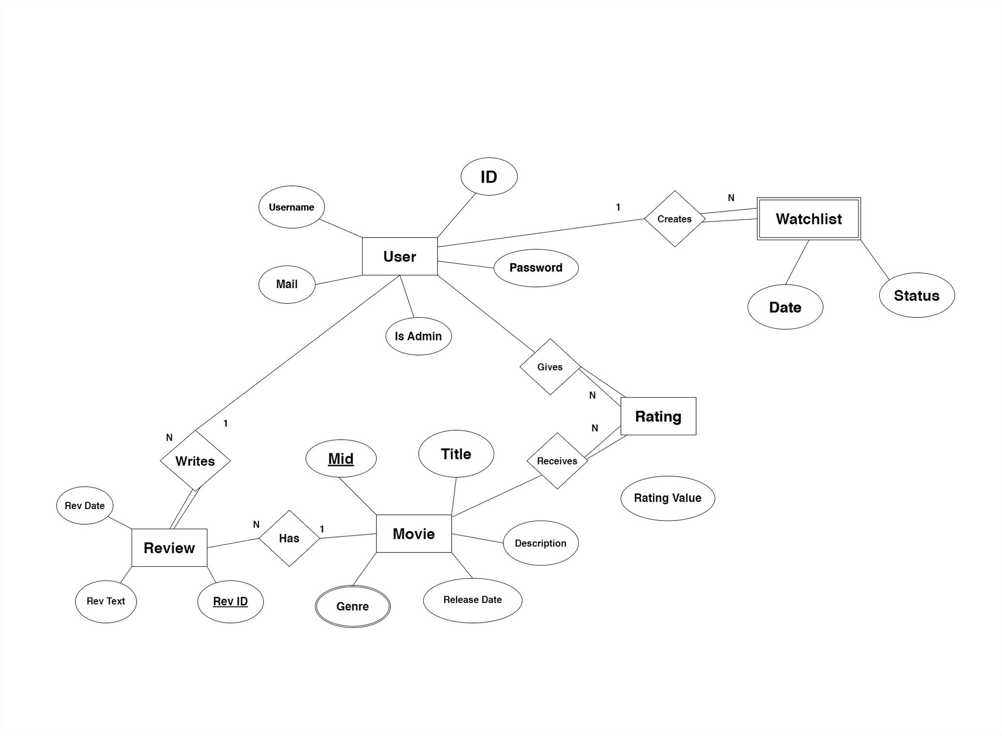

**Schema Diagram**

