GAMAGE, S.N. and ASANKA, P.P.G.D. 2022. Machine learning approach to predict mental distress of IT workforce in remote working environments. In *Proceedings of 2022 International research conference on Smart computing*

*and systems engineering (SCSE 2022), 1 September 2022, Colombo, Sri Lanka*. Hosted on IEEE [online], pages 211-216. Available from: ht[tps://doi.org/10.1109/scse56529.2022.9905229](https://doi.org/10.1109/scse56529.2022.9905229)

Machine learning approach to predict mental distress of IT workforce in remote working environments.

GAMAGE, S.N. and ASANKA, P.P.G.D.

2022

*© 2022 IEEE. Personal use of this material is permitted. Permission from IEEE must be obtained for all other uses, in any current or future media, including reprinting/republishing this material for advertising or promotional purposes, creating new collective works, for resale or redistribution to servers or lists, or reuse of any copyrighted component of this work in other works.*

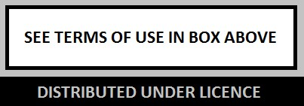

This document was downloaded from

https://openair.rgu.ac.uk

Machine Learning Approach to Predict Mental

Distress of IT Workforce in Remote Working Environments

|  |  |
| --- | --- |
| Sanduni Nilushika Gamage*  School of computing  Robert Gordon University, Scotland nilu.gamage95@gmail.com | P. P. G. Dinesh Asanka  Department of Industrial Management  University of Kelaniya, Sri Lanka dasanka@kln.ac.lk |
| Abstract - When considering online workers, due to the emergence of the coronavirus pandemic prevailing in the world, employees have been restricted to work remotely for a prolonged period. All the working arrangements are now based at home than before. Since this has been novel to society, the impact caused by this crisis on people is unknown in the short or long term. Since various factors can cause mental distress among online workers, periodic screening for mental distresses such as anxiety, depression, and stress is necessary for health and well-being. The causes of mental distress are multifactorial. They include socio-demographic, biological, economic, environmental, occupational, and psychological aspects. This paper proposes a concept of a screening system to predict mental distress given the external features associated with individuals, using supervised machine learning approaches and identifying the employees prone to higher risk and referring them early to professional assistance. The study was conducted concerning the circumstances in a pandemic era considering COVID-19 as the case study. The study was done with remote IT workers in Sri Lanka who work as a part of a software development team. 481 professionals participated in the study and were selected based on selection criteria and appropriate encoding techniques were utilized to encode categorical variables where most important 25 features were detected among 60 features using feature selection. Finally, classification techniques such as Random Forest, SVM, XGBoost, CatBoost, decision tree, and Naïve Bayes were used for modeling by which the CatBoost algorithm in overall measures outperformed other algorithms with a predictive accuracy of 97.1%, precision of 97.4%, recall of 99.7%, and f1 measure is 98.5%.  Keywords – classification, external features, IT employees, Machine Learning, mental distress  I. INTRODUCTION  Mental health is the well-being in which everyone realizes their potential, can handle day-to-day stresses of life, ability to work efficiently and productively, and ability to serve the community. So mental condition is considered a vital aspect of the health and well-being of an individual. Having various mental distress is a common issue among the majority of people in the fast-paced modern world. With changing lifestyles and work cultures, there is a higher risk of | increasing mental distress among people of various communities. Due to the deterioration of mental health individually, it directly impacts the destruction of the society since it reduces human efficiency and well-being.   1. Background to the Problem   During the pandemic and afterward, people who WFH (work from home) face risks related to the home setting, which often doesn’t meet standards in office environments.  The lack of suitable equipment, network issues, excess screen time, and uncomfortable physical environments can lead to mental distress among employees while delivering work. Similarly, since they have to share the spaces with various people such as partners, children, spouses, or roommates, personal and work-life separation become complicated and it can cause negative consequences for workers’ well-being.  Furthermore, many employees have to take on additional household chores due to staying at home, which creates extra stress and difficulties in reconciling work and family responsibilities. Another factor that causes serious mental distress is the fear of losing jobs. So that people tend to adopt unhealthy working practices such as long working hours, increased workload, avoid taking leaves when sick to please superiors to ensure job security [1]. Since various factors such as these can cause mental distress among online workers, periodic screening for mental distresses such as anxiety, depression, and stress is necessary for prolonged health. The causes of mental distress can vary in different instances. They can occur due to biological, economic, social, environmental, occupational, and psychological aspects [2]. Machine learning approaches can be used to automate the screening process of any mental distress prevailing and identify the employees prone to higher risk for early referral to medical or psychological assistance to enhance the mental health of the workforce.   1. Research Objectives   1) To identify that external features such as sociodemographic, biological, economic, environmental, occupational, and psychological aspects directly influence mental distress conditions of depression, |

1. anxiety, and stress among IT employees using machine learning approaches.
2. To provide aids to predict any mental distress by nonhealthcare providers before clinical/psychological diagnosis
3. It identifies the optimal prediction model for predicting mental distress among selected participant segments based on external factors.

# II. LITERATURE REVIEW

The study [2] applied different machine learning algorithms such as Logistic Regression, Catboost, Naïve Bayes, RFT, and SVM for classification. In the study of 470 seafarers’ information on occupation, health and socio-

demographics were collected and the state of anxiety and depression was assessed by Hospital Anxiety and Depression Scale. According to the study, the researchers found that Catboost produced the highest level of accuracy and precision of 82.6% and 84.1%, respectively. In another study [3], machine learning techniques of logistic regression, KNN classifier, Decision trees, Random Forest, Boosting, and Bagging are used to analyze stress levels among working adults and identify the factors which strongly affect them. The data from OSMI mental health survey responses of working professionals in tech was used for the study. Boosting performed better than other classifications and 75.13% accuracy was signified by the application. The study has derived that gender, family history of illness, and employer mental health benefits to their employees had more importance in deriving the mental health issues. In the study, it has been proved that people who work in the tech industry are at a higher risk of developing stress. The study on the effect of COVID- 19 on Australian adults' mental well-being was conducted using 1296 participants over 18 years [4]. Depression, anxiety, and well-being were measured using a survey including validated scales of PHQ-9, GAD-7, and WHO – 5. The association between mental health and COVID -19 was measured using linear regression, and COVID -19 on work, social functioning, and sociodemographic features were derived. The study concluded that exposure to the virus had a minimal association with mental health while pandemic-infused work and social functioning impairments were strongly associated with increased depression and anxiety symptoms and decreased psychological well-being. Detection of child depression using machine learning methods was conducted on children and adolescents aged 4 -17 years using The YMM, the second Australian Child and Adolescent Survey of Mental Health and Wellbeing 2013–14 where the study was conducted with 6310 participants [5]. The Boruta algorithm was used for feature selection while The Tree-based Pipeline Optimization Tool (TPOT classifier) was used for model selection where random forest outperformed other models such as XG Boost, Decision Tree, and Gaussian naïve Bayes. By the study, 11 features were identified to detect depression among children and adolescents. The anxiety and depression prediction have been conducted for automated diagnosis among elderly patients using socio-demographic and health-related factors [6]. Ten classifications of machine learning have been utilized with ten-fold cross-validation from which the highest accuracy was achieved by random forest classifier for a dataset with 510 participants. HADS (Hamilton anxiety and depression scale, hospital anxiety, and depression scale) [7] score was used to evaluate the distress level, and ten features have been identified as most prominent in causing anxiety and depression among the geriatric population. The study focuses on implementing a system to identify mentally distressed individuals in a target population with the use of AI and machine learning [8]. Two populations who were aged between 18 to 21 and 22 to 26 have participated with 300 and 356 individuals respectively. A questionnaire with 20 questions was used for data collection and clustering accommodated for label creation for similar groups. Afterward, machine learning techniques such as support vector machines, decision trees, naïve Bayes classifier, Knearest neighbour classifier, ensemble (bagging), tree ensemble (random forest), and logistic regression were used for classification model generation. The performance of each classifier was measured using precision, recall, accuracy, f1 measure, and SVM, KNN, bagging and RF performed equivalent efficiency.

# III. METHODOLOGY

A.

Conceptual Framework

Fig. 1. Conceptual Framework

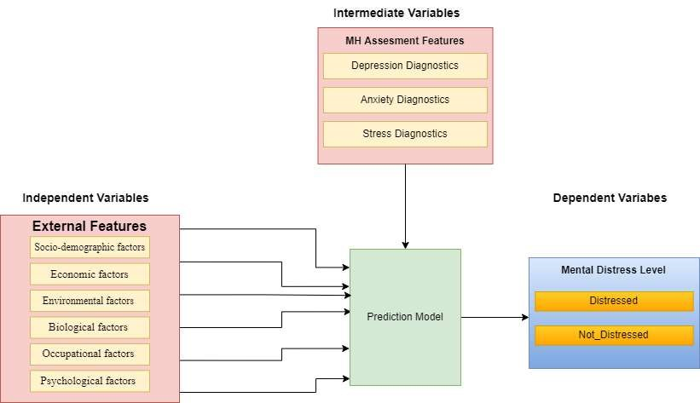

As illustrated in the following Fig. 1, independent variables taken from questions related to external features in the questionnaire were considered along with mental health (MH) assessment features which act as intermediate variables. MH assessment features were derived from the questionnaire with separate questions and they were used to derive the mental distress level in training the model and assessing the efficiency of predicting dependent variables.

## 1) Independent variables – external factors

* Socio-demographic factors age, sex, education, marital status, household status, employment, income, children at home, age of children, living status, Relationship status [2] [4].
* Economic factors Monthly income, Income of spouse/partner, Availability of income for parents, Ability to have a helper, Financial satisfaction, Debt status [1].
* Environmental factors Suitable equipment for WFH, Network stability, Interruptions to work, duration of WFH, Work outside working hours, availability of a separate workspace, Power stability [9].
* Biological factors Any treatment for mental illness before WFH, family history of mental illness, presence of chronic diseases, Average hours of sleep/day, Average screen time [9].
* Occupational factors Employment status, WFH status (last 6 months), Job satisfaction, Working in Sri Lankan time zone, Duration of work, Employer mental health benefits, Average annual leaves taken, Difficulty in taking leaves, Relationship with superiors/ colleagues, Work preference [1] [10].
* Psychological factors Recent loss of someone

(friend/ relative), internet addiction, Responsibility of parents/ relatives/ siblings/ friends, peer relationships, Elders with disabilities, Preference to travel to work, Impact of WFH on life, Occurrence of work/family conflicts during WFH, Frequency of leisure travel [8].

## 2) Intermediate Variables

* Depression diagnostics: PHQ-9 score [11]
* Anxiety diagnostics: GAD-7 score [12]
* Stress diagnostics: PSS score [13]

3) Dependent variables

• Mental distress Distressed, Not Distressed

## B. Research Hypothesis

External features such as socio-demographic, biological, economic, environmental, occupational, and psychological factors directly influence the mental health condition of an individual.

## C. Study Variables

The questionnaire consisted of mainly two types of questions as below:

1. Questions to understand mental distress type(Q-

MD)

1. Questions to extract external features (Q-EF)

Answers to these questions acted as variables in determining the mental distress status and relevant external features associated with them.

* Answers to Q-MD are used to assess the mental health condition of an individual.
* Answers to Q-EF are used to derive the external features associated.

## D. Study Population

The IT employees who are members of a software development team such as software engineers, QA engineers, business analysts, tech leads, project managers, etc were considered. The participants need to be working from home for more than a year for 40 hours per week or more to be eligible for the study. Furthermore, participants suffering from any mental disorders prior to WFH and diagnosed by a qualified professional were excluded from the survey. Additionally, the necessary consent of the participants was taken with the questionnaire.

## E. Objective Implementation

The objective implementations are derived in detail as follows.

1. Provided a questionnaire including questions to extract external features affecting mental distress and questions to assess the mental condition of an individual.
2. Derived mental distress level according to predefined standards in DMS – 5.
3. Identified the impact of external features on mental distress and train a model
4. Predict possible mental distress given the external features via a trained model
5. Choose the best model to derive the mental distress given the external features.
6. Provided the system which can test the mental distress level of any individual by himself before professional assistance.

The prediction model was trained using answers obtained from the questionnaire. Where it derived the relationship between mental distress and external features. Hence when a new instance of external features is included, the trained model can derive the possible mental condition.

Fig. 2 provides an overview of the overall research process conducted in the study.

Fig. 2. Overall research process

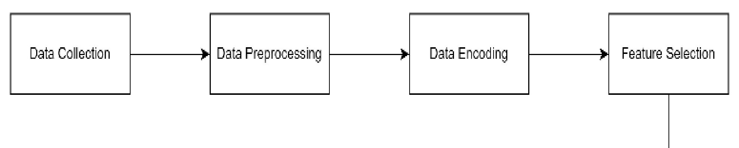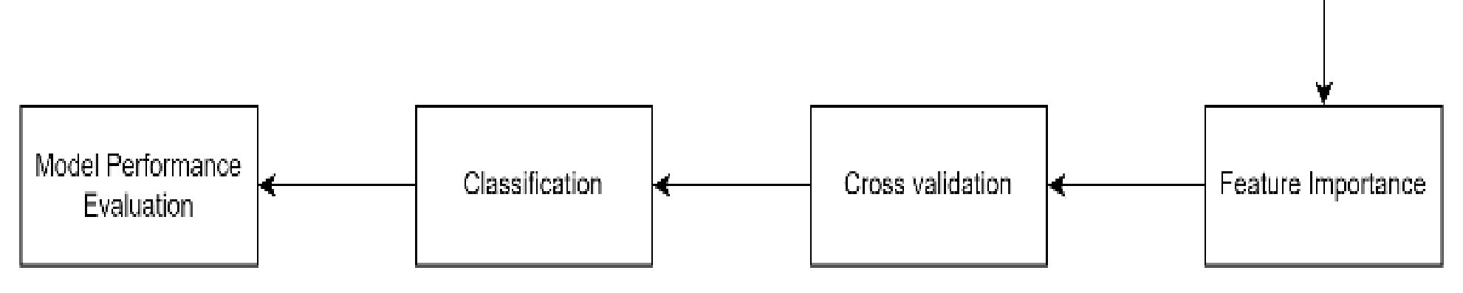

## F. Data Collection and Analysis

The data was collected in a form of a questionnaire and it comprised two main types of questions to extract external features and to assess mental distress prevailing.

## 1) Extracting external features

External features that were considered in predicting the mental distress of an individual have been identified in the literature survey and the questionnaire was formulated to obtain information such as age, sex, education level, household and children, living conditions, financial status, available WFH facilities, any prevailing health concerns and history, nature of work and employer conditions.

## 2) Assessing the mental health condition

Questions related to determining the mental distress level (Q-EF) consisted of a scale for responses and scores for each severity condition. The distress level can be determined based on the scores obtained by each respondent based on the values for each score as determined in Table I. The scores are made by referring to the DSM-5 manual, PHQ-9, GAD-7, and, PSS which are standard diagnostic criteria for mental distress.

TABLE I. MENTAL DISTRESS SEVERITY MEASURES SCALE MATRIX

|  |  |  |
| --- | --- | --- |
| Distress | Response Scale | Severity measure |
| Depression | 'not at all' - 0  'several days' - 1  'more than half the days' - 2  'nearly every day' – 3 | PHQ -9 score  None 0-4  Moderate 5-14  Severe 15-27 |
| Anxiety | 'not at all - 0  'several days' - 1  'more than half the days' - 2 'nearly every day’– 3 | GAD – 7 score  None 0-5  Moderate 6-15  Severe 16-21 |
| Stress | 1. - never 2. - almost never 3. - sometimes 4. - fairly often 5. - very often | PSS score  None 0-13  Moderate 14-26  Severe 27-40 |

Referring to the standard scale, the parameters were derived as target variables as given in below Table II.

# TABLE II. TARGET VARIABLE IDENTIFICATION

|  |  |  |
| --- | --- | --- |
| Distress | Severity measure | Target variable |
| Depression | None 0-4 | Not distressed |
| Moderate 5-14  Severe 15-27 | Distressed |
| Anxiety | None 0-5 | Not distressed |
| Moderate 6-15  Severe 16-21 | Distressed |
| Stress | None 0-13 | Not distressed |
| Moderate 14-26  Severe 27-40 | Distressed |

Accordingly, there are two target variables distressed or not distressed based on the severity score of each distress measure. As per PHQ-9, GAD- 7 and PSS score an individual can be categorized into 8 groups, “No Depression-No Anxiety – No Stress” or “No Depression- Anxiety – Stress” or “No Depression-No Anxiety – Stress” or “Depression - Anxiety – No Stress” or “Depression-No Anxiety – No Stress” or “Depression-No Anxiety – Stress” or “No

Depression - Anxiety – No Stress” or “Depression - Anxiety

– Stress”. Except for the “No Depression-No Anxiety – No Stress” group, all others need to be treated for mental distress

as the basis of any medical screening test is to identify affected individuals for referral to doctors for confirmation of the diagnosis and provide necessary medical care. Since this research aims to test the applicability of machine learning techniques in implementing mental distress screening tools, the outcomes are derived in two groups “No Depression-No Anxiety – No Stress” which is labelled as “Not distressed” while “Depression and/or Anxiety and/or Stress” which is labelled as “Distressed” [2] [6]. Then binary classification techniques can be applied for the implementation

## G. Data Pre-Processing

The survey data collected via the questionnaire were statistically analysed using machine learning techniques combined with python programming language. About 60 variables were used to analyse the external features affecting the mental distress of an individual while 16 variables were used to label the data on the prevailing distress level. As the initial step of data pre-processing, the eligible data are selected where the participants are a member of the software development team, had been working from home for more than a year for 40 hours per week or more, and not prevailing from any mental health condition before WFH. Then the parameters which don’t account for prediction such as

Feedback, Timestamp, Consent_1, Consent_2, Consent_3, SW_DEV, and WFH_Eligibility were dropped. Then missing values were handled and categorical data were encoded using different techniques such as binary encoding, label encoding, and frequency encoding.

## H. Feature Importance and Feature Selection

Feature selection is one of the most important steps in machine learning implementation as it eliminates irrelevant and redundant features from independent variables. In this study, there are 60 variables of which only 1 is numerical and 59 are categorical. The categorical data need to be encoded to be used in feature selection.

Since there are various types of data, different encoding techniques have been utilized. For numerical interval variables, the mean value is used as the variable parameter, variables with values yes/no had are replaced with 1/0 where Yes = 1 and No = 0, nominal variables and high cardinality variables are encoded with frequency encoding as they performed better than another encoding such as hashing, target encoding and finally ordinal variables are encoded with ordinal encoding. By referring to values in Table 1 and Table 2, mental health condition is derived as distressed or not distressed which is then converted to 1/0 where distressed = 1 and not- distressed = 0. For feature selection, an extra tree classifier has been used and Fig. 3 depicts the variables which are derived as the most important 25 features in the study.

Fig. 3. Most important feature

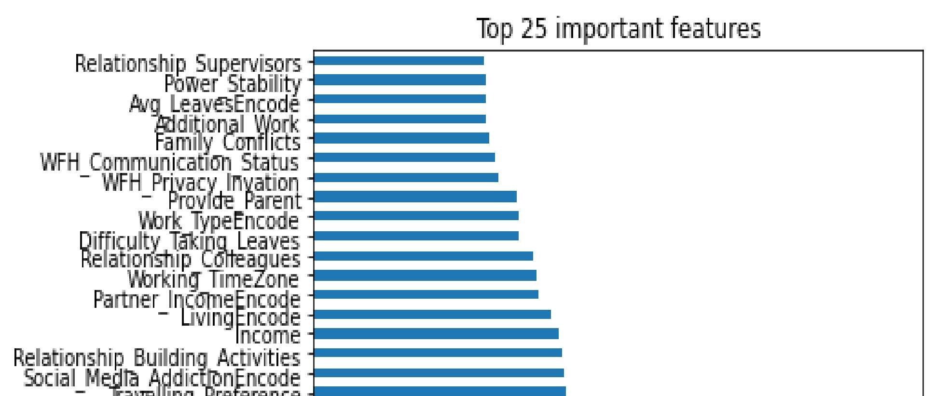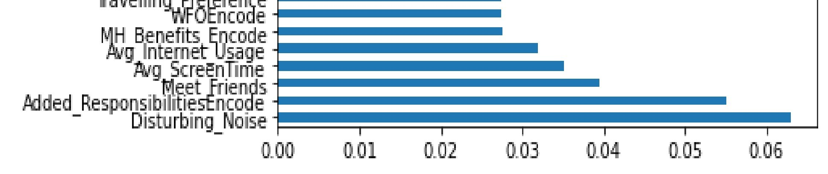

## I. Machine Learning Classifiers

The collected data were processed to derive the insights and are cross-validated using stratified 10-fold crossvalidation as the data are imbalanced and limited. The target variables of distress levels were determined by the scores generated for standard mental health assessment questions in the questionnaire (Q-MD) according to TABLE I, then the target variables are derived as Not_Distressed and Distressed according to available distress levels given in TABLE II. Afterward, the most important features are selected and classification techniques are applied to train and derive the best model suitable.

The methodology of implementing the system is as follows in Fig. 4.

Fig. 4. Implementation process flow

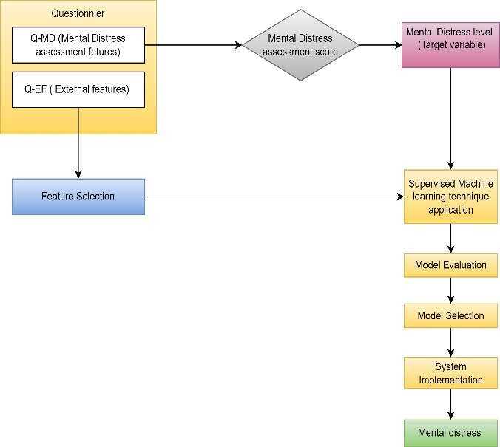

The generic steps in constructing the model with different classifiers are given in Fig. 5 below.

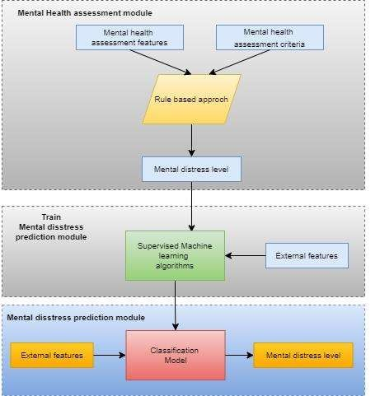

Fig. 5. Construction of the model

# IV. RESULTS

Most important features are selected from feature selection and classification techniques of Random forest [9] [5] [6], SVM [9], XGBoost [3], CatBoost [2], Decision tree [14], and Naïve Bayes [15] are used for classification and the results as follows in table 4. The model's performance is evaluated in terms of measuring accuracy, precision, recall, and f1 score [16].

# TABLE III. RESULTS OF CLASSIFIERS ON TEST DATA

|  |  |  |  |  |
| --- | --- | --- | --- | --- |
| Model | Accuracy | Precision | Recall | F1 score |
| Naïve Bayes | 96.2% | 98.2% | 97.9% | 98% |
| XGBoost | 96.8% | 97.9% | 98.8% | 98.3% |
| CatBoost | 97.1% | 97.4% | 99.7% | 98.5% |
| Decision tree | 95.6% | 97.9% | 98.2% | 98.2% |
| Support vector machine | 96.2% | 96.5% | 1 | 98.2% |
| Random forest | 96.8% | 97% | 99.4% | 98.3% |

Based on the performance tabulated above, the CatBoost algorithm in overall measures outperforms other algorithms with a predictive accuracy of 97.1%, precision of 97.4%, recall of 99.7%, and f1 measure is 98.5%. Table III determines that the most important features used for classification to derive a higher efficiency belong to all the categories of external features considered in the study, including socio-demographic, biological, economic, environmental, occupational, and psychological aspects. In which most features were occupational and psychological. Which determines that the initial hypothesis of external features such as socio-demographic, biological, economic, environmental, occupational, and psychological factors directly influence the mental health condition of an individual is true and can be accepted.

# TABLE IV . EXTERNAL FEATURE DISTRIBUTION

|  |  |
| --- | --- |
| External feature category | Feature |
| Socio-demographic | Living |
| Biological | Average screen time |
| Economical | Partner Income, Income |
| Environmental | Power_Stability, Disturbing noises |
| Occupational | Relationship_Supervisors,Avg_Leaves,  Additional_work, WFH_Communication status, Work type, Difficulty taking leaves, Relationship building activities, Relationship_Colleagues, Traveling preference, WFO, Mental health benefits |
| Psychological | Family_Conflicts, WFH_privacy invation, Provide_parents, Social media addiction, Average internet usage, Frequency of meeting friends, Added responsibilities of family |

# V. DISCUSSION

The objective of this study is to derive a classification model that can be utilized in implementing a screening system to identify mental distress among individuals with the use of machine learning techniques and determine the influence of external factors on the mental condition of a remote worker. Machine learning is a state of the art in predictive modelling. In the current study, different machine learning classifiers are used to screen the IT employers in Sri Lanka who are prone to any mental distress, particularly depression, anxiety, and stress.

Screening for mental health disorders with machine learning techniques is an evolving concept. Its applicability to various segments of society has not been properly established. The impact of remote working on the mental condition of employees during a pandemic era isn’t

considered for studies since this is novel to the entire global context. Therefore, this study is conducted to identify the impact by considering COVID-19 as the case study. Employees who were made to work remotely for prolonged periods due to the recent COVID-19 pandemic are a vulnerable group of the population since it has directly impacted the lifestyles of the people and the knowledge is very less about the consequences in the long run. Any study was not found to be conducted on this population and with the considering factors. In the current study, the impact of various external factors such as socio-demographic, biological, economic, social, environmental, occupational, and psychological factors are considered to determine the mental distress level of an individual. Even though much research had been conducted to derive mental distress in various individuals considering various factors such as the DASS-21 questionnaire on the state of feelings of individuals [3], external factors affecting the nature of employment [2], weather conditions, and psychological sensor readings [9], job satisfaction [10], behaviour [8], etc. In this perspective, the present article is the first of its kind specifically in the Sri Lankan context and the external factors which are used have not been used in the same study previously. Several machine learning algorithms such as Naïve Bayes, XGBoost, CatBoost, Decision trees, Random Forest, and SVM were used in implementing the prediction model to derive the mental distress concerning various external features of different categories. After evaluation of each model, it was found that the CatBoost algorithm most efficiently predicts the distress level of the individuals with considered independent variables. This model can be linked to treating psychiatrists for feedback and subsequent iterations can further increase and validate model efficiency. Though external validation of classifiers was made with 10-fold cross-validation, further research is necessary to derive the most appropriate features in effective modelling that can be applied globally.

# VI. CONCLUSION AND FUTURE SCOPE

This research emphasizes applying machine learning techniques to the automated screening of mental disorders, specifically depression, anxiety, and stress. With this technology, time-consuming manual screening can be replaced with this, and additionally, individuals can have the privilege of screening for their mental distress presence before any clinical diagnosis. This will be beneficial to both employer and employee. This study has used supervised machine learning models such as random forest, support vector machine, decision trees, XGBoost and CATBoost for the classification of survey data obtained through the questionnaire in which the CatBoost algorithm was found most effective in prediction. In the current study, it is restricted to a specific group of the working population, but it can be used to evaluate various online workers in different geographical locations as well as in the future this can be extended to different employment categories except for the information technology industry. This can further be developed to screen for mental illness and any other noncommunicable illness. Other state of the art machine learning algorithms such as deep learning can be tested for their applicability and additionally image processing can be incorporated to detect mental conditions from behavioural analysis such as facial expressions. For that, very intense research is required in the field of digital health technologies for mental health screening.

# REFERENCES

[1] “Papandrea, D 2020, Managing work-related psychosocial risks during the COVID-19 pandemic, ILO, Geneva, viewed 02 Jun 2022.” [2] A. Sau and I. Bhakta, “Screening of anxiety and depression among the seafarers using machine learning technology,” Informatics in Medicine

Unlocked, vol. 16, p. 100149, 2019, doi: 10.1016/j.imu.2018.12.004. [3] U. S. Reddy, A. V. Thota, and A. Dharun, “Machine Learning

Techniques for Stress Prediction in Working Employees,” in 2018

IEEE International Conference on Computational Intelligence and Computing Research (ICCIC), Madurai, India, Dec. 2018, pp. 1–4. doi: 10.1109/ICCIC.2018.8782395.

1. A. Dawel et al., “The Effect of COVID-19 on Mental Health and Wellbeing in a Representative Sample of Australian Adults,” Front.

Psychiatry, vol. 11, p. 579985, Oct. 2020, doi:

10.3389/fpsyt.2020.579985.

1. U. M. Haque, E. Kabir, and R. Khanam, “Detection of child depression using machine learning methods,” PLoS ONE, vol. 16, no. 12, p. e0261131, Dec. 2021, doi: 10.1371/journal.pone.0261131.
2. A. Sau and I. Bhakta, “Predicting anxiety and depression in elderly patients using machine learning technology,” Healthc. technol. lett.,

vol. 4, no. 6, pp. 238–243, Dec. 2017, doi: 10.1049/htl.2016.0096.

1. R. P. Snaith, “The Hospital Anxiety And Depression Scale,” Health

Qual Life Outcomes, vol. 1, no. 1, p. 29, 2003, doi: 10.1186/14777525-1-29.

1. M. Srividya, S. Mohanavalli, and N. Bhalaji, “Behavioral Modeling for Mental Health using Machine Learning Algorithms,” J Med Syst, vol. 42, no. 5, p. 88, May 2018, doi: 10.1007/s10916-018-0934-5. [9] S. Kumar and I. Chong, “Correlation Analysis to Identify the Effective

Data in Machine Learning: Prediction of Depressive Disorder and Emotion States,” IJERPH, vol. 15, no. 12, p. 2907, Dec. 2018, doi:

10.3390/ijerph15122907.

1. J. E. Yoo and M. Rho, “Exploration of Predictors for Korean Teacher

Job Satisfaction via a Machine Learning Technique, Group Mnet,”

Front. Psychol., vol. 11, p. 441, Mar. 2020, doi:

10.3389/fpsyg.2020.00441.

1. K. Kroenke, R. L. Spitzer, and J. B. W. Williams, “The PHQ-9: Validity of a brief depression severity measure,” J Gen Intern Med, vol.

16, no. 9, pp. 606–613, Sep. 2001, doi: 10.1046/j.15251497.2001.016009606.x.

1. R. L. Spitzer, K. Kroenke, J. B. W. Williams, and B. Löwe, “A Brief Measure for Assessing Generalized Anxiety Disorder: The GAD-7,” Arch Intern Med, vol. 166, no. 10, p. 1092, May 2006, doi:

10.1001/archinte.166.10.1092.

1. S. Cohen, “PERCEIVED STRESS SCALE,” p. 5.
2. V. Laijawala, A. Aachaliya, H. Jatta, and V. Pinjarkar, “Mental Health Prediction using Data Mining : A Systematic Review,” SSRN Journal,

2020, doi: 10.2139/ssrn.3561661.

1. A. Priya, S. Garg, and N. P. Tigga, “Predicting Anxiety, Depression and Stress in Modern Life using Machine Learning Algorithms,”

Procedia Computer Science, vol. 167, pp. 1258–1267, 2020, doi:

10.1016/j.procs.2020.03.442.

1. A. Tharwat, “Classification assessment methods,” ACI, vol. 17, no. 1, pp. 168–192, Jan. 2021, doi: 10.1016/j.aci.2018.08.003.