Abyssinica SIL Features
The Ethiopic script does not require much rendering except for some combining marks for gemination and vowel length. Abyssinica SIL provides both OpenType and Graphite rendering solutions for rendering the combining marks and for kerning as well as for the special glyph variations that can occur for the Ethiopic script.

Features
When Abyssinica SIL is used in applications that support Graphite or OpenType, and that provide an appropriate user interface, various user-controllable font features are available allowing access to alternatively-designed glyphs.
The table below gives a visual representation of the featured character glyphs in the font. The shaded lines show the default character(s). The other lines show the first alternate and, if available, the second alternate.

List of Graphite features and OpenType Character Variants
Feature Name | Feature setting | Feature IDs | Character shapes
Punctuation | Ethiopic-style |  | ! $ % * + / 0 1 2 3 4 5 6 7 8 9 = ? ¡ © « ² ³ ¹ » × ‘ ’ “ ” ‹ › ⁰ ⁴ ⁵ ⁶ ⁷ ⁸ ⁹ €
 | Latin-style | cv01=1 | ! $ % * + / 0 1 2 3 4 5 6 7 8 9 = ? ¡ © « ² ³ ¹ » × ‘ ’ “ ” ‹ › ⁰ ⁴ ⁵ ⁶ ⁷ ⁸ ⁹ €
mwa alternates (U+121F) | Standard |  | ሟ
 | Alternate-1 | cv04=1 | ሟ1
 | Alternate-2 | cv04=2 | ሟ2
rwa alternate (U+122F) | Standard |  | ሯ
 | Alternate | cv05=1 | ሯ²
xoa alternate (U+1287) | Standard |  | ኇ
 | Alternate | cv17=1 | ኇ
xwa alternates (U+1288..U+128D) | Standard |  | ኈ ኊ ኋ ኌ ኍ
 | Handwriting | cv18=1 | ኈ ኊ ኋ ኌ ኍ
nwa alternate (U+1297) | Standard |  | ኗ
 | Alternate | cv19=1 | ኗ¹
nya alternates (U+1298..U+129E) | Standard |  | ኘ ኙ ኚ ኛ ኜ ኝ ኞ
 | Disconnected | cv20=1 | ኘ ኙ ኚ ኛ ኜ ኝ ኞ3
nywa alternates (U+129F) | Standard |  | ኟ
 | Disconnected | cv21=1 | ኟ³
 | Cohen | cv21=2 | ኟ²
kxwaa alternate (U+12C3) | Standard |  | ዃ
 | Alternate | cv26=1 | ዃ²
zha alternates (U+12E0..U+12E6) | Standard |  | ዠ ዡ ዢ ዣ ዤ ዥ ዦ
 | Cohen | cv31=1 | ዠ ዡ ዢ ዣ ዤ ዥ ዦ4
 | Chaine | cv31=2 | ዠ ዡ ዢ ዣ ዤ ዥ ዦ5
dda alternates (U+12F8..U+12FE) | Standard |  | ዸ ዹ ዺ ዻ ዼ ዽ ዾ
 | Alternate | cv32=1 | ዸ ዹ ዺ ዻ ዼ ዽ ዾ6
gwaa alternates (U+1313) | Standard |  | ጓ
 | Sebat Bet | cv40=1 | ጓ7
 | Alone Stokes | cv40=2 | ጓ8
gga alternates (U+1318..U+131E) | Standard |  | ጘ ጙ ጚ ጛ ጜ ጝ ጞ
 | Disconnected | cv41=1 | ጘ ጙ ጚ ጛ ጜ ጝ ጞ9
ggwaa alternate (U+131F) | Standard |  | ጟ
 | Disconnected | cv42=1 | ጟ⁹
phe alternate (U+1335) | Standard |  | ጵ
 | Alternate | cv45=1 | ጵ10
tswa alternate (U+133F) | Standard |  | ጿ
 | Alternate | cv46=1 | ጿ
fwa alternates (U+134F) | Standard |  | ፏ
 | Cohen-1 | cv48=1 | ፏ¹
 | Cohen-2 | cv48=2 | ፏ¹
rya alternate (U+1358) | Standard |  | ፘ
 | Alternate | cv49=1 | ፘ²
mya alternate (U+1359) | Standard |  | ፙ
 | Alternate | cv50=1 | ፙ²
mwi alternates (U+1381) | Standard |  | ᎁ
 | Sebat Bet | cv60=1 | ᎁ⁷
 | Leslau | cv60=2 | ᎁ¹¹
mwe alternates (U+1383) | Standard |  | ᎃ
 | Sebat Bet | cv61=1 | ᎃ⁷
 | Leslau | cv61=2 | ᎃ¹¹
bwe alternate (U+1387) | Standard |  | ᎇ
 | Alternate | cv62=1 | ᎇ¹¹
fwee alternate (U+138A) | Standard |  | ᎊ
 | Alternate | cv63=1 | ᎊ11
fwe alternate (U+138B) | Standard |  | ᎋ
 | Alternate | cv64=1 | ᎋ¹¹
pwe alternate (U+138F) | Standard |  | ᎏ
 | Alternate | cv65=1 | ᎏ¹¹
ggwa alternates (U+2D93..U+2D96) | Standard |  | ⶓ ⶔ ⶕ ⶖ
 | Disconnected | cv70=1 | ⶓ ⶔ ⶕ ⶖ⁹
3rd form alternates | Standard |  | ቊ ኲ ዂ ጒ ᎅ ᎍ
(U+124A U+12B2 U+12C2 U+1312 U+1385 U+138D) | Alternate | cv80=1 | ቊ ኲ ዂ ጒ ᎅ ᎍ⁷
6th form alternates | Standard |  | ቍ ኵ ዅ ጕ
(U+124D U+12B5 U+12C5 U+1315) | Alternate | cv85=1 | ቍ ኵ ዅ ጕ⁷

List of Language-specific features
The language-specific features that are in the font are demonstrated below:
default | Sebat Bet Gurage (GR: sgw / OT: CHG) | Gumuz (GR: guk / OT: GMZ)
ኘ ኙ ኚ ኛ ኜ ኝ ኞ ኟ  ጓ ᎁ ቊ ኲ ዂ ጒ ᎅ ᎍ  ቍ ኵ ዅ ጕ | ኘ ኙ ኚ ኛ ኜ ኝ ኞ ኟ  ጓ ᎁ ቊ ኲ ዂ ጒ ᎅ ᎍ  ቍ ኵ ዅ ጕ | ኘ ኙ ኚ ኛ ኜ ኝ ኞ ኟ  ጓ ᎁ ቊ ኲ ዂ ጒ ᎅ ᎍ  ቍ ኵ ዅ ጕ

Use of Graphite Features, OpenType Character Variants, and Language-specific features

LibreOffice
In LibreOffice 3.4+ the font features can be turned on by choosing the font (ie Abyssinica SIL), followed by a colon, followed by the feature ID, and then followed by the feature setting. So, for example, if the “dda alternates” are desired, the font selection would be “Abyssinica SIL:cv32=1”. If you wish to apply two (or more) features, you can separate them with an “&”. Thus, “Abyssinica SIL:cv32=1&cv20=1” would apply “dda alternates” plus the “nya alternates” feature.
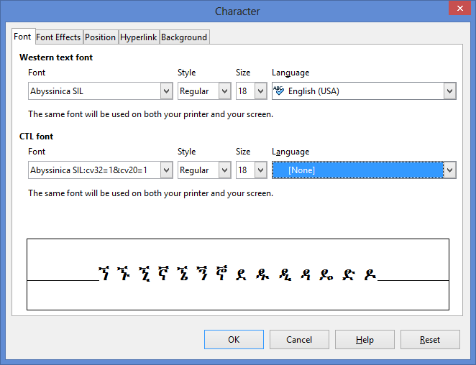
Newer versions of LibreOffice have a user interface which allows selection of the Font Features. Select your text (or style) and go to Format / Character. Choose the Abyssinica SIL font and click on Features. Then select the features you wish to select.
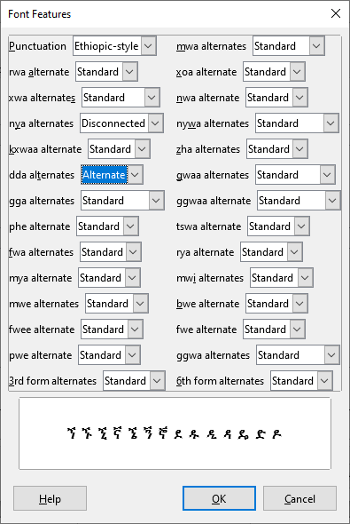
In LibreOffice a language feature can be used by adding the Language to LibreOffice or by choosing the font to be “Abyssinica SIL:lang=sgw” (for Sebat Bet Gurage) or “Abyssinica SIL:lang=guk” (for Gumuz).

XeTeX
For XeTeX, Graphite Feature IDs are not used. Use the Feature Name and Feature setting, e.g., if Character Variant 32 was desired, the font selection would be: "Abyssinica SIL/GR:dda alternates=Alternate" at 12pt
Languages in XeTeX can be accessed by using: "Abyssinica SIL/GR:language=sgw" (for Graphite) or "Abyssinica SIL:Ethi:language=CHG" (for OpenType).

OpenType Character Variants
Currently there are very few applications which support OpenType Character Variants.
For applications which do support OpenType Character Variants, such as in CSS, the Character Variant ID and setting is chosen. For example, in CSS, if cv32, is desired, you might have this code in your .css:
...
@font-face {
font-family: AbyssinicaSIL;
src: url(AbyssinicaSIL-Regular.woff);
}
.cv320 {
font-family: AbyssinicaSIL;
font-feature-settings: "cv32" 0;
}
.cv321 {
font-family: AbyssinicaSIL;
font-feature-settings: "cv32" 1;
}
...

and this in your .html:
<p class=cv320> ዸ ዹ ዺ ዻ ዼ ዽ ዾ</cv320> [cv32=0]</p>
<p class=cv321> ዸ ዹ ዺ ዻ ዼ ዽ ዾ</cv321> [cv32=1]</p>

Which would produce this:
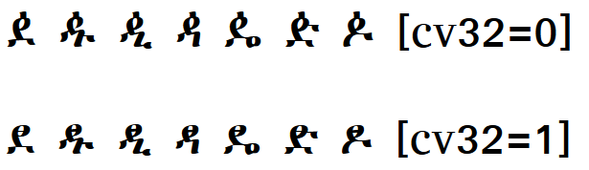

Language features
If an application allows you to select either the Gumuz or Sebat Bet language, the default glyphs will change based on Sebat Bet or Gumuz preferences.
It is also possible to choose the language through the font menu in LibreOffice:
Gumuz: ኘ ኙ ኚ ኛ ኜ ኝ ኞ ኟ (Abyssinica SIL:lang=guk)
Sebat Bet: ጓ ᎁ ቊ ኲ ዂ ጒ ᎅ ᎍ ቍ ኵ ዅ ጕ (Abyssinica SIL:lang=sgw)

TypeTuner
At this point, most applications do not make use of these features (neither Graphite or OpenType Character Variants nor language features) so another solution is needed to use the variant characters. TypeTuner creates tuned fonts that use the variant glyph in place of the standard glyph. The TypeTuner Web site is http://scripts.sil.org/ttw/fonts2go.cgi.

References
Alone, John Philip Herbert Mackenzie. 1946 (Fourth edition). The Alone-Stokes Short Manual of the Amharic Language (with vocabularies). Macmillan and Co. Limited: London.
Chaîne, Marius. 1907. Grammaire éthiopienne. Imprimerie catholique. Beyrouth.
Cohen, Marcel. 1970 Seconde edition. Traité de langue amharique (Abyssinie). Institut d'ethnologie: Paris.
Leslau, Wolf. 1966. Ethiopians Speak: Studies in Cultural Background. Part 2: Chaha. University of California Publication. Near Eastern Studies, Volume 9. University of California Press: Berkeley
Praetorius, Franz. 1955. Aethiopische Grammatik mit Paradigmen, Litteratur, Chrestomathie und Glossar. Frederick Ungar Publishing Co. New York.

Download here: http://www.libreoffice.org/download.
http://tug.org/xetex/
1Chaîne (p 3), Cohen (table 2)
2Cohen (table 2)
3Gumuz language preference
4Alone-Stokes, Chaîne (p 3), Cohen (table 1)
5Chaîne (p 3)
6Archaic Oromo language preference
7Sebat Bet language preference
8Alone-Stokes (inside back cover)
9Bilen language preference
10Praetorius (p 6)
11Leslau

