Akatab Documentation

Smart Font Features
Graphite and OpenType features are used by software shaping (aka rendering) engines to render the proper shaping of Tifinagh characters, whether typed from left-to-right or right-to-left. Some features, such as the forming of bi-consonant ligatures and contextual upward shifting of the yal and yan characters, are done automatically. In addition, some applications let the user select certain optional features.

Default shaping by Graphite and OpenType
The forming of bi-consonant ligatures is done automatically by the shaping engine. For example, if the following Tifinagh characters are entered in sequence: ⵔ (yar), ⵿ (Tifinagh consonant joiner) and ⵜ (yat), the result is ⵔ⵿ⵜ as the bi-consonant ligature. Examples of bi-consonant ligatures are shown on page three.
Another function of the shaping engine is to output alternate glyphs in certain contexts. An example is an ⵏ (yan) followed by another ⵏ (yan) e.g. ⵏⵏ. See page 4 for configuration instructions for Microsoft Word.

Rendering of right-to-left text
These are the default left-to-right Tifinagh characters in the Akatab font:
ⴰ ⵗ ⴾ ⵈ ⵆ ⵂ ⴱ ⵀ ⵔ ⵙ ⴷ ⴸ ⴹ ⵎ ⵟ ⴼ ⵢ ⵉ ⴴ ⴶ ⵑ ⵏ ⵍ ⵐ ⵛ ⵜ ⵓ ⵚ ⵌ ⵣ ⵋ ⵰ ⵿
These are the right-to-left Tifinagh characters in the Akatab font (note the orientation of characters is changed):
‮ⴰ ⵗ ⴾ ⵈ ⵆ ⵂ ⴱ ⵀ ⵔ ⵙ ⴷ ⴸ ⴹ ⵎ ⵟ ⴼ ⵢ ⵉ ⴴ ⴶ ⵑ ⵏ ⵍ ⵐ ⵛ ⵜ ⵓ ⵚ ⵌ ⵣ ⵋ ⵰ ⵿ ‬
There are two special characters that are used to change the direction and the text for the Tifinagh characters:
- U+202E (RIGHT-TO-LEFT OVERRIDE) for right-to-left Tifinagh
Use this invisible character at the beginning of a string of Tifinagh text. The following text will be right-to-left and the directionality of characters is changed to right-to-left. You may want to format the full text to align right.
- U+202C (POP DIRECTIONAL FORMATTING) to change direction
Use this invisible character to change the direction of a string of any text. In this context, the following text will revert to left-to-right. Here is an example of changing direction in the same line of text. Note that the first part is right-to-left Tifinagh text; then the direction changes for Latin text: ‮ⵓⵏⴾ ‬ “This is me”

Selecting variant characters
Sometimes a variant character is needed in place of one of the default characters. Some applications allow the user to select the correct character variants. There are two features that are used for variants—Stylistic Sets and Character Variants.
Microsoft Word and Adobe InDesign have a user interface to select the Stylistic Sets features. Akatab has seven stylistic sets (ss01 through ss07). See the help in the application for assistance in using this feature.
Akatab has 17 Character Variant features with 21 selections (cv01-cv07 and cv31-cv40). See the next section for help in using these features in LibreOffice. In the web folder of the font download, there are examples for Character Variants using .css and .html files to use in web programming.

Using Akatab in LibreOffice

Akatab character variants (using cvxx feature)
To get a variant, select the character(s) and type the feature code into the font dialog box as shown in the examples.
Default | Variant | Font feature code | Examples in LibreOffice
ⴰ | ⴰ | Akatab:cv01=1 | 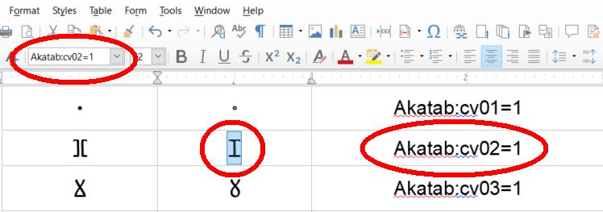
ⴼ | ⴼ | Akatab:cv02=1
ⴴ | ⴴ | Akatab:cv03=1
ⵐ | ⵐ | Akatab:cv04=1
ⵓ | ⵓ | Akatab:cv05=1
ⵣ | ⵣ | Akatab:cv06=1
ⵋ | ⵋ | Akatab:cv07=1
ⴱ⵿ⵜ | ⴱ⵿ⵜ | Akatab:cv31=1
ⵔ⵿ⵜ | ⵔ⵿ⵜ | Akatab:cv32=1 | 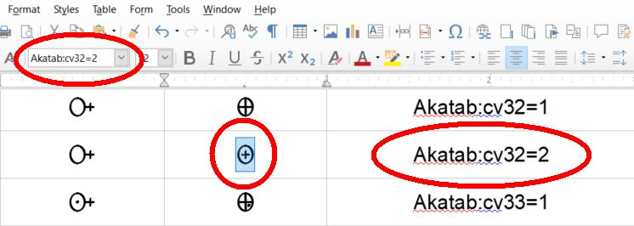
ⵔ⵿ⵜ | ⵔ⵿ⵜ | Akatab:cv32=2
ⵙ⵿ⵜ | ⵙ⵿ⵜ | Akatab:cv33=1
ⵙ⵿ⵜ | ⵙ⵿ⵜ | Akatab:cv33=2
ⵎ⵿ⵜ | ⵎ⵿ⵜ | Akatab:cv34=1
ⴼ⵿ⵜ | ⴼ⵿ⵜ | Akatab:cv35=1
ⵏ⵿ⴾ | ⵏ⵿ⴾ | Akatab:cv36=1
ⵏ⵿ⵜ | ⵏ⵿ⵜ | Akatab:cv37=1
ⵏ⵿ⵜ | ⵏ⵿ⵜ | Akatab:cv37=2
ⵍ⵿ⵜ | ⵍ⵿ⵜ | Akatab:cv38=1
ⵓ⵿ⵜ | ⵓ⵿ⵜ | Akatab:cv39=1
ⵌ⵿ⵜ | ⵌ⵿ⵜ | Akatab:cv40=1
ⵌ⵿ⵜ | ⵌ⵿ⵜ | Akatab:cv40=2

Bi-consonants (ligatures based on default characters)
These ligatures are formed after typing the character sequences shown in the examples below. Type the first character e.g. ⴱ, the joiner ⵿ (using the RightAlt or AltGr key – see keyboard documentation) and then the second character e.g. ⵜ, to get the ⴱ⵿ⵜ (BT) ligature.
ⴱ⵿ ⵜ ⴱ⵿ⵜ BT | ⵏ⵿ ⴷ ⵏ⵿ⴷ ND | ⵏ⵿ ⴴ ⵏ⵿ⴴ NGHH | ⵛ⵿ ⴾ ⵛ⵿ⴾ SHK
ⵀ⵿ ⵜ ⵀ⵿ⵜ B(alt)T | ⵏ⵿ ⴸ ⵏ⵿ⴸ NDH | ⵏ⵿ ⴶ ⵏ⵿ⴶ NJ | ⵏ⵿ ⵛ ⵏ⵿ⵛ NSH
ⵔ⵿ ⴾ ⵔ⵿ⴾ RK | ⵎ⵿ ⵜ ⵎ⵿ⵜ MT | ⴶ⵿ ⵜ ⴶ⵿ⵜ JT | ⵛ⵿ ⵜ ⵛ⵿ⵜ SHT
ⵔ⵿ ⵜ ⵔ⵿ⵜ RT | ⵏ⵿ ⴼ ⵏ⵿ⴼ NF | ⵏ⵿ ⴾ ⵏ⵿ⴾ NK | ⵓ⵿ ⵜ ⵓ⵿ⵜ WT
ⵙ⵿ ⴾ ⵙ⵿ⴾ SK | ⴼ⵿ ⵜ ⴼ⵿ⵜ FT | ⵏ⵿ ⵜ ⵏ⵿ⵜ NT | ⵌ⵿ ⵜ ⵌ⵿ⵜ ZZT
ⵏ⵿ ⵙ ⵏ⵿ⵙ NS | ⵉ⵿ ⵜ ⵉ⵿ⵜ YT | ⵍ⵿ ⴾ ⵍ⵿ⴾ LK | ⵣ⵿ ⵜ ⵣ⵿ⵜ ZT
ⵙ⵿ ⵜ ⵙ⵿ⵜ ST | ⴴ⵿ ⵜ ⴴ⵿ⵜ GHHT | ⵍ⵿ ⵜ ⵍ⵿ⵜ LT | ⵋ⵿ ⵜ ⵋ⵿ⵜ ZHT

Bi-consonant variants (ligatures based on variant characters)
These variants are formed by applying the font feature code either to the character (as above) or to the whole ligature.
ⵏ⵿ⴼ | NF | ligature using an alternate F | Akatab:cv02=1
ⴼ⵿ⵜ | FT | ligature using an alternate F | Akatab:cv02=1
ⴴ⵿ⵜ | GHHT | ligature using an alternate GHH | Akatab:cv03=1
ⵏ⵿ⴴ | NGHH | ligature using an alternate GHH | Akatab:cv03=1
ⵓ⵿ⵜ | WT | ligature using an alternate W | Akatab:cv05=1
ⵣ⵿ⵜ | ZT | ligature using an alternate Z | Akatab:cv06=1
ⵋ⵿ⵜ | ZHT | ligature using an alternate ZH | Akatab:cv07=1

Contextual substitutions (raised variants)
These will substitute automatically as the characters are typed.
ⵏⵏ | NN | ⵍⵍ | LL
ⵏⵍ | NL | ⵍⵏ | LN

Superscript vowels (for literacy aids)
Superscript vowels correspond to U+E300 – U+E304 respectively and are shown between Tifinagh characters for clarity.
ⵏⵏ ⵏⵏ ⵏⵏ ⵏⵏ ⵏⵏ

Diacritics (for research and literacy aids)
Type the Tifinagh character followed by either a combining acute (U+0301) or tilde (U+0303).
ⵗ́ ⴾ́ ⵈ́ ⵆ́ ⵂ́ ⴱ́ ⵀ́ ⵔ́ ⵙ́ ⴷ́ ⴸ́ ⴹ́ ⵎ́ ⵟ́ ⴼ́ ⵢ́ ⵉ́ ⴴ́ ⴶ́ ⵑ́ ⵏ́ ⵍ́ ⵐ́ ⵛ́ ⵜ́ ⵓ́ ⵌ́ ⵣ́ ⵋ́
ⵗ̃ ⴾ̃ ⵈ̃ ⵆ̃ ⵂ̃ ⴱ̃ ⵀ̃ ⵔ̃ ⵙ̃ ⴷ̃ ⴸ̃ ⴹ̃ ⵎ̃ ⵟ̃ ⴼ̃ ⵢ̃ ⵉ̃ ⴴ̃ ⴶ̃ ⵑ̃ ⵏ̃ ⵍ̃ ⵐ̃ ⵛ̃ ⵜ̃ ⵓ̃ ⵌ̃ ⵣ̃ ⵋ̃
Type the Tifinagh character followed by either a combining dot above (U+0307) or ring above (U+030A).
ⵗ̇ ⴾ̇ ⵈ̇ ⵆ̇ ⵂ̇ ⴱ̇ ⵀ̇ ⵔ̇ ⵙ̇ ⴷ̇ ⴸ̇ ⴹ̇ ⵎ̇ ⵟ̇ ⴼ̇ ⵢ̇ ⵉ̇ ⴴ̇ ⴶ̇ ⵑ̇ ⵏ̇ ⵍ̇ ⵐ̇ ⵛ̇ ⵜ̇ ⵓ̇ ⵌ̇ ⵣ̇ ⵋ̇

Configuring Microsoft Word for Windows
Since Akatab uses OpenType features to display ligatures and contextual alternates, the user needs to check the OpenType settings in Microsoft Word to ensure they are enabled.
Select all (Ctrl+A) or a select portion of the text then follow the instructions by number in the illustration.
1. Click the Font dialog box launcher.
2. Select the Advanced tab.
3. Select which ligatures you want to display (Standard and Contextual is all that is needed).
4. The Use Contextual Alternates box should be ticked.
Click OK to close the dialog box.
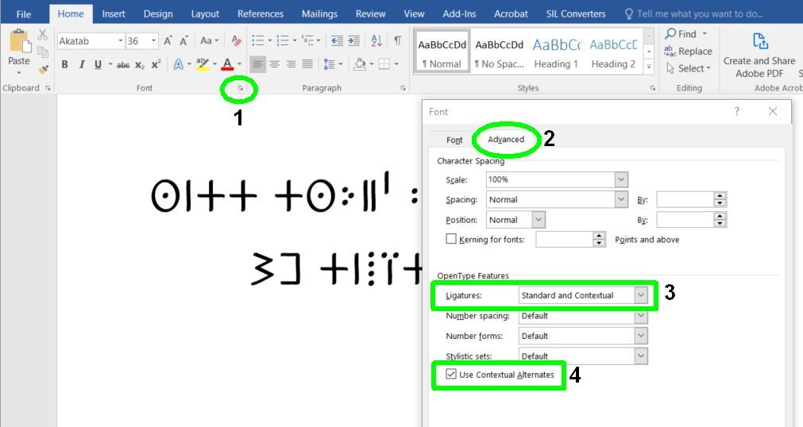
To enable Stylistic Sets, select the text where you want to show the variant style. Open the Font dialog as instructed above. In the Stylistic sets drop-down box, select the number that corresponds with the desired style.
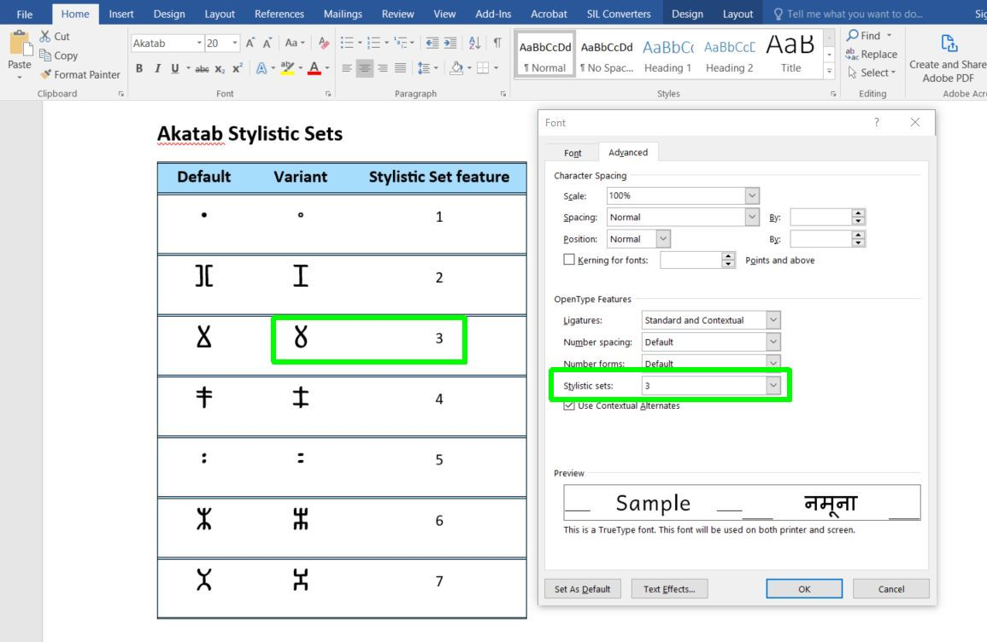

Configuring Microsoft Word for Mac
Since Akatab uses OpenType features to display ligatures and contextual alternates, the user needs to check the OpenType settings in Microsoft Word to ensure they are enabled.
Select all (Ctrl+A) or a select portion of the text then follow the instructions by number in the illustration.
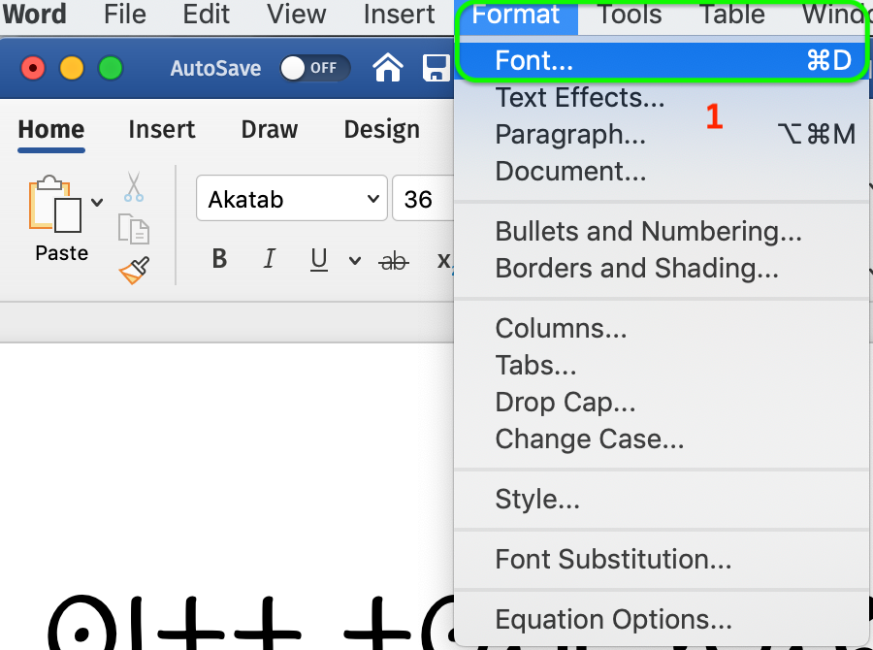
1. Click Format | Font to open the Font dialog box.
2. Select the Advanced tab.
3. Select which ligatures you want to display
(Standard and Contextual is all that is needed).
4. The Use Contextual Alternates box should be ticked.
Click OK to close the dialog box.
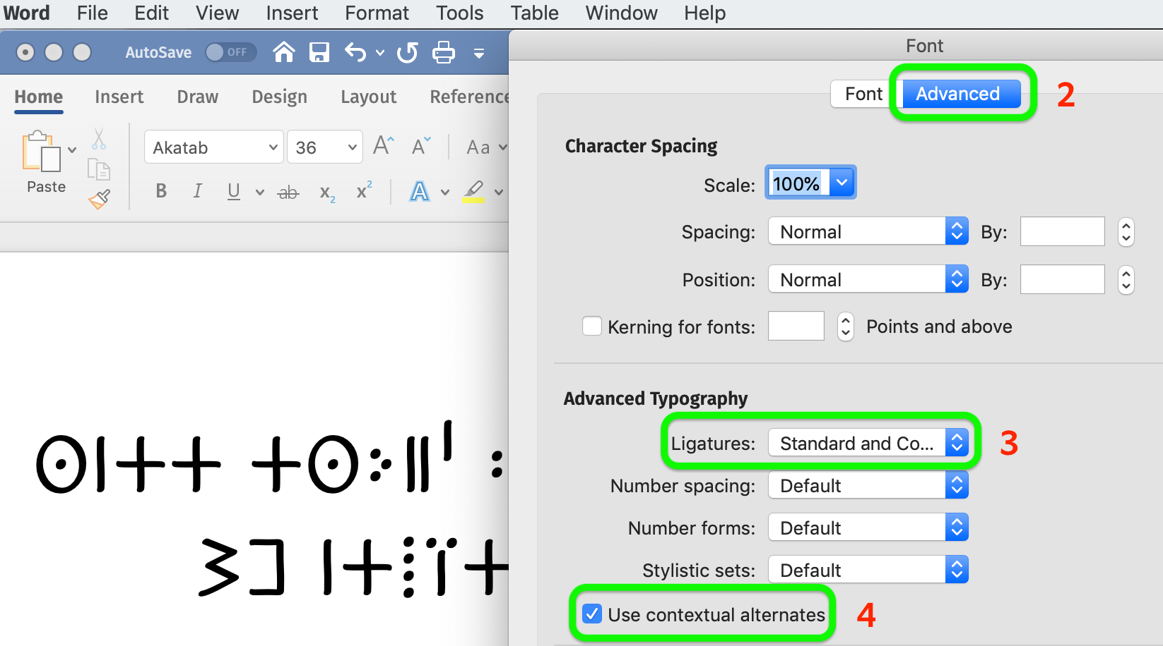
To enable Stylistic Sets, select the text where you want to show the variant style. Open the Font dialog as instructed above. In the Stylistic sets drop-down box, select the number that corresponds with the desired style.
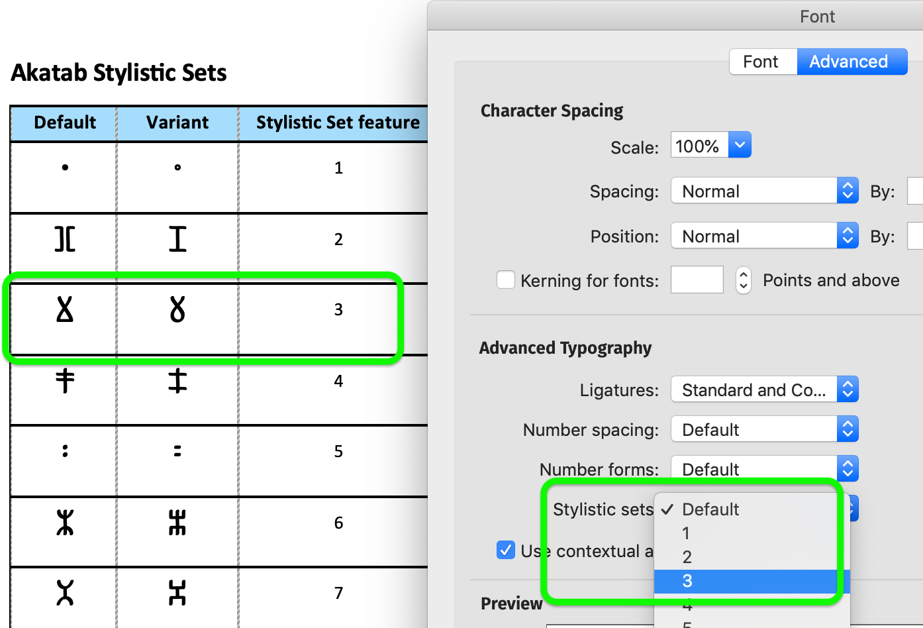

See https://www.libreoffice.org/ to download this free office suite.

