Tagmukay Smart Font Features
Graphite and OpenType features are used by software shaping (aka rendering) engines to render the proper shaping of Tifinagh characters. Some features such as the forming of bi-consonant ligatures and contextual slanting of the ella and enna characters are done automatically. In addition, some applications let the user select certain optional features.

Default shaping by Graphite and OpenType
The forming of bi-consonant ligatures is done automatically by the shaping engine. For example, if the following Tifinagh characters are entered in sequence: ⵔ (erra) ⵿ (Tifinagh consonant joiner) and ⵜ (etta), the result is ⵔ⵿ⵜ (erta) as the bi-consonant ligature.

How to access user-selected Graphite features
When Tagmukay is used in applications that support Graphite that provide an appropriate user interface, various user-controllable font features are available that allow access to variant glyphs. These variants might be preferable for use in some contexts. See your software documentation for help in applying the feature.
As an example, in LibreOffice 3.4+ the font features can be turned on by choosing the font (e.g. Tagmukay), followed by a colon, followed by the feature ID, and then followed by the feature setting. For example, if the Tawallammat enja stylistic variant is desired, the font selection would be “Tagmukay:ss01=1”.
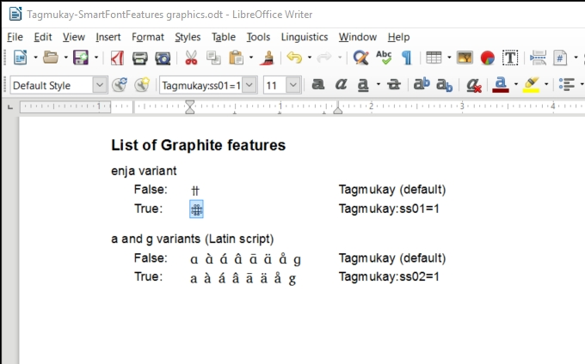

If you only want to apply the feature to part of the text, select the desired text (shown highlighted) and then type in the desired feature ID in the font box (where the arrow is pointing).

List of Graphite features
enja stylistic variant
 | False: | ⵏ⵿ⵌ | Tagmukay (default)
 | True: | ⵏ⵿ⵌ | Tagmukay:ss01=1
a and g variants (Latin script)
 | False: | a à á â ã ä å g | Tagmukay (default)
 | True: | a à á â ã ä å g | Tagmukay:ss02=1

How to access user-selected OpenType features
Some applications have a user interface to access optional OpenType features, in this case the Stylistic Sets features for Tagmukay. See your software documentation for help in applying a feature. For example, to access stylistic sets in InDesign, choose Window > Type & Tables > Character. Click the fly-out menu at the panel’s upper right, choose OpenType > Stylistic Sets and then choose ss01 and/or ss02.

The download for LibreOffice can be found at http://www.libreoffice.org/.

