Lepcha Unicode MSKLC Keyboard

Background and overview
The Lepcha Windows keyboard was designed for the Lepcha language. This implementation of the Lepcha keyboard has been built using Microsoft Keyboard Layout Creator 1.4.
The keyboard is somewhat based on the legacy font layout that the “JG Lepcha” font used. To type LEPCHA LETTER KA, you would type the letter "k" on the keyboard. To type LEPCHA LETTER KHA, you would type "K".
The Lepcha script, as encoded in Unicode, requires some reordering. That means that although the vowel might display before a consonant, it is actually stored in the computer after the consonant. This keyboard requires you to type characters in Unicode order. That is:
C(.)(R)(Y)(V)(F)(^)
This translates into Consonant followed by optional nukta, followed by optional Ra, followed by optional Ya, followed by optional Dependent vowel, followed by optional Consonant sign, followed by optional Ran. It is then up to the font to display them in the correct order.
In the charts below, the keystroke is in the top row, the character is below that and the Unicode Scalar Value (USV) is in the 3rd row. To type ᰕᰧᰵᰶᰙᰳᰶ you would type "miV_zD_". To type ᰣᰤᰩᰭ you would type "A?oX".

Software requirements
- Windows XP or later.
- Because Lepcha is not implemented in Windows Uniscribe rendering, the only way this keyboard will work is if it is used with the Mingat font (http://scripts.sil.org/Mingzat) using an application that supports Graphite rendering, such as LibreOffice.

Installing and uninstalling the keyboard
To install the keyboard, go to the Lepcha folder, and double-click on Setup.exe.
Repeat this procedure to uninstall the keyboard.
Note: While one can remove the keyboard from within the “Text Services and Input Languages” control panel, the Setup program does a more thorough job of removing all components of the keyboard from the system.

Activating the keyboard
The software used to create the keyboard (Microsoft Keyboard Layout Creator) requires that the keyboard be associated with some language. Unfortunately, Windows does not yet offer Lepcha as an option, so a different language had to be chosen. Luxembourgish was used.
Installing the keyboard should have activated the Language Toolbar. This will usually be located near the right end of the Taskbar, but it may be free floating. It will display a two-letter language code which indicates what the current input language is. (EN will be displayed if the input language is English.)
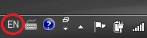

Click on the existing language code to change it.
A menu will pop up showing the input language options. To select Lepcha, click on
“LB – Luxembourgish (Luxembourgh)”.

You can now use the keyboard in your document. The layout of the keyboard is on the next pages.

Modifying the keyboard layout
Microsoft Keyboard Layout Creator is required to edit and rebuild the keyboard. All source files should be included with this distribution. The source files include:
Lepcha.klc
LepchaMSKLCLayout.odt

Keyboard Layout

Consonants
k | W | K | g | x | G | c | C | j | J | t | T
ᰀ | ᰁ | ᰂ | ᰃ | ᰄ | ᰅ | ᰆ | ᰇ | ᰈ | ᰉ | ᰊ | ᰋ
1c00 | 1c01 | 1c02 | 1c03 | 1c04 | 1c05 | 1c06 | 1c07 | 1c08 | 1c09 | 1c0a | 1c0b
d | n | p | Y | P | f | F | b | E | m | I | q
ᰌ | ᰍ | ᰎ | ᰏ | ᰐ | ᰑ | ᰒ | ᰓ | ᰔ | ᰕ | ᰖ | ᰗ
1c0c | 1c0d | 1c0e | 1c0f | 1c10 | 1c11 | 1c12 | 1c13 | 1c14 | 1c15 | 1c16 | 1c17
Q | z | y | r | l | h | H | v | s | S | w | A
ᰘ | ᰙ | ᰚ | ᰛ | ᰜ | ᰝ | ᰞ | ᰟ | ᰠ | ᰡ | ᰢ | ᰣ
1c18 | 1c19 | 1c1a | 1c1b | 1c1c | 1c1d | 1c1e | 1c1f | 1c20 | 1c21 | 1c22 | 1c23

Dependent Vowels
a | i | O | o | u | U | e
◌ᰦ | ᰧ◌ | ᰨ◌ | ᰩ◌ | ◌ᰪ | ◌ᰫ | ◌ᰬ
1c26 | 1c27 | 1c28 | 1c29 | 1c2a | 1c2b | 1c2c

Consonant Signs
X | M | L | N | B | R | D | Z | V
◌ᰭ | ◌ᰮ | ◌ᰯ | ◌ᰰ | ◌ᰱ | ◌ᰲ | ◌ᰳ | ᰴ◌ | ᰵ◌
1c2d | 1c2e | 1c2f | 1c30 | 1c31 | 1c32 | 1c33 | 1c34 | 1c35

Various Signs
? | / | _ | ;
ᰤ | ᰥ | ◌ᰶ | ◌᰷
1c24 | 1c25 | 1c36 | 1c37

Numerals
0 | 1 | 2 | 3 | 4 | 5 | 6 | 7 | 8 | 9
᱀ | ᱁ | ᱂ | ᱃ | ᱄ | ᱅ | ᱆ | ᱇ | ᱈ | ᱉
1c40 | 1c41 | 1c42 | 1c43 | 1c44 | 1c45 | 1c46 | 1c47 | 1c48 | 1c49

Extra-orthographical Marks / Punctuation
' | ” | = | + | . | { | } | |
᰻ | ᰼ | ᰽ | ᰾ | ᰿ | ᱍ | ᱎ | ᱏ
1c3b | 1c3c | 1c3d | 1c3e | 1c3f | 1c4d | 1c4e | 1c4f

Consonant Conjuncts
k? | W? | K? | g? | x? | t? | T? | d? | p? | Y? | P? | f?
ᰀᰤ | ᰁᰤ | ᰂᰤ | ᰃᰤ | ᰄᰤ | ᰊᰤ | ᰋᰤ | ᰌᰤ | ᰎᰤ | ᰏᰤ | ᰐᰤ | ᰑᰤ
F? | b? | E? | m? | I? | r? | l? | h? | H? | v? | S? | a?
ᰒᰤ | ᰓᰤ | ᰔᰤ | ᰕᰤ | ᰖᰤ | ᰛᰤ | ᰜᰤ | ᰝᰤ | ᰞᰤ | ᰟᰤ | ᰡᰤ | ᰣᰤ
k/ | g/ | G/ | p/ | f/ | b/ | m/ | h/
ᰀᰥ | ᰃᰥ | ᰅᰥ | ᰎᰥ | ᰑᰥ | ᰓᰥ | ᰕᰥ | ᰝᰥ
k/? | g/? | G/? | p/? | f/? | b/? | m/? | h/?
ᰀᰥᰤ | ᰃᰥᰤ | ᰅᰥᰤᰅ | ᰎᰥᰤ | ᰑᰥᰤ | ᰓᰥᰤ | ᰕᰥᰤ | ᰝᰥᰤ

Nuktas
k;/ | g;/ | h;/ | r; | z;
ᰀ᰷ᰥ | ᰃ᰷ᰥ | ᰝ᰷ᰥ | ᰛ᰷ | ᰙ᰷

Keyboard Layout

Unshifted

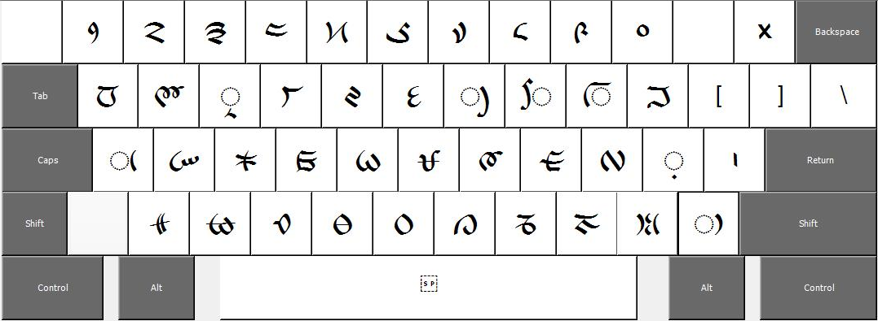

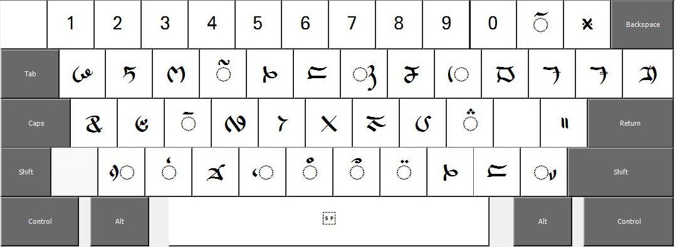
Shifted

License
The Lepcha MSKLC Keyboard is copyright ©2013 by SIL International. It is distributed under the X11 free software license:

SIL International X11-style License
Permission is hereby granted, free of charge, to any person obtaining a copy of this software and associated documentation files (the "Software"), to deal in the Software without restriction, including without limitation the rights to use, copy, modify, merge, publish, distribute, sublicense, and/or sell copies of the Software, and to permit persons to whom the Software is furnished to do so, subject to the following conditions:
The above copyright notice and this permission notice shall be included in all copies or substantial portions of the Software.
THE SOFTWARE IS PROVIDED "AS IS", WITHOUT WARRANTY OF ANY KIND, EXPRESS OR IMPLIED, INCLUDING BUT NOT LIMITED TO THE WARRANTIES OF MERCHANTABILITY, FITNESS FOR A PARTICULAR PURPOSE AND NONINFRINGEMENT. IN NO EVENT SHALL SIL INTERNATIONAL BE LIABLE FOR ANY CLAIM, DAMAGES OR OTHER LIABILITY, WHETHER IN AN ACTION OF CONTRACT, TORT OR OTHERWISE, ARISING FROM, OUT OF OR IN CONNECTION WITH THE SOFTWARE OR THE USE OR OTHER DEALINGS IN THE SOFTWARE.
Except as contained in this notice, the name of SIL International shall not be used in advertising or otherwise to promote the sale, use or other dealings in this Software without prior written authorization from SIL International.

Technical Support
If you have problems using the Lepcha keyboard, please contact:
User Support
SIL Non-Roman Script Initiative
7500 W. Camp Wisdom Rd
Dallas, TX 75236
USA
E-mail: mailto:nrsi@sil.org

