Akha ACT Keyboard layout
SIL Non-Roman Script Initiative (NRSI)

Installing the Keyboard
The keyboard driver can only be installed on Windows 2000, XP or Vista. This Akha ACT keyboard is a Unicode keyboard and will only work with Unicode applications.
The keyboard is packaged with a setup file as well as several .msi files. In order to someday uninstall your keyboard (and if you ever want to upgrade to a newer version you will want to!) you must keep all of the files on your computer.
To install the MSKLC keyboard:
- Download the zip file and extract the files to a folder of your choosing.
- In Windows Explorer, double-click the Akha folder to view the contents.
- Double-click setup.exe.
- When User Account Control window appears, click Allow (on Vista only).
- When the window showing “Akha ACT has been successfully installed” appears, click Close.
- Reboot your computer.

Selecting the Keyboard
The Akha ACT keyboard has been automatically associated with the English language. To use the keyboard, open the application you wish to type in.
To select the keyboard:
- Make sure English is selected by clicking the language ID in the system tray. For example, this will be “EN” if English. Select English.
- Right-click a blank area on the taskbar and if necessary, unlock the taskbar, by clicking “Lock the taskbar” to remove the checkmark by it.
- Drag the dotted divider on the taskbar so that you can see both “EN” and a small keyboard icon. This icon is used to change between various keyboards.
- Click the keyboard icon and select Akha ACT.

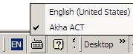
Your new keyboard should be active and ready to use.
Note that if you hover over the keyboard icon, it will tell you the name of the current keyboard (if you hover over the Language ID it will tell you your language is Akha ACT).
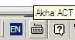
To turn off the Akha ACT keyboard:
- Click the keyboard icon on the system tray and select the language you are switching to.
Note that if only one keyboard is assigned to a language, the keyboard icon will not appear, since there is no other keyboard to choose.

Fonts
The newest versions of Doulos SIL (http://scripts.sil.org/DoulosSILfont) and Charis SIL (http://scripts.sil.org/CharisSILfont) contain all of the characters used in this keyboard. Older versions may not have all of the characters.

Akha ACT Keyboard Layout
The keyboard layout is exactly the same as the US English keyboard with the exception of 7 keys. These are:
keystroke | Result
^ (shift+6) | ʼ
| | ˉ
\ | ˍ
{ | ˇ
} | ˆ
[ | ˯
] | ˰

A keyboard layout chart is also provided as a visual reference.

Unshifted

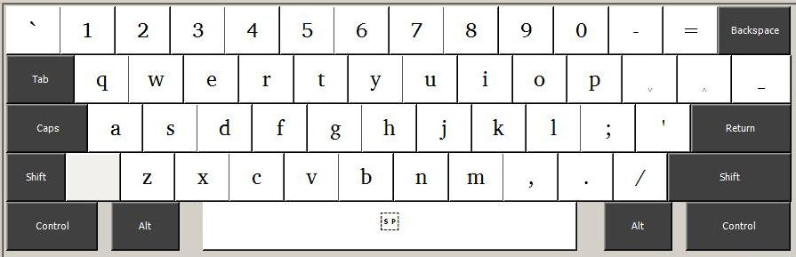

Shifted

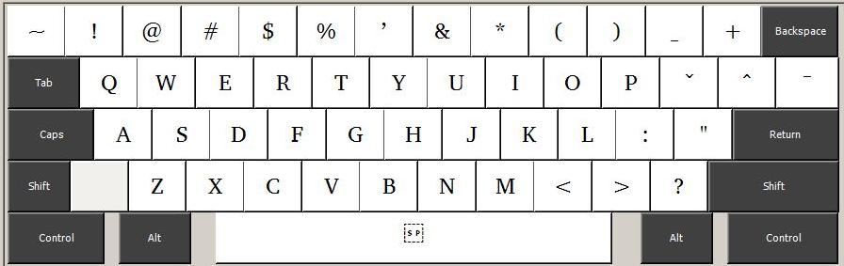

Associating the Keyboard with a Different Language
This keyboard is automatically associated with the English language. If you wish to associate it with a different language, follow these instructions:
For Windows XP:
- Go to Start / (Setting) / Control Panel / Regional and Language Options / Languages tab
- Click on the Details… button.
- Click on Add.
- Where it says Input Language, choose Icelandic (or you can choose another language to associate it with).
- Choose Akha ACT for Keyboard Layout/IME.
- Click OK.
- Click on Language Bar button. Make sure Show the Language bar on the desktop is selected.
- If you wish to assign a "hotkey" in order to switch to this keyboard, you may do so by clicking on Key Settings…, select Switch to Icelandic… and select Change Key Sequence…. Select Enable Key Sequence and choose the keystrokes you wish to assign to this keyboard (for the purposes of these instructions- Left-Alt+Shift+9)
- Click on OK, OK and OK.
- You may need to reboot before you are able to select the keyboard.
For Windows Vista:
- Go to Start / Control Panel / Regional and Language Options / Keyboards and Languages tab
- Click on the Change Keyboards… button.
- Click on Add.
- Where it says Input Language, choose Icelandic (or you can choose another language to associate it with).
  - Click on the "+" to expand your selection
  - Click on Show more… and select Akha ACT
  - Click OK.
- Click on Language Bar tab. For the Language bar, select either Floating on Desktop or Docked in the taskbar.
- If you wish to assign a "hotkey" in order to switch to this keyboard, you may do so by clicking on Advanced Key Settings, select your keyboard and select Change Key Sequence…. Select Enable Key Sequence and choose the keystrokes you wish to assign to this keyboard (for the purposes of these instructions- Left-Alt+Shift+9)
- Click on OK, OK and OK.
- You may need to reboot before you are able to select the keyboard.

Uninstalling the Keyboard
When you are ready to uninstall your keyboard:
- Right-click on the keyboard icon and select Settings…
- In Text Services and Input Languages / Settings tab, select “Akha ACT” and click Remove, then click OK.
- Find the Akha folder where you originally installed the keyboard.
- Double-click setup.exe.
- Click Remove the keyboard layout, if it is not already selected.
- Click Finish.
- When the User Account Control dialog box appears, click Allow (Vista only).
- When the Installation Complete dialog box appears indicating the keyboard has been removed, click Close.
- You may need to reboot before the keyboard is completely removed from the system.
The keyboard has been uninstalled. You may also wish to delete the Akha folder to remove the files and install program.

Technical Support
If you have problems using the Akha ACT keyboard, please contact:
User Support
SIL Non-Roman Script Initiative
7500 W. Camp Wisdom Rd.
Dallas, TX 75236
USA
E-mail: mailto:sil_fonts@sil.org

Unfortunately, Windows does not have an "Akha" language. After installing, if you wish, you can associate it with any other language (see separate section which discusses how to do that).

