Extented Kalman Filter Project

# Local environment setup

Windows10, visual studio 2017

Udacity’s project <https://github.com/udacity/CarND-Extended-Kalman-Filter-Project>

Reference <https://github.com/fkeidel/CarND-Term2-ide-profile-VisualStudio>

Term2 Simulator <https://github.com/udacity/self-driving-car-sim/releases>

# Test

1. Project run

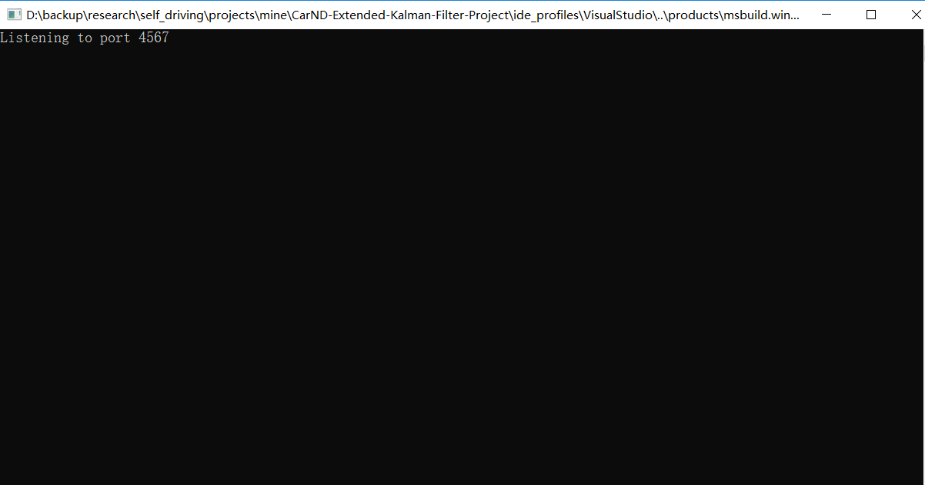

1. Simulator run

