
Problem Statement:

In Financial Institutions getting their customers to do a fixed deposit in the banks is a vital and at most important for the bank as they bank uses it and pays an interest amount to those deposited customers. To ask every customer for a term deposit is not viable as well as time consuming process, can you come up with a Logistic Regression model to predict customers who will do a term deposit or not.

The output variable in the dataset is Y which is discreet and binary. Snapshot of the dataset is given below.
Problem Statement: -
Prediction of election results has become trivial in these days, the outcome variable is (0/1) and the other factors that affect a candidate win or loss is amount of money spent, popularity and more. Perform Logistic Regression on the dataset and classify the candidates.

Solution:

There are five basic steps when you’re implementing Multiple linear regression:
- Import the packages and classes you need.
- Provide data to work with and eventually do appropriate transformations.
- Create a regression model and fit it with existing data.
- Check for collinearity between independent variables and between independent and dependent variables .
- Check for overfitting issue
- Apply the model for predictions.
The first step is to import the package numpy and
import numpy as np
Now, you have all the functionalities you need to implement logistic regression.
relavancy check of dependent variable with independent variables by multiple plots
# bank_data[‘age'].plot.hist(bins=15)
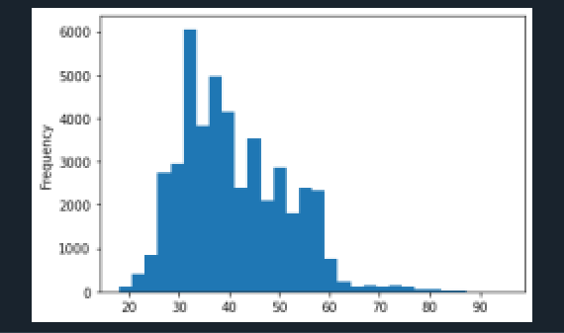

sns.jointplot(x=’age',y='balance',data=bank_data)
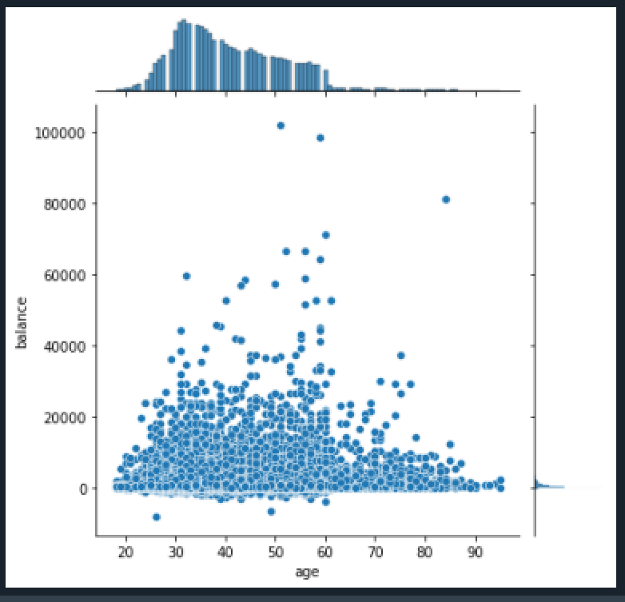

Pairplot of bank_dataof first 200 samples

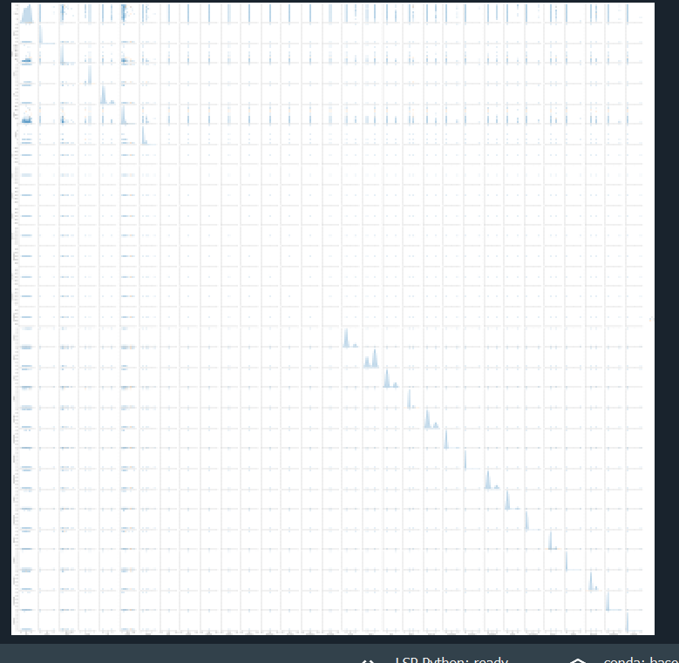

Building the Model

Train and Test Data Sets
We must now divide our dataset into two distinct parts. A training set and a testing set. We can use scikit-learn for this.
Prior to segmenting the data, we will need to define our input and output variables i.e. X and y. For the purpose of this article, we will stick to numerical data when defining the input values for X.
Training and testing the model
We will go ahead and import the Logistic Regression from the sklearn.linear_model library:
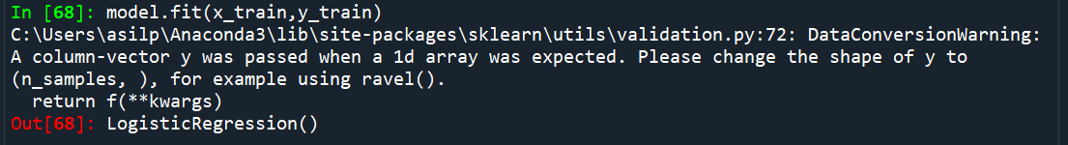

By importing scikit-learn's ‘accuracy_score’ we can swiftly assess the accuracy of our model and using confusion matrix we can visualize the accuracy of model

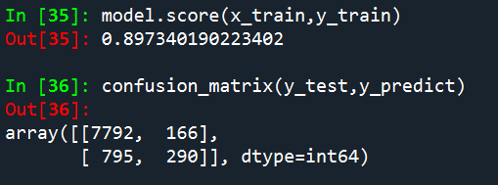

Conclusion
The obtained result shows the power of Machine Learning algorithms. A basic Logistic Regression model has proven to be very successful in solving this classification problem.

