Table code

<https://bootsnipp.com/snippets/V7ypB>

framework

<https://mdbootstrap.com/>

Transparency Hex colors

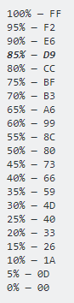

Charts (official and youtube video)

<https://www.chartjs.org/>

<https://www.youtube.com/watch?v=sE08f4iuOhA>

Gradient

<https://cssgradient.io/>

color Wheel

<https://color.adobe.com/create>

validation

<https://mdbootstrap.com/articles/jquery/validate-forms-with-validate-js/>