AnyCargh
Organizational Structure & Team Directory
This document sets out AnyCargh's organizational structure — an eleven-member team led by the Chief Executive Officer, organized across three functional areas: Operations & Logistics, Sales & Business Development, and Finance & Administration. The structure is built to support the company's core services: vehicle importation and shipping, vehicle sales, car rentals, fleet management, logistics coordination, and customer service and marketing.
Organizational Chart
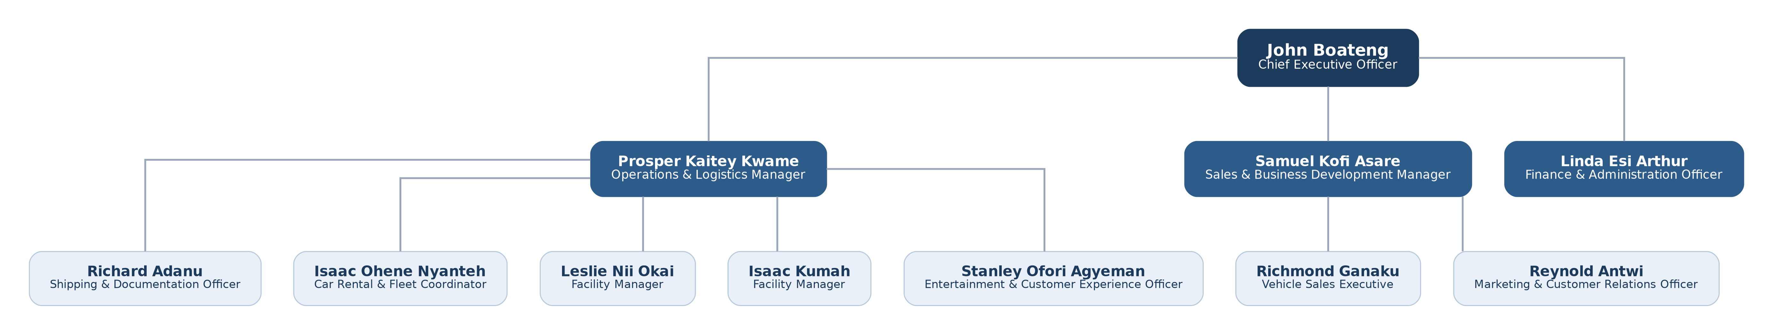

Team Directory
No. | Name | Position | Key Roles & Responsibilities
01 | John Boateng | Chief Executive Officer (CEO) | Sets the company's vision and strategy, oversees business performance, approves major investments, builds partnerships, manages key stakeholders, ensures legal compliance, and drives business growth.
02 | Prosper Kaitey Kwame | Operations & Logistics Manager | Oversees day-to-day operations, coordinates vehicle imports and exports, manages shipping schedules, supervises fleet movement, ensures timely vehicle delivery, and improves operational efficiency.
03 | Samuel Kofi Asare | Sales & Business Development Manager | Develops sales strategies, manages the sales team, identifies new business opportunities, builds corporate partnerships, negotiates contracts, and drives revenue growth.
04 | Linda Esi Arthur | Finance & Administration Officer | Manages accounting, payroll, budgeting, invoicing, expense tracking, office administration, procurement support, and prepares financial reports for management.
05 | Richmond Ganaku | Vehicle Sales Executive | Markets and sells vehicles, follows up with leads, conducts vehicle demonstrations, prepares quotations, manages customer relationships, and ensures high customer satisfaction.
06 | Reynold Antwi | Marketing & Customer Relations Officer | Manages social media and digital marketing, creates promotional campaigns, responds to customer inquiries, manages online listings, strengthens the company's brand, and supports customer retention.
07 | Richard Adanu | Shipping & Documentation Officer | Handles import/export documentation, liaises with shipping lines, customs agents, and ports, tracks shipments, processes vehicle registration documents, and ensures compliance with shipping regulations.
08 | Isaac Ohene Nyanteh | Car Rental & Fleet Coordinator | Manages rental bookings, allocates vehicles, oversees rental agreements, monitors vehicle availability, coordinates fleet utilization, and ensures timely returns and inspections.
09 | Stanley Ofori Agyeman | Entertainment & Customer Experience Officer | Creates a comfortable, engaging, and enjoyable environment for customers while they wait, enhancing the overall customer experience and the company's brand image.
10 | Leslie Nii Okai | Facility Manager | Ensures the garage, office, and surrounding facilities are safe, functional, clean, and operating efficiently while supporting daily business operations.
11 | Isaac Kumah | Facility Manager | Ensures the garage, office, and surrounding facilities are safe, functional, clean, and operating efficiently while supporting daily business operations.
Reporting Lines
Operations & Logistics — Shipping & Documentation Officer, Car Rental & Fleet Coordinator, Facility Managers (2), Entertainment & Customer Experience Officer
Sales & Business Development — Vehicle Sales Executive, Marketing & Customer Relations Officer
Finance & Administration — reports directly to the CEO; no direct reports

