# FOC

## PID Control Parameter (k,Y) for FOC

FOC is field oriented control which means the stator and rotor magnetic field are aligned at certain angle. The magnetic field is caused by the current so that stator current is the stator field direction.

Normally, the stator and rotor field are aligned at 90 degree or if there is advanced angle, it is 85 degree and so. Now let’s assume degree θ is the desired angle between them. A typical three phase system below:

Iu +Iv +Iw =0 ----------------(1)

Is cos A =Iu , where Is is resultant of stator current vector ----------------(2)

Is cos (120-A) =Iv = Is/2 *(-cosA+sinA) ---------------(3)

Is cos (240-A) =Iw = Is /2 * (-cos A- sinA)  ---------------(4)

Iv2+Iw2+Iu2= Is2(cos A2 +1/2 cosA2+3/2sinA2)= 3/2 * Is2

Is2 (3/2)= Iv2+Iu2+ (Iu+Iv)2=2(Iu2+Iv2+IvIu)

🡺 Is2=4/3 *(Iu2+Iv2+IvIu)---------------(5)

Is

A

From above 5 equations, we know Is is the stator current controlling the stator field or the torque. A is the stator field with respect to one reference axis. Let ‘s say if we use AD converter and measured the value of Iu and Iv,

We will have (3)/(2), Iv/Iu= 0.5 * ( -1 + tan A) .

Rearrange it,

tan A= (Iv/Iu+0.5)/

Is2=4/3 *(Iu2+Iv2+IvIu) , Is2 is +ve value

Now Is and A are both control parameter. Is controls the torque and A is the angle of stator field. In fact, we need the information of rotor field angle for finding A. Let ‘s say the rotor field angle is B with respect to same reference axis. The rotor field is inclined angle B with respect to reference axis.

Projecting Is to the rotor axis,

Id = Is cos (A-B)= 0 🡺 A-B =90 🡺 tan A= -1/tanB

Iq= Is sin (A-B)= Is 🡺 Is is a target value for control

Is

rotor

A

B

stator

Iq

From (6), it implies tanA * tanB =-1

If value of B is known from measuring the back emf, we will have tan A=-1/tanB;

That is (Iv/Iu+1/2)/ = -1/tanB

To solve it, Iv/Iu= -/tanB -0.5 =k if lv<lu

or Iu/Iv=1/k if Iu<Iv ---------------(7)

this avoid the case when Iu=0 has infinite solution

We assume A-B=90 is done through controlling Vd voltage in the PID loop.

Substitute (7) in to Is, we have

( Is)2 = 4/3 *(Iu2+Iv2+IvIu)

We replace Is2 *3/4 = (Iu2+Iv2+IvIu) = Y , controlling Is2  is same as controlling Is

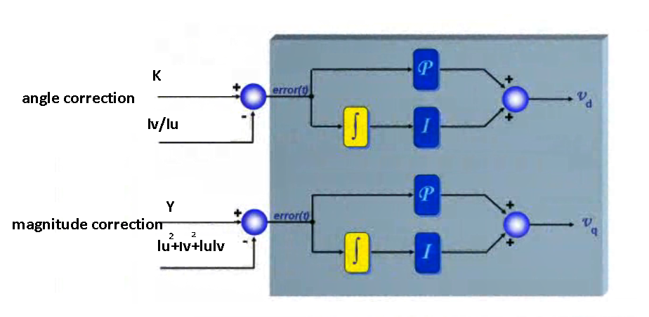

K can be found from a lookup table , k= f(B),

It should be noted the resultant voltage vector driving the motor and measured current vector are not necessarily in phase. In a motor there is inductive component. Vs is determined through controlling the angle and magnitude of current vector.

Iu

Iv

Angle A

magnitude Is

Vd

Iu/Iv=k

Y

Y=k*Is=lu2+Iv2+IuIv

Vq

B

Angle C

magnitude Vs

SVM table (T1,T2)

Tu

Tv

Tw

PID controller

rpm

Ḃ

Rpm=60*f

motor

The whole control system starts with measuring stator current Iu and Iv and then output Vs and angle C.

There is certain value of Vd such that fulfills: k= Iv/Iu

There is certain value of Vq such that fulfills: target Y= lu2+lv2+IuIv

Once Vd and Vq is found : C= artan (Vq/Vd) , Vs= (Vq2+Vd2)1/2

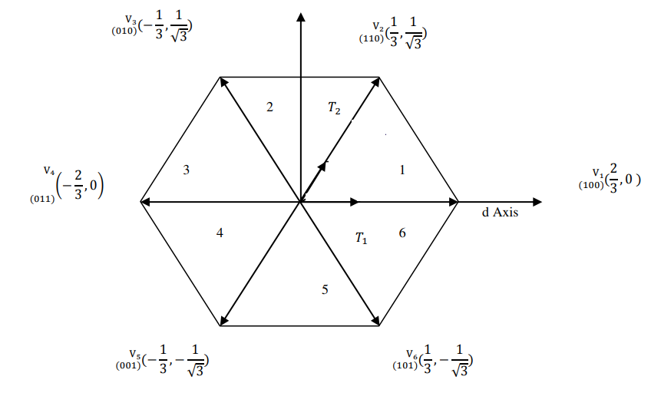

B

rotor

stator

C

Final step is converting the Vs to PWM pulse

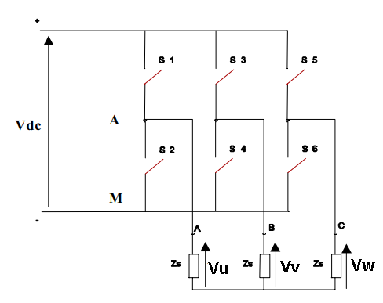

To project the Vs voltage vector to SVM

ϴ = (C+B) mode 60

First find out angle of Vs belongs to which sector (I-6)

Vs will be represented by two adjacent vector V1,V2

## Space Vector Modulation Table (T1,T2)

For a smooth rotation, Vs is running in a unit circle. The resultant Vs is breakdown to two vectors in the SVM table. For example we use V1, V2 and they are separated by 60 degree. Is is the resultant of V1 and V2. We can write equation below:



Let sample period is T=T0 +T1+T2

Now Vs = T1/T *V1+ T2/T *V2

We assume V1 max=V2 max =Vmax=2/3Vdc

Use sin law,

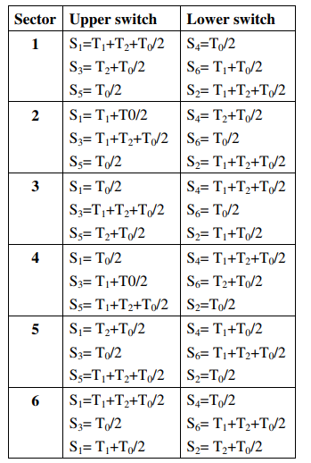

Vs /sin120= (T1/T) *V1max / sin (60-ϴ)

Vs /sin120 = (T2/T) * V2max /sin ϴ

Rearranging, we have

T2/T=  sin ϴ * *Vs/Vmax = sin ϴ* K1 --------------------(8)

T1/T= sin (60-ϴ ) *  * Vs/Vmax= sin (60-ϴ ) *K1-------------(9)

Where K1= * Vs/Vmax= Vs/Vdc

T0/T=1 –(T1/T + T2/T)

It should be noted (T1+T2)/T is always <1, max of T1+T2 occur at θ=30, now,

(T1+T2)/T =K1 <1 🡺 Vs< 0.866 Vmax or Vs< Vdc/

That is in SVPWM, Vs is always 14% than Vmax

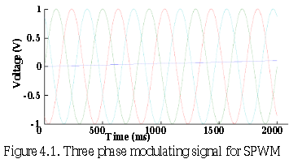

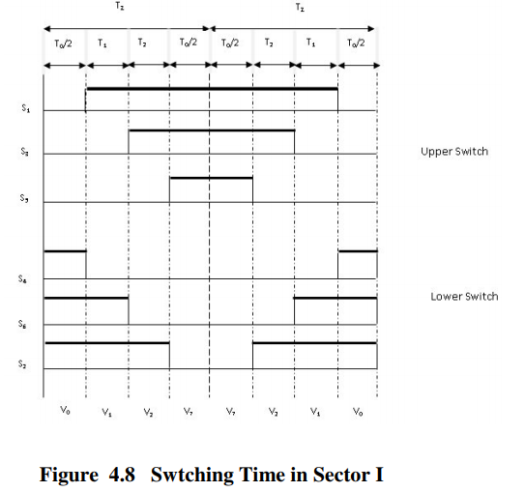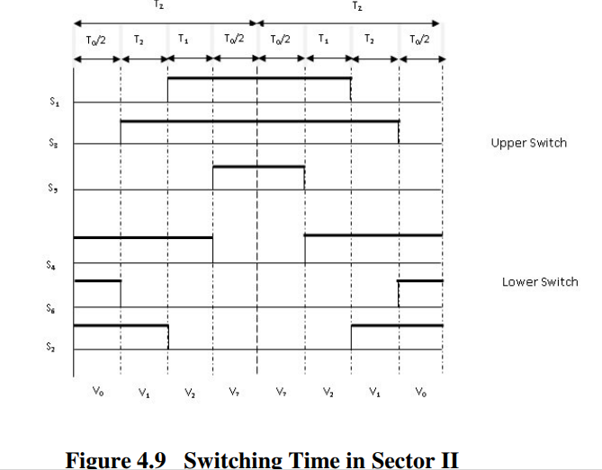

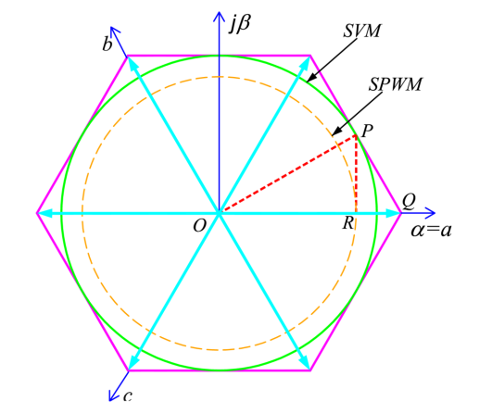

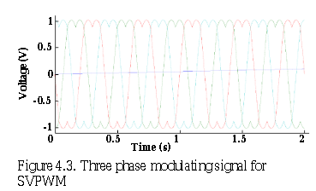

Max power

The reason why SVM cannot use full power is because we want to keep a unit circle trajectory. Previously, it shows θ=0, Vs≤0.866Vmax . What if we allow the trajectory in non-unit circle shape, we shall be able to drive always in maximum power, now atθ=0, Vs=Vmax . The key rule to obey is (T0+T1+T2)/T<1. Let assume T0 is not significant.

(T1+T2)/T =1 ----------------------(10)

new trajectory to utilize full power

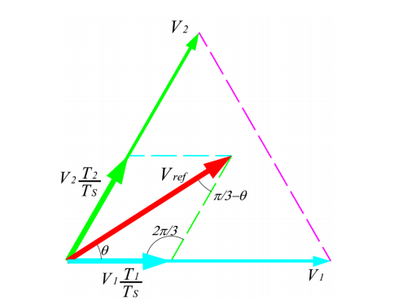

from (8),(9), * Vs/Vmax (sinθ+sin (60-θ)) =1

Vs/Vmax =(sinθ+sin (60-θ)) ----------------------(11)

Now atθ=0, Vs=Vmax, Vsmin occurs at θ=30, Vsmax= 0.866Vmax.

The power increase is counted from the area.

area of hexagon / area of circle in = (0.866)2π=1.10 , we increase the power by 10%

substitute (11) to (8), (9), we have

T1/T=  sin (60-ϴ ) /(sinθ+sin (60-θ)) , T2/T=  sin (ϴ ) /(sinθ+sin (60-θ)).

Summary, for Vs < 0.866Vmax, we keep unity circle and apply

T1/T= sin (60-ϴ )*K1 ; T2/T= sin (ϴ )*K1  Where K1= * Vs/Vmax

If we use max power mode, use a table h(ϴ)= sin (ϴ ) /(sinθ+sin (60-θ))

T1/T= h(60-ϴ)*K1; T2/T= h(ϴ)*K1  now Vs can extended up to Vmax

## Rotor Position Sensing using bemf

There are two methods. The zero crossing method may need more AD and IO. We prefer using method 2 which is estimator and observer method

### Method 1 (zero crossing)

Zero crossing method need one phase floating. This method is for 120degree commutation or square wave commutation

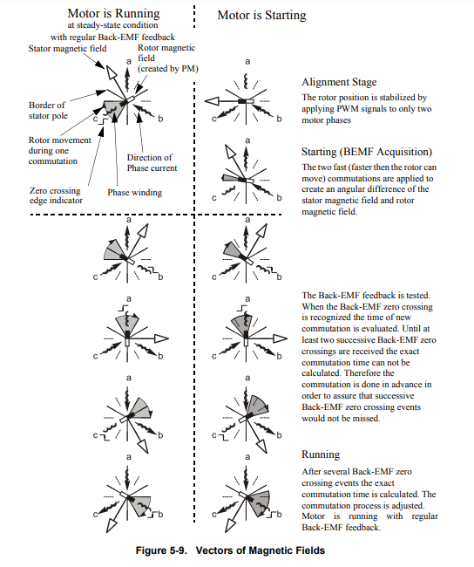

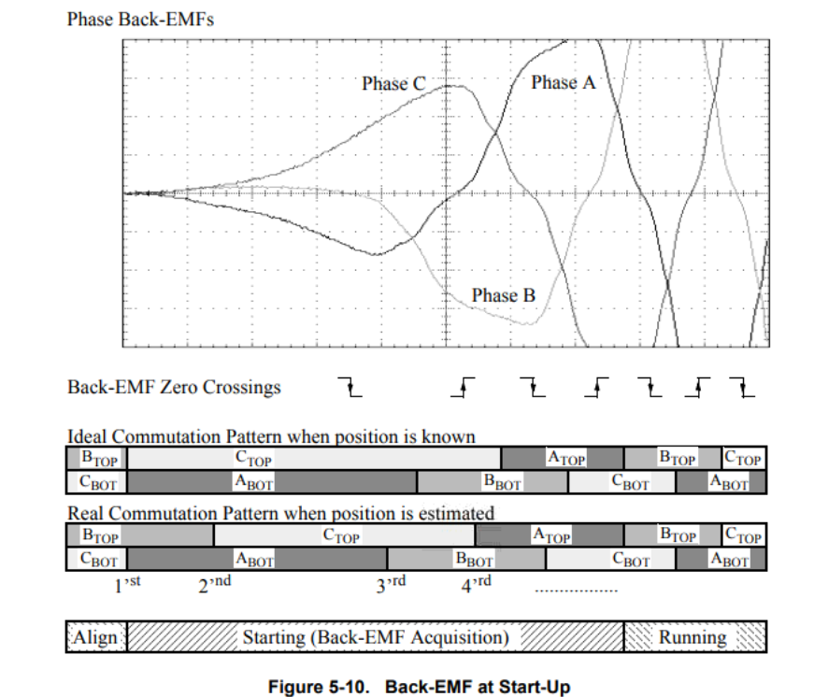

When sensing of zero crossing is better at the duration with PWM is switched off.

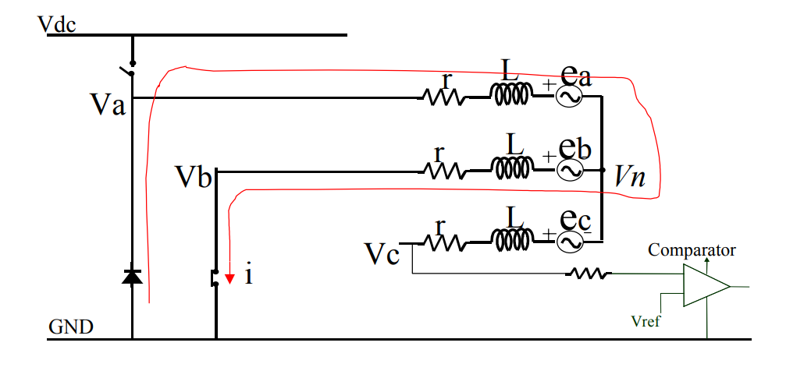

From phase A, we have : 0 –r i -Ldi/dt –ea =Vn  ---------------(12)

From phase B, we have : Vn=r i +Ldi/dt -eb  ---------------(13)

A balanced three phase system , ea+eb+ec=0

So when PWM is switched off, (12)+(13), we have 2Vn= -(ea+eb) = ec, Vn=ec/2

The input voltage to comparator is Vc=Vn +ec= 3/2 ec. So the voltage measured at a floating terminal is proportional to its back emf.

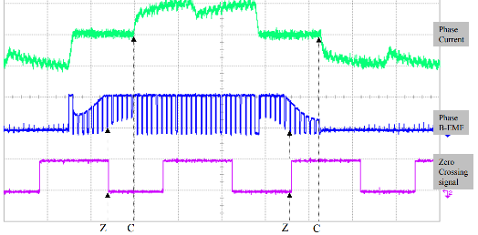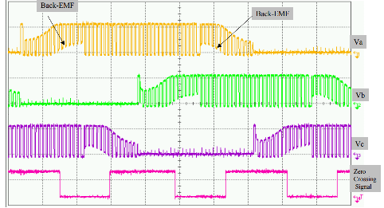

### Method 2 (observer method)

FOC control is a kind of 180 degree commutation. There is no floating terminal available. So zero crossing method is no longer works here. To detect the position of rotor we have to use observer method.

First, we derive the back emf in αβ plane.

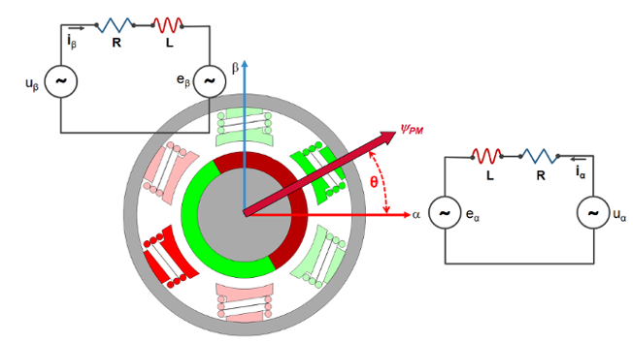

We express voltage in vector form, we will have: |Vs| ej(C+B)=|Is| ejb* |Z|* ejc= |Is| *|Z| * ej(b+c)

Obviously equating the magnitude and direction: |Vs|= |Is|* |Z| and a= b+c or a-b=c

where a-b is the angle between voltage vector and current vector.

We have Z =, c=2.

Vs

If we add back emf in the equation, |Vs| eja = |Is| *|Z| * ej(b+c) + |Es|ejd