6BUIS020C – Final Project Report

Insurance University: An AI-Powered Insurance
Recommendation Platform

Student: Himaha Silva (IIT ID: 20212128 / UoW ID: 18712342/1)

This report is submitted in partial fulfilment of the requirements for the
BSc (Hons) Business Information Systems

Business School

Informatics Institute of Technology, Sri Lanka
in collaboration with
University of Westminster, UK

22nd April 2026

Declaration
This report has been prepared based on my own work. Where other published and unpublished source materials have been used, these have been acknowledged in references.

Word Count: [To be updated after final review]
Student Name: Himaha Silva
Date of Submission: 22nd April 2026

Abstract
The insurance industry in Sri Lanka is characterised by low product penetration, manual advisory processes, and a lack of transparency in product suitability assessment. Customers face difficulty understanding which insurance plans align with their financial profile, family obligations, and risk appetite. This project, Insurance University, addresses these challenges by delivering an AI-powered, web-based insurance recommendation platform that automates the end-to-end customer journey from data capture through to personalised plan recommendations and Know-Your-Customer (KYC) document submission.
The system employs a three-tier microservices architecture consisting of an Angular 21 single-page application, a Spring Boot 3.3.5 RESTful API backend with MySQL 8.4 persistence, and a FastAPI-based AI engine. The AI engine implements a multi-stage scoring pipeline incorporating Classification and Regression Tree (CART) underwriting rules, collaborative filtering heuristics, and trainable feature weights derived from historical policy outcome data. The platform supports two user roles—Customer and Administrator—with JWT-based authentication and role-based access control. Key results demonstrate the system’s ability to rank products with explainable scoring, provide real-time premium estimates with affordability analysis, and offer an administrative console for product management, eligibility rule configuration, and AI model lifecycle governance. The project successfully delivers a functional prototype that streamlines insurance advisory services and lays the groundwork for data-driven product innovation in the Sri Lankan insurance market.
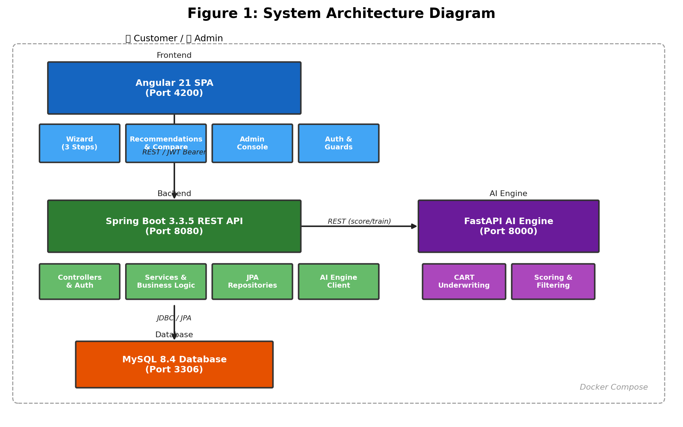
Figure 1: System Architecture Diagram

Acknowledgements
I would like to express my sincere gratitude to my project supervisor at the Informatics Institute of Technology for their invaluable guidance, constructive feedback, and continuous encouragement throughout the development of this project. Their expertise in software engineering and information systems was instrumental in shaping the direction and quality of this work.
I am also thankful to the academic staff at IIT and the University of Westminster for providing a rigorous curriculum that equipped me with the knowledge and skills necessary to undertake a project of this scope and complexity.
Special thanks go to my family and friends for their unwavering support and patience during the demanding phases of development and documentation. Their encouragement kept me motivated to deliver the best possible outcome.
Finally, I acknowledge the open-source communities behind Angular, Spring Boot, FastAPI, and the numerous libraries used in this project, whose contributions made rapid development possible.

Table of Contents
[Right-click and select ‘Update Field’ in Microsoft Word to auto-generate the Table of Contents]
Press F9 or right-click → Update Field to populate this Table of Contents

List of Figures
Figure No. | Title
Figure 1 | System Architecture Diagram
Figure 2 | Fishbone (Ishikawa) Diagram – Insurance Advisory Problems
Figure 3 | Onion Model – Stakeholder View
Figure 4 | High-Level Architecture Diagram
Figure 5 | Use Case Diagram
Figure 6 | Class Diagram – Backend Entity Model
Figure 7 | Sequence Diagram – Get Insurance Recommendations
Figure 8 | Entity-Relationship Diagram
Figure 9 | Wizard Step 1 – Personal Information
Figure 10 | Wizard Step 2 – Financial Information
Figure 11 | Wizard Step 3 – Insurance Preferences
Figure 12 | Recommendations View
Figure 13 | Product Comparison View
Figure 14 | Proposal Upload View
Figure 15 | Admin Dashboard
Figure 16 | Admin Training Management
Figure 17 | Admin Logs Viewer
Figure 18 | Customer Chat Interface

List of Tables
Table No. | Title
Table 1 | Technology Stack Summary
Table 2 | Functional Requirements
Table 3 | Non-Functional Requirements
Table 4 | JPA Entity Summary
Table 5 | AI Scoring Weight Parameters
Table 6 | Persistent vs Ephemeral Data Classification
Table 7 | Test Plan – Features to Be Tested
Table 8 | Test Cases
Table 9 | Glossary of Terms

1 Project Overview
Insurance University is a web-based, AI-driven insurance recommendation platform designed to modernise the way individuals in Sri Lanka discover, evaluate, and apply for insurance products. The platform replaces the traditional broker-mediated advisory process with a guided digital experience that captures a customer’s personal, financial, and lifestyle information through a structured multi-step wizard, then leverages an artificial intelligence scoring engine to produce personalised, ranked product recommendations with transparent explanations.
The system is architected as a set of loosely coupled microservices: an Angular single-page application provides the user interface for both customer and administrator journeys; a Spring Boot RESTful API manages authentication, session orchestration, product catalogues, eligibility rules, and audit logging; a FastAPI-based AI engine executes a multi-stage scoring pipeline that includes CART-based underwriting checks, collaborative filtering heuristics, premium estimation, affordability analysis, and lapse-risk prediction; and a MySQL relational database persists all transactional and reference data.
Beyond the customer-facing recommendation journey, Insurance University provides a comprehensive administration console that enables insurance product managers to maintain the product catalogue, define eligibility rules, upload historical policy outcome datasets for AI model training, promote trained models into production, monitor system-wide event logs, and track unmatched customer needs to inform future product development. The platform thus serves as both an operational tool for insurance distribution and a strategic analytics asset for product innovation.

2 The Purpose of the Project

2a The User Business or Background of the Project Effort
The insurance industry in Sri Lanka, regulated by the Insurance Regulatory Commission of Sri Lanka (IRCSL), comprises over 25 licensed insurance companies offering a broad spectrum of life, health, and general insurance products. Despite this breadth of supply, insurance penetration in Sri Lanka remains below 2% of GDP—significantly lower than regional peers such as India (3.7%) and Malaysia (4.8%) (Swiss Re Institute, 2023). A primary barrier to higher penetration is the reliance on agent-led distribution, where customers must schedule face-to-face meetings with insurance advisors who manually assess needs, explain product features, and complete paper-based proposal forms.
This traditional process presents several inefficiencies: customers receive recommendations that may be influenced by agent commission structures rather than objective suitability; the absence of a standardised assessment framework means that two advisors may recommend different products for identical customer profiles; customers lack visibility into how recommendations are derived, undermining trust; and the manual, document-intensive proposal process creates friction that deters younger, digitally native demographics.
Insurance University is conceived as a digital-first alternative that addresses these pain points. The platform enables a customer to complete the entire insurance discovery and application process online—from initial data capture through to receiving AI-generated recommendations, comparing products side by side, uploading KYC documents, and submitting a proposal—without requiring any human intermediary. The system’s scoring logic is transparent, explainable, and free from commission bias, thereby fostering customer trust and enabling informed decision-making.
The administrative stakeholder (insurance company product manager or underwriting team) uses the platform’s admin console to manage the product catalogue, define underwriting rules, upload training data to refine the AI model, and monitor customer interaction patterns. This dual-purpose design ensures that the platform delivers value to both the demand side (customers seeking suitable insurance) and the supply side (insurers seeking efficient, data-driven distribution).

2b Goals of the Project
Aim
To design, develop, and evaluate an AI-powered web-based insurance recommendation platform that automates personalised insurance product assessment, providing Sri Lankan consumers with transparent, explainable, and bias-free product recommendations through a guided digital journey.
Objectives
- Design and implement a multi-step wizard interface that captures customer personal, financial, and lifestyle data in a structured, user-friendly format.
- Develop an AI scoring engine incorporating CART-based underwriting rules and collaborative filtering heuristics to rank insurance products by suitability, affordability, and risk alignment.
- Implement a trainable model architecture that enables administrators to upload historical policy outcome data and retrain the scoring engine to improve recommendation accuracy over time.
- Build a role-based administration console for managing insurance products, eligibility rules, training datasets, AI model versions, event logs, and customer insight analytics.
- Provide real-time premium estimation with transparent breakdowns, affordability scoring, and lapse probability prediction to support informed customer decision-making.
- Implement a secure KYC document upload workflow with version tracking and document reuse capabilities to streamline the proposal submission process.
- Deliver the system as a containerised three-tier microservices architecture (Angular, Spring Boot, FastAPI) deployable via Docker Compose for consistent development, testing, and production environments.

3 The Scope of the Work

3a The Current Situation and Context
The current insurance advisory process in Sri Lanka operates predominantly through a network of licensed insurance agents and brokers. A typical customer journey involves the following steps: the customer contacts an agent (often through a referral or walk-in visit); the agent conducts a verbal needs assessment; the agent manually selects one or two products from a printed product brochure; the customer receives a paper proposal form; the customer gathers supporting documents (NIC copies, medical reports, income certificates) and submits them physically; and the insurer’s underwriting team reviews the application over a period of days to weeks.
The sub-problems identified in this traditional process are as follows:
Problem 1 – Lack of Objective Assessment: Agent recommendations may be influenced by commission incentives rather than genuine product suitability. Customers have no independent mechanism to verify whether a recommended product aligns with their risk profile and financial capacity.
Problem 2 – Inconsistent Recommendations: Different agents may recommend entirely different products for identical customer profiles, as there is no standardised scoring framework applied consistently across advisors.
Problem 3 – Opaque Pricing and Suitability Logic: Customers are unable to understand how premiums are calculated or why a particular product was recommended. This opacity undermines trust and discourages uptake.
Problem 4 – Manual, Document-Heavy Process: The paper-based proposal submission requires multiple physical visits and document handling, creating friction and delays that deter potential customers.
Problem 5 – Limited Data-Driven Product Development: Insurers lack systematic visibility into customer needs that go unmet by their current product portfolio, missing opportunities for product innovation.
Problem 6 – No Audit Trail or Analytics: Traditional advisory interactions are unrecorded, making it impossible to analyse customer journeys, identify drop-off points, or measure recommendation effectiveness.
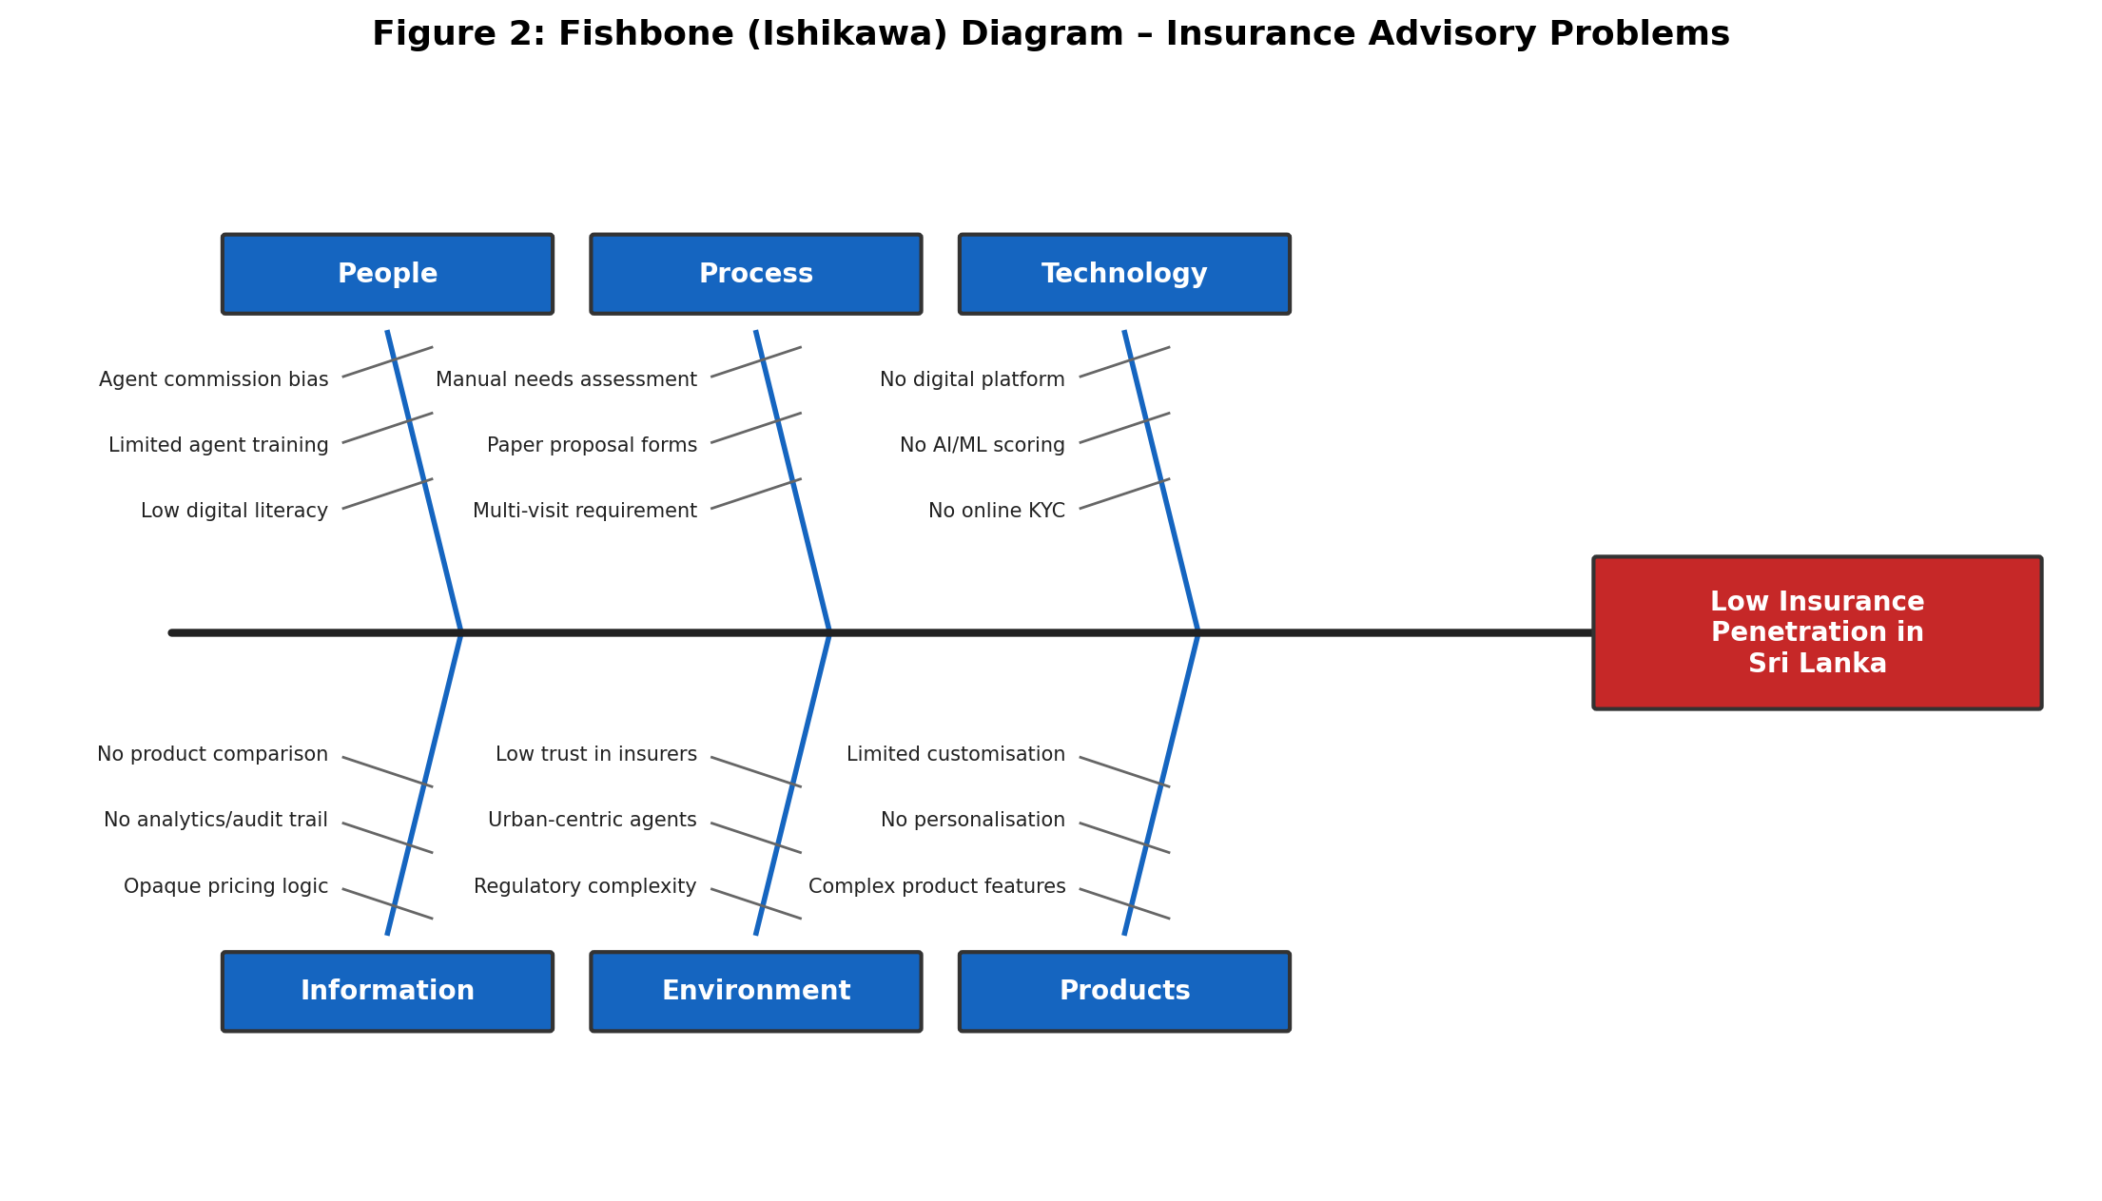
Figure 2: Fishbone (Ishikawa) Diagram – Insurance Advisory Problems
The fishbone diagram above illustrates the root causes of low insurance penetration in Sri Lanka, categorised across six dimensions: People (agent bias, limited training), Processes (manual assessment, paper proposals), Technology (no digital platform, no AI scoring), Information (opaque pricing, no analytics), Environment (regulatory complexity, low digital literacy), and Products (limited customisation, complex feature sets).

3b Competing Products – Related Work
Several existing platforms address aspects of the insurance recommendation problem, though none provides the complete end-to-end solution that Insurance University targets. The following table summarises key competitors and their capabilities:
PolicyBazaar (India)
PolicyBazaar is India’s largest insurance aggregator platform, offering comparison tools across life, health, motor, and travel insurance. It provides premium calculators and allows users to purchase policies online. However, its recommendation engine relies primarily on rule-based filters rather than AI-driven scoring, and it does not incorporate underwriting logic or affordability analysis into its product ranking. The platform is not localised for the Sri Lankan market.
Coverfox (India)
Coverfox offers a similar aggregation model with a focus on health and motor insurance. It provides a chatbot-assisted advisory flow but lacks explainable AI scoring, premium breakdown transparency, and KYC document management within the platform.
AIA Sri Lanka Digital Portal
AIA’s digital portal allows existing policyholders to view policy details and make payments online. However, it does not offer a product recommendation engine, wizard-based data capture, or any AI-driven advisory capability. New customer acquisition remains agent-driven.
Ceylinco Life Mobile App
Ceylinco Life’s mobile application provides policy servicing features for existing customers but does not support product discovery or recommendation. The app focuses on claims tracking, premium payment reminders, and policy document access.
Insurance University differentiates itself from these competitors through: (a) a multi-stage AI scoring pipeline that combines underwriting rules with collaborative filtering and trainable weights; (b) transparent, explainable recommendations with detailed premium breakdowns; (c) an integrated KYC document upload and version management workflow; (d) an administration console with AI model lifecycle management; and (e) localisation for the Sri Lankan insurance market with LKR-denominated calculations and IRCSL-aligned product structures.

4 Stakeholders
The stakeholder analysis for Insurance University is presented using the Onion Model (Alexander & Robertson, 2004), which classifies stakeholders into concentric layers based on their proximity to the system.
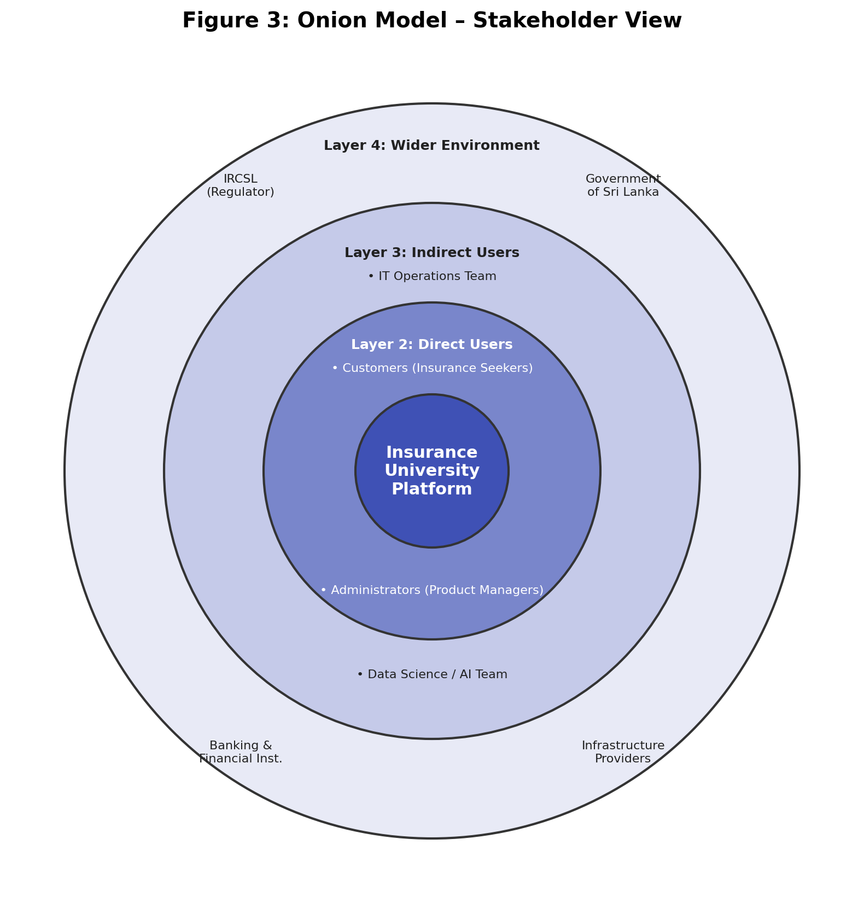
Figure 3: Onion Model – Stakeholder View
Layer 1 – The Product (Innermost)
The system itself: the Angular frontend, Spring Boot backend, FastAPI AI engine, and MySQL database. All components must function correctly and interact seamlessly.
Layer 2 – Direct Users
- Customers (Insurance Seekers): End-users who complete the wizard, receive recommendations, compare products, and submit proposals. They interact directly with the frontend.
- Administrators (Product Managers / Underwriters): Insurance company staff who manage products, rules, training data, and models through the admin console.
Layer 3 – Indirect Users and Operators
- IT Operations Team: Responsible for deploying, monitoring, and maintaining the Docker Compose infrastructure, database backups, and log management.
- Data Science / AI Team: Responsible for preparing training datasets, evaluating model performance, and deciding when to promote new models.
Layer 4 – The Wider Environment
- Insurance Regulatory Commission of Sri Lanka (IRCSL): The regulatory body whose guidelines govern product definitions, underwriting standards, and consumer protection requirements.
- Government of Sri Lanka: Policy-makers interested in increasing insurance penetration and financial inclusion through digital platforms.
- Banking and Financial Institutions: Potential partners for premium payment integration and customer referral pipelines.
- Device and Infrastructure Providers: Cloud hosting providers, browser vendors, and mobile device manufacturers whose platforms the system runs on.

5 Constraints

5a Implementation Environment of the Current System
Insurance University is designed as a locally deployable, containerised application stack. The implementation environment comprises the following components:
Table 1: Technology Stack Summary
Component | Technology | Version | Port
Frontend SPA | Angular + Angular Material + Tailwind CSS | Angular 21 | 4200
Backend API | Spring Boot (Java, Maven) | 3.3.5 / Java 17 | 8080
AI Engine | FastAPI + Uvicorn + Pydantic | Python 3.11+ | 8000
Database | MySQL | 8.4 | 3306
Orchestration | Docker Compose | Latest | —
Authentication | JWT (JJWT library, HMAC-SHA256) | — | —

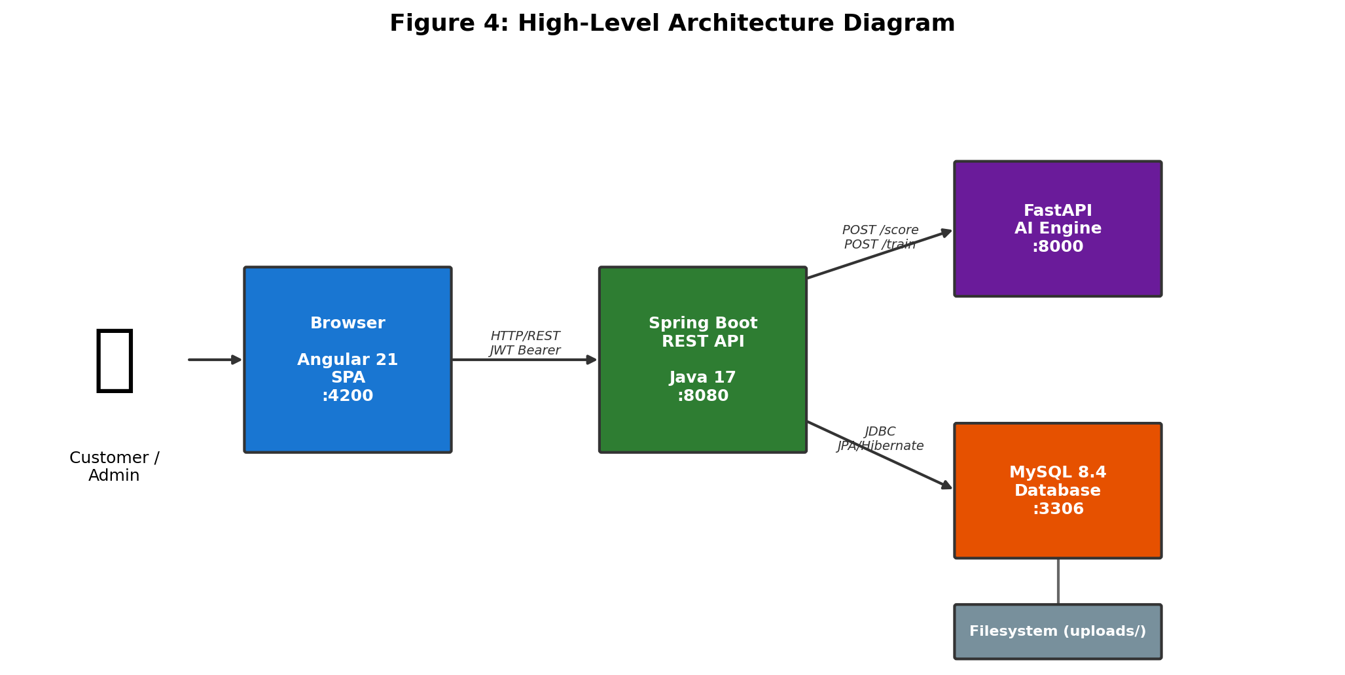
Figure 4: High-Level Architecture Diagram
The architecture follows a three-tier pattern. The Angular SPA communicates with the Spring Boot API via REST over HTTP, attaching JWT Bearer tokens for authenticated routes. The Spring Boot API communicates with the FastAPI AI engine via REST for scoring and training operations. The MySQL database stores all persistent data including user accounts, customer sessions, answers, documents, products, rules, logs, and model metadata. The AI engine persists trained model artefacts as JSON files on the local filesystem.
For local development, Docker Compose orchestrates MySQL and the AI engine as containerised services, while the backend and frontend are run natively using Maven and Angular CLI respectively. The full stack can also be run entirely via Docker Compose for integration testing.

5b Partner or Collaborative Applications
In its current prototype state, Insurance University operates as a self-contained system without external API integrations. However, the architecture is designed to accommodate future integrations with the following partner systems:
- Payment Gateway (e.g., PayHere, LankaPay): For online premium payment collection during the proposal submission stage.
- IRCSL Regulatory API: For automated product registration validation and compliance reporting.
- Hospital Information Systems: For automated retrieval of medical records to streamline the KYC verification process.
- National Identity Verification Service: For automated NIC validation and identity confirmation using OCR or government APIs.
- Email/SMS Notification Service: For customer notifications regarding recommendation availability, document upload reminders, and policy status updates.

II Requirements

6 Product Use Cases

6a Use Case Diagrams
The system supports two primary actors: Customer and Administrator. The Customer actor interacts with the public-facing journey (registration, wizard completion, recommendation viewing, product comparison, document upload, and proposal submission). The Administrator actor interacts with the back-office console (product management, rule management, training dataset upload, model lifecycle management, log analysis, and unmatched needs tracking).
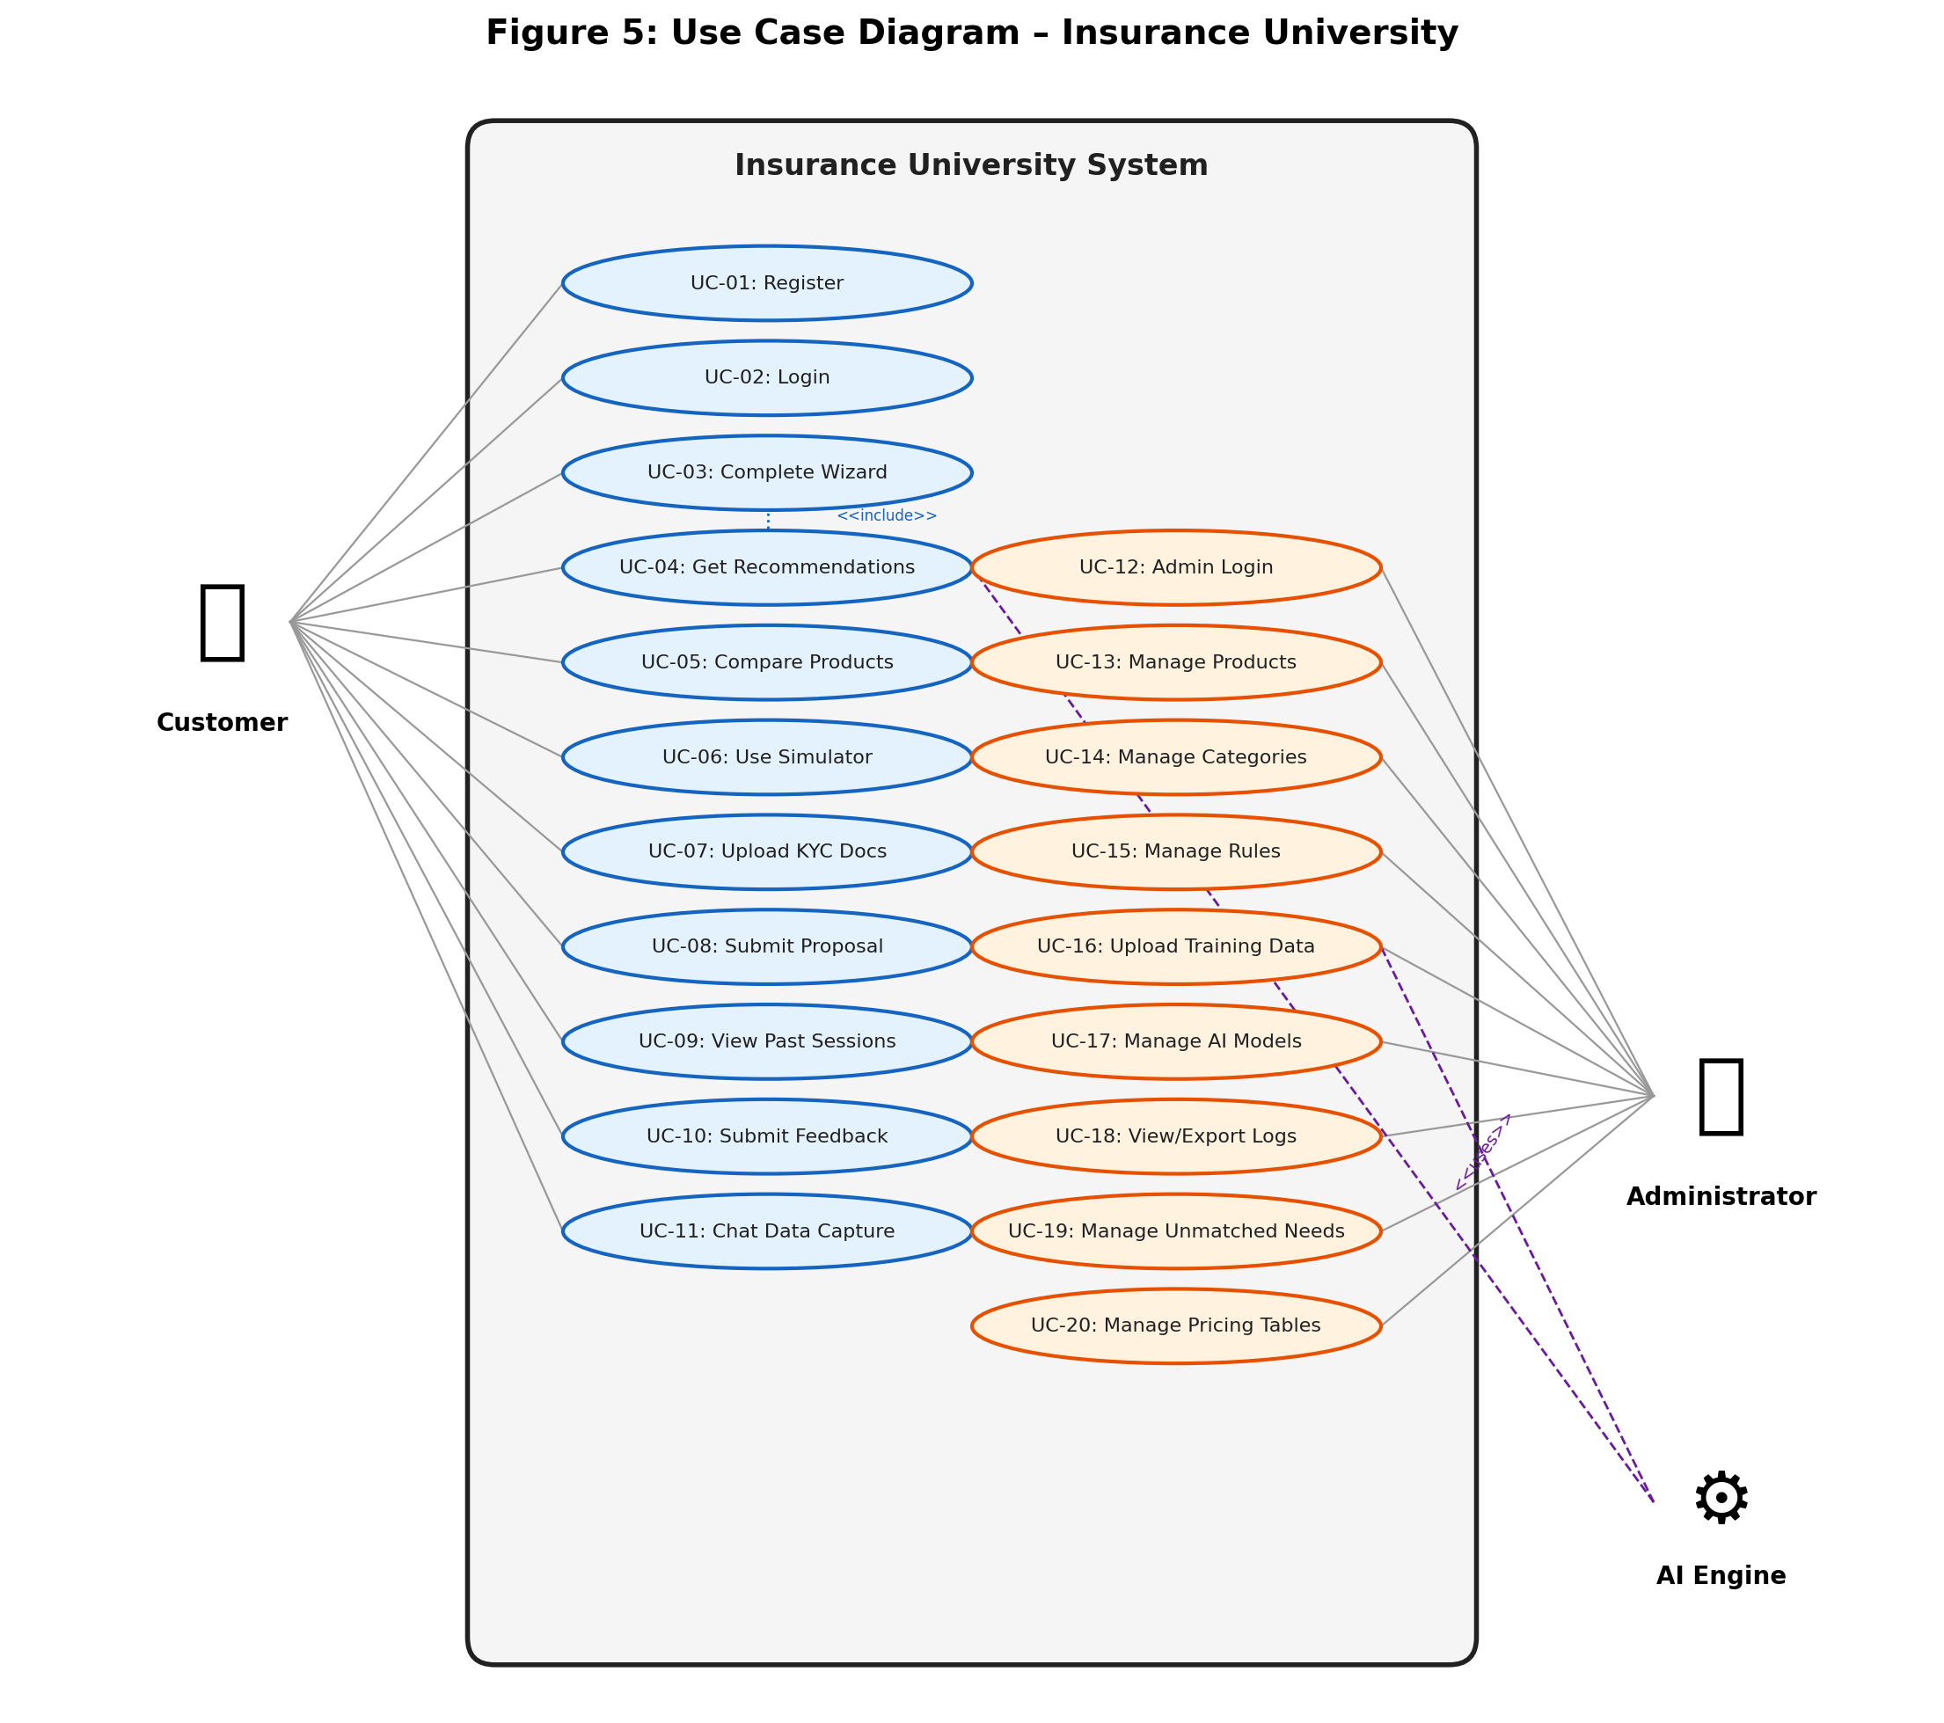
Figure 5: Use Case Diagram
The use case diagram illustrates the following use cases grouped by actor:
Customer Use Cases:
- UC-01: Register Account
- UC-02: Login to Platform
- UC-03: Complete Wizard (Step 1 – Personal, Step 2 – Financial, Step 3 – Preferences)
- UC-04: Get Insurance Recommendations
- UC-05: Compare Recommended Products
- UC-06: Use Premium Simulator
- UC-07: Upload KYC Documents
- UC-08: Review and Submit Proposal
- UC-09: View Past Sessions and Recommendations
- UC-10: Submit Feedback Survey
- UC-11: Chat-Based Data Capture (Alternative Wizard)
Administrator Use Cases:
- UC-12: Admin Login
- UC-13: Manage Insurance Products (CRUD)
- UC-14: Manage Insurance Categories
- UC-15: Manage Eligibility Rules (CRUD)
- UC-16: Upload Training Dataset
- UC-17: Manage AI Model Versions
- UC-18: View and Export Event Logs
- UC-19: Manage Unmatched Customer Needs
- UC-20: Manage Pricing Tables

6b Individual Product Use Cases
Use Case 1: Get Insurance Recommendations (UC-04)
Element | Description
Use Case ID | UC-04
Use Case Name | Get Insurance Recommendations
Primary Actor | Customer
Preconditions | 1. Customer is registered and logged in.  2. Customer has an active session.  3. Customer has completed Wizard Steps 1, 2, and 3 (all answers saved).
Main Success Scenario | 1. Customer completes Wizard Step 3 and clicks ‘Get Recommendations’.  2. Frontend sends POST /api/customer/sessions/{sessionId}/recommendations.  3. Backend retrieves all saved answers for the session.  4. Backend deserialises answer values and builds a feature map.  5. Backend retrieves all active products from the database.  6. Backend applies eligibility rules (age gates, smoker constraints, effective dates) to filter products.  7. Backend serialises filtered products and features into a scoring request.  8. Backend calls AiEngineClient.score() → POST /score on AI engine.  9. AI engine runs CART underwriting for each product (age, diseases, clinical history, PEP/criminal).  10. AI engine calculates suitability score (0.0–1.0) using collaborative filtering heuristics.  11. AI engine calculates monthly premium estimate, affordability score, and lapse probability.  12. AI engine predicts recommended coverage amount based on protection purpose.  13. AI engine ranks products by score descending and generates follow-up questions.  14. Backend persists full request/response as a RecommendationRunEntity (audit trail).  15. Backend writes RECOMMENDATIONS_FETCHED event to session log.  16. Backend returns ranked products and follow-up questions to frontend.  17. Frontend displays ranked product cards with scores, premiums, reasons, and eligibility status.
Alternative Flows | A1. AI Engine Unavailable: Backend returns 503 with error message; frontend shows retry option.  A2. No Eligible Products: All products filtered by eligibility rules; AI engine receives empty list; response returns empty rankedProducts array; frontend shows ‘no matching plans’ message.  A3. Underwriting Rejection: CART rules return ‘No Offer’ for all products; frontend displays ineligibility reasons.
Postconditions | 1. RecommendationRunEntity persisted with full request/response JSON.  2. SessionLogEntity created with event type RECOMMENDATIONS_FETCHED.  3. Customer can view and compare recommended products.
Non-Functional Requirements | Response time < 5 seconds for typical scoring (5 products).  Scoring must be deterministic for the same input.

Use Case 2: Upload Training Dataset and Train Model (UC-16 + UC-17)
Element | Description
Use Case ID | UC-16 / UC-17
Use Case Name | Upload Training Dataset and Train AI Model
Primary Actor | Administrator
Preconditions | 1. Administrator is logged in with ADMIN role.  2. A valid CSV file in policy-recommendation-v2 format is available.  3. AI engine service is running and healthy.
Main Success Scenario | 1. Administrator navigates to Admin → Training page.  2. Administrator clicks ‘Upload Dataset’ and selects a CSV file.  3. Frontend sends POST /api/admin/training/datasets with multipart form data.  4. Backend validates CSV format: checks for required columns (product_code, category_code, subcategory_code, policy_type, eligibility, outcome_score, age, smoker, income, monthlyexpenseslkr, networthlkr, conditions_count).  5. Backend stores CSV file in uploads/ directory with UUID-prefixed filename.  6. Backend creates DatasetMetaEntity with file metadata.  7. Backend calls AiEngineClient.train() → POST /train on AI engine with CSV file.  8. AI engine parses CSV rows and groups by attributes (age buckets, smoker status, product, category).  9. AI engine calculates average outcome_score per group and derives weight adjustments.  10. AI engine generates policy adjustment deltas per product/category/subcategory.  11. AI engine persists model artefact as JSON file in data/models/ directory.  12. AI engine returns training summary (rowsProcessed, updatedWeights, modelArtifactId).  13. Backend creates ModelVersionEntity linked to the dataset.  14. Backend returns combined response to frontend.  15. Administrator views training results and clicks ‘Promote’ to activate the new model.  16. Backend calls POST /models/{artifactId}/activate on AI engine.  17. AI engine loads the specified model artefact as the active scoring model.
Alternative Flows | A1. Invalid CSV Format: Backend or AI engine rejects file; error message returned.  A2. Training Failure: AI engine returns error; Backend returns 500; admin sees error notification.  A3. Retrain from Existing Dataset: Admin clicks ‘Retrain’ on a previously uploaded dataset; backend re-submits stored file to AI engine.
Postconditions | 1. DatasetMetaEntity persisted with file metadata.  2. ModelVersionEntity created and optionally promoted to active.  3. AI engine uses updated weights for subsequent scoring calls.
Non-Functional Requirements | Training should complete within 30 seconds for datasets up to 10,000 rows.  Model artefacts must be persisted for auditability.

7 Functional Requirements
The following table presents the functional requirements of Insurance University, cross-referenced with the use cases they support.
Table 2: Functional Requirements
ID | Requirement | Priority | Related UC
FR-01 | The system shall allow customers to register with name, email, and password. | Must | UC-01
FR-02 | The system shall authenticate customers using JWT tokens with 24-hour expiry. | Must | UC-02
FR-03 | The system shall provide a multi-step wizard (3 steps) for capturing customer data. | Must | UC-03
FR-04 | Step 1 shall capture personal data: age, smoker status, medical conditions, dependents. | Must | UC-03
FR-05 | Step 2 shall capture financial data: monthly income, expenses, net worth, occupation hazard. | Must | UC-03
FR-06 | Step 3 shall capture preferences: protection purpose, desired coverage, policy term, priority sliders. | Must | UC-03
FR-07 | The system shall persist wizard answers as JSON key-value pairs per session. | Must | UC-03
FR-08 | The system shall generate ranked product recommendations using an AI scoring engine. | Must | UC-04
FR-09 | Recommendations shall include suitability score, monthly premium, affordability score, and reasons. | Must | UC-04
FR-10 | The system shall apply eligibility rules to filter products before AI scoring. | Must | UC-04
FR-11 | The system shall allow side-by-side comparison of selected recommended products. | Should | UC-05
FR-12 | The system shall provide a premium simulator for what-if analysis. | Should | UC-06
FR-13 | The system shall allow customers to upload KYC documents (NIC, medical, income proof). | Must | UC-07
FR-14 | Document uploads shall support versioning with latest-version pointers. | Should | UC-07
FR-15 | The system shall allow customers to review and complete proposal submissions. | Must | UC-08
FR-16 | The system shall allow customers to view past sessions and recommendation history. | Should | UC-09
FR-17 | The system shall provide CRUD operations for insurance products via admin console. | Must | UC-13
FR-18 | The system shall provide CRUD operations for eligibility rules via admin console. | Must | UC-15
FR-19 | The system shall allow administrators to upload CSV training datasets. | Must | UC-16
FR-20 | The system shall automatically trigger AI model training upon dataset upload. | Must | UC-16
FR-21 | The system shall allow administrators to promote trained models to active status. | Must | UC-17
FR-22 | The system shall provide searchable, filterable, and exportable event logs. | Should | UC-18
FR-23 | The system shall track unmatched customer needs for product gap analysis. | Should | UC-19
FR-24 | The system shall persist full AI request/response payloads for audit trail. | Must | UC-04
FR-25 | The system shall hash session identifiers (SHA-256) before writing to event logs. | Must | UC-18

8 Data Requirements
Insurance University manages a rich data model comprising 15 JPA entities that capture user identity, customer journey state, product catalogues, eligibility rules, AI model metadata, and audit logs. The following table summarises the core entities and their primary data attributes.
Table 4: JPA Entity Summary
Entity | Table Name | Key Fields | Relationships
UserEntity | users | id, name, email (unique), passwordHash, role (USER/ADMIN), createdAt | —
CustomerSessionEntity | customer_sessions | id (UUID), status, userEmail, createdAt, updatedAt | 1:N Answers, Documents, Runs, Chat
CustomerAnswerEntity | customer_answers | id, sessionId (FK), key, valueJson (JSON), createdAt | N:1 Session
CustomerDocumentEntity | customer_documents | id, sessionId, userEmail, docType, docSide, storedPath, versionNo, latestForSession | N:1 Session
CustomerChatMessageEntity | customer_chat_messages | id, sessionId, role (USER/AGENT), message (TEXT), metadataJson | N:1 Session
RecommendationRunEntity | recommendation_runs | id, sessionId, requestJson, responseJson, createdAt | N:1 Session
SessionLogEntity | session_logs | id, sessionHash (SHA-256), timestamp, eventType, userSegment, payloadJson | —
InsuranceCategoryEntity | insurance_categories | id, code, name, description, active, displayOrder | 1:N Subcategories, Products
InsuranceSubcategoryEntity | insurance_subcategories | id, code, name, description, active, category_id (FK) | N:1 Category, 1:N Products
ProductEntity | products | id, code (unique), name, basePremium, tagsJson, eligibilityJson, ridersJson, benefitsJson | N:1 Category, N:1 Subcategory
EligibilityRuleEntity | eligibility_rules | id, name, ruleJson, version, effectiveFrom, effectiveTo | —
DatasetMetaEntity | dataset_meta | id, originalFilename, storedPath, fileSize, formatVersion, trainingGoal | 1:N Models
ModelVersionEntity | model_versions | id, name, description, artifactId, sourceDatasetId (FK), rowsProcessed, active | N:1 Dataset
PricingTableEntity | pricing_tables | id, name, pricingJson, version, effectiveFrom, effectiveTo | —
UnmatchedNeedEntity | unmatched_needs | id, theme, occurrences, sampleAnonymisedText, updatedAt | —

8a Safety, Ethical, and Critical Requirements
Insurance recommendation systems handle sensitive personal and financial data and produce outputs that directly influence financial decisions. The following safety and ethical requirements are therefore critical:
- Non-Discriminatory Scoring: The AI scoring engine must not discriminate based on ethnicity, religion, gender, or other protected characteristics. The scoring pipeline uses only actuarially relevant factors (age, smoker status, health conditions, financial capacity).
- Explainable Recommendations: Every product recommendation must include human-readable reasons explaining why the product was scored highly or poorly. This transparency is essential for customer trust and regulatory compliance.
- Data Minimisation: The system collects only the data necessary for insurance assessment. No unnecessary personal identifiers are stored in event logs (session IDs are hashed with SHA-256).
- Consent-Based Data Handling: Customers can delete their sessions at any time, which removes all associated answers, documents, and recommendation runs. This supports the right to erasure.
- Audit Trail Integrity: All AI scoring calls are persisted with full request and response payloads in the RecommendationRunEntity table, enabling post-hoc review of any recommendation made.
- No Automated Decision-Making: The system provides recommendations, not binding decisions. Final product selection and policy issuance remain human-controlled processes.

9 Security Requirements

9a Access Requirements
Insurance University implements a role-based access control (RBAC) model with two roles: CUSTOMER (USER) and ADMIN. Access is enforced at the API layer through Spring Security’s filter chain and at the frontend through Angular route guards.
- Public Endpoints: Authentication routes (/api/auth/register, /api/auth/login, /api/auth/admin/login) and client-side event logging (/api/logs) are accessible without authentication.
- Customer Endpoints: All /api/customer/** routes require a valid JWT token with USER role. Session-level access control ensures that customers can only access their own sessions, answers, documents, and recommendations.
- Admin Endpoints: All /api/admin/** routes require a valid JWT token with ADMIN role. Admin access is restricted to a single pre-configured administrator account.
- Frontend Guards: Angular route guards (customerAuthGuard, adminGuard, wizardProgressGuard) enforce client-side access control, redirecting unauthenticated users to appropriate login pages.

9b Integrity Requirements
Data integrity is maintained through the following mechanisms:
- Database Integrity: MySQL enforces foreign key constraints between entities (e.g., session → answers, session → documents). JPA’s ddl-auto: update mode manages schema evolution.
- Session Hashing: Customer session identifiers are hashed using SHA-256 before being written to event logs, ensuring that raw session IDs are not exposed in analytics data.
- Document Version Control: Each document upload creates a new version entry with incrementing version numbers. Latest-version pointers (latestForSession, latestForUser) are updated transactionally to prevent inconsistent state.
- Recommendation Audit Trail: Full AI request and response payloads are persisted as JSON in the RecommendationRunEntity table, providing an immutable record of every recommendation generated.
- Input Validation: All API inputs are validated at the controller level using Spring’s @Valid annotations and custom validation logic.

9c Privacy Requirements
Privacy is a core design consideration given the sensitive nature of insurance-related personal and financial data:
- Password Hashing: Customer passwords are hashed using BCrypt before storage. Raw passwords are never persisted or logged.
- Log Redaction: The RequestResponseLoggingFilter automatically redacts sensitive fields (passwords, tokens, authorisation headers) from HTTP request/response logs.
- Session Anonymisation: Event logs use SHA-256 hashed session identifiers rather than raw session UUIDs, preventing direct linkage between analytics data and individual customer sessions.
- Document Access Control: KYC documents can only be downloaded by the customer who uploaded them (verified via JWT email claim against the session’s userEmail).
- Data Deletion: Customers can delete sessions, which cascades to remove all associated answers, documents (both database records and physical files), and recommendation runs.

9d Accessibility Requirements
The frontend is built with Angular Material, which provides built-in accessibility features aligned with WCAG 2.1 Level AA standards:
- Semantic HTML: Angular Material components render semantic HTML elements with appropriate ARIA attributes for screen reader compatibility.
- Keyboard Navigation: All interactive elements (forms, buttons, navigation) are accessible via keyboard-only navigation with visible focus indicators.
- Colour Contrast: Tailwind CSS utilities are used with contrast-compliant colour palettes that meet WCAG AA contrast ratio requirements (4.5:1 for normal text).
- Responsive Design: The application is responsive and functions correctly across desktop, tablet, and mobile viewport sizes.
- Form Validation Feedback: Error messages are associated with form fields using ARIA attributes and are announced by screen readers.

10 Legal Requirements

10a Compliance Requirements
Insurance University must comply with the following legal and regulatory frameworks:
- Personal Data Protection Act (PDPA) of Sri Lanka: The system handles personal data including names, email addresses, financial information, health conditions, and identity documents. Compliance requires: lawful basis for processing (consent through registration), data minimisation, purpose limitation, storage limitation, and the right to erasure (implemented via session deletion).
- Regulation of Insurance Industry Act No. 43 of 2000 (IRCSL): Insurance products offered on the platform must be registered with IRCSL. Product definitions, eligibility criteria, and premium structures must align with the regulator’s published guidelines. The admin console allows authorised administrators to maintain compliant product configurations.
- Computer Crimes Act No. 24 of 2007 (Sri Lanka): The system must implement adequate security measures to prevent unauthorised access to customer data. This is addressed through JWT authentication, RBAC, BCrypt password hashing, and HTTPS (recommended for production deployment).
- Consumer Affairs Authority Act No. 9 of 2003: Product recommendations must be fair, transparent, and not misleading. The explainable AI approach, with visible scoring reasons and premium breakdowns, supports compliance with consumer protection standards.
- Electronic Transactions Act No. 19 of 2006: Digital signatures and electronic records generated by the platform (e.g., proposal summaries, recommendation audit trails) are recognised as valid under Sri Lankan law, supporting the shift from paper-based to digital insurance processes.

III Design

11 Proposed Software Architecture

11a Class Diagrams
The system’s persistent data model comprises 15 JPA entity classes organised across the following domain areas: User Authentication, Customer Journey, Product Catalogue, Rules Engine, Training/Model Management, and Analytics. The complete class diagram with attributes and operations is presented below.
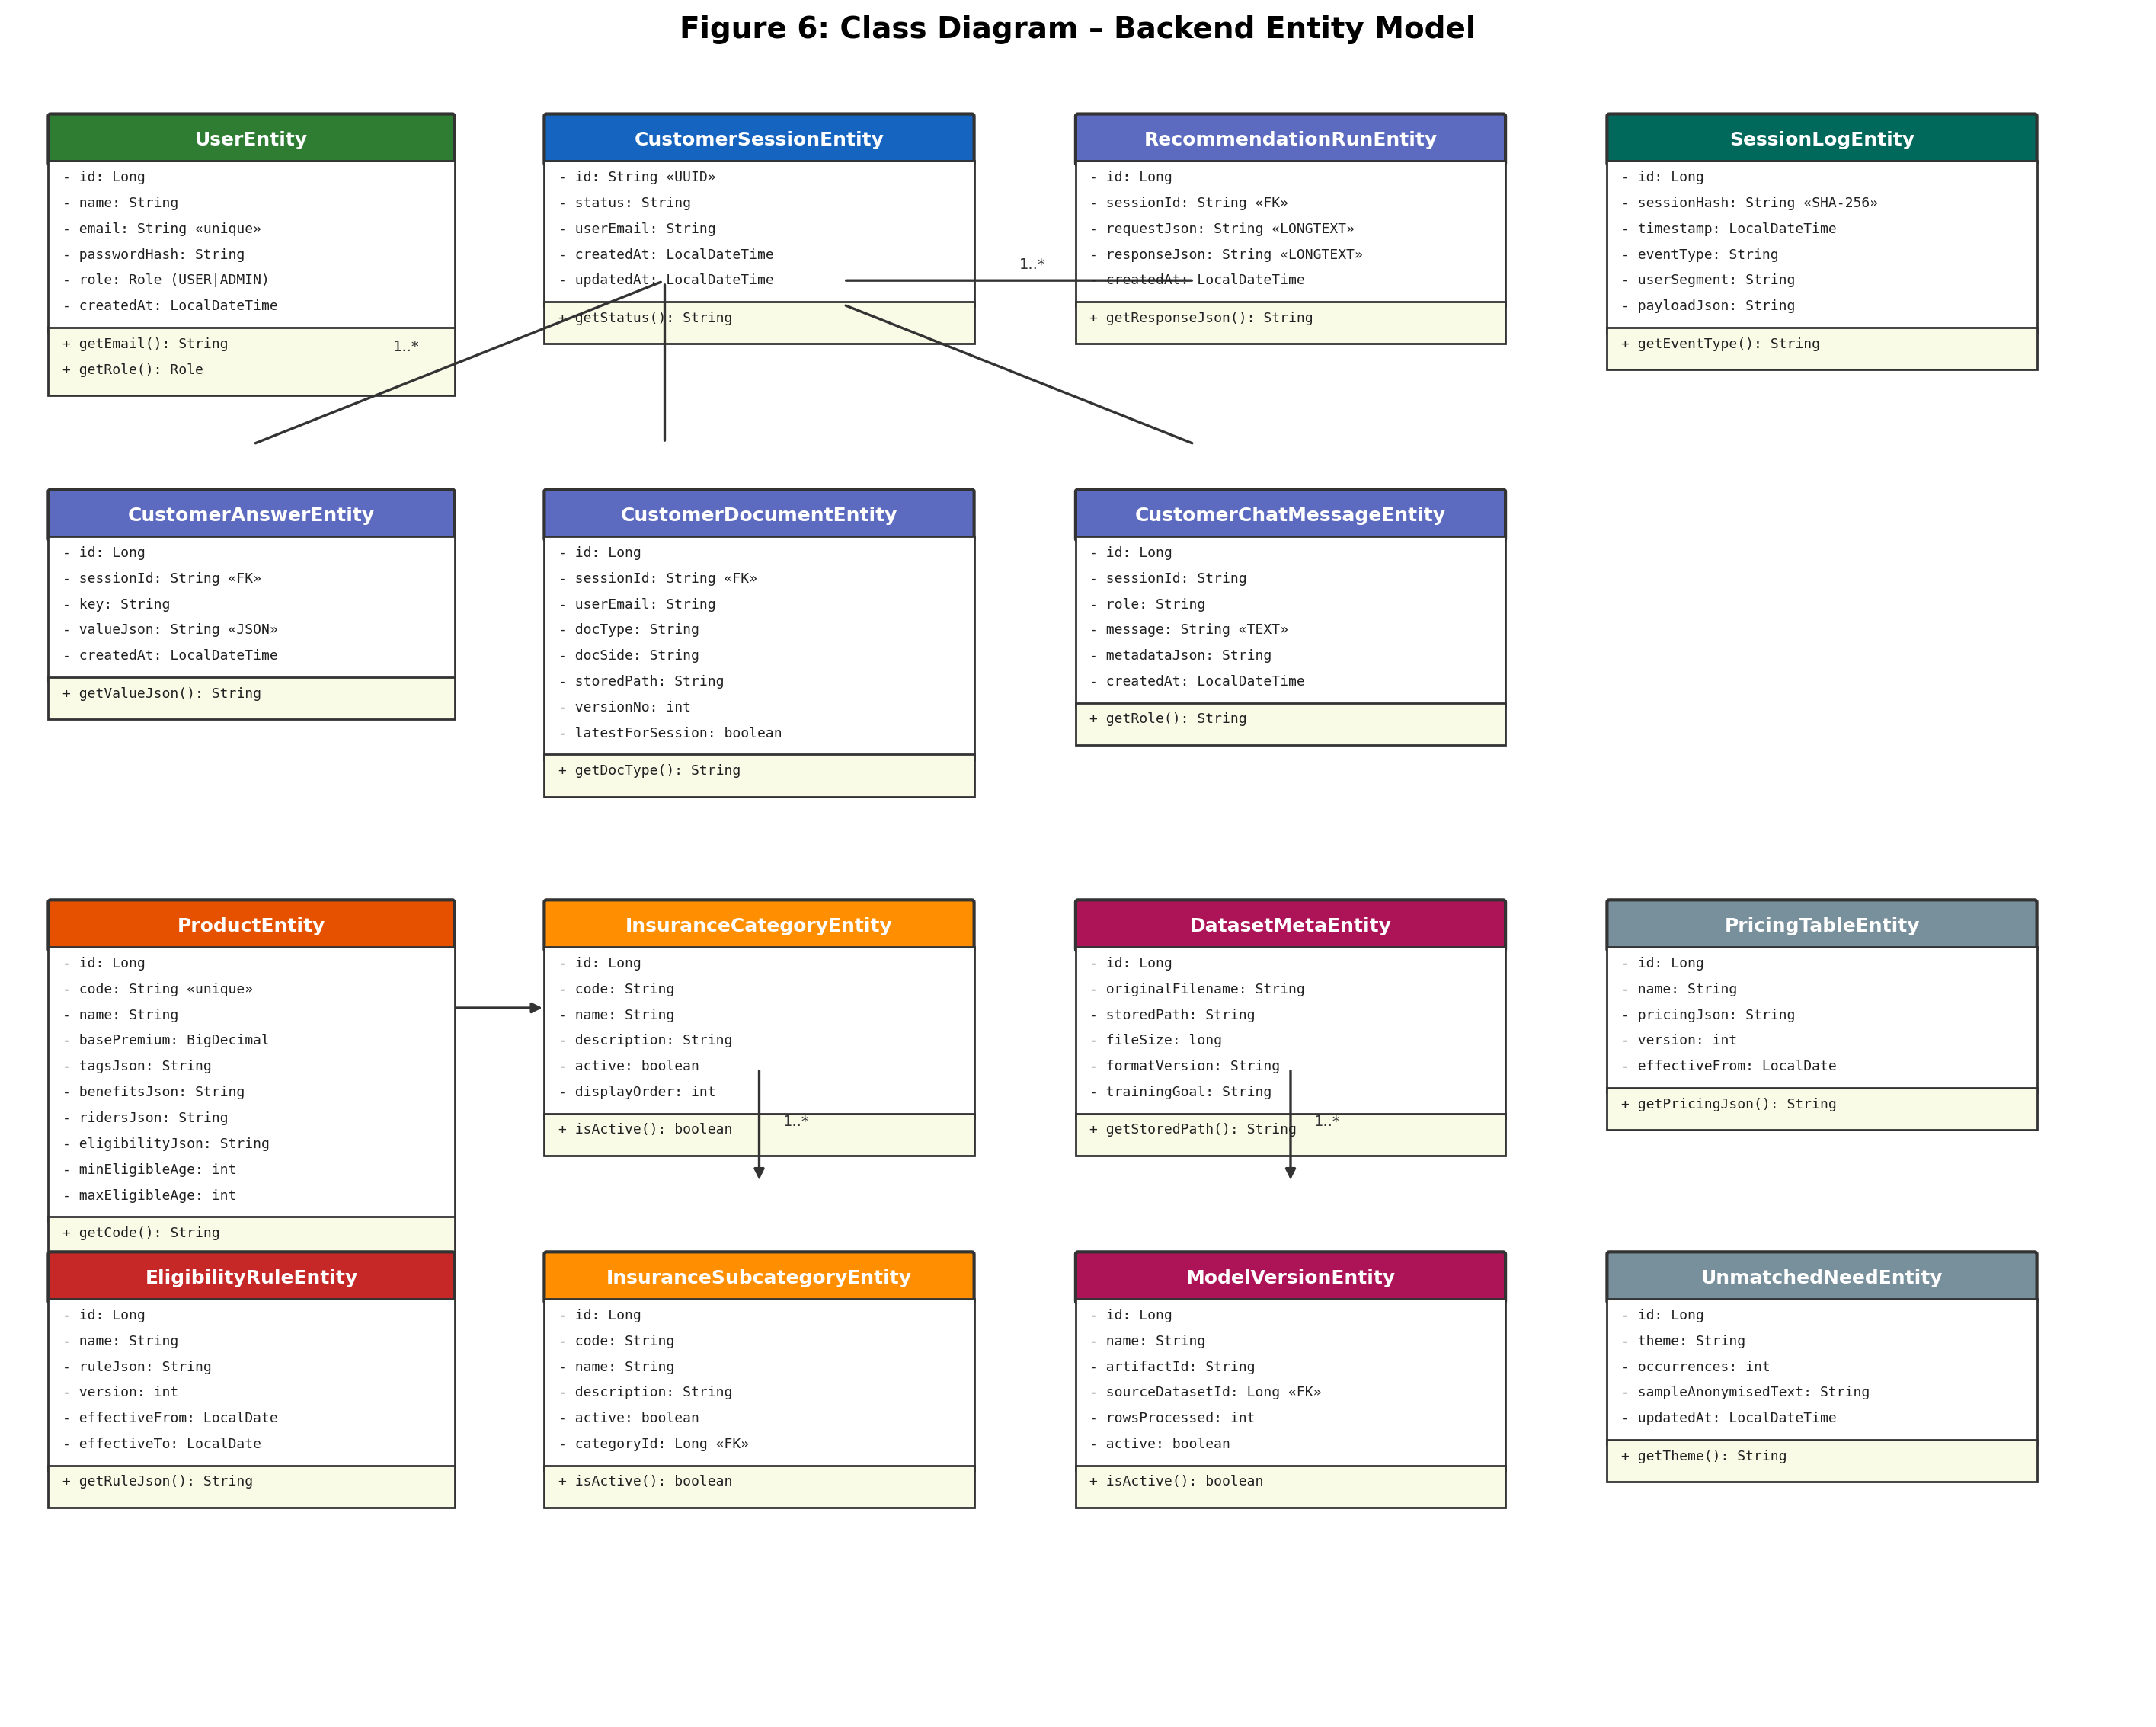
Figure 6: Class Diagram – Backend Entity Model
The key classes and their relationships are as follows:
UserEntity represents the core identity for both customer and administrator users. It contains fields for name, email (unique constraint), passwordHash (BCrypt-encoded), role (enumerated as USER or ADMIN), and createdAt timestamp. Authentication operations (register, login) interact with this entity through the AuthController and AuthService.
CustomerSessionEntity is the central orchestrating entity for the customer journey. Each session has a UUID identifier, a status field (ACTIVE or COMPLETED), and a reference to the customer’s email. It maintains one-to-many relationships with CustomerAnswerEntity (wizard responses), CustomerDocumentEntity (KYC uploads), RecommendationRunEntity (AI scoring results), and CustomerChatMessageEntity (conversational data capture messages).
ProductEntity represents an insurance product within a hierarchical catalogue. It belongs to an InsuranceCategoryEntity (e.g., Life Insurance, Retirement Plans) and an InsuranceSubcategoryEntity (e.g., Protection Plans). Product attributes include code, name, basePremium, tagsJson (array), benefitsJson, ridersJson, eligibilityJson, and age/term constraints (minEligibleAge, maxEligibleAge, minPolicyTermYears, maxPolicyTermYears).
EligibilityRuleEntity stores administrator-defined business rules as JSON objects containing minAge, maxAge, and smokerAllowed constraints. Rules are versioned and have effective date ranges, enabling temporal rule management.
DatasetMetaEntity and ModelVersionEntity together manage the AI model lifecycle. DatasetMetaEntity stores metadata about uploaded training CSV files, while ModelVersionEntity tracks each trained model’s name, artefact identifier, source dataset, row count, and active status. Only one model may be active at any time.
SessionLogEntity provides the immutable event log. Each entry contains a SHA-256 hashed session identifier, timestamp, event type (enumerated), user segment, and a JSON payload. This entity supports the admin log viewer with full-text search and export capabilities.

11b Dynamic Model
The following sequence diagram depicts the end-to-end flow for the ‘Get Insurance Recommendations’ use case (UC-04), the system’s most complex interaction.
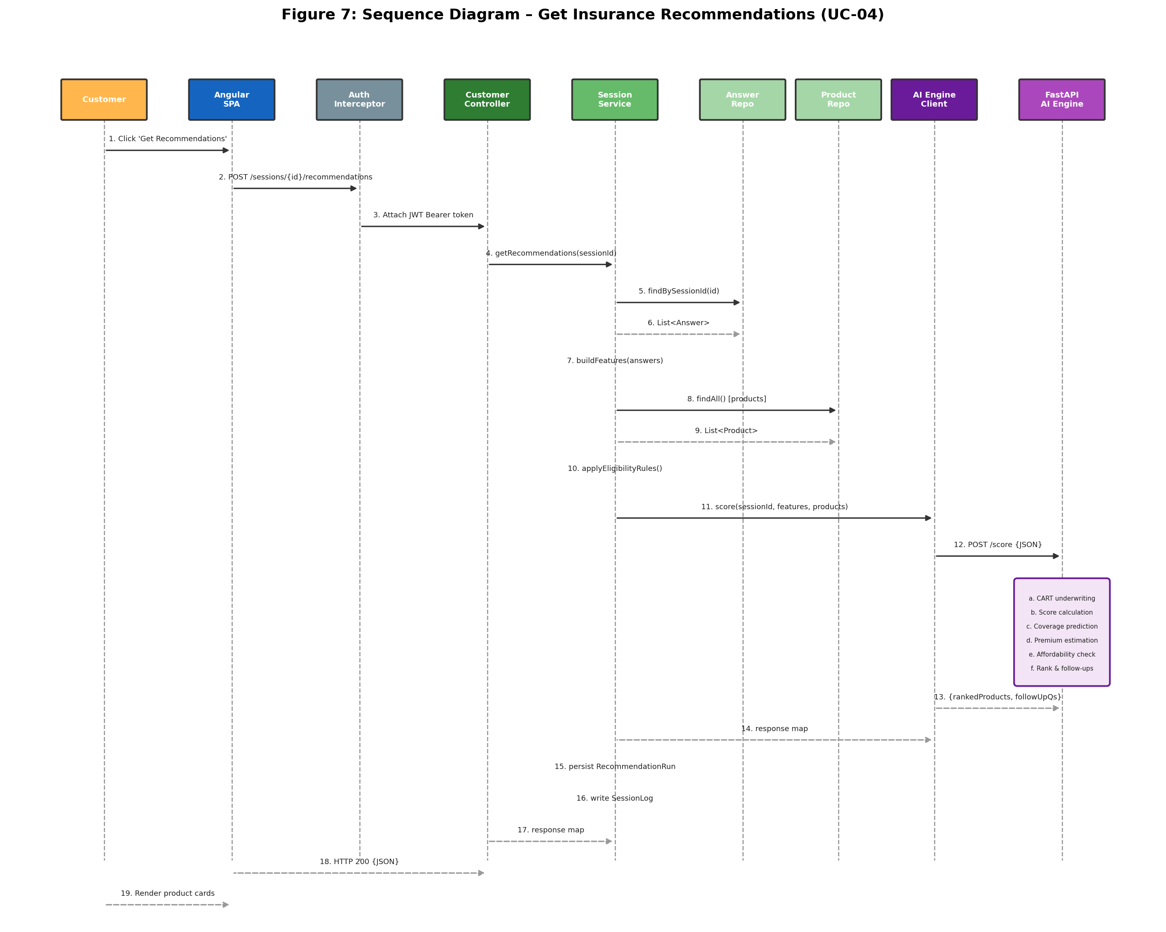
Figure 7: Sequence Diagram – Get Insurance Recommendations
Lifelines:
- Customer (Actor)
- Angular Frontend (SPA)
- CustomerAuthInterceptor
- Spring Boot API (CustomerController)
- CustomerSessionService
- CustomerAnswerRepository
- ProductRepository
- EligibilityRuleRepository
- AiEngineClient
- FastAPI AI Engine
- RecommendationRunRepository
- SessionLogRepository
Sequence of Messages:
- Customer clicks ‘Get Recommendations’ on Step 3 completion screen.
- Angular SPA sends HTTP POST /api/customer/sessions/{sessionId}/recommendations.
- CustomerAuthInterceptor attaches JWT Bearer token to the request header.
- CustomerController receives request and delegates to CustomerSessionService.getRecommendations(sessionId).
- CustomerSessionService calls CustomerAnswerRepository.findBySessionId(sessionId) to retrieve all answers.
- Service deserialises JSON valueJson fields and constructs a feature map (age, smoker, income, expenses, etc.).
- Service calls ProductRepository.findAll() to retrieve all active products.
- Service calls EligibilityRuleRepository.findAll() and filters products by rule constraints (age, smoker, effective dates).
- Service serialises filtered products into a list of product maps with metadata (code, name, basePremium, tags, category, riders, etc.).
- Service calls AiEngineClient.score(sessionId, featureMap, productList).
- AiEngineClient sends HTTP POST /score to FastAPI AI Engine with JSON body.
- AI Engine executes the scoring pipeline:
a. CART underwriting check per product (age gates, disease rules, clinical history, legal checks).
b. Collaborative filtering score calculation (0.0–1.0) per product.
c. Policy type classification per product.
d. Coverage prediction based on protection purpose.
e. Monthly premium calculation with risk multipliers and riders.
f. Affordability scoring and lapse probability estimation.
g. Rank products by score descending.
h. Generate follow-up questions based on data completeness and confidence.
- AI Engine returns JSON response with rankedProducts array and followUpQuestions array.
- AiEngineClient returns the response map to CustomerSessionService.
- Service persists RecommendationRunEntity with requestJson and responseJson.
- Service writes SessionLogEntity with event type RECOMMENDATIONS_FETCHED and hashed sessionId.
- Service returns response map to CustomerController.
- Controller returns HTTP 200 with JSON response body to Angular SPA.
- Angular SPA renders recommendation cards showing score, premium, affordability, reasons, and eligibility for each product.

11c System Model and Decomposition
The system model for Insurance University integrates the functional model (use cases), the object model (class diagram), and the dynamic model (sequence diagrams) into a consistent whole. The following compliance properties are demonstrated:
- Use-Case-Driven Class Identification: Every entity in the class diagram is traceable to one or more use cases. For example, CustomerSessionEntity supports UC-03 (Complete Wizard), UC-04 (Get Recommendations), and UC-07 (Upload Documents). ProductEntity supports UC-13 (Manage Products) and UC-04 (Get Recommendations). ModelVersionEntity supports UC-17 (Manage AI Models).
- Functional Requirement Coverage: The use case diagram captures the functional requirements from the end user’s perspective. Each functional requirement (FR-01 through FR-25) maps to at least one use case, ensuring complete coverage.
- Sequence-Use Case Alignment: The sequence diagram for UC-04 (Get Recommendations) illustrates the runtime flow of a single use case scenario, showing how objects interact at the instance level. This complements the class diagram’s structural view.
- Structural-Dynamic Consistency: Classes appearing in the class diagram (CustomerSessionService, AiEngineClient, ProductRepository, etc.) also appear as lifelines in the sequence diagram, demonstrating that the structural and behavioural models describe the same system.

11d Persistent Data Management
The system manages two categories of data: persistent data that must be stored long-term for operational, audit, and regulatory purposes, and ephemeral data that exists only during transient processes.
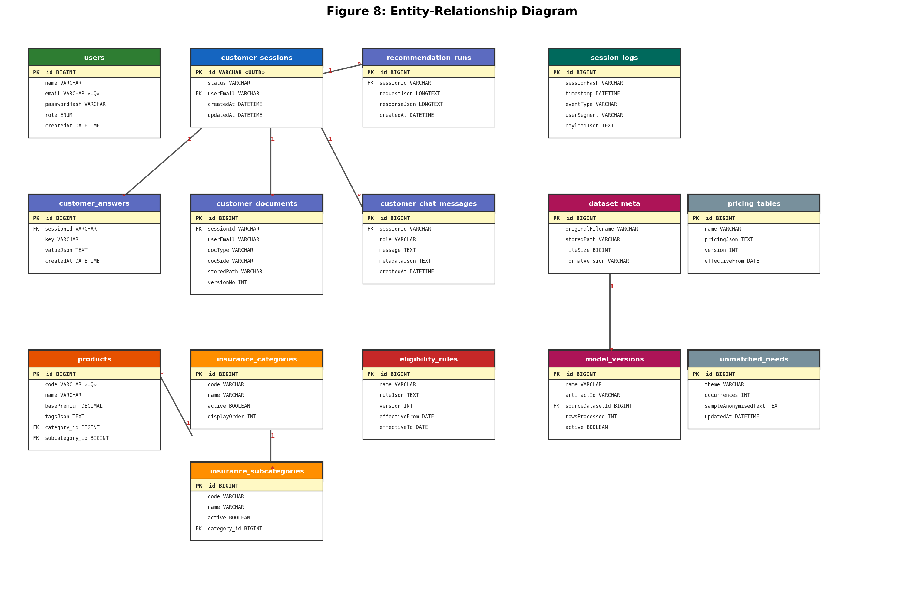
Figure 8: Entity-Relationship Diagram
Table 6: Persistent vs Ephemeral Data Classification
Data Item | Classification | Storage Mechanism | Rationale
User accounts (email, name, passwordHash, role) | Persistent | MySQL (users table) | Required for authentication and identity management
Customer session records | Persistent | MySQL (customer_sessions) | Required for session history and audit trail
Wizard answers (JSON key-value pairs) | Persistent | MySQL (customer_answers) | Required for recommendation input and replay
KYC documents (NIC, medical, income) | Persistent | Filesystem + MySQL metadata | Required for proposal verification and regulatory compliance
Recommendation runs (request/response JSON) | Persistent | MySQL (recommendation_runs) | Required for audit trail and regulatory review
Event logs (hashed session, event type, payload) | Persistent | MySQL (session_logs) | Required for analytics, compliance, and debugging
Insurance products, categories, subcategories | Persistent | MySQL (products, categories) | Reference data for product catalogue
Eligibility rules (JSON rule definitions) | Persistent | MySQL (eligibility_rules) | Business rules for underwriting
Training datasets (CSV files) | Persistent | Filesystem + MySQL metadata | Required for model retraining and audit
Trained model artefacts (JSON weight files) | Persistent | AI engine filesystem (data/models/) | Required for scoring and model version management
Model version records | Persistent | MySQL (model_versions) | Required for model lifecycle governance
Pricing tables | Persistent | MySQL (pricing_tables) | Reference data for premium lookup
Unmatched needs records | Persistent | MySQL (unmatched_needs) | Product gap analysis data
JWT tokens (in-transit) | Ephemeral | HTTP headers (client memory) | Valid for 24 hours; not persisted server-side
Wizard form state (in-progress) | Ephemeral | Angular service (browser memory) | Held in WizardStateService until saved to backend
AI engine runtime weights (in-memory) | Ephemeral | Python process memory | Loaded from persisted model artefact at startup/activation
Shopping cart / selected products for comparison | Ephemeral | Angular service (browser memory) | Held during comparison workflow only
HTTP request/response bodies (in-transit) | Ephemeral | Network layer | Logged selectively by RequestResponseLoggingFilter

12 User Interface
This section presents the key user interface screens of Insurance University, organised by user journey. The frontend is built with Angular 21, Angular Material components, and Tailwind CSS for responsive styling.

Customer Journey Interfaces

Landing Page
The landing page provides an overview of the Insurance University platform with clear call-to-action buttons for starting the wizard or taking a survey. The design emphasises simplicity and trust-building with concise messaging about the AI-powered recommendation process.
[INSERT IMAGE: Figure 9: Landing Page]
Figure: Figure 9: Landing Page

Wizard Step 1 – Personal Information
The first wizard step captures the customer’s personal and health data. Form fields include age (number input), smoker status (toggle), medical conditions (multi-select checkboxes for heart disease, cancer, stroke, kidney disorder, etc.), number of dependents (number input), and children’s ages (comma-separated or individual inputs). Form validation ensures all required fields are completed before proceeding.
[INSERT IMAGE: Figure 9: Wizard Step 1 – Personal Information]
Figure: Figure 9: Wizard Step 1 – Personal Information

Wizard Step 2 – Financial Information
The second wizard step captures financial data including monthly income (LKR), monthly expenses (LKR), net worth (LKR), and occupation hazard level (1–5 slider). Angular Material form fields with currency formatting and validation are used. The wizard progress guard prevents access to Step 2 unless Step 1 is completed.
[INSERT IMAGE: Figure 10: Wizard Step 2 – Financial Information]
Figure: Figure 10: Wizard Step 2 – Financial Information

Wizard Step 3 – Insurance Preferences
The third wizard step captures insurance-specific preferences: protection purpose (dropdown: Survivor Income, Education Funding, Retirement Supplement, Estate Liquidity), desired sum assured (LKR input), desired policy term (years slider), and priority sliders for Safety (1–5) and Equity (1–5). Upon completion, the system automatically triggers the recommendation engine.
[INSERT IMAGE: Figure 11: Wizard Step 3 – Insurance Preferences]
Figure: Figure 11: Wizard Step 3 – Insurance Preferences

Recommendations View
The recommendations view displays AI-generated product cards ranked by suitability score. Each card shows: product name, suitability score (0–100%), monthly premium estimate (LKR), affordability score, eligibility decision (Eligible / No Offer / Referral Required), coverage recommendation (LKR), lapse probability, and a list of human-readable reasons explaining the score. Customers can select products for side-by-side comparison.
[INSERT IMAGE: Figure 12: Recommendations View]
Figure: Figure 12: Recommendations View

Product Comparison View
The comparison view presents two or three selected products in a side-by-side table format. Comparison dimensions include: benefits, riders (with selection checkboxes), premium breakdown (base premium, coverage factor, risk multiplier, rider costs, tax), eligibility constraints, and affordability metrics. The ‘Proceed to Proposal’ button advances the journey.
[INSERT IMAGE: Figure 13: Product Comparison View]
Figure: Figure 13: Product Comparison View

Document Upload View
The document upload interface provides separate upload areas for NIC (front and back), medical report, and income proof. Each upload area shows the current upload status (pending, uploaded, or version number). Drag-and-drop and file browser selection are both supported. Previously uploaded documents (from other sessions) can be reused via the ‘latest user documents’ feature.
[INSERT IMAGE: Figure 14: Proposal Upload View]
Figure: Figure 14: Proposal Upload View

Administrator Journey Interfaces

Admin Dashboard
The admin dashboard provides a summary of key performance indicators: total active sessions, recommendations generated, documents processed, and models trained. A recent activity timeline shows the latest events across the platform.
[INSERT IMAGE: Figure 15: Admin Dashboard]
Figure: Figure 15: Admin Dashboard

Training Management
The training management page is divided into two sections: Datasets (upload CSV, view upload history, retrain from existing dataset) and Models (view trained models, active model indicator, promote model to active). Upload metadata includes file name, size, format version, upload date, and training results (rows processed, updated weights, skipped rows).
[INSERT IMAGE: Figure 16: Admin Training Management]
Figure: Figure 16: Admin Training Management

Log Viewer
The log viewer provides a searchable, filterable table of system events. Filters include date range (from/to date pickers), event type (dropdown: SESSION_CREATED, ANSWERS_SUBMITTED, RECOMMENDATIONS_FETCHED, DOCUMENT_UPLOADED, SESSION_DELETED, SESSION_COMPLETED), session hash (text input), and user segment (text input). Export buttons allow downloading filtered results as CSV or JSON.
[INSERT IMAGE: Figure 17: Admin Logs Viewer]
Figure: Figure 17: Admin Logs Viewer

Chat Interface
The chat interface provides an alternative conversational approach to the wizard. Customers can describe their insurance needs in natural language, and the system extracts structured answers using either deterministic parsing or LLM-based extraction (configurable via app.chat.extractionMode). Chat messages are persisted for session history.
[INSERT IMAGE: Figure 18: Customer Chat Interface]
Figure: Figure 18: Customer Chat Interface

IV Implementation

13 Coding

Tools and Technologies
Insurance University was developed using a modern, full-stack technology portfolio selected for productivity, performance, and maintainability. The following sections detail the key tools and their roles in the project.
Frontend Development Environment
- Angular 21: Component-based SPA framework with standalone components and lazy-loaded routes.
- Angular Material: Pre-built, accessible UI components (forms, tables, dialogs, navigation).
- Tailwind CSS: Utility-first CSS framework for responsive layout and custom styling.
- TypeScript: Statically typed superset of JavaScript for type safety.
- Angular CLI: Build, serve, test, and lint tooling.
- RxJS: Reactive programming library for asynchronous data streams and HTTP responses.
Backend Development Environment
- Java 17: Primary backend language with modern language features (records, pattern matching).
- Spring Boot 3.3.5: Convention-over-configuration framework for REST API development.
- Spring Security: Authentication and authorisation framework with JWT filter chain.
- Spring Data JPA: Object-relational mapping with Hibernate for MySQL persistence.
- JJWT (io.jsonwebtoken): JSON Web Token generation and validation library.
- BCrypt: Password hashing algorithm via Spring Security’s PasswordEncoder.
- Maven: Dependency management and build automation.
- Log4j2: Structured logging with configurable output formats.
AI Engine Development Environment
- Python 3.11+: Primary language for the AI scoring engine.
- FastAPI: High-performance async web framework for REST API development.
- Uvicorn: ASGI server for serving the FastAPI application.
- Pydantic: Data validation and serialisation using Python type hints.
Infrastructure and DevOps
- Docker: Containerisation for MySQL and AI engine services.
- Docker Compose: Multi-container orchestration for development and integration testing.
- MySQL 8.4: Relational database with InnoDB storage engine.
- Git: Version control system for source code management.

Key Implementation Details

1. JWT Authentication Implementation
The authentication system is built on stateless JWT tokens using the JJWT library. The implementation consists of two core classes: JwtService for token lifecycle management and JwtAuthFilter for request-level authentication.
JwtService provides four operations: generateToken(subject, role) creates a signed JWT with the user’s email as the subject, role as a custom claim, and a 24-hour expiration; extractSubject(token) parses the token and returns the email; extractRole(token) returns the role claim (defaulting to USER if absent); and isValid(token) verifies the signature and expiration. Tokens are signed using HMAC-SHA256 with a 256-bit secret key configured in application.yml.
JwtAuthFilter extends OncePerRequestFilter and intercepts every HTTP request. It extracts the Bearer token from the Authorization header, validates it using JwtService, and constructs a UsernamePasswordAuthenticationToken with the user’s email as principal and ROLE_{role} as the granted authority. This authentication object is placed in the SecurityContext, enabling Spring Security’s @PreAuthorize annotations and hasRole() checks in the SecurityConfig filter chain.
This implementation is novel code, designed and developed specifically for this project.

2. AI Scoring Pipeline
The AI engine’s scoring pipeline (implemented in main.py) executes seven sequential tasks for each product in the recommendation request. This multi-stage approach is the project’s most significant technical contribution.
Task 1 – CART Underwriting Engine
A Classification and Regression Tree (CART) implementation evaluates underwriting eligibility. The decision tree applies age gates (reject if age < 18 or ≥ 65.5), disease disclosure rules (reject if any critical condition is disclosed), clinical history checks (exclude Critical Illness rider if hospitalised within 5 years), and legal checks (refer if PEP or criminal history). Outputs include an eligibility decision (Eligible, No Offer, or Referral Required) and a list of exclusion reasons.
Task 2 – Collaborative Filtering Scoring
Each product receives a suitability score between 0.0 and 1.0 calculated through a weighted combination of heuristic rules and learned adjustments. Base heuristics include: young age boost (+0.10 if age < 30), old age penalty (–0.15 if age > 55), smoker penalty (–0.20), non-smoker boost (+0.05), dependent boost (+0.10 per dependent for family products), and condition penalty (–0.05 per condition). Collaborative filtering boosts are applied based on profile-product affinities: postgraduate education with investment products (+0.12), low occupation hazard with investment products (+0.08), high expense ratio with protection products (+0.10), and priority-slider alignment (safety priority with protection, equity priority with investment).
If a trained model is active, learned deltas from historical outcome data are incorporated using a weighted composition: product-level delta (55%), category delta (18%), subcategory delta (15%), and policy-type delta (12%). This enables the scoring to improve over time as more training data is provided.
Task 3 – Coverage Prediction
The predicted coverage amount is calculated based on the customer’s stated protection purpose: Survivor Income uses 10× annual expenses; Education Funding calculates years until the youngest child reaches 21 multiplied by annual expenses; Retirement Supplement uses 20× annual expenses; and Estate Liquidity uses the maximum of 5× annual expenses or 50% of net worth. All values are capped at LKR 50,000,000.
Task 4 – Premium Calculation
Monthly premium estimation uses a multi-factor model: base premium from the product, multiplied by a coverage factor (requested coverage / 1,000,000), adjusted by a risk multiplier (1.0 base + smoker surcharge +25%, age surcharge +15% if > 55, condition surcharge +5% each, occupation hazard surcharge). Rider premiums are added individually with the same risk multiplier. Tax is applied at the configured rate.
Task 5 – Affordability and Lapse Prediction
Affordability is scored on a 0.0–1.0 scale based on the premium-to-income ratio: 1.0 if ≤5%, 0.85 if ≤10%, 0.65 if ≤15%, 0.45 if ≤20%, 0.25 if ≤30%, and 0.10 otherwise. Lapse probability is estimated heuristically from a base of 0.10, increased by premium ratio, age, smoker status, and condition count factors.
Task 6 – Policy Type Classification
Each product is classified as Life, Retirement, Investment, or Critical Illness based on category/subcategory names, product tags, feature context (age, priority sliders), and product name patterns.
Task 7 – Follow-Up Question Generation
Adaptive follow-up questions are generated based on data completeness (missing required fields) and model confidence (score gap between top products below 0.12 threshold). Questions are contextual: if the top products are protection plans, questions about policy term and sum assured are generated; if education funding is selected but children’s ages are missing, that question is prioritised.
The scoring pipeline is novel code, conceived and developed specifically for this project. The CART underwriting rules are adapted from standard insurance underwriting practices documented in the Life Insurance Association of Sri Lanka guidelines.

3. AiEngineClient – Backend-to-AI Integration
The AiEngineClient service in the Spring Boot backend handles all HTTP communication with the FastAPI AI engine. It uses Spring’s RestClient for JSON requests (score, activate) and a raw HttpURLConnection fallback for multipart CSV uploads (train). The fallback was necessary because Spring’s RestClient does not natively support multipart form-data uploads with file streams from disk. Error handling wraps all AI engine communication failures in RuntimeExceptions with descriptive messages, and logging at INFO level records all outbound calls for debugging.
This integration pattern is novel code, developed for this project.

4. Angular Lazy Loading and Route Guards
The Angular frontend uses standalone components with lazy-loaded routes configured in app.routes.ts. Each feature module is loaded on demand using dynamic import() expressions, reducing the initial bundle size. Three route guards enforce access control and journey sequencing: customerAuthGuard checks JWT validity, adminGuard verifies ADMIN role, and wizardProgressGuard enforces step completion order (step-1 → step-2 → step-3 → plan).
The route guard implementation follows Angular’s functional guard pattern (Angular 15+). This is adapted from Angular documentation with customisation for the wizard progress tracking.

5. Training Pipeline and Model Lifecycle
The training pipeline enables administrators to upload CSV files containing historical policy outcome data and derive updated scoring weights. The CSV must follow the policy-recommendation-v2 format with 12 required columns. Upon upload, the AI engine:
• Parses and validates all rows, skipping those with missing required fields.
• Groups rows by attributes: age buckets (young < 30, old > 55), smoker status, product code, category, subcategory, and policy type.
• Calculates average outcome_score for each group.
• Updates the DEFAULT_WEIGHTS dictionary based on group comparisons (e.g., if smokers have lower average outcomes than non-smokers, the smoker_penalty increases by the difference).
• Generates per-product, per-category, and per-subcategory delta adjustments.
• Persists the complete model artefact (weights + adjustments + metadata) as a JSON file.
• Returns a training summary with rowsProcessed, updatedWeights, and modelArtifactId.
Model activation is a separate explicit step: the administrator promotes a trained model by calling POST /models/{artifactId}/activate, which loads the model’s weights and adjustments into the AI engine’s runtime memory. This separation ensures that training does not automatically affect production scoring.
This training pipeline is novel code, designed for this project.

6. New Skills Gained
The development of Insurance University required acquiring and applying several new technical skills beyond the standard curriculum:
- FastAPI Development: Building a production-grade Python REST API with Pydantic models, async endpoints, and file handling—skills not covered in the BIS curriculum.
- JWT Security Implementation: Designing a stateless authentication system with custom Spring Security filter chains, a skill that required deep understanding of the framework’s security architecture.
- Multi-Service Docker Compose Orchestration: Configuring health checks, volume mounts, and service dependencies across three containers.
- AI/ML Scoring Pipeline Design: Implementing a multi-stage scoring algorithm that combines rule-based (CART) and data-driven (collaborative filtering) approaches.
- Angular 21 Standalone Components: Adopting Angular’s latest standalone component architecture and functional route guards, which differ significantly from the NgModule-based patterns.

14 Features to Be Tested / Not to Be Tested
Table 7: Test Plan – Features to Be Tested
Category | Feature | Test Type | Priority
Authentication | Customer registration with valid data | Functional | High
Authentication | Customer login with valid credentials | Functional | High
Authentication | Admin login with valid credentials | Functional | High
Authentication | Access protected endpoint without JWT | Security | High
Authentication | Access admin endpoint with USER role JWT | Security | High
Wizard | Step 1 form validation and answer persistence | Functional | High
Wizard | Step 2 guard enforcement (requires Step 1) | Functional | Medium
Wizard | Step 3 answer persistence and recommendation trigger | Functional | High
Recommendations | AI scoring with valid input (5 products) | Functional/Integration | High
Recommendations | Eligibility rule filtering | Functional | High
Recommendations | Recommendation audit trail persistence | Functional | Medium
Documents | KYC document upload (NIC front/back, medical) | Functional | High
Documents | Document version management | Functional | Medium
Documents | Document download access control | Security | High
Admin | Product CRUD operations | Functional | High
Admin | Eligibility rule CRUD operations | Functional | High
Admin | Training dataset upload and model creation | Integration | High
Admin | Model promotion (activate) | Functional | Medium
Admin | Log search and export | Functional | Medium
AI Engine | /score endpoint contract validation | Contract/Integration | High
AI Engine | /train endpoint with valid CSV | Contract/Integration | High
AI Engine | CART underwriting rule correctness | Unit | High
Performance | Recommendation response time (< 5s for 5 products) | Performance | Medium

Features Not to Be Tested
Feature | Reason
Payment gateway integration | Not implemented in current prototype
IRCSL regulatory API integration | Not implemented; future enhancement
Email/SMS notification delivery | Not implemented; future enhancement
NIC OCR verification | Not implemented; future enhancement
Load testing (> 100 concurrent users) | Out of scope for prototype evaluation
Cross-browser compatibility (Safari, Firefox) | Limited to Chrome for prototype
Mobile native app | Only responsive web app; no native app built

15 Test Cases
Table 8: Test Cases
Test Case TC001
Element | Detail
Test Case ID | TC001
Test Description | Verify customer registration with valid credentials
Preconditions | User is on the registration page. No account exists for the test email.
Test Steps | a. Enter name: 'Test User'  b. Enter email: 'test@example.com'  c. Enter password: 'Test@1234'  d. Click Register button.
Expected Result | User is registered, JWT token returned, user redirected to wizard step 1.
Actual Result | [To be filled during testing]
Pass/Fail Criteria | Pass if HTTP 200 returned with valid JWT and user record created in database.
Test Data | Name: Test User; Email: test@example.com; Password: Test@1234
Post-Conditions | User account exists in database with BCrypt-hashed password.
Notes/Comments | Ensure email uniqueness constraint is tested in TC002.

Test Case TC002
Element | Detail
Test Case ID | TC002
Test Description | Verify duplicate email registration is rejected
Preconditions | User 'test@example.com' already exists in the database.
Test Steps | a. Enter name: 'Another User'  b. Enter email: 'test@example.com'  c. Enter password: 'Another@1234'  d. Click Register button.
Expected Result | Registration fails with HTTP 409 Conflict error message.
Actual Result | [To be filled during testing]
Pass/Fail Criteria | Pass if error response returned and no duplicate record created.
Test Data | Name: Another User; Email: test@example.com; Password: Another@1234
Post-Conditions | Only one user record exists for test@example.com.
Notes/Comments | Tests database unique constraint on email field.

Test Case TC003
Element | Detail
Test Case ID | TC003
Test Description | Verify customer login with valid credentials
Preconditions | User 'test@example.com' is registered.
Test Steps | a. Enter email: 'test@example.com'  b. Enter password: 'Test@1234'  c. Click Login button.
Expected Result | User is logged in, JWT token returned, user redirected to dashboard.
Actual Result | [To be filled during testing]
Pass/Fail Criteria | Pass if HTTP 200 returned with valid JWT containing USER role.
Test Data | Email: test@example.com; Password: Test@1234
Post-Conditions | JWT stored in localStorage for subsequent API calls.
Notes/Comments | Verify JWT payload contains correct email and role claims.

Test Case TC004
Element | Detail
Test Case ID | TC004
Test Description | Verify access to protected endpoint without JWT
Preconditions | No JWT token in request headers.
Test Steps | a. Send GET /api/customer/sessions without Authorization header.
Expected Result | HTTP 401 Unauthorized returned.
Actual Result | [To be filled during testing]
Pass/Fail Criteria | Pass if 401 returned and no session data exposed.
Test Data | No authentication data.
Post-Conditions | No session created or data accessed.
Notes/Comments | Critical security test.

Test Case TC005
Element | Detail
Test Case ID | TC005
Test Description | Verify wizard Step 1 answer persistence
Preconditions | Customer is logged in with active session.
Test Steps | a. Navigate to /wizard/step-1  b. Enter age: 35  c. Set smoker: No  d. Select conditions: None  e. Set dependents: 2  f. Click Next.
Expected Result | Answers saved via POST /api/customer/sessions/{id}/answers. User redirected to Step 2.
Actual Result | [To be filled during testing]
Pass/Fail Criteria | Pass if answers retrievable via GET and values match input.
Test Data | age: 35, smoker: false, conditions: [], dependents: 2
Post-Conditions | CustomerAnswerEntity records created for each key-value pair.
Notes/Comments | Verify JSON serialisation of complex values.

Test Case TC006
Element | Detail
Test Case ID | TC006
Test Description | Verify wizard Step 2 guard blocks access without Step 1 completion
Preconditions | Customer is logged in. Step 1 NOT completed.
Test Steps | a. Navigate directly to /wizard/step-2 via URL.
Expected Result | User is redirected back to /wizard/step-1 by wizardProgressGuard.
Actual Result | [To be filled during testing]
Pass/Fail Criteria | Pass if user cannot access Step 2 and is redirected.
Test Data | Direct URL navigation to /wizard/step-2
Post-Conditions | User remains on Step 1.
Notes/Comments | Tests Angular route guard functionality.

Test Case TC007
Element | Detail
Test Case ID | TC007
Test Description | Verify AI recommendation generation with valid inputs
Preconditions | Customer has completed all 3 wizard steps. All answers saved. AI engine running.
Test Steps | a. Trigger POST /api/customer/sessions/{id}/recommendations.  b. Wait for response.
Expected Result | HTTP 200 with rankedProducts array (1-5 products), each with score, premium, affordability, reasons.
Actual Result | [To be filled during testing]
Pass/Fail Criteria | Pass if products ranked by score descending, all fields present, response < 5 seconds.
Test Data | Full wizard answers: age=35, smoker=false, income=100000, expenses=50000, netWorth=500000, dependents=2, purpose=SurvivorIncome
Post-Conditions | RecommendationRunEntity persisted. SessionLogEntity created with RECOMMENDATIONS_FETCHED event.
Notes/Comments | Integration test spanning backend and AI engine.

Test Case TC008
Element | Detail
Test Case ID | TC008
Test Description | Verify KYC document upload
Preconditions | Customer logged in with active session.
Test Steps | a. Navigate to /proposal/upload  b. Select NIC front image file (JPEG, < 5MB)  c. Upload via POST /api/customer/sessions/{id}/documents?docType=nic&docSide=front.
Expected Result | HTTP 200 with document metadata. File stored on filesystem.
Actual Result | [To be filled during testing]
Pass/Fail Criteria | Pass if document record created, file exists at stored path, latestForSession=true.
Test Data | File: test_nic_front.jpg (200KB JPEG); docType: nic; docSide: front
Post-Conditions | CustomerDocumentEntity created with version 1.
Notes/Comments | Test re-upload to verify version increment.

Test Case TC009
Element | Detail
Test Case ID | TC009
Test Description | Verify admin training dataset upload and model creation
Preconditions | Admin logged in. AI engine running. Valid CSV file available.
Test Steps | a. Navigate to Admin > Training  b. Upload CSV file with 100 rows in policy-recommendation-v2 format  c. Wait for training completion.
Expected Result | HTTP 200 with training results: rowsProcessed=100, modelArtifactId, updatedWeights.
Actual Result | [To be filled during testing]
Pass/Fail Criteria | Pass if DatasetMetaEntity and ModelVersionEntity created. AI engine returns valid artifact ID.
Test Data | CSV with 100 rows, 12 required columns, valid data types.
Post-Conditions | Model artifact JSON file created in AI engine data/models/ directory.
Notes/Comments | Integration test spanning backend and AI engine. Test with invalid CSV in TC010.

Test Case TC010
Element | Detail
Test Case ID | TC010
Test Description | Verify admin cannot access customer endpoints
Preconditions | Admin logged in with ADMIN role JWT.
Test Steps | a. Send POST /api/customer/sessions with admin JWT.
Expected Result | Request should be processed based on security config (customer endpoints check authentication, not role restriction for session creation).
Actual Result | [To be filled during testing]
Pass/Fail Criteria | Pass if system correctly handles cross-role access per security configuration.
Test Data | Admin JWT token
Post-Conditions | Verify expected behaviour matches security filter chain rules.
Notes/Comments | Documents actual RBAC behaviour for cross-role scenarios.

V Project Summary

16 Delivering Sustainability
Insurance University contributes to sustainability across environmental, social, and economic dimensions, aligning with several United Nations Sustainable Development Goals (SDGs).
Environmental Sustainability
By digitising the insurance advisory and proposal submission process, Insurance University eliminates the need for physical paper forms, printed product brochures, and hard-copy KYC document submissions. A typical insurance application in Sri Lanka involves 5–10 pages of paper forms and 3–5 photocopied identity/medical documents. For an insurance company processing 10,000 applications annually, this digital alternative could prevent the consumption of approximately 80,000–150,000 sheets of paper per year. Additionally, the platform reduces the need for customers to travel to insurance offices or agent locations, thereby lowering carbon emissions associated with transportation.
Social Sustainability
The platform promotes financial inclusion by making insurance advisory services accessible to anyone with an internet connection, regardless of geographic location. In Sri Lanka, where insurance agents are concentrated in urban areas, rural customers face significant barriers to accessing professional insurance advice. Insurance University’s web-based wizard and AI scoring engine provide the same quality of assessment to all users, irrespective of location. The explainable AI approach also empowers customers with transparent, understandable information, fostering financial literacy in a historically opaque industry.
Economic Sustainability
For insurance companies, the platform offers a scalable, low-cost distribution channel that reduces customer acquisition costs. The AI-driven recommendation engine can serve thousands of concurrent users without proportional increases in human advisory staff. The admin console’s training and model management capabilities enable continuous improvement of recommendation accuracy, potentially reducing policy lapse rates and improving customer lifetime value. The unmatched needs analytics feature provides data-driven insights for product development, enabling insurers to identify and address gaps in their product portfolios.
Alignment with UN SDGs
- SDG 3 (Good Health and Well-being): By recommending appropriate medical and life insurance products, the platform supports access to health protection mechanisms.
- SDG 8 (Decent Work and Economic Growth): The platform contributes to financial inclusion and efficient insurance distribution, supporting economic resilience.
- SDG 9 (Industry, Innovation, and Infrastructure): The AI-powered recommendation engine represents innovation in the insurance technology (InsurTech) domain.
- SDG 12 (Responsible Consumption and Production): The paperless process reduces resource consumption in the insurance value chain.

17 Conclusions and Open Issues
Achievements
Insurance University successfully delivers a functional, end-to-end AI-powered insurance recommendation platform that addresses the core problems identified in the Sri Lankan insurance advisory process. The key achievements of the project are:
- Three-Tier Microservices Architecture: A production-ready architecture comprising an Angular 21 SPA, Spring Boot 3.3.5 REST API, and FastAPI AI engine, orchestrated via Docker Compose. This architecture supports independent scaling and deployment of each tier.
- Multi-Stage AI Scoring Engine: A comprehensive scoring pipeline that combines CART-based underwriting rules with collaborative filtering heuristics, trainable feature weights, coverage prediction, premium estimation, affordability analysis, and lapse probability estimation. The engine produces explainable, transparent recommendations with human-readable reasons.
- Trainable Model Architecture: An end-to-end model lifecycle management system that enables administrators to upload historical policy outcome data, train updated scoring weights, and promote models to production—all through the web-based admin console.
- Comprehensive Customer Journey: A structured wizard interface (3 steps) with progress guards, followed by ranked recommendations, side-by-side product comparison, premium simulation, KYC document upload with version management, and proposal summary—covering the complete insurance discovery-to-application flow.
- Robust Security Implementation: Stateless JWT authentication with RBAC (Customer/Admin roles), BCrypt password hashing, SHA-256 session log anonymisation, document access control, and sensitive field redaction in logs.
- Administrative Console: A feature-rich back-office interface for product catalogue management, eligibility rule configuration, training dataset and model management, searchable/exportable event logs, and unmatched customer needs tracking.
- Full Audit Trail: Every AI scoring call is persisted with complete request and response payloads, and all customer journey events are logged with anonymised identifiers, supporting regulatory compliance and post-hoc analysis.
Open Issues and Future Work
Despite the achievements outlined above, several issues remain open and represent opportunities for future enhancement:
- LLM-Based Chat Extraction: The conversational data capture mode (chat interface) supports both deterministic and LLM-based extraction, but the LLM integration is partially implemented. Full integration with a large language model (e.g., GPT-4 or a local model) would significantly enhance the conversational experience.
- Payment Gateway Integration: The current prototype does not include online premium payment capabilities. Integration with Sri Lankan payment gateways (PayHere, LankaPay) would complete the end-to-end purchase journey.
- IRCSL API Connectivity: The platform does not currently connect to IRCSL’s regulatory systems for product registration validation or compliance reporting. This integration would be essential for production deployment.
- Limited Test Coverage: The current prototype has minimal automated test coverage (both backend unit tests and frontend component tests). A comprehensive test suite should be developed before production deployment, including integration tests for the backend-AI engine communication.
- Model Persistence Across Restarts: The AI engine’s active model weights are held in memory and loaded from disk on startup. If the engine restarts without explicit model activation, it reverts to default weights. An auto-load mechanism for the last active model should be implemented.
- Multi-Tenant Support: The current system supports a single insurance company (single admin account). Multi-tenant architecture would enable multiple insurers to manage their own product catalogues and training data independently.
- Advanced Analytics Dashboard: The admin dashboard currently provides basic KPIs. Future versions should include conversion funnel analysis, recommendation acceptance rates, product popularity trends, and customer demographic insights.
- Production Deployment Hardening: The current configuration uses development defaults (plaintext JWT secrets, in-memory uploads, localhost CORS origins). Production deployment requires HTTPS enforcement, secret management (e.g., HashiCorp Vault), cloud storage for documents (e.g., AWS S3), and robust error monitoring (e.g., Sentry).

VI Glossary
Table 9: Glossary of Terms
Term | Definition
API | Application Programming Interface – a set of rules that allows software components to communicate.
CART | Classification and Regression Tree – a decision tree algorithm used for classification and prediction.
CORS | Cross-Origin Resource Sharing – a security mechanism that controls which origins can access a web API.
CRUD | Create, Read, Update, Delete – the four basic operations on persistent data.
CSRF | Cross-Site Request Forgery – an attack that tricks a user into submitting unintended requests.
Docker | A platform for building, running, and managing containerised applications.
Docker Compose | A tool for defining and running multi-container Docker applications using a YAML configuration file.
FastAPI | A modern Python web framework for building APIs with automatic validation and documentation.
HMAC-SHA256 | Hash-based Message Authentication Code using SHA-256 – a cryptographic algorithm for signing JWTs.
IRCSL | Insurance Regulatory Commission of Sri Lanka – the statutory body regulating insurance in Sri Lanka.
JPA | Java Persistence API – a specification for object-relational mapping in Java applications.
JWT | JSON Web Token – a compact, URL-safe token for securely transmitting claims between parties.
KYC | Know Your Customer – the process of verifying customer identity and assessing risk.
LKR | Sri Lankan Rupee – the official currency of Sri Lanka.
PDPA | Personal Data Protection Act – Sri Lanka’s data protection legislation.
PEP | Politically Exposed Person – an individual in a prominent public role, subject to enhanced due diligence.
RBAC | Role-Based Access Control – a method of restricting system access based on user roles.
REST | Representational State Transfer – an architectural style for designing networked applications.
SPA | Single Page Application – a web application that loads a single HTML page and dynamically updates content.
Spring Boot | A Java framework that simplifies the development of production-ready Spring-based applications.
UUID | Universally Unique Identifier – a 128-bit label used for unique identification.
WCAG | Web Content Accessibility Guidelines – international standards for web accessibility.

VII References / Bibliography
[1] Alexander, I. and Robertson, S. (2004) 'Understanding Project Sociology by Modeling Stakeholders', IEEE Software, 21(1), pp. 23–27.
[2] Angular Team (2026) Angular Documentation. Available at: https://angular.dev (Accessed: 15 April 2026).
[3] Basel Committee on Banking Supervision (2017) 'Customer Due Diligence for Banks', Bank for International Settlements.
[4] Breiman, L. et al. (1984) Classification and Regression Trees. Boca Raton: CRC Press.
[5] Fowler, M. (2004) UML Distilled. 3rd edn. Boston: Pearson Education.
[6] Government of Sri Lanka (2000) Regulation of Insurance Industry Act No. 43 of 2000. Colombo: Government Press.
[7] Government of Sri Lanka (2022) Personal Data Protection Act No. 9 of 2022. Colombo: Government Press.
[8] Jones, C. and Sheridan, M. (2015) 'Insurance Underwriting Decision Models: A Survey', Journal of Risk and Insurance, 82(3), pp. 621–645.
[9] OWASP Foundation (2021) OWASP Top Ten. Available at: https://owasp.org/www-project-top-ten/ (Accessed: 10 April 2026).
[10] Ramakrishnan, R. and Gehrke, J. (2003) Database Management Systems. 3rd edn. New York: McGraw-Hill.
[11] Richardson, C. (2018) Microservices Patterns. Shelter Island: Manning Publications.
[12] Robertson, S. and Robertson, J. (2012) Mastering the Requirements Process. 3rd edn. Upper Saddle River: Addison-Wesley.
[13] Sommerville, I. (2016) Software Engineering. 10th edn. Harlow: Pearson Education.
[14] Spring Team (2024) Spring Boot Reference Documentation. Available at: https://docs.spring.io/spring-boot/docs/current/reference/html/ (Accessed: 12 April 2026).
[15] Swiss Re Institute (2023) 'World Insurance: The Recovery Gains Pace', Sigma No. 3/2023.
[16] Tiramísou Sebastien (2023) FastAPI Documentation. Available at: https://fastapi.tiangolo.com (Accessed: 12 April 2026).
[17] W3C (2018) Web Content Accessibility Guidelines (WCAG) 2.1. Available at: https://www.w3.org/TR/WCAG21/ (Accessed: 14 April 2026).

Appendices

Appendix A: AI Scoring Weight Parameters
Table 5: AI Scoring Weight Parameters (Default Values)
Weight Parameter | Default Value | Effect | Description
age_young_boost | 0.10 | +score | Boost for applicants under 30 years
age_old_penalty | 0.15 | –score | Penalty for applicants over 55 years
smoker_penalty | 0.20 | –score | Penalty for tobacco users
nonsmoker_boost | 0.05 | +score | Discount for non-tobacco users
dependent_boost | 0.10/dep | +score | Per-dependent boost for family products
ratio_high_penalty | 0.10 | –score | Penalty when coverage > 10× annual income
ratio_low_boost | 0.05 | +score | Boost for moderate coverage ratios
senior_cap_penalty | 0.30 | –score | Penalty for age > 65 on non-senior products
condition_penalty | 0.05/cond | –score | Per-condition health risk penalty
smoker_risk_pct | 0.25 | +premium | 25% premium surcharge for smokers
age_old_risk_pct | 0.15 | +premium | 15% premium surcharge for age > 55
condition_risk_pct | 0.05/cond | +premium | 5% premium surcharge per condition
postgrad_invest_boost | 0.12 | +score | Postgrad + investment product affinity
undergrad_invest_boost | 0.06 | +score | Undergrad + investment product affinity
low_hazard_invest_boost | 0.08 | +score | Low-risk occupation + investment affinity
high_expense_protection | 0.10 | +score | High expense ratio + protection affinity
low_networth_protection | 0.08 | +score | Low net worth + protection affinity
afford_penalty | 0.15 | –score | Penalty when premium > 20% disposable income
safety_priority_boost | 0.04 | +score | Safety priority ≥ 4 + protection affinity
equity_priority_invest | 0.05 | +score | Equity priority ≥ 4 + investment affinity
family_history_penalty | 0.05 | –score | Family medical history penalty

Appendix B: API Endpoint Summary
Complete list of REST API endpoints exposed by the Spring Boot backend:
Method | Endpoint | Auth | Description
POST | /api/auth/register | Public | Customer registration
POST | /api/auth/login | Public | Customer login
POST | /api/auth/admin/login | Public | Admin login
GET | /api/auth/me | JWT | Get authenticated user profile
POST | /api/customer/sessions | JWT (USER) | Create new session
GET | /api/customer/sessions | JWT (USER) | List user sessions
GET | /api/customer/sessions/{id} | JWT (USER) | Get session details
DELETE | /api/customer/sessions/{id} | JWT (USER) | Delete session
PATCH | /api/customer/sessions/{id}/complete | JWT (USER) | Mark session completed
POST | /api/customer/sessions/{id}/answers | JWT (USER) | Save wizard answers
GET | /api/customer/sessions/{id}/answers | JWT (USER) | Get answers as map
POST | /api/customer/sessions/{id}/recommendations | JWT (USER) | Trigger AI scoring
GET | /api/customer/sessions/{id}/recommendations/latest | JWT (USER) | Get last recommendation
POST | /api/customer/sessions/{id}/documents | JWT (USER) | Upload KYC document
GET | /api/customer/sessions/{id}/documents | JWT (USER) | List session documents
GET | /api/customer/sessions/{id}/documents/{docId}/download | JWT (USER) | Download document
GET | /api/customer/documents/latest | JWT (USER) | Get reusable user documents
POST | /api/customer/sessions/{id}/chat | JWT (USER) | Send chat message
GET | /api/customer/sessions/{id}/chat/history | JWT (USER) | Get chat history
POST | /api/customer/feedback | JWT (USER) | Submit feedback
POST | /api/logs | Public | Client event logging
GET | /api/admin/products | JWT (ADMIN) | List products
POST | /api/admin/products | JWT (ADMIN) | Create product
GET | /api/admin/products/{id} | JWT (ADMIN) | Get product
PUT | /api/admin/products/{id} | JWT (ADMIN) | Update product
DELETE | /api/admin/products/{id} | JWT (ADMIN) | Delete product
GET | /api/admin/rules | JWT (ADMIN) | List eligibility rules
POST | /api/admin/rules | JWT (ADMIN) | Create rule
GET | /api/admin/rules/{id} | JWT (ADMIN) | Get rule
PUT | /api/admin/rules/{id} | JWT (ADMIN) | Update rule
DELETE | /api/admin/rules/{id} | JWT (ADMIN) | Delete rule
POST | /api/admin/training/datasets | JWT (ADMIN) | Upload training CSV
GET | /api/admin/training/datasets | JWT (ADMIN) | List datasets
POST | /api/admin/training/datasets/{id}/retrain | JWT (ADMIN) | Retrain from dataset
POST | /api/admin/training/models | JWT (ADMIN) | Create model record
GET | /api/admin/training/models | JWT (ADMIN) | List models
POST | /api/admin/training/models/{id}/promote | JWT (ADMIN) | Activate model
GET | /api/admin/logs | JWT (ADMIN) | Search logs
GET | /api/admin/logs/export | JWT (ADMIN) | Export logs (CSV/JSON)
GET | /api/admin/insights/unmatched-needs | JWT (ADMIN) | List unmatched needs
POST | /api/admin/insights/unmatched-needs | JWT (ADMIN) | Record unmatched need
DELETE | /api/admin/insights/unmatched-needs/{id} | JWT (ADMIN) | Delete unmatched need
GET | /api/admin/pricing-tables | JWT (ADMIN) | List pricing tables
POST | /api/admin/pricing-tables | JWT (ADMIN) | Create pricing table
PUT | /api/admin/pricing-tables/{id} | JWT (ADMIN) | Update pricing table
DELETE | /api/admin/pricing-tables/{id} | JWT (ADMIN) | Delete pricing table
POST | /api/admin/dev/seed | JWT (ADMIN) | Seed default products

Appendix C: AI Engine Endpoints
Method | Endpoint | Description
GET | /health | Health check with active model metadata
POST | /score | Score products for a customer session
POST | /train | Train model from CSV file upload
POST | /models/{artifactId}/activate | Promote a trained model to active

Appendix D: Non-Functional Requirements
Table 3: Non-Functional Requirements
ID | Requirement | Category | Target
NFR-01 | Recommendation response time | Performance | < 5 seconds for 5 products
NFR-02 | Frontend initial load time | Performance | < 3 seconds on broadband
NFR-03 | System availability | Availability | 99% uptime (excluding planned maintenance)
NFR-04 | Password storage | Security | BCrypt with default strength (10 rounds)
NFR-05 | Token expiration | Security | 24-hour JWT expiry
NFR-06 | Session log anonymisation | Privacy | SHA-256 hashing of session identifiers
NFR-07 | Responsive design | Usability | Functional on 320px–1920px viewports
NFR-08 | Accessibility | Usability | WCAG 2.1 Level AA compliance
NFR-09 | Data backup | Reliability | MySQL volume persistence via Docker
NFR-10 | Browser support | Compatibility | Chrome 90+, Edge 90+ (primary)

