Methods of Coronary Artery Segmentation in Medical Images: A review

陈喆鑫 郑滢 朱子衿

（东南大学吴健雄学院，江苏省 南京市）

指导教师：杨冠羽 副教授

**Abstract:**

Currently, the number of people suffering from cardiovascular diseases(CVD) in China is about 290 million, and the number is still increasing year by year. In addition to the risk of death, the high morbidity and disability rates of cardiovascular diseases impose a heavy economic and psychological burden on society, families and individuals. Among them, coronary artery disease (CAD) is the most common cardiovascular disease. Accurate coronary artery segmentation is very important for the diagnosis and treatment of coronary artery disease. However, coronary artery structure is thin and small, and may be accompanied by lesions caused by stenosis, therefore it is difficult to get efficient and accurate segmentation. To address this problem, researchers have tried various methods to reduce the segmentation difficulty, while improving the accuracy and efficiency. Traditional segmentation algorithms are mostly designed based on the correlation between pixels or the structure features of vessels. In recent years, with the development of machine learning, training neural network for coronary artery segmentation has become a research hotspot. In this survey, we review and classify the methods of coronary artery segmentation. For each method, we introduce its techniques and the segmentation results. We conclude the survey by discussing the research challenges and future directions.

**Keywords:** coronary artery segmentation, medical image, neural network, traditional methods, review

**1.Introduction**

Cardiovascular disease is one of the most serious health problems in China and even in the world, and the majority of all cardiovascular diseases can be attributed to coronary artery problems. Therefore, the task of coronary artery segmentation is very important.

The coronary artery is the blood vessel that sits at the top of the heart and grows around it, which is shaped like a crown. It is the artery that supplies blood to the heart. A well-flowing coronary artery ensures that the heart has enough nutrients to keep itself moving. Coronary artery disease is mostly caused by the stenosis of the left or right artery, and the purpose of coronary artery segmentation is to more clearly extract the shape, thickness and other characteristics of the coronary artery for further analysis, diagnosis and treatment. At present, advanced cardiac imaging technology has become an important tool to help doctors treat heart disease. However, the regular review of images takes considerable time and requires a high level of expertise from doctors. Coronary artery segmentation, which can greatly simplify the review process, has received greater attention.

However, the structure of coronary artery is extremely complex and hard to segment. The diameter of coronary artery is only 2mm-5mm, and even 1mm in stenosis area. It also has many thin and tiny vessel branches. To achieve coronary artery segmentation, traditional methods include regional-growing approaches, level-set methods, centerline-based methods, etc. In recent years, machine learning method has shown its advantages in various fields, so many researchers also begin to train neural network to segment the coronary artery.

In this survey, we focus on various methods of coronary artery segmentation. We divide them into traditional methods and machine learning methods. For each method, we introduce its techniques and the segmentation result. The rest of the paper is organized as follows. In Section 2, we review traditional coronary artery segmentation methods, and In Section 3, we focus on deep learning methods. Finally, in Section 4, we put forward the research challenges and future directions.

**2. Traditional methods of** **coronary artery segmentation**

Traditional coronary artery segmentation methods include regional-growing method, level-set method, Frangi’s vesselness filter, center-line based method, etc. These segmentation algorithms are mostly designed based on the correlation between pixels or the structure features of vessels, using mathematical techniques to extract vessels features.

**2.1 Regional-growing approaches**

Reginal-growing approaches are suitable for the extraction of coronary vessels, which are dendritical structures. The basic idea of region growing is to search the intravascular pixels from the selected seed points, then add the suitable pixels iteratively to the blood vessel regions according to a predefined growth criterion. The intensity similarity is a basic growing criterion for the image segmentation, which considers the pixels with similar intensities to be from the same object. In recent years, many researchers try combining region growing technique with other algorithms to get satisfying results.

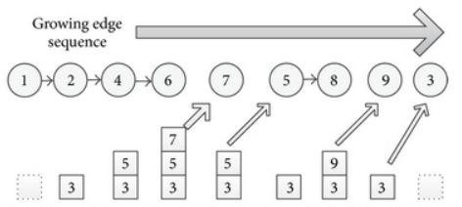

Fig.1 Process description of the algorithm of region growth

In *A coronary artery segmentation method based on multiscale analysis and region growing -ScienceDirect*[1], a method of region growing and multi-scale analysis is proposed to extract coronary artery vessels. The method takes advantages of multiscale Hessian analysis strength, defining a robust new region growing criterion tailored to the coronary artery segmentation problem. This method successfully avoid the problem of vascular loss when the intensity of blood vessels is low caused by plaques, but will result in over- or under-segmentation. A completely automated algorithm to segment coronary artery and extract centerline has been proposed in *Region based coronary artery segmentation using modified frangi’s vesselness measure*[2]. It gets seed points automatically, and segment the left and right coronary arteries respectively using region growing method. In *A coronary artery segmentation method based on region growing with variable sector search area*[3], a region growing method based on variable sector region searching is proposed. The method successfully segment complicated coronary structures. Further validation studies of stenoses detection and catheter removal may be required of this work.

Regional-growing methods segment the connected regions with the same characteristics, and provide good boundary information and segmentation results. However, native region growing technique also has some disadvantages: (1) it needs manual interaction to obtain seed points; (2) it is sensitive to noise; (3) the problem of over-segmentation will occur as a result of partial volume effect.

**2.2 Level-set methods**

Level Set Method (LSM) is a numerical technique for interface tracing and shape modeling. It is used for numerical calculation of evolving curves and surfaces, tracking the topological structure changes of objects. It has a good performance in the task of coronary artery segmentation.

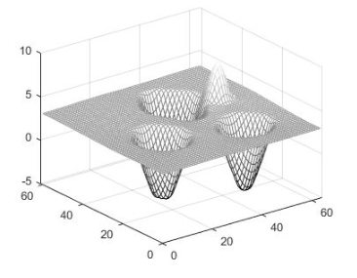

Fig.2 Level set algorithm for surface modeling

In *Coronary Artery CT Image Segmentation Based on Level Set Method*[4], a method of coronary artery CT image segmentation based on LSM is proposed. The results show that compared with manual method, the reconstruction time of level set method is reduced by about 10 times, and the fractional flow reserve (FFR) value is satisfying. However, this method required manual mark of the range of the target coronary artery area. In *Segmentation of Coronary Artery Using Region Based Level Set with Edge Preservation*[5], a level set method for segmentation of coronary artery is presented. In this method, local intensity information is introduced into the level set formulation where the bias field is estimated by a linear combination of a given set of orthogonal basis functions. This method reduces miss- and over-segmentation caused by noise.

The advantage of the level set method is that evolving curves and surfaces is numerically calculated on a Cartesian grid without having to parameterize them. Another advantage of the level set method is that it is easy to track changes in the object's topology.

**2.3** **Frangi’s vesselness filter**

Frangi’s vesselness filter is an edge detection enhanced filtering algorithm based on Hessian matrix. It is sensitive to round tubular structures. When the scale of vessels is set, it segments those vessels which fit the bill. Therefore, it is well suited for coronary artery segmentation. *Region based coronary artery segmentation using modified Frangi’s vesselness measure*[6] presents a fully automated method for coronary artery extraction using modified Frangi's vesselness measure and region based segmentation. In this method, grayness and gradient based measures are used while computing Frangi's vesselness measure to improve the extraction of coronary arteries.

Frangi’s filter is good at segmenting blood vessels, but the scale needs to be set artificially, and it also segments the blood vessels in the lungs, requiring additional post-processing.

**2.4 Other related methods**

Besides those methods stated above, there are also many other traditional methods for coronary artery segmentation. In *Automatic centerline extraction of coronary arteries in coronary computed*

*tomographic angiography*[7], a fully automatic coronary artery extraction method for CCTA images is presented, which mainly relies on an improved Frangi’s vesselness filter. This method is centerline-based, and extract coronary arteries in CCTA images with excellent performances in extraction ability and accuracy.*Deformable tree models for 2d and 3d branching structures extraction*[8] proposes a deformable tree model for coronary artery segmentation, which is validated on 2D MR angiography images and 3D CT data. *Tracking elongated structures using statistical snakes*[9] introduces a statistic snake that learns and tracks image features by means of static learning techniques. In this approach, a sound statistical model is introduced to define a likelihood estimate of the grey-level local image profiles together with their local orientation. Each of these methods has its own advantages and disadvantages. In fact, there are still many problems need to deal with in the task of coronary artery segmentation.

1. **Deep-learning Based Methods**

Deep learning has had a tremendous impact on various fields of computer vision, particularly approaches for medical image segmentation. In the field of coronary artery segmentation, different types of neural networks are applied as tools for deep learning. Apart from that, tree structures and graphical connectivity have been introduced as prior knowledge in coronary artery centerline extraction and other approaches. In recent years, some more strategies have been taken on the stage, namely weakly-supervised segmentation and knowledge transfer.

**3.1 Variants of networks**

**3.1.1 Convolutional Neural Network(CNN)**

Convolutional neural network is a special kind of multilevel perceptron architecture, where an input image passes through a sequence of classification tests that can extract and recognize its consistent intensity patterns and finally make a prediction about the image according to these patterns. The way how CNN works is to extract and recognize patterns in images through the layers and functions to make judgments about the special features in it. The process is based on learning from a large number of image datasets whose special features are already highlighted.

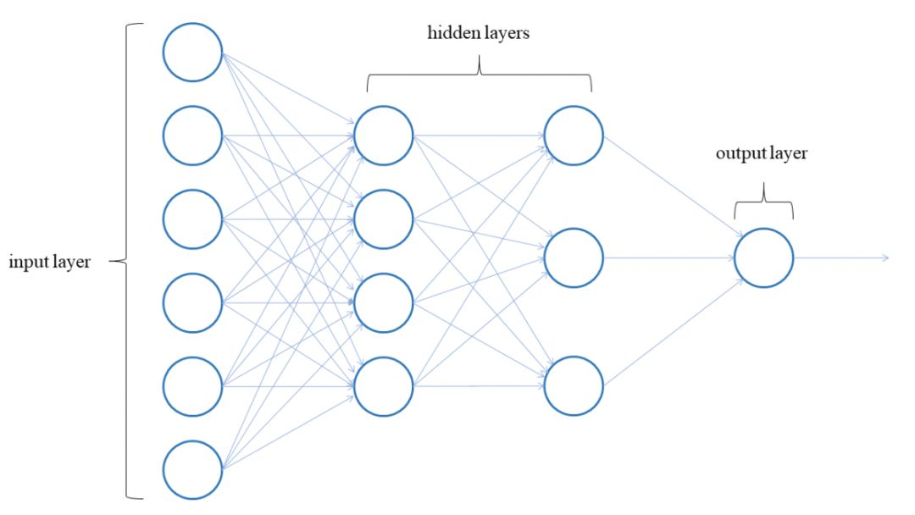

Fig.3 CNN network structure

In *Multi-Resolution 3D Convolutional Neural Networks for Automatic Coronary Centerline Extraction in Cardiac CT Angiography Scans*[10], a 3D CNN is trained to predict the most likely direction and radius of an artery at any given point in a cardiac CT angiography(CCTA) image based on a local image patch. Starting from a single seed point placed manually or automatically anywhere in a coronary artery, a tracker follows the vessel centerline in two directions using the predictions of the CNN. Tracking is terminated when no direction can be identified with high certainty. The CNN is trained using manually annotated centerlines in training images. The proposed method is able to accurately and efficiently determine the direction and radius of coronary arteries based on information derived directly from the image data.

With shared convolutional kernel, CNNs can easily deal with high-dimensional data. However, instead of images, the output of CNNs is usually numbers or vectors, which loses two-dimensional features. Other disadvantages of CNN are mainly high storage and low computational efficiency.

**3.1.2 Fully Convolutional Network(FCN) and U-Net**

An FCN has a structure slightly different from a CNN, with a fully-connected layer changed into a convolutional layer. Medical image formats are diverse, and FCN can input images of any size. The newly-added skip connection structure ensures both robustness and accuracy of the network.

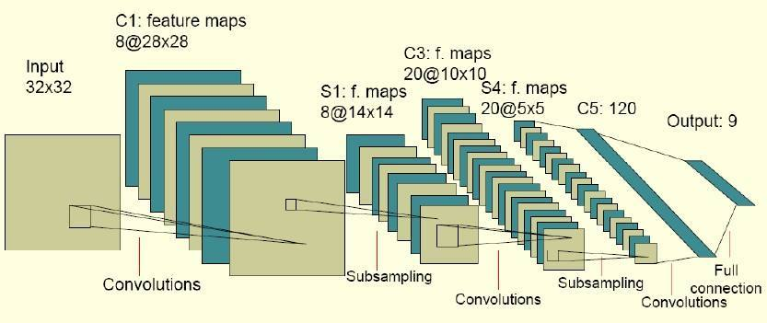

Fig.4 FCN network structure

A relatively new architecture on the basis of FCN is called U-Net convolutional network, dedicated to biomedical image analysis, which performs better in medical images. U-Net combines CNNs and data enhancement technology to increase the amount of medical data. Divided into encoder part and decoder part, the U-Net’s U-shaped structure and layer jump connection make it possible to better extract high-level semantic information and preserve low-level structural features.

On the basis of U-Net, Lien Kamp et al. introduced the 3D U-Net in 2016 in *3D U-Net: Learning Dense Volumetric Segmentation from Sparse Annotation*[11]. After improvements, the 3D U-Net can input three-dimensional images, which has good versatility. Zhou et al. introduced the U-Net++ in 2018 in *UNet++: A Nested U-Net Architecture for Medical Image Segmentation*[12], which reduces the semantic gap between the feature maps of the encoder and decoder sub-networks. Finally, in 2020 in *Automated Design of Deep Learning Methods for Biomedical Image Segmentation*[13], Fabian Isensee et al. Proposed nnU-net, which automatically adapts to distinctive datasets and, in terms of huge-amount tasks, surpasses networks specialized for some certain segmentation missions.

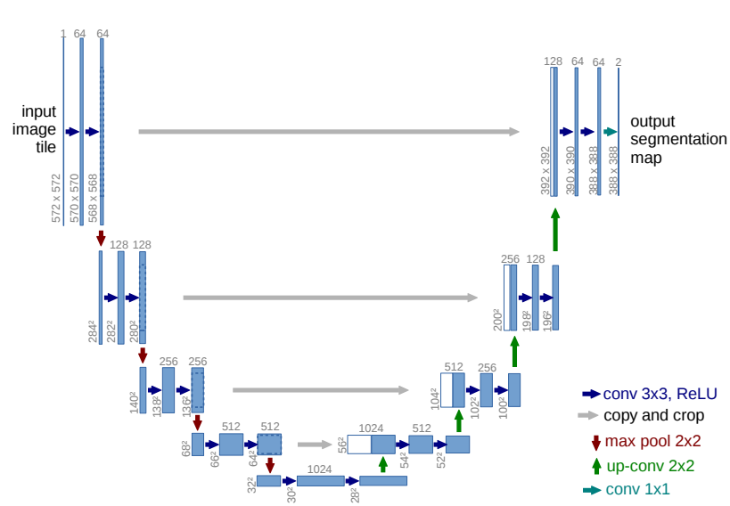

Fig.5 UNET network structure

Extracting coronary artery centerline from a segmentation mask faces multiple notable challenges, namely multiple branches and significant branch diameter changes. To address such problems, in *DeepCenterline: A Multi-task Fully Convolutional Network for Centerline Extraction*[14], a two-head multi-task FCN is proposed which simultaneously generates a locally normalized distance map and a list of branch endpoints. The multi-task FCN accomplishes two tasks: computing a normalized centerline distance map and detecting branch endpoints. Skip-connections are added among features of same scale to facilitate good use of information.

In *Coronary Artery Segmentation in Cardiac CT Angiography Using 3D Multi-Channel U-net* [15], 3D U-Net is applied in extraction of coronary artery area from Computed Tomographic Angiography (CTA). To overcome the difficulties caused by attenuation ambiguity, a 3D multi-channel U-Net architecture is proposed for fully automatic 3D coronary artery reconstruction from CTA. Other than using the original CTA image, the main idea of the approach is to incorporate the vesselness map into the input of the U-Net, which serves as the reinforcing information to highlight the tubular structure of coronary arteries.

**3.1.3 Graph Convolutional Network(GCN)**

GCNs are a recent development in deep learning-based medical image analysis, applied mostly in Non Euclidean Structure where CNNs may perform unsatisfactory results. They have high potential for graph-based applications in airway extraction in chest CT and cortical segmentation. The GCN consists of layers that aggregate information from neighboring nodes. By concatenating several such layers, information from a growing neighborhood of nodes in the graph is combined.

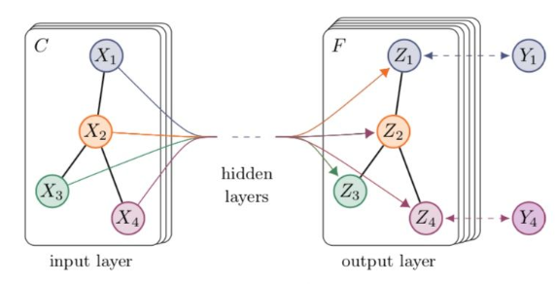

Fig.6 GCN network structure

In *Graph Convolutional Networks for Coronary Artery Segmentation in Cardiac CT Angiography*[16], GCNs are used to obtain a coronary artery surface mesh based on a CCTA image and an automatically extracted coronary artery centerline, to predict the spatial location of vertices in a tubular surface mesh that segments the coronary artery lumen. Predictions for individual vertex locations are based on local image features as well as on features of neighboring vertices in the mesh graph.

**3.1.4 Graphical adversarial network(GAN)**

For image segmentation tasks, networks usually predict the category of each pixel at the pixel-wise. The segmentation results may lack continuity and obviously differ from the ground-truth, because deep networks usually ignore the correlation between pixels. In *UENet: A Novel Generative Adversarial Network for Angiography Image Segmentation*[17], Xiaotong Shi et al. explore to use generative adversarial mechanism to deal with the above problems. GANs can be treated as a competitive procedure between the generator and the discriminator.

Two problems will be handled with conditional generative adversarial networks (cGANs): blood vessel discontinuity and intra-class inconsistency. To extract better feature of fine coronary arteries in angiography imaging, cGAN was modified to achieve the artery segmentation.

**3.1.5** **PSPNet**

Using an image block around the pixel as the input of the CNN network for training and prediction is the characteristic of traditional CNN-based segmentation methods. This method has several disadvantages, namely requiring a lot of storage space, long segmentation time and others. FCN overcomes the above shortcomings by recovering the category to which each pixel belongs from the abstract features, but it does not fully consider the relationship between pixels. Ignore the spatial regularization step used in the usual pixel classification-based segmentation method, which makes the network lack of spatial consistency.

In *Semantic Image Segmentation with Deep Convolutional Nets and Fully Connected CRFs*[18], Zhao et al. proposed Pyramid Scene Parsing Network (PSPNet). After feature extraction was performed on the input data, they input the feature map into the pyramid pooling module, and finally cascaded to get the feature surface, and then learned and adjusted the parameters by calculating the loss and back propagation algorithm. Compared with Global Pooling, this structure is better for obtaining multi-size global information.

In *Coronary angiography image segmentation based on PSPNet*[19], Zhu et al. proposed segmentation of coronary angiography images based on PSPNet network, which was compared with FCN, and analyzed and discussed the experimental results using three evaluation indicators of precision, recall and Fl-score. Aiming at the complex and changeable structure of coronary angiography images and over-fitting or parameter structure destruction, they implemented the parallel multi-scale convolutional neural network model using PSPNet, using small sample transfer learning that limits parameter learning method.

**3.2 Deep-learning prior knowledge**

When deep-learning is applied in multi-classification tasks, the models are often complex and time-consuming. To address such problem, methods combining prior knowledge and deep-learning have been put forward. Prior knowledge is the object structures manually set and inserted in the network before training, so that deep-learning receives better results in less time. Tree and graphical structures are mainly used in coronary artery segmentation.

**3.2.1 Tree structures**

Inspired by recent ideas to use tree-structured long short-term memory (LSTM) to model the underlying tree structures for NLP tasks, in *Learning Tree-Structured Representation for 3D Coronary Artery Segmentation*[20], Bin et al. proposed a novel tree-structured convolutional gated recurrent unit(ConvGRU) model to learn the anatomical structure of the coronary artery. Their tree-structured model considers the local spatial correlations in the input data as the convolutions are used for input-to-state as well as state-to-state transitions, thus more suitable for image analysis. To conduct voxel-wise segmentation, a tree-structured segmentation framework is presented. It consists of a fully convolutional network for multi-scale discriminative feature extraction and the final prediction, and a tree-structured ConvGRU layer for anatomical structure modeling.

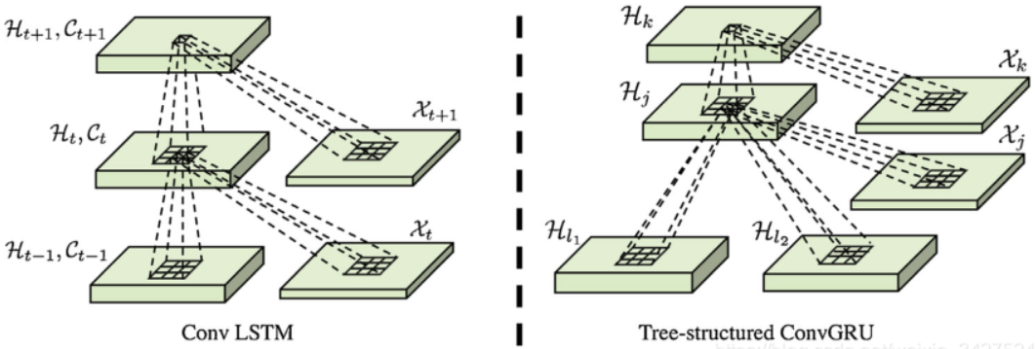

Fig.7 Tree structure model

**3.2.2 Graphical structures**

Existing methods using CNNs have mostly relied on local appearances learned on the regular image grid, without consideration of the graphical structure of vessel shape. Effective use of the strong relationship that exists between vessel neighborhoods can help improve the vessel segmentation accuracy. In *Deep Vessel Segmentation By Learning Graphical Connectivity*[21], Shin et al. incorporated a graph neural network into a unified CNN architecture to jointly exploit both local appearances and global vessel structures. They extensively performed comparative evaluations on four retinal image datasets and a coronary artery X-ray angiography dataset, showing that the proposed method outperforms or is on par with current state-of-the-art methods in terms of the average precision and the area under the receiver operating characteristic curve.

**3.3 Deep-learning strategies**

As the structure of coronary artery is extremely complex and hard to segment, some strategies have been proposed to meet the standard of less training datasets, better segmentation results.

**3.3.1 Weakly-supervised segmentation**

The segmentation of coronary arteries in X-ray angiograms by convolutional neural networks is promising yet limited by the requirement of precisely annotating all pixels in a large number of training images, which is extremely labor-intensive especially for complex coronary trees. To alleviate the burden on the annotator, in *Weakly Supervised Vessel Segmentation in X-ray Angiograms by Self-Paced Learning from Noisy Labels with Suggestive Annotation*[22], Zhang et al. proposed a novel weakly supervised training framework that learns from noisy pseudo labels generated from automatic vessel enhancement, rather than accurate labels obtained by fully manual annotation. They proposed an annotation-refining self-paced learning framework (AR-SPL) to correct the potential errors using suggestive annotation. An elaborate model-vesselness uncertainty estimation was also proposed to enable the minimal annotation cost for suggestive annotation, based on not only the CNNs in training but also the geometric features of coronary arteries derived directly from raw data.

**3.3.2 Knowledge Transfer**

As is mentioned in the former section, classic unsupervised methods fail to produce satisfactory results and modern supervised learning requires manual annotation which is often time-consuming and can sometimes be infeasible. In *Annotation-Free Cardiac Vessel Segmentation via Knowledge Transfer from Retinal Images*[23], Yu et al. proposed a knowledge transfer based shape-consistent generative adversarial network (SC-GAN), which is an annotation-free approach that uses the knowledge from publicly available annotated fundus dataset to segment coronary arteries, known as knowledge transfer. The proposed network is trained in an end-to-end fashion, generating and segmenting synthetic images that maintain the background of coronary angiography and preserve the vascular structures of retinal vessels and coronary arteries.

1. **Future directions and developments**

In the following sections, we discuss in detail the potential future research directions for semantic segmentation of coronary artery.

* 1. **Combined traditional and deep-learning direction**

We conclude that compared with deep-learning methods, traditional methods are more dependent on prior knowledge and make full use of coronary and vessel structures. As a comparison, deep-learning methods perform better in efficiency, precision, and they dispense with manual intervention. However, deep learning thus far has not been well integrated with prior knowledge. As a result, a potential direction is to combine deep learning and traditional methods to reach better segmentation results. Current ideas involve that two methods are processed in parallel, and finally a new loss function is designed in combination.

* 1. **More diverse methods of supervision**

When it comes to medical images, it’s always time-consuming and labor-intensive to label most of the images by hand. While basic CNN and other network models need a large number of training datasets, newly-discovered methods perform well or even better requiring fewer datasets. They include weakly-supervision and knowledge transfer as mentioned above, as well as self-supervised and semi-supervised neural networks. More approaches are to be discovered in terms of such problem.

* 1. **More schemes based on prior knowledge**

Anatomy, feature and position prior knowledge all serve as essential means to improve neural networks and improve their accuracy, and prior knowledge has been gradually associated with deep-learning image segmentation. Current ideas involve interactive segmentation algorithm which brings in anatomy backgrounds and materials.

**References:**

[1] A A K, A A B, B A M, et al. A coronary artery segmentation method based on multiscale analysis and region growing - sciencedirect[J]. Computerized Medical Imaging and Graphics, 2016, 48:49-61.

[2] SUKANYA A, RAJESWARI R, MURUGAN K S. Region based coronary artery segmentation using modified frangi’s vesselness measure[J]. International Journal of Imaging Systems and Technology, 2020, 30(3).

[3] MA G, YANG J, ZHAO H. A coronary artery segmentation method based on region growing with variable sector search area[J]. Technology and health care: official journal of the European Society for Engineering and Medicine, 2020, 28(2): 1-10.

[4] 黄山程晓光. 基于水平集方法的冠状动脉 CT 图像分割[J]. 北京生物医学工程, 2020, v.39(06):23-27+35.

[5] CHAOLU, FENG, YANG, et al. Segmentation of coronary artery using region based level set with edge preservation[J]. Journal of Medical Imaging and Health Informatics, 2016, 6(7):1727-1731.

[6] SUKANYA A, RAJESWARI R, MURUGAN K S. Region based coronary artery segmentation using modified frangi’s vesselness measure[J]. International Journal of Imaging Systems and Technology, 2020, 30(3).

[7] YANG G, KITSLAAR P, FRENAY M, et al. Automatic centerline extraction of coronary arteries in coronary computed tomographic angiography[J]. The international journal of cardiovascular imaging, 2012, 28(4):921-933. 22

[8] MILLE, J, COHEN, et al. Deformable tree models for 2d and 3d branching structures extraction[J]. Proc Cvpr IEEE, 2009.

[9] TOLEDO R, ORRIOLS X, BINEFA X, et al. Tracking elongated structures using statistical snakes[C]//Proceedings IEEE Conference on Computer Vision and Pattern Recognition. CVPR 2000 (Cat. No.PR00662). [S.l.: s.n.], 2002.

[10] SALAHUDDIN Z, LENGA M, NICKISCH H. Multi-resolution 3d convolutional neural networks for automatic coronary centerline extraction in cardiac ct angiography scans[J]. 2020.

[11] IEK Z, ABDULKADIR A, LIENKAMP S S, et al. 3d u-net: Learning dense volumetric segmentation from sparse annotation[J]. Springer, Cham, 2016.

[12] ZHOU Z, SIDDIQUEE M, TAJBAKHSH N, et al. Unet++: A nested u-net architecture for medical image segmentation[J]. 2018.

[13] ISENSEE F, JGER P F, KOHL S, et al. Automated design of deep learning methods for biomedical image segmentation[J]. 2019.

[14] GUO Z, BAI J, YI L, et al. Deepcenterline: A multi-task fully convolutional network for centerline extraction[J]. Springer, Cham, 2019.

[15] CHEN Y C, LIN Y C, WANG C P, et al. Coronary artery segmentation in cardiac ct angiography using 3d multi-channel u-net[J]. 2019.

[16] Graph convolutional networks for coronary artery segmentation in cardiac ct angiography[J]. Springer, Cham, 2019.

[17] SHI X, DU T, CHEN S, et al. Uenet: A novel generative adversarial network for angiography image segmentation[C]//2020 42nd Annual International Conference of the IEEE Engineering in Medicine and Biology Society (EMBC) in conjunction with the 43rd Annual Conference of the Canadian Medical and Biological Engineering Society. [S.l.: s.n.], 2020.

[18] CHEN L C, PAPANDREOU G, KOKKINOS I, et al. Semantic image segmentation with deep convolutional nets and fully connected crfs[J]. arXiv, 2014.

[19] ZHU X, CHENG Z, WANG S, et al. Coronary angiography image segmentation based on pspnet[J]. Computer Methods and Programs in Biomedicine, 2020, 200(4):105897.

[20] KONG B, WANG X, BAI J, et al. Learning tree-structured representation for 3d coronary artery segmentation[J].

Computerized Medical Imaging and Graphics, 2019, 80:101688.

[21] SHIN S Y, LEE S, YUN I D, et al. Deep vessel segmentation by learning graphical connectivity[J]. 2018.

[22] ZHANG J, WANG G, XIE H, et al. Weakly supervised vessel segmentation in x-ray angiograms by self-paced learning from noisy labels with suggestive annotation[J]. Neurocomputing, 2020.

[23] YU F, ZHAO J, GONG Y, et al. Annotation-free cardiac vessel segmentation via knowledge transfer from retinal images[J]. arXiv, 2019.