Bucket sort can be exceptionally fast because of the way elements are assigned to buckets, typically using an array where the index is the value. This means that more auxiliary memory is required for the buckets at the cost of running time than more comparison sorts. It runs in O(n+k) time in the average case where n is the number of elements to be sorted and k is the number of buckets.

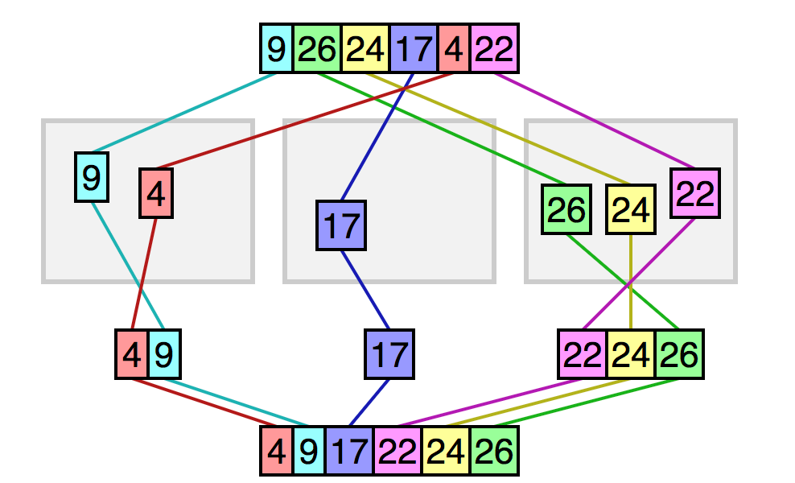

While bucket sort is a distribution sort, it typically uses a comparison sort to sort the buckets after they have been allocated.