**Program: Implement merge sort in java.**

Merge sort is a divide and conquer algorithm.

**Steps to implement Merge Sort:**  
  
1) Divide the unsorted array into n partitions, each partition contains 1 element. Here the one element is considered as sorted.  
2) Repeatedly merge partitioned units to produce new sublists until there is only 1 sublist remaining. This will be the sorted list at the end.

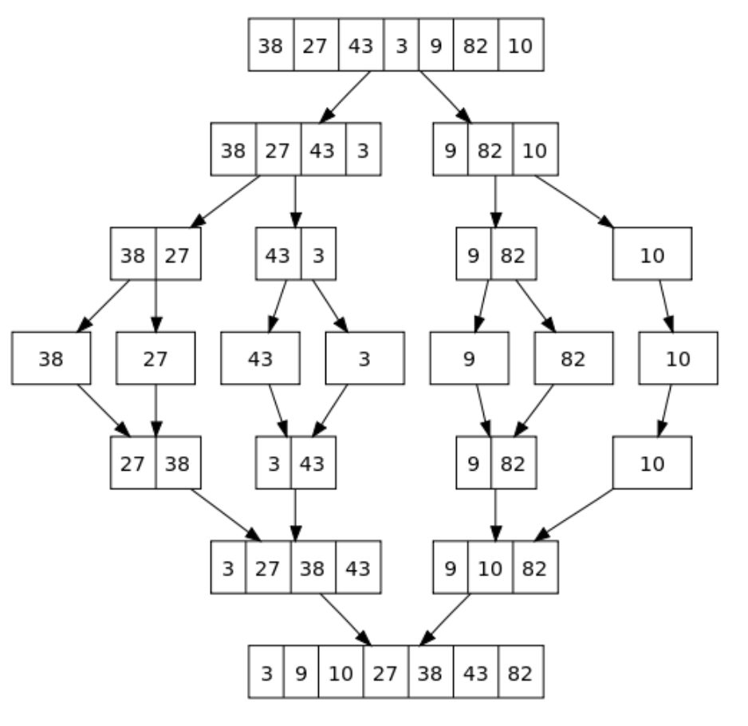

Merge sort is a fast, stable sorting routine with guaranteed O(n*log(n)) efficiency. When sorting arrays, merge sort requires additional scratch space proportional to the size of the input array. Merge sort is relatively simple to code and offers performance typically only slightly below that of quicksort.