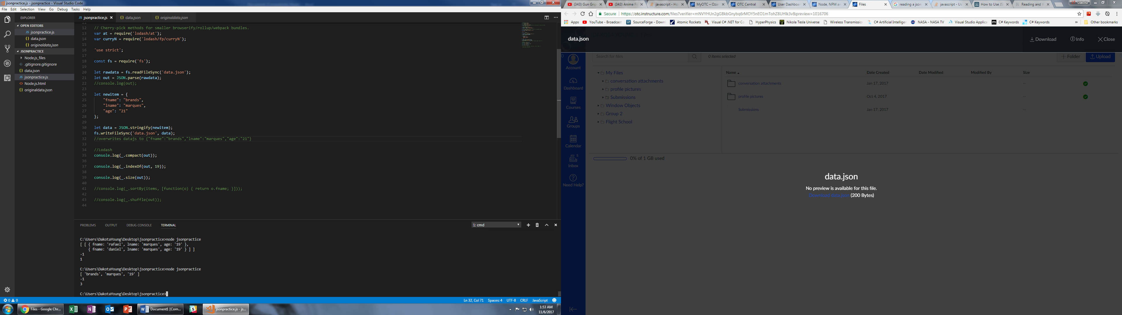

Top output is the original code and the bottom is after the write which changes the new outputs.