***LANDING PAGE – NO TITLE***

***PAGE 2 - WHAT WE DO***

# **What we Do?**

TechNet Consulting is an expert in identifying the customer’s needs to help them strategize for the current and future IT Infrastructure needs. We offer Consulting, Scoping, Solutioning, Design, Planning, Implementation and service roll out service packages.

Our offerings are across a wide variety of Technologies across various OEM’s for a wide range of industries.

# **Our Services**

TechNet Consulting offers a bouquet of services which can be availed in various forms of packages and billing services, ranging from Time & Materials based consulting to Fixed Price (Pre-Scoped) projects. We specialise in Enterprise Networks, Data Center Networks, IP Telephony networks, Wireless Networks, Network Security, Virtualization and Cloud Computing for small to medium to large scale deployments.

# **Technology Platforms**

* Enterprise Data, Voice and Wireless
* Enterprise Security
* Data Center Networks
* Cloud Networks – Hosted, Hybrid and Private.
* Collaboration
* Wireless Networks – Office, Outdoor, Industrial grade
* Virtualization
* Cloud Computing
* End User Computing
* Software Defined Datacenter

# **OEM Expertise**

* Cisco - Data, Voice, Wireless, DC, Security
* Aruba - Wireless
* Juniper – Wan & Security
* Checkpoint
* QRadar
* FireEye
* Riverbed – WAN Optimisation
* F5
* Citrix
* Bluecoat
* Imperva
* VMware
* Openstack
* NSX
* Microsoft – O365, Skype
* Amazon Web Services - Cloud
* Azure – Cloud
* Hyper Converged Infrastructure



* Citrix XenDesktop and VMware Horizon

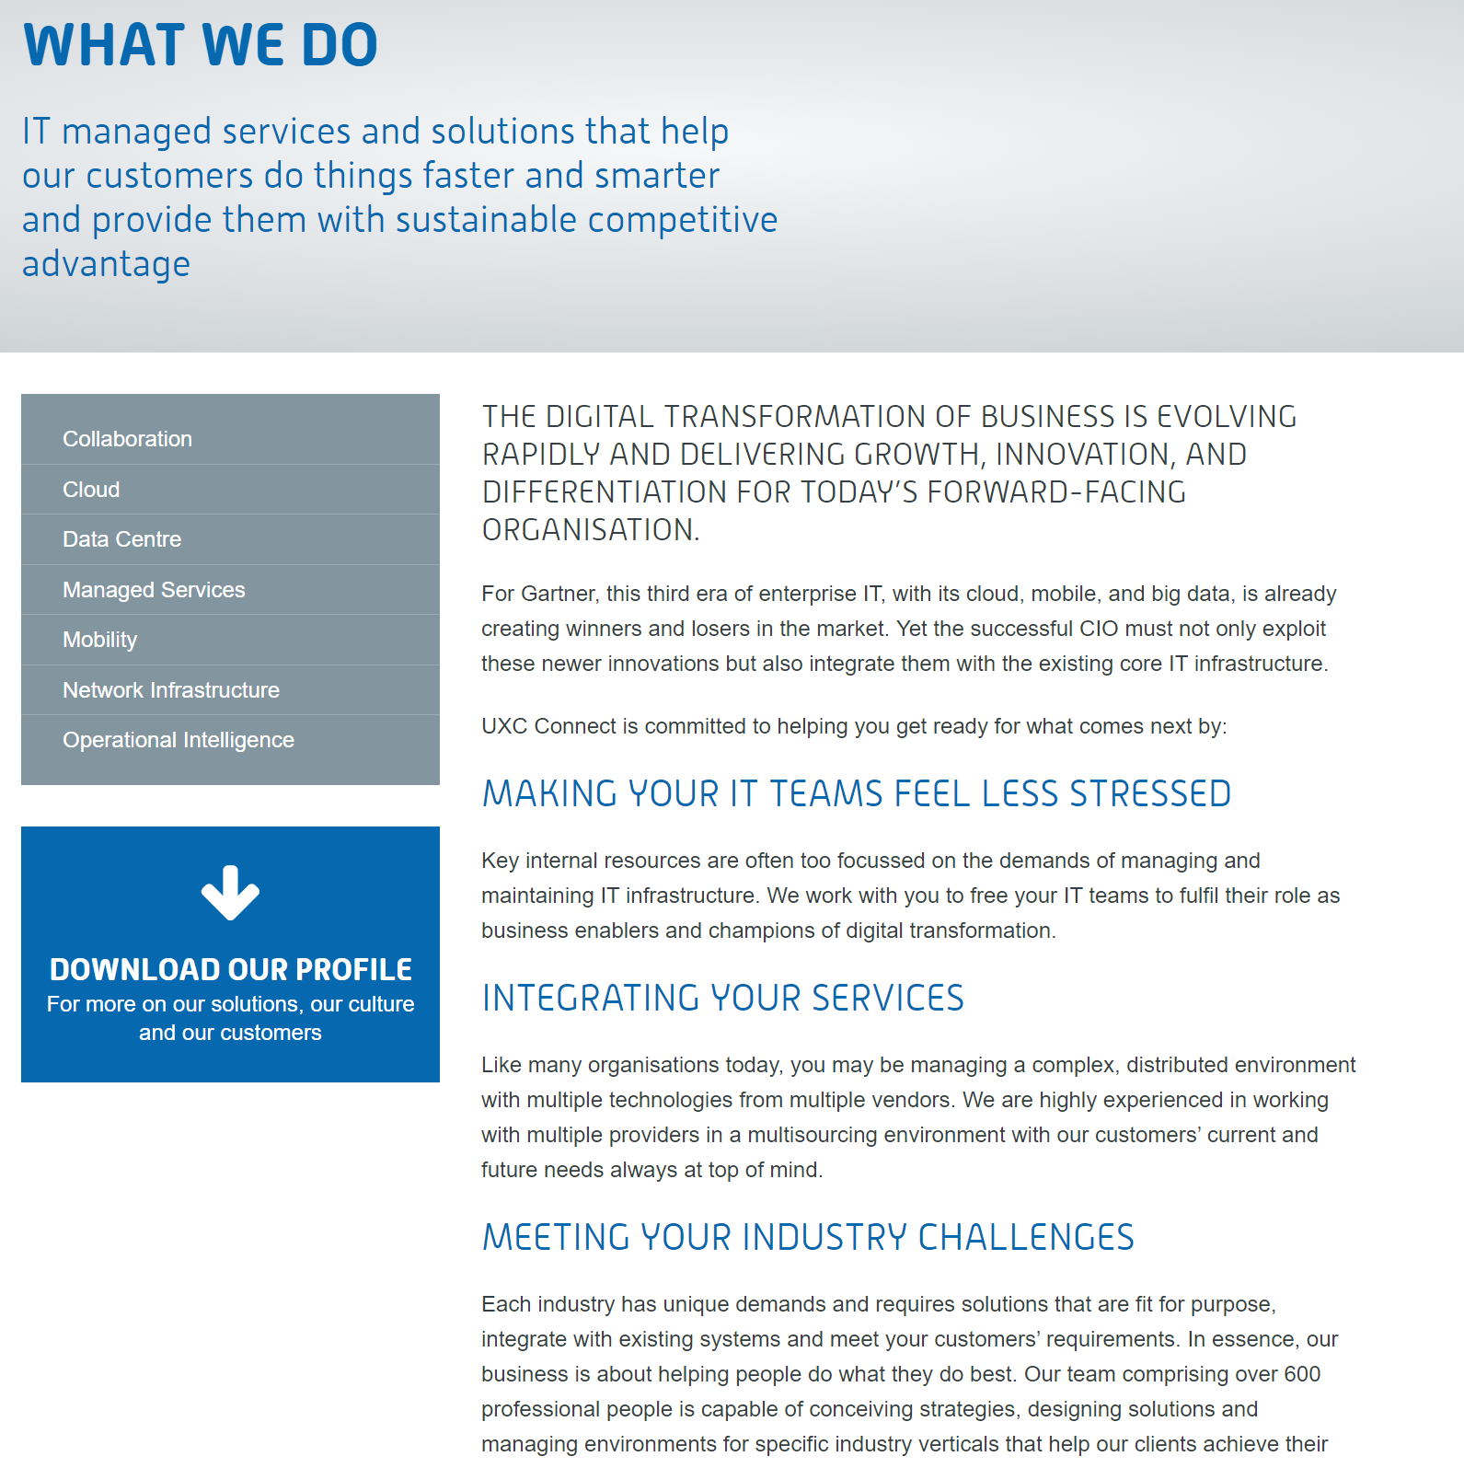

***PAGE 3 - PROSPECTIVE CLIENTS***

# **Prospective Industries**

* Finance
* Healthcare
* Public Services
* Education
* Retail
* Manufacturing

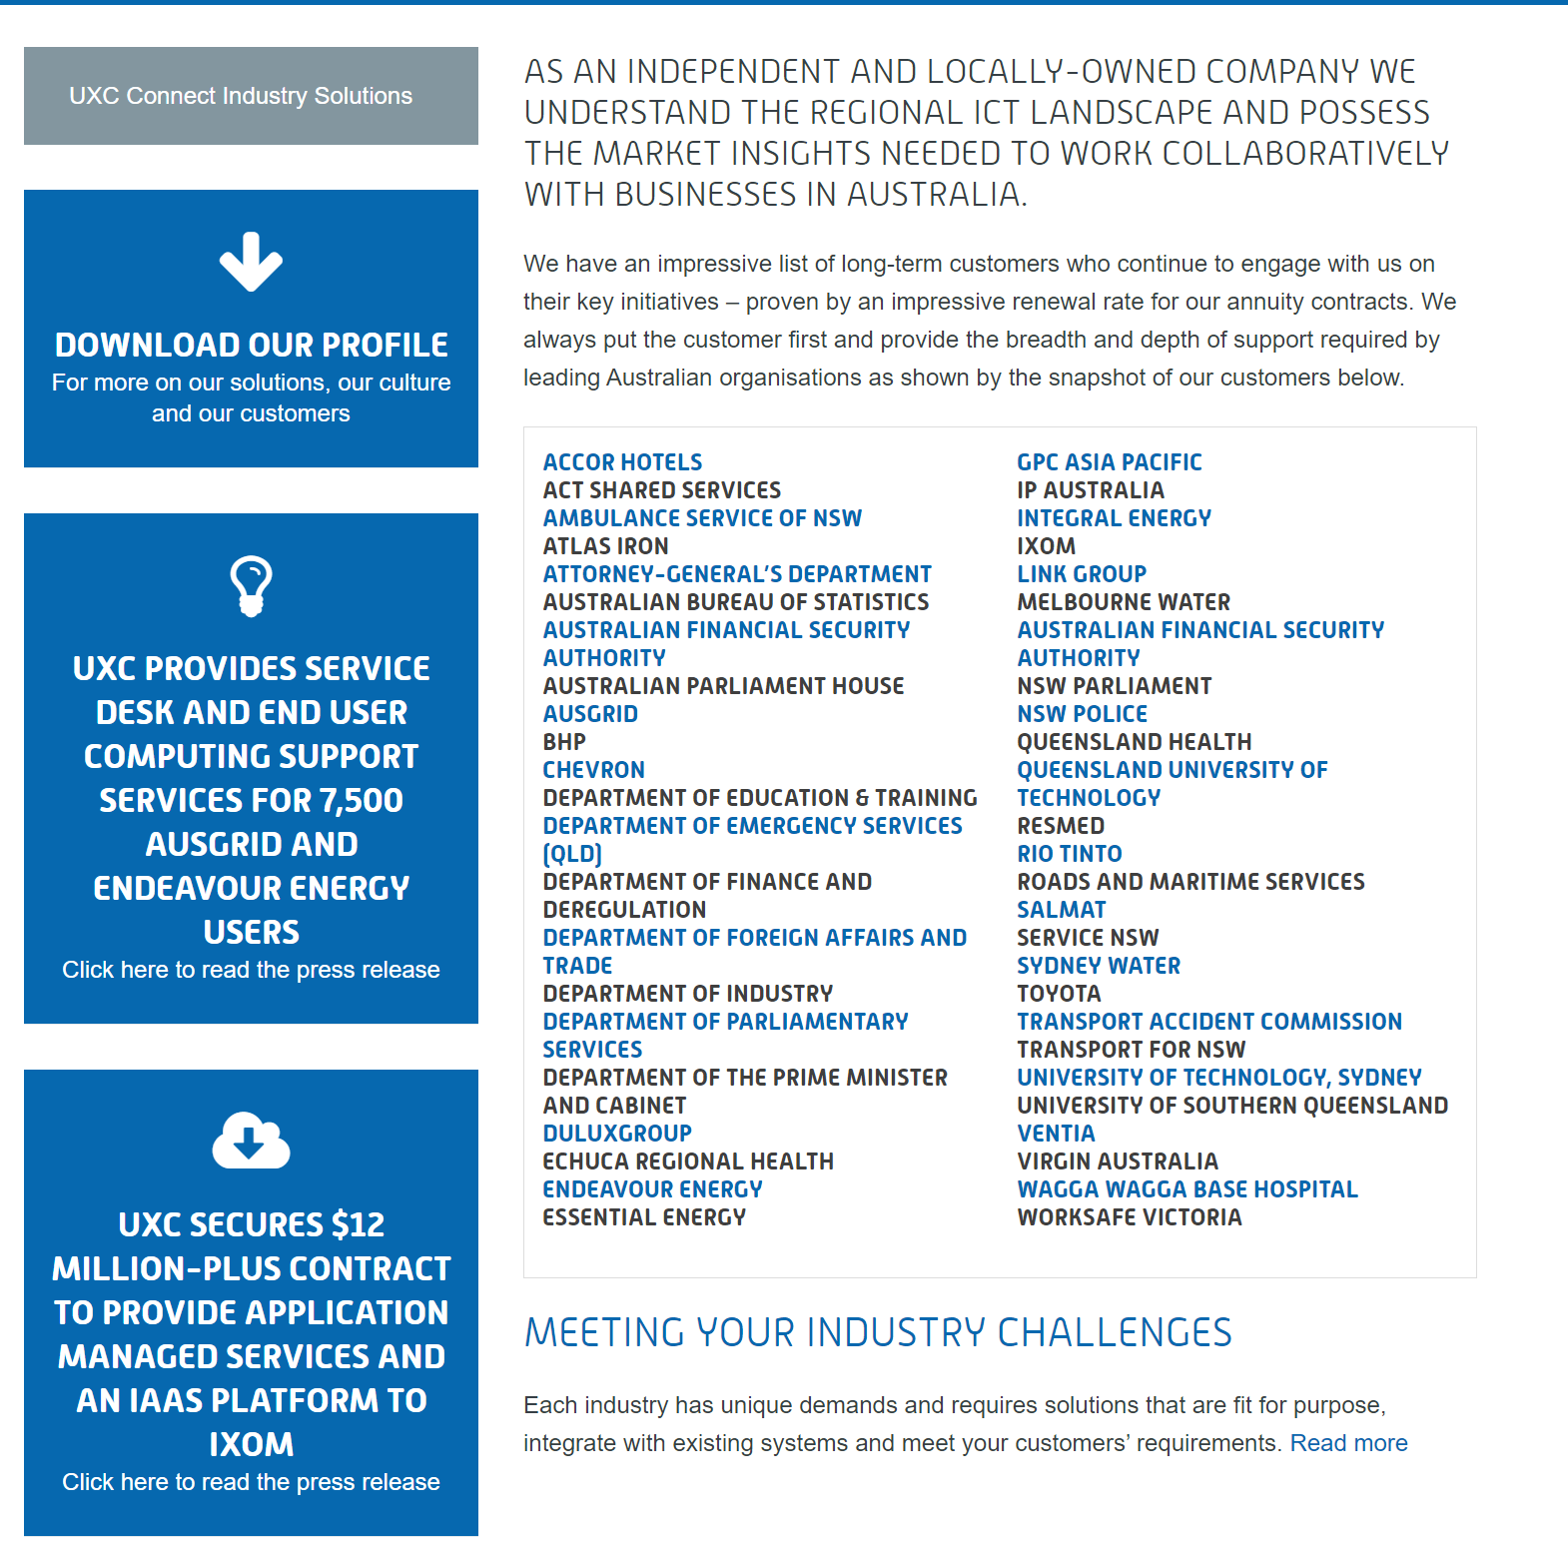

***PAGE 4 - OUR PARTNERS***

***PAGE 5 - CONTACTS***

[info@technetconsulting.com.au](mailto:info@technetconsulting.com.au)

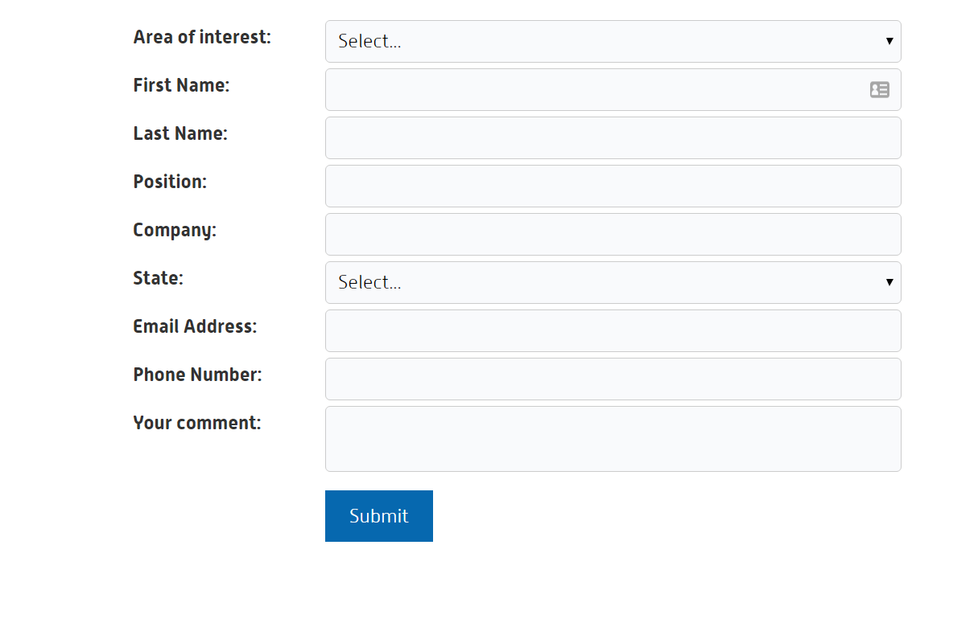

***PAGE 6 - WHO WE ARE / ABOUT US***

# **Who are We?**

TechNet Consulting is a group people who are experts of IT Communication and Networks. With over 75 years of combined experience in Data-center Technologies and IT Network infrastructure consulting, sales, design, deployment and support.

We have serviced clients across all major industries and we have expertise in handling all major IT Network technologies.

Our people are Industry certified experts and have been associated with some of the biggest brands in the IT infrastructure world. We are experienced in technological and procedural challenges associated with projects as large as $200 million.

People at TechNet have dealt with modern IT Technical challenges for clients across a wide spread of Industries. We pride ourselves in our impeccable work ethic with our focus being the client and their needs without compromising their IT goals.

# **Our People - Expertise**

## **Amit Pal Singh**

* Cisco Certified Internet work Expert (CCIE R&S, CCIE SP, CCIE Voice)
* Cisco Certified Design Expert (CCDE)

## **Parantap Singh Rathi**

* Cisco Certified Internet work Expert (CCIE R&S)
* VMWare Certified Professional (Data Center Virtualisation and Network Virtualisation)

## **Tushar Singla**

* Cisco Certified Internet work Expert (CCIE R&S)
* Aruba Certified Professional

