1. Navigate to the repository on GIT - https://github.com/silverbullet123/FlagExplorer

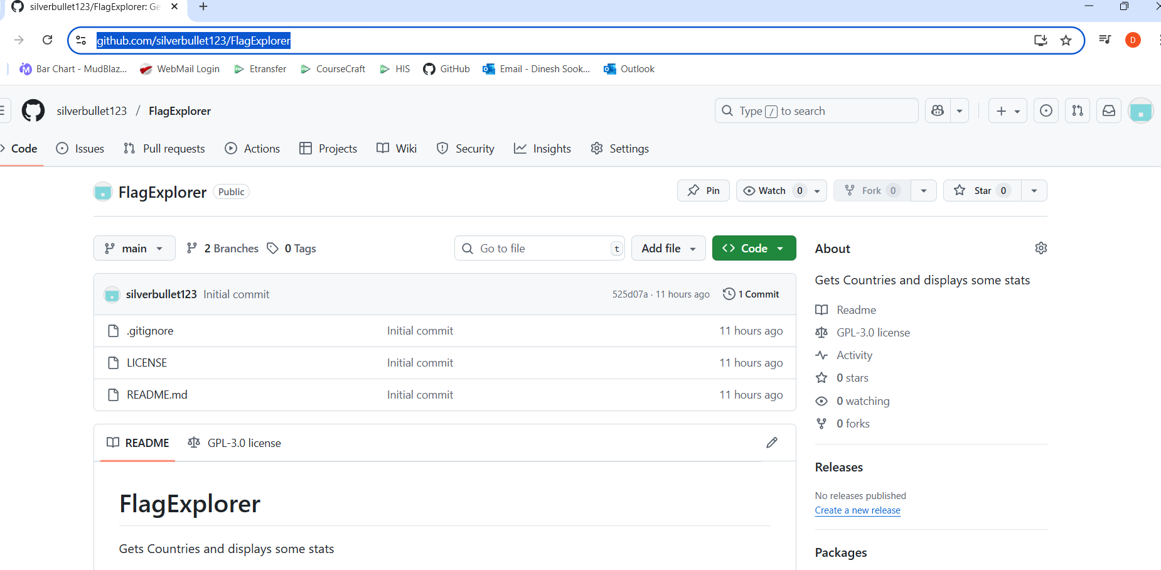

2. Clone the repository, download the zip or use GIT Hub Desktop.

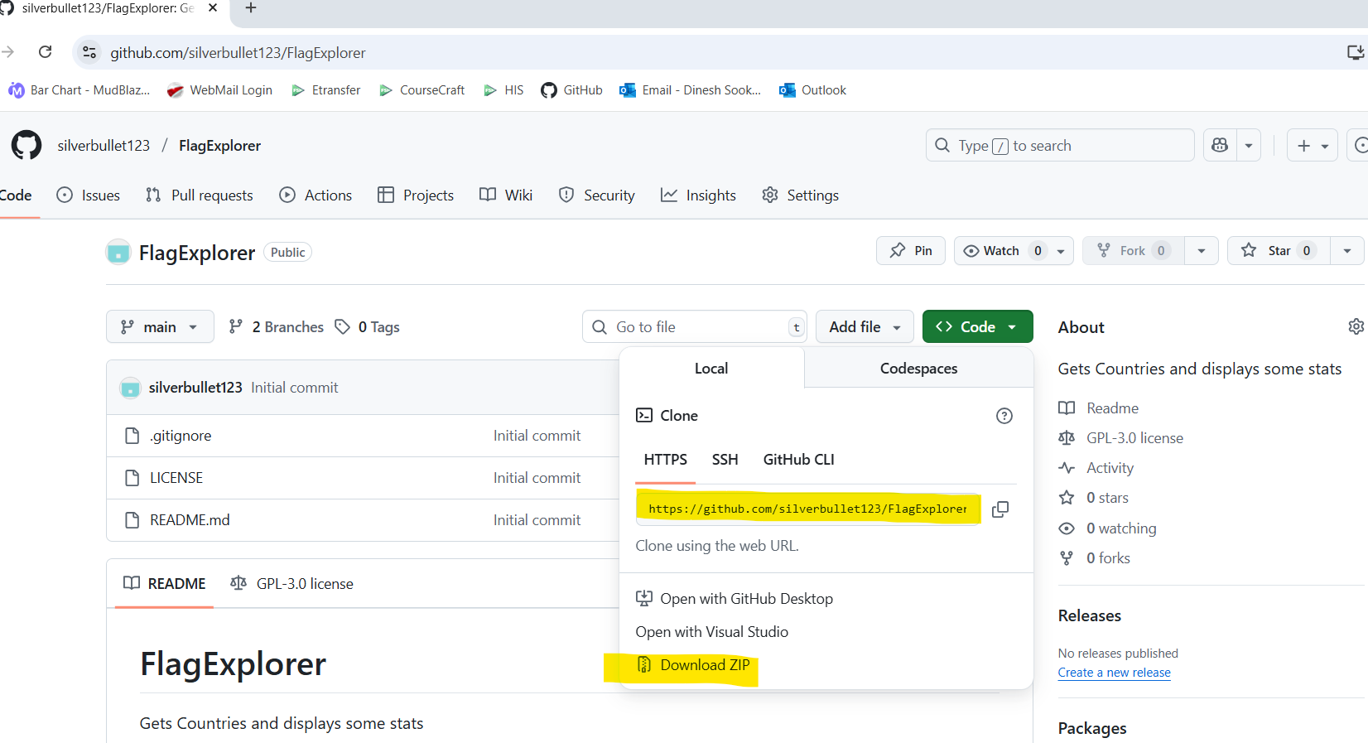

3. In the root of the FlagsExplorer directory you will find the gitignore, azure-pipeline.yml , readme and the licence as requested. The AngularFlagFE contains the Angular Frontend for the application. The FlagExplorer contains the API that FE commincates with, and is also responsible for retrieving the data being used from https://restcountries.com/v3.1/all.

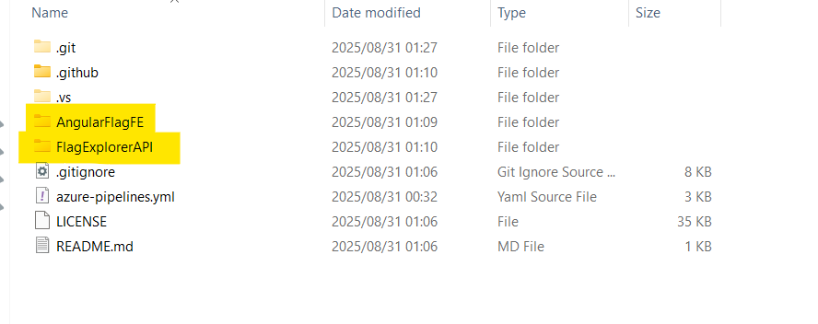
4. In Order to run the Api , open the FlagExplorerAPI folder, and open the solution using your favourite ide (Visual Studio).

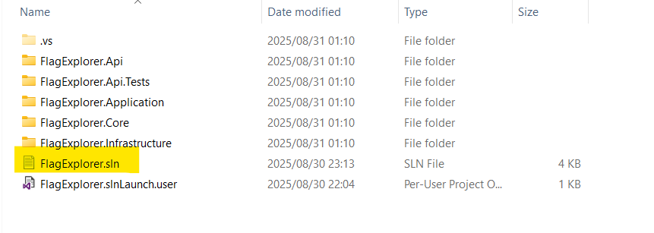
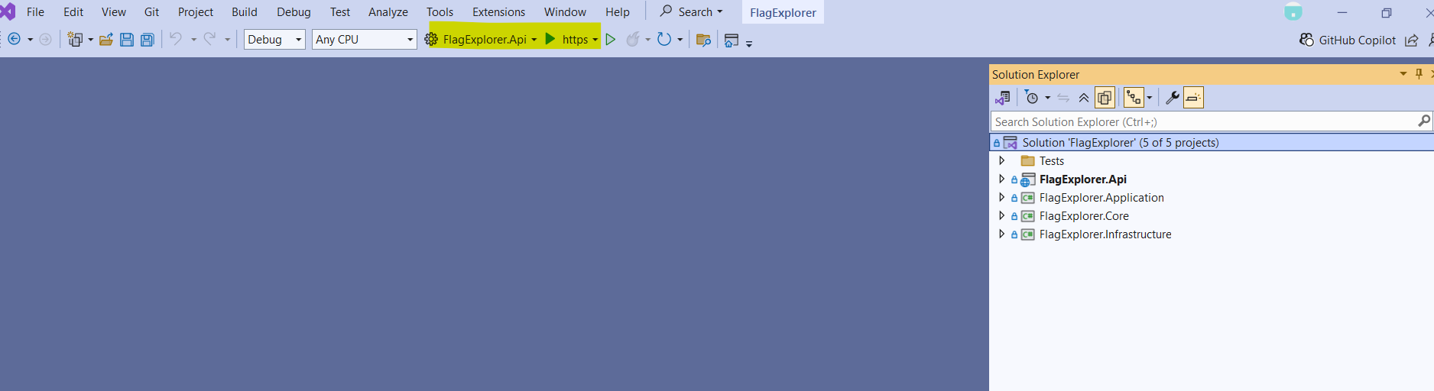
Use the Green Button to start the API. The api will start on https://localhost:7051 and http://localhost:5041. You can also bring it up in the browser using swagger.

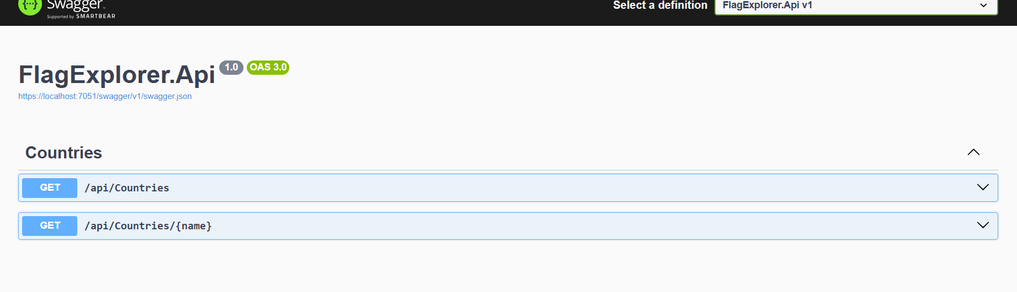
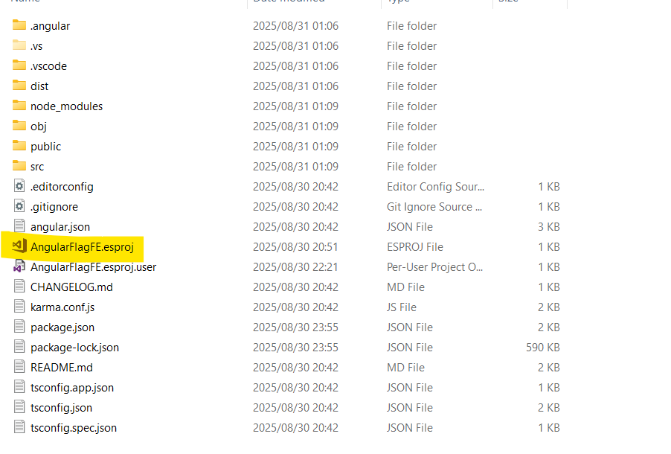
5. In order to run the Angular Front end open the AngularFlagFe folder and open the csproj file in your favourite ide (Visual Studio).

Use the green play button to start the app.
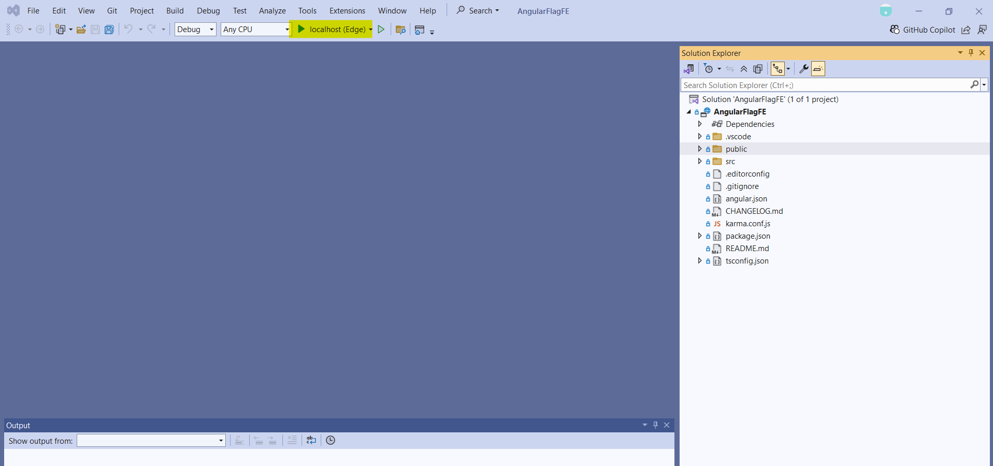

6. The World of Flags Should open up. Click any flag to navigate to its detail.

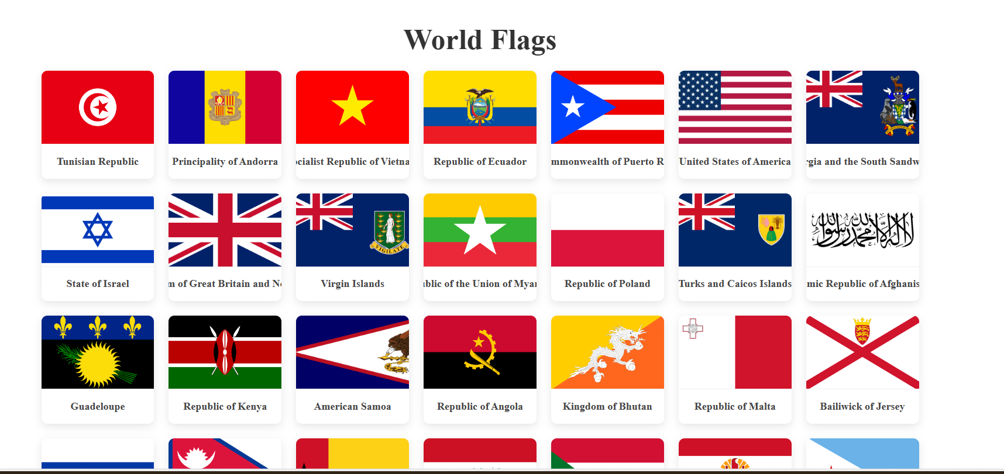

Use the back button to navigate back to the home screen.

