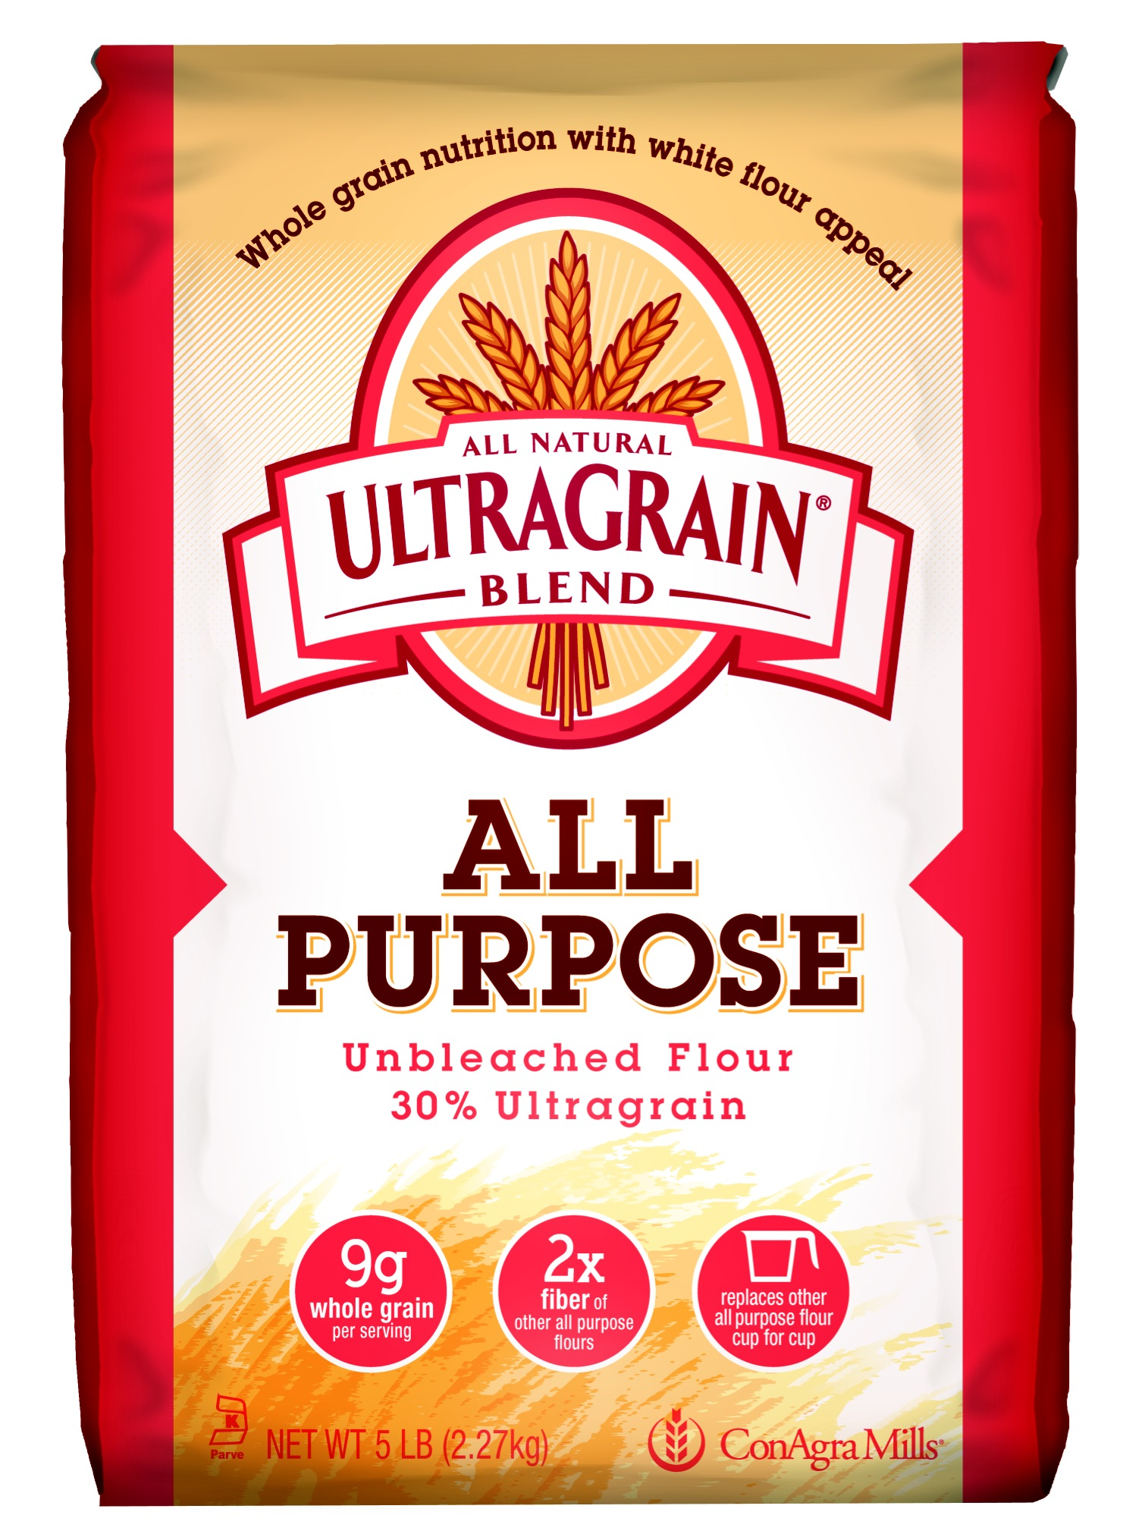

Dear Parents,
Ensuring the health and well-being of your child or children is something we take very seriously. Given the fact that 40 percent of children’s daily food consumption occurs at school, we’re well aware ________ School District plays a critical role in ensuring proper nutrition and encouraging healthy eating habits.

For this reason, _____________ School District is constantly looking for high-quality foods that are just as nutritious as they are appealing to our students. This year, we are participating in a unique sampling program called SuperKids, featuring foods made with the all-natural whole grain ingredients Ultragrain® whole wheat flour and Sustagrain®, the ultra-high fiber whole grain. In fact, Ultragrain has already transformed many of the foods you find in the grocery store and can even be purchased for use at home. As we explore nutritious new menu options for school meals, SuperKids provides us with free samples of a variety of whole grain breakfast, lunch and snack foods.

Please note the sample products made with Ultragrain and Sustagrain were selected by foodservice professionals from our school district. In addition, they were chosen for their overall nutritional value, whole grain content, as well as the likelihood of appealing to students’ tastes.

As part of the process, we may involve students in taste testing to help us gather feedback and better evaluate the sample products. We’ll then consider that information when making our future menu choices. I feel very strongly that SuperKids is an excellent tool that aids us in our decision-making process and welcome any questions you may have about the program or our participation in it.

The benefits of good nutrition can last a lifetime, and we welcome your positive reinforcement and support. Now’s the time to get involved and encourage physical activity as well as a healthy daily diet--including whole grain foods like those offered through the SuperKids Program.

Sincerely,

(Your Name)
(Title)
(School District Name)
(Telephone)

